Investment Portfolio Optimization Report
Project of Investment, 2026

1. Data Description and Assumptions

1.1 Data Description
This study examines 10 Shenwan (SW) Level-1 industry indices over the period from January 5, 2015 to December 31, 2025, covering 2,674 trading days. The 10 industries are: 农林牧渔 (Agriculture, 801010), 有色金属 (Non-Ferrous Metals, 801050), 电子 (Electronics, 801080), 家用电器 (Home Appliances, 801110), 食品饮料 (Food & Beverage, 801120), 医药生物 (Pharma & Bio, 801150), 公用事业 (Utilities, 801160), 房地产 (Real Estate, 801180), 银行 (Banking, 801780), and 机械设备 (Machinery, 801890).
Daily closing index levels and daily returns (in percentage form) were downloaded from the CSMAR (China Stock Market & Accounting Research) database. The risk-free rate is the overnight SHIBOR (Shanghai Interbank Offered Rate), downloaded from the RESSET database for the same period.

1.2 Risk-Free Rate Conversion
The overnight SHIBOR is quoted as an annualized percentage rate using the Actual/360 day-count convention, which is the standard for the Chinese interbank market. To convert to a daily rate in decimal form:
r_daily = r_annual(%) / (360 x 100)
The average overnight SHIBOR over the sample period is 1.9231% per annum, corresponding to an average daily risk-free rate of 0.005342% (or 0.00005342 in decimal).

1.3 Assumptions
(1) Investors are mean-variance optimizers following the Markowitz framework. (2) Short-selling is allowed: portfolio weights are unconstrained and may be negative. (3) The risk aversion coefficient is A = 3, with utility function U = E(r) - (1/2) x A x sigma^2. (4) Returns are independently and identically distributed (i.i.d.) over the sample period. (5) This is a single-period investment model with no transaction costs or taxes. (6) All assets are perfectly divisible and liquid. (7) Investors can borrow and lend at the risk-free rate (SHIBOR overnight).

Table 1: Descriptive Statistics of Daily Returns
Index | Daily Mean Return | Daily Std Dev | Annualized Mean Return | Annualized Std Dev
农林牧渔 (801010) | 0.0229 | 1.7695 | 5.7695 | 28.0892
有色金属 (801050) | 0.0534 | 2.1171 | 13.4506 | 33.6084
电子 (801080) | 0.0517 | 2.1177 | 13.0238 | 33.6167
家用电器 (801110) | 0.0427 | 1.8170 | 10.7608 | 28.8440
食品饮料 (801120) | 0.0652 | 1.8503 | 16.4369 | 29.3727
医药生物 (801150) | 0.0173 | 1.7182 | 4.3692 | 27.2762
公用事业 (801160) | 0.0034 | 1.5446 | 0.8664 | 24.5204
房地产 (801180) | -0.0208 | 1.8612 | -5.2410 | 29.5452
银行 (801780) | 0.0157 | 1.3855 | 3.9492 | 21.9943
机械设备 (801890) | 0.0228 | 1.7917 | 5.7547 | 28.4421

Table 2: Correlation Matrix of Daily Returns
 | 农林牧渔 | 有色金属 | 电子 | 家用电器 | 食品饮料 | 医药生物 | 公用事业 | 房地产 | 银行 | 机械设备
农林牧渔 | 1.0000 | 0.6100 | 0.6141 | 0.5707 | 0.5610 | 0.6664 | 0.6744 | 0.6052 | 0.3334 | 0.7048
有色金属 | 0.6100 | 1.0000 | 0.7009 | 0.6293 | 0.5422 | 0.6155 | 0.6083 | 0.5342 | 0.3930 | 0.7931
电子 | 0.6141 | 0.7009 | 1.0000 | 0.6684 | 0.5473 | 0.7429 | 0.5854 | 0.5573 | 0.3015 | 0.8709
家用电器 | 0.5707 | 0.6293 | 0.6684 | 1.0000 | 0.7396 | 0.6901 | 0.5404 | 0.5821 | 0.5361 | 0.7235
食品饮料 | 0.5610 | 0.5422 | 0.5473 | 0.7396 | 1.0000 | 0.6845 | 0.4489 | 0.4607 | 0.4933 | 0.5898
医药生物 | 0.6664 | 0.6155 | 0.7429 | 0.6901 | 0.6845 | 1.0000 | 0.5854 | 0.5662 | 0.3492 | 0.7795
公用事业 | 0.6744 | 0.6083 | 0.5854 | 0.5404 | 0.4489 | 0.5854 | 1.0000 | 0.6688 | 0.4451 | 0.7116
房地产 | 0.6052 | 0.5342 | 0.5573 | 0.5821 | 0.4607 | 0.5662 | 0.6688 | 1.0000 | 0.5269 | 0.6655
银行 | 0.3334 | 0.3930 | 0.3015 | 0.5361 | 0.4933 | 0.3492 | 0.4451 | 0.5269 | 1.0000 | 0.3927
机械设备 | 0.7048 | 0.7931 | 0.8709 | 0.7235 | 0.5898 | 0.7795 | 0.7116 | 0.6655 | 0.3927 | 1.0000

2. Markowitz Step 1: Efficient Frontier of Risky Assets
In the first step, we consider only the 10 risky industry indices (no risk-free asset). We compute the Global Minimum-Variance Portfolio (GMV) and the minimum-variance frontier.
Let mu denote the (10x1) vector of mean daily returns and Sigma the (10x10) covariance matrix. The minimum-variance frontier is derived analytically using the two-fund theorem. Define:
A = 1' * Sigma^(-1) * mu
B = mu' * Sigma^(-1) * mu
C = 1' * Sigma^(-1) * 1
D = B*C - A^2
The GMV portfolio weights are: w_gmv = Sigma^(-1) * 1 / C
GMV portfolio: E(r) = 3.5103% (annualized), sigma = 18.7994% (annualized).
For any target return E, the minimum variance is: sigma^2 = (C*E^2 - 2*A*E + B) / D. The upper branch of this hyperbola (above the GMV) constitutes the efficient frontier.

Key Code: Step 1
# Step 1: Efficient Frontier (risky assets only)
mu = returns.mean().values # (10,) daily mean returns
Sigma = returns.cov().values # (10,10) covariance matrix
Sigma_inv = np.linalg.inv(Sigma)
ones = np.ones(10)
A = ones @ Sigma_inv @ mu
B = mu @ Sigma_inv @ mu
C = ones @ Sigma_inv @ ones
D = B * C - A**2
w_gmv = Sigma_inv @ ones / C # GMV portfolio weights
# Frontier: sigma^2 = (C*E^2 - 2*A*E + B) / D

3. Markowitz Step 2: Tangency Portfolio & CML
In the second step, we introduce the risk-free asset (overnight SHIBOR) and find the tangency portfolio — the point on the efficient frontier that maximizes the Sharpe ratio. The tangency portfolio is the optimal risky portfolio.
With short-selling allowed, the analytical solution is:
w* = Sigma^(-1) * (mu - r_f * 1) / [1' * Sigma^(-1) * (mu - r_f * 1)]

Table 3: Tangency Portfolio Weights
Industry | Weight (%)
农林牧渔 | 92.6788
有色金属 | 213.3934
电子 | 404.6602
家用电器 | 61.2533
食品饮料 | 397.9541
医药生物 | -342.3841
公用事业 | -47.0029
房地产 | -361.0476
银行 | 36.5371
机械设备 | -356.0423
Tangency portfolio (annualized): E(r) = 143.2642%, sigma = 152.2363%, Sharpe ratio = 0.9322.
The Capital Market Line (CML) passes through the risk-free point (0, r_f) and the tangency portfolio (sigma_p, E(r_p)):
E(r_c) = r_f + [(E(r_p) - r_f) / sigma_p] * sigma_c
The slope of the CML (reward-to-variability ratio) is the annualized Sharpe ratio: 0.9322.

Key Code: Step 2
# Step 2: Tangency Portfolio & CML
rf = shibor_daily.mean() # average daily risk-free rate
excess_mu = mu - rf * np.ones(10)
w_tang = Sigma_inv @ excess_mu / (ones @ Sigma_inv @ excess_mu)
mu_tang = w_tang @ mu
sigma_tang = np.sqrt(w_tang @ Sigma @ w_tang)
sharpe = (mu_tang - rf) / sigma_tang # daily Sharpe ratio
# CML: E(r_c) = rf + sharpe * sigma_c

4. Markowitz Step 3: Complete Portfolio (Utility Maximization)
In the third step, we use the investor's utility function to determine the optimal allocation between the tangency portfolio and the risk-free asset.
The investor maximizes: U = E(r_c) - (1/2) * A * sigma_c^2
Substituting E(r_c) = r_f + y*(E(r_p) - r_f) and sigma_c = y*sigma_p:
U = r_f + y*(E(r_p) - r_f) - (1/2)*A*y^2*sigma_p^2
Taking the First-Order Condition (FOC): dU/dy = 0
dU/dy = (E(r_p) - r_f) - A*y*sigma_p^2 = 0
Solving for y*:
y* = (E(r_p) - r_f) / (A * sigma_p^2)
With A = 3, E(r_p) = 0.568509% (daily), r_f = 0.005342% (daily), sigma_p = 9.589985% (daily):
y* = (0.568509% - 0.005342%) / (3 x (9.589985%)^2) = 0.2041
Since y* = 0.2041, the investor allocates 20.41% of wealth to the tangency portfolio and 79.59% to the risk-free asset.
Complete portfolio (annualized): E(r_c) = 30.3141%, sigma_c = 31.0741%.

Key Code: Step 3
# Step 3: Complete Portfolio (Utility Maximization)
A = 3 # risk aversion coefficient
# FOC: dU/dy = (mu_tang - rf) - A * y * sigma_tang^2 = 0
y_star = (mu_tang - rf) / (A * sigma_tang**2)
mu_complete = rf + y_star * (mu_tang - rf)
sigma_complete = abs(y_star) * sigma_tang

5. Graphs
Figure 1 shows the minimum-variance frontier (dashed = lower branch, solid = efficient frontier), the Capital Market Line (CML), the Global Minimum-Variance portfolio (green square), the tangency portfolio (red star), the complete portfolio (purple circle), and the 10 individual industry indices (black triangles).
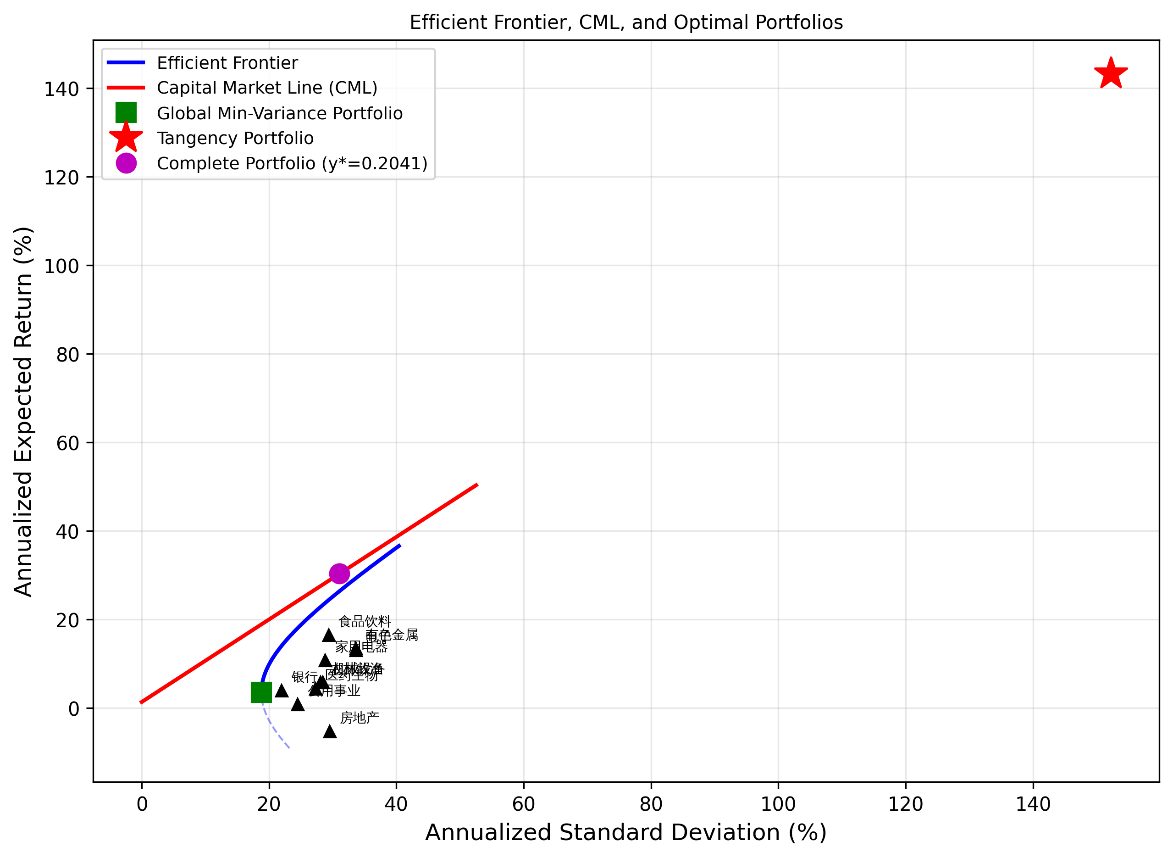
Figure 2 shows the tangency portfolio weights. Blue bars indicate long positions and red bars indicate short positions.
