**Testing** **whether daily returns of major stock markets are independent, using chi squared test. And deciding where to invest, using runs test**

If each market is not influenced from each other, all markets should share similar ratio of “positive return” for a given period. I’ve selected 4 major markets : KOSPI(Korea), S&P 500 (US), FTSE 250(UK), NIKKEI 225(Japan).

First, we would compare basic characteristics of those 4 markets. Figures below are the empirical histogram and the standard deviation of daily returns during 2016~2021.

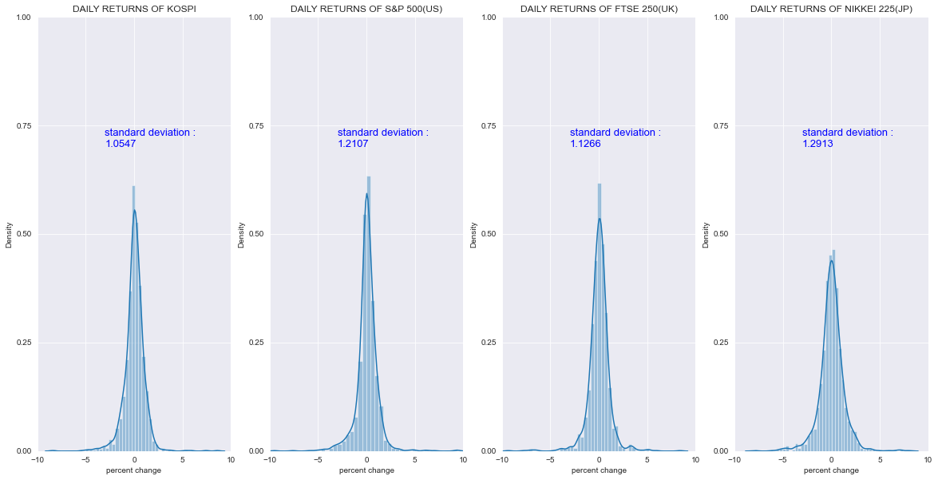Japan Market is observed to be the most volatile market among the group, followed by the US market.

Table below show the performance during the period 2016~2021.

Heatmap figure below shows correlation between markets. The strongest correlation with the S&P 500 is the NIKKEI 225.

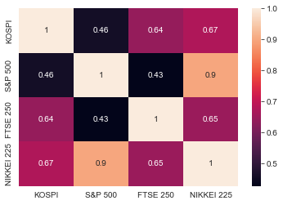

Now, we are testing whether daily returns of major stock markets are independent.

**Null hypothesis** : returns and markets are independent events.

**Alternative hypothesis** : positive/negative returns proportions differ in markets. Some markets have higher return ratios.

Below tables are the observations and expected frequency. Expected frequency is calculated by multiplying the total positive/negative return ratio with the sum of each market. For example, expected positive KOSPI return is 1226*0.5425.

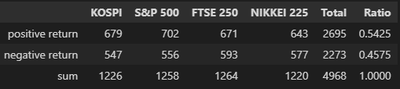

<observations>

<expected frequency>

Significance level is set at 5%, and the statistic and critical value is shown together below.

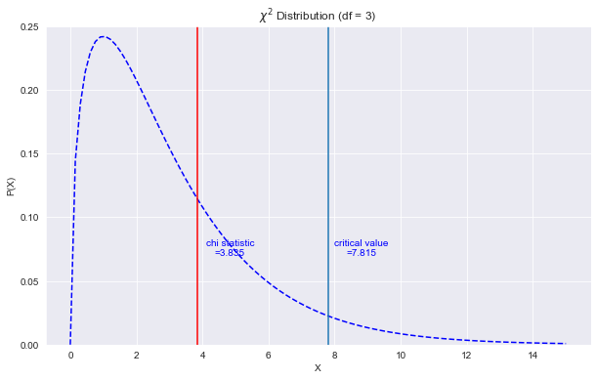

p-value is at approximately 0.2799, which says there is no strong evidence to reject the null hypothesis.

However grouping percent changes into 2 groups is simple so I reorganized the data into 3 groups : 0.5 standard deviation plus average daily returns, between -0.5 ~ 0.5 standard deviation, 0.5 standard deviation below average daily returns.

<observations>

<expected frequency>

Significance level is set at 5%, and the statistic and critical value is shown together below.

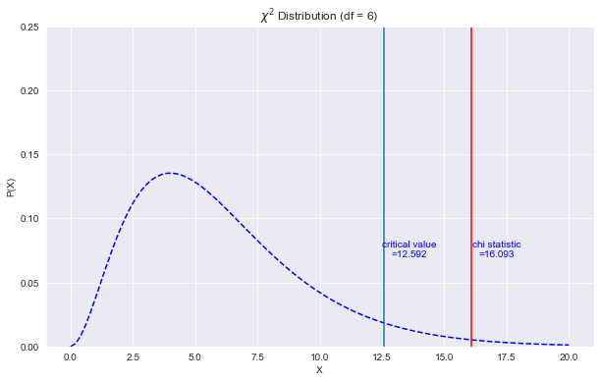

p-value is 0.01326, so rejecting the null hypothesis is possible. Now we can accept the alternative hypothesis.

We got two different conclusions when testing two cases.

Now we are trying to search for positive momentum asset groups. In order to apply momentum strategy, we want to test whether there is some kind of inertia in the movement of daily returns, so we run a Wald–Wolfowitz runs test.

We would run 4 one-sided z-tests. Significance level is set at 5%. Z Critical point is 1.64.

**Null hypothesis** : movements are random.

**Alternative hypothesis** : some kind of upward movement exists.

Table above shows the Z scores and the p-values. Except for the ‘S&P 500’, we failed to reject the null hypothesis. Only the US market index showed significantly upward movements. For an intermediate term investment, we would want to invest in the US Market index, and try to avoid UK Market index.

**Reference**

통계학 제 3판, 류근관

Runs test codes : <https://www.geeksforgeeks.org/runs-test-of-randomness-in-python/>