Part 2: My Finance with Roommates

Conceptual Model:

* Objects:
  + Expense is consisted of date, category, split(Y/N), total amount, roommate(1), roommate(1) money received(Y/N) … roommate(4), roommate(4) money received(Y/N), your amount.
  + Expense list.
  + File
  + Initial number of roommates
  + Pi-chart
  + Line-chart
  + Expense category list
* Relationships:
  + Expense list contain a list of expenses in the same month.
  + Pi-chart is generated using the expense list data.
  + Line-chart is generated using the expense list data.
  + Expense category list contain a list of categories.
  + File contains all of expense lists.

* Operations:
* Insert, Delete, Edit, Save, Save As, Load, Export to Excel Spreadsheet, Refresh.

Semantic Level Design:

|  |  |
| --- | --- |
| Function | Create a Expense List Entry |
| Parameters(explicit & implicit) | Date, Category, Split(Y/N), Total Amount, Roommate(1), Roommate(1) Money Received(Y/N) … Roommate(4), Roommate(4) Money Received(Y/N), Your Amount |
| Description | A new expense entry is created containing all information supplied by the user. This information is stored in the system for making charts. After entering the information, the user can either choose to cancel, save and add another entry, or just save. |
| Feedback | If a user chooses to cancel, the user will be returned to the previous page. No changes will occur in the expense list. If the user has chosen to save and add another, they will be redirected to a new blank form for entering information for a new expense. IF they had chosen to save, they will return to the page they came from. If a save occurred, an alert will be displayed on the screen, informing the user that the information has been saved, This alert should show the amount and category entered. |
| Error Conditions | The money format is incorrect. If the wrong money amount is supplied, an error will occur. It will remain on the same page with error message so that error can be corrected. |
| The category is not selected. If the category is not supplied, an error will occur. It will remain on the same page with error message so that so that error can be corrected. |

|  |  |
| --- | --- |
| Function | Edit an Expense in Expense List |
| Parameters(explicit & implicit) | Date, Category, Split(Y/N), Total Amount, Roommate(1), Roommate(1) Money Received(Y/N) … Roommate(4), Roommate(4) Money Received(Y/N), Your Amount |
| Description | An edited expense is saved in the list containing all information supplied by the user. This information is stored in the system for making charts. After entering the information, the user can either choose to cancel, save and delete. |
| Feedback | If a user chooses to cancel, the user will be returned to the previous page. No changes will occur in the expense list. If they had chosen to save or delete, they will return to the page they came from. If a save occurred, an alert will be displayed on the screen, informing the user that the information has been saved. If a delete occurred, an alert will be displayed on the screen, informing the user that the information has been deleted. These alerts should show the amount and category entered. |
| Error Conditions | The money format is incorrect. If the wrong money amount is supplied, an error will occur. It will remain on the same page with error message so that error can be corrected. |
| The category is not selected. If the category is not supplied, an error will occur. It will remain on the same page with error message so that so that error can be corrected. |

|  |  |
| --- | --- |
| Function | Load a Saved Expense File |
| Parameters(explicit & implicit) | File Name |
| Description | A saved expense list will be opened with the file name supplied by the user. This information is loaded in the system. After successfully loading the information, the user can see the expenses. |
| Feedback | If a user chooses to cancel, the user will be returned to the previous page. No changes will occur. If the file name exists, an alert will be displayed on the screen, informing the user that the information has been loaded. The user can see the expenses. |
| Error Conditions | The file name does not exist. If the wrong file name is supplied, an error will occur. It will remain on the same page with error message so that error can be corrected. |

|  |  |
| --- | --- |
| Function | Save a Expense File |
| Parameters(explicit & implicit) | File Name |
| Description | A expense list will be saved with the file name supplied by the user. This information is saved into a file. After successfully saving the information, the user will remain on the same page. |
| Feedback | If a user chooses to cancel, the user will be returned to the previous page. No changes will occur. If the file name exists, an alert will be displayed on the screen, informing the user that the file name already exists. From the alert, user can select “Replace” or “Cancel” button. |
| Error Conditions | The file name contains invalid character. If the wrong file name is supplied, an error will occur. It will remain on the same page with error message so that error can be corrected. |

Syntactic Level Design:

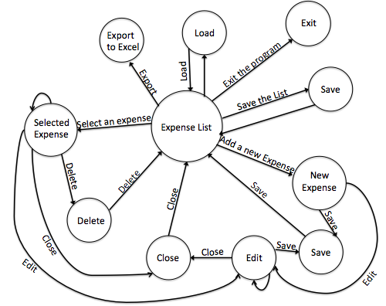

Lexical Level Design:

* Expense List -> Select one Expense -> Edit -> Save
* Expense List -> Select one Expense -> Delete
* Expense List -> Select one Expense - > Edit -> Close
* Expense List -> Create a New Expense -> Edit -> Save
* Expense List -> Create a New Expense -> Close
* Expense List -> Save -> Exit
* Expense List -> Exit
* Load an Expense List -> Expense List -> Exit
* Expense List -> Export to an Excel Spreadsheet