AutoValiSearch
Controlled LLM-driven workflow for configuration search and validation.
Stage I searches bounded training configs. Stage II searches deployable validation policies.
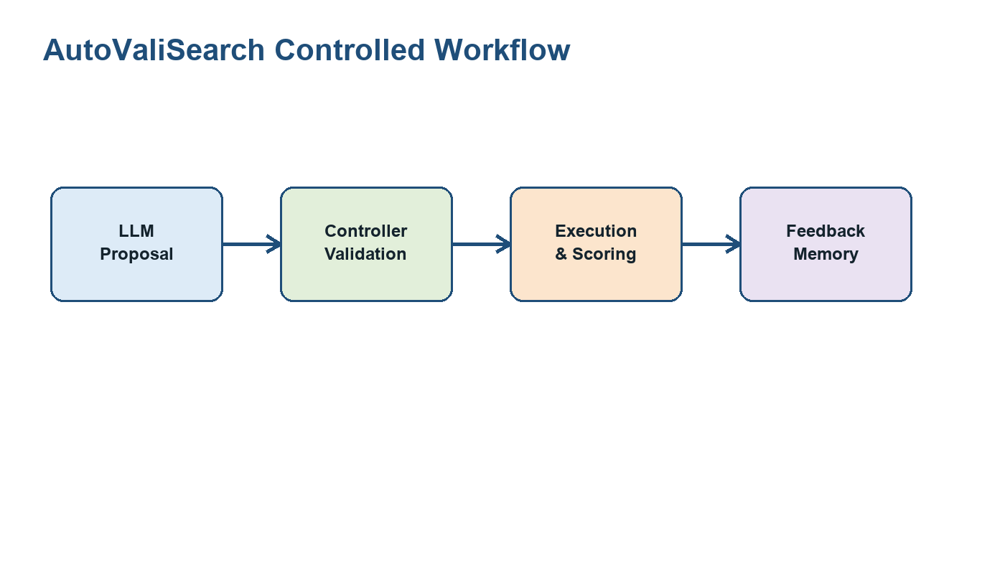

Stage I: Configuration Search
One trial = one config over 4 splits x 2 seeds. Methods: llm_broad, botorch_broad, tpe_broad. Search space size: 4096.

Stage I Results
PACS: LLM 77.226 vs BoTorch 76.810 vs TPE 76.902.
VLCS: LLM 67.852 vs BoTorch 67.478 vs TPE 67.721.
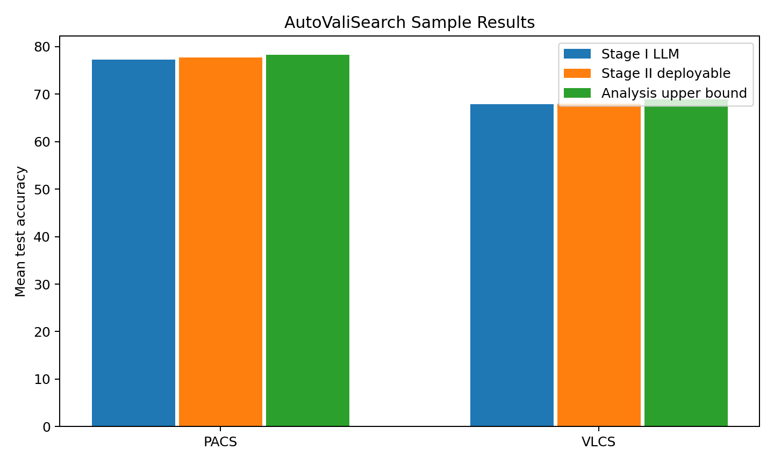

Stage II: Validation Workflow
LLM proposes validation policy DSL. Controller compiles, repairs, caches view scores, selects checkpoints, and applies safety fallback.
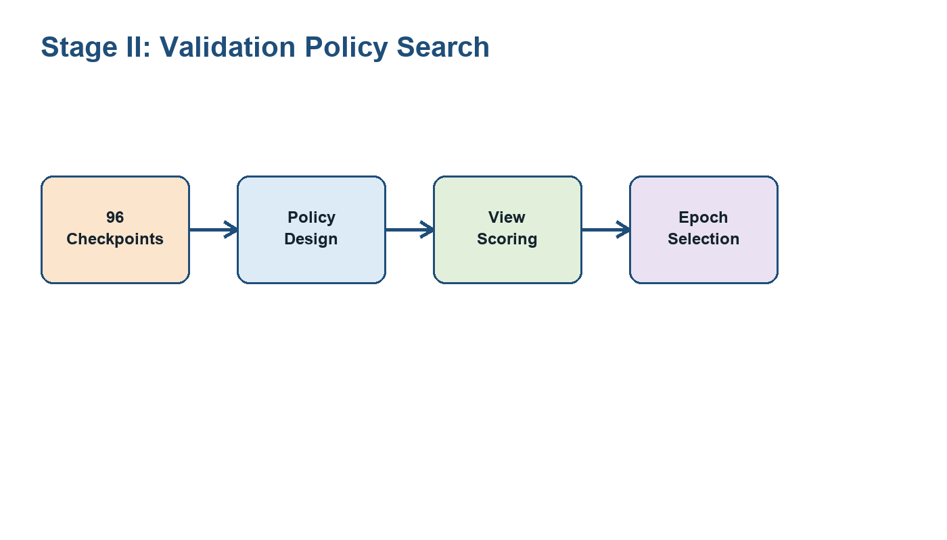

Stage II Results
PACS policy robust_rank_weighted_v11: 77.736, gain +0.510.
VLCS policy source_dominant_weighted_v7: 67.988, gain +0.136.
Upper bound is analysis-only.


