Clinical Opthalmic Oncology - Cancer Survival

Last updated: 2023-11-14

Emily C. Zabor

# Load the data - adjust path to dataset as needed  
load(here::here("uveal_survival_data.rds"))  
  
# Load the needed libraries - install first if needed using install.packages() function  
library(survival)  
library(ggsurvfit)  
library(gtsummary)

# Calculate the total number of subjects  
ntotal <- nrow(uveal_survival_data)

There are 1021 total subjects in the synthetic dataset.

# Calculate the follow-up time among the event-free  
medfup <-   
 summary(  
 uveal_survival_data$survival_time[  
 uveal_survival_data$survival_status == 0]  
 )

The median follow-up time among survivors was 4 years (IQR: 1.9 - 6).

# Calculate the number of events  
nevents <- sum(uveal_survival_data$survival_status == 1)

During this time, 357 subjects died from any cause.

# Create the Kaplan-Meier survival curves according to prognostic status  
km_fit <- survfit2(Surv(survival_time, survival_status) ~ prognosis_status,  
 data = uveal_survival_data)

# Plot the resulting curves  
km_fit |>   
 ggsurvfit() +   
 add_risktable(risktable_stats = "n.risk") +   
 labs(  
 x = "Years from diagnosis",  
 title = "Figure 1: Kaplan-Meier plot of survival probability according to prognostic group") +   
 ylim(c(0, 1)) +   
 scale_x_continuous(breaks = seq(0, 20, 1)) +   
 theme(plot.title = element_text(size = 10))

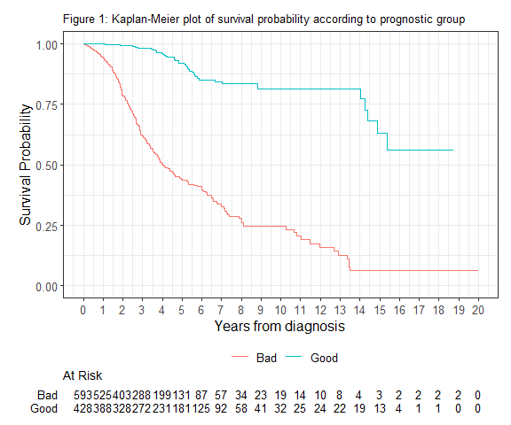

# Add the median, 5-year, and log-rank test  
km_fit |>   
 ggsurvfit() +   
 add_risktable(risktable_stats = "n.risk") +   
 labs(x = "Years from diagnosis",  
 title = "Figure 2: Kaplan-Meier plot with median and 5-year survival, and log-rank p-value") +   
 ylim(c(0, 1)) +   
 add_quantile(y_value = 0.5, linetype = "dotted", color = "grey30",   
 linewidth = 0.8) +  
 add_quantile(x_value = 5, linetype = "dashed", color = "grey30",   
 linewidth = 0.8) +  
 add_pvalue() +   
 scale_x_continuous(limits = c(0, 12), breaks = seq(0, 12, 1)) +   
 theme(plot.title = element_text(size = 10))

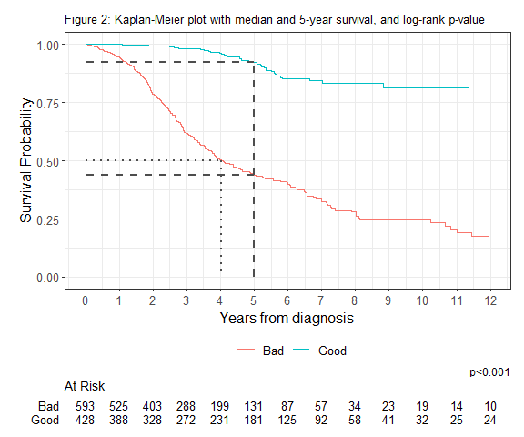

# Calculate the median survival time by group  
tbl_survfit(  
 km_fit,  
 probs = 0.5,  
 label = list(prognosis_status = "Prognostic status"),  
 label_header = "**Median Survival**"  
)

| **Characteristic** | **Median Survival** |
| --- | --- |
| Prognostic status |  |
| Bad | 4.0 (3.7, 4.9) |
| Good | — (15, —) |

# Calculate 5-year survival time by group  
tbl_survfit(  
 km_fit,  
 times = 5,  
 label = list(prognosis_status = "Prognostic status"),  
 label_header = "**5-year Survival**"  
)

| **Characteristic** | **5-year Survival** |
| --- | --- |
| Prognostic status |  |
| Bad | 44% (39%, 49%) |
| Good | 92% (89%, 96%) |

# Add an age variable per 10 years to the dataset  
uveal_survival_data <-   
 uveal_survival_data |>   
 mutate(  
 age_10 = age_at_diagnosis / 10  
 )  
  
# Fit the MV Cox model  
mod <- coxph(Surv(survival_time, survival_status) ~ prognosis_status +  
 age_10 + sex, data = uveal_survival_data)  
  
tbl_regression(  
 mod,  
 label = list(prognosis_status = "Prognosis status",  
 age_10 = "Age at diagnosis (per 10 years)",  
 sex = "Sex"),  
 exponentiate = TRUE  
 ) |>   
 bold_labels() |>   
 add_global_p() |>   
 modify_caption("Table 1: Multivariable Cox proportional hazards regression model results")

Table 1: Multivariable Cox proportional hazards regression model results

| **Characteristic** | **HR**1 | **95% CI**1 | **p-value** |
| --- | --- | --- | --- |
| **Prognosis status** |  |  | <0.001 |
| Bad | — | — |  |
| Good | 0.12 | 0.08, 0.16 |  |
| **Age at diagnosis (per 10 years)** | 1.24 | 1.14, 1.35 | <0.001 |
| **Sex** |  |  | 0.001 |
| Female | — | — |  |
| Male | 1.41 | 1.15, 1.74 |  |
| 1HR = Hazard Ratio, CI = Confidence Interval | | | |