Table of Contents

Document Version 2

1. Purpose 3

1.1. Intended Audience 3

1.2. Intended Use 3

1.3. Scope 3

1.4. Definitions and Acronyms 3

2. Overall System Description 4

2.1. Use Case Diagrams 4

2.2. System Architecture 6

2.3. Functional Requirements 8

2.3.1. In-store checkout system – Start Menu and Scan Item

2.3.2. In-store checkout system – Checkout and payment

2.3.3. In-store checkout system – Rest mode

2.3.4. Online payment system

3.1. Non-Functional Requirements 11

3.1.1. Non-Functional Requirement xxxx

4. Software Architecture 12

4.1. Static Software Architecture 12

# Document Version

|  |  |  |  |  |
| --- | --- | --- | --- | --- |
| No | Update | Name | Date | Version |
| 1. | Initial version |  |  | 1.0 |

# Purpose

## Intended Audience

1. This SRS document outlines the System Requirements and Software Design for a Supermarket Self-Checkout System. The intended audience includes System and Software Engineers involved in the development and implementation of this solution.

## 1.2 Intended Use

1. The SRS defines the overall System Architecture and Requirements as well as the Software Architecture and Design. This document also specifies the definition of the System Requirements which shall be used as the input for System Test cases and Software Unit Test cases.

## 1.3 Scope

## 1.4 Definitions and Acronyms

|  |  |
| --- | --- |
| **Acronym** | **Description** |
| IR | Infra-Red |
| LED | Light Emitting Diode |
| LCD | Liquid Crystal Display |
| RFID | Radio-Frequency Identification |
| DC motor | Direct Current Motor |
| HMI | Human Machine Interface |
| SW | Software |
| HW | Hardware |
| ATM | Automated Teller Machine |
| QR code | Quick Response Code |

# Overall System Description

## 2.1 Use Case Diagram (Online)

## 2.2 Use Case Diagram (In store)

## 2.3 System Architecture

|  |  |  |
| --- | --- | --- |
| **Input Components** | GPIO Pin | Functions/Uses |
| Keypad | GPIO6 / GPIO20 / GPIO19 / GPIO13 (Rows) GPIO12 / GPIO5 / GPIO16 (Columns) | - User inputs for selection, quantity, and ATM PIN entry. |
| RFID Card Reader | GPIO7 (SPI0_CE1_N) GPIO11 (SPI0_SCLK) GPIO9 (SPI0_MISO) GPIO10 (SPI0_MOSI) | - Contactless payment via PayWave or member card authentication. |
| IR Sensor | GPIO17 | - Detect presence of a product in the scanning area or detect user in checkout zone. |
| Temperature/Humidity Sensor | GPIO21 | - Monitor environment (optional, ensures machine isn’t overheating or humid). |
| Accelerometer | GPIO2 (I2C SDA1) GPIO3 (I2C SCL1) | -Detect tampering or shaking of the machine. |
| Ultrasonic Sensor | GPIO25 (Trigger), GPIO27 (Echo) | - Detects proximity of user at kiosk or measures empty shelf space. |

|  |  |  |
| --- | --- | --- |
| **Output Components** | GPIO Pin | Functions / Uses |
| LCD Display | GPIO2 (SDA1), GPIO3 (SCL1) | - Shows scan instructions, item list, total cost, payment status, etc |
| DC Motor | GPIO23 | - Used to simulate a product pusher/conveyor belt |
| Buzzer | GPIO18 | -Alerts on failed verification, tampering, or transaction completion/failure. |
| Servo Motor | GPIO26 | - Opens a secured drawer or cabinet upon successful payment. |
| LED | GPIO24 | -works in tandem with buzzer, Alerts on failed verification, tampering, or transaction completion/failure. |

## 2.4 Functional Requirements

### 2.4.1 In-store checkout system – Start menu and scan item

|  |  |
| --- | --- |
| **REQ_ID** | **Requirement** |
| REQ_01 | When the in-store checkout system is powered ON, the LCD screen displays   * “Press 1 to start” * “Press 9 if done” |
| REQ_02 | When “1” is being pressed on the keypad, the LCD screen displays:   * Line 1: "[Product name] : [price]” * Line 2: “Total: $0.00” * Line 1 should be null when nothing is scanned yet |
| REQ_03 | When the barcode is scanned, check if it is a valid barcode:   * If it is invalid, display “Invalid Barcode” * If it is valid, add [Product name] and [Price] in Line 1, update to cumulative total to “Total: $Y.YY”. |

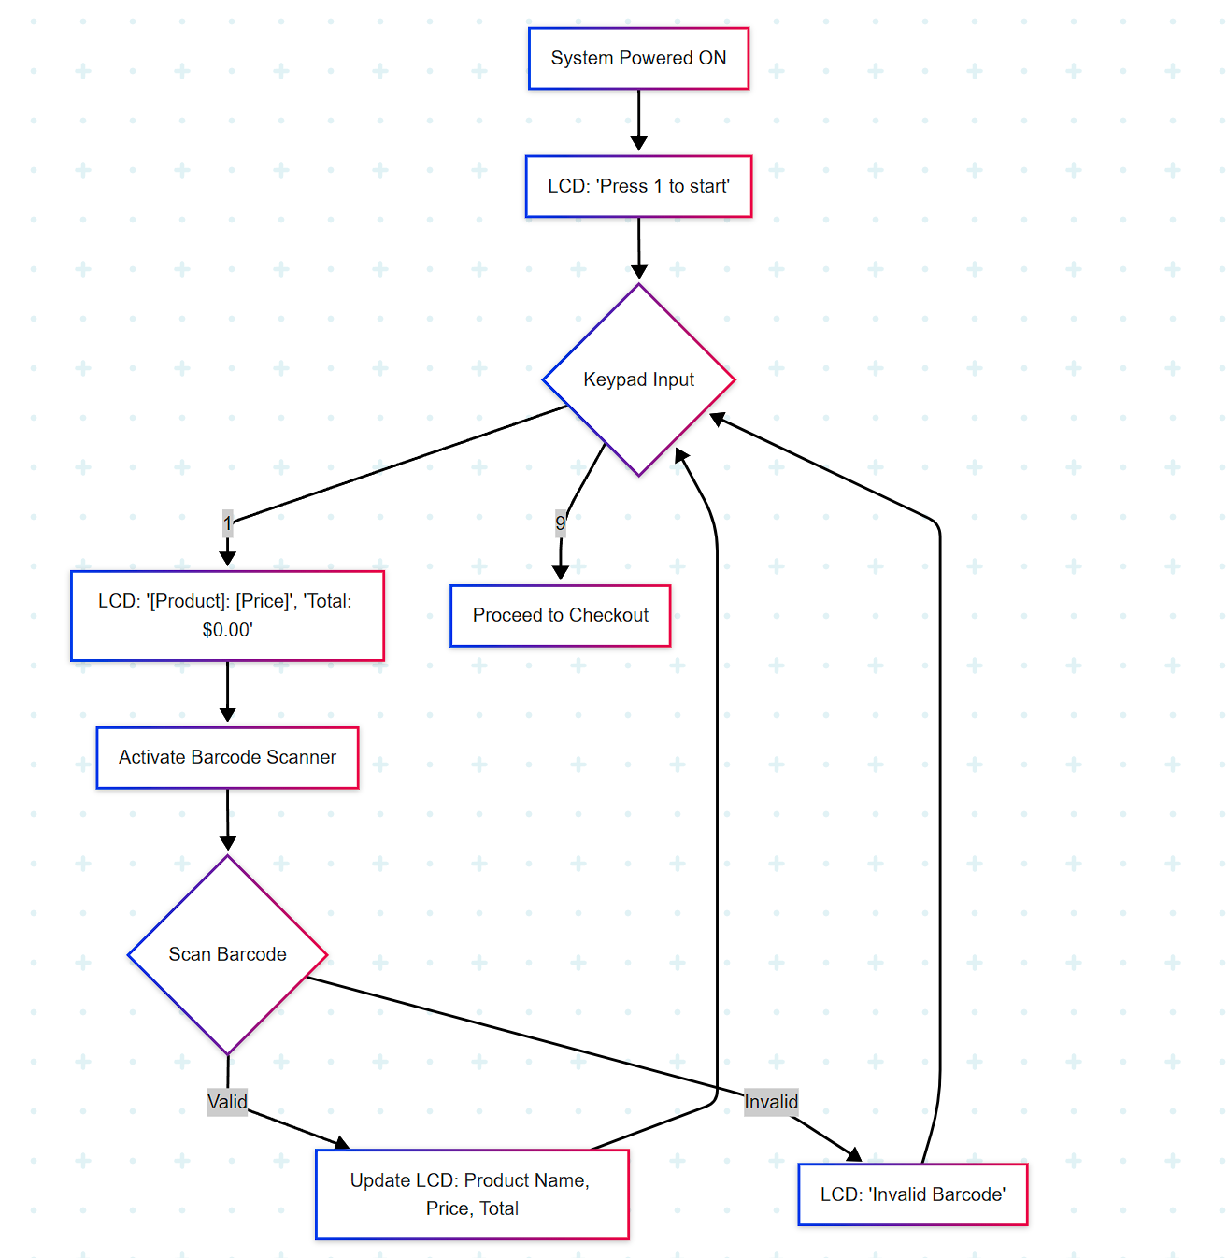

### 2.4.2 In-store checkout system – Checkout and payment

|  |  |
| --- | --- |
| **REQ_ID** | **Requirement** |
| REQ_04 | When “9” is being pressed on the keypad, detect if there are valid items selected:  If the total amount is 0:   * The LCD display: “No items scanned” * Restart the session to REQ_1   If the total amount is not 0:   * the LCD display: * Line 1: “1. ATM payment” * Line 2: “2. PayWave” |
| REQ_05 | When “1” is being pressed on the keypad   * The LCD display “Enter PIN” * Numeric Keypad shall capture PIN input * The system validates the PIN and process payment * If successful, display “Payment Approved”; If unsuccessful, display “Invalid PIN” and LED should light up for 1 second and turn off. |
| REQ_06 | When “2” is being pressed on the keypad   * Activate the RFID Card Reader * System shall detect the RFID card and process payment * If successful, display “Payment Approved”; If it fails, LCD display “Payment Declined” and LED should light up for 1 second and turn off. |

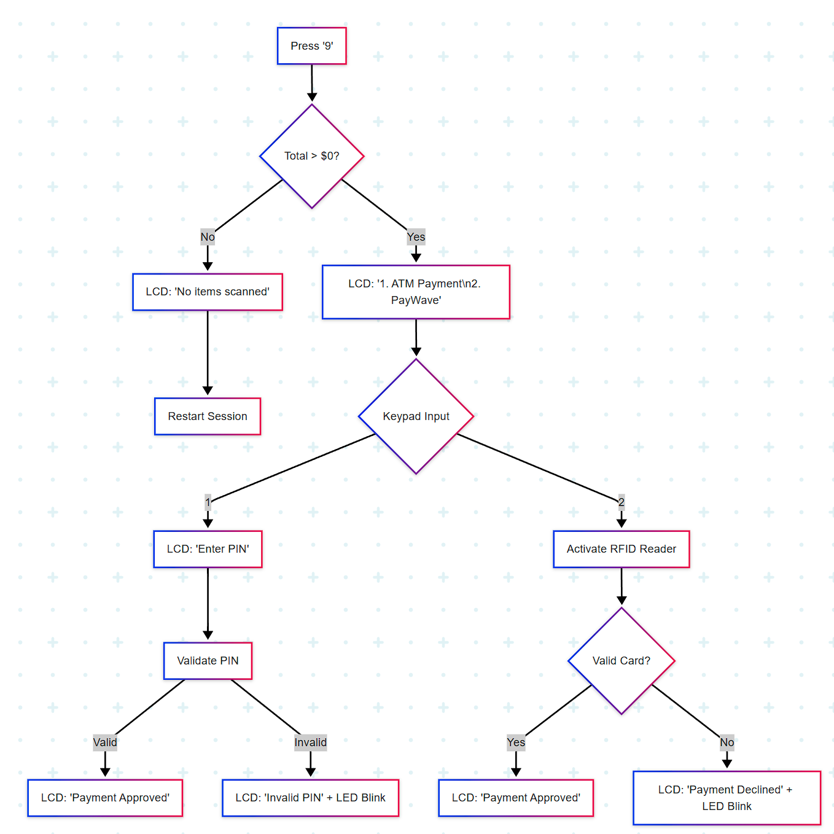

### 2.4.3 In-store checkout system – Rest mode

|  |  |
| --- | --- |
| **REQ_ID** | **Requirement** |
| REQ_07 | When “*” and “#” are being pressed at the same time, the LCD turns OFF.  (Active mode -> Rest Mode) |
| REQ_08 | When “*’ and “0” are being pressed at the same time, the LCD turns ON.  (Rest mode -> Active Mode) |

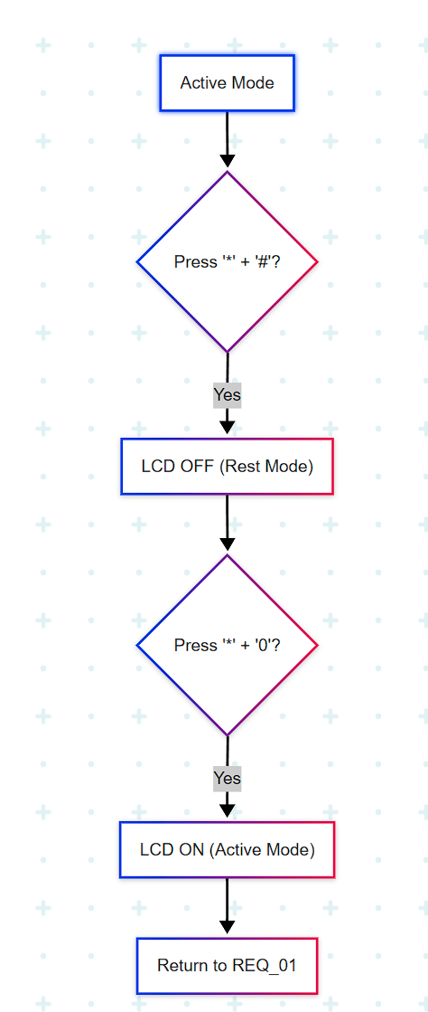

### 2.4.4 Online checkout system

|  |  |
| --- | --- |
| **REQ_ID** | **Requirement** |
| REQ_09 | On the initial webpage, “Online Supermarket” and “Start” should be displayed.  - When the “Start” button is being pressed, it shall jump to item selection webpage (see REQ_10) |
| REQ_10 | On this page, all items are displayed on the screen (sorted), click on the item  - shows a picture of the product and its price  - choose no. of items to purchase (key in the number)  - add up to the total amount |
| REQ_11 | There should always be a “Proceed to checkout” button on the page  - once being pressed, proceed to the online payment webpage. |
| REQ_12 | On the online payment page,  - display “pick up by self” and “delivery” option  - If “pick up by self” selected, jump to the “Payment approved” page  - If “delivery” selected, ask user to key in the address, and add total by $4. |
| REQ_13 | After paid,  - “pick up by self”: generate a QR code to pick up the items.  - “pick up by self”: display “Payment approved, see u later!”  - “delivery”: display “Payment approved, hope to see you again!” |

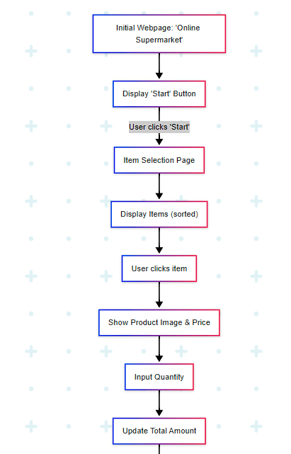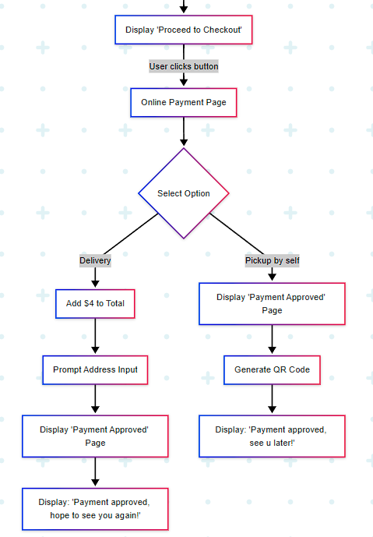

## Non-Functional Requirements

### Power management

For the kiosk in physical store, there is 2 power mode Off Mode and Active. The transitions between the Off Mode and Active Mode are triggered by the

events labelled “enterOffMode” and “enterActive”

|  |  |
| --- | --- |
| **REQ_ID** | **Requirement** |
| REQ-14 | **‘enterOffMode’ trigger Condition 1**   * When “*” and “#” are being pressed at the same time, the LCD turns OFF. |
| REQ-15 | **‘enterActive’ trigger Condition 1**   * When “*” and “0” are being pressed at the same time during Off Mode, the LCD turns On. Back to REQ-01. |
| REQ-16 | * Active mode is default when powered ON |

# Software Architecture

## Static Software Architecture

The Software Architecture defines the various Software Components that are developed to realize the implementation of the system requirements.

**Database**

**HMI**

**Application Layer**

**Hardware Abstraction Layer (HAL)**

**Display**

**Barcode**

**RFID**

**Online Webpage**

**PayWave**

**Camera**

**Barcode Reader**

**Keypad**

**Cart**

**Delivery Option**

**ATM**

**Laptop**

**QR code**

**Power Mgt**