Structure of a production line

General information
This production line has been realized with the GSC hardware and software standard.
Hardware: System control with TIA CPU1518F with integrated safety function,
Periphery: Profinet Safety
Engineering: TIA
Visualization: TIA WinCC Unified
Software:

Software structure
The software structure of this machine is according to the GSC standard by BMW strictly derived from the AKZ. Components with their own operating mode are organized in groups. All groups and components are collected under the PLC.

"PLC"
The “PLC” includes everything that is controlled by the central controller of this machine. In the HMI the “PLC” is also referred as “++ST000”.
"GROUP"
Components with an operating mode can be grouped to a group of operating modes. This group collects the status and enables the control of all component operating modes that belong to this group. Typically, the group is named like a station and all components of this station belong to that group. For example, a group can be called ++ST700.
"COMPONENT"
The smallest entity of a control-technological line structure are components. Such a component can come with or without an operating mode. For example, a protective door like ++ST010+SD001 does not have an operating mode. A conveyor like ++ST700+TL001 usually has its own operating mode.

Visualization
The visualization that is running on each panel (HMI) is based on a basic screen that shows the whole machine. You are able to zoom in and move around. Some elements or more detailed information on an element can only be seen on specific zoom levels and below. Other elements may be only visible on a specific preselection. You can select an element by clicking on it. Once selected this element gets a blue frame around it.

 | NOTE
Once a selected element is outside of the visible area or is to close to the edge of the
visible area, the element gets deselected automatically!

General Operating modes
The current operating mode is shown by the background color of the corresponding HMI element. There are the following operating modes possible:

- Automatic start (white)
- Automatic preselection (yellow)
- Manual mode (green)
- Resequencing start (blue / white)
- Resequencing preselection (blue)
- Service mode (green)

General functions of the Operating modes
Automatic start:

All drives and units are operated, controlled or switched on and off independently by the logic of the central controller. No manual movement is possible.

The predefined normal production sequence is looped as long as new parts are provided.

Automatic preselection:

This operating mode is the state between “Manual” and “Automatic start”. Before you get to “Automatic start” you always need to switch “Automatic preselection” first. In this mode there will be no movement started by the logic of the central controller. Also no manual movement is possible. If a fault message of the classes “Safety Error” , “Immediate Stop” , “Stop in Home” (delayed) or “Controlled Stop” (delayed) are present, the operating mode will always fall back from “Automatic start” to this operating mode.

Manual mode:

Interlocked manual operation of the individual system elements is possible. Operating options are available in accordance with the automatic sequence. Damage to the system and conveyed goods is prevented as far as possible.

Resequencing start:

All drives and units are operated, controlled or switched on and off independently by the logic of the central controller. No manual movement is possible.

The machine automatically selects the most suitable home position if possible. Subsequently the sequence to reach this home position is started once.

Resequencing preselection:

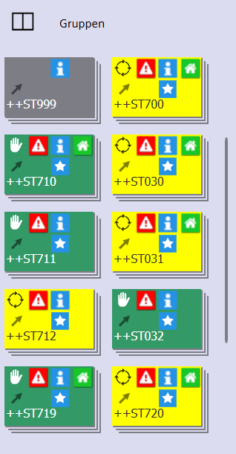
This operating mode is the state between “Manual” and “Resequencing start”. Before you get to “Resequencing start” you always need to switch “Resequencing preselection” first. In this mode there will be no movement started by the logic of the central controller. Also no manual movement is possible. If a fault message of the classes “Safety Error” , “Immediate Stop” , “Stop in Home” (delayed) or “Controlled Stop” (delayed) are present, the operating mode will always fall back from “Resequencing start” to this operating mode.

Service mode:

Unlocked manual operation of all drives and units. This operating mode can only be started from “Manual”. Mechanical damage to the system is not locked!

 | NOTE
When activating the service operating mode you are responsible for all damages to the
machine!

In the service operating mode all interlocks are deactivated and are also not visualized in the HMI!

Operating modes of PLC, GROUPS and COMPONENTS
The “PLC” operating mode can be selected on the top left edge.

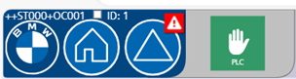

One or more “GROUP” can be selected on the preselection for operating modes in the lower left corner. All groups of this machine are then shown on the left side under the category “Groups”.

One or more “COMPONENT” with an operating mode can be selected on the preselection for operating modes in the lower left corner. All components with an operating mode of this machine are then shown on the left side under the category “FGs”.
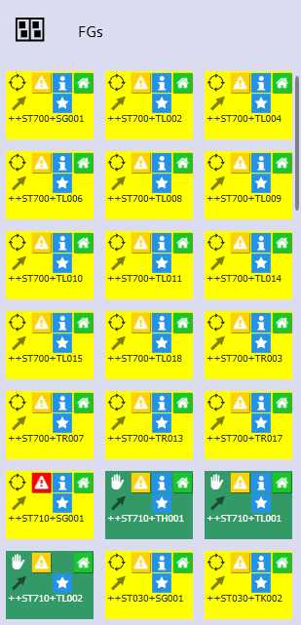

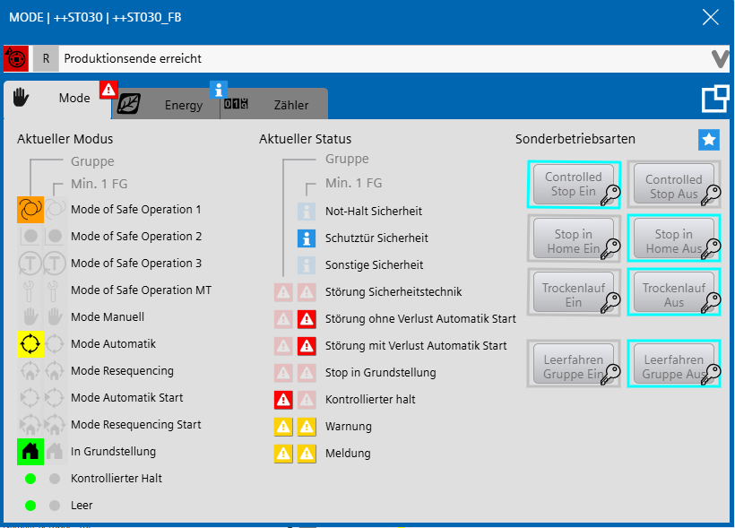

Each operating mode has an HMI element with a detail screen as shown in the picture above. To open this detail screen right click on the element of the respective operating mode. The special operating modes that are defined in the GSC-Standard are controlled by the buttons on the right.

The selected operating mode is inherited between the PLC, GROUP and COMPONENT level. So switching the operating mode with the “PLC” selected in the HMI will also switch all groups, if possible by the permissions of that panel and the current state of the line. Switching the operating mode with a “GROUP” selected in the HMI will also switch all components of that group, if possible by the permissions of that panel and the current state of the line.

In return the status of the level selected and the operating modes below is shown on the left and the middle. Under “Current mode” and “Current messages”.

Fault messages
The three levels of the operating modes also apply for fault messages. So the effect of a fault message on the “PLC” level will also effect all Groups and Components. And a fault message on “GROUP”-Level will also affect all “COMPONENT” in that group. Possible effects of faults include:

- Safety Error (Drop automatic start mode and drop release of manual mode)
- Immediate Stop (Drop automatic start mode)
- Stop in Home (Drop automatic start mode once a home position is reached)
- Controlled Stop (Drop automatic start mode once all movement is stopped)

Furthermore, there are the following fault messages, that have no effect to the operating mode, but may have an indirect effect:

- Error without Stop
- Warning
- Message

Devices

Operation Panels (HMI)
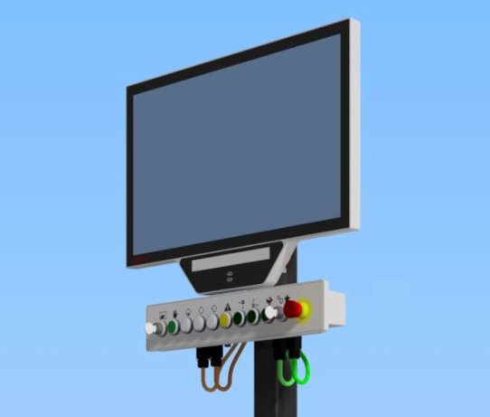

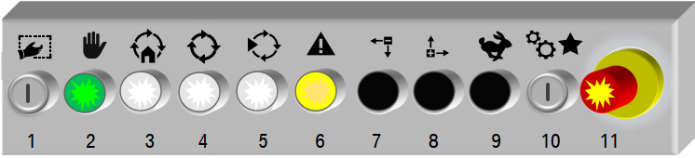

The operation and monitoring of the machine is possible with the OC-Panel and various OP-Panels. They act as a human machine interface (HMI). The OC001 Panel is the main panel, including software packages that can be used to monitor or modify directly the PLC program of the machine.

With the buttons on the extension box below each panel the machine can be operated. The buttons control the selected components (blue frame on HMI) on the Panel.

Button No. | Function
1 | Keyswitch SSG1 for operating enabling (turn right) or select all operating modes on the HMI screen (turn left then quickly turn right)
2 | Illuminated (green) push button for selecting Manual operating mode
3 | Illuminated (white) push button for selecting Resequencing operating mode
4 | Illuminated (white) push button for selecting Automatic preselection operating mode
5 | Illuminated (white) push button for selecting Automatic start or Resequencing start operating mode
6 | Illuminated (yellow) push button to acknowledge fault messages and safety errors
7 | Push button to start movement back / down for selected drives and units  (only in Manual operationg mode)
8 | Push button to start movement forward / up for selected drives and units  (only in Manual operationg mode)
9 | Push button to start fast movement speed for selected drives and units  (only in Manual operationg mode)
10 | Keyswitch SSG10 for entering Service operating mode (turn and hold left)  (colloquially known as “lose your job key”)  The special mode (turn right) is not used.
11 | Emergency stop button pushbutton for stopping the line in an emergency.

Stack light Panel
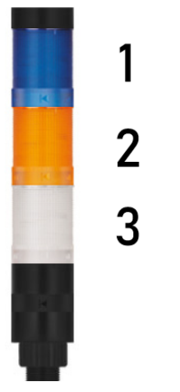

Light No. | Color | Function
1 | Blue | ON: Planned break active  (currently not supported by GSC-Standard)
2 | Orange | OFF: no fault messages  FLASHING: active fault messages in at least one component assigned to this panel.
3 | White | ON: All components assigned to this panel are in operating mode “Automatic start”.  FLASHING: At least one component assigned to this panel is not in operating mode “Automatic start”.

Main cabinet +CE001
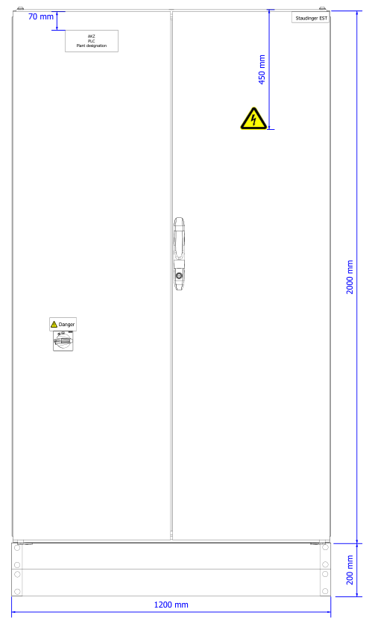

The main cabinet +CE001 contains the voltage supply for the machine (24V and 400V). Furthermore, all subordinate cabinets are fused here. The main switch is installed in the left door of the control cabinet. The main switch is black and there-fore has no emergency stop function.

During normal operation, the control cabinet must always be closed. Before opening the control cabinet for maintenance work, the main switch must be switched off and secured against being switched on again.

Safety light curtain
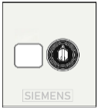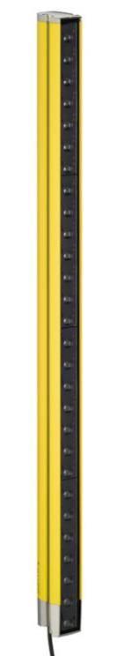

Between the safety areas there are holes in the fence so the cluster of cells on a workpiece carrier can travel through. From one cell to another. To ensure that no personnel passes through those holes, there are safety light curtains that cover these holes. If a protective door is not fully closed and locked and the light curtain is interrupted, both cells will have a safety error.

To acknowledge this safety error, make sure the safety light curtain is clear and then turn the nearby key switch with a SSG10 key.

Robot system
A robot system consists of the manipulator, the control cabinet with control panel and the programming device connected to it.

The IRC5 consists of various modules:
- Control module
- Drive module
- Process module

 | NOTE
Further information on the structure of the control system and operation can be found
in the robot manuals.

Operation

 | NOTE
The machine must only be operated by operating personnel in accordance with chapter
3.3.4 “Personnel selection” in “MAN_00201_Manual_General“.

Information on operation in the supplier's documentation must be observed.

Qualified persons in compliance with the safety instructions may only carry out all work on the electrical system and after the system operator has instructed them.

Switching on the machine
To switch on the machine, carry out the following activities:

- Ensure that the air supply is switched on.
- Set the main switch on the control cabinet to the “I ON” position.
- Close and acknowledge all safety devices.
- Select the desired operating mode.

The machine is now switched on.

Switching off the machine
To switch off the machine, carry out the following activities:

- Move the whole machine to the home position.
- Select MANUAL operating mode.
- Set the main switch on the control cabinet to the “O OFF” position.
- Turn off the air supply.

The machine is now switched off.

Switching off in an emergency
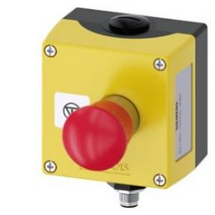

Stop the system immediately with any emergency stop button on the line in the following cases:

- Personnel are inside the machine and the machine is in operating mode “Automatic start” (white LED-button on the protective door is on) or “Resequencing start”.
- Personnel are in the robot's working area while the robot is working.
- The robot endangers personnel or damages mechanical equipment.
- The system poses other health hazards

If an emergency stop button on the system is pressed, all machines stop immediately. As soon as all drives stop, all doors are released: The doors can then be opened

Switching on again after an emergency
All emergency stop switches with pushbuttons have a locking mechanism that must be released in order to remove the emergency stop condition of the device.

In many cases this is done by turning the pushbutton, but there are also devices where you have to pull the switch to release the lock.

 | DANGER
There may still be a danger to life if the reason for the emergency stop persists and the emergency stop button is still released.

Before releasing, ensure that the dangerous situation that caused the emergency stop no longer exists.

Entering the machine

 | DANGER
Risk of death!

The machine must only be entered through the protective doors!

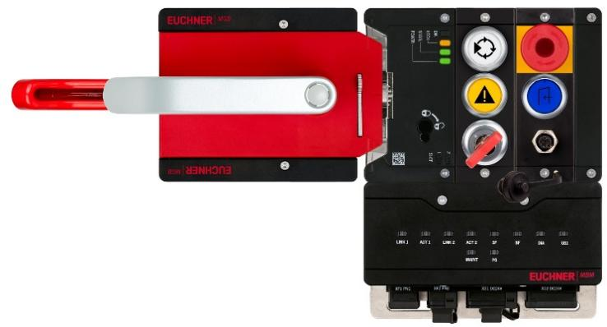

Each protective door has one Euchner handle module with a locking module as shown in the picture above. Also including an escape release from the inside (red handle) and a guard locking function.

Opening protective doors

 | DANGER
Risk of death!

The Lock Out / Tag Out procedure must be followed before entering the machine:

- U-Locks must be attached to the fold-out lockout mechanism or the
second automatically extending lockout mechanism on the handle module.

To open the safety door, carry out the following activities:

Carry your personal safety lock with you and use it to secure the safety doors when you want to enter the cell! (Lock Out / Tag Out)

- Press the “REQUEST GATE ACCESS” button (blue) to request the access.
The indicator light of “REQUEST GATE ACCESS” (blue) starts blinking.
- Wait until the cell comes to a complete stop. When all conditions are met the cell will lose the operation mode Automatic start, the guard locking unlocks the handle and the indicator light of “REQUEST GATE ACCESS” (blue) lights up solid.
- The door now may be opened.
- Once the handle is down the second automatically extending lockout mechanism comes out of the handle module and the fold-out lockout mechanism will be unlocked.
- Apply your U-Lock to the fold-out lockout mechanism or the second automatically extending lockout mechanism. (Lock Out / Tag Out)
- You may now enter the cell.

 | NOTE
 | In the case the cell does not meet all conditions to release opening the protective door (Step 2.), it is possible to force entrance by holding the “REQUEST GATE ACCESS” (blue) button for a configured time. Typically 4s.

Closing protective doors

 | DANGER
Risk of death!

There is a risk of death if the machine is operated without or with non-functioning safety equipment!

Furthermore, there is a danger to life if the machine is switched on when people are inside the danger zone.

The system may only be switched to automatic mode if there is no person in the danger zone.

To close the safety door, carry out the following activities:

- Make sure that there is no person in the cell and no lock or tag attached to the handle module.
- Close the protective door.
The indicator light of “REQUEST GATE ACCESS” (blue) will go out.
The guard locking will lock the door.
- Acknowledge the door by pressing the “ACKNOWLEDGE” (yellow) button.
The indicator light of “ACKNOWLEDGE” (yellow) will stop blinking.
- (optional) To continue the automatic production in this cell press the “AUTO START” (white) button. If there are no further faults, the indicator light of “AUTO START” (white) will light up solid and the cell will start moving in automatic mode again.

 | WARNING
Devices of the cell may already start moving after acknowledging the protective door (Step 3.) due to the air pressure building up or brakes being released!

Even when “AUTO START” (white) has not been selected (Step 4.).

