Layout

 | NOTE
The mechanical structure of the system is described in the operating instructions of the
machine manufacturer.

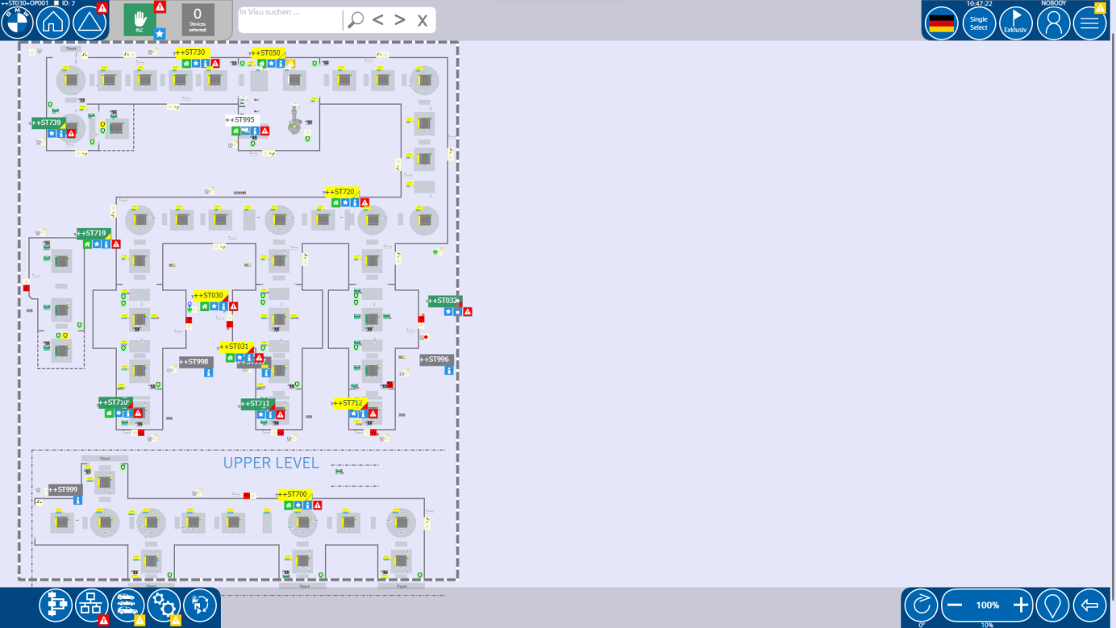

Production process in the production line
The purpose of this machine is the preparation of the incoming cluster of battery cells. This is necessary for the application of the cell contacting system (CCS) onto the cluster in the following machines.

There are two craft stations (acrylic and UV station).
Acrylic is ST030,ST031 and ST032. UV station is ST050,the other are transmission units.
The first transmission station is ST700.First enter the acrylic station to spray then enter the UV station to cure.

General Information

 | NOTE
 | Acrylic and UV station are controlled through PNPN signals.

Components of the production line
Safety zone 1
Station ++ST700 – Conveyor system

Safety zone 2
Station ++ST710 – Conveyor and lift system

Safety zone 3
Station ++ST030 – acrylic Station

Safety zone 4
Station ++ST711 – Conveyor and lift system

Safety zone 5
Station ++ST031 – acrylic Station

Safety zone 6
Station ++ST712 – Conveyor and lift system

Safety zone 7
Station ++ST032 – acrylic Station

Safety zone 8
Station ++ST719 – Conveyor and lift system

Safety zone 9
Station ++ST720 – Conveyor system

Safety zone 10
Station ++ST050 – UV Station

Safety zone 11
Station ++ST730 – Conveyor system

Safety zone 12
Station ++ST739 – Conveyor system

Emergency Stops

Emergency Stop zone 1
All Station

Emergency Stop zone 2
Station ++ST700 – Conveyor system
Station ++ST710 – Conveyor and lift system
Station ++ST711 – Conveyor and lift system
Station ++ST712 – Conveyor and lift system
A1TS03 – Other PLC

Emergency Stop zone 3
Station ++ST030 – acrylic Station

Emergency Stop zone 4
Station ++ST031 – acrylic Station

Emergency Stop zone 5
Station ++ST032 – acrylic Station

Emergency Stop zone 6
Station ++ST719 – Conveyor and lift system
Station ++ST720 – Conveyor system
Station ++ST050 – UV Station
Station ++ST730 – Conveyor system
Station ++ST739 – Conveyor system
A1HG02 – Other PLC

Protective Circuit Areas

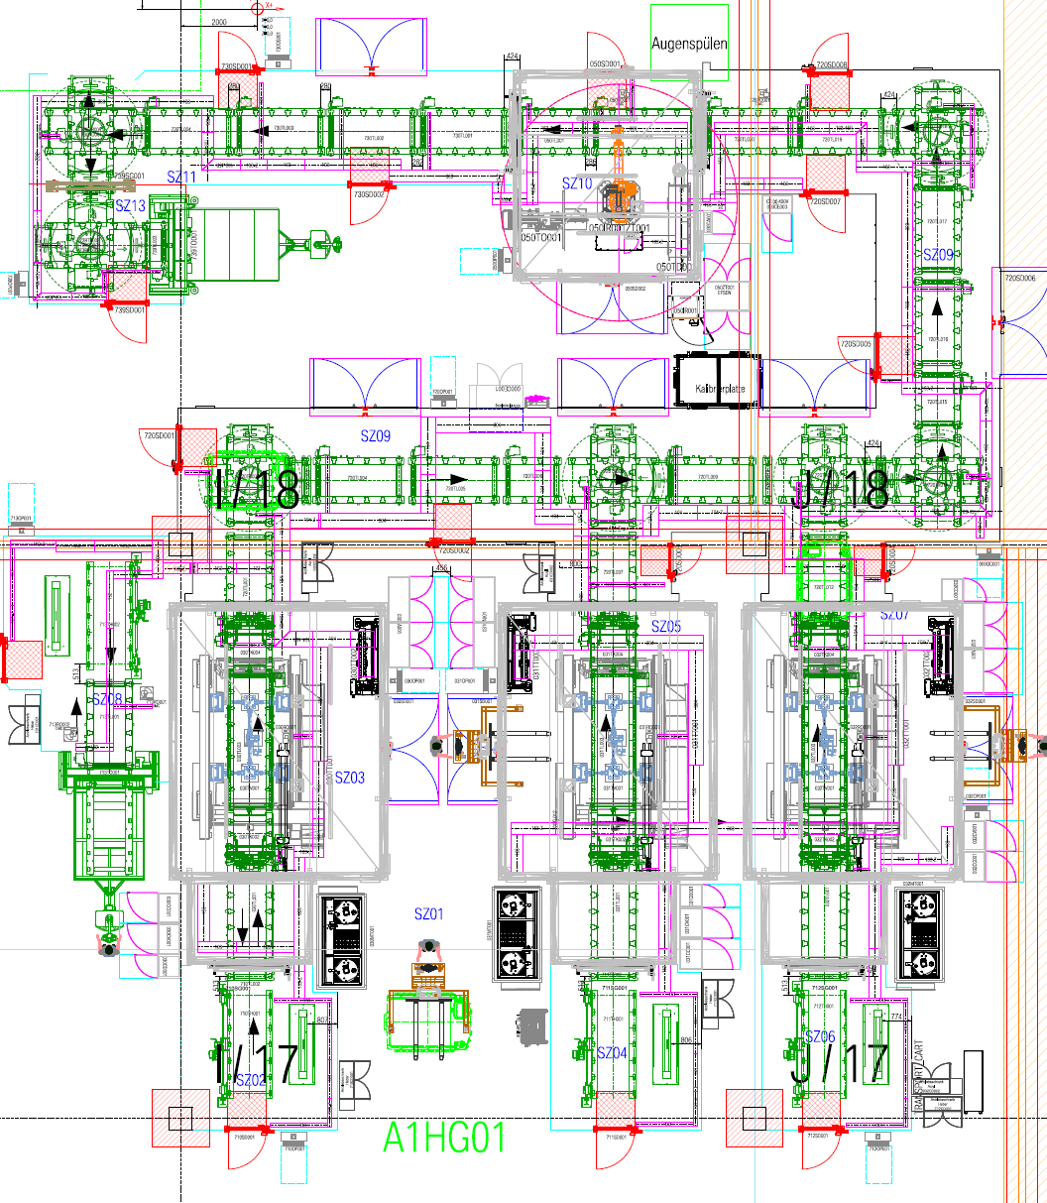

Safety zone 1
Station ++ST700 – Conveyor system

Safety zone 2
Station ++ST710 – Conveyor and lift system

Safety zone 3
Station ++ST030 – acrylic Station

Safety zone 4
Station ++ST711 – Conveyor and lift system

Safety zone 5
Station ++ST031 – acrylic Station

Safety zone 6
Station ++ST712 – Conveyor and lift system

Safety zone 7
Station ++ST032 – acrylic Station

Safety zone 8
Station ++ST719 – Conveyor and lift system

Safety zone 9
Station ++ST720 – Conveyor system

Safety zone 10
Station ++ST050 – UV Station

Safety zone 11
Station ++ST730 – Conveyor system

Safety zone 12
Station ++ST739 – Conveyor system

Special operating mode functions

Controlled Stop
When the special operating mode “Controlled Stop” is selected on PLC Level all groups and components will stop the movement in the next possible step without interrupting a running process.

Stop in Home
When the special operating mode “Stop in Home” is selected on PLC Level all groups and components will stop the movement in the next possible Home position.

Dry run
The special operating mode “Dry Run” is not defined and not programmed for this line on PLC Level.

Run empty
When the special operating mode “Run empty PLC” is selected all clusters trying to enter the line will be stopped at the conveyors ++ST010+TL001 respectively ++ST011+TL001 in front of the laser cabins.

Special functions

General Information
There are no special functions on PLC-Level in this machine. The special functions of the individual stations you can look up in the following chapters:

Interfaces
This PLC has two connections to adjacent machines over PN-PN Couplers. The connection serves the purpose of exchanging the following data:

- Signals between conveyors
- Releases
- Interlocks
- Information about current operating modes and faults
- Safety signals

Connection with 026A1TS03
HG01 and it only transmits. The following signals are exchanged:

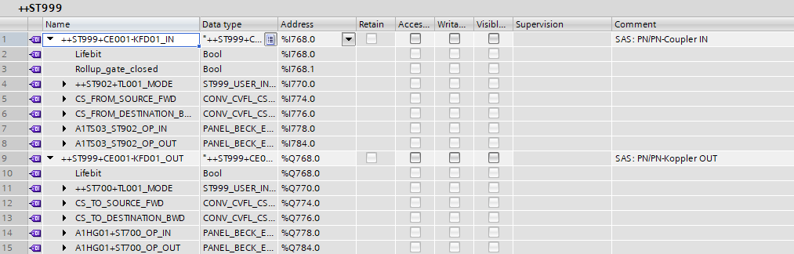

Connection with 026A1HG02
HG01 and it only transmits. The following signals are exchanged:

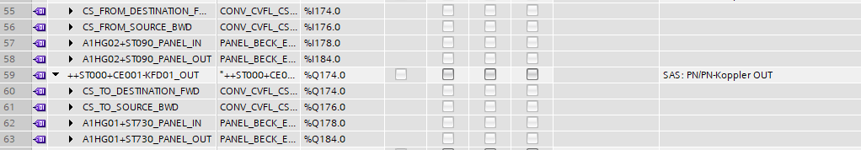

Type management
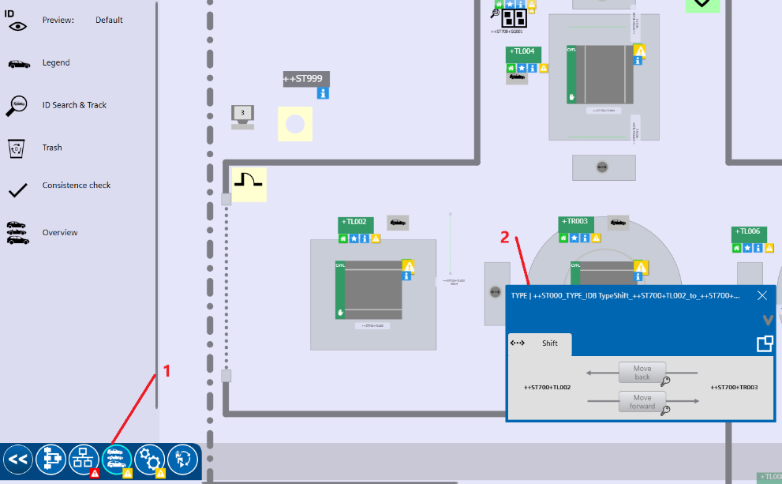

The Type-Data of this line is mainly requested from IPS-C where it is needed on each processing station, decision points, etc. For a better overview and some special cases, the Type Data from IPS-C is shifted further down the line. To view the Type Data and shifting elements in the line you need to activate the type view over the preselection on the lower left corner. The button for the preselection is a symbol of three different cars (see 1 at the picture above).

The shifting of the Type Data of one cluster from one Type Dataplace to another is done automatically. If you wish to shift it manually you can use the round element next to the Type Dataplace (see 2 at the picture above). It lets you shift the Type Data back and forth between two Type Dataplaces in the direction of normal production. For this you need both corresponding components in manual mode.

General Information

 | DANGER
Due to lack of type checking sensors the Type Data is essential for the line to start the correct process sequence in processing stations. If the Type Data is not matching the
actual cluster in the line a crash there is inevitable.

A crash will most likely start the cluster of live cells to burn, to explode or to emit
hazardous vapors and acids.

 | Forbidden
 | Do never change the Type Data of a cluster!

