Layout Conveyor ++ST710

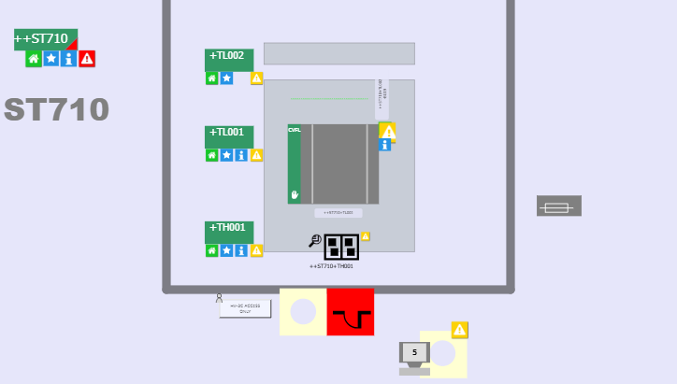

Production process in ++ST710
Only transmission lines.

General Information

 | NOTE
 | The light curtain is interrupted when opening the safety door and need to be reset on both sides.

Constituents of ++ST710
This transmission lines consists of the following components with an operating mode:

- ++ST710+TL001: Roller conveyor
- ++ST710+TH001:Lifter
- ++ST710+SG001: Pneumatically movable bulkhead

This transmission lines consists of the following components without an operating mode:

- ++ST710+SD001: Protective door
- ++ST710+OP001: Operation Panel (HMI)

Special operating mode functions

Controlled Stop
When the special operating mode “Controlled Stop” is selected on the GROUP Level all components of this group will stop the movement in the next possible step without interrupting a running process.

Stop in Home
When the special operating mode “Stop in Home” is selected on the GROUP Level all components of this group will stop the movement in the next possible Home position.

Dry run
The special operating mode “Dry Run” is not defined and not programmed for this station.

Run empty
When the special operating mode “Run empty Group” is selected all clusters trying to enter the line will be stopped at the conveyor ++ST710+TL001 in front of the laser cabin.

Special functions

General Information
There are no special functions in this station.

Available Types

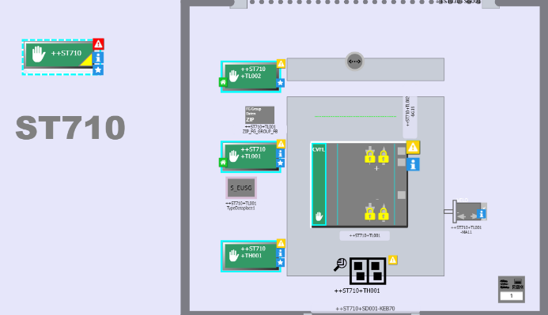

In this station there are two types available for the type dataplaces.

S_EUSG: Is the Type number 1. It is the smaller cluster of cells

S_CKSB: Is the Type number 2. It is the smaller cluster of cells

S_CKSG: Is the Type number 3. It is the smaller cluster of cells

M_EKSG: Is the Type number 4. It is the larger cluster of cells

MHEKSG: Is the Type number 5. It is the larger cluster of cells

M_EKSB: Is the Type number 6. It is the larger cluster of cells

