Layout UV Station ++ST050

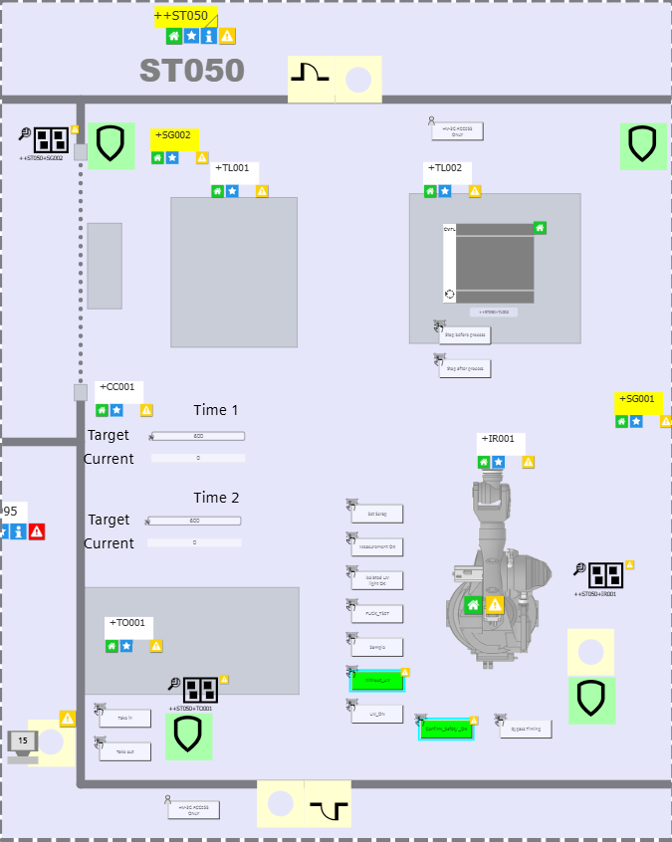

Production process in ++ST050

When the battery enters the UV station, a Puck test must be performed first. After obtaining the data, press the “Mesurement OK” button on the interface. The battery then proceeds into the UV station to begin the curing process.
Before releasing JOB1, the ICAD triggers a measurement function. After curing is completed, the UV lamp returns , and the ICAD performs another measurement. The data obtained from the ICAD measurement is compared with the data from the initial puck test, triggering an alarm or warning based on the comparison results
JOB1: UV curing
JOB50: PUCK test
JOB51:Sample test

Constituents of ++ST010
This transmission lines consists of the following components with an operating mode:

- ++ST050+IR001: Robot with UV lamp
- ++ST050+TL001: Roller conveyor
- ++ST050+TL002: Roller conveyor
- ++ST050+TO001:Trolley

This transmission lines consists of the following components without an operating mode:

- ++ST050+OP001: Operation Panel (HMI)
- ++ST050+SD001: Protective door
- ++ST050+SD002: Protective door

Maintenance programs

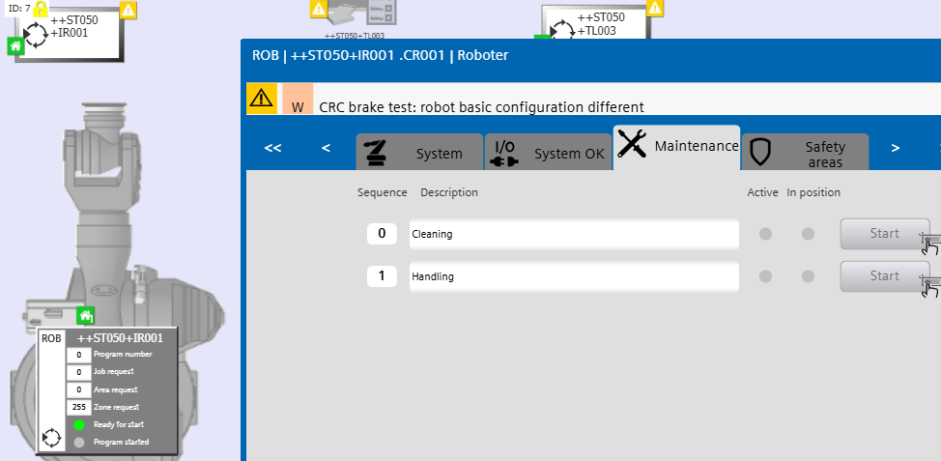

To request a maintenance position, press the corresponding “Start” button. The robot will start driving to the selected position as soon as possible. When no other program is active and safety / interlocks are clear. Once in position the “in position” will light on. The robot will remain in the maintenance position until the “Start” button is pressed again. Then the robot drives back to the home position.

The maintenance positions are selected individually for each robot.

Special operating mode functions

Controlled Stop
When the special operating mode “Controlled Stop” is selected on the GROUP Level all components of this group will stop the movement in the next possible step without interrupting a running process.

Stop in Home
When the special operating mode “Stop in Home” is selected on the GROUP Level all components of this group will stop the movement in the next possible Home position.

Dry run
When the special operating mode “Dry run” is selected the ++ST010 Group the lifter +TV001 including the fixture +FX001 and all four robots will drive the normal process sequence without a part and without an actual process.

Before the dry run will start, you must select one or more types that you want to do drive in dry run. Over the HMI buttons close to the station or in the detail screen of the station

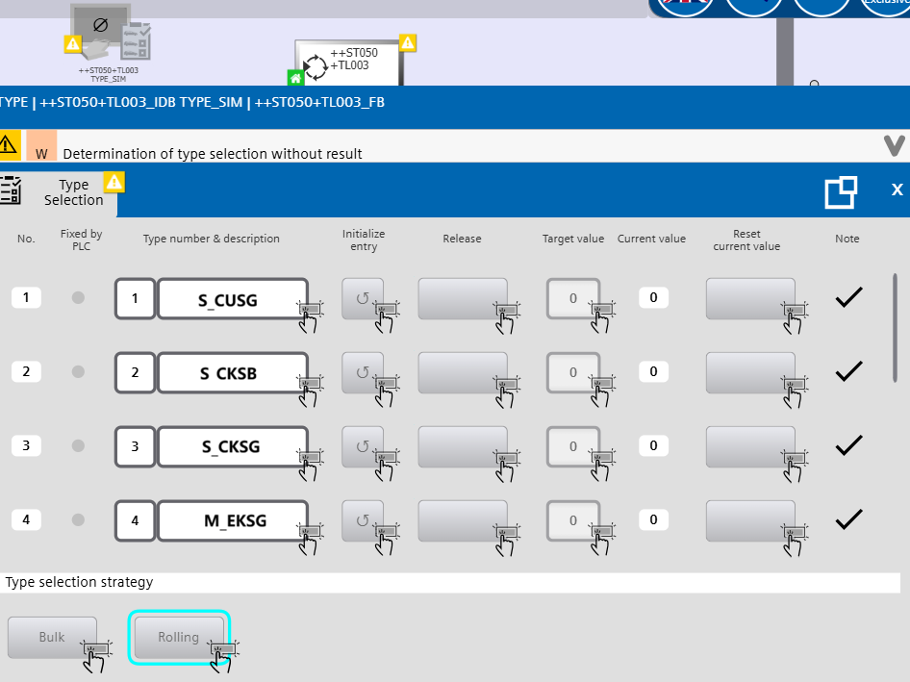

Run empty
When the special operating mode “Run empty Group” is selected all clusters trying to enter the line will be stopped at the conveyor ++ST050+TL002 in front of the laser cabin.

Special functions

Stop before / after buttons
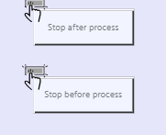

To stop the sequence in a specific constellation you have four buttons in the detail screen of this station. Each button can be selected any time but will be active only when the sequence has reached the selected constellation. When any of the four buttons is active the sequence is halted until the active button is deselected again. So the production will stop even though the whole line remains in the “Automatic start” operating mode.

Stop before process:
This button will stop the station before the process starts. After an unfinished part has entered the station and is prepared for the process.

Stop after process:
This button will stop the station after finishing the process of the current part. The finished part will remain in the position required for the process.

The robot repeats the process until the count provided in the HMI for “Input MFU2 TF1 Cycle Count” is reached. Go inside to remove the processed coupons for inspection. Then deselect the button in the HMI to release all robots to drive to home position.

Available Types
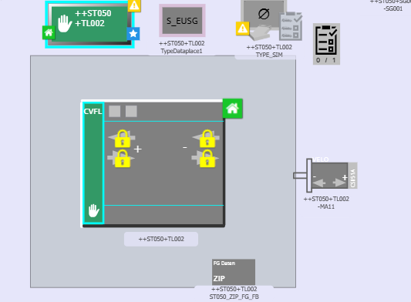

In this station there are two types available for the type dataplaces.

S_EUSG: Is the Type number 1. It is the smaller cluster of cells

S_CKSB: Is the Type number 2. It is the smaller cluster of cells

S_CKSG: Is the Type number 3. It is the smaller cluster of cells

M_EKSG: Is the Type number 4. It is the larger cluster of cells

MHEKSG: Is the Type number 5. It is the larger cluster of cells

M_EKSB: Is the Type number 6. It is the larger cluster of cells

