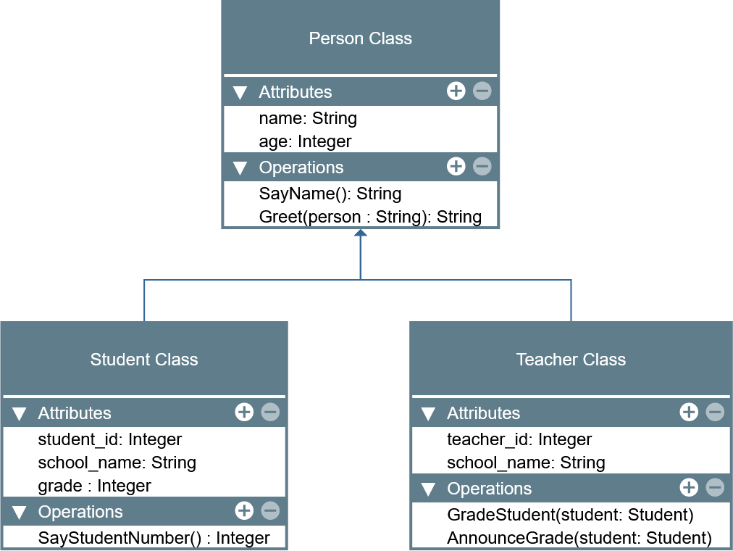

LABORATORY MANUAL

Object-Oriented Programming (CPE 103)

|  |  |
| --- | --- |
| **Laboratory Activity No. 2.1** | |
| **Literals, Operators, and Variables** | |
| **Course Code:** CPE103 | **Program:** BSCPE |
| **Course Title:** Object-Oriented Programming | **Date Performed:** 25/01/2025 |
| **Section:** BS CpE 1A | **Date Submitted:** 25/01/2025 |
| **Name:** Junichiro H. Uy | **Instructor:** Maria Rizette M. Sayo |
| **1. Objective(s):** | |
| This activity aims to familiarize students in the various data types of Python, assign values to variables, and perform operations in a Python program. | |
| **2. Intended Learning Outcomes (ILOs):** | |
| The students should be able to:   * 1. Assign different values to variables in Python   2. Perform different operations available with variables in Python | |
| **3. Discussion:** | |
| The **Python** programming language is an interpreted language meaning the lines are evaluated line -by-line at runtime because there is no compile time at Python. This means that Python can dynamically allocate memory to variables as needed depending on the line of code that it interprets that is why Python is also referred to as a Dynamically typed language.  Like other programming languages such as C/C++ and Java, Python can also assign values to specific blocks of memory through variables as well as perform operations such as but not limited to Addition, Subtraction, Multiplication, Division, and Modulo(remainder). This activity will focus on assigning values and performing operations in Python.  Recall that a **variable** is a name that points to a specific location in memory where the data is stored. A variable can be allocated memory based on the data type it is assigned with which in Python can be: **Integer**, **Float**, **Complex Number**, **Boolean**, and **String**. In Python, **lists**, **tuples**, and **dictionaries** are also referred to as data types specifically sequences. More information can be found here ([https://docs.python.org/3.8/reference/datamodel.html?highlight=data%20type#objects -values-and-types](https://docs.python.org/3.8/reference/datamodel.html?highlight=data%20type&objects-values-and-types)). These will be discussed further in lab activities.  Variables in Python are assigned in the following manner:  variable_name = value  **Literals** refers to the raw data given in a variable or constant. Literals can be some of the following: Numeric, Complex, String, Boolean, Special. Other literals are list, tuple, dict, set, and Unicode literals. | |
| **4. Materials and Equipment:** | |
| Desktop Computer with Anaconda Python /Python Colab Windows Operating System | |
| **5. Procedure:** | |
| **Perform the activity using the Jupyter Notebook**  This activity can be done either locally on Anaconda’s Jupyter Notebook or online through Google Collaboratory which offers a free Jupyter Notebook environment for Google Users. IPython Notebook files (.ipynb) that are saved in the Google Drive can be opened on Google Collaboratory. Additional guides are available on the IPython Notebook template file that is provided wit h  this activity. If the template is not present, these are the valuable links for reference: | |

|  |
| --- |
| <https://jupyter-notebook.readthedocs.io/en/stable/examples/Notebook/Notebook%20Basics.html> <https://colab.research.google.com/notebooks/welcome.ipynb> <https://colab.research.google.com/notebooks/markdown_guide.ipynb>  **Assigning variables of different data types in Python**   1. In an empty cell, declare a variable **value** and assign it the value of 5 then display its value using print(). 2. Create a new cell and type the command: type(value) then run the cell. The output should be like the image below.      1. In a new cell, use the same variable **value** and assign it the value of 5.0 then print the value. 2. Repeat step 2.   **Note:** You may choose to decide how you execute the code in the cells for the next tasks in the procedure.   1. Repeat these steps for the following values:    1. 2+3j    2. ‘Hello World’    3. “Hello World”    4. True    5. False    6. [1,2,3,4,5]    7. (1,2,3,4,5)    8. { ‘name’: ‘Your_name’ }    9. None 2. Re-assign the **value** variable to be equal to 5. 3. Declare a new variable named **value2** to be equal to -6.   **Performing Operations with Python**   1. Using **value** and **value2**. Type the command: print(**value**+**value2**) 2. Repeat step 1 for the following values of **value** and **value2**:   Hint: You may try using this assignment ***value, value2 = 5, -6*** in the Notebook for the following steps:   * 1. value, value2 = 5.0, 6   2. value, value2 = -5, 6.1   3. value, value2 = “Hello”, ‘world’   Note: Modify the code so that hello and world would be separated.   * 1. value, value2 = [1,2,3], [4,5,6]   2. value, value2 = (1,2,3), (4,5,6)   3. value, value2 = {"name":"Royce"}, {"age":2}   Note: Observe the outputs carefully and try repeating them using subtraction. |
| 1. Using value, value2 = 30, 4. Type the commands:    1. print(value*value2)    2. print(value2**2)    3. print(value2**3)    4. print(value*value2+value2**2+1)    5. print(value/value2)    6. print(value%value2)   **Receiving Input Data using Python**  Data can be received through keyboard input in Python by using the input() function. The input function has the following syntax:  **input(“Message Name”)**  The “Message Name” is an optional String parameter that can be customized to prompt the user for a message instead of having to print a message prompt separately. The default return value of the input() function is a String containing the value received from the keyboard. This value can be assigned to a variable shown in the example below:  **name = input(“Enter your name: “)**  **Assigning Input Data to a Variable**  Finding a person’s BMI (metric)   1. Declare a new variable named **name** and assign it the value **input(“Enter your name”)** 2. Create another variable named **weight** and assign it the value **input(“Enter your weight(kg): “)** 3. Create another variable named **height** and assign it the value **input(“Enter your meters(m): “)** 4. Declare another variable called **bmi** and assign it the formula 𝑏𝑚𝑖 = 𝑤𝑒𝑖𝑔ℎ𝑡   ℎ𝑒𝑖𝑔ℎ𝑡2   1. Address the errors displayed step#4. You can accomplish this by converting the String input to another data type. An example would be:   **weight** = input(“Enter your weight(kg)”)  **weight** = float(weight)  Or simply **weight** = float(input(“Enter your weight(kg): “))  There are many functions available that can convert one data type to another. Some of which are the following:  int(), float(), str()  Other functions which maybe used in the later lab activities are: complex(real, imaginary), list(), tuple(), set(), dict(), ord(), bin(), hex(), oct().   1. Print the persons’s name, weight, height, and bmi Name: John Ray   Weight: 60  Height: 1.6764  BMI = 21.3499  **Guide:** 5.5 feet ~ 1.6764 m |
| **Hint:** You can combine two values by converting the output value to String and Concatenating (Addition) the operator on two strings.  print(“Value: “+str(12))  You may explore many other methods to format values onto the print() function in Python. Another example is the following:  print(“Value: “, 12) |
| **6. Supplementary Activity:** |
| **Tasks**   1. **Write the Python equivalent code of the following C code:**   int main(){  float base = 0, height = 0, area = 0; printf(“Enter the base of the triangle: “); scanf(“%f”, &base);  printf(“Enter the height of the triangle: “); scanf(“%f”, &height);  area = (1/2)*base*height;  print(“The area of the triangle is %f”, area);  }   * <https://colab.research.google.com/drive/1iLJ-HD8DLx3_Ci32X0JjpYMyjOJ_WPIb#scrollTo=foWj1T0Tz44s&line=2&uniqifier=1>  1. **Write a program that would convert Celsius to Fahrenheit given the formula: F = (C × 9/5) + 32 Example of conversion:**   **0°C = 32 °F**  **-20°C = -4 °F**     * <https://colab.research.google.com/drive/1iLJHD8DLx3_Ci32X0JjpYMyjOJ_WPIb#scrollTo=8tyD_ZPY2z77&line=1&uniqifier=1>  1. **Write a program that can determine the distance between two points given the coordinates using the formula:**   𝒅 = √(𝒙𝟐 − 𝒙𝟏)𝟐 + (𝒚𝟐 − 𝒚𝟏)𝟐 **Hint/Rule: No library or package is needed to implement this equation. Example: x2, y2 = -3, 3 and x1, y1 = 2, 2 d = 5.099019514**   * <https://colab.research.google.com/drive/1iLJ-HD8DLx3_Ci32X0JjpYMyjOJ_WPIb#scrollTo=p__qc3a44J7B&line=1&uniqifier=1>   **Questions:**   * 1. **Give one major difference in syntax that Python has with other languages such as C?** * In Python, indentation is used to define blocks of code like in loops or functions, and it’s required for the code to work. While, C uses curly braces {} to define blocks, and indentation is optional, mainly for readability   1. **How does variable assignment differ in Python compared with other languages such as C?** * Python doesn’t require you to declare the type of a variable before using it. You just assign a value, and Python automatically determines its type (this is called dynamic typing).unlike in C, , you need to declare the variable type first, like int, float, or char, before using it because C is statically typed.   1. **Try assigning variable names that start with numbers, and special characters. Is the assigning of variables that start with numbers accepted by Python? For Special Characters? Is there an exception for variables special characters?** * Python doesn’t allow variable names that start with numbers or most special characters. Variable names must start with a letter (a-z, A-Z) or an underscore (_) and can only include letters, numbers, or underscores after that. For example: * Valid: age, _name, score1 * Invalid: 1score, @value, $money * The only exception is the underscore (_), which can be used at the beginning of a variable name.   1. **Do the assignment operators (+, -, *, /, %, **) work for all data types? Why or Why not?** * Operators like +, -, *, /, %, and ** don’t work for every data type because their behavior depends on the type. For example: * + works for both numbers (adds them) and strings (joins them together). * * works for numbers (multiplication) and strings (repetition). * % (modulo) and ** (exponentiation) are strictly for numbers. Using them with other data types, like strings or lists, will result in an error.   1. **How does the * operator differ from the ** operator?** * * is used for multiplication, while ** is used for exponentiation. |

|  |
| --- |
|  |
| **7. Conclusion:** |
| * Simply by doing away with many of the strict constraints found in languages like C, Python makes coding easier. Code that uses indentation instead of braces to define code blocks is clearer and easier to read. Python is more flexible thanks to dynamic typing, which enables programmers to assign values without explicitly declaring variable types. However, this flexibility occasionally results in less predictable code behavior. Python variable name is simple, but it adheres to more stringent guidelines to guarantee uniformity and clarity. Even though Python's operators are very flexible, how they work depends on the kind of data being used. All things considered, Python's architecture places a high value on efficiency and simplicity, making it a great option for novices while yet having the capacity to manage challenging programming tasks. |
| **8. Assessment Rubric:** |