# Electricity. Color code 1.

1. What is the value of this resistance?

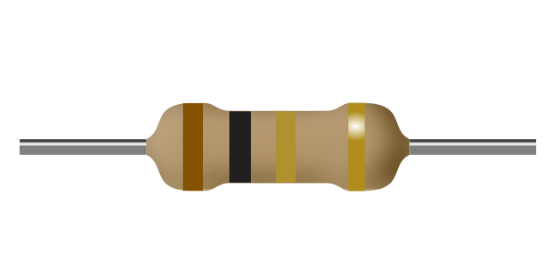

a) 10Ω

b) 1.0Ω

c) 1.0kΩ

d) 101Ω

1. What is the value of this resistance?

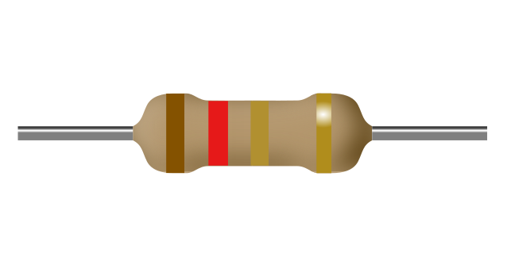

a) 1.2kΩ

b) 1.2Ω

c) 12Ω

d) 121Ω

1. What is the value of this resistance?

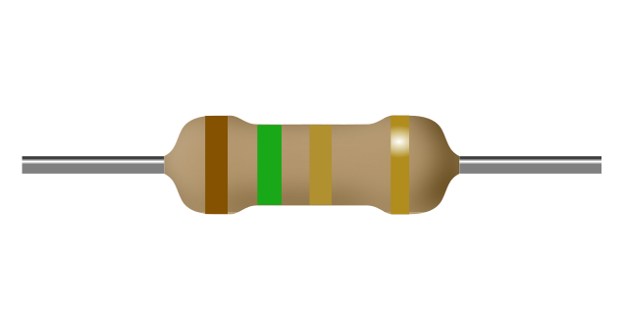

a) 1.5kΩ

b) 15Ω

c) 1.5Ω

d) 151Ω

1. What is the value of this resistance?

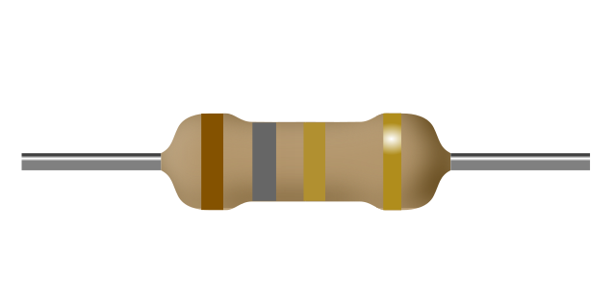

a) 181Ω

b) 1.8kΩ

c) 1.8Ω

d) 18Ω

1. What is the value of this resistance?

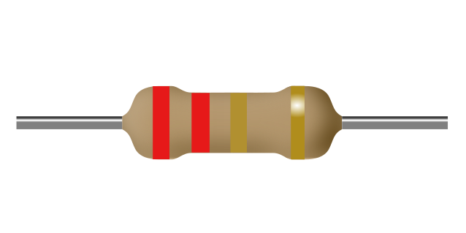

a) 2.2Ω

b) 22Ω

c) 221Ω

d) 2.2kΩ

1. What is the value of this resistance?

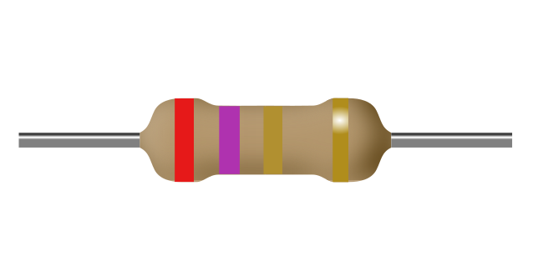

a) 2.7Ω

b) 271Ω

c) 2.7kΩ

d) 27Ω

1. What is the value of this resistance?

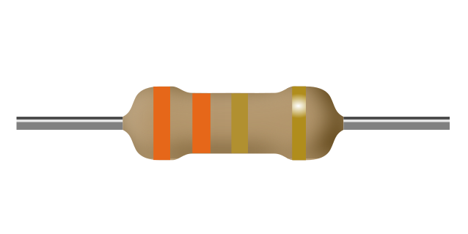

a) 3.3kΩ

b) 3.3Ω

c) 331Ω

d) 33Ω

1. What is the value of this resistance?

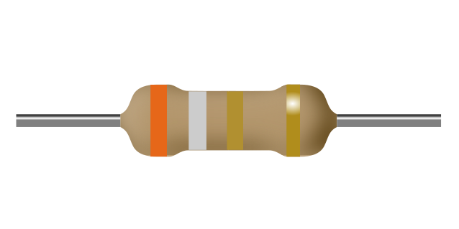

a) 391Ω

b) 39Ω

c) 3.9kΩ

d) 3.9Ω

1. What is the value of this resistance?

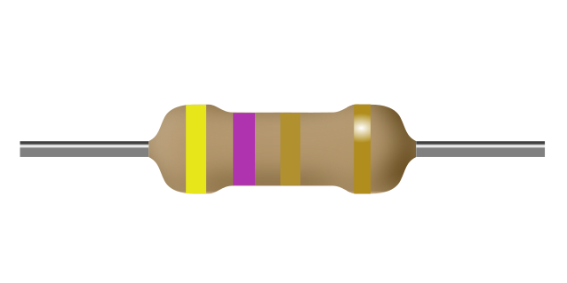

a) 4.7Ω

b) 4.7kΩ

c) 471Ω

d) 47Ω

1. What is the value of this resistance?

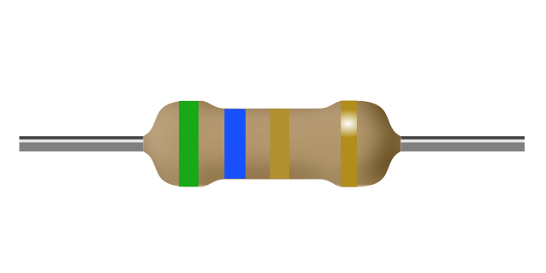

a) 5.6kΩ

b) 561Ω

c) 5.6Ω

d) 56Ω

1. What is the value of this resistance?

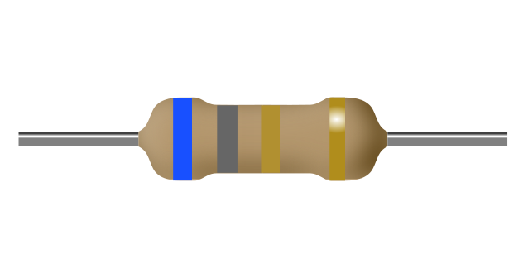

a) 681Ω

b) 6.8Ω

c) 6.8kΩ

d) 68Ω

1. What is the value of this resistance?

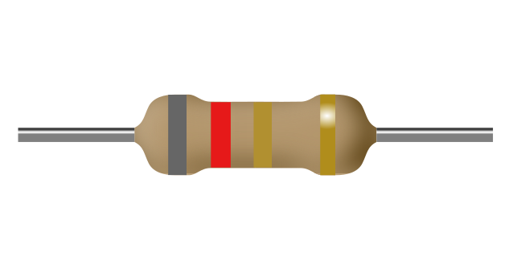

a) 8.2kΩ

b) 821Ω

c) 82Ω

d) 8.2Ω

1. What is the value of this resistance?

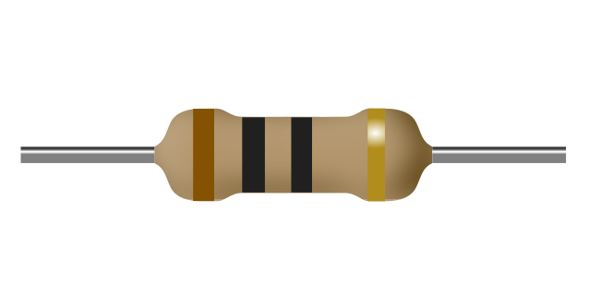

a) 1.0Ω

b) 100Ω

c) 10Ω

d) 10kΩ

1. What is the value of this resistance?

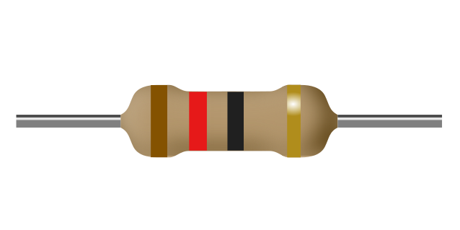

a) 120Ω

b) 1.2Ω

c) 12Ω

d) 12kΩ

1. What is the value of this resistance?

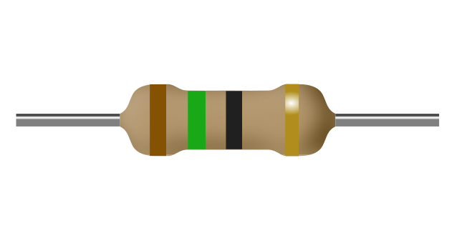

a) 1.5Ω

b) 15Ω

c) 150Ω

d) 15kΩ

1. What is the value of this resistance?

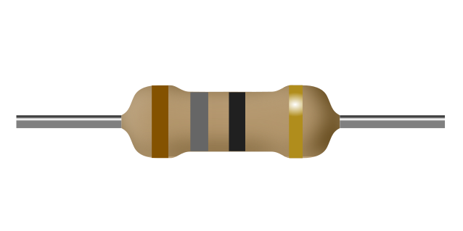

a) 18Ω

b) 18kΩ

c) 180Ω

d) 1.8Ω

1. What is the value of this resistance?

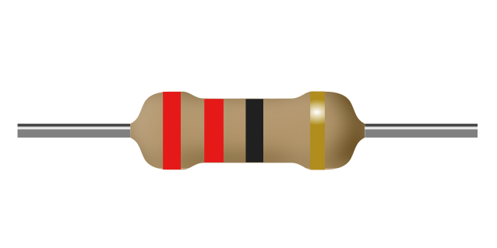

a) 2.2Ω

b) 22Ω

c) 220Ω

d) 22kΩ

1. What is the value of this resistance?

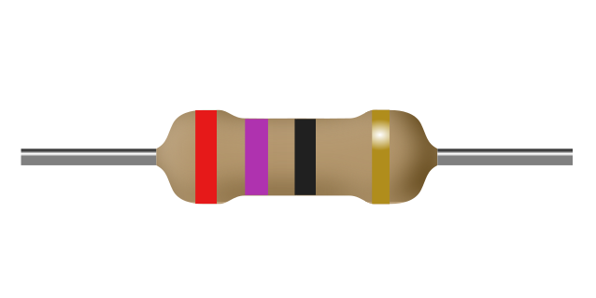

a) 27Ω

b) 27kΩ

c) 270Ω

d) 2.7Ω

1. What is the value of this resistance?

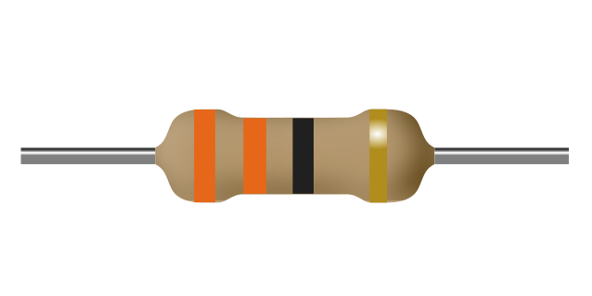

a) 330Ω

b) 33kΩ

c) 3.3Ω

d) 33Ω

1. What is the value of this resistance?

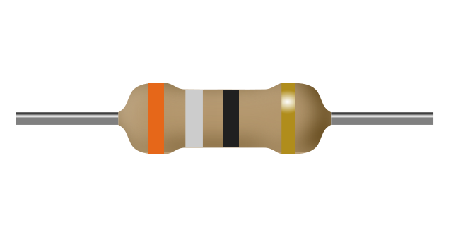

a) 39Ω

b) 39kΩ

c) 3.9Ω

d) 390Ω

1. What is the value of this resistance?

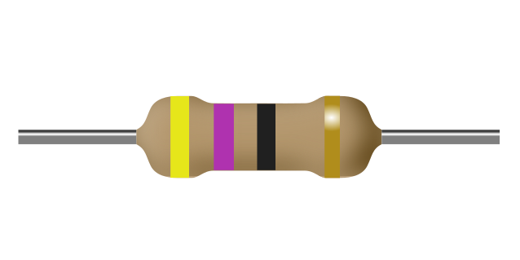

a) 47Ω

b) 470Ω

c) 4.7Ω

d) 47kΩ

1. What is the value of this resistance?

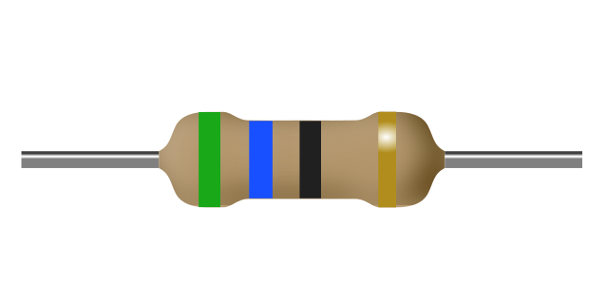

a) 5.6Ω

b) 56kΩ

c) 560Ω

d) 56Ω

1. What is the value of this resistance?

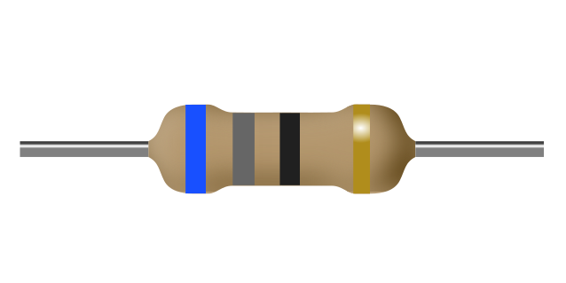

a) 6.8Ω

b) 68Ω

c) 68kΩ

d) 680Ω

1. What is the value of this resistance?

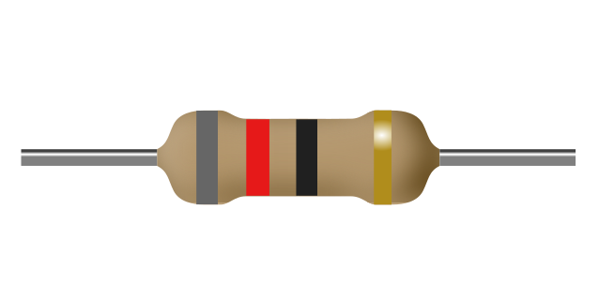

a) 82kΩ

b) 82Ω

c) 820Ω

d) 8.2Ω

1. What is the value of this resistance?

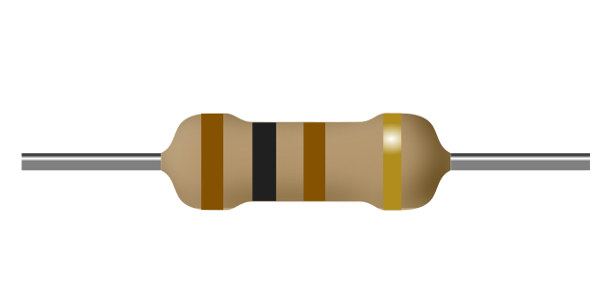

a) 10Ω

b) 101Ω

c) 100Ω

d) 10kΩ

1. What is the value of this resistance?

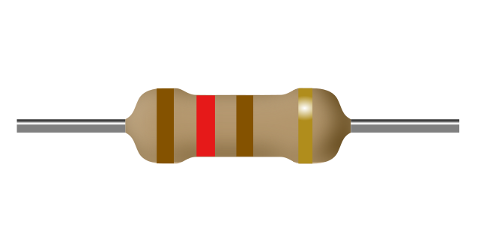

a) 120Ω

b) 121Ω

c) 12kΩ

d) 12Ω

1. What is the value of this resistance?

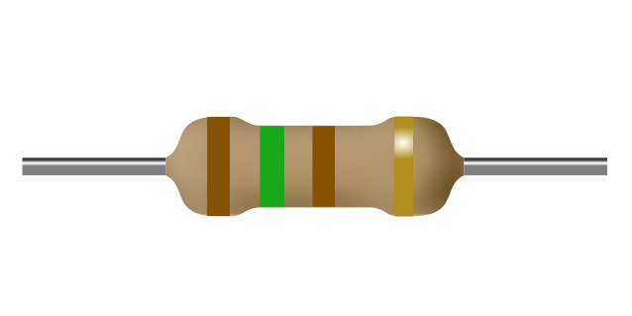

a) 150Ω

b) 151Ω

c) 15Ω

d) 15kΩ

1. What is the value of this resistance?

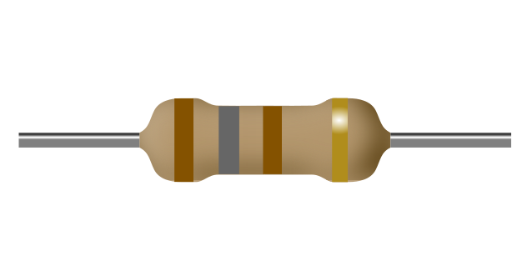

a) 18Ω

b) 180Ω

c) 18kΩ

d) 181Ω

1. What is the value of this resistance?

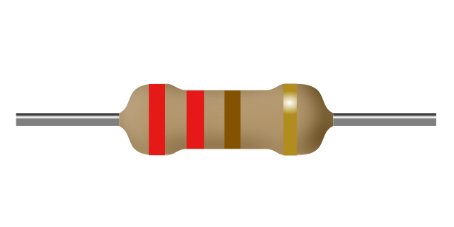

a) 22Ω

b) 22kΩ

c) 220Ω

d) 221Ω

1. What is the value of this resistance?

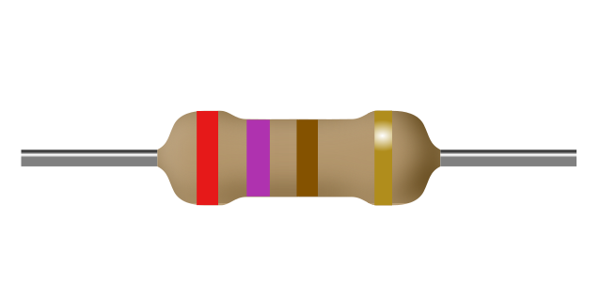

a) 270Ω

b) 27kΩ

c) 271Ω

d) 27Ω

1. What is the value of this resistance?

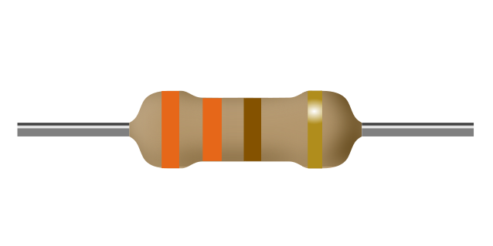

a) 33kΩ

b) 330Ω

c) 33Ω

d) 331Ω

1. What is the value of this resistance?

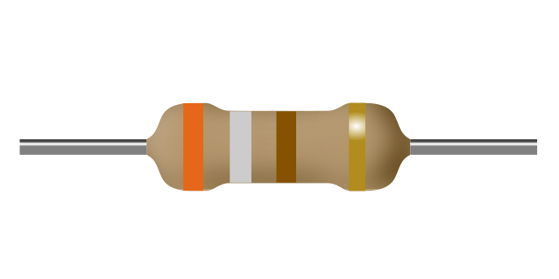

a) 39kΩ

b) 391Ω

c) 390Ω

d) 39Ω

1. What is the value of this resistance?

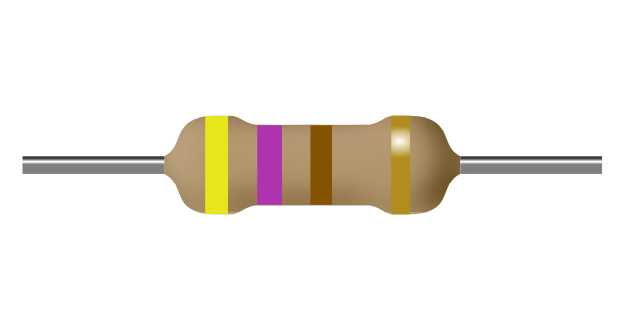

a) 470Ω

b) 47Ω

c) 47kΩ

d) 471Ω

1. What is the value of this resistance?

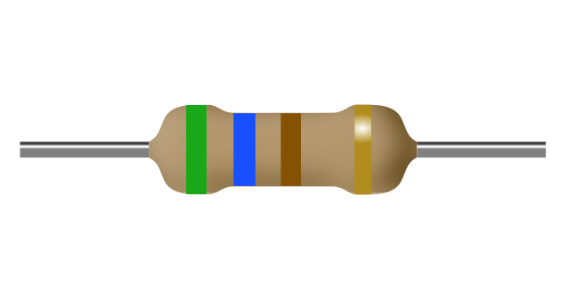

a) 56kΩ

b) 560Ω

c) 56Ω

d) 561Ω

1. What is the value of this resistance?

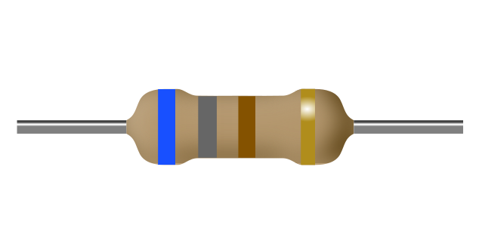

a) 68Ω

b) 681Ω

c) 680Ω

d) 68kΩ

1. What is the value of this resistance?

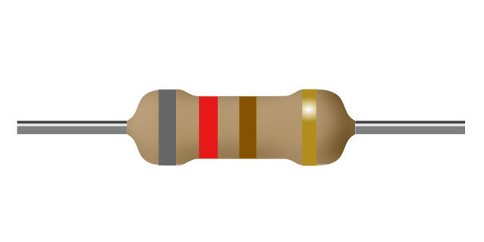

a) 821Ω

b) 82kΩ

c) 820Ω

d) 82Ω

1. What is the value of this resistance?

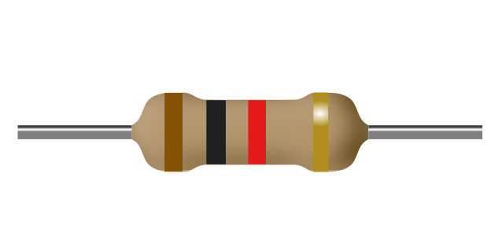

a) 10Ω

b) 102Ω

c) 1.0kΩ

d) 10kΩ

1. What is the value of this resistance?

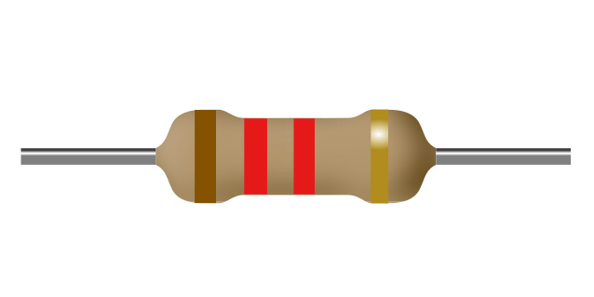

a) 12Ω

b) 12kΩ

c) 122Ω

d) 1.2kΩ

1. What is the value of this resistance?

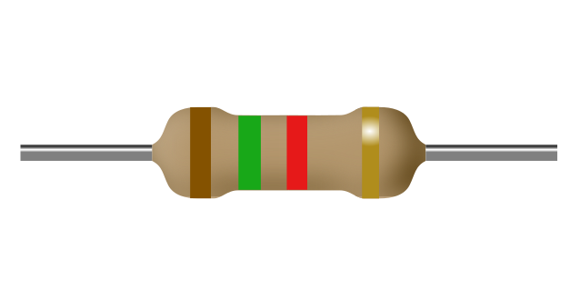

a) 152Ω

b) 15Ω

c) 1.5kΩ

d) 15kΩ

1. What is the value of this resistance?

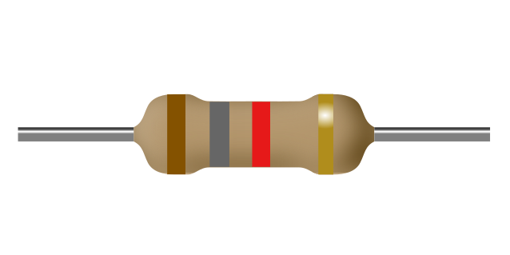

a) 18Ω

b) 182Ω

c) 18kΩ

d) 1.8kΩ

1. What is the value of this resistance?

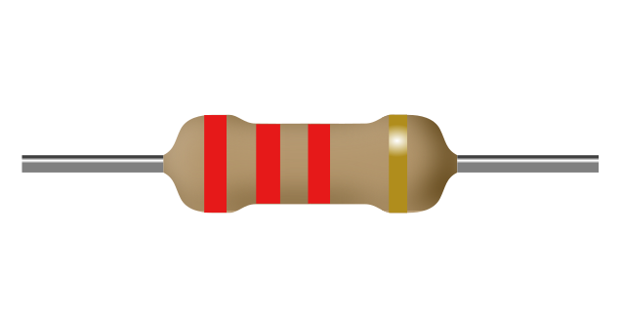

a) 22Ω

b) 22kΩ

c) 222Ω

d) 2.2kΩ

1. What is the value of this resistance?

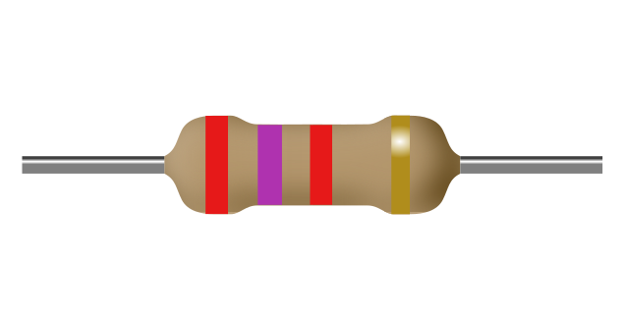

a) 27Ω

b) 2.7kΩ

c) 272Ω

d) 27kΩ

1. What is the value of this resistance?

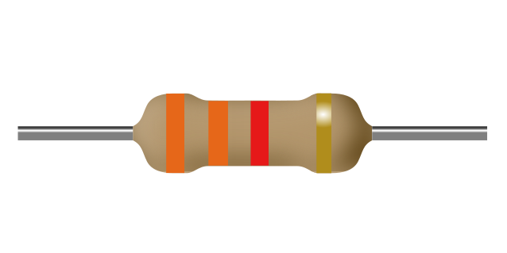

a) 332Ω

b) 33kΩ

c) 33Ω

d) 3.3kΩ

1. What is the value of this resistance?

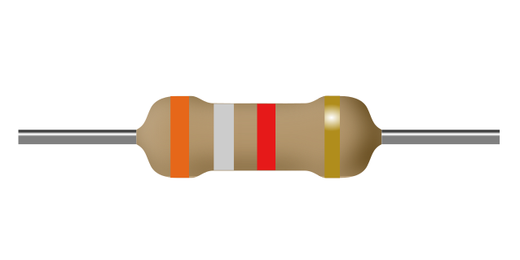

a) 39kΩ

b) 392Ω

c) 3.9kΩ

d) 39Ω

1. What is the value of this resistance?

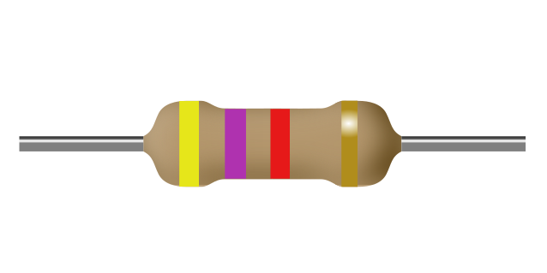

a) 47Ω

b) 472Ω

c) 47kΩ

d) 4.7kΩ

1. What is the value of this resistance?

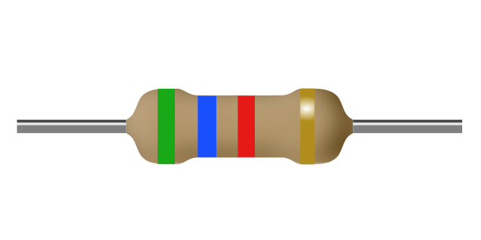

a) 56kΩ

b) 562Ω

c) 5.6kΩ

d) 56Ω

1. What is the value of this resistance?

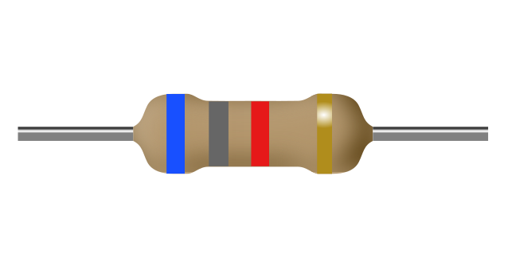

a) 68kΩ

b) 6.8kΩ

c) 682Ω

d) 68Ω

1. What is the value of this resistance?

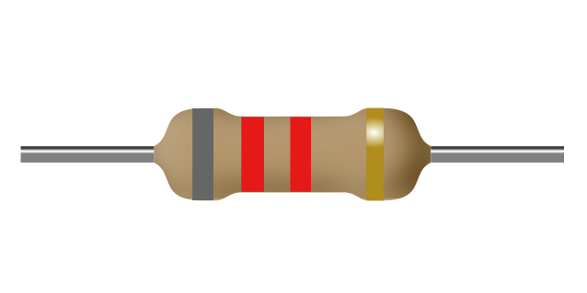

a) 8.2kΩ

b) 82Ω

c) 822Ω

d) 82kΩ

1. What is the value of this resistance?

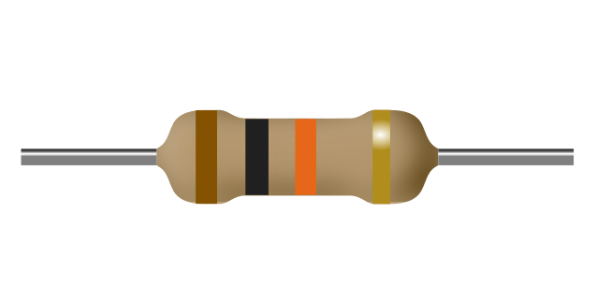

a) 10Ω

b) 103Ω

c) 1.0MΩ

d) 10kΩ

1. What is the value of this resistance?

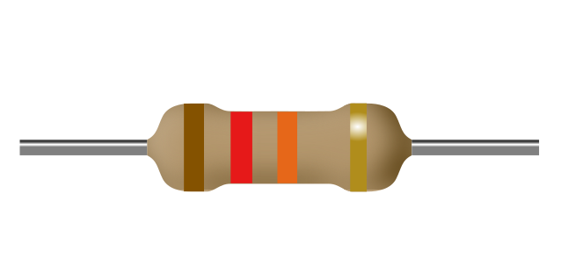

a) 12Ω

b) 12kΩ

c) 1.2MΩ

d) 123Ω

1. What is the value of this resistance?

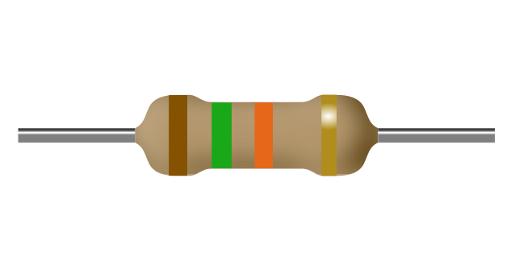

a) 1.5MΩ

b) 15Ω

c) 15kΩ

d) 153Ω

1. What is the value of this resistance?

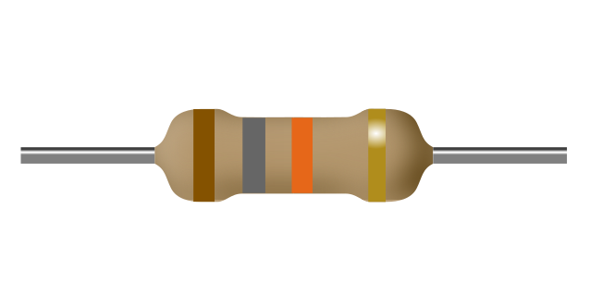

a) 18Ω

b) 18kΩ

c) 183Ω

d) 1.8MΩ

1. What is the value of this resistance?

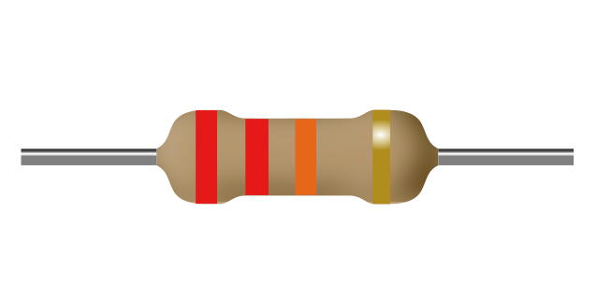

a) 2.2MΩ

b) 223Ω

c) 22Ω

d) 22kΩ

1. What is the value of this resistance?

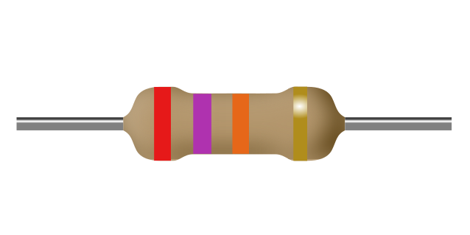

a) 273Ω

b) 27Ω

c) 27kΩ

d) 2.7MΩ

1. What is the value of this resistance?

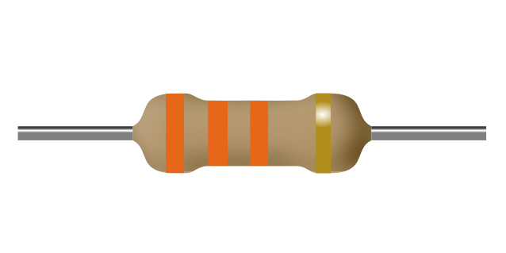

a) 3.3MΩ

b) 33kΩ

c) 333Ω

d) 33Ω

1. What is the value of this resistance?

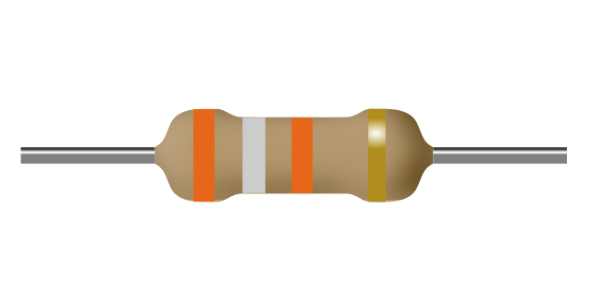

a) 39Ω

b) 3.9MΩ

c) 393Ω

d) 39kΩ

1. What is the value of this resistance?

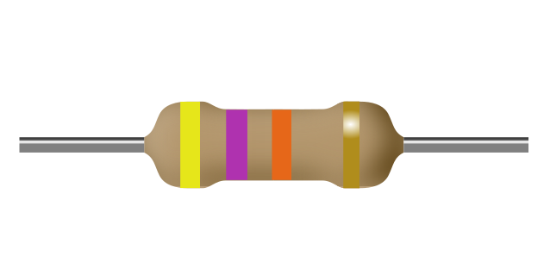

a) 473Ω

b) 47Ω

c) 4.7MΩ

d) 47kΩ

1. What is the value of this resistance?

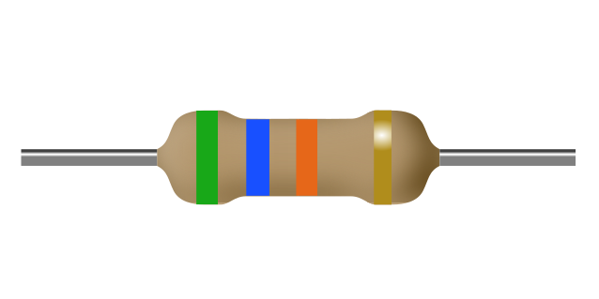

a) 56Ω

b) 5.6MΩ

c) 56kΩ

d) 563Ω

1. What is the value of this resistance?

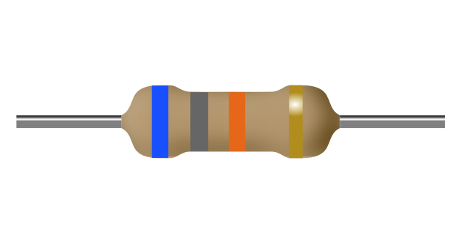

a) 6.8MΩ

b) 68kΩ

c) 68Ω

d) 683Ω

1. What is the value of this resistance?

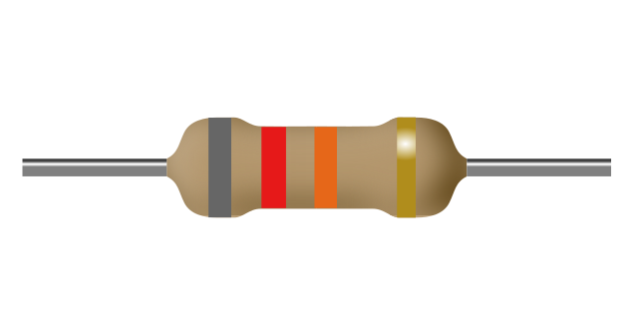

a) 8.2MΩ

b) 82kΩ

c) 823Ω

d) 82Ω

1. What is the value of this resistance?

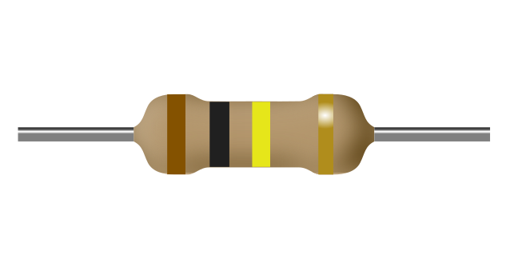

a) 100kΩ

b) 104Ω

c) 10kΩ

d) 100Ω

1. What is the value of this resistance?

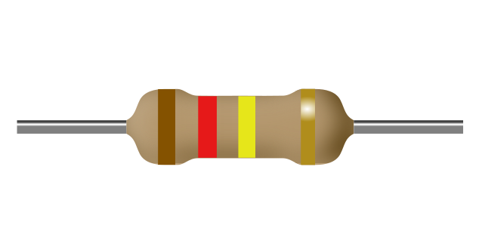

a) 120kΩ

b) 124Ω

c) 12kΩ

d) 120Ω

1. What is the value of this resistance?

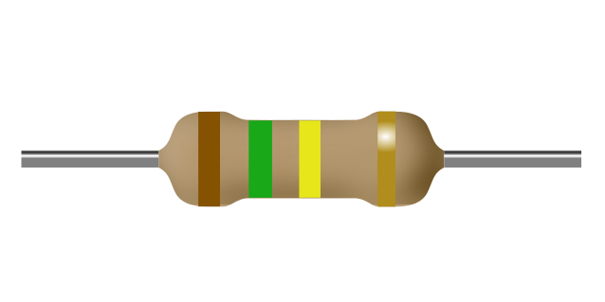

a) 154Ω

b) 150Ω

c) 150kΩ

d) 15kΩ

1. What is the value of this resistance?

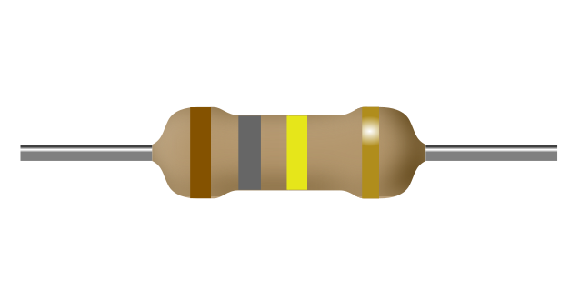

a) 180kΩ

b) 18kΩ

c) 184Ω

d) 180Ω

1. What is the value of this resistance?

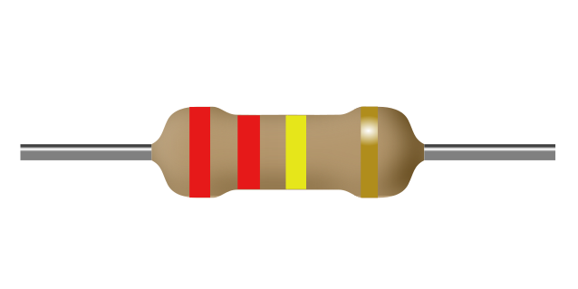

a) 224Ω

b) 22kΩ

c) 220kΩ

d) 220Ω

1. What is the value of this resistance?

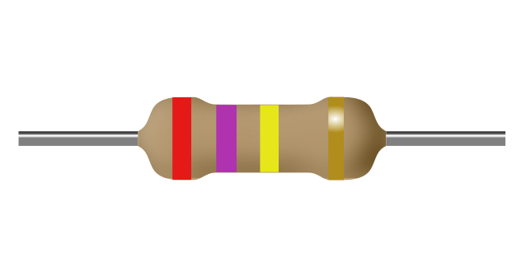

a) 270kΩ

b) 270Ω

c) 274Ω

d) 27kΩ

1. What is the value of this resistance?

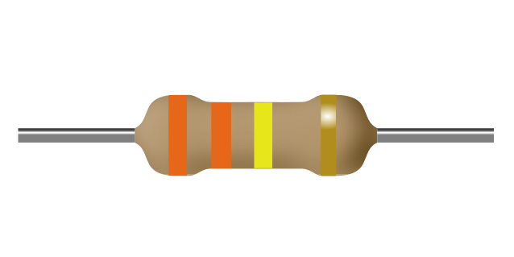

a) 330Ω

b) 330kΩ

c) 334Ω

d) 33kΩ

1. What is the value of this resistance?

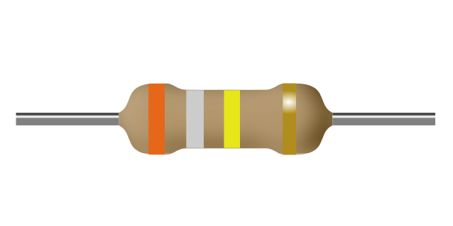

a) 394Ω

b) 390kΩ

c) 39kΩ

d) 390Ω

1. What is the value of this resistance?

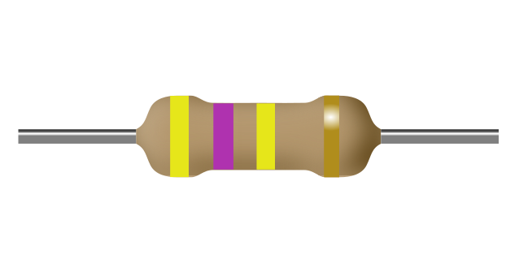

a) 47kΩ

b) 470kΩ

c) 474Ω

d) 470Ω

1. What is the value of this resistance?

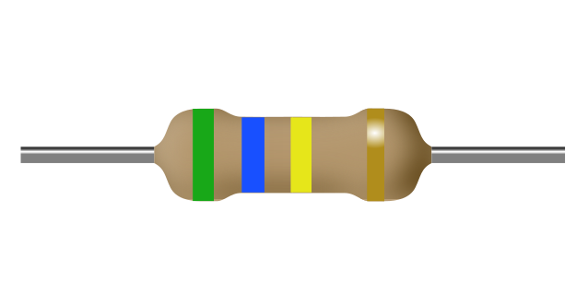

a) 560Ω

b) 564Ω

c) 560kΩ

d) 56kΩ

1. What is the value of this resistance?

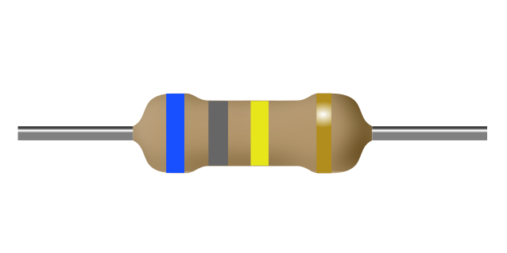

a) 68kΩ

b) 680kΩ

c) 680Ω

d) 684Ω

1. What is the value of this resistance?

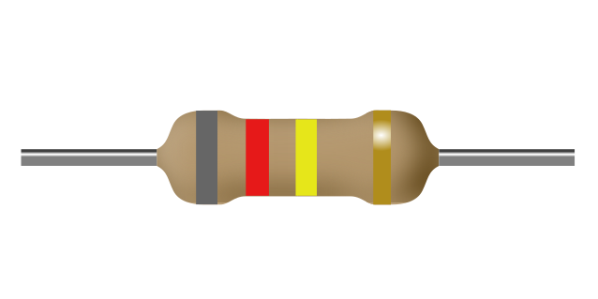

a) 820Ω

b) 824Ω

c) 820kΩ

d) 82kΩ

1. What is the value of this resistance?

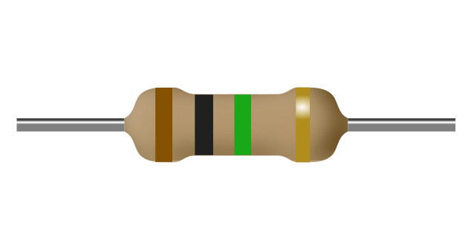

a) 1.0kΩ

b) 100kΩ

c) 1.0MΩ

d) 105Ω

1. What is the value of this resistance?

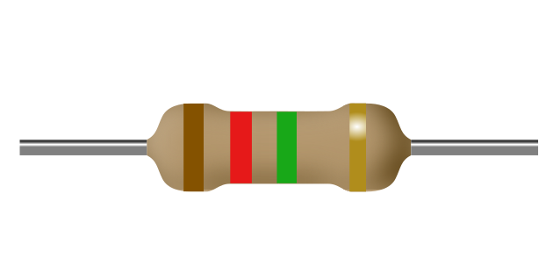

a) 1.2kΩ

b) 120kΩ

c) 125Ω

d) 1.2MΩ

1. What is the value of this resistance?

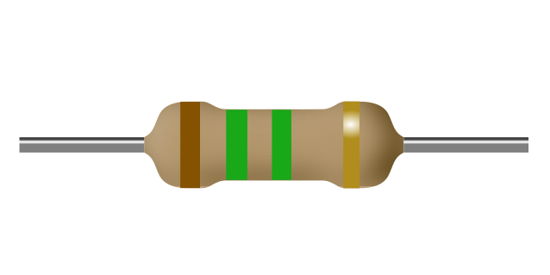

a) 1.5MΩ

b) 1.5kΩ

c) 155Ω

d) 150kΩ

1. What is the value of this resistance?

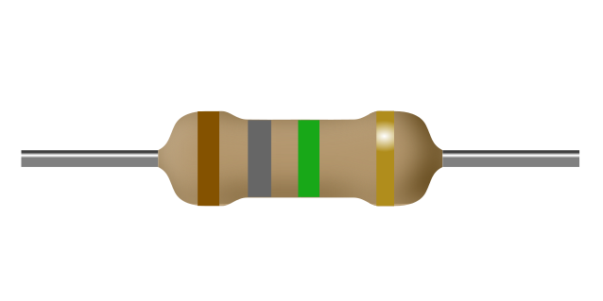

a) 1.8MΩ

b) 180kΩ

c) 1.8kΩ

d) 185Ω

1. What is the value of this resistance?

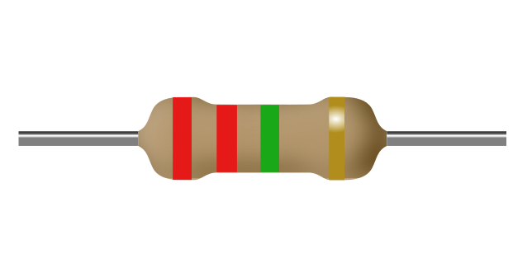

a) 220kΩ

b) 2.2MΩ

c) 2.2kΩ

d) 225Ω

1. What is the value of this resistance?

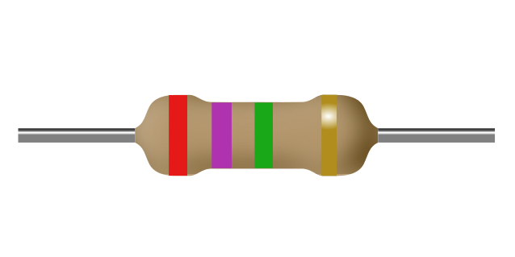

a) 2.7MΩ

b) 2.7kΩ

c) 270kΩ

d) 275Ω

1. What is the value of this resistance?

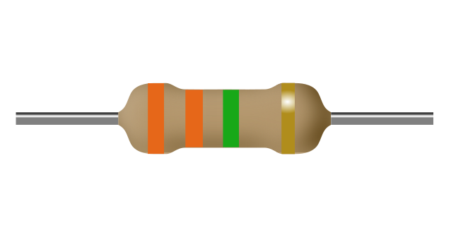

a) 330kΩ

b) 335Ω

c) 3.3MΩ

d) 3.3kΩ

1. What is the value of this resistance?

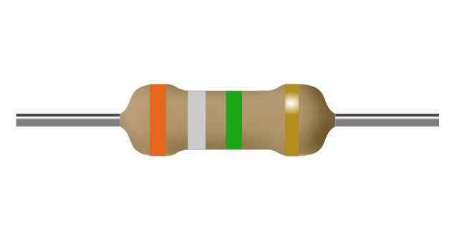

a) 390kΩ

b) 395Ω

c) 3.9kΩ

d) 3.9MΩ

1. What is the value of this resistance?

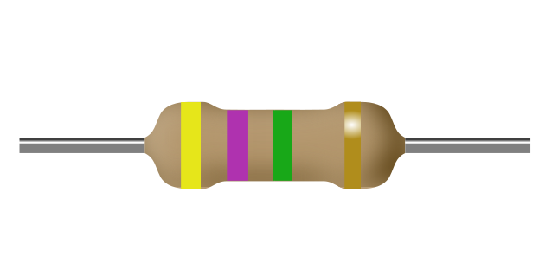

a) 4.7kΩ

b) 475Ω

c) 470kΩ

d) 4.7MΩ

1. What is the value of this resistance?

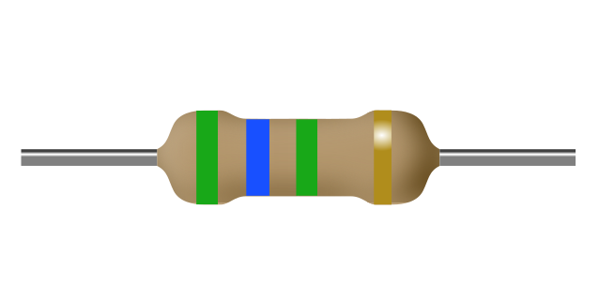

a) 560kΩ

b) 5.6kΩ

c) 565Ω

d) 5.6MΩ

1. What is the value of this resistance?

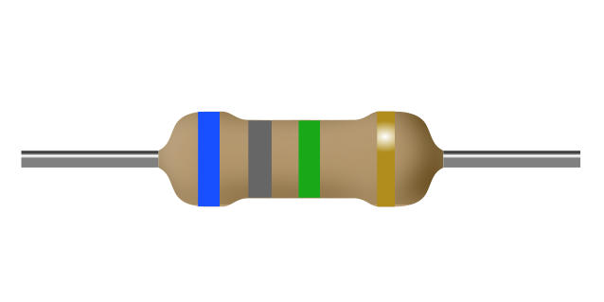

a) 680kΩ

b) 6.8MΩ

c) 6.8kΩ

d) 685Ω

1. What is the value of this resistance?

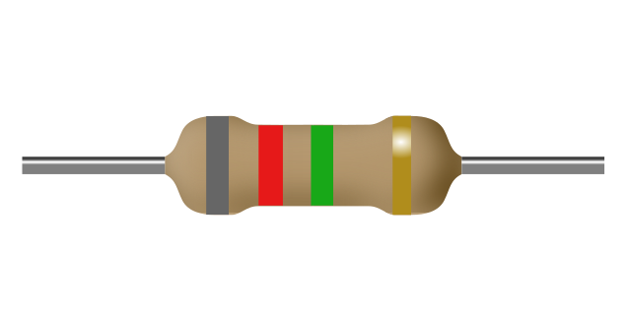

a) 8.2MΩ

b) 8.2kΩ

c) 820kΩ

d) 825Ω