# Electricity. Identificar serie, paralelo, cortocircuito.

1. How is the following circuit connected?

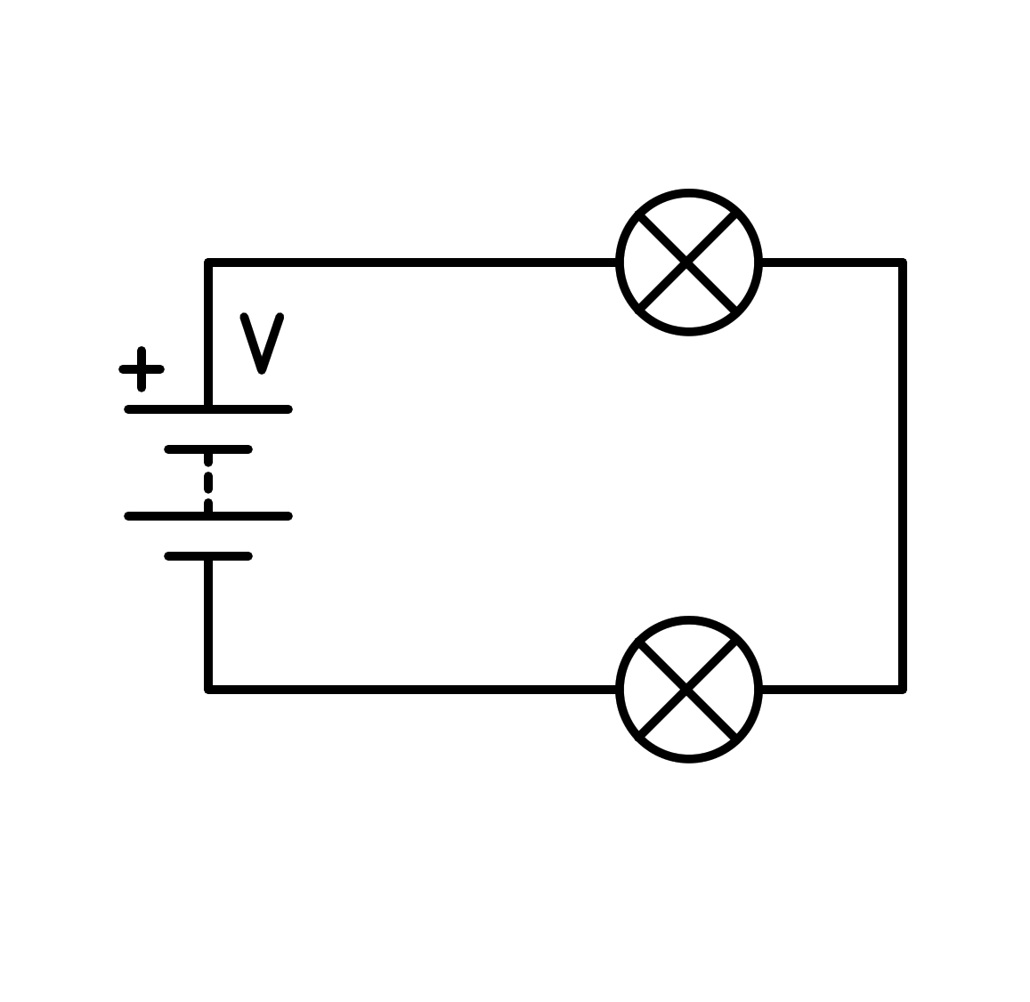

a) In series

b) In parallel

c) Short circuit in the battery

d) Short circuit in the light bulb

1. How is the following circuit connected?

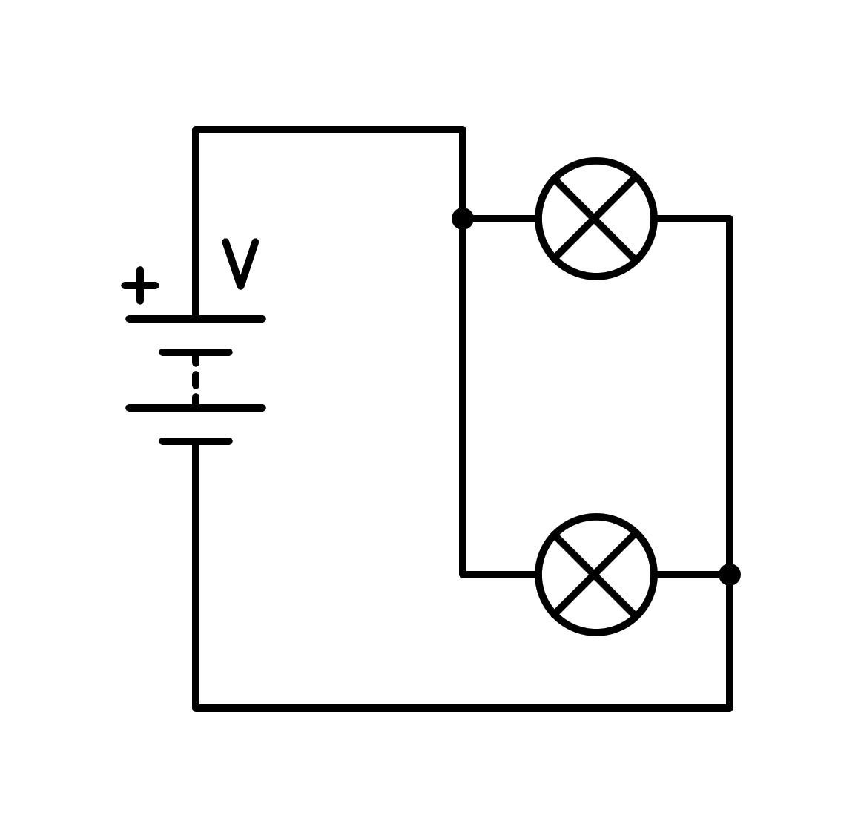

a) Short circuit in the light bulb

b) In series

c) Short circuit in the battery

d) In parallel

1. How is the following circuit connected?

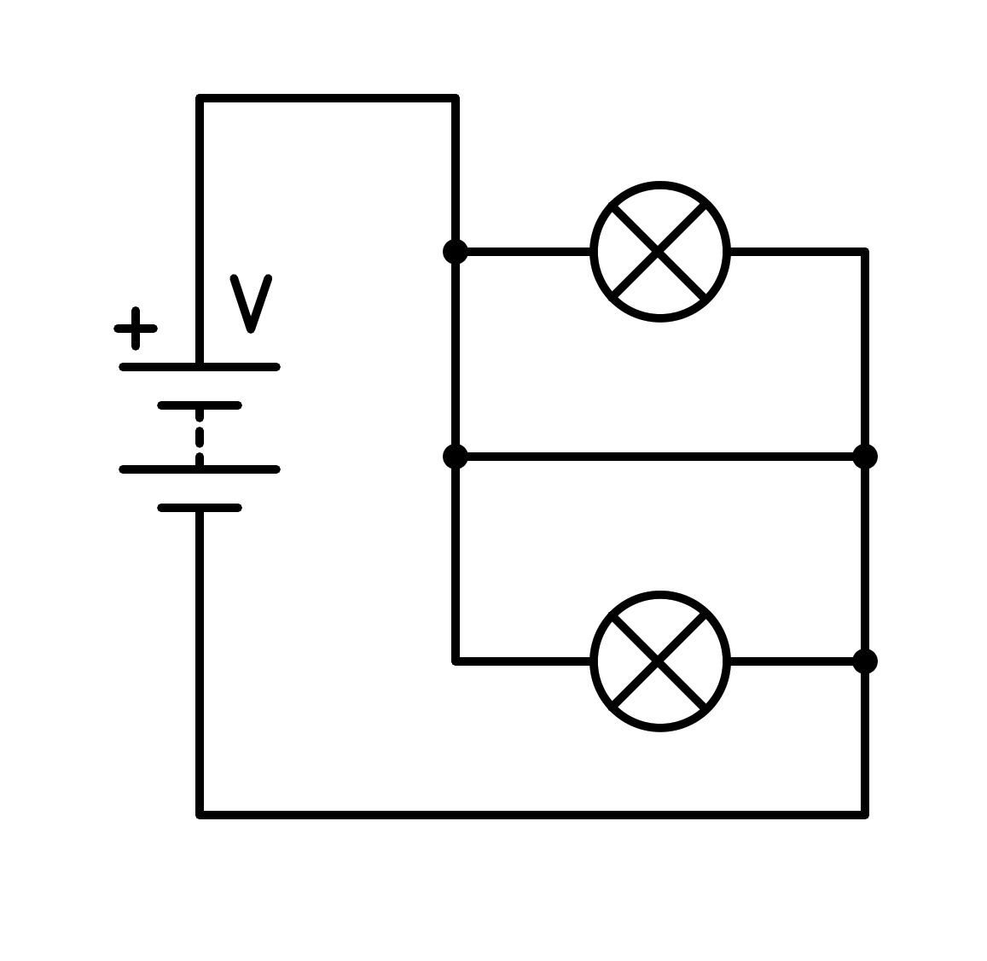

a) In series

b) Short circuit in the battery

c) In parallel

d) Short circuit in the light bulb

1. How is the following circuit connected?

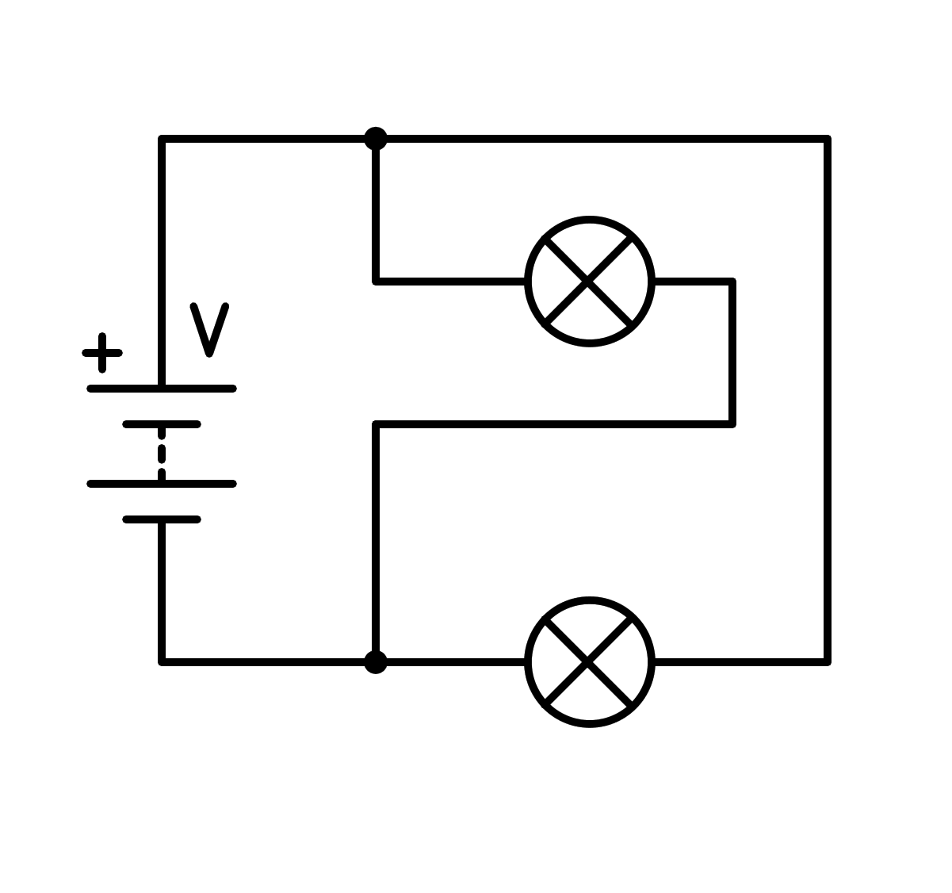

a) Short circuit in the battery

b) In parallel

c) In series

d) Short circuit in the light bulb

1. How is the following circuit connected?

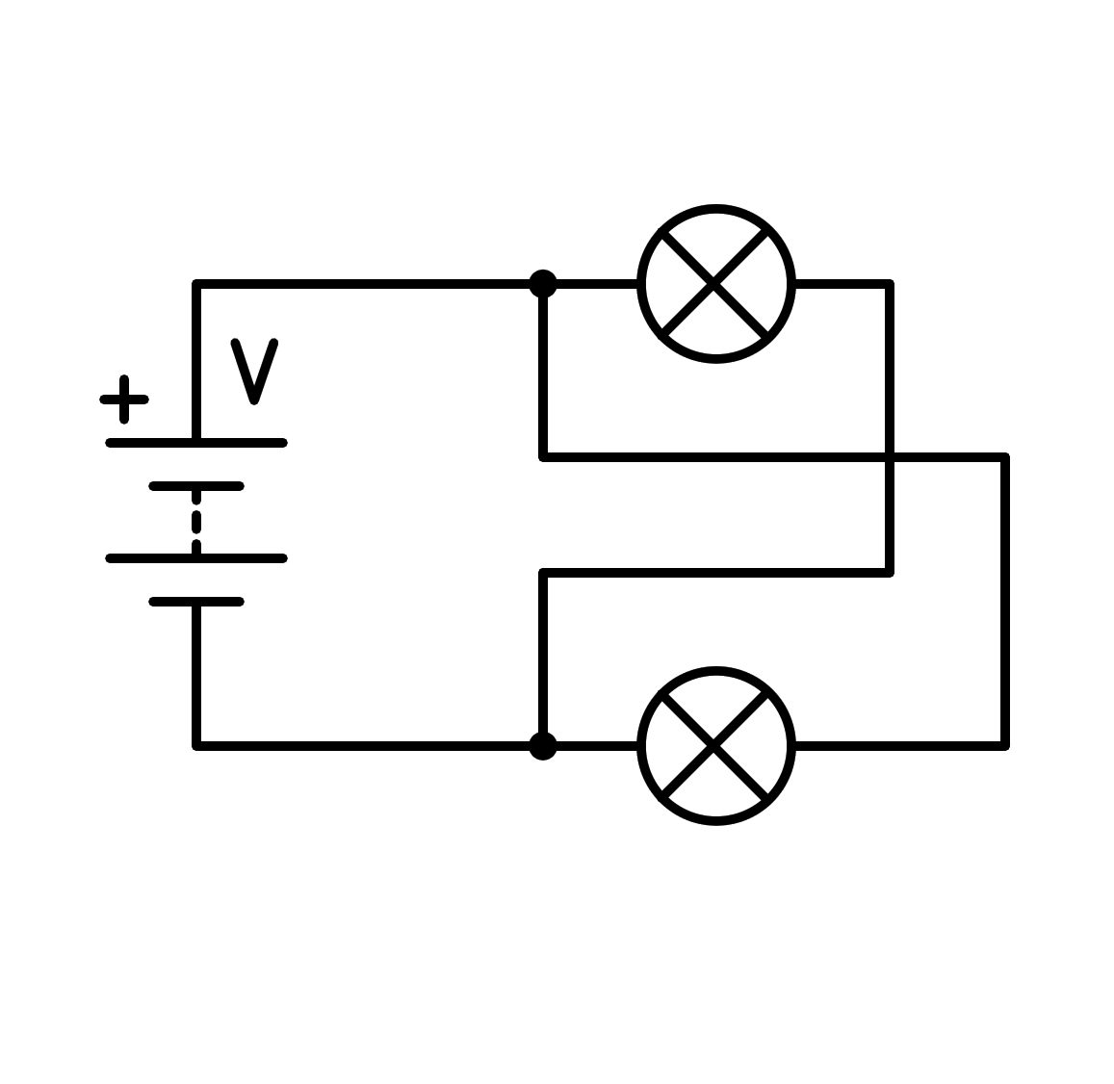

a) Short circuit in the battery

b) Short circuit in the light bulb

c) In parallel

d) In series

1. How is the following circuit connected?

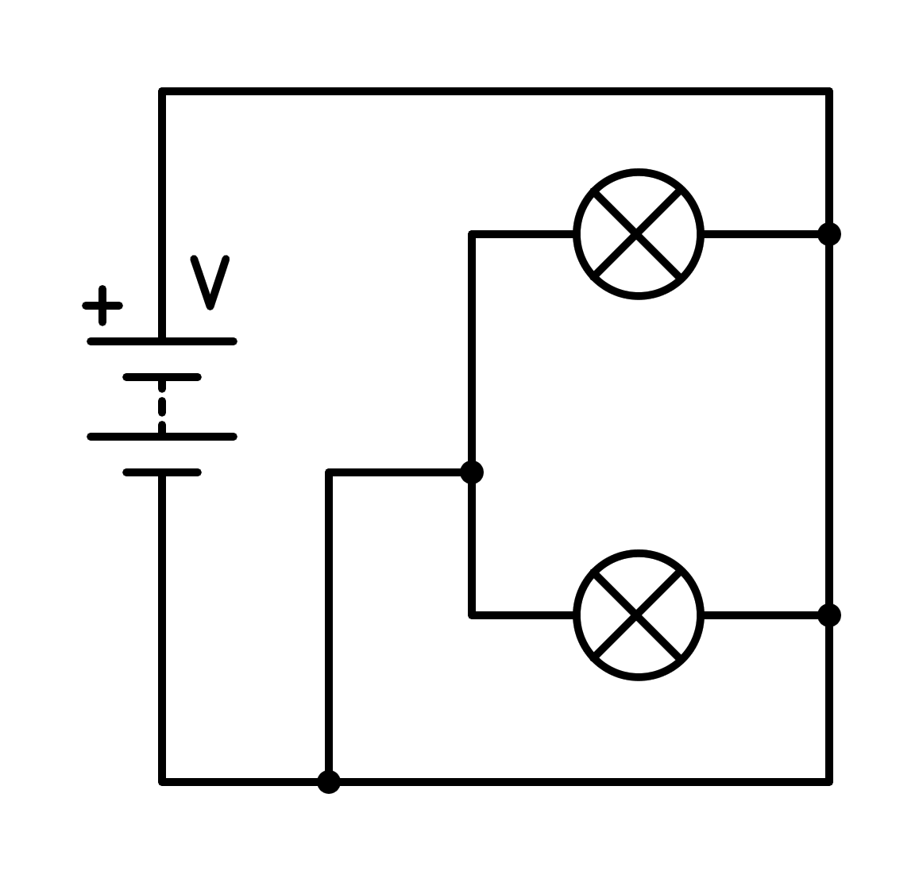

a) Short circuit in the light bulb

b) Short circuit in the battery

c) In series

d) In parallel

1. How is the following circuit connected?

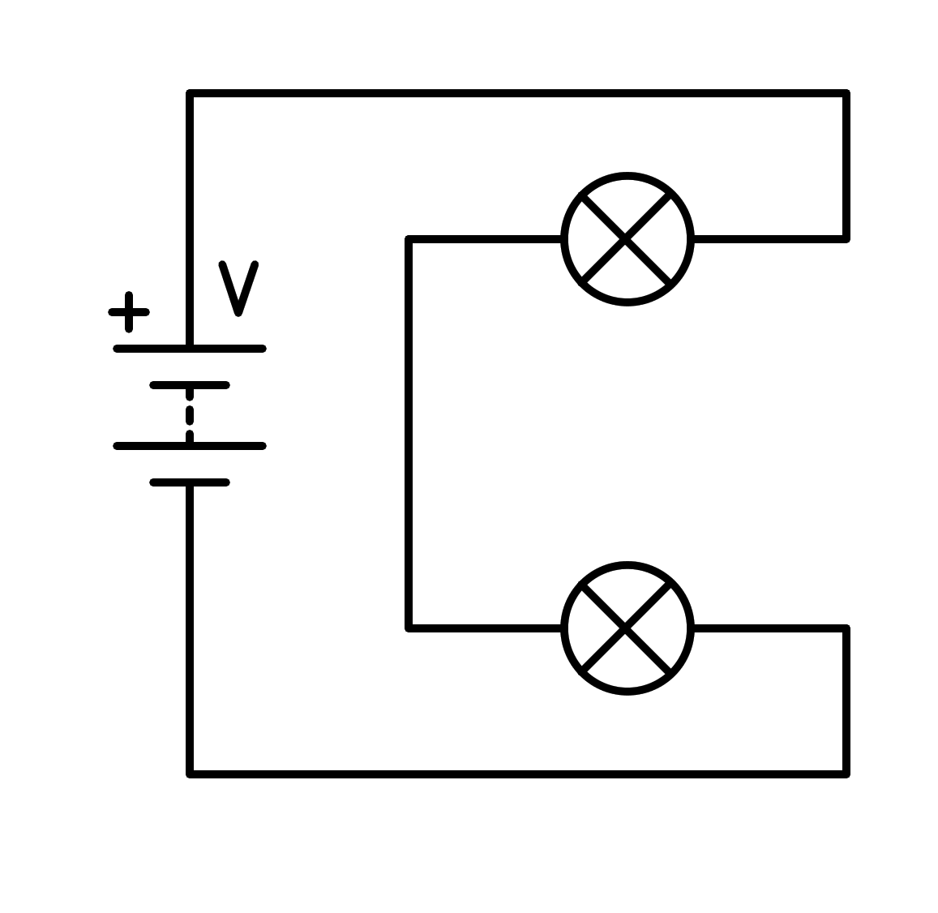

a) Short circuit in the light bulb

b) In series

c) In parallel

d) Short circuit in the battery

1. How is the following circuit connected?

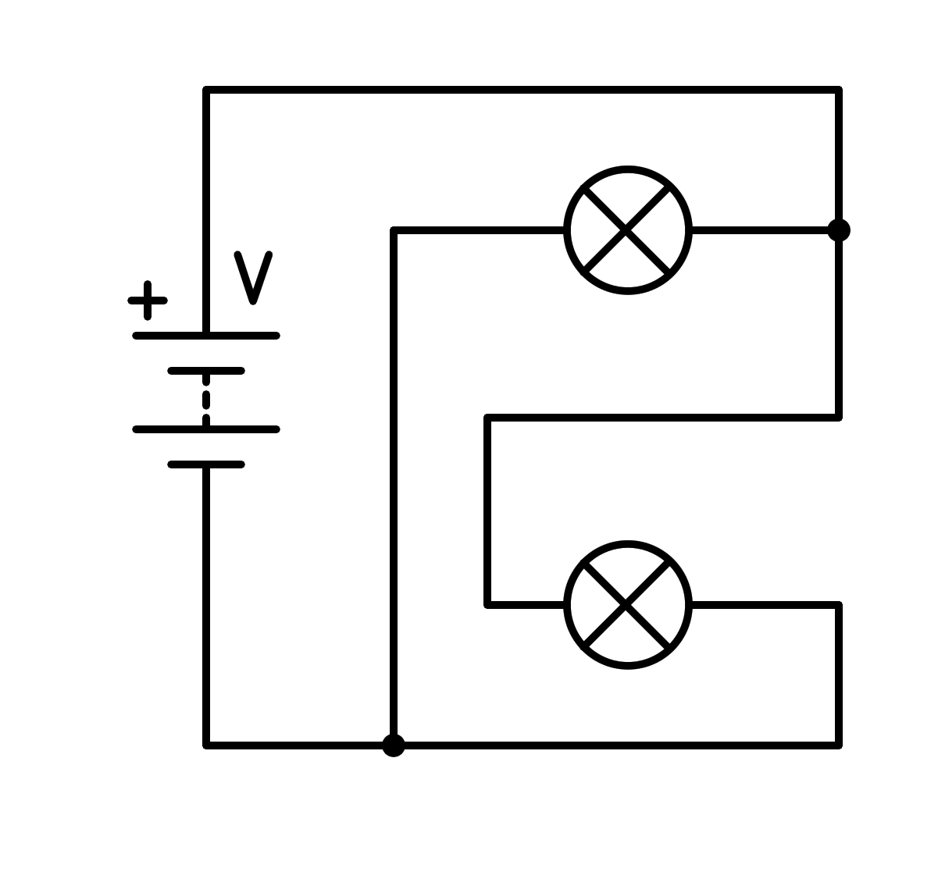

a) In parallel

b) In series

c) Short circuit in the light bulb

d) Short circuit in the battery

1. How is the following circuit connected?

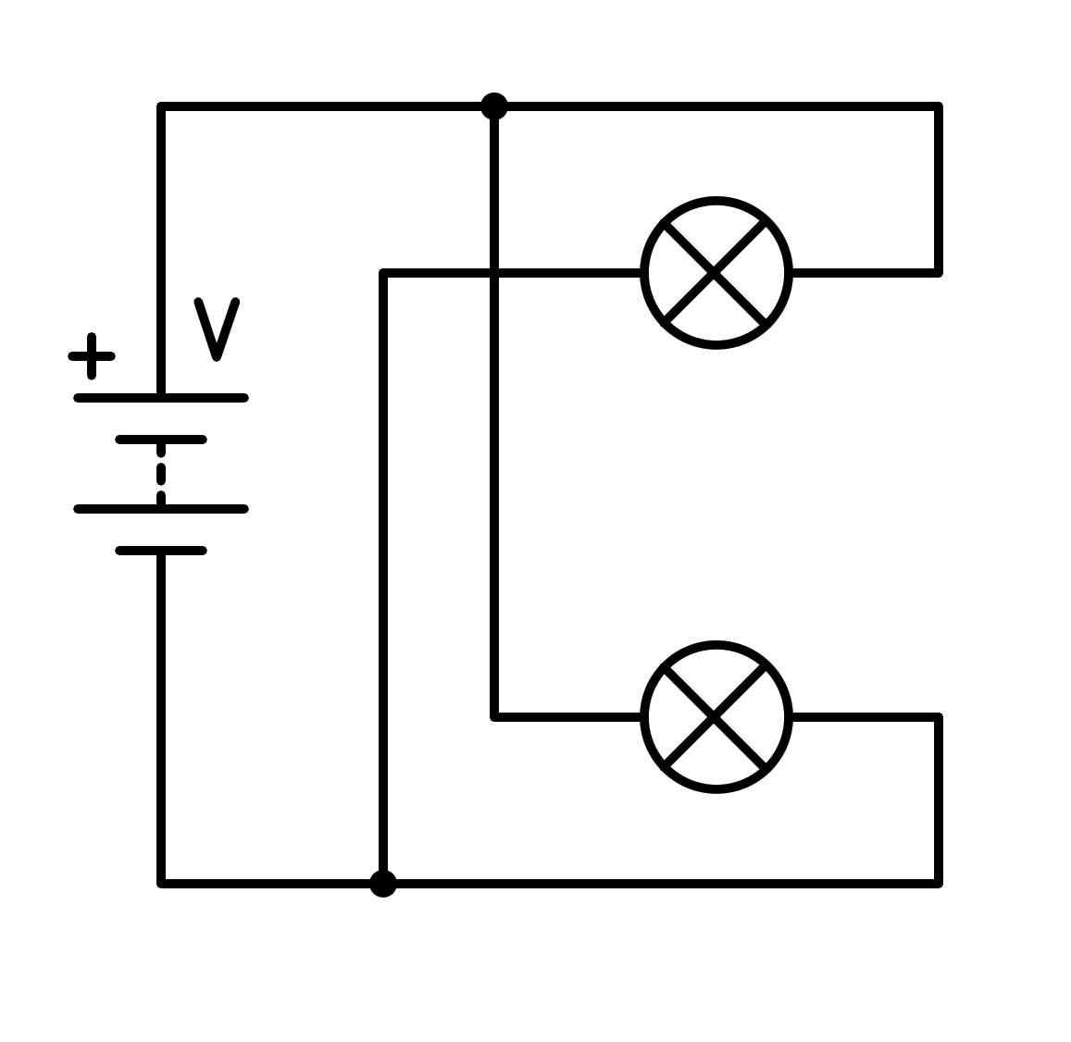

a) In series

b) Short circuit in the light bulb

c) In parallel

d) Short circuit in the battery

1. How is the following circuit connected?

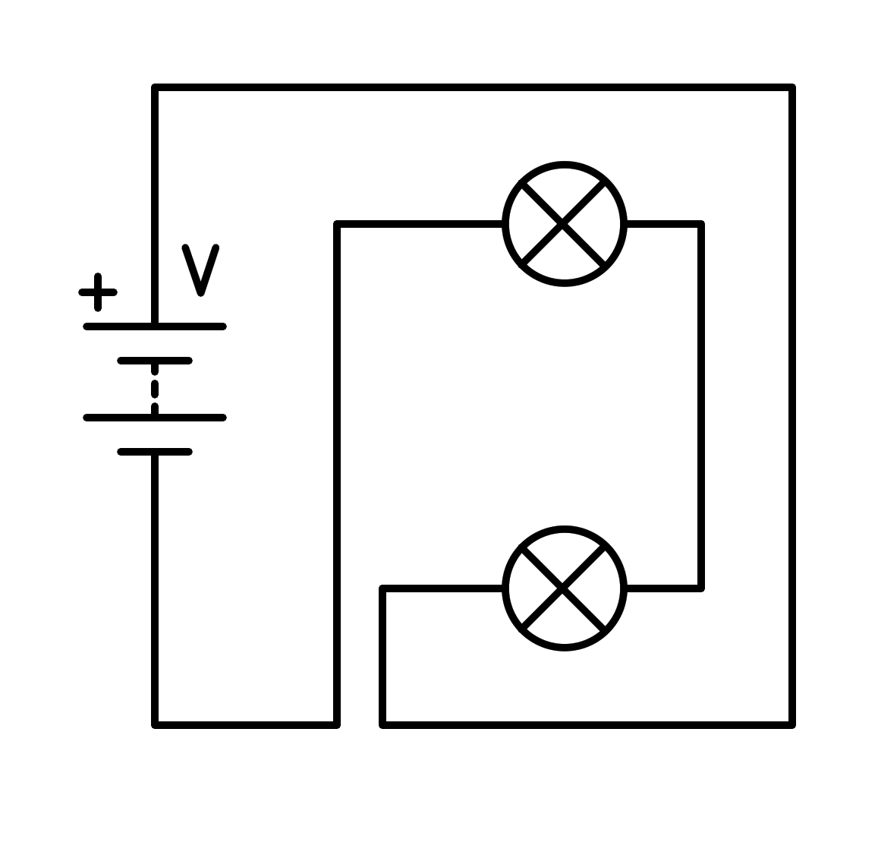

a) Short circuit in the battery

b) In parallel

c) Short circuit in the light bulb

d) In series

1. How is the following circuit connected?

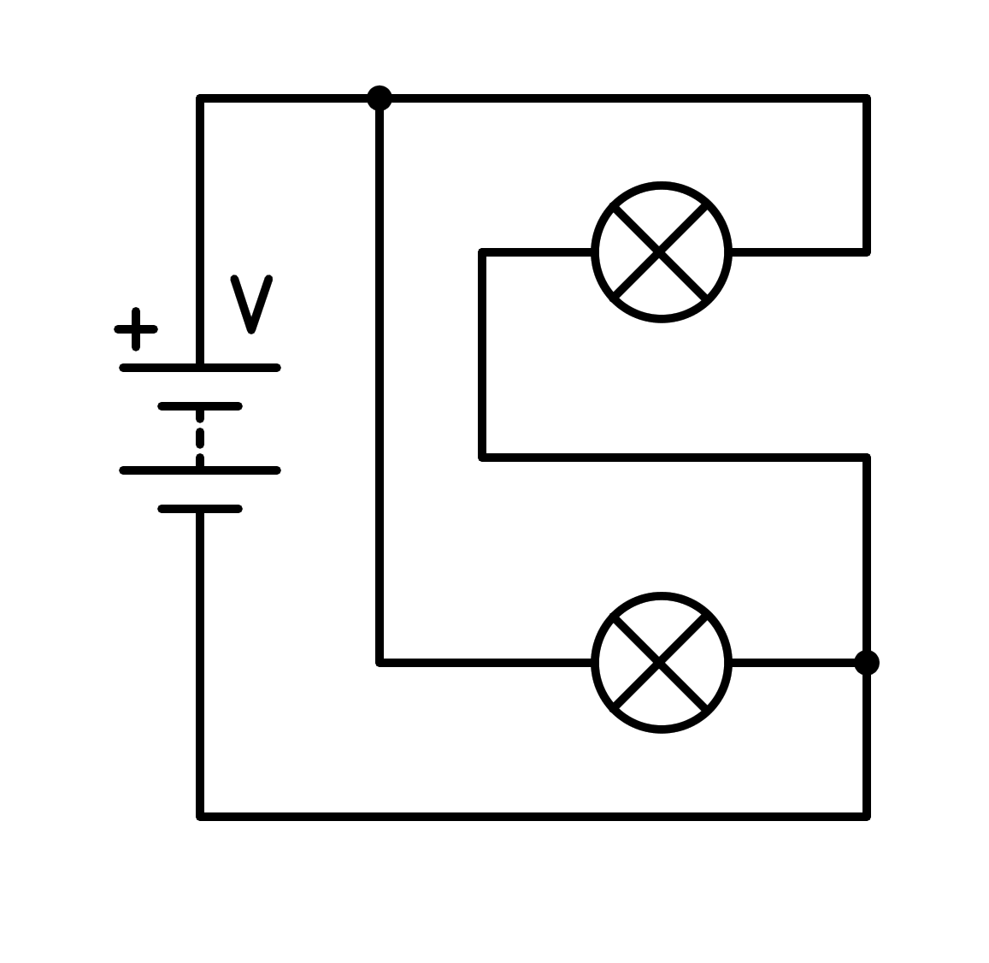

a) In parallel

b) Short circuit in the light bulb

c) In series

d) Short circuit in the battery

1. How is the following circuit connected?

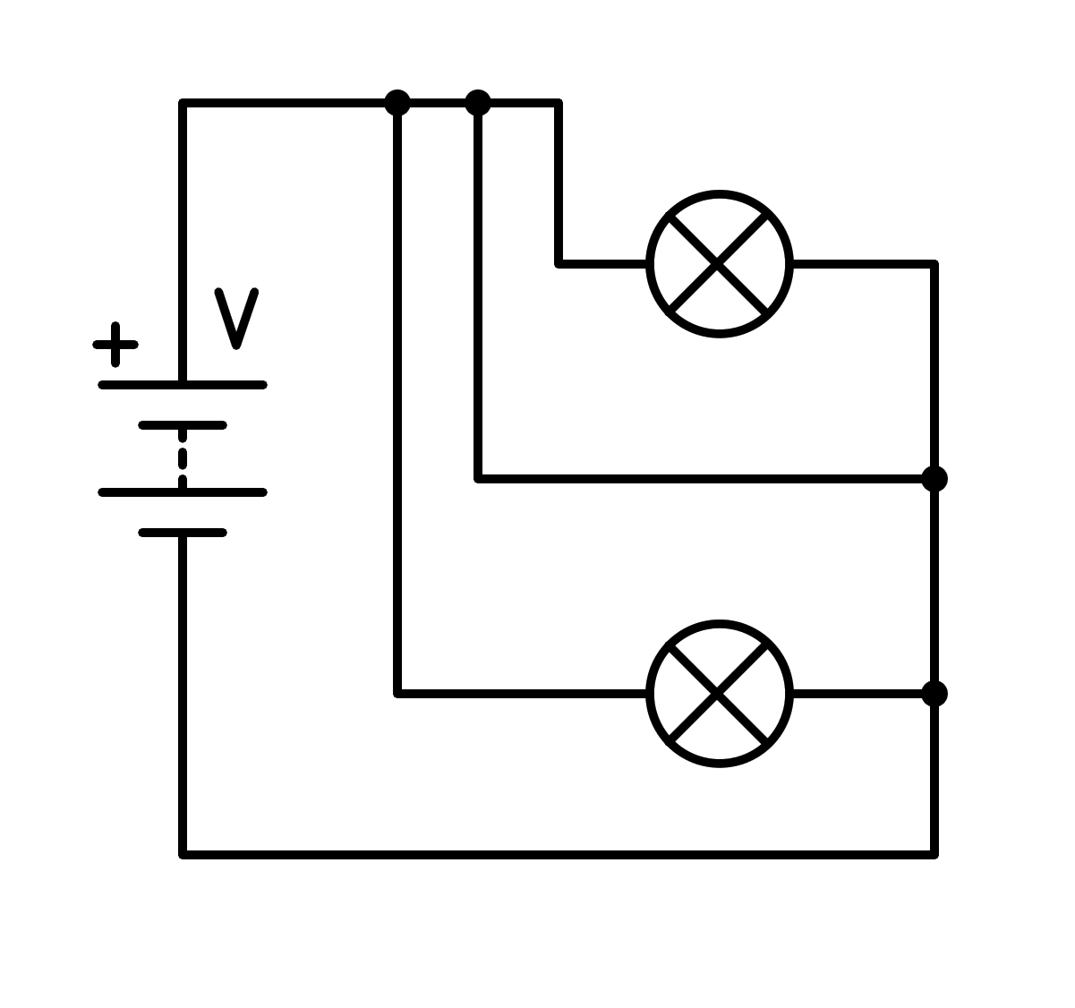

a) Short circuit in the light bulb

b) Short circuit in the battery

c) In series

d) In parallel

1. How is the following circuit connected?

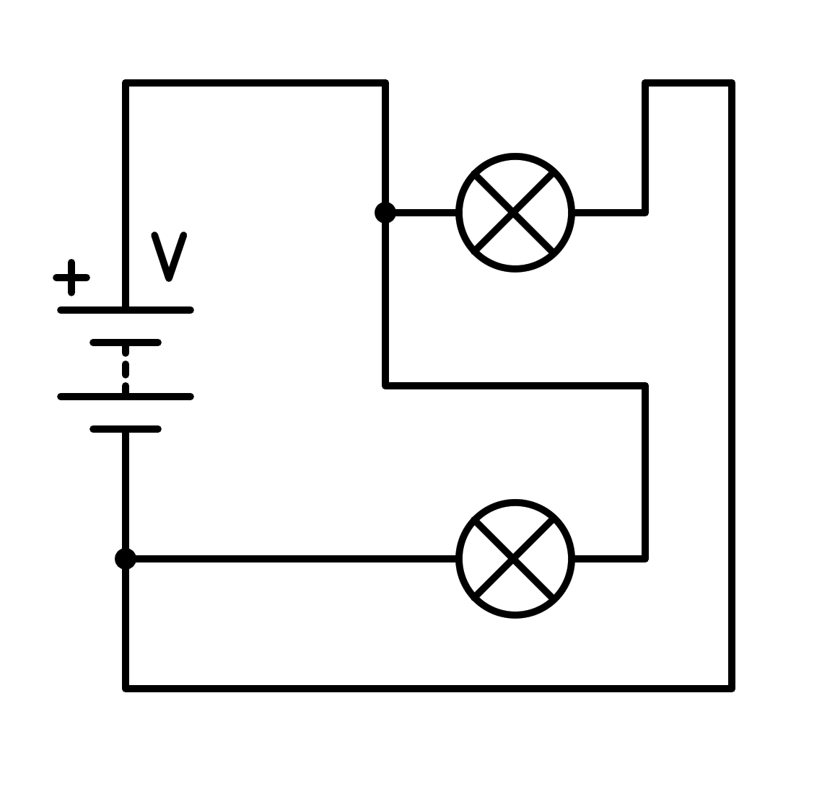

a) In parallel

b) Short circuit in the battery

c) In series

d) Short circuit in the light bulb

1. How is the following circuit connected?

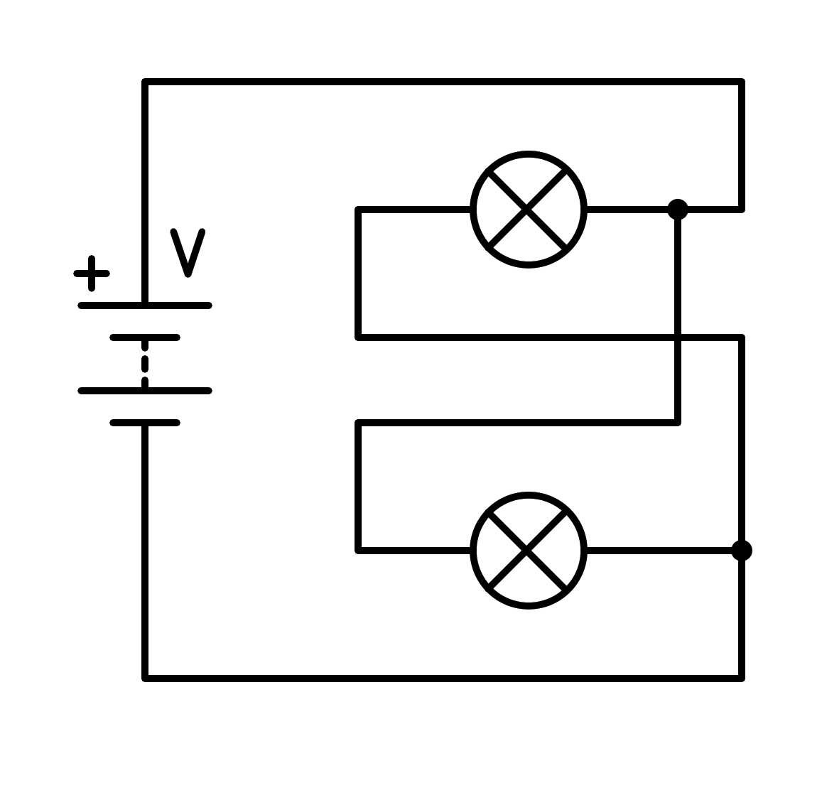

a) In parallel

b) In series

c) Short circuit in the battery

d) Short circuit in the light bulb

1. How is the following circuit connected?

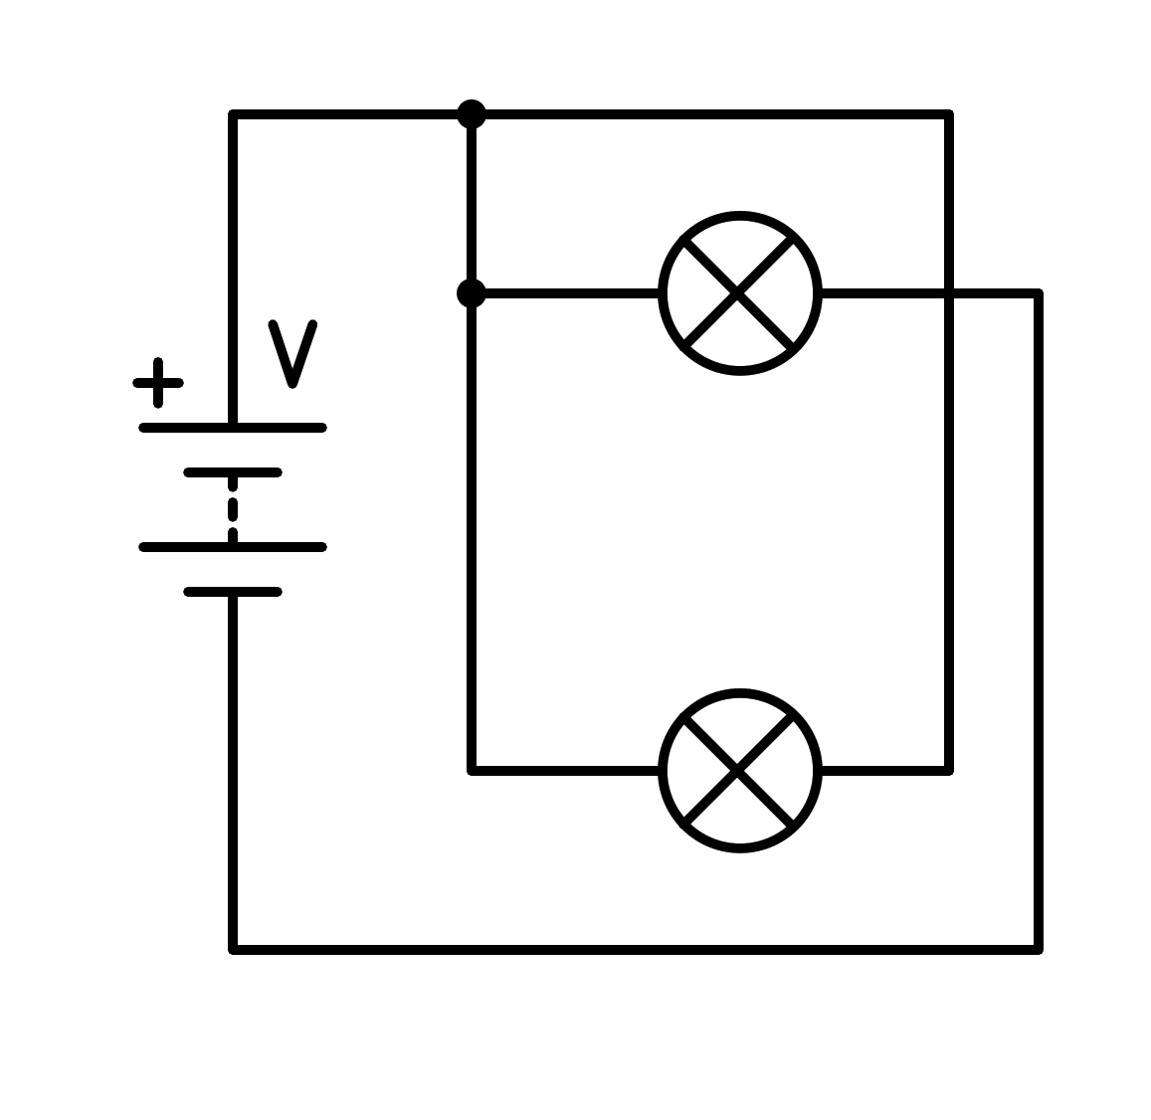

a) Short circuit in the battery

b) In series

c) In parallel

d) Short circuit in the light bulb

1. How is the following circuit connected?

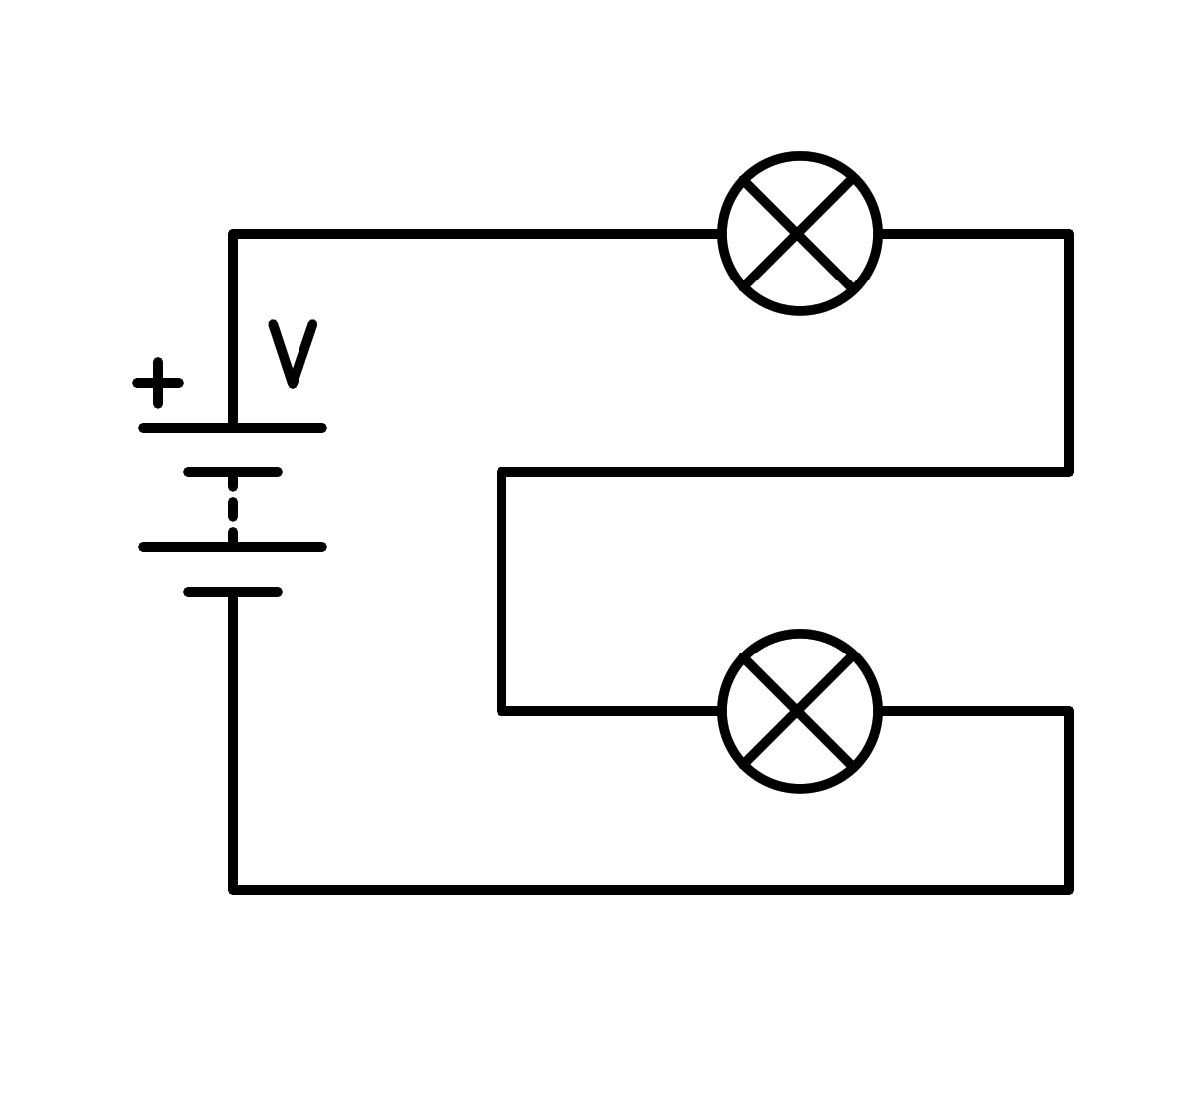

a) In series

b) Short circuit in the light bulb

c) In parallel

d) Short circuit in the battery

1. How is the following circuit connected?

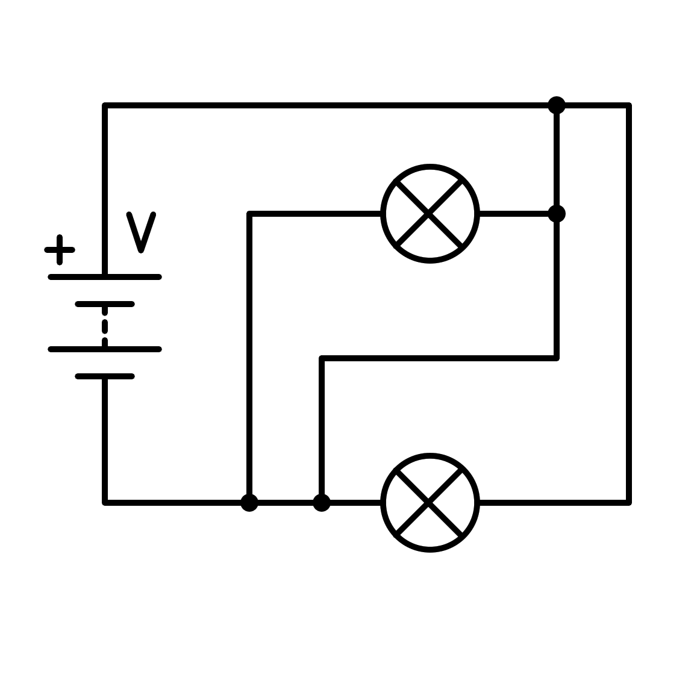

a) Short circuit in the light bulb

b) In parallel

c) Short circuit in the battery

d) In series

1. How is the following circuit connected?

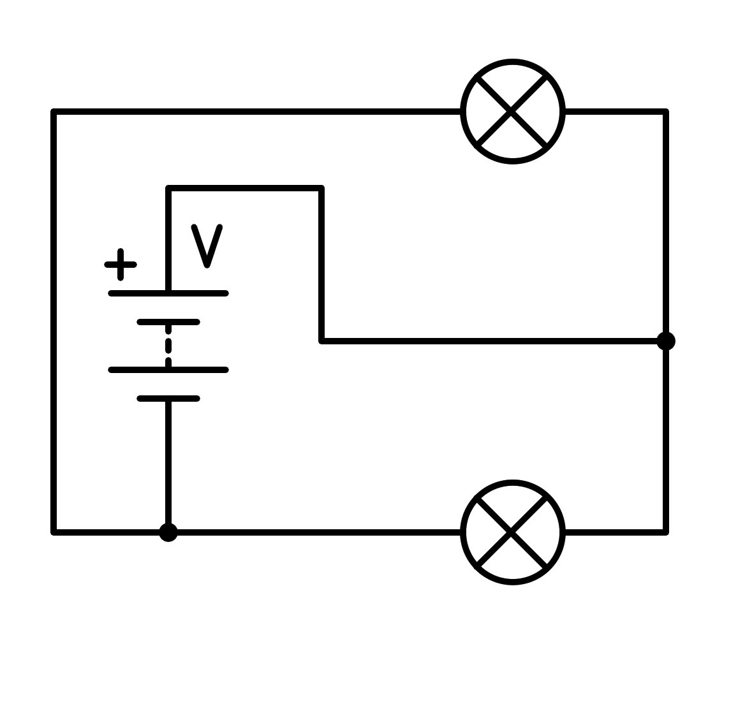

a) In parallel

b) Short circuit in the light bulb

c) Short circuit in the battery

d) In series

1. How is the following circuit connected?

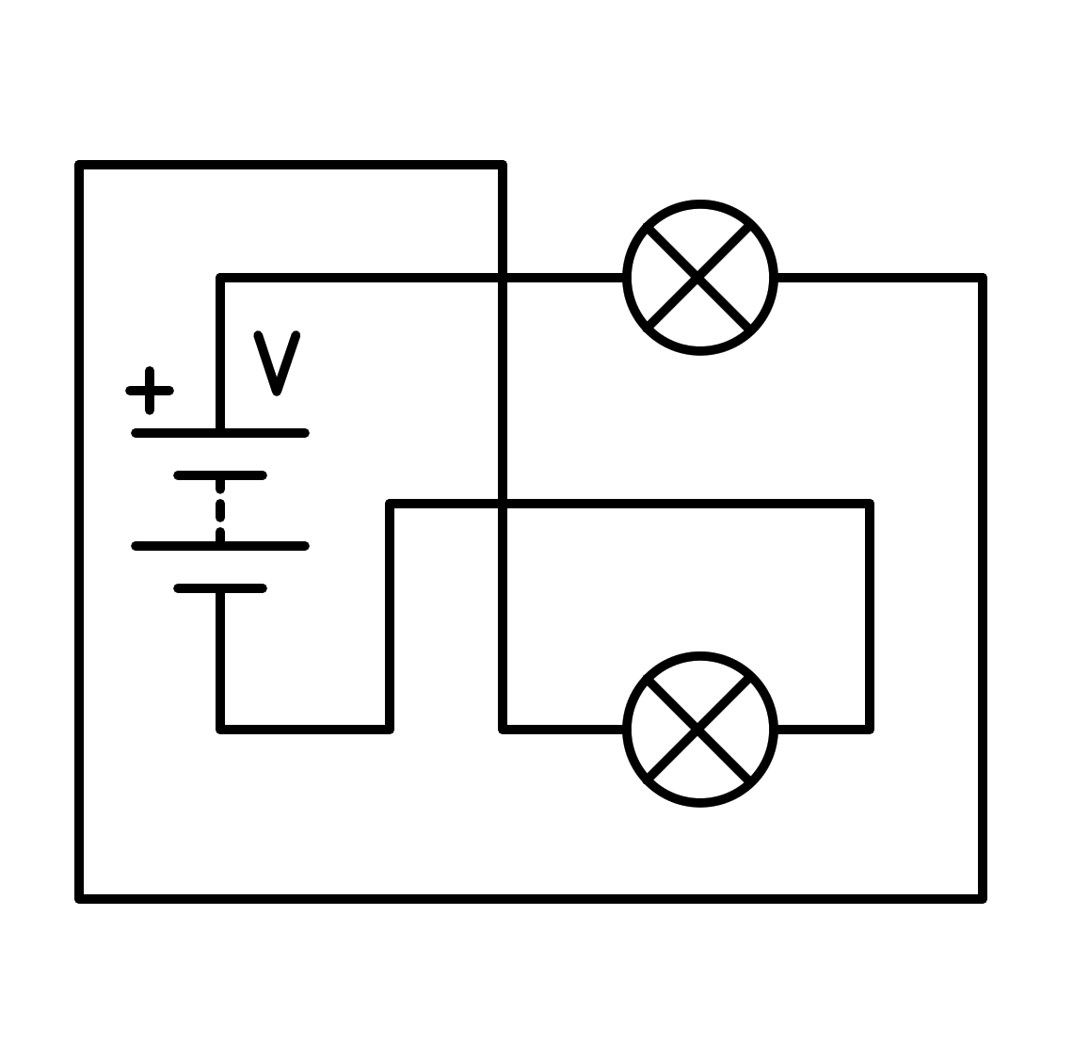

a) In series

b) In parallel

c) Short circuit in the light bulb

d) Short circuit in the battery

1. How is the following circuit connected?

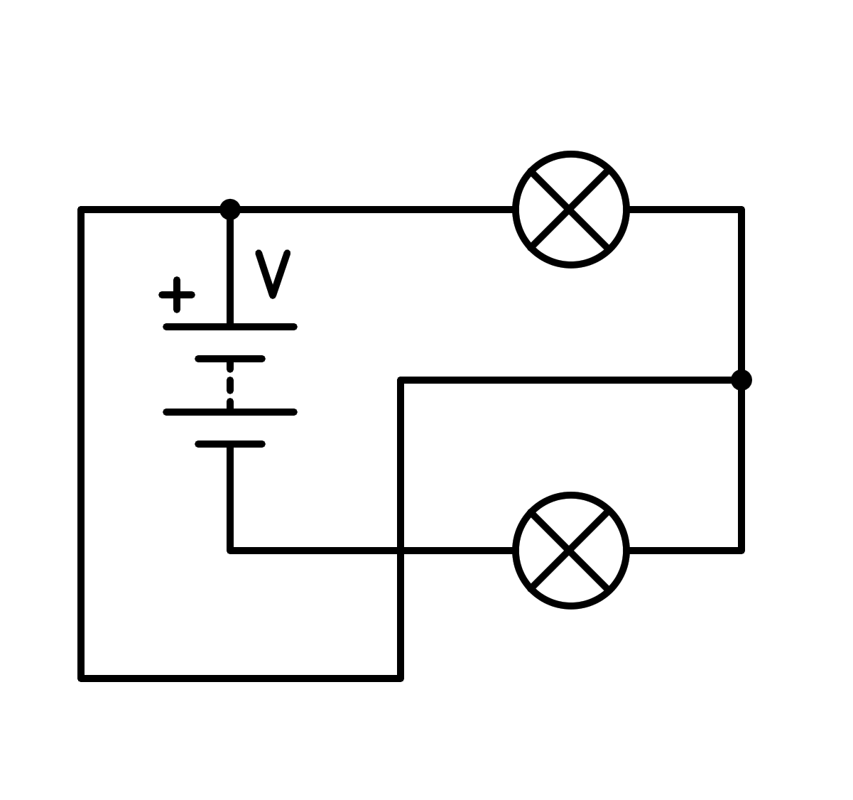

a) Short circuit in the battery

b) In parallel

c) In series

d) Short circuit in the light bulb

1. How is the following circuit connected?

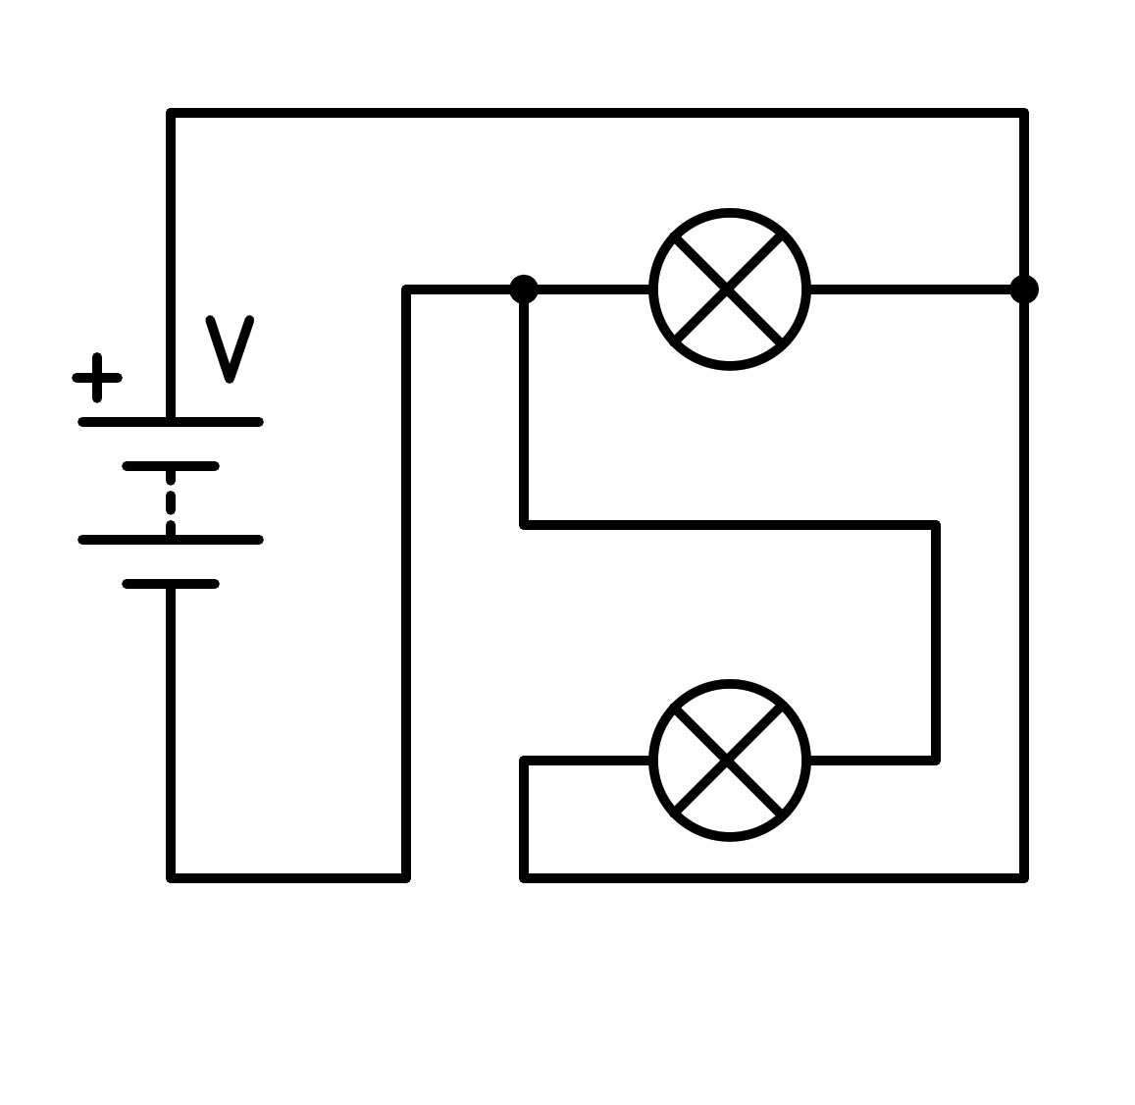

a) Short circuit in the battery

b) In series

c) In parallel

d) Short circuit in the light bulb

1. How is the following circuit connected?

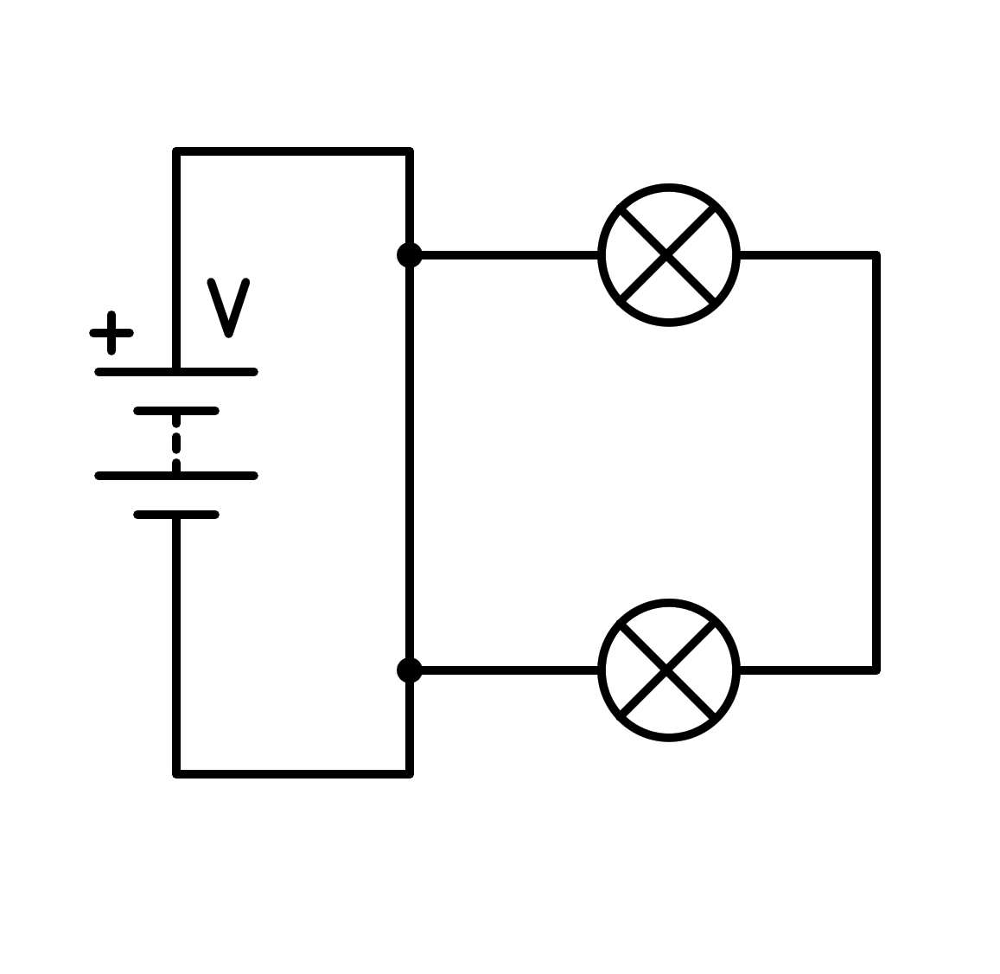

a) In series

b) Short circuit in the battery

c) In parallel

d) Short circuit in the light bulb

1. How is the following circuit connected?

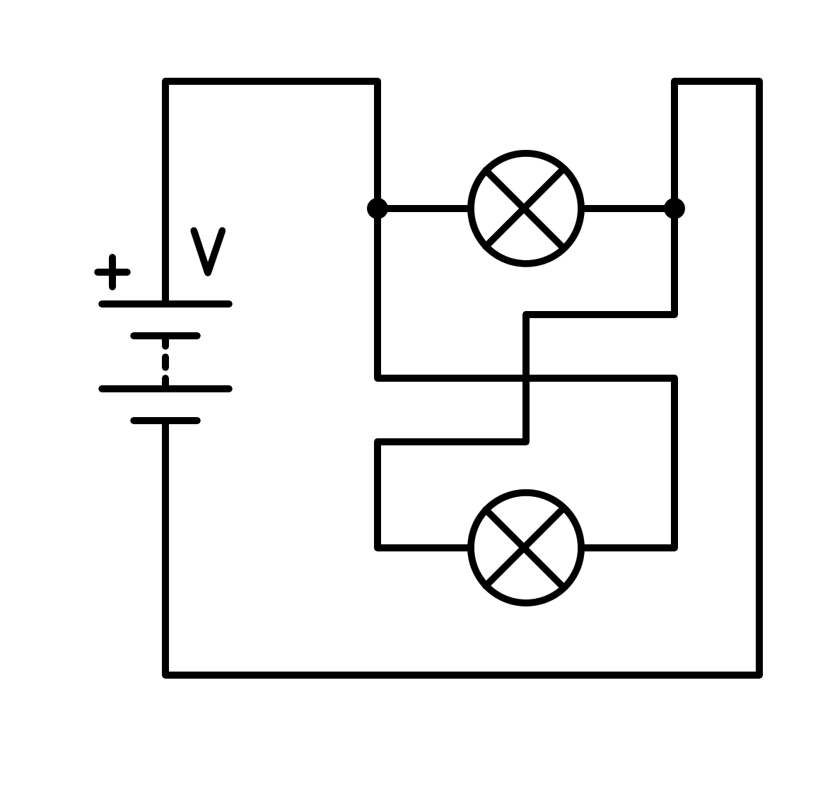

a) Short circuit in the battery

b) Short circuit in the light bulb

c) In parallel

d) In series

1. How is the following circuit connected?

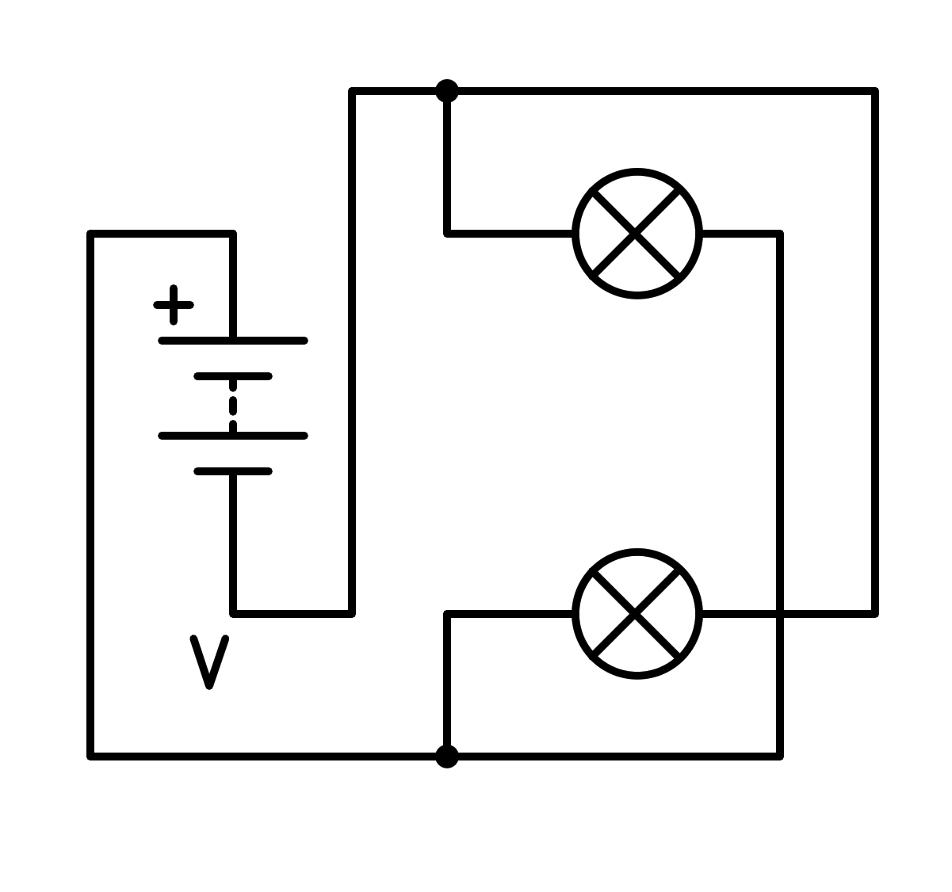

a) In series

b) Short circuit in the battery

c) Short circuit in the light bulb

d) In parallel

1. How is the following circuit connected?

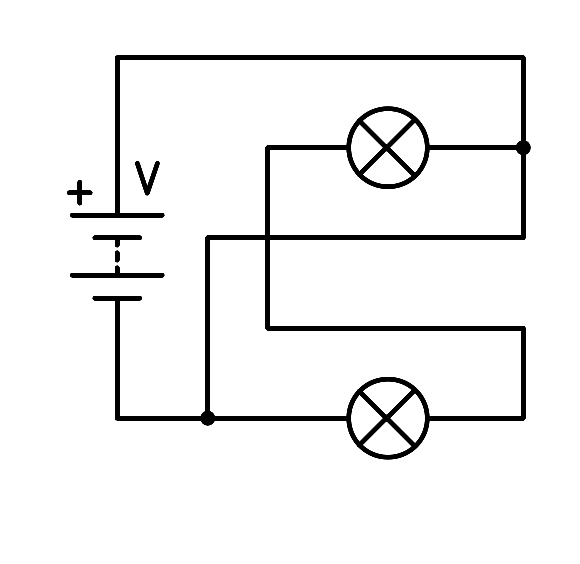

a) Short circuit in the battery

b) In series

c) In parallel

d) Short circuit in the light bulb

1. How is the following circuit connected?

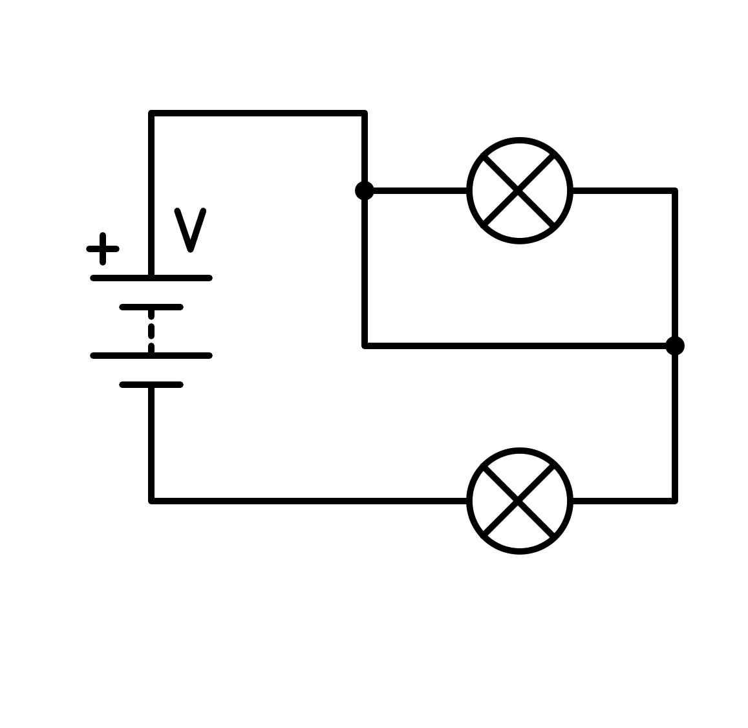

a) Short circuit in the light bulb

b) Short circuit in the battery

c) In parallel

d) In series

1. How is the following circuit connected?

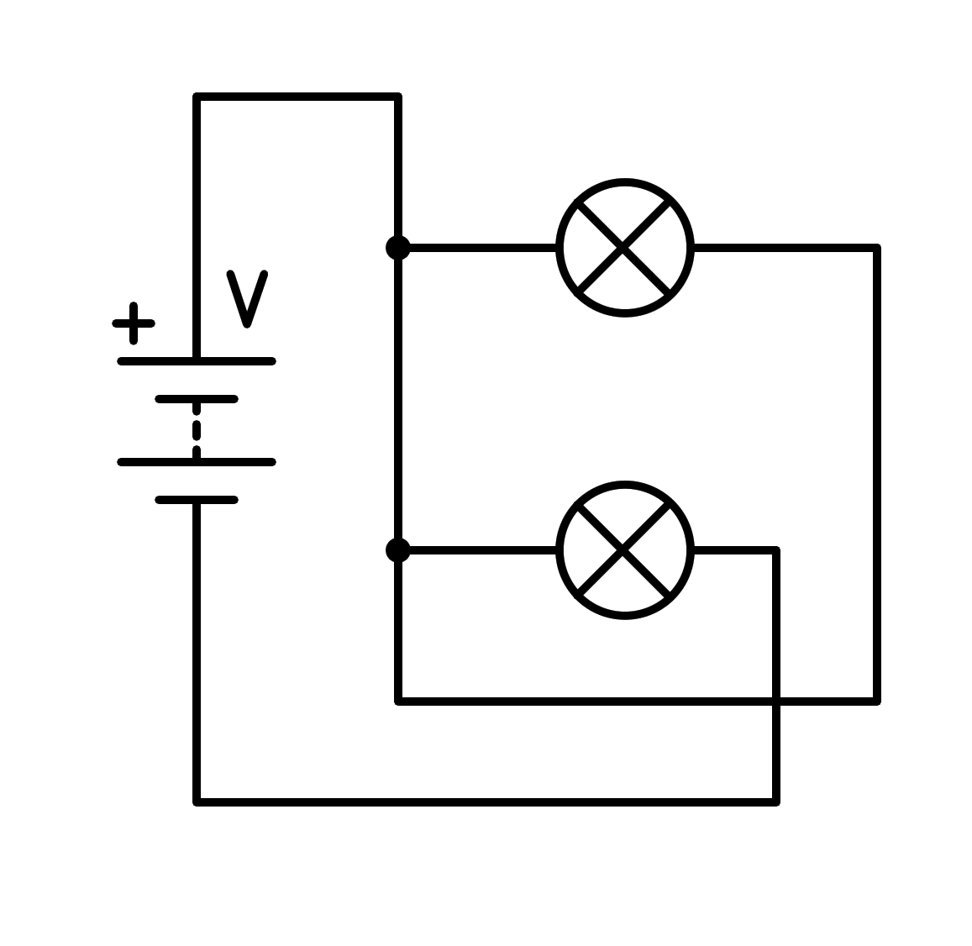

a) In parallel

b) Short circuit in the battery

c) In series

d) Short circuit in the light bulb

1. How is the following circuit connected?

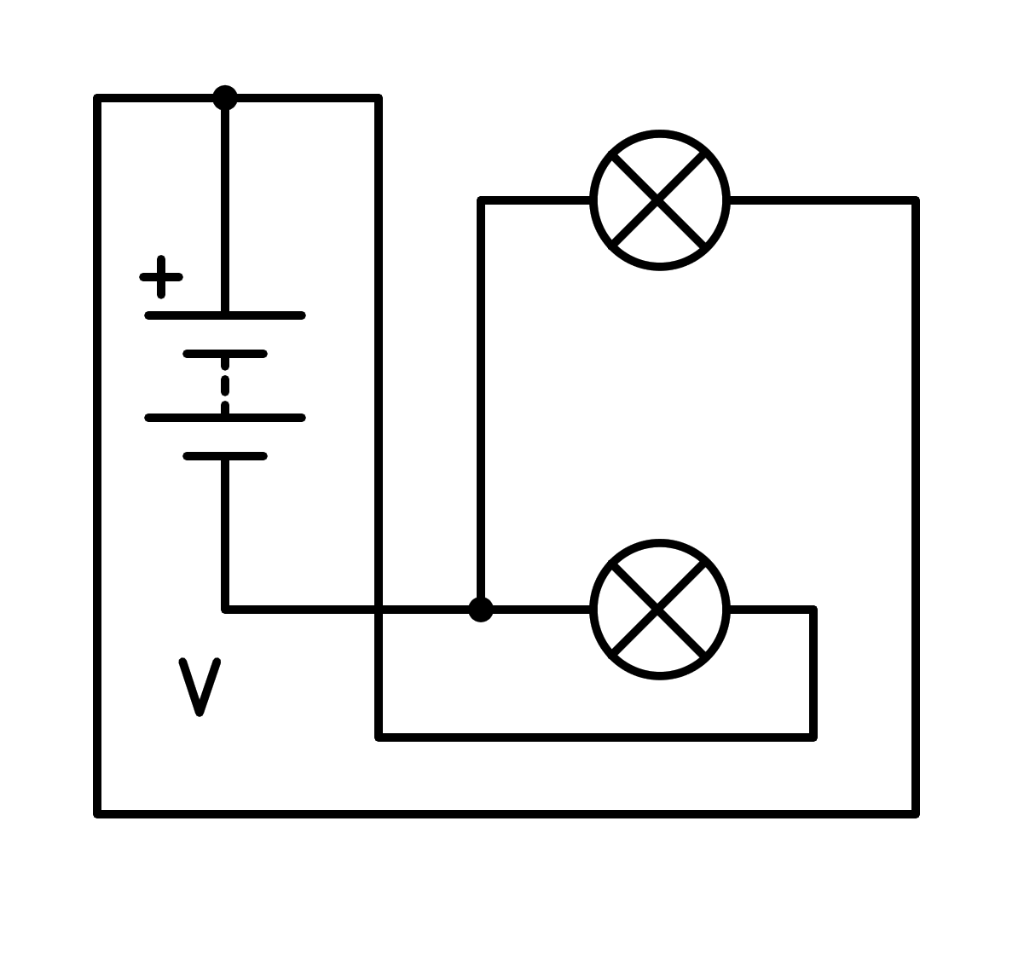

a) Short circuit in the light bulb

b) Short circuit in the battery

c) In parallel

d) In series

1. How is the following circuit connected?

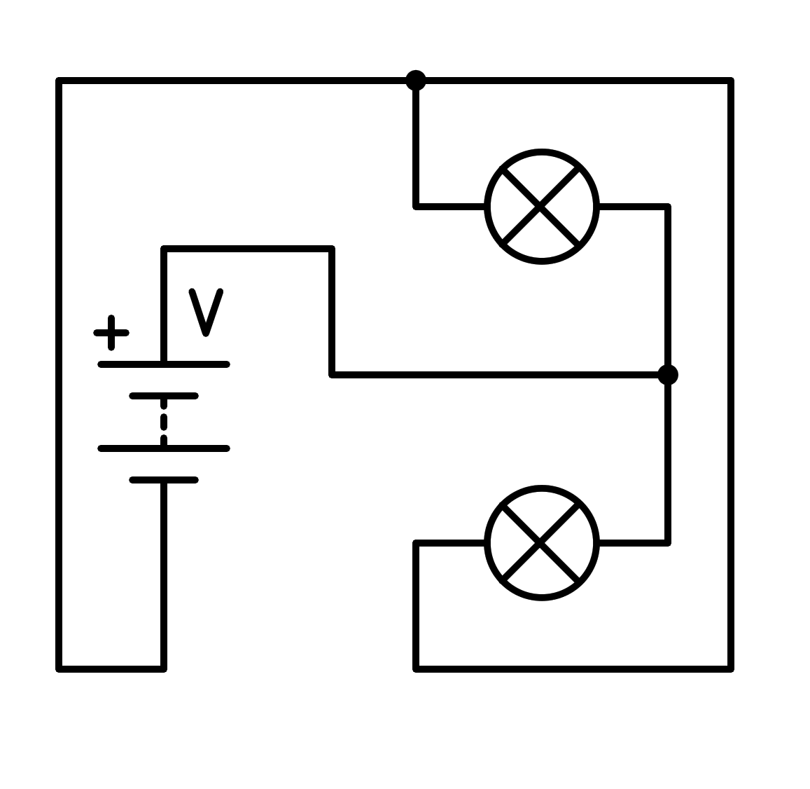

a) In series

b) Short circuit in the light bulb

c) In parallel

d) Short circuit in the battery

1. How is the following circuit connected?

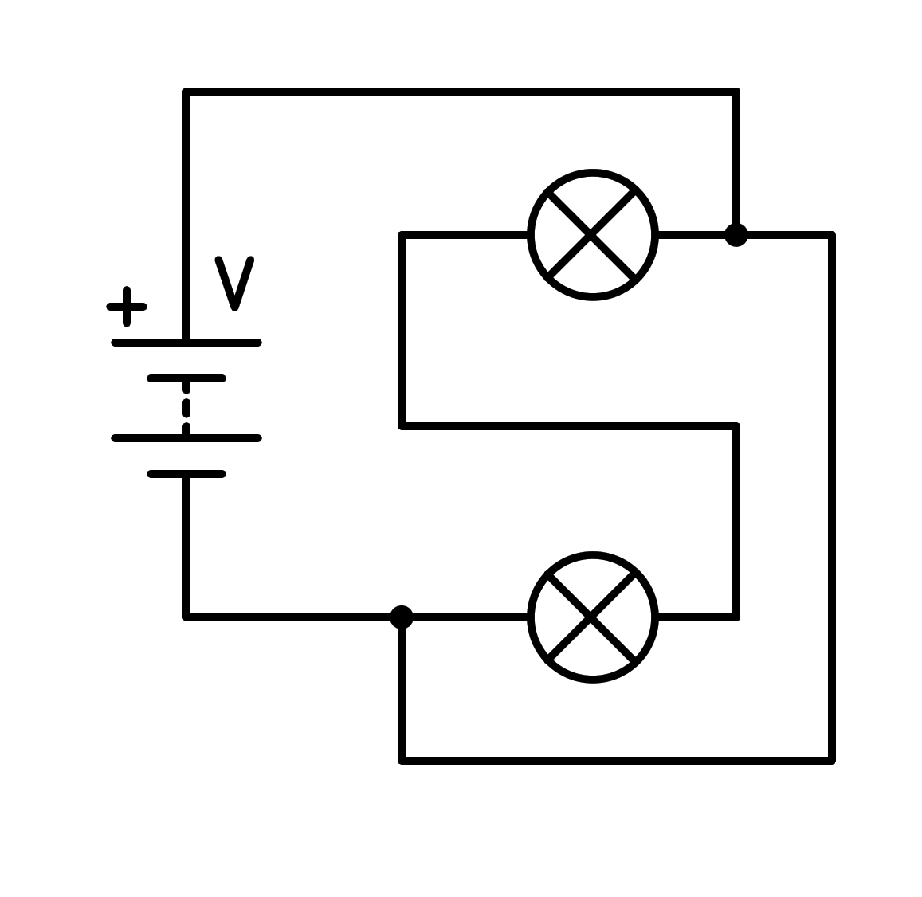

a) Short circuit in the battery

b) In parallel

c) In series

d) Short circuit in the light bulb

1. How is the following circuit connected?

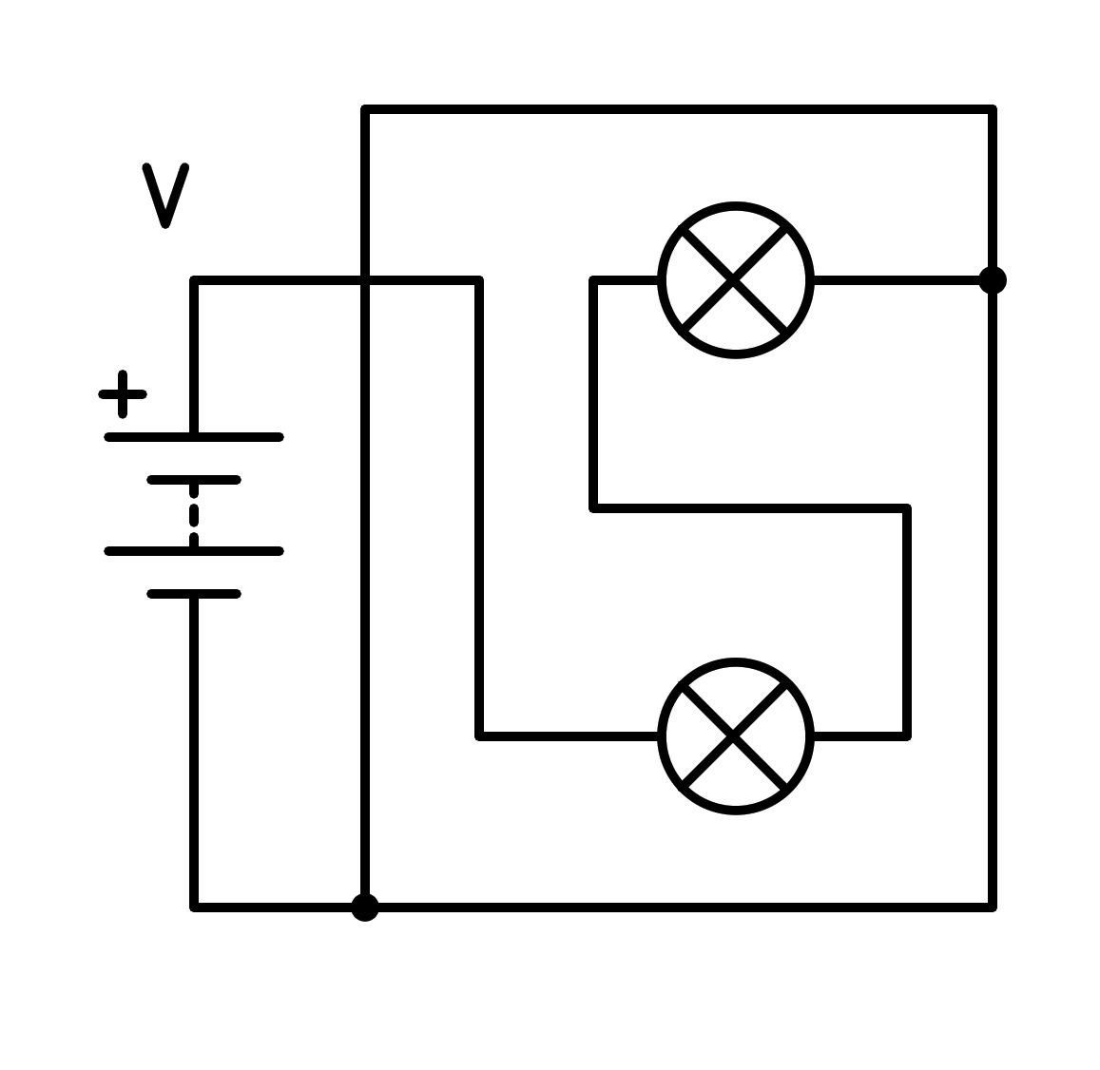

a) In parallel

b) In series

c) Short circuit in the battery

d) Short circuit in the light bulb

1. How is the following circuit connected?

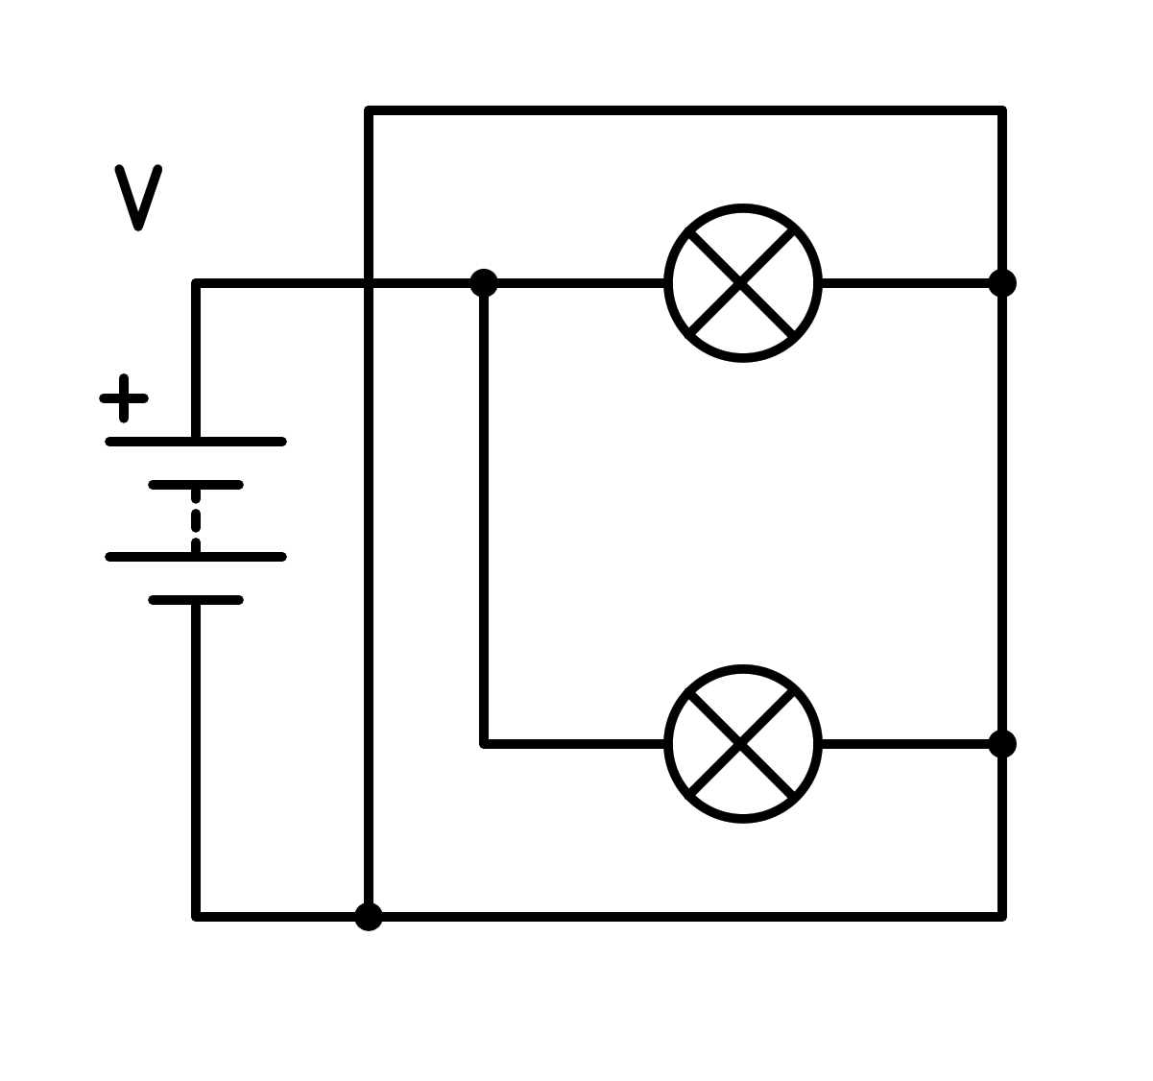

a) Short circuit in the light bulb

b) In parallel

c) In series

d) Short circuit in the battery

1. How is the following circuit connected?

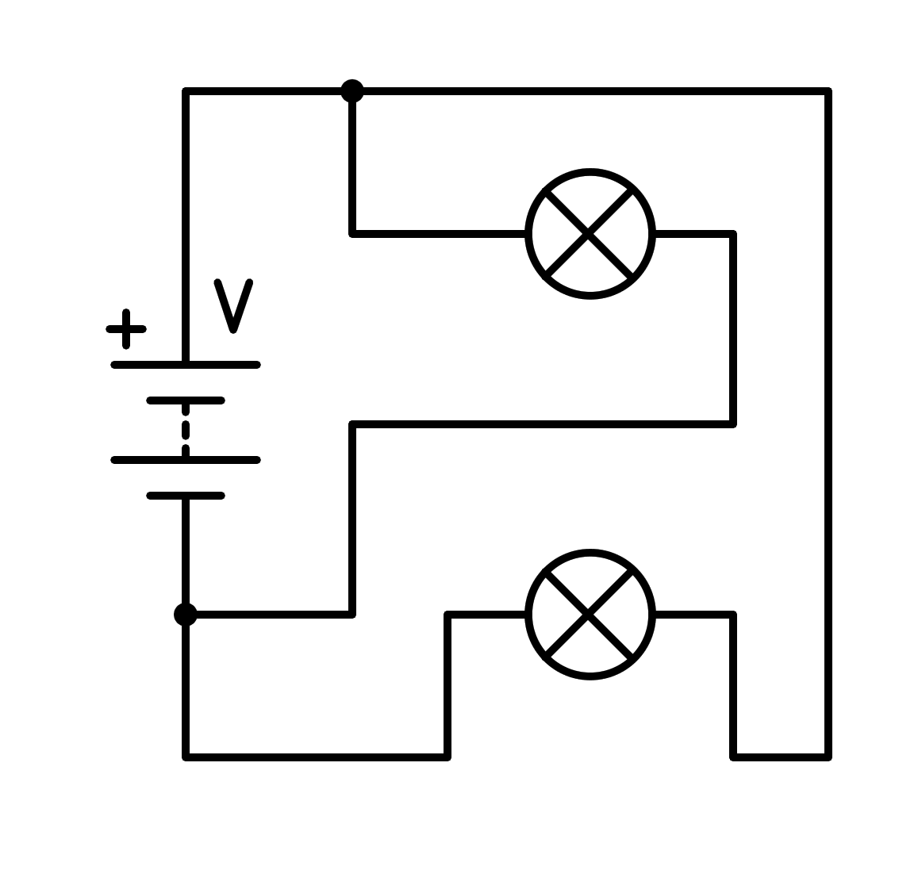

a) Short circuit in the battery

b) In series

c) Short circuit in the light bulb

d) In parallel

1. How is the following circuit connected?

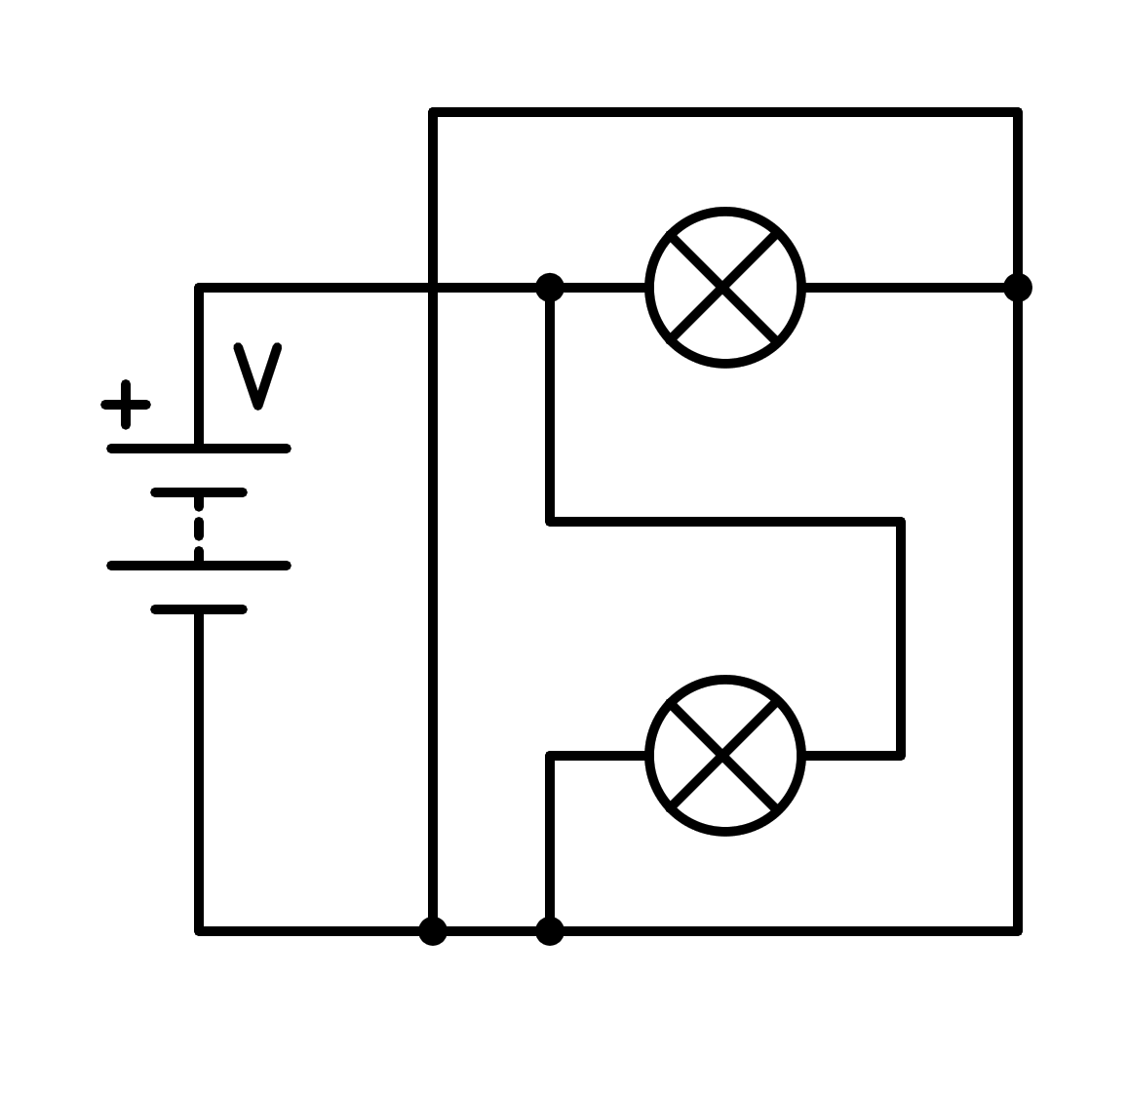

a) Short circuit in the light bulb

b) Short circuit in the battery

c) In series

d) In parallel

1. How is the following circuit connected?

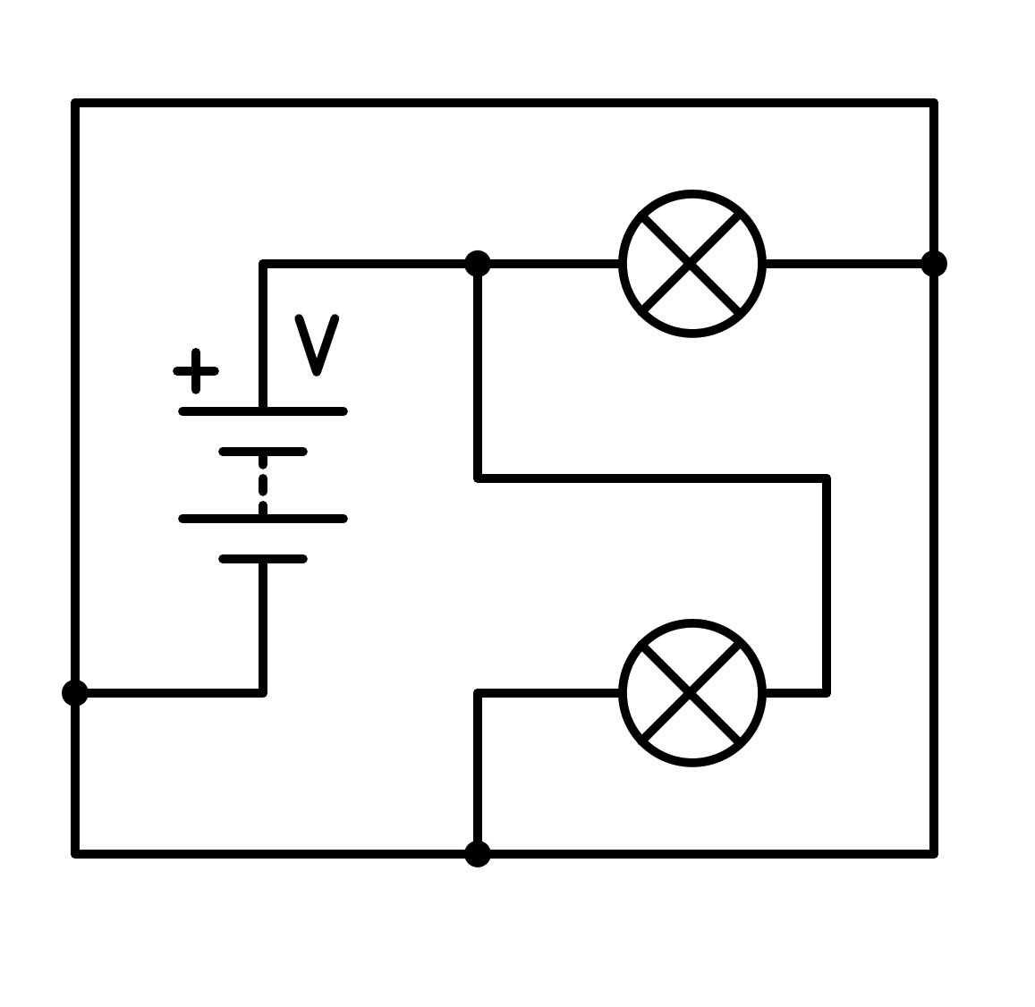

a) In series

b) Short circuit in the light bulb

c) Short circuit in the battery

d) In parallel

1. How is the following circuit connected?

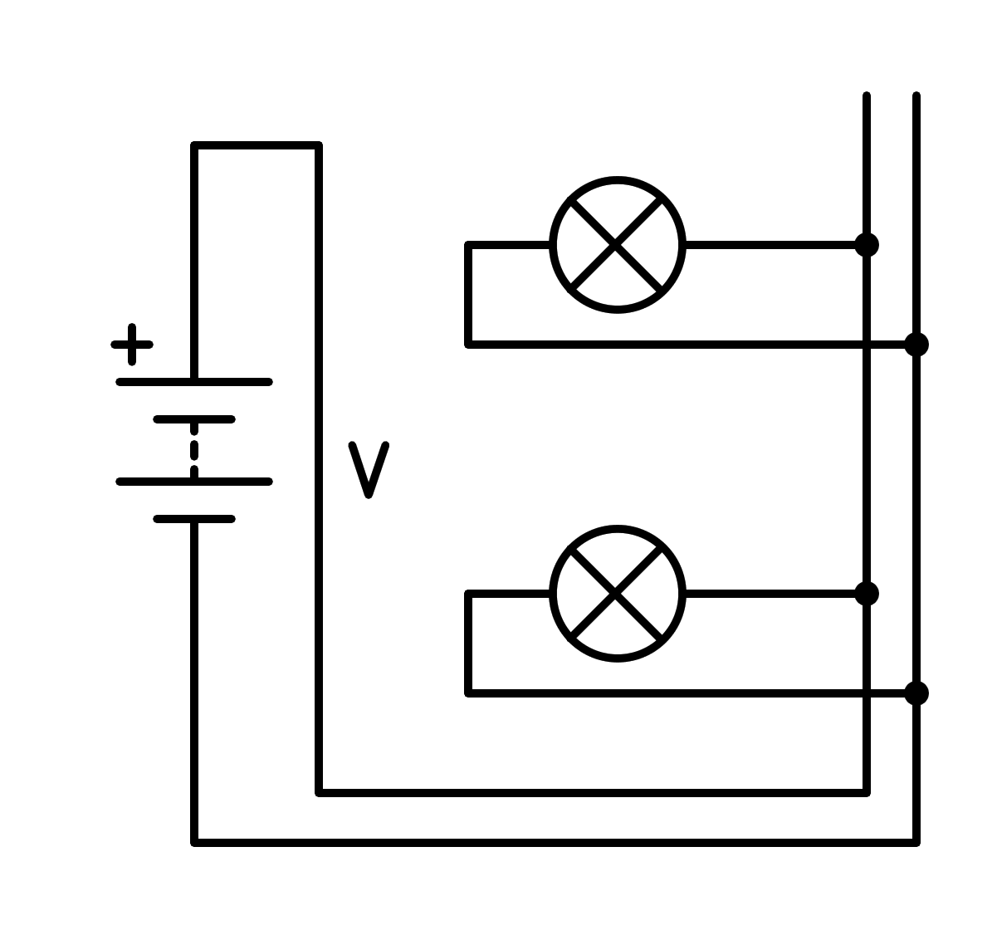

a) In series

b) Short circuit in the battery

c) In parallel

d) Short circuit in the light bulb

1. How is the following circuit connected?

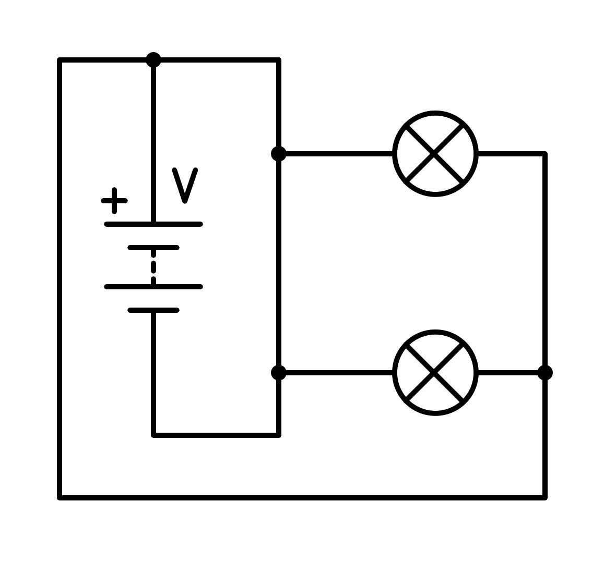

a) In parallel

b) In series

c) Short circuit in the battery

d) Short circuit in the light bulb

1. How is the following circuit connected?

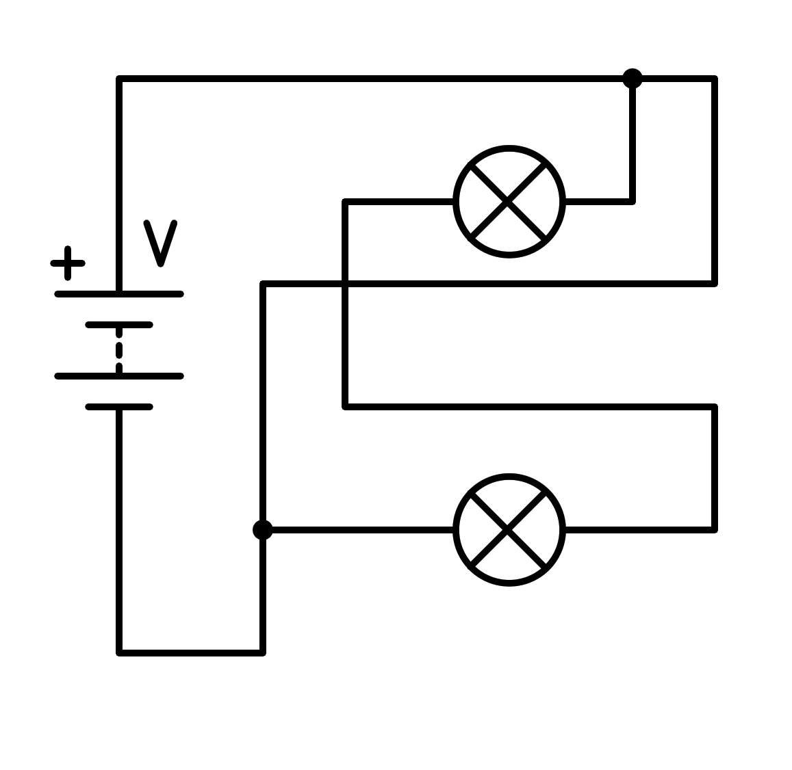

a) Short circuit in the light bulb

b) In parallel

c) In series

d) Short circuit in the battery

1. How is the following circuit connected?

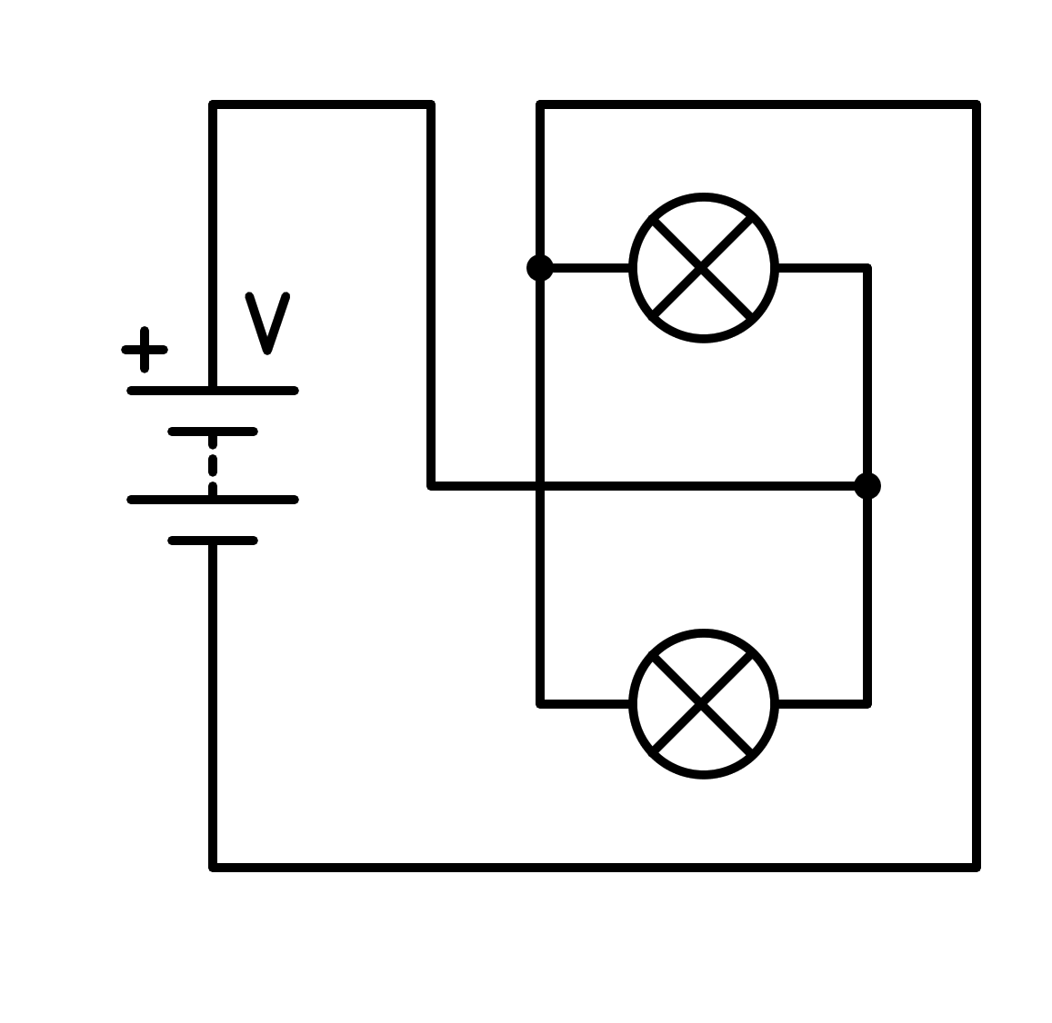

a) Short circuit in the light bulb

b) In series

c) Short circuit in the battery

d) In parallel

1. How is the following circuit connected?

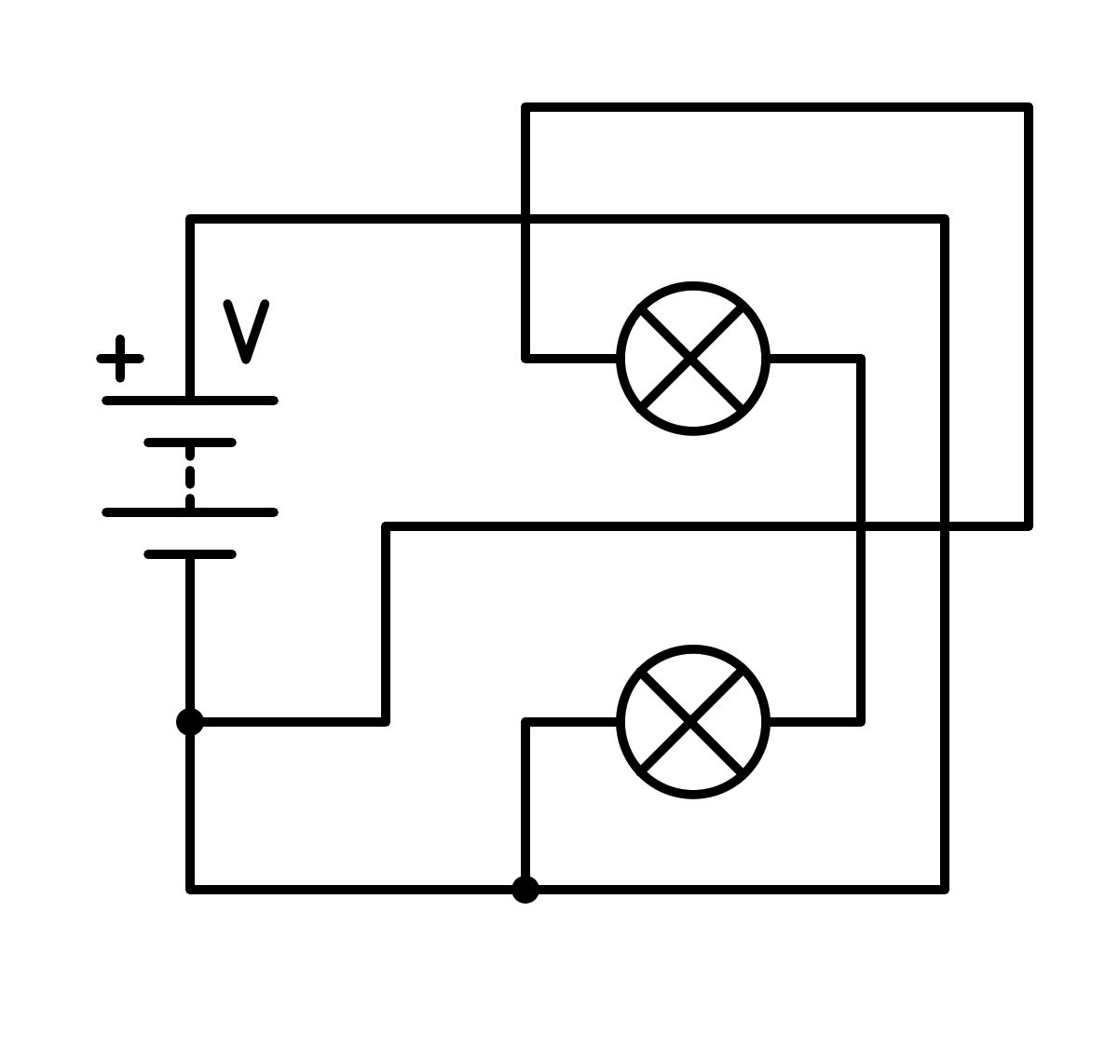

a) In parallel

b) In series

c) Short circuit in the battery

d) Short circuit in the light bulb