**UNIVERSITY OF ENERGY AND NATURAL RESOURCES, SUNYANI.**

**SCHOOL OF SCIENCE**

**DEPARTMENT OF INFORMATION TECHNOLOGY**

**AND DECISION SCIENCES**



# COMPREHENSIVE ERP SYSTEM DOCUMENTATION FOR GROUP 12.

**GROUP 12 MEMBERS**

BISMARK JOE-OWUYAW UEB3208920

STEPHAN KWABENA ASANTE UEB3217520

JESSE DANSO DANQUAH UEB3250922

ELIJAH DAYON ABU UEB3269022

AHI FELICITY UEB3266422

OHENEBA MANU FRANKLINA UEB3259022

BISMARK AQUAH UEB3205922

AMPONSAH STEPHEN JNR. UEB3202022

AMOAKO EMMANUEL UEB3219920

TABLE OF CONTENT

COMPREHENSIVE ERP SYSTEM DOCUMENTATION FOR GROUP 12 1

INTRODUCTION 1

SYSTEM ARCHITECTURE 2

DETAILED MODULES AND FUNCTIONALITIES 2

Inventory Management: 2

Production Planning and Control: 2

Sales and Order Processing: 3

Purchasing and Supplier Management: 3

Finance and Accounting: 3

Human Resources Management: 3

Reporting and Analytics: 4

IMPLEMENTATION AND DEPLOYMENT PLAN 4

Redeployment: 4

Deployment: 4

Post deployment: 5

Continuous Improvement: 5

CONCLUSION 5

# INTRODUCTION

This document provides a full account of the ERP system designed for a mini manufacturing company, detailing the architecture, modules, and a comprehensive plan for deployment and continuous improvement. The system is engineered to streamline operations, enhance productivity, and support scalability for future growth, ensuring a cohesive workflow across various departments.

# SYSTEM ARCHITECTURE

The ERP system designed for a mini manufacturing company integrates various business processes to enhance operational efficiency and support informed decision-making. The system utilizes a cloud platform to ensure scalability and is accessible via web and mobile interfaces. It adopts a three tier architecture:

1. Presentation Layer: Provides a user-friendly interface adaptable to different user skill levels, ensuring ease of use across web and mobile platforms.

2. Application Layer: Manages business logic, processes data, enforces business rules, and handles user requests efficiently.

3. Data Layer: Features a secure, centralized database that stores data from all modules, ensuring consistency and real-time access.

# DETAILED MODULES AND FUNCTIONALITIES

## **Inventory Management:**

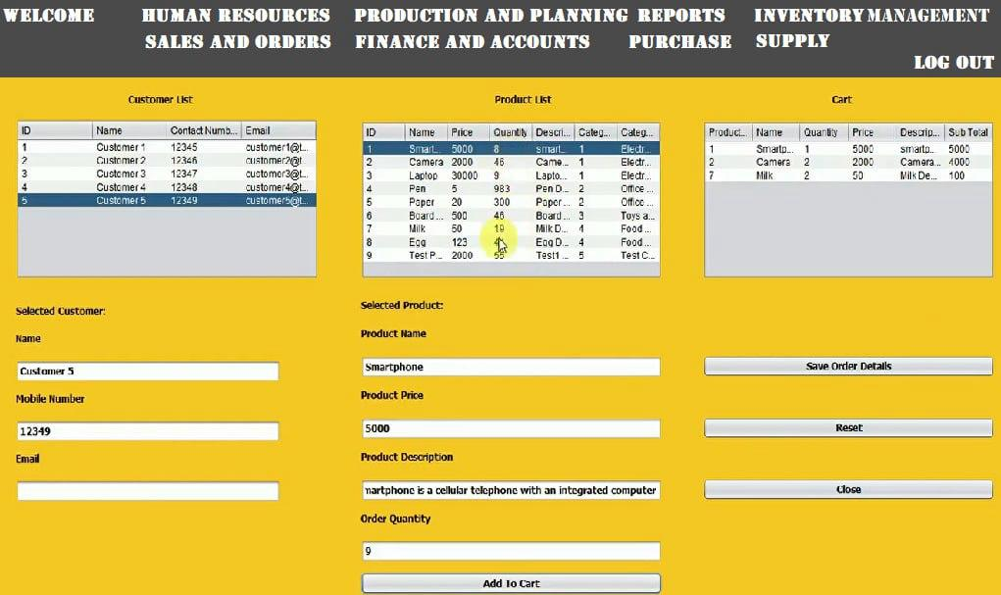

This feature is designed to maintain optimal inventory levels by automating the process of generating purchase orders. It operates based on predefined thresholds for each inventory item. When the stock level of an item falls below the specified threshold, the system automatically triggers a purchase order to replenish the item, ensuring that the company never runs into stock-outs which could interrupt production or sales processes. This feature can be customized to consider lead times, seasonal demand variations, and supplier reliability to enhance inventory efficiency.

Key capabilities include:

* **Dynamic Threshold Setting:** Allows for customization of minimum stock levels based on sales velocity, historical demand, and forecasted needs.
* **Supplier Integration:** Automatically sends replenishment orders to suppliers, and can integrate with supplier systems for real-time updates on order status.
* **Notification System:** Alerts inventory managers via notifications when automated orders are placed, allowing for manual intervention if needed.

## Inventory Forecasting

Inventory Forecasting uses historical sales data and analytical models to predict future inventory requirements. This proactive feature helps in planning for future demand, ensuring that the company is neither overstocked nor understocked.

Functionalities include:

* **Trend Analysis:** Analyzes past sales trends to forecast future demand, taking into account seasonal variations, market trends, and economic factors.
* **Safety Stock Calculation:** Determines the appropriate level of safety stock to maintain based on forecast accuracy, lead time variability, and the cost of stockouts.
* **Scenario Planning:** Supports simulation of various inventory scenarios to understand the impact of unexpected changes in demand or supply chain disruptions.

## **Production Planning and Control:**

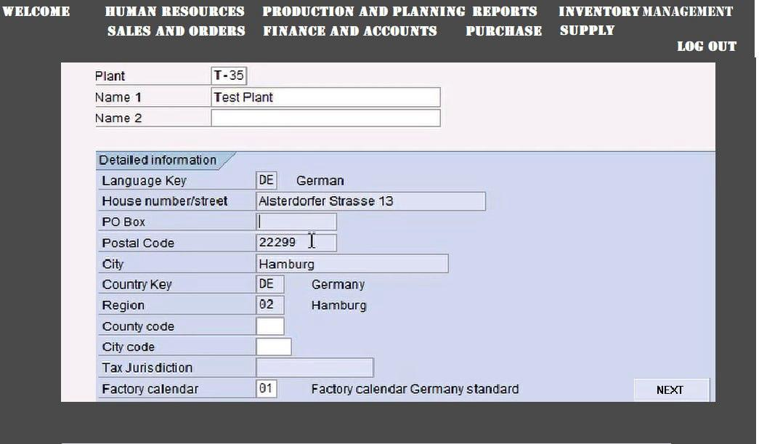

The Production Planning and Control module in the ERP system encompasses several critical features designed to optimize manufacturing operations:

1. Master Production Schedule (MPS): Aligns manufacturing operations with demand forecasts and capacity constraints to optimize resource use and minimize downtime. It dynamically adjusts to changes, improving coordination across departments.

2. Work Order Management: Manages the lifecycle of production orders from initiation to completion. It ensures on-time delivery and adherence to quality standards by tracking order progress, managing documents, and optimizing resource scheduling.

3. Quality Control: Integrates quality checks throughout the production process to maintain product standards and compliance. This feature sets quality benchmarks, performs in-process inspections, and utilizes feedback to enhance production processes.

4. Resource Allocation: Strategically allocates human and machine resources to efficiently meet production demands. It optimizes resource usage, manages costs, matches workforce skills with job requirements, and adapts to changes in production schedules.

These functionalities ensure that the manufacturing process is efficient, meets quality standards, and optimally uses resources, contributing significantly to the productivity and profitability of the operations.

## **Sales and Order Processing:**

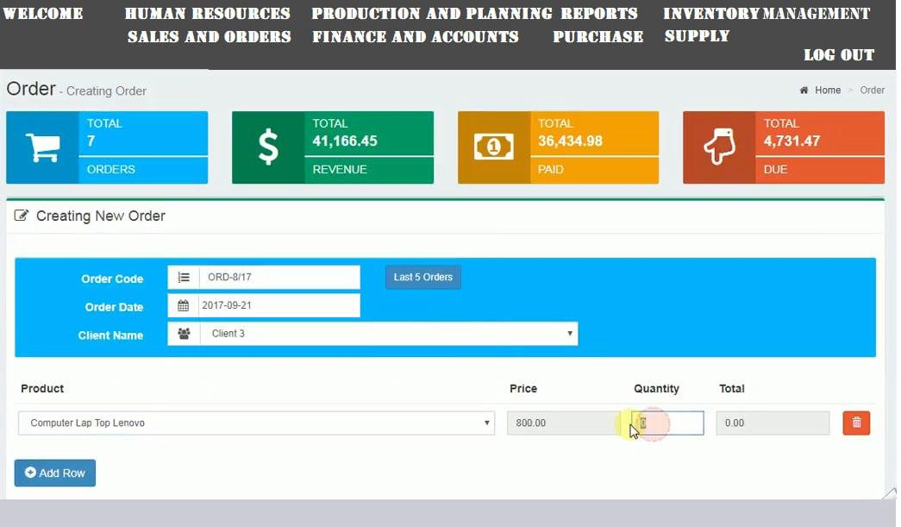

Enhanced Features of the Sales and Order Processing Module

Order Entry and Tracking

This feature simplifies the process of order placement and enhances the customer and staff experience by providing real-time updates on order status. It streamlines data entry, reduces errors, and ensures that both customers and staff are informed about the progress of orders from placement through to delivery.

Enhanced capabilities include:

- Automated Order Confirmation: Sends immediate confirmation emails or SMS messages to customers upon order placement.

- Mobile Tracking: Enables tracking via mobile devices, offering customers and staff flexibility to monitor order status on-the-go.

- Integration with Logistics: Integrates with logistic systems to provide accurate and timely delivery updates, improving overall customer satisfaction.

Customer Relationship Management (CRM)

The CRM component of the ERP system focuses on managing detailed customer profiles, tracking all customer interactions, and analyzing sales history to enhance customer retention and loyalty. It acts as a central repository for customer data, facilitating improved marketing strategies and personalized customer service.

Additional functionalities:

- Customer Segmentation: Allows for detailed segmentation of customers based on buying behavior, preferences, and demographics, enabling targeted marketing efforts.

- Interaction Tracking: Records every interaction with customers, providing a comprehensive view of customer relationships and identifying opportunities for future sales.

- Automated Feedback Collection: Integrates tools for collecting customer feedback post-purchase, which informs service improvements and product development.

Invoicing and Payments

This feature automates the generation of invoices and tracks payments, ensuring financial transactions are processed efficiently and accurately. It seamlessly integrates with the finance module to provide real-time financial data, aiding in quick reconciliation and financial reporting.

Enhanced capabilities include:

- Multi-Currency Support: Facilitates transactions in different currencies, which is essential for global operations.

- Automated Reminders: Sends automated reminders for due payments to customers, helping to reduce delinquencies.

- Secure Payment Gateways: Integrates with various secure payment platforms to offer customers safe and versatile payment options.

Sales Forecasting

Sales Forecasting uses historical sales data along with analytical tools to predict future sales trends. This information is crucial for strategic planning, inventory management, and marketing initiatives.

Additional functionalities:

- Predictive Analytics: Employs advanced predictive analytics to refine sales forecasts based on market trends, economic indicators, and consumer behavior insights.

- Scenario Planning: Supports planning for various sales scenarios, helping to prepare for market fluctuations and potential disruptions.

- Integration with Marketing: Aligns sales forecasts with marketing campaigns, ensuring that promotional activities are well-timed and targeted based on anticipated sales periods.

These enhanced features within the Sales and Order Processing module significantly improve operational efficiency, customer satisfaction, and strategic decision-making capabilities, driving sales growth and enhancing the overall performance of the business.

## **Purchasing and Supplier Management:**

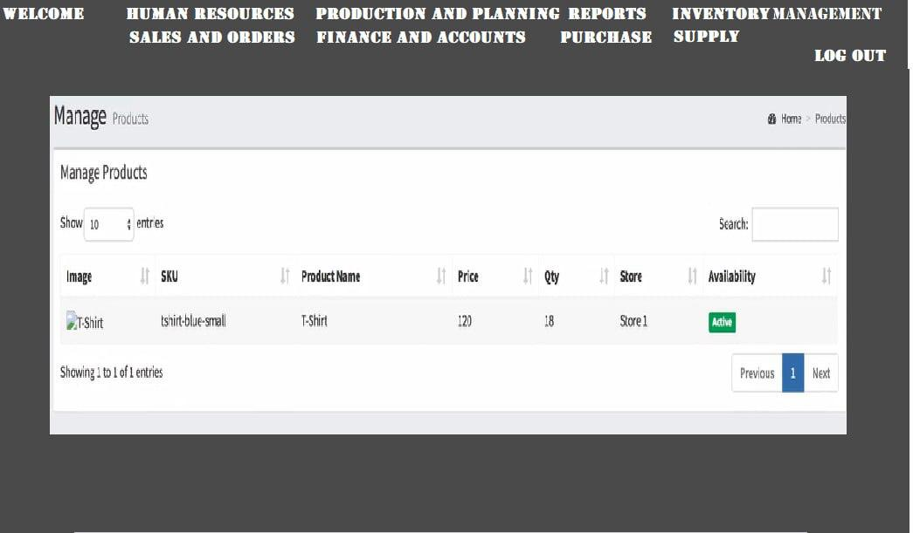

Supplier Evaluation: Assesses supplier performance to ensure quality and compliance.

Contract Management: Manages purchasing contracts, ensuring compliance and handling renewals.

Purchase Requisitions: Streamlines the requisition to purchase order process.

Spend Analysis: Analyzes spending to identify cost saving opportunities.

## **Finance and Accounting:**

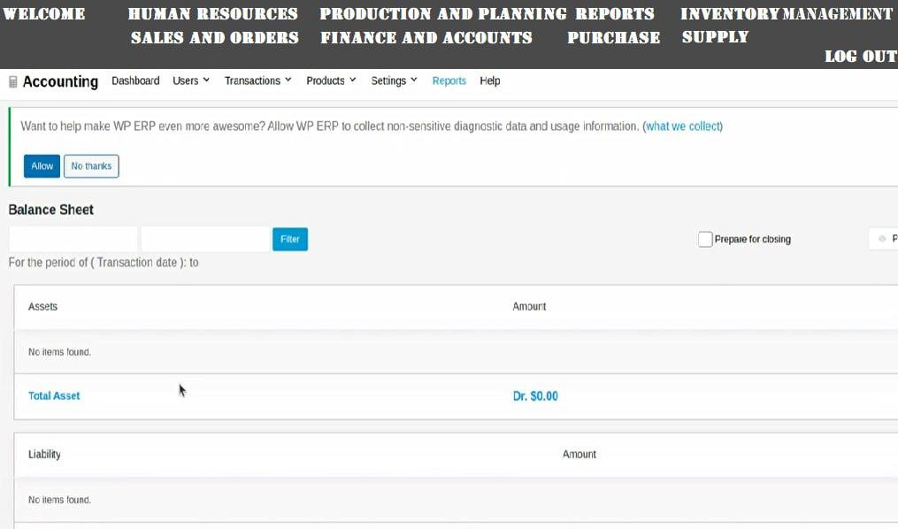

General Ledger

The General Ledger acts as the central repository for all accounting data, ensuring accuracy and consistency across financial records. It captures every transaction within the company, providing a comprehensive view of financial health.

- Audit Trail: Maintains a detailed audit trail that helps in tracking changes and ensuring accountability and transparency.

- Integration with Other Modules: Seamlessly integrates with modules like Sales, Purchasing, and HR to gather financial data, reducing manual entry and potential errors.

Asset Management

Asset Management oversees the entire lifecycle of company assets, from acquisition through to depreciation and eventual disposal. It helps in optimizing the use and valuation of assets over time.

- Preventive Maintenance Scheduling: Automates the scheduling of maintenance tasks to prolong asset life and ensure operational efficiency.

- Disposal Management: Manages the disposal process of assets, ensuring compliance with environmental standards and financial regulations regarding asset write-offs.

Budgeting and Forecasting

This feature supports comprehensive financial planning and monitoring, allowing for detailed budget preparation and financial forecasting to guide corporate strategy and operational decisions.

- What-if Analysis: Provides tools for what-if scenario planning, helping management understand the financial implications of different strategic choices.

- Rolling Forecasts: Allows for the creation of rolling forecasts that adjust to changing business conditions, providing more accurate and timely data for decision-making.

Regulatory Compliance

Manages financial reporting and ensures compliance with local and international financial regulations. This feature is crucial for maintaining corporate integrity and avoiding legal penalties.

- Automated Compliance Reports: Generates compliance reports automatically, ensuring timely submissions to regulatory bodies.

- Real-time Monitoring of Compliance Changes: Keeps track of changes in financial regulations and updates system processes accordingly to maintain compliance at all times.

Each of these expanded features within the Finance and Accounting module significantly enhances the ability to manage financial data accurately, optimize asset utilization, plan financially for future needs, and ensure compliance with all necessary regulations. These enhancements help secure the financial stability and integrity of the business.

## **Human Resources Management:**

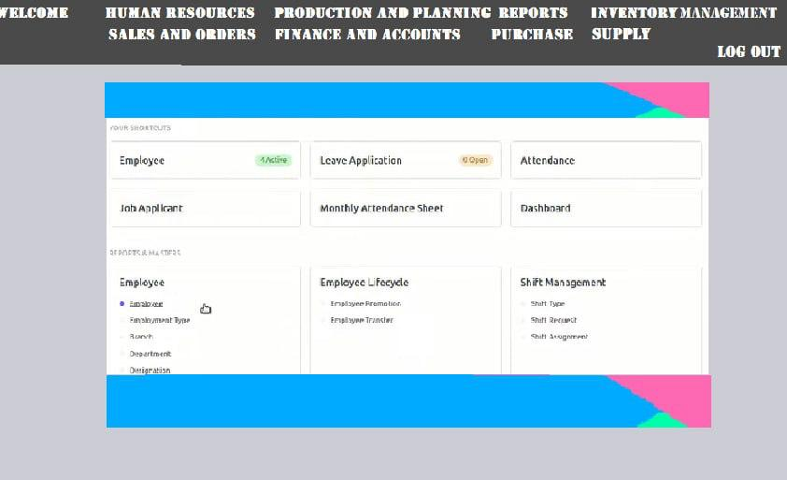

Employee Records: Keeps detailed and updated employee information.

Payroll System: Automates payroll processing and manages tax calculations.

Talent Management: Supports recruitment, onboarding, and employee development.

Benefits Administration: Manages various employee benefits efficiently.

## **Reporting and Analytics:**

Customizable Dashboards: Allows creation of personalized dashb

oards for monitoring KPIs.

Real-time Reporting: Provides immediate access to data for timely decision-making.

Data Visualization: Offers tools for complex data interpretation through visual aids.

Advanced Analytics: Applies sophisticated analytics for deeper operational insights.

# IMPLEMENTATION AND DEPLOYMENT PLAN

# SECURITY

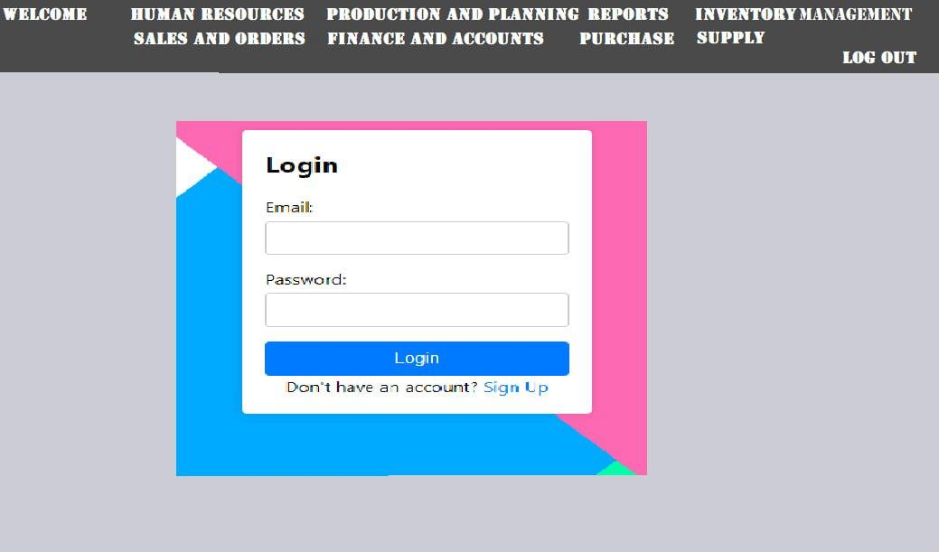

The ERP system includes robust security measures designed to protect sensitive data and maintain secure operations. Key security features include data encryption, user authentication with multi-factor authentication, role-based access control, regular security audits, and network security with firewalls and intrusion detection systems. Additionally, the system supports data backup and recovery protocols to ensure data integrity and availability, with compliance management to adhere to regulatory standards. These comprehensive security features safeguard the system against unauthorized access and potential security threats, ensuring a secure environment for all business operations.

## Redeployment:

Training: Extensive user training sessions with hands-on activities and detailed manuals.

System Testing: Comprehensive testing including unit, integration, and user acceptance testing.

## Deployment:

Initial Setup: Tailor the ERP system to match specific operational processes, including setting up user roles and permissions.

Hardware and Infrastructure Setup: Establish necessary hardware and network infrastructure to support the ERP system, ensuring scalability and security.

Integration with Existing Systems: Seamlessly integrate the ERP with existing systems using APIs and custom middleware to ensure continuity and functionality.

Data Migration: Cleanse, map, test, and validate data in phases to ensure integrity and functionality, with rigorous verification after each phase.

System Stabilization: Allow end-users to confirm operational workflows within the new system, optimize system performance, and conduct security audits.

Final Go Live: Conduct final training, provide robust go live support, and perform a comprehensive post live review to ensure the system meets business objectives.

## Post deployment:

Support Structure: Set up a dedicated support team for ongoing technical issues.

Feedback Loop: Regularly collect and analyze user feedback for continuous improvement.

## Continuous Improvement:

System Updates: Regularly update the system to incorporate new features and enhance security.

Training Refreshers: Provide ongoing training to accommodate new system features and maximize user efficiency.

# CONCLUSION

The ERP system designed for a mini manufacturing company provides a comprehensive solution to integrate and enhance various business operations, improving efficiency and decision-making. It features a user-friendly, cloud-based architecture with modules covering inventory management, production planning, sales, purchasing, finance, human resources, and analytics. The system is prepared for smooth deployment with detailed planning for training, data migration, and post-deployment support, ensuring minimal disruption. The ERP is scalable, adaptable to technological advances and future business needs, making it a long-term asset for the company’s growth and success.