DataAnalysis_Ver2

## Block effect

The soil texture and stone: soil ratio is inherent properties that could not alter. The soil texture is converted into a geometric mean of particle size distribution, dg:

*dg = exp[-0.0196C+0.023(100-S-C)+0.0576S]*

where C and S are the proportion of clay and sand (in %). Smaller dg means high in clay and large dg means high in sand.

## Analysis of Variance Table  
##   
## Response: Stone:soil ratio  
## Df Sum Sq Mean Sq F value Pr(>F)   
## Block 1 0.8647 0.86470 137.59 < 2.2e-16 ***  
## Residuals 494 3.1045 0.00628   
## ---  
## Signif. codes: 0 '***' 0.001 '**' 0.01 '*' 0.05 '.' 0.1 ' ' 1

## $statistics  
## MSerror Df Mean CV  
## 0.006284492 494 0.1500926 52.81727  
##   
## $parameters  
## test p.ajusted name.t ntr alpha  
## Fisher-LSD none Block 6 0.05  
##   
## $groups  
## Stone:soil groups  
## 1 0.25564314 a  
## 4 0.14368798 b  
## 2 0.13268747 bc  
## 6 0.11744914 bc  
## 3 0.11732956 c  
## 5 0.08806181 d  
##

## Analysis of Variance Table  
##   
## Response: DG_soilTx  
## Df Sum Sq Mean Sq F value Pr(>F)   
## Block 1 0.005896 0.0058964 79.062 < 2.2e-16 ***  
## Residuals 494 0.036842 0.0000746   
## ---  
## Signif. codes: 0 '***' 0.001 '**' 0.01 '*' 0.05 '.' 0.1 ' ' 1

## $statistics  
## MSerror Df Mean CV  
## 7.457839e-05 494 10.00454 0.08631958  
##   
## $parameters  
## test p.ajusted name.t ntr alpha  
## Fisher-LSD none Block 6 0.05  
##   
## $groups  
## DG_soilTx groups  
## 1 10.017079 a  
## 5 10.007599 b  
## 4 10.006603 bc  
## 3 10.004710 c  
## 6 9.995205 d  
## 2 9.994402 d

The result showed that each block significantly inherent different soil physical properties (soil texture and stone:soil ratio).

## Stability Anova Test in 2019 and 2023

In this anova test, we will test the effect of treatment,block&plot(location) and year on soil stability.

## Analysis of Variance Table  
##   
## Response: Stability  
## Df Sum Sq Mean Sq F value Pr(>F)   
## Treatment 2 25.154 12.577 439.1143 < 2.2e-16 ***  
## Year_Stability 1 86.029 86.029 3003.6786 < 2.2e-16 ***  
## Block 1 0.638 0.638 22.2708 3.097e-06 ***  
## Plot 1 0.065 0.065 2.2853 0.1313   
## Treatment:Year_Stability 2 16.866 8.433 294.4362 < 2.2e-16 ***  
## Residuals 488 13.977 0.029   
## ---  
## Signif. codes: 0 '***' 0.001 '**' 0.01 '*' 0.05 '.' 0.1 ' ' 1

## $statistics  
## MSerror Df Mean CV  
## 0.02864124 488 0.798357 21.19819  
##   
## $parameters  
## test p.ajusted name.t ntr alpha  
## Fisher-LSD none Year_Stability 2 0.05

## Stability groups Year   
## <dbl> <chr> <chr>  
## 1 0.422 b 2019   
## 2 1.26 a 2023

## Stability groups Treatment  
## <dbl> <chr> <chr>   
## 1 1.07 a A_Viti   
## 2 0.795 b D_Viti   
## 3 0.526 c T_Viti

## Stability groups Block  
## 1 0.975 a 1   
## 2 0.962 a 2   
## 3 0.881 b 3   
## 4 0.583 c 4   
## 5 0.502 d 5   
## 6 0.501 d 6

## Stability groups `Interaction between Treatment and Year`  
## 1 0.472 d A_Viti:2019   
## 2 1.65 a A_Viti:2023   
## 3 0.430 d D_Viti:2019   
## 4 1.49 b D_Viti:2023   
## 5 0.365 e T_Viti:2019   
## 6 0.701 c T_Viti:2023

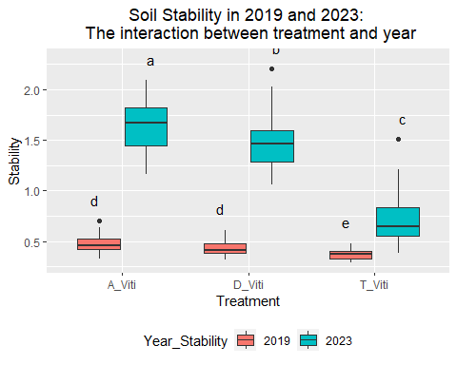

Based on the figure above, A-Viti and D-Viti were significantly dramatically increased while T-Viti was a small increase from 2019 to 2023. After 4 years, both A-Viti and D-Viti were significantly higher than T-Viti. A-Viti demonstrates the best performance on soil stability.

## Bulk Density in 2020 and 2023

## Analysis of Variance Table  
##   
## Response: Bulk_Density  
## Df Sum Sq Mean Sq F value Pr(>F)   
## Treatment 2 0.8419 0.4210 15.2989 3.615e-07 ***  
## Year_Bulk 1 17.9109 17.9109 650.9248 < 2.2e-16 ***  
## Depth 1 0.1367 0.1367 4.9684 0.02628 *   
## Block 1 0.6611 0.6611 24.0245 1.302e-06 ***  
## Plot 1 0.0413 0.0413 1.5001 0.22125   
## Treatment:Depth 2 0.9510 0.4755 17.2805 5.650e-08 ***  
## Treatment:Year_Bulk 2 0.6880 0.3440 12.5023 5.087e-06 ***  
## Year_Bulk:Depth 1 1.1995 1.1995 43.5922 1.070e-10 ***  
## Treatment:Year_Bulk:Depth 2 0.7803 0.3902 14.1798 1.038e-06 ***  
## Residuals 482 13.2627 0.0275   
## ---  
## Signif. codes: 0 '***' 0.001 '**' 0.01 '*' 0.05 '.' 0.1 ' ' 1

## $statistics  
## MSerror Df Mean CV  
## 0.02751607 482 1.28353 12.92371  
##   
## $parameters  
## test p.ajusted name.t ntr alpha  
## Fisher-LSD none Year_Bulk 2 0.05  
  
## $groups  
## Bulk_Density groups  
## 2022 1.498669 a  
## 2021 1.109220 b

## $statistics  
## MSerror Df Mean CV  
## 0.02751607 482 1.28353 12.92371  
##   
## $parameters  
## test p.ajusted name.t ntr alpha  
## Fisher-LSD none Treatment 3 0.05  
  
## Bulk_Density groups  
## T_Viti 1.317942 a  
## A_Viti 1.304501 a  
## D_Viti 1.223263 b

## $statistics  
## MSerror Df Mean CV  
## 0.02751607 482 1.28353 12.92371  
##   
## $parameters  
## test p.ajusted name.t ntr alpha  
## Fisher-LSD none Block 6 0.05  
  
## $groups  
## Bulk_Density groups  
## 6 1.439142 a  
## 2 1.314353 b  
## 5 1.279023 bc  
## 3 1.253962 c  
## 1 1.229248 c  
## 4 1.219613 c  
##   
## attr(,"class")  
## [1] "group"

## $statistics  
## MSerror Df Mean CV  
## 0.02751607 482 1.28353 12.92371  
##   
## $parameters  
## test p.ajusted name.t ntr alpha  
## Fisher-LSD none Depth 2 0.05  
  
## Bulk_Density groups  
## 30 1.300758 a  
## 10 1.266441 b  
  
## # Groups: Interaction between Treatment and year [6]  
## `Interaction between Treatment and year` Bulk_Density groups  
## <chr> <dbl> <chr>   
## 1 A_Viti:2022 1.54 a   
## 2 T_Viti:2022 1.52 a   
## 3 D_Viti:2022 1.40 b   
## 4 T_Viti:2021 1.13 c   
## 5 D_Viti:2021 1.13 c   
## 6 A_Viti:2021 1.06 d

## # A tibble: 6 × 3  
## # Groups: Interaction between Treatment and depth [6]  
## `Interaction between Treatment and depth` Bulk_Density groups  
## <chr> <dbl> <chr>   
## 1 T_Viti:30 1.38 a   
## 2 A_Viti:30 1.33 a   
## 3 A_Viti:10 1.28 b   
## 4 D_Viti:10 1.27 b   
## 5 T_Viti:10 1.26 b   
## 6 D_Viti:30 1.18 c

## # A tibble: 4 × 3  
## # Groups: Interaction between depth and year [4]  
## `Interaction between depth and year` Bulk_Density groups  
## <chr> <dbl> <chr>   
## 1 10:2022 1.53 a   
## 2 30:2022 1.47 b   
## 3 30:2021 1.16 c   
## 4 10:2021 1.05 d

## # A tibble: 12 × 3  
## # Groups: Interaction between Treatment,depth and year [12]  
## `Interaction between Treatment,depth and year` Bulk_Density groups  
## <chr> <dbl> <chr>   
## 1 A_Viti:30:2023 1.56 a   
## 2 T_Viti:10:2023 1.55 ab   
## 3 D_Viti:10:2023 1.52 ab   
## 4 A_Viti:10:2023 1.51 ab   
## 5 T_Viti:30:2023 1.49 b   
## 6 D_Viti:30:2023 1.29 c   
## 7 T_Viti:30:2020 1.29 c   
## 8 D_Viti:10:2020 1.13 d   
## 9 D_Viti:30:2020 1.12 d   
## 10 A_Viti:30:2020 1.08 de   
## 11 A_Viti:10:2020 1.04 ef   
## 12 T_Viti:10:2020 0.975 f

The bulk density has an interaction between treatment, soil depth and year. All treatment increased their bulk density from 2020 to 2023. In 2023, the bulk density in 10 cm was not significantly different between the treatments while in 30cm, A-viti had significantly highest bulk density. We assume that the root length of cover crop was not more than 30. While a lower bulk density in 30 cm on T-Viti may due to tillage activities. D-Viti had the significantly lowest bulk density because the fig and pomegranate roots could grow deeper and alter the soil compaction.

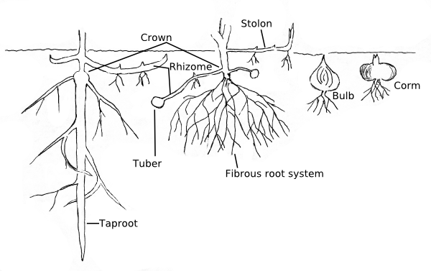

## Correlation Test

|  |  |  |  |
| --- | --- | --- | --- |
| Parameters | Parameters | correlation | P-value<0.05 |
| CN | NH4 | -0.63218 | significant |
| CN | NO3 | -0.57874 | significant |
| TotalOM | Cmin | 0.512006 | significant |
| Nmin | DG_soilTx | 0.540145 | significant |
| Bulk_Density | CN | 0.546345 | significant |
| Bulk_Density | Stability | 0.547137 | significant |
| TotalN | DG_soilTx | 0.555495 | significant |
| TotalOM | DG_soilTx | 0.557477 | significant |
| TotalN | Stone:soil | 0.560639 | significant |
| CN | Humidity | 0.609531 | significant |
| TotalOM | Stone:soil | 0.633459 | significant |
| Stability | CN | 0.679766 | significant |
| TotalN | NH4 | 0.682562 | significant |
| Stability | Humidity | 0.687913 | significant |
| Bulk_Density | Humidity | 0.7432 | significant |
| NO3 | NH4 | 0.785144 | significant |
| NO3 | F_Mechanical actions | 0.803028 | significant |
| Nmin | Nmin% | 0.811462 | significant |
| Cmin | Cmin% | 0.874626 | significant |
| TotalOM | TotalN | 0.88064 | significant |

What is the range of correlation that we should accept?

## Stability Modelling

## Call:  
## lm(formula = Stability ~ Treatment + TotalOM + Year_Stability +   
## TotalN + CN + Cmin + `Cmin%` + NO3 + NH4 + Nmin_Drysoil +   
## `Nmin%` + humidity, data = modelling)  
##   
## Residuals:  
## Min 1Q Median 3Q Max   
## -0.165015 -0.058627 0.000288 0.089717 0.172916   
##   
## Coefficients:  
## Estimate Std. Error t value Pr(>|t|)   
## (Intercept) -6.620328 3.123522 -2.120 0.045568 *   
## TreatmentD_Viti -0.029100 0.070745 -0.411 0.684804   
## TreatmentT_Viti -1.863088 0.264947 -7.032 4.69e-07 ***  
## TotalOM -4.658482 1.230037 -3.787 0.001012 **   
## Year_Stability2023 0.579011 0.143644 4.031 0.000559 ***  
## TotalN 8.741772 2.696527 3.242 0.003743 **   
## CN 0.594074 0.208214 2.853 0.009245 **   
## Cmin 0.005672 0.002081 2.726 0.012329 *   
## `Cmin%` -0.801470 0.258826 -3.097 0.005267 **   
## NO3 0.320431 0.046440 6.900 6.27e-07 ***  
## NH4 -0.155066 0.028172 -5.504 1.57e-05 ***  
## Nmin_Drysoil -0.212481 0.058811 -3.613 0.001543 **   
## `Nmin%` 1.845093 0.642266 2.873 0.008840 **   
## humidity 0.088850 0.037286 2.383 0.026240 *   
## ---  
## Signif. codes: 0 '***' 0.001 '**' 0.01 '*' 0.05 '.' 0.1 ' ' 1  
##   
## Residual standard error: 0.1231 on 22 degrees of freedom  
## Multiple R-squared: 0.9664, Adjusted R-squared: 0.9466   
## F-statistic: 48.74 on 13 and 22 DF, p-value: 3.812e-13

**Model Assumption Check**

## Shapiro-Wilk normality test  
##   
## data: modelling$res.Stb_2  
## W = 0.95928, p-value = 0.2042

*It is normal*

1. Homoscedasticity Test

##   
## studentized Breusch-Pagan test  
##   
## data: Stb_2  
## BP = 16.852, df = 13, p-value = 0.2062

It is homoscedasticity.

The model for soil stability is acceptable.

##Bulk Density Modelling

##   
## Call:  
## lm(formula = bulk ~ `Nmin%` + humidity + soiltx, data = Bulk_model)  
##   
## Residuals:  
## Min 1Q Median 3Q Max   
## -0.34961 -0.03857 0.02086 0.06759 0.22381   
##   
## Coefficients:  
## Estimate Std. Error t value Pr(>|t|)   
## (Intercept) 62.46621 20.87783 2.992 0.00530 **   
## `Nmin%` 0.15936 0.06018 2.648 0.01246 *   
## humidity 0.07366 0.00683 10.786 3.45e-12 ***  
## soiltx -6.24246 2.08940 -2.988 0.00536 **   
## ---  
## Signif. codes: 0 '***' 0.001 '**' 0.01 '*' 0.05 '.' 0.1 ' ' 1  
##   
## Residual standard error: 0.1135 on 32 degrees of freedom  
## Multiple R-squared: 0.7922, Adjusted R-squared: 0.7727   
## F-statistic: 40.65 on 3 and 32 DF, p-value: 5.025e-11

Normality  
## Shapiro-Wilk normality test  
##   
## data: Bulk_model$res.Bulk.2  
## W = 0.91244, p-value = 0.007603

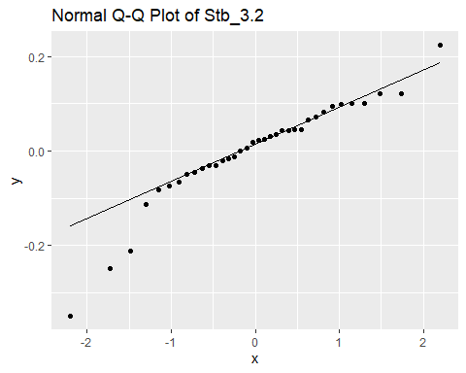

Shapiro-Wilk normality test and QQ plot have rejected the normality.

##   
## studentized Breusch-Pagan test  
##   
## data: Bulk.2  
## BP = 4.3326, df = 3, p-value = 0.2277

The Breusch-Pagan test is accept Ho. It is homoscedasticity.

The bulk density model is not formed.