SOFTWARE DEVELOPMENT LIFE CYCLE
For the development of our system, my group members and I selected the Agile Model as our Software Development Life Cycle (SDLC) methodology. We chose Agile for the following reasons:
- Our project is relatively small in size, making Agile the most suitable methodology according to our course framework.
- We are working with limited resources and budget as students, and Agile is well suited for projects with constrained resources.
- The project requires us to complete system architecture design, UI/UX prototyping in Figma, UML diagrams, GitHub integration, project planning, software licensing, and full documentation within a fixed academic timeline ending in Week 11. Agile enables us to divide the workload into manageable sprints and complete tasks systematically.
- The MediCare Clinic Queue Management System contains multiple modules that can be developed and tested independently before integration.
- Agile encourages teamwork, continuous feedback, collaboration, and shared responsibility among group members.

HOW OUR SYSTEM WILL BE DEVELOPED USING AGILE
The MediCare Clinic Queue Management System will be developed through a series of short and focused sprints. Rather than building the entire system at once, we will develop one module at a time, test it, review it as a group, and improve it before moving to the next sprint.
At the end of each sprint, a working portion of the system will be available. GitHub will be used throughout the project to manage versions, track changes, and facilitate collaboration among team members. Figma will be used to create and refine the UI/UX prototype, while project documentation will be updated continuously throughout development.
AGILE STAGES AND WHAT HAPPENS IN EACH
Planning
As a group, we identified the main problem our system aims to solve: long waiting times, inefficient queue management, overcrowding, and poor patient flow in healthcare facilities. We gathered system requirements, assigned responsibilities among team members, selected our development tools, and created a sprint schedule from Week 4 to Week 11.
Design
We designed the system architecture using a four-layer structure consisting of the Presentation Layer, Application Layer, Data Layer, and Administrative Functions. During this phase, we also created the Figma prototype containing more than ten user interface screens representing the functionality of the system.
Development
- The system was developed sprint by sprint:
- Sprint 1: User Authentication and Patient Registration
- Sprint 2: Queue Management and Queue Ticket
- Sprint 3: Appointment Booking and Notifications
- Sprint 4: Reports, Analytics, and Administrative Functions

At the end of each sprint, the completed features were reviewed and evaluated before progressing to the next stage.
Testing
Testing was carried out continuously after each sprint. Every module was tested to ensure proper functionality. Bugs and errors were identified and corrected immediately, and improvements were incorporated into subsequent sprints.
Deployment
All project deliverables, including the project report, Figma prototype, UML diagrams, database scripts, and source code, were uploaded to GitHub. GitHub served as both the collaboration platform and the final project repository.
Maintenance
Although the MediCare Clinic Queue Management System is currently a prototype, future enhancements have been identified. These include SMS notifications, multi-clinic support, online appointment booking, cloud database integration, and real-time queue tracking. These improvements would be implemented in future Agile sprints.

SYSTEM ARCHITECTURE DESIGN
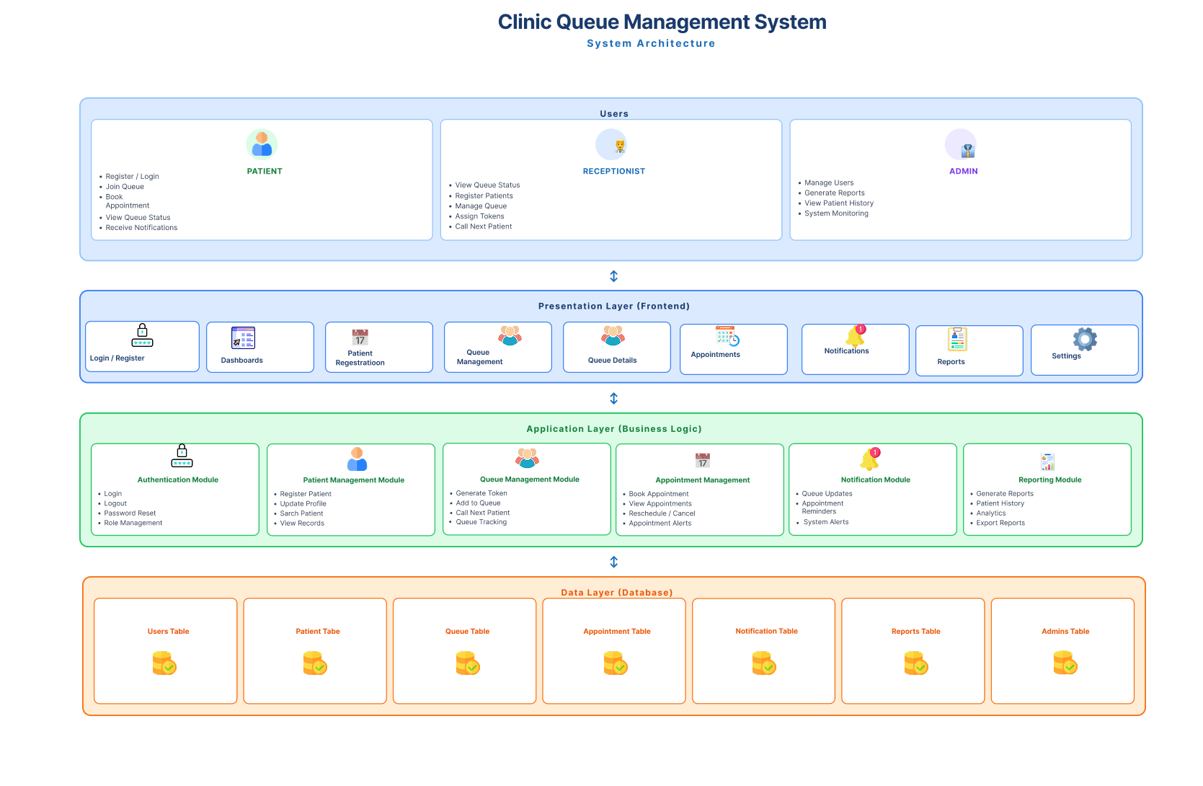
The MediCare Clinic Queue Management System is based on a four-layer architecture.
When patients arrive at the clinic, they interact with the User Interface through screens such as Login, Patient Registration, Appointment Booking, Queue Management, and Queue Tracking. The information entered by users is sent to the Application Layer, which acts as the core processing unit of the system.
The Application Layer handles all business logic, including patient registration, token generation, queue prioritization, appointment scheduling, notification management, and report generation.
After processing, data is stored in the Database Layer, which securely maintains patient records, queue information, appointments, user accounts, and notification logs. This eliminates dependence on paper-based systems and improves information accessibility.
Clinic administrators and receptionists interact with the system through the Administrative Functions module. Through this interface, staff can monitor queues, update patient statuses, manage appointments, generate reports, and oversee system activities.
Together, the Presentation Layer, Application Layer, Data Layer, and Administrative Functions work seamlessly to ensure efficient patient flow, reduced waiting times, and improved service delivery.
PROTOTYPE DEVELOPMENT

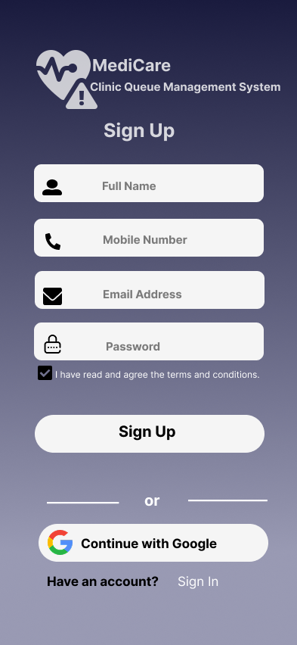
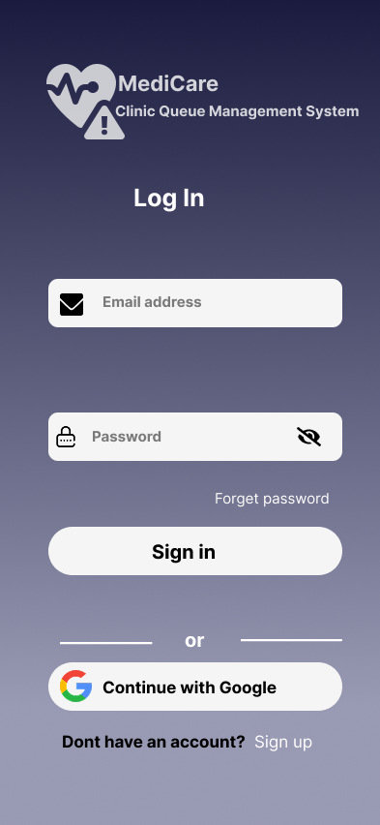
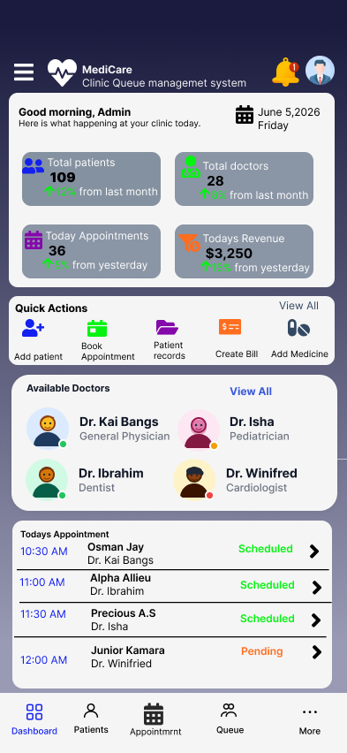

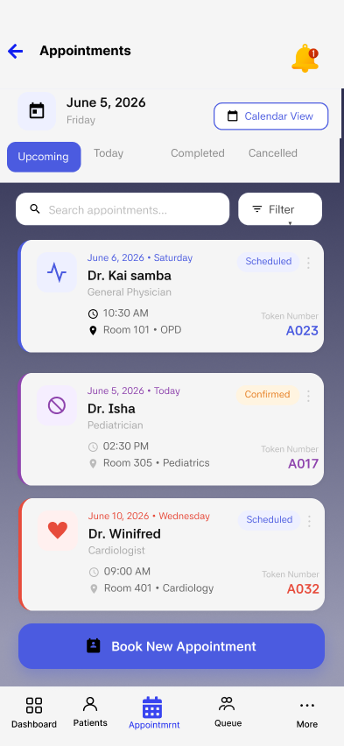
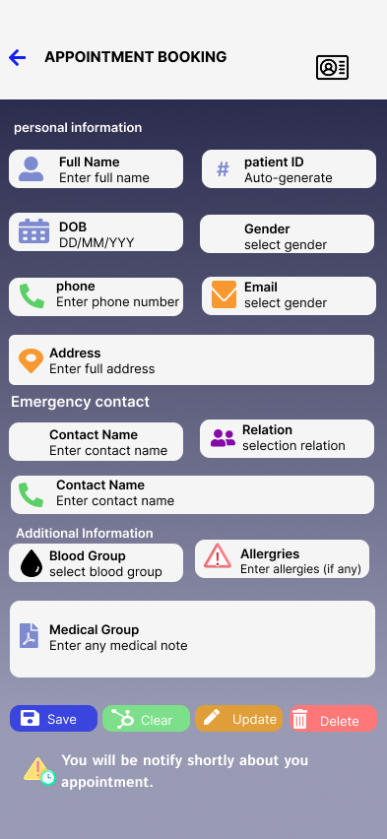

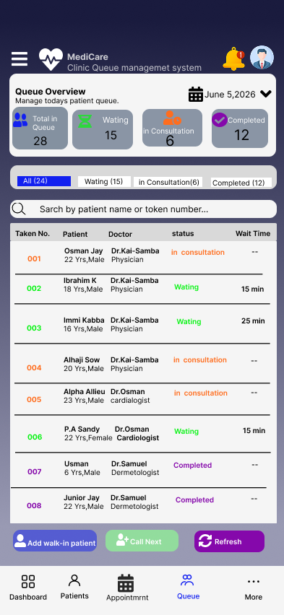
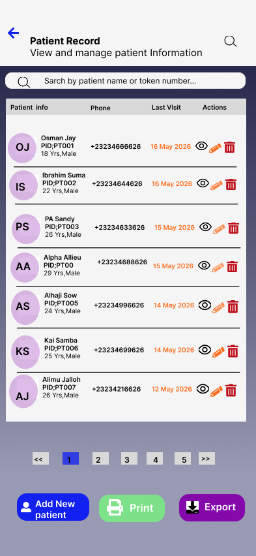

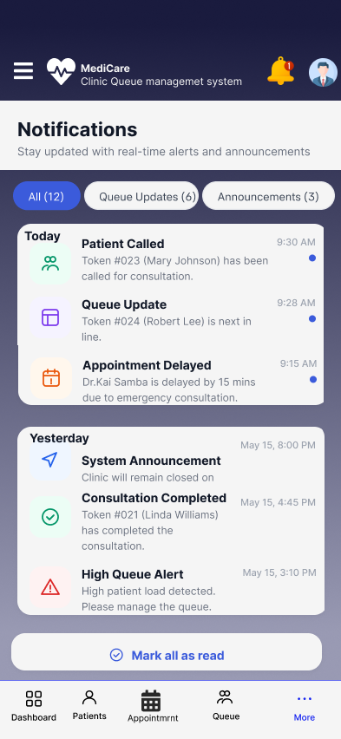
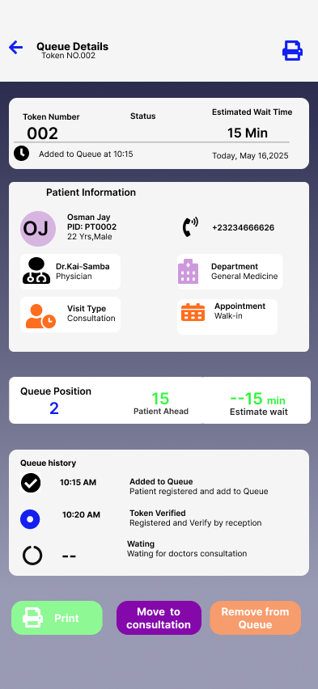

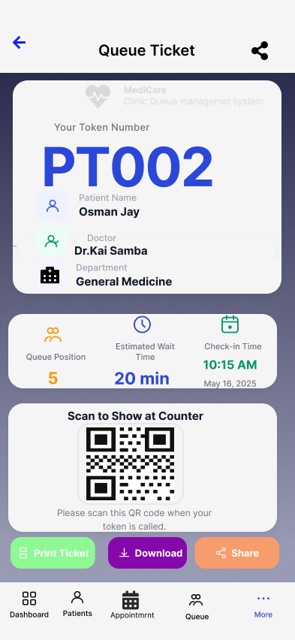
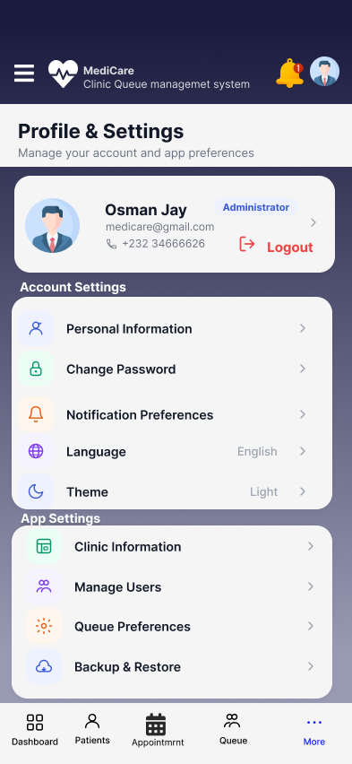

SCREENSHOTS OF GITHUB
Screenshots of the GitHub repository used for project collaboration, version control, and documentation are presented below.
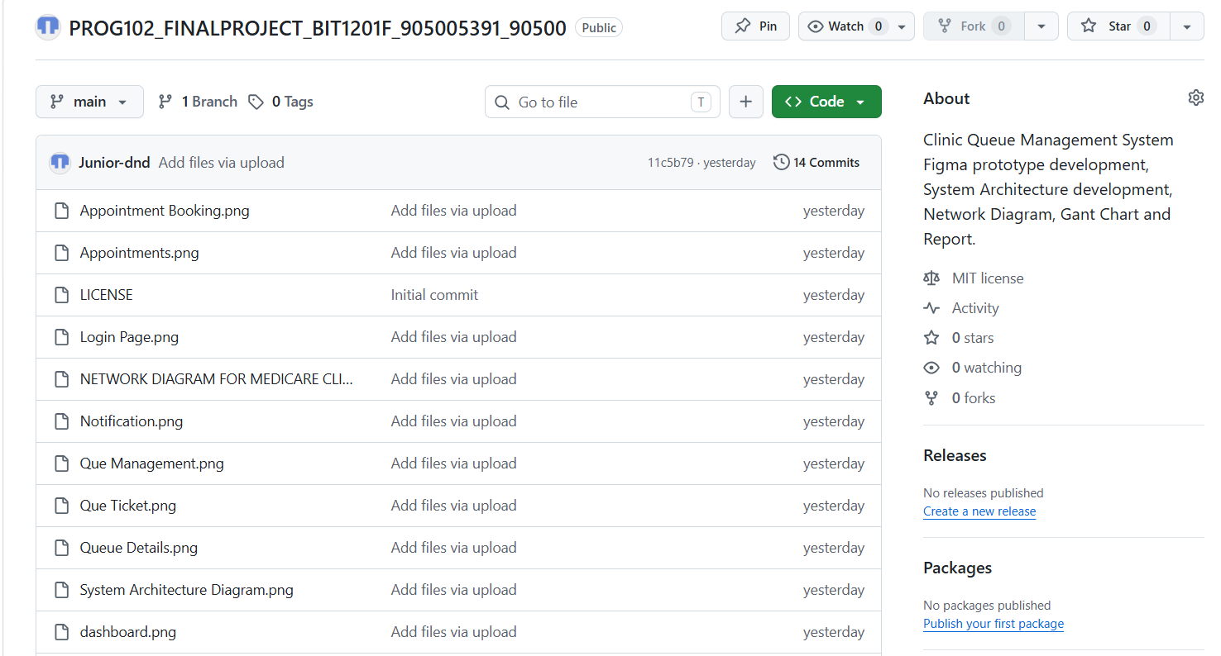

PROJECT PLAN
Below is the project plan for our MediCare Clinic Queue Management System**:
1. Planning and Research
2.Assembleing Requirements
3. System Architecture Design
4. Figma Prototype Development
5. GitHub & Documentation
6. Testing and Correction
7. Final Report and Submission
Below is the Activity chart for the project plan above:
CODE | Tasks | Duration [Days/ Week] | Dependencies
1 | Planning & Research | 6 days (Week 4) | none
2 | Assembling Requirements | 6 days (Week 5) | 1
3 | System Architecture Design | 12 days (Week 6&7) | 1&2
4 | Figma Prototype Development | 24 days (Week 7-10) | 2&3
5 | GitHub & Documentation | 18 days (Week 9-11) | 3&4
6 | Testing & Correction | 18 days (Week 8-10) | 4
7 | Final Report & Submission | 6 days (Week 11) | 3,4,5,6
T1(ES:0,EF:6)
T2(ES:6,EF:12)
T3(ES:12,EF:24)
T4(ES:24,EF:48)
T5(ES:48,EF:66)
T6(ES:48,EF:66)
T7(ES:66,EF:72)
LICENSE, DESIGN QUALITY & SDG RELEVANCE
Software License
My group members and I have chosen to release the MediCare Clinic Queue Management System under the MIT License.
We selected this license because it is simple, open-source, and encourages adoption by healthcare organizations, clinics, NGOs, and developers. The MIT License permits users to freely use, modify, and distribute the system while retaining the original copyright notice.
Unlike restrictive licenses, MIT promotes innovation and allows the system to be customized according to the needs of different healthcare institutions. The license file is included in our GitHub repository as LICENSE.txt.

DESIGN QUALITY (UI/UX)
My group members and I designed the MediCare Clinic Queue Management System with simplicity, accessibility, and usability as our primary goals.
A consistent blue and white color scheme was used throughout the application to create a professional healthcare-oriented appearance. Every screen contains clear titles, intuitive navigation, and well-organized layouts.
Buttons are clearly labeled and easily identifiable, enabling users to interact with the system efficiently. Information is presented in a structured manner to reduce confusion and improve user experience.
The interface was designed to accommodate users with varying levels of digital literacy, ensuring that both patients and clinic staff can use the system with minimal training.

SDG RELEVANCE – SDG 3: GOOD HEALTH AND WELL-BEING
The MediCare Clinic Queue Management System directly supports Sustainable Development Goal 3: Good Health and Well-Being.
Healthcare facilities often experience overcrowding, long waiting times, inefficient patient flow, and poor queue management. These challenges negatively affect the quality and accessibility of healthcare services.
Our system addresses these issues by introducing digital queue management, appointment scheduling, patient registration, and real-time queue tracking. By reducing waiting times and improving clinic organization, patients receive medical attention more efficiently.
The system also minimizes administrative delays, improves patient satisfaction, and enhances the overall quality of healthcare delivery.
Through these features, the MediCare Clinic Queue Management System contributes to the achievement of SDG 3 by promoting efficient, accessible, and patient-centered healthcare services.

