import java.util.ArrayList;
import java.util.List;
public abstract class Animal {
public abstract void makeSound();
public abstract boolean canFly();
}
class Dog extends Animal{
@Override
public void makeSound(){
System.out.println("Woof");
}
@Override
public boolean canFly(){
return false;
}
}
class Cat extends Animal{
@Override
public void makeSound(){
System.out.println("Meow");
}
@Override
public boolean canFly() {
return false;
}
}
class Bird extends Animal{
@Override
public void makeSound(){
System.out.println("Tweet");
}
@Override
public boolean canFly(){
return true;
}
}
class Zoo {
private final List<Animal> animals;
public Zoo() {
animals = new ArrayList<>();
}
public void addAnimal(Animal animal){
animals.add(animal);
}
public void displaySounds(){
System.out.println("animal Sounds:");
for (Animal animal : animals){
animal.makeSound();
}
}
public void displayFlyers(){
System.out.println("Animals that fly");
for (Animal animal : animals){
if (animal.canFly()){
System.out.println(animal.getClass().getSimpleName());
}
}
}
}

public class ZooApp {
public static void main(String[] args){
Animal dog = new Dog();
Animal cat = new Cat();
Animal bird = new Bird();
Zoo zoo = new Zoo();
zoo.addAnimal(dog);
zoo.addAnimal(cat);
zoo.addAnimal(bird);
zoo.displaySounds();
zoo.displayFlyers();
}
}
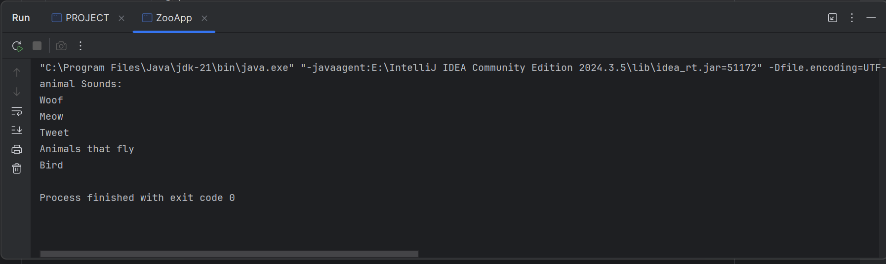

abstract class PaymentMethod {
public abstract void processPayment(double amount);
}
class CreditCard extends PaymentMethod {
@Override
public void processPayment(double amount){
System.out.println("Processing $" +amount+ "payment through the credit card");
}
}
class PayPal extends PaymentMethod {
@Override
public void processPayment(double amount){
System.out.println("Processing $" +amount+ "payment through PayPal");
}
}
class BankTransfer extends PaymentMethod {
@Override
public void processPayment(double amount){
System.out.println("Processing $" +amount+ "payment through bank transfer");
}
}
class PaymentProcessor {
public void process(PaymentMethod paymentMethod, double amount){
paymentMethod.processPayment(amount);
}
}

public class A {
public static void main(String[] args){
PaymentMethod creditCard = new CreditCard();
PaymentMethod payPal = new PayPal();
PaymentMethod bankTransfer = new BankTransfer();
PaymentProcessor processor = new PaymentProcessor();
processor.process(creditCard,100.50);
processor.process(payPal,100.50);
processor.process(bankTransfer,100.50);
}
}
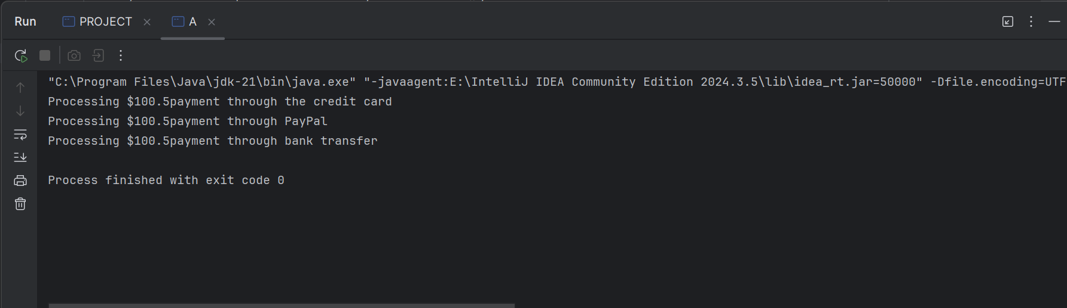

import java.util.ArrayList;
import java.util.List;
abstract class Vehicle {
protected double fuelCapacity;
public Vehicle(double fuelCapacity) {
this.fuelCapacity = fuelCapacity;
}
public abstract double calculateRange();
}
class Car extends Vehicle {
public Car(double fuelCapacity){
super(fuelCapacity);
}
@Override
public double calculateRange(){
return fuelCapacity*10;
}
}
class Truck extends Vehicle {
public Truck(double fuelCapacity){
super(fuelCapacity);
}
@Override
public double calculateRange(){
return fuelCapacity*5;
}
}
class Motorcycle extends Vehicle {
public Motorcycle(double fuelCapacity){
super(fuelCapacity);
}
@Override
public double calculateRange(){
return fuelCapacity*15;
}
}
class Logistics {
private final List<Vehicle> vehicles;
public Logistics(){
this.vehicles = new ArrayList<>();
}
public void addVehicle(Vehicle vehicle){
vehicles.add(vehicle);
}
public void displayRanges(){
System.out.println("Vehicle Range:");
for (Vehicle vehicle : vehicles){
System.out.println(vehicle.getClass().getSimpleName() + "Range" + vehicle.calculateRange() + "km");
}
}
}
public class B {
public static void main(String[] args) {
Vehicle car = new Car(50);
Vehicle truck = new Truck(100);
Vehicle motorcycle = new Motorcycle(20);
Logistics logistics = new Logistics();
logistics.addVehicle(car);
logistics.addVehicle(truck);
logistics.addVehicle(motorcycle);
logistics.displayRanges();
}
}

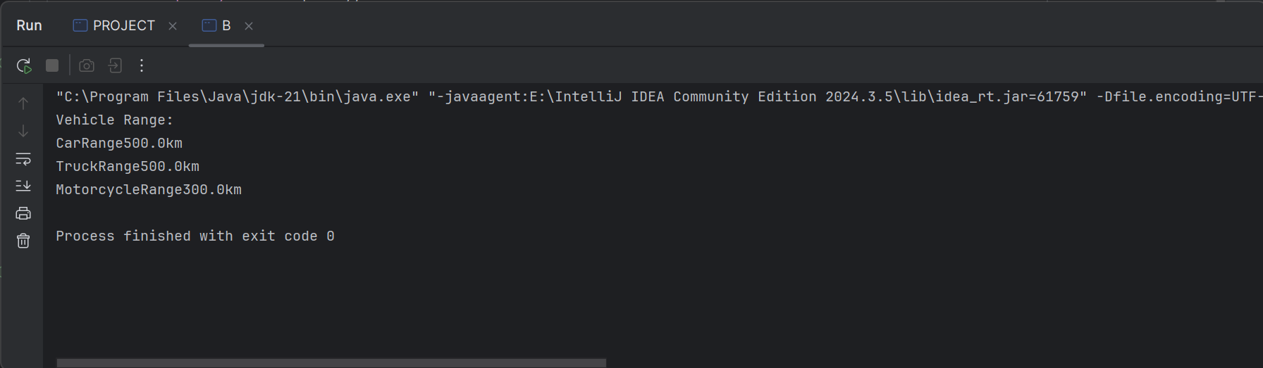
// Payment interface
interface Payment
{
void processPayment(double amount);
}
// Credit Card Payment class
record CreditCardPayment(String cardNumber, String cvv) implements Payment {
// Constructor
@Override
public void processPayment(double amount) {
System.out.println("Processing credit card payment of $" + amount);
}
}
// Debit Card Payment class
record DebitCardPayment(String cardNumber, String pin) implements Payment {
// Constructor
@Override
public void processPayment(double amount) {
System.out.println("Processing debit card payment of $" + amount);
}
}
// Digital Wallet Payment class
record DigitalWalletPayment(String walletId, String password) implements Payment {
// Constructor
@Override
public void processPayment(double amount) {
System.out.println("Processing digital wallet payment of $" + amount);
}
}
// Payment Processor class
class Payment_Processor
{
public void process(Payment payment, double amount)
{
payment.processPayment(amount);
}
}
// Main class
public class D
{
public static void main(String[] args)
{
// Create payment methods
Payment creditCard = new CreditCardPayment("1234567890123456", "123");
Payment debitCard = new DebitCardPayment("9876543210987654", "4567");
Payment digitalWallet = new DigitalWalletPayment("wallet123", "password");
// Create payment processor
Payment_Processor processor = new Payment_Processor();
// Process payments
processor.process(creditCard, 100.50);
processor.process(debitCard, 200.75);
processor.process(digitalWallet, 300.00);
}
}

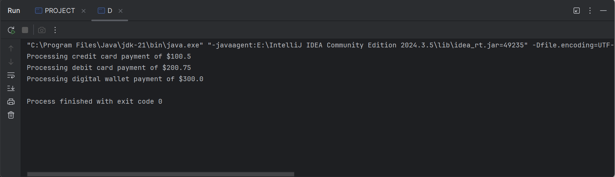

// Custom exception class
class BookingException extends Exception {
public BookingException(String message) {
super(message);
}
}
public class FlightBookingSystem {
public static void main(String[] args) {
int availableSeats = 5; // Example available seats
// Simulate user inputs
int[] requestedSeatsList = {3, 0, 6, 2};
for (int requestedSeats : requestedSeatsList) {
System.out.println("Trying to book " + requestedSeats + " seats...");
try {
bookSeats(availableSeats, requestedSeats);
availableSeats -= requestedSeats;
System.out.println("Seats booked successfully. Remaining seats: " + availableSeats);
} catch (RuntimeException e) {
System.out.println("Error: " + e.getMessage());
} catch (BookingException e) {
System.out.println("Error: " + e.getMessage());
break; // No more bookings allowed as the flight is fully booked
} finally {
System.out.println("Booking attempt finished.\n");
}
}
}
public static void bookSeats(int availableSeats, int requestedSeats) throws BookingException {
if (requestedSeats <= 0) {
throw new IllegalArgumentException("Requested seats must be greater than 0.");
}
if (availableSeats == 0) {
throw new BookingException("Flight is fully booked.");
}
if (requestedSeats > availableSeats) {
throw new RuntimeException("Not enough seats available.");
}
}
}

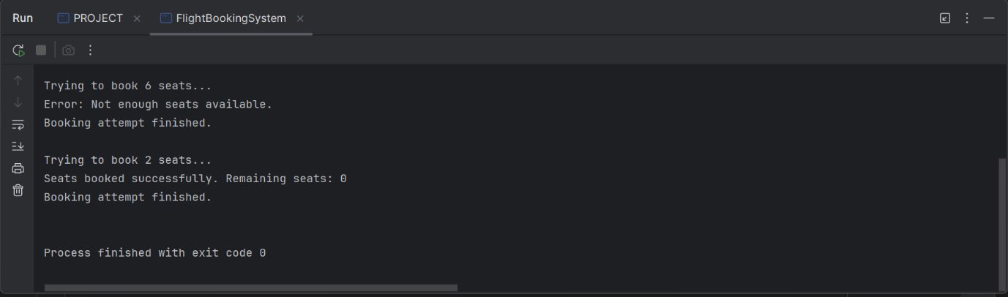

import java.util.Scanner;
public class FundTransfer
{
public static void main(String[] args)
{
Scanner scanner = new Scanner(System.in);
try
{
// Input: Sender's account balance
System.out.print("Enter sender's account balance: ");
double accountBalance = scanner.nextDouble();
// Input: Transfer amount
System.out.print("Enter transfer amount: ");
double transferAmount = scanner.nextDouble();
// Perform the transfer
double updatedBalance = transferFunds(accountBalance, transferAmount);
// If no exceptions are thrown, display the updated balance
System.out.println("Transfer successful! Updated balance: $" + updatedBalance);
}
catch (IllegalArgumentException | ArithmeticException | SecurityException e)
{
System.out.println("Error: " + e.getMessage());
}
finally
{
System.out.println("Transaction process completed.");
}
scanner.close();
}
/**
* Method to handle fund transfer logic.
*
* @param accountBalance The sender's current account balance.
* @param transferAmount The amount to transfer.
* @return The updated account balance after a successful transfer.
* @throws IllegalArgumentException if the transfer amount is not positive.
* @throws ArithmeticException if the account balance is insufficient.
* @throws SecurityException if the transfer amount exceeds the limit.
*/
public static double transferFunds(double accountBalance, double transferAmount)
{
// Check if the transfer amount is positive
if (transferAmount <= 0)
{
throw new IllegalArgumentException("Transfer amount must be greater than zero.");
}
// Check if the transfer amount exceeds the account balance
if (transferAmount > accountBalance)
{
throw new ArithmeticException("Insufficient balance for the transfer.");
}
// Check if the transfer amount exceeds $10,000
if (transferAmount > 10000)
{
throw new SecurityException("Transfer amount exceeds the maximum limit of $10,000.");
}
// Deduct the transfer amount from the account balance
return accountBalance - transferAmount;
}
}

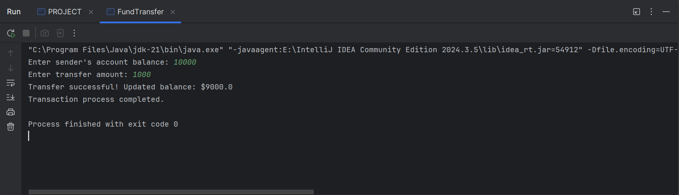

import javax.swing.*;
import javax.swing.table.DefaultTableModel;
import java.awt.*;
import java.awt.event.*;
import java.sql.*;
import java.util.regex.*;
public class StudentRegistration {
private static final String DB_URL = "jdbc:mysql://DESKTOP-D02Q457\\EXPRESS";
private static final String DB_USER = "root";
private static final String DB_PASSWORD = "Junior2!2!";
public static void main(String[] args) {
SwingUtilities.invokeLater(() -> new StudentRegistration().createAndShowGUI());
}
private void createAndShowGUI() {
JFrame frame = new JFrame("Student Registration");
frame.setDefaultCloseOperation(JFrame.EXIT_ON_CLOSE);
frame.setSize(600, 500);
JPanel panel = new JPanel(new GridLayout(6, 2, 10, 10));
JTextField nameField = new JTextField();
JTextField ageField = new JTextField();
JTextField emailField = new JTextField();
JComboBox<String> courseBox = new JComboBox<>(new String[]{"Computer Science", "Mathematics", "Physics"});
JButton registerButton = new JButton("Register");
JButton showButton = new JButton("Show Students");
panel.add(new JLabel("Name:"));
panel.add(nameField);
panel.add(new JLabel("Age:"));
panel.add(ageField);
panel.add(new JLabel("Email:"));
panel.add(emailField);
panel.add(new JLabel("Course:"));
panel.add(courseBox);
panel.add(registerButton);
panel.add(showButton);
JTable table = new JTable(new DefaultTableModel(new String[]{"ID", "Name", "Age", "Course", "Email"}, 0));
JScrollPane tableScroll = new JScrollPane(table);
frame.setLayout(new BorderLayout());
frame.add(panel, BorderLayout.NORTH);
frame.add(tableScroll, BorderLayout.CENTER);
frame.setVisible(true);
registerButton.addActionListener(e -> {
String name = nameField.getText().trim();
String ageText = ageField.getText().trim();
String email = emailField.getText().trim();
String course = courseBox.getSelectedItem().toString();
if (name.isEmpty() || ageText.isEmpty() || email.isEmpty()) {
JOptionPane.showMessageDialog(frame, "All fields must be filled!", "Validation Error", JOptionPane.ERROR_MESSAGE);
return;
}
int age;
try {
age = Integer.parseInt(ageText);
if (age < 0) throw new NumberFormatException();
} catch (NumberFormatException ex) {
JOptionPane.showMessageDialog(frame, "Age must be a valid non-negative number!", "Validation Error", JOptionPane.ERROR_MESSAGE);
return;
}
if (!isValidEmail(email)) {
JOptionPane.showMessageDialog(frame, "Invalid email format!", "Validation Error", JOptionPane.ERROR_MESSAGE);
return;
}
try (Connection conn = connectToDatabase()) {
String sql = "INSERT INTO students(name, age, course, email) VALUES (?, ?, ?, ?)";
PreparedStatement stmt = conn.prepareStatement(sql);
stmt.setString(1, name);
stmt.setInt(2, age);
stmt.setString(3, course);
stmt.setString(4, email);
stmt.executeUpdate();
JOptionPane.showMessageDialog(frame, "Student registered successfully!");
nameField.setText("");
ageField.setText("");
emailField.setText("");
} catch (SQLException ex) {
JOptionPane.showMessageDialog(frame, "Error saving student: " + ex.getMessage(), "Database Error", JOptionPane.ERROR_MESSAGE);
}
});
showButton.addActionListener(e -> {
DefaultTableModel model = (DefaultTableModel) table.getModel();
model.setRowCount(0); // Clear existing data
try (Connection conn = connectToDatabase();
Statement stmt = conn.createStatement();
ResultSet rs = stmt.executeQuery("SELECT * FROM students")) {
while (rs.next()) {
int id = rs.getInt("id");
String name = rs.getString("name");
int age = rs.getInt("age");
String course = rs.getString("course");
String email = rs.getString("email");
model.addRow(new Object[]{id, name, age, course, email});
}
} catch (SQLException ex) {
JOptionPane.showMessageDialog(frame, "Error retrieving students: " + ex.getMessage(), "Database Error", JOptionPane.ERROR_MESSAGE);
}
});
}
private static Connection connectToDatabase() throws SQLException {
return DriverManager.getConnection(DB_URL, DB_USER, DB_PASSWORD);
}
private static boolean isValidEmail(String email) {
String regex = "^[\\w.-]+@[\\w.-]+\\.\\w{2,}$";
return Pattern.matches(regex, email);
}
}
create database sch_form;
use sch_form;

CREATE TABLE students (
id INT PRIMARY KEY ,
name VARCHAR(100),
age INT,
course VARCHAR(100),
email VARCHAR(100)

);

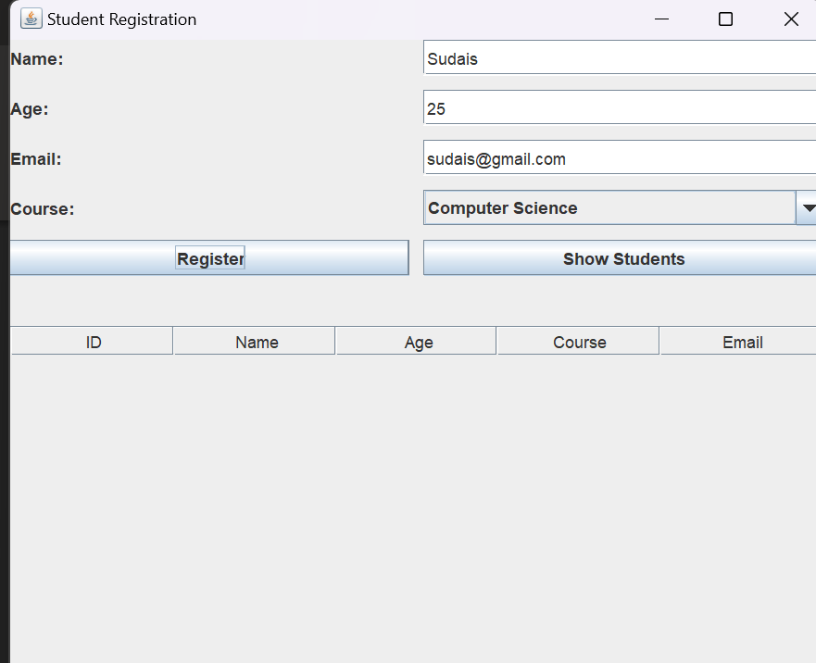

import javax.swing.*;
import javax.swing.table.DefaultTableModel;
import java.awt.*;
import java.sql.*;
import java.text.SimpleDateFormat;
import java.util.Date;
import java.util.regex.Pattern;
public class HotelReservation {
private static final String DB_URL = "jdbc:mysql://localhost:3306/hoteldb";
private static final String DB_USER = "root";
private static final String DB_PASSWORD = "password";
private DefaultTableModel tableModel;
public static void main(String[] args) {
SwingUtilities.invokeLater(() -> new HotelReservation().createAndShowGUI());
}
private void createAndShowGUI() {
JFrame frame = new JFrame("Hotel Reservation");
frame.setDefaultCloseOperation(JFrame.EXIT_ON_CLOSE);
frame.setSize(700, 600);
JPanel formPanel = new JPanel(new GridLayout(7, 2, 10, 10));
JTextField nameField = new JTextField();
JTextField emailField = new JTextField();
JTextField guestsField = new JTextField();
JComboBox<String> roomTypeBox = new JComboBox<>(new String[]{"Single", "Double", "Suite"});
JSpinner checkInSpinner = new JSpinner(new SpinnerDateModel());
checkInSpinner.setEditor(new JSpinner.DateEditor(checkInSpinner, "yyyy-MM-dd"));
JSpinner checkOutSpinner = new JSpinner(new SpinnerDateModel());
checkOutSpinner.setEditor(new JSpinner.DateEditor(checkOutSpinner, "yyyy-MM-dd"));
JButton reserveButton = new JButton("Make Reservation");
JButton showButton = new JButton("Show Reservations");
formPanel.add(new JLabel("Guest Name:"));
formPanel.add(nameField);
formPanel.add(new JLabel("Email:"));
formPanel.add(emailField);
formPanel.add(new JLabel("Number of Guests:"));
formPanel.add(guestsField);
formPanel.add(new JLabel("Room Type:"));
formPanel.add(roomTypeBox);
formPanel.add(new JLabel("Check-in Date:"));
formPanel.add(checkInSpinner);
formPanel.add(new JLabel("Check-out Date:"));
formPanel.add(checkOutSpinner);
formPanel.add(reserveButton);
formPanel.add(showButton);
frame.add(formPanel, BorderLayout.NORTH);
tableModel = new DefaultTableModel(new String[]{"ID", "Guest Name", "Email", "Room Type", "Guests", "Check-in", "Check-out"}, 0);
JTable table = new JTable(tableModel);
frame.add(new JScrollPane(table), BorderLayout.CENTER);
frame.setVisible(true);
reserveButton.addActionListener(e -> {
String guestName = nameField.getText().trim();
String email = emailField.getText().trim();
String guestsStr = guestsField.getText().trim();
String roomType = (String) roomTypeBox.getSelectedItem();
Date checkInDate = (Date) checkInSpinner.getValue();
Date checkOutDate = (Date) checkOutSpinner.getValue();
if (guestName.isEmpty() || email.isEmpty() || guestsStr.isEmpty()) {
JOptionPane.showMessageDialog(frame, "Please fill all fields.", "Validation Error", JOptionPane.ERROR_MESSAGE);
return;
}
if (!isValidEmail(email)) {
JOptionPane.showMessageDialog(frame, "Please enter a valid email.", "Validation Error", JOptionPane.ERROR_MESSAGE);
return;
}
int numberOfGuests;
try {
numberOfGuests = Integer.parseInt(guestsStr);
if (numberOfGuests <= 0) {
JOptionPane.showMessageDialog(frame, "Number of guests must be greater than zero.", "Validation Error", JOptionPane.ERROR_MESSAGE);
return;
}
} catch (NumberFormatException ex) {
JOptionPane.showMessageDialog(frame, "Number of guests must be a valid integer.", "Validation Error", JOptionPane.ERROR_MESSAGE);
return;
}
if (!checkOutDate.after(checkInDate)) {
JOptionPane.showMessageDialog(frame, "Check-out date must be after check-in date.", "Validation Error", JOptionPane.ERROR_MESSAGE);
return;
}
if (saveReservation(guestName, email, roomType, numberOfGuests, checkInDate, checkOutDate)) {
JOptionPane.showMessageDialog(frame, "Reservation made successfully!");
nameField.setText("");
emailField.setText("");
guestsField.setText("");
}
});
showButton.addActionListener(e -> {
loadReservations();
});
}
private boolean isValidEmail(String email) {
// Simple email pattern check
String emailRegex = "^[\\w-.]+@[\\w-]+\\.[a-z]{2,}$";
return Pattern.compile(emailRegex, Pattern.CASE_INSENSITIVE).matcher(email).matches();
}
private Connection connectToDatabase() {
try {
return DriverManager.getConnection(DB_URL, DB_USER, DB_PASSWORD);
} catch (SQLException e) {
JOptionPane.showMessageDialog(null, "Database connection failed: " + e.getMessage(), "DB Error", JOptionPane.ERROR_MESSAGE);
return null;
}
}
private boolean saveReservation(String guestName, String email, String roomType, int numberOfGuests, Date checkIn, Date checkOut) {
String sql = "INSERT INTO reservations (guest_name, email, room_type, number_of_guests, check_in_date, check_out_date) VALUES (?, ?, ?, ?, ?, ?)";
try (Connection conn = connectToDatabase(); PreparedStatement pstmt = conn.prepareStatement(sql)) {
if (conn == null) return false;
pstmt.setString(1, guestName);
pstmt.setString(2, email);
pstmt.setString(3, roomType);
pstmt.setInt(4, numberOfGuests);
pstmt.setDate(5, new java.sql.Date(checkIn.getTime()));
pstmt.setDate(6, new java.sql.Date(checkOut.getTime()));
pstmt.executeUpdate();
return true;
} catch (SQLException e) {
JOptionPane.showMessageDialog(null, "Error saving reservation: " + e.getMessage(), "DB Error", JOptionPane.ERROR_MESSAGE);
return false;
}
}
private void loadReservations() {
String sql = "SELECT * FROM reservations";
tableModel.setRowCount(0); // Clear existing data
try (Connection conn = connectToDatabase(); Statement stmt = conn.createStatement(); ResultSet rs = stmt.executeQuery(sql)) {
if (conn == null) return;
SimpleDateFormat sdf = new SimpleDateFormat("yyyy-MM-dd");
while (rs.next()) {
int id = rs.getInt("id");
String guestName = rs.getString("guest_name");
String email = rs.getString("email");
String roomType = rs.getString("room_type");
int guests = rs.getInt("number_of_guests");
String checkIn = sdf.format(rs.getDate("check_in_date"));
String checkOut = sdf.format(rs.getDate("check_out_date"));
tableModel.addRow(new Object[]{id, guestName, email, roomType, guests, checkIn, checkOut});
}
} catch (SQLException e) {
JOptionPane.showMessageDialog(null, "Error loading reservations: " + e.getMessage(), "DB Error", JOptionPane.ERROR_MESSAGE);
}
}
}

CREATE TABLE reservations (
id INT PRIMARY KEY AUTO_INCREMENT,
guest_name VARCHAR(255),
email VARCHAR(255),
room_type VARCHAR(50),
number_of_guests INT,
check_in_date DATE,
check_out_date DATE
);
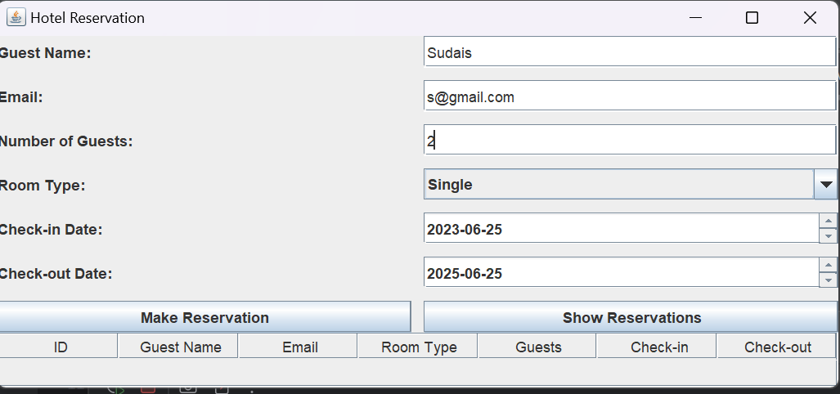

import javax.swing.*;
import javax.swing.table.DefaultTableModel;
import java.awt.*;
import java.awt.event.ActionEvent;
import java.awt.event.ActionListener;
import java.sql.*;
public class PayrollSystem {
private static final String DB_URL = "jdbc:sqlserver://localhost:1433;databaseName=PayrollDB";
private static final String DB_USER = "your_username";
private static final String DB_PASSWORD = "your_password";
private DefaultTableModel tableModel;
public static void main(String[] args) {
SwingUtilities.invokeLater(() -> new PayrollSystem().createAndShowGUI());
}
private void createAndShowGUI() {
JFrame frame = new JFrame("Payroll Management System");
frame.setDefaultCloseOperation(JFrame.EXIT_ON_CLOSE);
frame.setSize(700, 600);
JPanel formPanel = new JPanel(new GridLayout(6, 2, 10, 10));
JTextField empIDField = new JTextField();
JTextField empNameField = new JTextField();
JTextField basicSalaryField = new JTextField();
JTextField allowancesField = new JTextField();
JTextField deductionsField = new JTextField();
JButton saveButton = new JButton("Save Payroll");
JButton viewButton = new JButton("View Payroll");
formPanel.add(new JLabel("Employee ID:"));
formPanel.add(empIDField);
formPanel.add(new JLabel("Employee Name:"));
formPanel.add(empNameField);
formPanel.add(new JLabel("Basic Salary:"));
formPanel.add(basicSalaryField);
formPanel.add(new JLabel("Allowances:"));
formPanel.add(allowancesField);
formPanel.add(new JLabel("Deductions:"));
formPanel.add(deductionsField);
formPanel.add(saveButton);
formPanel.add(viewButton);
frame.add(formPanel, BorderLayout.NORTH);
tableModel = new DefaultTableModel(new String[]{"ID", "Employee ID", "Name", "Basic Salary", "Allowances", "Deductions", "Net Pay"}, 0);
JTable table = new JTable(tableModel);
frame.add(new JScrollPane(table), BorderLayout.CENTER);
frame.setVisible(true);
saveButton.addActionListener(e -> {
String empID = empIDField.getText().trim();
String empName = empNameField.getText().trim();
String basicSalaryStr = basicSalaryField.getText().trim();
String allowancesStr = allowancesField.getText().trim();
String deductionsStr = deductionsField.getText().trim();
if(empID.isEmpty() || empName.isEmpty() || basicSalaryStr.isEmpty() || allowancesStr.isEmpty() || deductionsStr.isEmpty()) {
JOptionPane.showMessageDialog(frame, "All fields must be filled.", "Input Error", JOptionPane.ERROR_MESSAGE);
return;
}
double basicSalary, allowances, deductions;
try {
basicSalary = Double.parseDouble(basicSalaryStr);
allowances = Double.parseDouble(allowancesStr);
deductions = Double.parseDouble(deductionsStr);
} catch (NumberFormatException ex) {
JOptionPane.showMessageDialog(frame, "Salary, Allowances, and Deductions must be valid numbers.", "Input Error", JOptionPane.ERROR_MESSAGE);
return;
}
double netPay = basicSalary + allowances - deductions;
if (savePayrollRecord(empID, empName, basicSalary, allowances, deductions, netPay)) {
JOptionPane.showMessageDialog(frame, "Payroll record saved successfully!");
empIDField.setText("");
empNameField.setText("");
basicSalaryField.setText("");
allowancesField.setText("");
deductionsField.setText("");
}
});
viewButton.addActionListener(e -> loadPayrollRecords());
}
private Connection connectToDatabase() {
try {
return DriverManager.getConnection(DB_URL, DB_USER, DB_PASSWORD);
} catch (SQLException e) {
JOptionPane.showMessageDialog(null, "Database connection failed: " + e.getMessage(), "DB Error", JOptionPane.ERROR_MESSAGE);
return null;
}
}
private boolean savePayrollRecord(String empID, String empName, double basicSalary, double allowances, double deductions, double netPay) {
String sql = "INSERT INTO Payroll (employee_id, employee_name, basic_salary, allowances, deductions, net_pay) VALUES (?, ?, ?, ?, ?, ?)";
try (Connection conn = connectToDatabase(); PreparedStatement pstmt = conn.prepareStatement(sql)) {
if (conn == null) return false;
pstmt.setString(1, empID);
pstmt.setString(2, empName);
pstmt.setDouble(3, basicSalary);
pstmt.setDouble(4, allowances);
pstmt.setDouble(5, deductions);
pstmt.setDouble(6, netPay);
pstmt.executeUpdate();
return true;
} catch (SQLException e) {
JOptionPane.showMessageDialog(null, "Error saving payroll record: " + e.getMessage(), "DB Error", JOptionPane.ERROR_MESSAGE);
return false;
}
}
private void loadPayrollRecords() {
String sql = "SELECT * FROM Payroll";
tableModel.setRowCount(0); // Clear existing rows
try (Connection conn = connectToDatabase(); Statement stmt = conn.createStatement(); ResultSet rs = stmt.executeQuery(sql)) {
if (conn == null) return;
while (rs.next()) {
int id = rs.getInt("id");
String employeeID = rs.getString("employee_id");
String employeeName = rs.getString("employee_name");
double basicSalary = rs.getDouble("basic_salary");
double allowances = rs.getDouble("allowances");
double deductions = rs.getDouble("deductions");
double netPay = rs.getDouble("net_pay");
tableModel.addRow(new Object[]{id, employeeID, employeeName, basicSalary, allowances, deductions, netPay});
}
} catch (SQLException e) {
JOptionPane.showMessageDialog(null, "Error loading payroll records: " + e.getMessage(), "DB Error", JOptionPane.ERROR_MESSAGE);
}
}
}
CREATE TABLE Payroll (
id INT PRIMARY KEY IDENTITY(1,1),
employee_id VARCHAR(50),
employee_name VARCHAR(255),
basic_salary FLOAT,
allowances FLOAT,
deductions FLOAT,
net_pay FLOAT
);
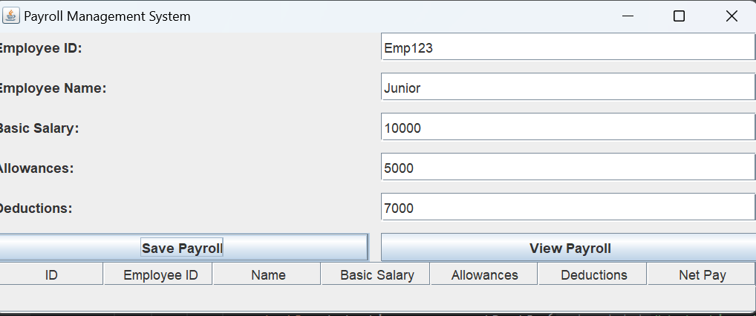
import javax.swing.*;
import javax.swing.table.DefaultTableModel;
import java.awt.*;
import java.awt.event.*;
import java.sql.*;
import java.time.LocalDateTime;
import java.time.format.DateTimeFormatter;
public class SalesInventorySystem {
private static final String DB_URL = "jdbc:sqlserver://localhost:1433;databaseName=SalesInventoryDB";
private static final String DB_USER = "your_username"; // replace with your DB user
private static final String DB_PASSWORD = "your_password"; // replace with your DB password
private DefaultTableModel tableModel;
public static void main(String[] args) {
SwingUtilities.invokeLater(() -> new SalesInventorySystem().createAndShowGUI());
}
private void createAndShowGUI() {
JFrame frame = new JFrame("Sales Inventory Management System");
frame.setDefaultCloseOperation(JFrame.EXIT_ON_CLOSE);
frame.setSize(900, 600);
frame.setLayout(new BorderLayout(10, 10));
JPanel productPanel = new JPanel(new GridLayout(5, 2, 10, 10));
JTextField prodIDField = new JTextField();
JTextField prodNameField = new JTextField();
JTextField priceField = new JTextField();
JTextField stockField = new JTextField();
JButton addProductButton = new JButton("Add Product");
JButton updateStockButton = new JButton("Update Stock");
productPanel.setBorder(BorderFactory.createTitledBorder("Product Management"));
productPanel.add(new JLabel("Product ID:"));
productPanel.add(prodIDField);
productPanel.add(new JLabel("Product Name:"));
productPanel.add(prodNameField);
productPanel.add(new JLabel("Price per Unit:"));
productPanel.add(priceField);
productPanel.add(new JLabel("Quantity in Stock:"));
productPanel.add(stockField);
productPanel.add(addProductButton);
productPanel.add(updateStockButton);
JPanel salesPanel = new JPanel(new GridLayout(3, 2, 10, 10));
JTextField salesProdIDField = new JTextField();
JTextField quantitySoldField = new JTextField();
JButton recordSaleButton = new JButton("Record Sale");
salesPanel.setBorder(BorderFactory.createTitledBorder("Sales Management"));
salesPanel.add(new JLabel("Product ID:"));
salesPanel.add(salesProdIDField);
salesPanel.add(new JLabel("Quantity Sold:"));
salesPanel.add(quantitySoldField);
salesPanel.add(new JLabel(""));
salesPanel.add(recordSaleButton);
tableModel = new DefaultTableModel(new String[]{"Product ID", "Name", "Price", "Stock"}, 0);
JTable inventoryTable = new JTable(tableModel);
JButton viewInventoryButton = new JButton("View Inventory");
JPanel rightPanel = new JPanel(new BorderLayout());
rightPanel.add(viewInventoryButton, BorderLayout.NORTH);
rightPanel.add(new JScrollPane(inventoryTable), BorderLayout.CENTER);
rightPanel.setPreferredSize(new Dimension(450, 0));
JPanel leftPanel = new JPanel(new BorderLayout(10, 10));
leftPanel.add(productPanel, BorderLayout.NORTH);
leftPanel.add(salesPanel, BorderLayout.CENTER);
frame.add(leftPanel, BorderLayout.WEST);
frame.add(rightPanel, BorderLayout.CENTER);
frame.setVisible(true);
addProductButton.addActionListener(e -> {
String id = prodIDField.getText().trim();
String name = prodNameField.getText().trim();
String priceStr = priceField.getText().trim();
String stockStr = stockField.getText().trim();
if (id.isEmpty() || name.isEmpty() || priceStr.isEmpty() || stockStr.isEmpty()) {
JOptionPane.showMessageDialog(frame, "Please fill all product fields.", "Input Error", JOptionPane.ERROR_MESSAGE);
return;
}
double price;
int stock;
try {
price = Double.parseDouble(priceStr);
stock = Integer.parseInt(stockStr);
} catch (NumberFormatException ex) {
JOptionPane.showMessageDialog(frame, "Price must be a number and stock must be an integer.", "Input Error", JOptionPane.ERROR_MESSAGE);
return;
}
if (addProduct(id, name, price, stock)) {
JOptionPane.showMessageDialog(frame, "Product added successfully!");
prodIDField.setText("");
prodNameField.setText("");
priceField.setText("");
stockField.setText("");
}
});
updateStockButton.addActionListener(e -> {
String id = prodIDField.getText().trim();
String stockStr = stockField.getText().trim();
if (id.isEmpty() || stockStr.isEmpty()) {
JOptionPane.showMessageDialog(frame, "Please enter Product ID and new stock quantity.", "Input Error", JOptionPane.ERROR_MESSAGE);
return;
}
int stock;
try {
stock = Integer.parseInt(stockStr);
} catch (NumberFormatException ex) {
JOptionPane.showMessageDialog(frame, "Stock must be an integer.", "Input Error", JOptionPane.ERROR_MESSAGE);
return;
}
if (updateStock(id, stock)) {
JOptionPane.showMessageDialog(frame, "Stock updated successfully!");
}
});
recordSaleButton.addActionListener(e -> {
String id = salesProdIDField.getText().trim();
String qtySoldStr = quantitySoldField.getText().trim();
if (id.isEmpty() || qtySoldStr.isEmpty()) {
JOptionPane.showMessageDialog(frame, "Please fill both Product ID and Quantity Sold.", "Input Error", JOptionPane.ERROR_MESSAGE);
return;
}
int qtySold;
try {
qtySold = Integer.parseInt(qtySoldStr);
} catch (NumberFormatException ex) {
JOptionPane.showMessageDialog(frame, "Quantity Sold must be an integer.", "Input Error", JOptionPane.ERROR_MESSAGE);
return;
}
if (recordSale(id, qtySold)) {
JOptionPane.showMessageDialog(frame, "Sale recorded successfully!");
salesProdIDField.setText("");
quantitySoldField.setText("");
}
});
viewInventoryButton.addActionListener(e -> loadInventory());
}
private Connection connectToDatabase() {
try {
return DriverManager.getConnection(DB_URL, DB_USER, DB_PASSWORD);
} catch (SQLException e) {
JOptionPane.showMessageDialog(null, "Database connection failed: " + e.getMessage(), "DB Error", JOptionPane.ERROR_MESSAGE);
return null;
}
}
private boolean addProduct(String productId, String productName, double pricePerUnit, int quantityInStock) {
String sql = "INSERT INTO Products (product_id, product_name, price_per_unit, quantity_in_stock) VALUES (?, ?, ?, ?)";
try (Connection conn = connectToDatabase(); PreparedStatement pstmt = conn.prepareStatement(sql)) {
if (conn == null) return false;
pstmt.setString(1, productId);
pstmt.setString(2, productName);
pstmt.setDouble(3, pricePerUnit);
pstmt.setInt(4, quantityInStock);
pstmt.executeUpdate();
return true;
} catch (SQLException e) {
JOptionPane.showMessageDialog(null, "Error adding product: " + e.getMessage(), "DB Error", JOptionPane.ERROR_MESSAGE);
return false;
}
}
private boolean updateStock(String productId, int newQuantity) {
String sql = "UPDATE Products SET quantity_in_stock = ? WHERE product_id = ?";
try (Connection conn = connectToDatabase(); PreparedStatement pstmt = conn.prepareStatement(sql)) {
if (conn == null) return false;
pstmt.setInt(1, newQuantity);
pstmt.setString(2, productId);
int updated = pstmt.executeUpdate();
if (updated == 0) {
JOptionPane.showMessageDialog(null, "Product ID not found.", "Update Error", JOptionPane.ERROR_MESSAGE);
return false;
}
return true;
} catch (SQLException e) {
JOptionPane.showMessageDialog(null, "Error updating stock: " + e.getMessage(), "DB Error", JOptionPane.ERROR_MESSAGE);
return false;
}
}
private boolean recordSale(String productId, int quantitySold) {
Connection conn = null;
PreparedStatement pstmtSale = null;
PreparedStatement pstmtUpdateStock = null;
PreparedStatement pstmtCheckStock = null;
ResultSet rs = null;
try {
conn = connectToDatabase();
if (conn == null) return false;
conn.setAutoCommit(false); // start transaction
String checkStockSql = "SELECT quantity_in_stock FROM Products WHERE product_id = ?";
pstmtCheckStock = conn.prepareStatement(checkStockSql);
pstmtCheckStock.setString(1, productId);
rs = pstmtCheckStock.executeQuery();
if (!rs.next()) {
JOptionPane.showMessageDialog(null, "Product ID not found.", "Sale Error", JOptionPane.ERROR_MESSAGE);
return false;
}
int currentStock = rs.getInt("quantity_in_stock");
if (quantitySold > currentStock) {
JOptionPane.showMessageDialog(null, "Insufficient stock for this sale.", "Sale Error", JOptionPane.ERROR_MESSAGE);
return false;
}
String insertSaleSql = "INSERT INTO Sales (product_id, quantity_sold, sale_date) VALUES (?, ?, ?)";
pstmtSale = conn.prepareStatement(insertSaleSql);
pstmtSale.setString(1, productId);
pstmtSale.setInt(2, quantitySold);
Timestamp now = new Timestamp(System.currentTimeMillis());
pstmtSale.setTimestamp(3, now);
pstmtSale.executeUpdate();
String updateStockSql = "UPDATE Products SET quantity_in_stock = quantity_in_stock - ? WHERE product_id = ?";
pstmtUpdateStock = conn.prepareStatement(updateStockSql);
pstmtUpdateStock.setInt(1, quantitySold);
pstmtUpdateStock.setString(2, productId);
pstmtUpdateStock.executeUpdate();
conn.commit();
return true;
} catch (SQLException e) {
try {
if (conn != null) conn.rollback();
} catch (SQLException rollbackEx) {
JOptionPane.showMessageDialog(null, "Rollback failed: " + rollbackEx.getMessage(), "DB Error", JOptionPane.ERROR_MESSAGE);
}
JOptionPane.showMessageDialog(null, "Error recording sale: " + e.getMessage(), "DB Error", JOptionPane.ERROR_MESSAGE);
return false;
} finally {
try {
if (rs != null) rs.close();
if (pstmtSale != null) pstmtSale.close();
if (pstmtUpdateStock != null) pstmtUpdateStock.close();
if (pstmtCheckStock != null) pstmtCheckStock.close();
if (conn != null) conn.setAutoCommit(true);
if (conn != null) conn.close();
} catch (SQLException e) {
}
}
}
private void loadInventory() {
String sql = "SELECT * FROM Products";
tableModel.setRowCount(0); // clear table
try (Connection conn = connectToDatabase(); Statement stmt = conn.createStatement(); ResultSet rs = stmt.executeQuery(sql)) {
if (conn == null) return;
while (rs.next()) {
String productId = rs.getString("product_id");
String productName = rs.getString("product_name");
double price = rs.getDouble("price_per_unit");
int stock = rs.getInt("quantity_in_stock");
tableModel.addRow(new Object[]{productId, productName, price, stock});
}
} catch (SQLException e) {
JOptionPane.showMessageDialog(null, "Error loading inventory: " + e.getMessage(), "DB Error", JOptionPane.ERROR_MESSAGE);
}
}
}
CREATE TABLE Products (
product_id VARCHAR(50) PRIMARY KEY,
product_name VARCHAR(255),
price_per_unit FLOAT,
quantity_in_stock INT
);

CREATE TABLE Sales (
sale_id INT IDENTITY(1,1) PRIMARY KEY,
product_id VARCHAR(50),
quantity_sold INT,
sale_date DATETIME,
FOREIGN KEY (product_id) REFERENCES Products(product_id)
);
