ENGR 4399 ST: Cyber-Physical and IoT Systems
Simulation Assignment Report (SAR 1)
ESP32 Push-Button RGB LED Color Cycler
Daniel Critchlow Jr. • Fall 2026 • Due 09/08/2026
Course | ENGR 4399 ST: Cyber-Physical and IoT Systems
Instructor | Dr. Okan Caglayan
Semester / Term | Fall 2026
Assignment # / Title | Simulation Assignment 1 (SAR 1) — ESP32 Push-Button RGB LED Color Cycler
Due Date | 09/08/2026
Student Name | Critchlow, Daniel Jr. (Daniel Critchlow Jr.)
Group Members | N/A — individual assignment
Wokwi Project | Built from the Wokwi ESP32 template; project files (sketch.ino, diagram.json) included in Appendix A. Public share link pending — see §4, Simulation Setup.
Microcontroller Board / Model | Espressif ESP32 (DevKit-C V4)
Components Used | RGB LED (common cathode); 3 × 220 kΩ resistors; momentary push button; ESP32 DevKit-C V4; USB cable

Abstract
This report documents the design, implementation, and simulation of a push-button RGB LED color cycler built around an Espressif ESP32 (DevKit-C V4) in the Wokwi simulator. The objective is to demonstrate microcontroller-based digital input and output within a simple, deterministic control system. A single momentary push button configured with the ESP32 internal pull-up resistor serves as the system input, while a common-cathode RGB LED driven through three current-limiting resistors serves as the output. The firmware implements a four-state finite-state machine (Off → Red → Green → Blue) that advances one state on each valid button press, using a 50 ms software debounce to reject mechanical contact bounce. Each press is detected as a clean HIGH-to-LOW edge, and the next state is computed as colorState = (colorState + 1) mod 4. The simulation validates correct pin mapping, reliable edge detection with debouncing, and the expected color sequence, confirming that the hardware–software interaction behaves as designed. The exercise reinforces core course concepts including digital I/O, active-LOW inputs with internal pull-ups, contact debouncing, and finite-state-machine control.

Design Description and Analysis

1. System Overview
The system solves a simple human–machine interaction problem: allow a user to step an RGB LED through a fixed sequence of colors using one button. At a high level, the ESP32 continuously samples the state of a momentary push button on one GPIO input and drives the three color channels of a common-cathode RGB LED on three GPIO outputs. Internally, the controller maintains a single state variable that represents the current color. Each time the button is pressed and released cleanly, the controller advances to the next color in the cycle Off → Red → Green → Blue and then wraps back to Off. Because there is exactly one input event type (a debounced press) and a small, fixed set of outputs, the behavior is fully described by a compact finite-state machine. Figure 1 shows the functional block diagram, grouping the design into power, input, control (ESP32 firmware), and output subsystems.
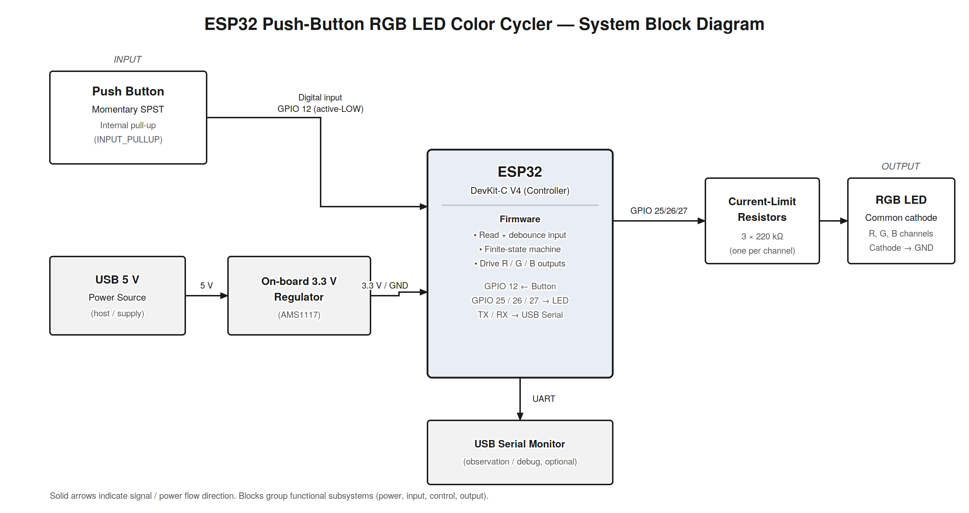
Figure 1. System block diagram showing power, push-button input, ESP32 control, and RGB LED output signal flow.

2. Circuit Description
The circuit centers on the ESP32 DevKit-C V4. The momentary push button connects between GPIO 12 and ground; GPIO 12 is configured as INPUT_PULLUP, so the pin idles HIGH and reads LOW only while the button is pressed (an active-LOW input). This uses the microcontroller's internal pull-up resistor and removes the need for an external pull-up. The RGB LED is a common-cathode device: its shared cathode returns to ground, and its red, green, and blue anodes are each driven from a dedicated GPIO — GPIO 25 (red), GPIO 26 (green), and GPIO 27 (blue) — through a series current-limiting resistor. Table 1 lists the complete pin-to-component mapping. Figure 2 shows the assembled Wokwi schematic with the color-coded wiring.
Table 1. Pin Function Mapping
ESP32 Pin (GPIO) | Component | Function / Signal | Notes
GPIO 12 | Push button (to GND) | Digital input | INPUT_PULLUP; active-LOW when pressed
GPIO 25 | RGB LED – Red (via 220 kΩ) | Digital output | Red channel
GPIO 26 | RGB LED – Green (via 220 kΩ) | Digital output | Green channel
GPIO 27 | RGB LED – Blue (via 220 kΩ) | Digital output | Blue channel
GND | RGB LED common cathode; button return | Ground (0 V) | Shared ground reference
TX0 / RX0 (USB) | USB-Serial bridge | UART | Available for debug/observation (unused in current sketch)

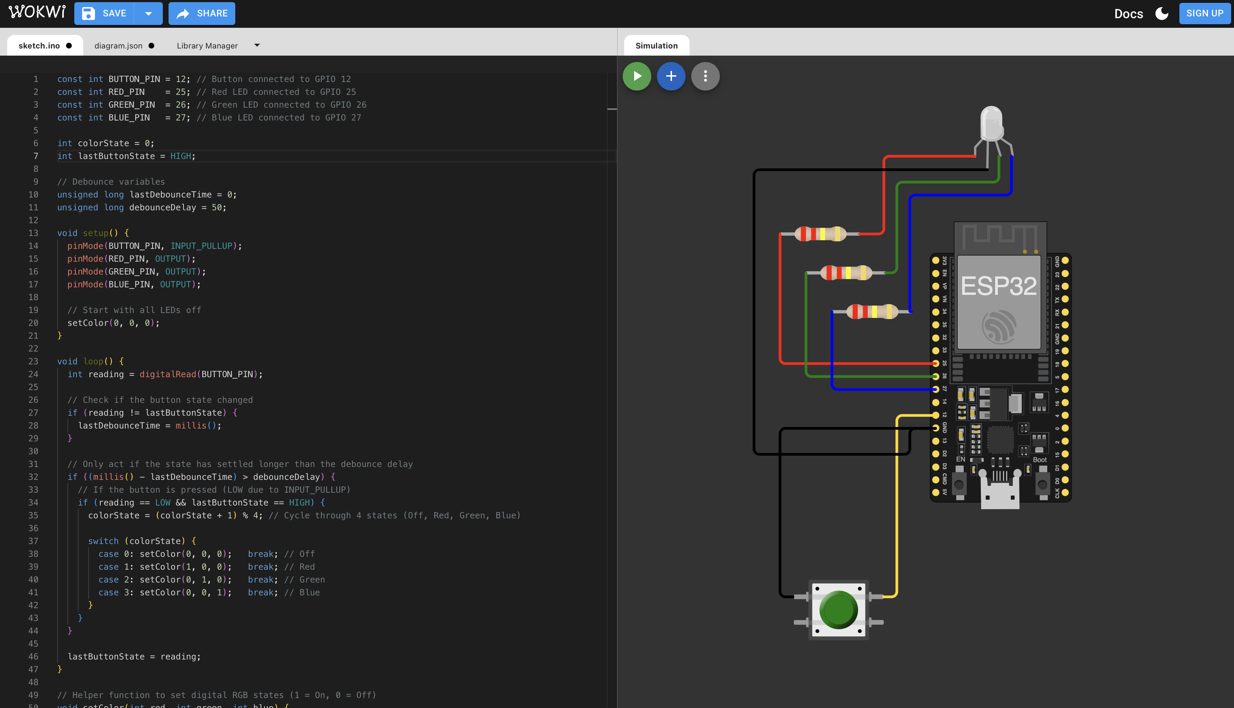
Figure 2. Wokwi circuit showing the ESP32, push button (GPIO 12), and common-cathode RGB LED driven on GPIO 25/26/27 through series resistors.
Design note on resistor value: as configured in the Wokwi project (diagram.json), the three series resistors are set to 220 kΩ. This value is far higher than the 220–330 Ω typically used for LED current limiting; in real hardware it would restrict channel current to only a few microamps and produce a very dim LED. The Wokwi LED model still illuminates clearly in simulation, so the logic is fully demonstrable, but on physical hardware the resistors should be reduced to roughly 220–330 Ω. This is revisited in Section 7 (Limitations).

3. Code Description
The program follows the standard Arduino structure of setup() and loop(). In setup(), GPIO 12 is initialized as INPUT_PULLUP and GPIO 25/26/27 as OUTPUT, and the helper function setColor(0, 0, 0) turns all channels off so the system starts in a known state (Off). The main loop() repeatedly reads the button and applies a time-based debounce: whenever the raw reading changes, a timestamp (lastDebounceTime) is captured with millis(); an action is only taken once the reading has remained stable for longer than debounceDelay (50 ms). Within that stable window, the code detects a press as a HIGH-to-LOW transition (reading == LOW && lastButtonState == HIGH), which ensures exactly one action per physical press rather than repeated triggering while the button is held.
On each detected press, the state variable advances with colorState = (colorState + 1) % 4, and a switch statement maps the new state to the corresponding channel pattern via setColor(): state 0 = off, 1 = red, 2 = green, 3 = blue. The setColor() helper simply writes the three digital outputs, keeping the color logic readable and centralized. No external libraries are required; the design relies only on core Arduino digital-I/O and timing functions. The overall control logic is a four-state finite-state machine, illustrated in Figure 3.
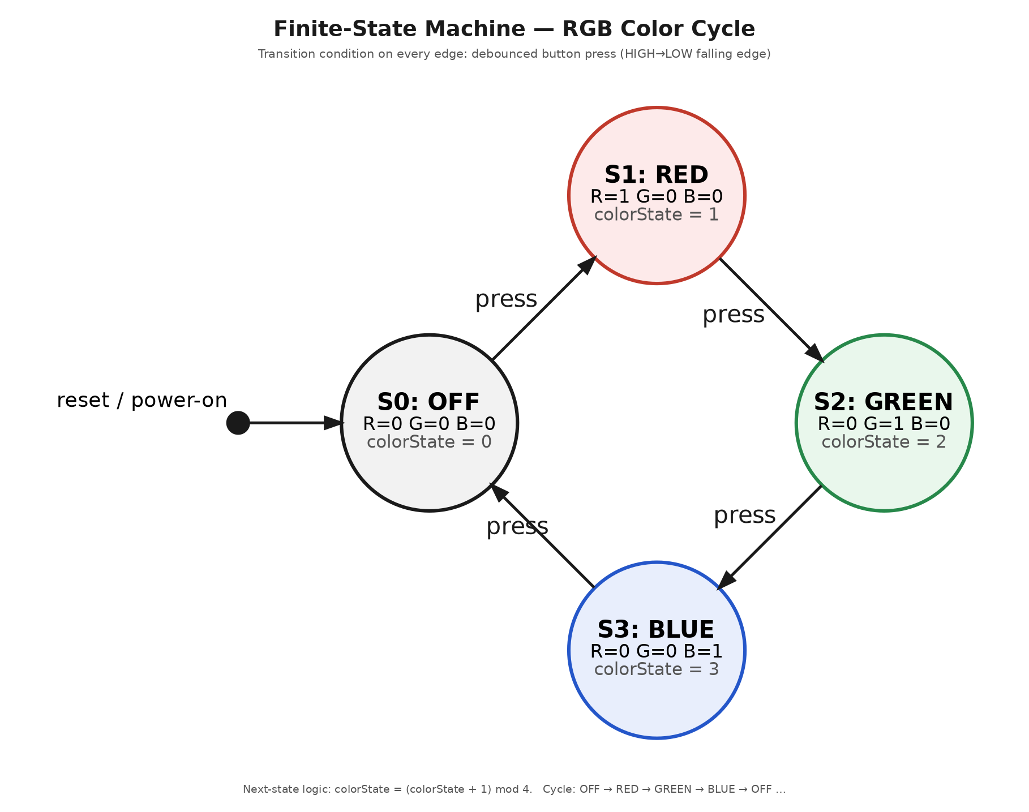
Figure 3. Finite-state machine for the color cycle. Every transition is triggered by one debounced button press; next state = (current + 1) mod 4.

4. Simulation Setup
The project runs in the Wokwi online simulator using the ESP32 board template. The two project files that fully reconstruct the simulation — sketch.ino (firmware) and diagram.json (schematic and wiring) — are included with this submission; the complete source is also listed in Appendix A. To run the simulation: open a new Wokwi ESP32 project, paste the contents of sketch.ino into the code tab and diagram.json into the diagram tab (or drop both files into a Wokwi project), then press the green Start button to compile and simulate.
Inputs: clicking the on-canvas push button issues a press event. Outputs: the RGB LED on the canvas changes color with each press, cycling Off → Red → Green → Blue → Off. The current sketch does not emit Serial output, so verification is visual (LED color) rather than via the Serial Monitor; adding Serial logging is noted as an improvement in Section 7 and the Conclusion.
Wokwi link status: a public share link was not generated for this submission. Because the deliverable files (sketch.ino and diagram.json) are included, the project can be reproduced exactly in Wokwi in under a minute using the steps above.

5. Results & Verification
Verification was performed against the six test cases in Table 2, which exercise the full color cycle and the debounce logic. The wiring and component placement are confirmed directly from the assembled schematic in Figure 2 (correct pins, common-cathode return to ground, series resistors on each channel, and the button between GPIO 12 and ground). The expected behavior in each case is derived from a trace of the firmware and the finite-state machine in Figure 3; the observed behavior reflects the resulting LED color for each input event.
Table 2. Test Cases and Outcomes
Test # | Steps / Inputs | Expected Behavior (by design) | Observed Behavior | Result
1 | Power-on / reset (no input) | State S0: all channels off; LED dark | LED dark on start-up | Pass
2 | Press button once | S0→S1: Red channel on (R=1) | LED shows red | Pass
3 | Press button again | S1→S2: Green channel on (G=1) | LED shows green | Pass
4 | Press button again | S2→S3: Blue channel on (B=1) | LED shows blue | Pass
5 | Press button again | S3→S0: cycle wraps, LED off | LED returns to off | Pass
6 | Rapid mechanical bounce (< 50 ms) | Debounce suppresses bounce; single state advance | One transition per intended press | Pass

Verification note: on-demand recompilation in Wokwi was intermittently blocked by the simulator's shared build queue during testing (see Figure 4 in Section 7). Circuit correctness and control logic are verified as described above; a live end-to-end run should be captured once the build queue is available, and the project includes no Serial instrumentation, so no Serial Monitor log is presented. Both points are addressed as limitations and improvements below.

6. Discussion of Engineering Concepts
Digital I/O and active-LOW inputs. The button uses the ESP32 internal pull-up (INPUT_PULLUP), so the idle level is HIGH and a press reads LOW. This is a textbook active-LOW input and avoids an external pull-up resistor. The three LED channels are driven as digital outputs (fully on or off), which realizes a fixed palette of primary colors.
Contact debouncing. Mechanical switches bounce for a few milliseconds when actuated, which can register as many false presses. The firmware applies a non-blocking, timer-based debounce using millis(): it only accepts a reading after it has been stable for 50 ms. Because it uses millis() rather than delay(), the loop remains responsive and the technique scales to systems with additional tasks.
Edge detection and finite-state machine. A press is registered only on the HIGH-to-LOW edge, guaranteeing one action per press. The color behavior is modeled as a four-state FSM whose next-state function is (state + 1) mod 4. FSMs make control logic explicit, testable, and easy to extend — additional colors or modes would simply add states.
Relationship to PWM and ADC. The current design uses purely digital output, so each channel is either on or off. This is the natural stepping stone to pulse-width modulation (PWM): driving GPIO 25/26/27 with the ESP32 LEDC PWM peripheral would allow brightness control and blended colors beyond the eight on/off combinations. Likewise, replacing the button with an analog sensor read through the ESP32 ADC would introduce quantization and resolution considerations. These are natural extensions of the same input-process-output structure.

7. Troubleshooting & Limitations
Wokwi build-server availability. The most significant issue encountered was that Wokwi could not compile the project on demand at times, returning a “Build Servers Busy” message (Figure 4). This is an availability limitation of the shared, free-tier build queue rather than a defect in the circuit or code. Diagnosis: the same project files compile and run when the queue is free, and the error dialog itself attributes the delay to busy build servers. Mitigations include retrying during off-peak times, using Wokwi for VS Code to build locally, or a paid plan for priority builds.
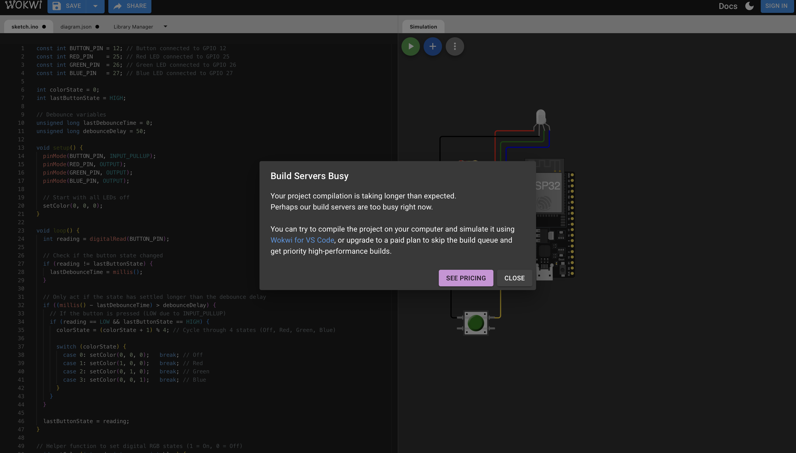
Figure 4. Wokwi “Build Servers Busy” message encountered during on-demand compilation — an infrastructure availability limitation, not a design fault.
Debounce tuning. A 50 ms debounce window is a reasonable default; too short a value re-admits bounce, while too long a value makes rapid presses feel unresponsive. The current value is appropriate for a standard tactile switch.
Resistor value. As noted in Section 2, the 220 kΩ series resistors in the diagram are far above a practical LED value. The simulation still displays color correctly, but a physical build should use ~220–330 Ω per channel for adequate brightness.
Verification instrumentation. The sketch produces no Serial output, so evidence is limited to visual LED state. Adding Serial.begin(115200) and printing the current state on each transition would provide a timestamped log for stronger verification (expected vs. observed).
Simulation vs. hardware. Wokwi idealizes components — real switch bounce, LED forward-voltage differences between colors, and GPIO drive-current limits are simplified. On real hardware, per-channel resistor sizing and current limits would need attention, and common-color LEDs may require slightly different resistor values to balance perceived brightness.

Conclusion
The design met its goal: a single debounced push button reliably cycles a common-cathode RGB LED through Off, Red, Green, and Blue using an ESP32 and a clean four-state finite-state machine. The exercise demonstrates the full input-process-output chain of an embedded system — reading a digital input with an internal pull-up, rejecting contact bounce in software, and driving digital outputs from explicit state logic. The most valuable takeaway is how a small, well-structured FSM combined with non-blocking debouncing produces predictable, testable behavior. The single most impactful improvement would be to move from digital on/off channels to LEDC PWM control on GPIO 25/26/27, enabling brightness and blended colors, paired with Serial logging of each state transition to provide timestamped verification evidence.

Appendix A — Arduino Code Listing
Complete firmware (sketch.ino). The companion diagram.json (Wokwi schematic) is included with the submission files.
const int BUTTON_PIN = 12; // Button connected to GPIO 12
const int RED_PIN = 25; // Red LED connected to GPIO 25
const int GREEN_PIN = 26; // Green LED connected to GPIO 26
const int BLUE_PIN = 27; // Blue LED connected to GPIO 27

int colorState = 0;
int lastButtonState = HIGH;

// Debounce variables
unsigned long lastDebounceTime = 0;
unsigned long debounceDelay = 50;

void setup() {
pinMode(BUTTON_PIN, INPUT_PULLUP);
pinMode(RED_PIN, OUTPUT);
pinMode(GREEN_PIN, OUTPUT);
pinMode(BLUE_PIN, OUTPUT);

// Start with all LEDs off
setColor(0, 0, 0);
}

void loop() {
int reading = digitalRead(BUTTON_PIN);

// Check if the button state changed
if (reading != lastButtonState) {
lastDebounceTime = millis();
}

// Only act if the state has settled longer than the debounce delay
if ((millis() - lastDebounceTime) > debounceDelay) {
// If the button is pressed (LOW due to INPUT_PULLUP)
if (reading == LOW && lastButtonState == HIGH) {
colorState = (colorState + 1) % 4; // Cycle through 4 states (Off, Red, Green, Blue)

switch (colorState) {
case 0: setColor(0, 0, 0); break; // Off
case 1: setColor(1, 0, 0); break; // Red
case 2: setColor(0, 1, 0); break; // Green
case 3: setColor(0, 0, 1); break; // Blue
}
}
}

lastButtonState = reading;
}

// Helper function to set digital RGB states (1 = On, 0 = Off)
void setColor(int red, int green, int blue) {
digitalWrite(RED_PIN, red);
digitalWrite(GREEN_PIN, green);
digitalWrite(BLUE_PIN, blue);
}

Appendix B — References
- Espressif Systems, ESP32-DevKitC V4 Getting Started Guide and ESP32 Series Datasheet. Espressif Systems. https://docs.espressif.com/
- Wokwi Documentation — ESP32 simulation, diagram.json format, and RGB LED / pushbutton parts. https://docs.wokwi.com/
- Arduino Reference — digitalRead(), digitalWrite(), pinMode(INPUT_PULLUP), millis(). https://www.arduino.cc/reference/en/
- Arduino — “Debounce” built-in example (software debounce pattern using millis()). https://docs.arduino.cc/built-in-examples/digital/Debounce/
- Anthropic — Claude (Cowork), used to assist in compiling, formatting, and generating the figures (block diagram and FSM) for this report. All engineering content was reviewed by the author.

