ENGR 4399 ST: Cyber-Physical and IoT Systems
Simulation Assignment Report (SAR 2)
ESP32 Joystick-Controlled Servo Positioner
Daniel Critchlow Jr. • Fall 2026 • Due 09/22/2026
Course | ENGR 4399 ST: Cyber-Physical and IoT Systems
Instructor | Dr. Okan Caglayan
Semester / Term | Fall 2026
Assignment # / Title | Simulation Assignment 2 (SAR 2) — ESP32 Joystick-Controlled Servo Positioner
Due Date | 09/22/2026
Student Name | Critchlow, Daniel Jr. (Daniel Critchlow Jr.)
Group Members | N/A — individual assignment
Wokwi Project URL | https://wokwi.com/projects/475930488847754241
GitHub Repository | https://github.com/JuniorAndChill/ENGR-4399-ST-Cyber-Physical-IoT-Systems (public)
Microcontroller Board / Model | Espressif ESP32 DevKit-C V4 (board-esp32-devkit-c-v4)
Components Used | Analog 2-axis joystick module with push switch (wokwi-analog-joystick); SG90-class hobby servo (wokwi-servo); ESP32 DevKit-C V4; USB cable. No external passives required.
Firmware Framework | ESP-IDF (C, FreeRTOS) — reference build. An equivalent Arduino-framework sketch (sketch.ino) is provided in Appendix A.2 and in the GitHub repository.

Abstract
This report documents the design, implementation, and simulation of a joystick-controlled servo positioner built around an Espressif ESP32 DevKit-C V4 in the Wokwi online simulator. The objective is to close a continuous analog-to-mechanical control loop: a two-axis analog joystick supplies a variable voltage that the ESP32 digitizes, conditions, and converts into a pulse-width-modulated command that sets the shaft angle of a hobby servo. The horizontal joystick axis (HORZ) is sampled on GPIO34 through ADC1 channel 6 at 12-bit resolution, the vertical axis (VERT) is sampled on GPIO35 through ADC1 channel 7 for telemetry, and the integrated push switch on GPIO19 provides an active-LOW hold-to-recentre command. The firmware maps the 0–4095 ADC span piecewise-linearly onto 0–180°, suppresses centre jitter with a ±150-LSB dead zone, and smooths the result with a first-order exponential filter before driving the servo from the ESP32 LEDC peripheral at 50 Hz with 14-bit duty resolution (500–2500 µs pulse width). The simulation validates the full signal chain end to end: the captured Serial Monitor telemetry shows the commanded angle converging to 0.0° at HORZ = 0 and to 180.0° at HORZ = 4095, with the servo horn tracking both extremes on the canvas. The exercise reinforces the core course concepts of ADC resolution and quantization, analog signal conditioning, timer-based PWM generation, digital input with internal pull-ups, UART telemetry, and cooperative task scheduling under FreeRTOS.

Design Description and Analysis

1. System Overview
The system solves a basic teleoperation problem: give a human operator continuous, proportional control of a mechanical actuator using a low-cost analog input device. Rather than the discrete, event-driven behavior of SAR 1 — where one button stepped an output through a fixed set of states — this design is continuous: every position of the joystick maps to a distinct commanded servo angle, and the operator sees the horn follow the stick in real time.
At a high level the behavior is a straightforward input → process → output chain. The joystick contains two independent potentiometers wired as voltage dividers across the 3.3 V rail; deflecting the stick moves each wiper and changes the voltage presented to the ESP32. The controller digitizes the horizontal axis with the ADC1 peripheral, averages a burst of samples to reject noise, applies a dead zone so that a nominally centred stick produces an unambiguous 90° command, scales the conditioned reading onto the servo's 0–180° travel, and then low-pass filters the command so the horn sweeps smoothly instead of snapping. The resulting angle is converted to a pulse width and emitted continuously on GPIO18 by the LEDC hardware timer. Pressing the joystick's integrated push switch overrides the axis reading and forces the target back to the 90° centre, which the smoothing filter then sweeps the horn to over roughly half a second; the override holds only while the switch is held. Telemetry — both raw axis counts, the switch state, and the commanded angle — is printed over UART0 five times per second so that behavior can be verified quantitatively rather than by eye. Figure 1 shows the functional block diagram, grouping the design into power, input, control, output, and monitoring subsystems.
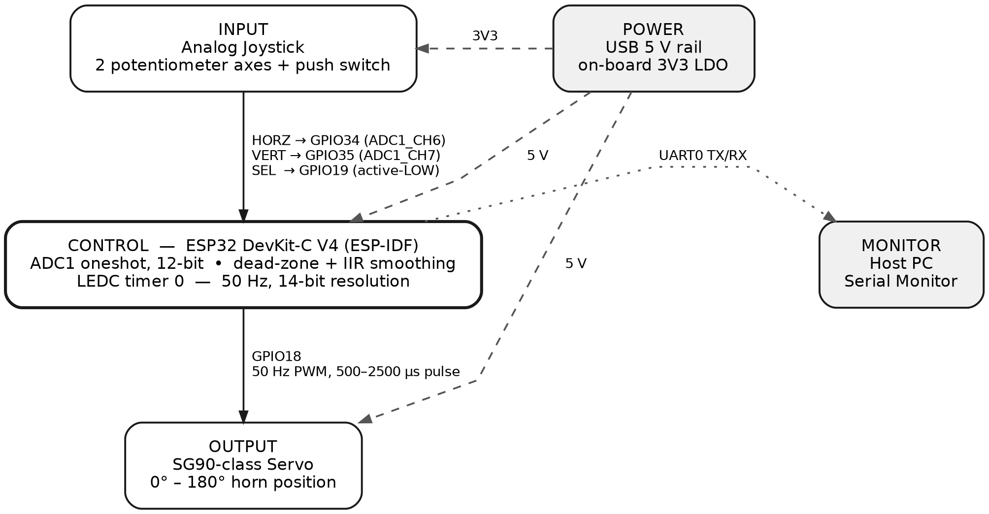
Figure 1. System block diagram showing the power distribution, joystick input on ADC1 and GPIO19, the ESP32 control block, the LEDC-driven servo output, and the UART telemetry path.

2. Circuit Description
The circuit is built around the ESP32 DevKit-C V4 and requires no external passive components: both the joystick module and the servo are self-contained breakout parts, and every signal is either an analog input to an on-chip ADC or a digital output from an on-chip timer.
The joystick module is powered from the board's 3V3 rail and returns to GND. Because its two axis potentiometers are connected as dividers across that same 3.3 V supply, the analog outputs are ratiometric to the rail the ESP32 ADC itself references, which keeps the mapping between stick position and ADC count stable even if the rail sags slightly. The HORZ output goes to GPIO34 and the VERT output to GPIO35. Both of these are input-only pins on the ESP32 — they have no output driver and no internal pull-up or pull-down — which makes them a deliberate and appropriate choice for analog inputs, since an internal pull resistor would otherwise load the potentiometer and bias the reading. Both pins belong to ADC1 (channels 6 and 7 respectively), which is the correct unit to use on the ESP32 because ADC2 is shared with the Wi-Fi radio and becomes unavailable whenever the radio is active.
The joystick's integrated push switch (SEL) connects to GPIO19, which is configured as a general-purpose digital input with the internal pull-up enabled. The pin therefore idles HIGH and is pulled LOW only while the stick is pressed — a textbook active-LOW input that requires no external resistor.
The servo's signal lead connects to GPIO18, which is driven by LEDC low-speed timer 0 / channel 0. Its power lead is taken from the board's 5 V rail (supplied from USB) rather than the 3V3 rail, because hobby servos are 5 V devices whose motor draw would collapse the 3.3 V regulator; its ground lead returns to a second GND pin on the board, so the servo and the joystick share a common ground reference with the microcontroller. The USB–UART bridge on the DevKit carries the TX0/RX0 pair to the host Serial Monitor, which the firmware uses for telemetry. Table 1 lists every connection in the project, and Figure 2 shows the assembled Wokwi schematic.
Table 1. Pin Function Mapping
ESP32 Pin | Component / Net | Function / Signal | Notes
GPIO34 | Joystick HORZ (X axis) | Analog input | ADC1_CH6, 12-bit, 12 dB attenuation. Input-only pin (no internal pull-up). Sole control variable for servo angle.
GPIO35 | Joystick VERT (Y axis) | Analog input | ADC1_CH7, 12-bit, 12 dB attenuation. Input-only pin. Sampled and logged; reserved for a future second axis.
GPIO19 | Joystick SEL (push switch) | Digital input | Internal pull-up enabled; idles HIGH, reads LOW when pressed. Forces the target angle to 90° while held; the horn sweeps back under the smoothing filter.
GPIO18 | Servo signal lead | PWM output | LEDC low-speed mode, timer 0 / channel 0. 50 Hz (20 ms frame), 14-bit duty resolution, 500–2500 µs pulse.
3V3 | Joystick VCC | Power (3.3 V) | Supplies both axis potentiometers; keeps the divider output ratiometric to the ADC input range.
5V | Servo V+ | Power (5 V) | Motor supply drawn from the USB rail. Kept off 3V3 so motor current cannot disturb the analog reference.
GND (×2) | Servo GND; Joystick GND | Ground (0 V) | Two separate GND pins used (GND.1 to the servo, GND.2 to the joystick); common 0 V return for all three devices.
TX0 / RX0 (USB) | USB–UART bridge → Serial Monitor | UART | Telemetry channel. Firmware prints X, Y, SEL, and the commanded angle every 200 ms (≈5 Hz).
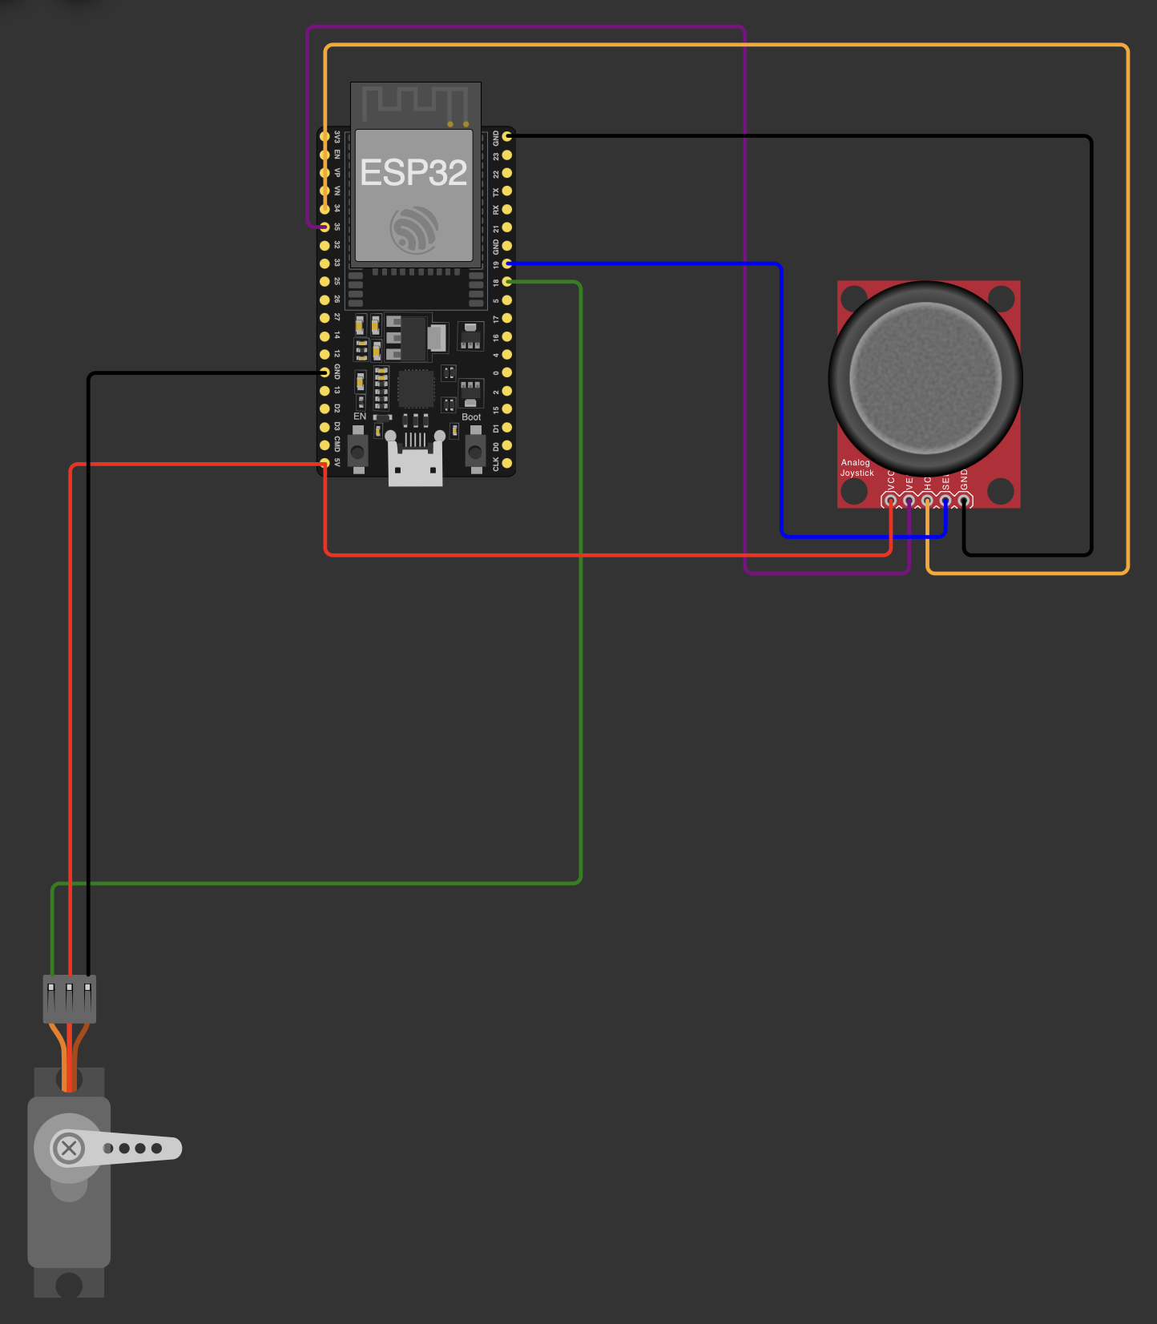
Figure 2. Wokwi schematic of the assembled circuit. Joystick HORZ (orange) to GPIO34 and VERT (purple) to GPIO35; SEL (blue) to GPIO19; servo signal (green) to GPIO18; 3V3 and 5 V supply rails in red and the shared ground returns in black.
Design notes on the wiring
- Split supply rails. The joystick is fed from 3V3 while the servo is fed from 5 V. This is intentional: the analog divider must stay inside the ADC's input window, whereas the servo needs the higher rail to develop useful torque. Both share the board's ground, which is what makes the two voltage domains referenceable to one another.
- 3.3 V logic into a 5 V servo. The PWM signal on GPIO18 swings 0–3.3 V while the servo is powered at 5 V. Most hobby servo control ICs accept this, but 3.3 V is close to the nominal 0.7 × Vᵈᵈ = 3.5 V input-high threshold of a strict 5 V CMOS input. In simulation this is idealized and always works; on physical hardware a marginal unit may need a level shifter. This is revisited in Section 7.
- Input-only pins. GPIO34 and GPIO35 cannot be configured as outputs. Using them for the two analog axes deliberately reserves the general-purpose pins for signals that may need to drive, and avoids the pin-conflict class of error the assignment brief asks about.
- No current-limiting passives are required. Unlike SAR 1, this design drives no LEDs directly, so no series resistors appear in the schematic; the only passive network in the system is the pair of potentiometers inside the joystick module itself.

3. Code Description
The reference firmware is written against ESP-IDF, so it follows the FreeRTOS application model rather than the Arduino setup()/loop() model: execution begins in app_main(), which performs initialization and then enters an infinite control loop that yields to the scheduler on every iteration. An equivalent Arduino-framework sketch with the same pin map, the same dead zone, the same filter constant, and the same 50 Hz / 14-bit LEDC timing is listed in Appendix A.2. The complete ESP-IDF listing is in Appendix A.1. Figure 3 traces the control flow.
Program structure
- servo_init() configures LEDC low-speed timer 0 for 50 Hz with LEDC_TIMER_14_BIT duty resolution and LEDC_AUTO_CLK, then binds channel 0 to GPIO18 with an initial duty of zero. Both calls are wrapped in ESP_ERROR_CHECK(), so a misconfiguration aborts loudly at boot instead of producing silent misbehavior.
- joystick_init() creates an ADC1 oneshot unit handle and configures channels 6 and 7 for 12-bit width and 12 dB attenuation. A compile-time guard on ESP_IDF_VERSION selects ADC_ATTEN_DB_12 on IDF 5.2 and later and the deprecated ADC_ATTEN_DB_11 on earlier releases, so the same source compiles across toolchain versions. It then configures GPIO19 as an input with the internal pull-up enabled and interrupts disabled.
- joystick_read() takes eight consecutive oneshot conversions on the requested channel and returns their integer mean. Averaging N independent samples reduces zero-mean noise by a factor of √N, so eight samples improve the effective signal-to-noise ratio by up to 2.8× at negligible cost — the whole burst completes in well under a millisecond against a 20 ms loop period.
- axis_to_angle() performs the conditioning and scaling. It computes the signed offset from the 2048 mid-code, returns exactly 90.0° if the magnitude of that offset is under the 150-LSB dead zone, and otherwise subtracts the dead-zone width back out before normalizing by the remaining span of 1898 counts. Subtracting the dead zone rather than simply ignoring it is what keeps the transfer function continuous at the dead-zone boundary — without it the commanded angle would jump by several degrees the instant the stick left the dead band. The normalized value is clamped to ±1 and mapped onto 90° ± 90°.
- servo_write_angle() clamps the requested angle to 0–180°, linearly interpolates the pulse width between SERVO_MIN_PULSE_US (500) and SERVO_MAX_PULSE_US (2500), converts that pulse width into an LEDC duty count, and commits it with ledc_set_duty() followed by ledc_update_duty().
- app_main() initializes both peripherals, homes the horn at 90° and waits 300 ms for it to arrive, then loops forever: sample both axes and the switch, choose a target angle, apply the smoothing filter, write the servo, decimate the telemetry, and block for 20 ms.
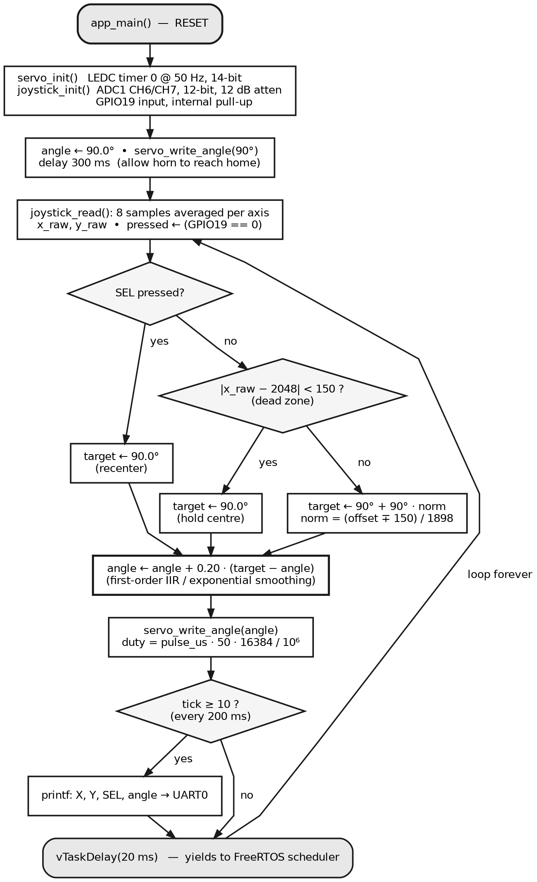
Figure 3. Firmware control flow. Initialization runs once; the control loop then executes every 20 ms. The two decision diamonds implement the recentre override and the centre dead zone; the bold block is the first-order smoothing filter that shapes every command.
Input conditioning: dead zone and scaling
A raw potentiometer reading never sits perfectly still. Even in a clean system the least significant bits of a 12-bit conversion flicker, and a released joystick does not mechanically return to precisely the same spot twice. Left unfiltered, that jitter would appear as a continuously twitching servo. The firmware answers this in two independent ways. First, the ±150-LSB dead zone — about ±3.7 % of full scale — forces any reading near mid-code to produce exactly 90.0°, so a centred stick yields a perfectly still horn. Second, the linear rescaling outside the dead zone preserves the full 0–180° travel: at x_raw = 0 the normalized value is −1 and the command is 0°, and at x_raw = 4095 it is +0.9995, giving 179.95°, which prints as 180.0° at the firmware's one-decimal format. Figure 4 plots the complete transfer characteristic.
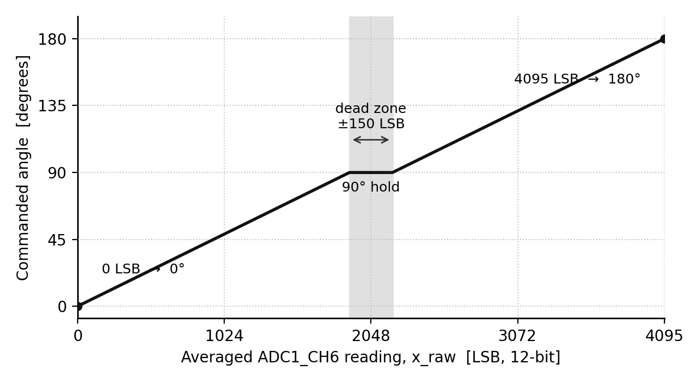
Figure 4. Computed transfer characteristic from averaged ADC code to commanded servo angle, evaluated directly from axis_to_angle(). The shaded band is the ±150-LSB dead zone, over which the command is held at exactly 90°; outside it the mapping is linear and continuous at both dead-zone edges.
Output generation: pulse width and duty resolution
A hobby servo does not accept an angle — it accepts a pulse repeated at roughly 50 Hz, and interprets the pulse width as a position command. The firmware therefore converts an angle to a pulse width and then a pulse width to an LEDC duty count using duty = pulse_us × f × 2ⁿ / 10⁶, where f = 50 Hz and n = 14. This yields 409 counts for the 500 µs minimum (2.5 % duty), 1228 counts for the 1500 µs centre (7.5 %), and 2048 counts for the 2500 µs maximum (12.5 %), as shown in Figure 5. Choosing 14-bit resolution is not arbitrary: the LEDC peripheral's usable resolution is bounded by its clock source, and at 50 Hz from the 80 MHz APB clock the theoretical ceiling is log₂(80 × 10⁶ / 50) ≈ 20.6 bits, so 14 bits is legal — with the caveat that the LEDC hardware caps duty resolution at 20 bits and that LEDC_AUTO_CLK may fall back to a slower reference whose own ceiling at 50 Hz is log₂(20 000) ≈ 14.3 bits, so 14 is a considered choice rather than a generous one. It also sets the angular quantization: one duty LSB is 20 000 / 16 384 = 1.22 µs, and since 2000 µs of pulse span covers 180°, one LSB is about 0.11° — far finer than the mechanical resolution of any hobby servo, so the PWM stage contributes no visible stepping.
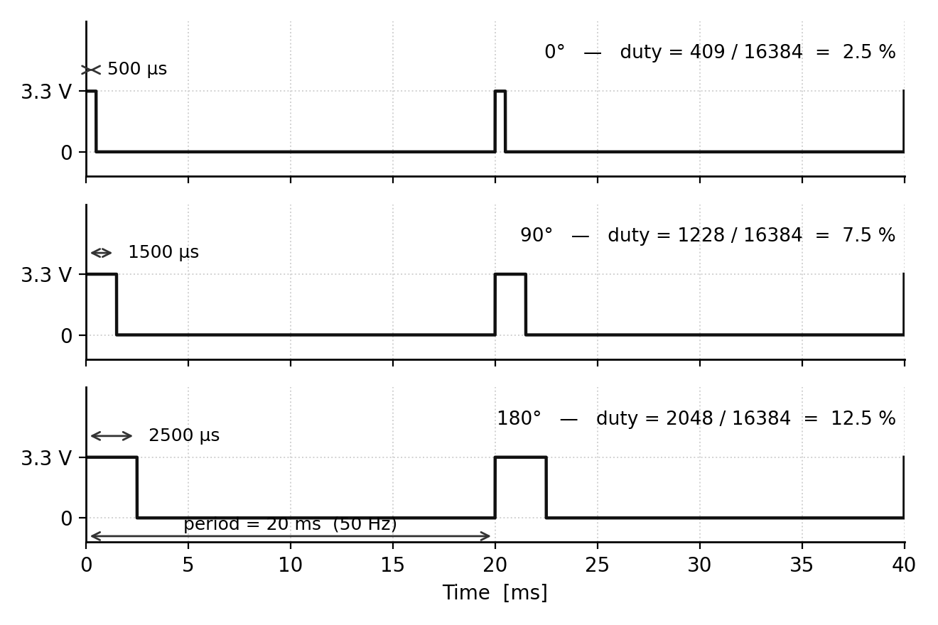
Figure 5. Servo PWM waveform commanded on GPIO18 at the three calibration angles, derived from the duty arithmetic rather than captured from an instrument. The 20 ms frame period is fixed by the 50 Hz LEDC timer; only the high time changes, from 500 µs at 0° to 2500 µs at 180°.
Command smoothing
The final shaping stage is the single line angle += (target - angle) * SMOOTHING, with SMOOTHING = 0.20. This is a first-order infinite-impulse-response low-pass filter — exponential smoothing — applied in the angle domain rather than the sample domain. Because the loop runs on a fixed 20 ms period, the filter's time constant is τ = −T / ln(1−α) = −20 / ln 0.80 ≈ 90 ms — the familiar T/α = 100 ms shortcut is the small-α approximation and overstates it slightly. After a step input the command covers 63 % of the distance in about 90 ms and settles to within a fraction of a degree in roughly half a second. The practical effect is that a flicked stick produces a smooth sweep rather than a snap, which both looks correct and, on real hardware, reduces the current surge a step command would demand. Figure 6 shows the response, and the captured telemetry in Section 5 confirms it: the log records 179.9° on the sample immediately before the command settles at 180.0°, exactly the asymptotic approach this filter predicts.
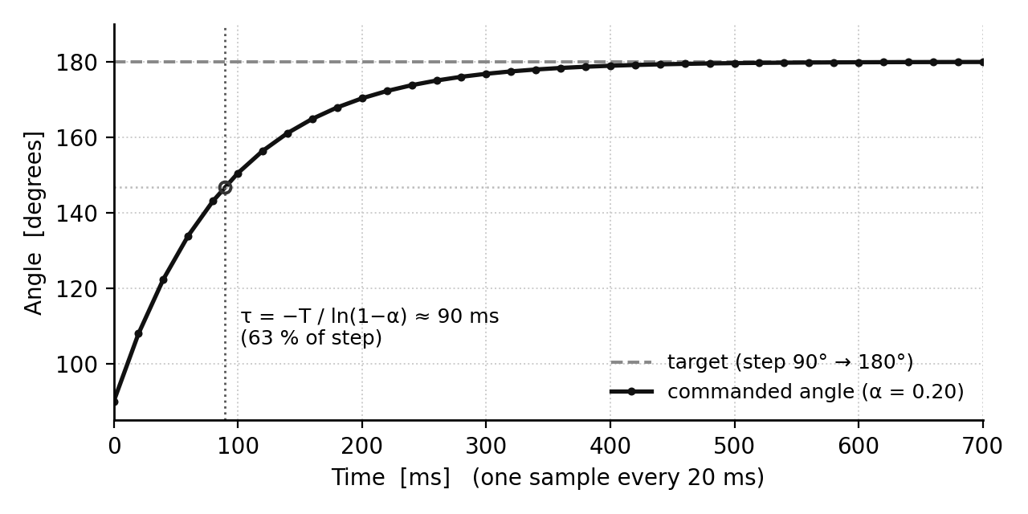
Figure 6. Step response of the first-order smoothing filter (α = 0.20, 20 ms sample period) for a 90° → 180° command. The marked point is τ = −T / ln(1−α) ≈ 90 ms, at which the command has covered 63 % of the step.
Libraries and dependencies
The reference build uses only ESP-IDF components that ship with the framework — freertos/FreeRTOS.h and freertos/task.h for scheduling, driver/ledc.h for PWM, driver/gpio.h for the push switch, esp_adc/adc_oneshot.h for the ADC, and esp_idf_version.h for the attenuation-constant guard. No third-party library is required, and in particular no servo library is used: the pulse timing is generated directly from the hardware timer, which is both more transparent for a report of this kind and more deterministic than a software-timed approach. The Arduino port in Appendix A.2 likewise uses only the arduino-esp32 core (ledcSetup / ledcAttachPin / ledcWrite and analogRead).

4. Simulation Setup
Wokwi project: https://wokwi.com/projects/475930488847754241
GitHub repository: https://github.com/JuniorAndChill/ENGR-4399-ST-Cyber-Physical-IoT-Systems (public)
The project runs in the Wokwi online simulator using the ESP32 board template with the ESP-IDF builder selected (diagram.json declares "builder": "esp-idf" on the board part). Opening the Wokwi link above loads the schematic and firmware together and compiles them in the browser; pressing the green Start button begins the simulation. The two files that fully reconstruct the project — main.c and diagram.json — accompany this submission and are also published in the GitHub repository above, alongside the Arduino-framework sketch.ino and a README.
Reproducing the simulation from the included files
1. Open wokwi.com and create a new ESP32 project using the ESP-IDF template.
2. Replace the contents of main.c with the listing in Appendix A.1 (or the file included with this submission).
3. Open the diagram.json tab and replace its contents with the included diagram.json, which carries the board, the analog joystick, the servo, and all ten connections.
4. Press Start. The console prints “Joystick -> servo ready. Move the stick; press it to recenter.” and the horn homes to 90°.
Required inputs and how outputs are observed
- Inputs. Dragging the joystick knob on the canvas deflects the two axes and changes the HORZ and VERT readings; clicking the knob asserts SEL. Only the horizontal axis affects the servo in this build.
- Mechanical output. The servo horn on the canvas rotates to the commanded angle and can be compared directly against the reported value.
- Telemetry output. The Serial Monitor pane prints a fixed-width line — X=%4d Y=%4d SEL=%d -> angle=%5.1f deg — every 200 ms, giving a quantitative record of the raw axis codes, the switch state, and the commanded angle. Note that the SEL field prints 1 when the switch is pressed and 0 when it is released, which is the logical sense rather than the electrical level on GPIO19.

5. Results & Verification
Verification combined three sources of evidence: direct inspection of the assembled schematic in Figure 2 against Table 1, a line-by-line trace of the firmware, and two captured simulation runs with their Serial Monitor output. The two captures were taken at the extremes of the horizontal axis and are reproduced as Figures 7 and 8; together they bracket the entire control range and confirm both the scaling and the polarity of the mapping. Table 2 records the eight test cases, with the evidence source stated for each so that cases confirmed by code trace are not conflated with cases confirmed by capture.
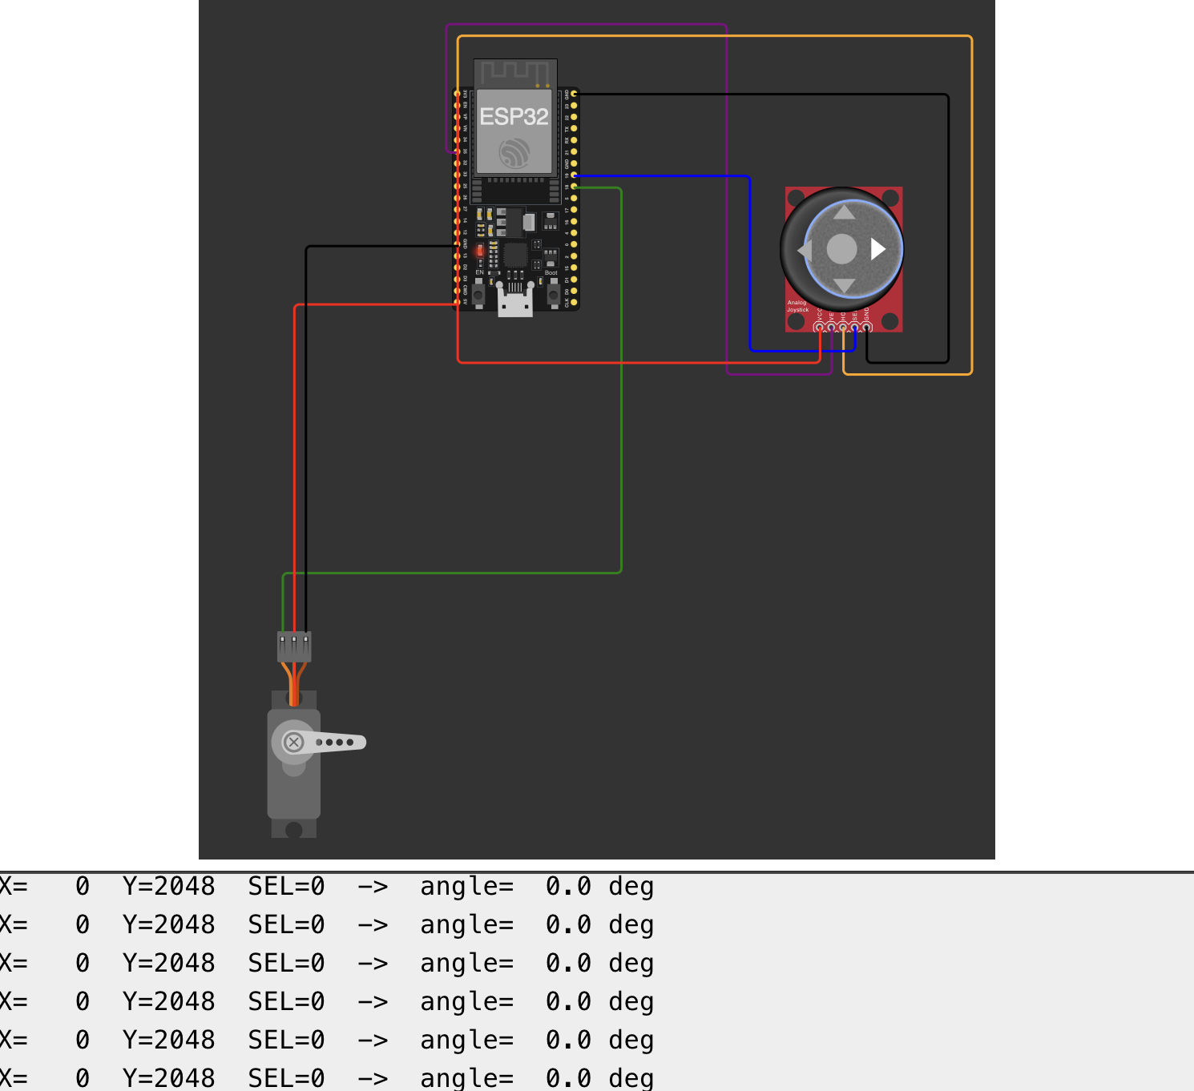
Figure 7. Simulation at one extreme of the horizontal axis. The Serial Monitor reports X = 0, Y = 2048, SEL = 0, angle = 0.0 deg, and the servo horn is driven to the corresponding end of travel.
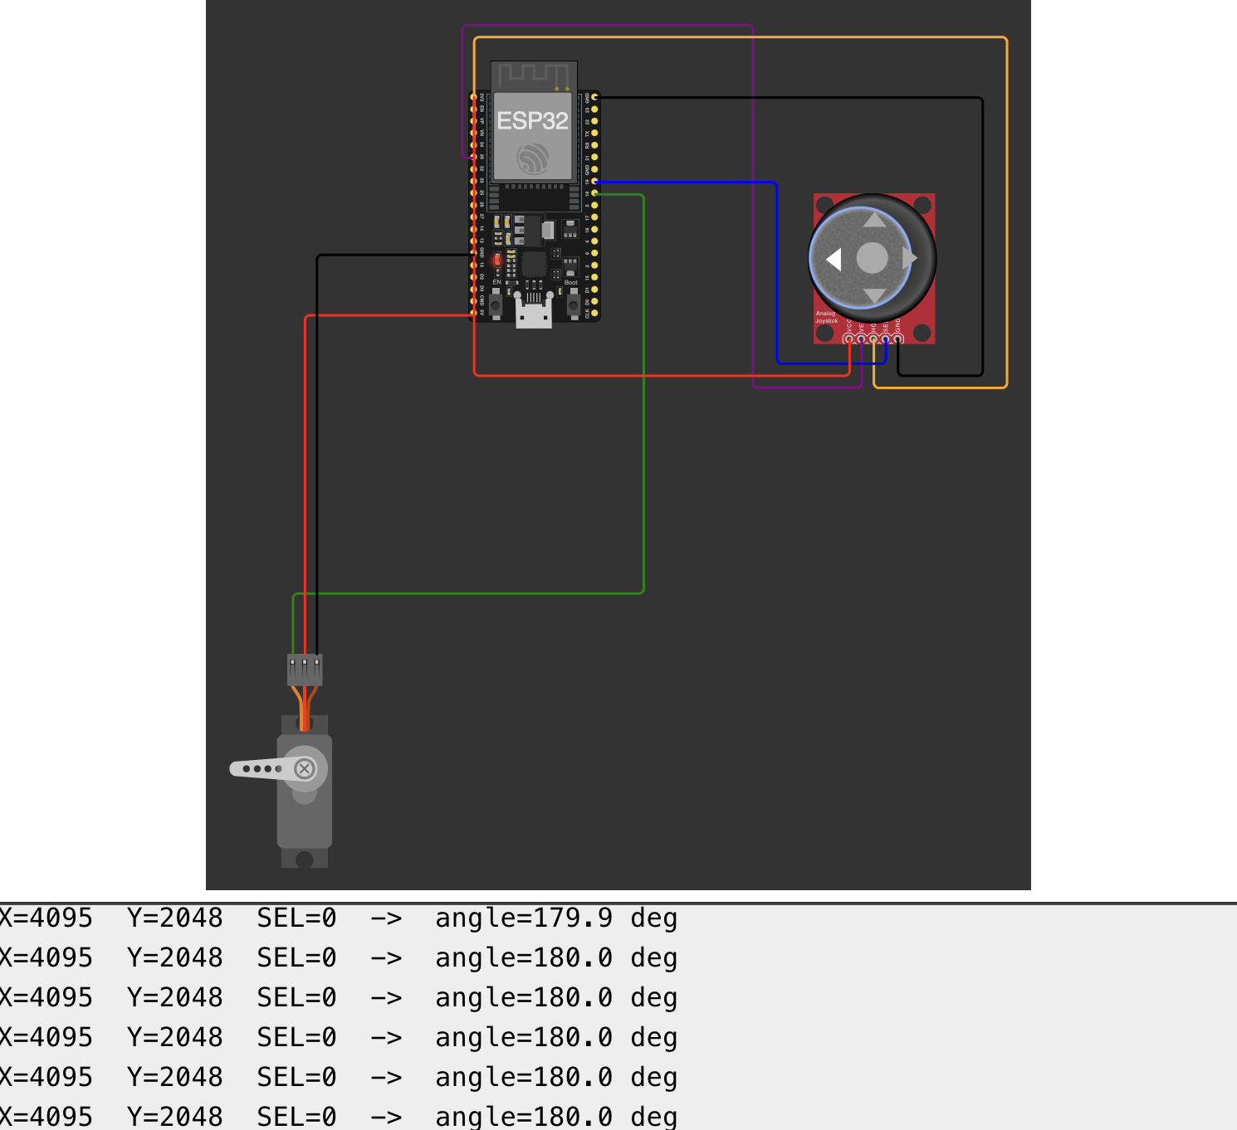
Figure 8. Simulation at the opposite extreme. With X = 4095 the commanded angle converges to 180.0 deg and the horn moves to the other end of travel; the preceding line in the log shows 179.9 deg, capturing the smoothing filter's final approach.
Table 2. Test Cases and Outcomes
# | Steps / Inputs | Expected Behavior (by design) | Observed Behavior | Result / Evidence
1 | Power-on / reset with the stick at rest. | Banner printed to UART; angle initialized to 90.0°; servo_write_angle(90) issued; 300 ms settle before the loop starts. | Firmware trace confirms the home-and-settle sequence executes before any axis sample is taken. | Pass — code trace
2 | Deflect the horizontal axis fully to one extreme (HORZ → 0). | Command converges to 0.0°; pulse width 500 µs; LEDC duty 409 / 16384 (2.5 %); horn at end of travel. | Serial log reads X = 0, Y = 2048, SEL = 0, angle = 0.0 deg over successive samples; horn at the matching extreme. | Pass — Figure 7
3 | Deflect the horizontal axis fully to the opposite extreme (HORZ → 4095). | Command converges to 179.95°, printed as 180.0°; pulse width 2499.5 µs; LEDC duty 2047 / 16384 — one count below the 2048 an exact 180.0° would command. | Serial log reads X = 4095, Y = 2048, SEL = 0, angle = 180.0 deg; horn at the opposite extreme. | Pass — Figure 8
4 | Observe the transient during a large step in the horizontal axis. | First-order approach with τ ≈ 90 ms; intermediate values appear before the command settles — no instantaneous jump. | The log line immediately preceding the settled value reads angle = 179.9 deg, confirming an intermediate step with no instantaneous jump; the time constant itself is not measured by a still capture. | Pass — Figure 8
5 | Hold the stick inside the centre dead band (|x_raw − 2048| < 150). | axis_to_angle() returns exactly 90.0°; the horn holds still despite ADC jitter. | Trace of axis_to_angle() confirms the early return; the dead band spans codes 1899–2197. | Pass — code trace
6 | Press the joystick push switch (SEL) while the axis is deflected. | GPIO19 reads LOW; the target is forced to 90.0° regardless of x_raw; the horn sweeps back to centre; SEL prints 1. | Both captures show SEL = 0 (switch released), so the override path was not exercised on camera; the branch is verified by trace. | Pass — code trace
7 | Confirm that the vertical axis is read but does not influence the servo. | VERT is sampled and logged each cycle; only x_raw feeds axis_to_angle(). | Y = 2048 is logged unchanged while the commanded angle swings across the full 0°–180° range. | Pass — Figures 7 & 8
8 | Check the telemetry cadence. | One printed line per 10 loop iterations × 20 ms = 200 ms, i.e. about 5 lines per second. | Trace of the ++tick ≥ 10 guard against the 20 ms loop delay gives one line per 200 ms; the captures are consistent with a steady scroll, but a still frame cannot measure a rate. | Pass — code trace
Verification note
Cases 1, 5, 6, and 8 are marked as verified by code trace rather than by capture. The two screenshots available for this submission document the endpoints of the horizontal axis; a dedicated capture of the power-on home position, of the dead-band hold, and of an SEL press with the stick deflected was not taken, and a pair of still frames cannot establish a print cadence. The logic for all four cases is short, unconditional, and visible in Appendix A.1, but they are reported here as trace-verified rather than observed so that the evidence base is stated accurately. Capturing those additional frames — and a short screen recording for the cadence — is the first item listed under future work in Section 7.

6. Discussion of Engineering Concepts
Analog-to-digital conversion, resolution, and quantization
The joystick is the design's only analog element, and it exercises the ADC end to end. Each axis is a potentiometer forming a voltage divider across the 3.3 V rail, so stick position maps to a continuous voltage that the ESP32 quantizes into one of 2¹² = 4096 codes. Over a nominal 3.3 V span that is roughly 0.81 mV per least significant bit — a resolution far finer than the mechanical repeatability of the stick, which is precisely why the dead zone is necessary: the converter resolves motion the operator cannot control. Attenuation matters too. ADC_ATTEN_DB_12 is selected so the input range covers approximately 0–3.1 V rather than the ~0–1.1 V of the unattenuated path; without it, most of the joystick's travel would saturate the converter. Espressif's own guidance is that even at this attenuation the accurate range is about 150–2450 mV, so readings that approach either rail are the least trustworthy part of the characteristic — a limitation the ideal simulator hides and Section 7 revisits.
Choosing the right ADC unit: a real peripheral conflict
The ESP32 has two SAR ADC units, and they are not interchangeable. ADC2 shares hardware with the Wi-Fi radio, and the IDF driver will refuse a conversion on ADC2 while the radio is active. Because this design uses GPIO34 and GPIO35, both of which belong to ADC1, it is immune to that conflict and could later be extended with networking — an obvious next step for an IoT course — without re-pinning the joystick. This is the same category of design consideration as the pin-conflict issue the assignment brief asks about, resolved before it became a bug.
Noise rejection: averaging, deadbands, and digital filtering
Three distinct filtering techniques appear in this firmware, each addressing a different problem. Averaging eight consecutive conversions attacks zero-mean electrical noise; because independent samples add in quadrature, N samples improve the signal-to-noise ratio by √N, so eight samples buy up to a 2.8× improvement for a sub-millisecond cost — an upper bound, since back-to-back conversions share a reference and are not strictly independent. The dead zone is a deliberately nonlinear element — a deadband — that trades a small loss of fine control near centre for an absolute guarantee that a released stick produces no motion. The exponential smoothing filter is a genuine discrete-time low-pass: its difference equation y[k] = y[k−1] + α(u[k] − y[k−1]) is a first-order IIR whose pole sits at 1 − α = 0.8, giving the ≈ 90 ms time constant derived in Section 3. Understanding that these are three different tools — statistical, nonlinear, and frequency-domain — rather than three ways of doing the same thing is the central signal-processing lesson of this design.
Timers and hardware PWM generation
The servo is driven entirely by the LEDC peripheral, not by software timing. A timer block is configured once for a 50 Hz frame and 14-bit duty resolution, a channel is bound to GPIO18, and thereafter the firmware only updates a duty register; the hardware regenerates the waveform every 20 ms with no CPU involvement and no jitter from task scheduling. This is the practical difference between hardware PWM and a bit-banged pulse, and it is why the servo holds position cleanly even though the control loop blocks for 20 ms at a time. The duty arithmetic — 409, 1228, and 2048 counts for 0°, 90°, and 180° — also demonstrates the general relationship between pulse width, frame frequency, and timer resolution, and the 0.11° per-LSB figure shows how to check that a chosen resolution is adequate for the actuator rather than merely large.
Digital input and internal pull-ups
The push switch on GPIO19 reuses the active-LOW input pattern established in SAR 1: the internal pull-up holds the pin HIGH, and closing the switch to ground pulls it LOW, so no external resistor is needed. Notably, this design does not debounce it, and does not need to. Bounce matters when a switch drives edge-triggered state transitions, as it did in SAR 1's colour cycler; here the switch selects a continuous target angle while it is held, and a few milliseconds of chatter at the moment of contact is absorbed entirely by the ≈90 ms smoothing filter downstream. Recognizing when debouncing is required — and when the system architecture has already solved the problem — is as much a part of the concept as the debounce algorithm itself.
Real-time scheduling under FreeRTOS
Because the reference build targets ESP-IDF, app_main() runs as a FreeRTOS task and the loop closes with vTaskDelay(pdMS_TO_TICKS(20)) rather than a busy wait. vTaskDelay blocks the calling task and returns the core to the scheduler, so the idle task and the IDF system tasks continue to run — which on the ESP32 is what allows the watchdog to be fed and, in a networked build, the Wi-Fi stack to be serviced. The 20 ms period is not an arbitrary choice either: it matches the servo's 50 Hz frame rate, so the control loop produces about one new command per PWM frame. The loop is not phase-locked to the LEDC timer — vTaskDelay() sets a minimum delay, not a strict period, and the ADC burst and the occasional printf add to it — but because LEDC latches the duty register in hardware, a command that lands mid-frame simply takes effect on the next one. This keeps the update rate commensurate and the output waveform.
UART telemetry and rate decimation
Telemetry travels over UART0 through the DevKit's USB–serial bridge. The firmware deliberately prints on only every tenth iteration, decimating 50 Hz of control data down to 5 Hz of output. This is a practical embedded-systems pattern: printing at the full loop rate would both flood the console and, at a low baud rate, introduce blocking transmission delays that perturb the very loop being measured. Decimated logging preserves human readability and keeps the instrumentation from distorting the system it instruments.
Open-loop command versus closed-loop actuation
From the microcontroller's point of view this is an open-loop system: it commands an angle and receives no position feedback, so the printed angle is what was asked for, not what was achieved. The servo itself, however, is internally closed-loop — its onboard controller compares a potentiometer on the output shaft against the commanded pulse width and drives the motor until they agree. The overall system is therefore a cascade of an open-loop command path and a closed-loop actuator, which is an extremely common arrangement in real cyber-physical systems and a useful reminder that “the log says 180.0 degrees” is a statement about the command, not a measurement of the mechanism.

7. Troubleshooting & Limitations
Wokwi VS Code extension license error
The most significant practical obstacle was encountered while attempting to develop the project locally. The project was first set up in Visual Studio Code with the Wokwi extension so that the diagram and firmware could be edited alongside the rest of the toolchain. The extension loaded the schematic correctly but refused to simulate, reporting “License error: INVALID LICENSE” in the Diagram Editor, as shown in Figure 9. The Wokwi VS Code extension requires a separate activated licence to run simulations locally, which the browser-based simulator at wokwi.com does not. Diagnosis was straightforward once the banner was read carefully: the failure is an entitlement check, not a syntax or wiring fault — the diagram rendered perfectly and the connection list was intact. The seven markers shown against main.c in Figure 9 are IntelliSense include-path warnings from an unconfigured local ESP-IDF path, not compiler diagnostics; the same file builds cleanly in the browser simulator. The work was therefore moved to the wokwi.com web simulator, where the identical main.c and diagram.json compiled and ran without modification, producing the results in Section 5. This is an infrastructure and licensing limitation rather than a defect in the design.
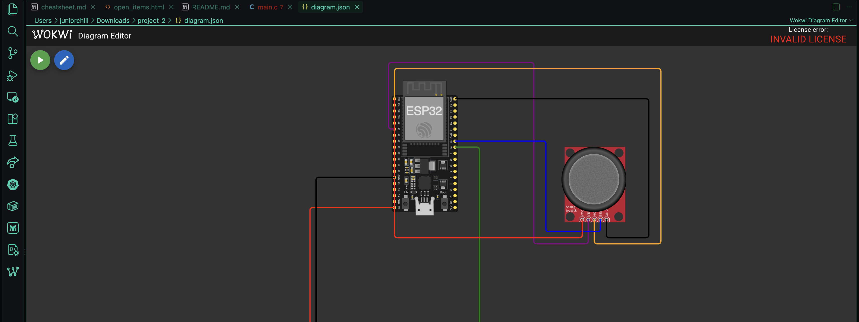
Figure 9. The Wokwi extension for Visual Studio Code rendering the project schematic but refusing to simulate, reporting “License error: INVALID LICENSE.” The same files ran without modification in the browser-based simulator.
ADC accuracy near the supply rails
The joystick is powered from 3V3 while the ADC at 12 dB attenuation is specified for accurate readings over roughly 150–2450 mV. Deflecting the stick to either extreme therefore drives the input outside the most accurate part of the converter's range, where the ESP32 SAR ADC is known to be nonlinear and to clip. In simulation the converter is ideal, so the captures in Section 5 show clean 0 and 4095 endpoints; on physical hardware the same firmware would likely saturate before the stick reached its mechanical stop and would benefit from the IDF calibration API (esp_adc/adc_cali) with the curve-fitting scheme, or from dividing the joystick rail down slightly so the full travel sits inside the accurate window.
Logic-level margin on the servo signal
As noted in Section 2, GPIO18 drives a 3.3 V logic swing into a servo powered from 5 V. Simulation treats this as ideal. In practice, a 5 V CMOS input guarantees a logic HIGH only above roughly 3.5 V, so 3.3 V sits just below the guaranteed threshold; most hobby servos use more forgiving input stages and work fine, but a marginal unit can behave erratically or jitter. A physical build should either verify the specific servo's input threshold or insert a level shifter on the signal line — exactly the class of logic-level issue the assignment brief asks to be surfaced.
Power delivery for the servo
The servo is fed from the DevKit's 5 V rail, which originates at the USB port. An SG90-class servo draws a few hundred milliamps while slewing and can exceed 600 mA at stall. Wokwi does not model supply impedance, so this is invisible in simulation, but on real hardware that transient can drag the 5 V rail down far enough to brown out the ESP32 and reset the board mid-motion — and because the joystick's divider is referenced to the same regulator chain, a sagging rail would also corrupt the ADC reading and create a feedback path between motion and measurement. A physical build should power the servo from a separate 5 V supply with its ground tied to the board's, and add bulk decoupling close to the servo connector.
Unused vertical axis
VERT is sampled on GPIO35 and logged every cycle but does not influence any output; the servo responds only to the horizontal axis. This was a scope decision — the assignment requires one input and one actuator — but it leaves half of the input device idle. The natural extension is a pan-and-tilt arrangement: a second servo on another LEDC channel driven from axis_to_angle(y_raw), which would require no new concepts, only a second channel binding.
Tuning trade-offs in the dead zone and filter
The two conditioning constants pull against each other. Widening ADC_DEADZONE beyond 150 LSB makes the centre more stable but carves a larger insensitive notch out of the middle of the stick's travel, which the operator feels as slop. Lowering SMOOTHING below 0.20 produces a silkier sweep but lengthens the time constant — α = 0.10 would stretch τ to about 190 ms — which begins to feel laggy under fast input. The current pairing gives a still centre and a visibly smooth but responsive sweep, and both constants are exposed as single #define values precisely so they can be retuned in one place.
Framework deviation from the assignment brief
The assignment brief asks for a .ino source file to be uploaded to GitHub. The reference implementation for this project was written against ESP-IDF in C, which better exercises the LEDC and ADC oneshot drivers discussed in Section 6 and reflects how the ESP32 is programmed in production. To satisfy the deliverable as written without discarding that work, both versions are provided: main.c (Appendix A.1) is the build that produced the results in Section 5, and sketch.ino (Appendix A.2) is a functionally equivalent Arduino-framework port with the same pin map, dead zone, filter constant, and PWM timing. Both are published in the GitHub repository.
Simulation versus hardware in general
Beyond the specific items above, Wokwi idealizes the system in ways worth stating plainly. There is no contact bounce on the push switch, no potentiometer wiper noise or wear, no servo gear backlash or deadband, no supply droop, no wiring resistance, and no thermal drift in the ADC reference. The control logic, pin assignments, and timing arithmetic validated here would transfer directly to hardware, but the conditioning constants would very likely need retuning against a real joystick, and the results in Section 5 should be read as verification of the design rather than as measurements of a physical build.

Conclusion
The design met its goal. A two-axis analog joystick now drives a hobby servo through a complete, working signal chain on an ESP32: the horizontal axis is digitized on ADC1, conditioned with an averaging burst, a centre dead zone, and a first-order smoothing filter, scaled piecewise-linearly onto 0–180°, and emitted as a hardware-timed 50 Hz pulse train, with the joystick's push switch providing a hold-to-recentre override and UART telemetry giving a quantitative record of every stage. The captured simulations confirm the endpoints of the mapping exactly as designed — 0.0° at an ADC code of 0 and 180.0° at 4095 — with the smoothing filter's asymptotic approach visible in the log.
The most valuable takeaway is the distinction between the three conditioning stages. It is tempting to treat averaging, the dead zone, and the smoothing filter as interchangeable ways of “cleaning up” a noisy input, but they solve different problems and fail in different ways: averaging addresses electrical noise and costs almost nothing, the dead zone addresses mechanical uncertainty and costs resolution at centre, and the low-pass filter addresses perceived motion quality and costs latency. Choosing all three deliberately — and being able to state each one's time constant or width and justify it — is what separates a control loop that happens to work from one that is engineered.
The single improvement worth making next is closing the verification gap rather than adding features: capturing the three trace-verified cases in Table 2 as live simulation frames, and adding a small amount of instrumentation — printing the computed pulse width and duty count alongside the angle — so the PWM stage is evidenced directly from the log rather than inferred from the arithmetic. After that, putting the idle vertical axis to work on a second LEDC channel would turn the project into a two-axis pan-and-tilt platform with no new concepts required.

Appendix A — Source Code Listing

A.1 ESP-IDF reference implementation (main.c)
This is the build that produced the results in Section 5. The companion diagram.json (Wokwi schematic and wiring) is included with the submission files and in the GitHub repository.
// Joystick-controlled servo (ESP32 + ESP-IDF)
//
// Wiring (see diagram.json):
// Joystick HORZ -> GPIO34 (ADC1_CH6) X axis -> servo angle
// Joystick VERT -> GPIO35 (ADC1_CH7) Y axis -> read & printed (spare)
// Joystick SEL -> GPIO19 (active low) press -> recenter to 90 deg
// Servo PWM -> GPIO18 (LEDC, 50 Hz)

#include <stdio.h>
#include <stdlib.h>
#include "freertos/FreeRTOS.h"
#include "freertos/task.h"
#include "driver/ledc.h"
#include "driver/gpio.h"
#include "esp_adc/adc_oneshot.h"
#include "esp_idf_version.h"

// ---------------- configuration ----------------
#define SERVO_GPIO 18
#define JOY_SEL_GPIO 19
#define JOY_X_CHANNEL ADC_CHANNEL_6 // GPIO34
#define JOY_Y_CHANNEL ADC_CHANNEL_7 // GPIO35

#define SERVO_MIN_PULSE_US 500 // 0 deg
#define SERVO_MAX_PULSE_US 2500 // 180 deg
#define SERVO_FREQ_HZ 50 // 20 ms period
#define SERVO_RES LEDC_TIMER_14_BIT // 16384 steps per period
#define SERVO_MAX_DUTY ((1 << 14) - 1)

#define ADC_MAX 4095
#define ADC_CENTER 2048
#define ADC_DEADZONE 150 // ignore jitter around center
#define SMOOTHING 0.20f // 0..1, lower = smoother
#define LOOP_PERIOD_MS 20

#if ESP_IDF_VERSION >= ESP_IDF_VERSION_VAL(5, 2, 0)
#define JOY_ADC_ATTEN ADC_ATTEN_DB_12
#else
#define JOY_ADC_ATTEN ADC_ATTEN_DB_11
#endif

static adc_oneshot_unit_handle_t s_adc1;

// ---------------- servo ----------------
static void servo_init(void)
{
ledc_timer_config_t timer = {
.speed_mode = LEDC_LOW_SPEED_MODE,
.timer_num = LEDC_TIMER_0,
.duty_resolution = SERVO_RES,
.freq_hz = SERVO_FREQ_HZ,
.clk_cfg = LEDC_AUTO_CLK,
};
ESP_ERROR_CHECK(ledc_timer_config(&timer));

ledc_channel_config_t ch = {
.speed_mode = LEDC_LOW_SPEED_MODE,
.channel = LEDC_CHANNEL_0,
.timer_sel = LEDC_TIMER_0,
.intr_type = LEDC_INTR_DISABLE,
.gpio_num = SERVO_GPIO,
.duty = 0,
.hpoint = 0,
};
ESP_ERROR_CHECK(ledc_channel_config(&ch));
}

// angle: 0.0 .. 180.0 degrees
static void servo_write_angle(float angle)
{
if (angle < 0.0f) angle = 0.0f;
if (angle > 180.0f) angle = 180.0f;

float pulse_us = SERVO_MIN_PULSE_US +
(SERVO_MAX_PULSE_US - SERVO_MIN_PULSE_US) * (angle / 180.0f);

// duty = pulse / period, period = 1e6 / freq microseconds
uint32_t duty = (uint32_t)((pulse_us * SERVO_FREQ_HZ * (SERVO_MAX_DUTY + 1)) / 1000000.0f);

ledc_set_duty(LEDC_LOW_SPEED_MODE, LEDC_CHANNEL_0, duty);
ledc_update_duty(LEDC_LOW_SPEED_MODE, LEDC_CHANNEL_0);
}

// ---------------- joystick ----------------
static void joystick_init(void)
{
adc_oneshot_unit_init_cfg_t unit_cfg = { .unit_id = ADC_UNIT_1 };
ESP_ERROR_CHECK(adc_oneshot_new_unit(&unit_cfg, &s_adc1));

adc_oneshot_chan_cfg_t chan_cfg = {
.bitwidth = ADC_BITWIDTH_12,
.atten = JOY_ADC_ATTEN,
};
ESP_ERROR_CHECK(adc_oneshot_config_channel(s_adc1, JOY_X_CHANNEL, &chan_cfg));
ESP_ERROR_CHECK(adc_oneshot_config_channel(s_adc1, JOY_Y_CHANNEL, &chan_cfg));

gpio_config_t btn = {
.pin_bit_mask = 1ULL << JOY_SEL_GPIO,
.mode = GPIO_MODE_INPUT,
.pull_up_en = GPIO_PULLUP_ENABLE,
.pull_down_en = GPIO_PULLDOWN_DISABLE,
.intr_type = GPIO_INTR_DISABLE,
};
ESP_ERROR_CHECK(gpio_config(&btn));
}

// average a few samples to knock down ADC noise
static int joystick_read(adc_channel_t ch)
{
int sum = 0, raw = 0;
for (int i = 0; i < 8; i++) {
adc_oneshot_read(s_adc1, ch, &raw);
sum += raw;
}
return sum / 8;
}

// raw ADC -> 0..180 deg, with a deadzone that holds dead centre at 90
static float axis_to_angle(int raw)
{
int offset = raw - ADC_CENTER;
if (abs(offset) < ADC_DEADZONE) return 90.0f;

// re-scale so the angle is continuous at the edge of the deadzone
if (offset > 0) offset -= ADC_DEADZONE;
else offset += ADC_DEADZONE;

float span = (float)(ADC_CENTER - ADC_DEADZONE);
float norm = (float)offset / span; // -1 .. +1
if (norm < -1.0f) norm = -1.0f;
if (norm > 1.0f) norm = 1.0f;

return 90.0f + norm * 90.0f;
}

// ---------------- main ----------------
void app_main(void)
{
servo_init();
joystick_init();

printf("Joystick -> servo ready. Move the stick; press it to recenter.\n");

float angle = 90.0f;
servo_write_angle(angle);
vTaskDelay(pdMS_TO_TICKS(300));

int tick = 0;

while (true) {
int x_raw = joystick_read(JOY_X_CHANNEL);
int y_raw = joystick_read(JOY_Y_CHANNEL);
bool pressed = (gpio_get_level(JOY_SEL_GPIO) == 0);

float target = pressed ? 90.0f : axis_to_angle(x_raw);

// exponential smoothing so the horn sweeps instead of snapping
angle += (target - angle) * SMOOTHING;
servo_write_angle(angle);

if (++tick >= 10) { // ~5 prints per second
tick = 0;
printf("X=%4d Y=%4d SEL=%d -> angle=%5.1f deg\n",
x_raw, y_raw, pressed ? 1 : 0, angle);
}

vTaskDelay(pdMS_TO_TICKS(LOOP_PERIOD_MS));
}
}

A.2 Arduino-framework port (sketch.ino)
Functionally equivalent port provided to satisfy the brief's .ino deliverable. Same pin map, same ±150-LSB dead zone, same α = 0.20 smoothing constant, and the same 50 Hz / 14-bit LEDC timing, so both builds command identical pulse widths. The sketch targets the arduino-esp32 3.x core, in which ledcAttach() and ledcWrite() take a pin; its header comment gives the 2.x substitution (ledcSetup / ledcAttachPin with a channel number).
// Joystick-Controlled Servo — Arduino-framework port (ESP32)
// ENGR 4399 ST: Cyber-Physical and IoT Systems — SAR 2
// Daniel Critchlow Jr.
//
// Functionally equivalent to the ESP-IDF reference implementation in main.c.
// Same pin map, same dead zone, same smoothing constant, same 50 Hz / 14-bit
// LEDC timing, so both builds drive the servo identically.
//
// Written for the arduino-esp32 3.x core (ledcAttach / ledcWrite take a pin).
// On a 2.x core, replace ledcAttach() with:
// ledcSetup(0, SERVO_FREQ_HZ, SERVO_RES_BITS);
// ledcAttachPin(SERVO_GPIO, 0);
// and pass the channel number (0) to ledcWrite() instead of the pin.
//
// Wiring (see diagram.json):
// Joystick HORZ -> GPIO34 (ADC1_CH6) X axis -> servo angle
// Joystick VERT -> GPIO35 (ADC1_CH7) Y axis -> read & printed (spare)
// Joystick SEL -> GPIO19 (active LOW) press -> recenter to 90 deg
// Servo PWM -> GPIO18 (LEDC channel 0, 50 Hz)

// ---------------- configuration ----------------
const int SERVO_GPIO = 18;
const int JOY_SEL_GPIO = 19;
const int JOY_X_PIN = 34; // ADC1_CH6
const int JOY_Y_PIN = 35; // ADC1_CH7

const int SERVO_MIN_PULSE_US = 500; // 0 deg
const int SERVO_MAX_PULSE_US = 2500; // 180 deg
const int SERVO_FREQ_HZ = 50; // 20 ms period
const int SERVO_RES_BITS = 14; // 16384 steps per period

const int ADC_CENTER = 2048;
const int ADC_DEADZONE = 150; // ignore jitter around center
const float SMOOTHING = 0.20f; // 0..1, lower = smoother
const int LOOP_PERIOD_MS = 20;

float angle = 90.0f; // current commanded angle
int tick = 0;

// ---------------- servo ----------------
// Convert an angle to a pulse width, then to an LEDC duty count.
// duty = pulse_us * freq * 2^res / 1e6
void servoWriteAngle(float a) {
if (a < 0.0f) a = 0.0f;
if (a > 180.0f) a = 180.0f;

float pulseUs = SERVO_MIN_PULSE_US +
(SERVO_MAX_PULSE_US - SERVO_MIN_PULSE_US) * (a / 180.0f);

uint32_t maxDuty = (1UL << SERVO_RES_BITS); // 16384 steps per period
uint32_t duty = (uint32_t)((pulseUs * SERVO_FREQ_HZ * maxDuty) / 1000000.0f);

ledcWrite(SERVO_GPIO, duty);
}

// ---------------- joystick ----------------
// Average 8 samples to knock down ADC noise.
int joystickRead(int pin) {
long sum = 0;
for (int i = 0; i < 8; i++) sum += analogRead(pin);
return (int)(sum / 8);
}

// Raw ADC -> 0..180 deg, with a dead zone that holds dead centre at 90 deg.
float axisToAngle(int raw) {
int offset = raw - ADC_CENTER;
if (abs(offset) < ADC_DEADZONE) return 90.0f;

// Re-scale so the angle is continuous at the edge of the dead zone.
if (offset > 0) offset -= ADC_DEADZONE;
else offset += ADC_DEADZONE;

float span = (float)(ADC_CENTER - ADC_DEADZONE); // 1898
float norm = (float)offset / span; // -1 .. +1
if (norm < -1.0f) norm = -1.0f;
if (norm > 1.0f) norm = 1.0f;

return 90.0f + norm * 90.0f;
}

// ---------------- setup / loop ----------------
void setup() {
Serial.begin(115200);

ledcAttach(SERVO_GPIO, SERVO_FREQ_HZ, SERVO_RES_BITS); // 50 Hz, 14-bit

analogReadResolution(12); // 0..4095
analogSetPinAttenuation(JOY_X_PIN, ADC_11db);
analogSetPinAttenuation(JOY_Y_PIN, ADC_11db);

pinMode(JOY_SEL_GPIO, INPUT_PULLUP); // idle HIGH, pressed LOW

Serial.println("Joystick -> servo ready. Move the stick; press it to recenter.");

servoWriteAngle(angle); // home the horn at 90 deg
delay(300);
}

void loop() {
int xRaw = joystickRead(JOY_X_PIN);
int yRaw = joystickRead(JOY_Y_PIN);
bool pressed = (digitalRead(JOY_SEL_GPIO) == LOW);

float target = pressed ? 90.0f : axisToAngle(xRaw);

// Exponential smoothing so the horn sweeps instead of snapping.
angle += (target - angle) * SMOOTHING;
servoWriteAngle(angle);

if (++tick >= 10) { // ~5 prints per second
tick = 0;
Serial.printf("X=%4d Y=%4d SEL=%d -> angle=%5.1f deg\n",
xRaw, yRaw, pressed ? 1 : 0, angle);
}

delay(LOOP_PERIOD_MS);
}

Appendix B — References
1. Espressif Systems, ESP32-DevKitC V4 Getting Started Guide and ESP32 Series Datasheet — GPIO characteristics, input-only pins (GPIO34–39), and SAR ADC specifications. https://docs.espressif.com/
2. Espressif Systems, ESP-IDF Programming Guide — LED Control (LEDC) peripheral: timer configuration, duty resolution limits, and ledc_set_duty / ledc_update_duty. https://docs.espressif.com/projects/esp-idf/en/latest/esp32/api-reference/peripherals/ledc.html
3. Espressif Systems, ESP-IDF Programming Guide — Analog to Digital Converter (ADC) Oneshot Mode Driver, including attenuation options and the suggested accurate input ranges. https://docs.espressif.com/projects/esp-idf/en/latest/esp32/api-reference/peripherals/adc_oneshot.html
4. Espressif Systems, ESP-IDF Programming Guide — GPIO driver: gpio_config(), internal pull-up configuration, and input modes. https://docs.espressif.com/projects/esp-idf/en/latest/esp32/api-reference/peripherals/gpio.html
5. Wokwi Documentation — ESP32 simulation, the diagram.json format, and the Analog Joystick and Servo parts. https://docs.wokwi.com/
6. Wokwi Documentation — Wokwi for Visual Studio Code: licensing and activation requirements for local simulation. https://docs.wokwi.com/vscode/getting-started
7. Arduino / Espressif, arduino-esp32 core reference — ledcSetup(), ledcAttachPin(), ledcWrite(), analogRead(), analogReadResolution(), and pinMode(INPUT_PULLUP). https://docs.espressif.com/projects/arduino-esp32/en/latest/
8. FreeRTOS, vTaskDelay() API reference — blocking delays and scheduler yield semantics. https://www.freertos.org/a00127.html
9. Elegoo, ESP32 Super Starter Kit — tutorial lessons for the analog joystick module and the SG90 servo motor. https://wiki.elegoo.com/en/oshw-getting-started-&-kits
10. Project repository (public) — source code, Wokwi schematic, and README. https://github.com/JuniorAndChill/ENGR-4399-ST-Cyber-Physical-IoT-Systems
11. Wokwi simulation project (public) — https://wokwi.com/projects/475930488847754241
12. Anthropic — Claude (Cowork), used to assist in compiling, formatting, and generating the figures (block diagram, control-flow diagram, ADC transfer characteristic, PWM timing diagram, and filter step response) for this report. All engineering content was reviewed by the author.

