Simulation Assignment Report (SAR 3)
Course: ENGR 4321 Microcontroller and Embedded Systems
Student: Daniel Critchlow Jr.
Date: February 23, 2026

1. Project Title and Brief Description
Project Title: ESP32 IoT Weather Station with OpenWeatherMap API
This project implements a real-time weather monitoring system using the ESP32 microcontroller and the Wokwi simulation platform. The system connects to WiFi, retrieves live weather data from the OpenWeatherMap API, parses JSON responses, and displays temperature and humidity information on an I2C LCD1602 display. This project demonstrates practical IoT concepts including WiFi connectivity, HTTP client communication, JSON data parsing, and peripheral interfacing.

2. Block Diagram

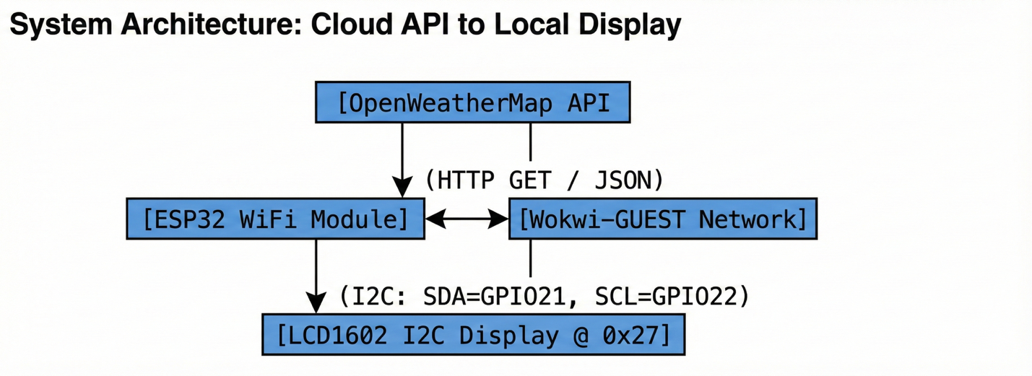

3. Links
Wokwi Simulation: https://wokwi.com/projects/456814650004210689
GitHub Repository: https://github.com/JuniorAndChill/ENGR4321-Microcontrollers-Embedded-Systems/tree/main/SAR3

4. Source Code Explanation
The project uses the WiFi.h and HTTPClient libraries for network connectivity. The code is structured into three main components:
WiFi Configuration:
const char* ssid = "Wokwi-GUEST"; const char* password = "";
Wokwi requires the special network name "Wokwi-GUEST" with an empty password to enable simulated internet connectivity.
HTTP GET Request:
String url = "http://api.openweathermap.org/data/2.5/weather?q=" + city + "," + countryCode + "&units=metric&APPID=" + apiKey; http.begin(url); int code = http.GET();
The HTTPClient library handles the REST API communication. The OpenWeatherMap endpoint returns weather data in JSON format with temperature in metric units (Celsius).
JSON Parsing:
int tempIndex = json.indexOf("\"temp\":"); String tempStr = json.substring(tempIndex + 7, json.indexOf(",", tempIndex));
Simple string parsing extracts temperature and humidity values from the JSON response without requiring external JSON parsing libraries, keeping the code minimal and efficient for Wokwi compilation.

5. Discussion: System Behavior and Challenges
System Behavior
The ESP32 successfully initializes WiFi connectivity using the Wokwi-GUEST network. After establishing a connection, the system performs HTTP GET requests to the OpenWeatherMap API every 10 seconds. The JSON response containing weather data for New Braunfels, TX is parsed, and the extracted temperature and humidity values are displayed on the LCD. The Serial Monitor provides debugging output showing the raw JSON response and connection status.
Technical Challenges
Several challenges were encountered during development:
1. Library Compilation Issues: The Arduino_JSON library caused extended compilation times and occasional failures in Wokwi. This was resolved by implementing manual string parsing instead of relying on the JSON library, significantly reducing code complexity and compilation time.
2. Network Configuration: Wokwi requires specific network settings. The wokwi.toml configuration file must include [net] enable = true to allow HTTP requests. Additionally, the SSID must be exactly "Wokwi-GUEST" with an empty password.
3. URL Encoding: City names with spaces (e.g., "New Braunfels") initially caused API errors. The HTTPClient library handles URL encoding automatically when spaces are included directly in the string.
4. I2C LCD Integration: The LCD1602 I2C display required proper pin mapping (SDA to GPIO21, SCL to GPIO22) and the correct I2C address (0x27). The degree symbol for temperature display was implemented using the ASCII character code 223.
Conclusion
This project successfully demonstrates ESP32 WiFi connectivity, cloud API integration, and real-time data display in a simulated environment. The simplified code approach ensures reliable compilation in Wokwi while maintaining all required IoT functionality including WiFi connection, HTTP communication, JSON data exchange, and LCD output.

