
Republic of the Philippnes
Department of Education
Cordillera Administrative Region
SCHOOLS DIVISION BAGUIO CITY

Enclosure 1 to Division Memorandum
Annex A: ANECDOTAL RECORD (for learners manifesting difficulties)
Instructions for use:
This form shall be accomplished by each subject teacher, with one form per learner.
Observations and initial interventions must be gathered and implemented over a period of one (1)to three (3) weeks, or sooner if the manifested difficulty observed is of significant concern.
Submit completed forms to the Class Adviser for consolidation and referral to the Multidisciplinary Team (MDT)/ SNED coordinator for intervention planning.
All entries must reflect actual observed classroom behavior, performance, or participation.
Ensure confidentiality, and secure parental/ guardian consent prior to MDT discussions or referral to programs such as pull-out classes.
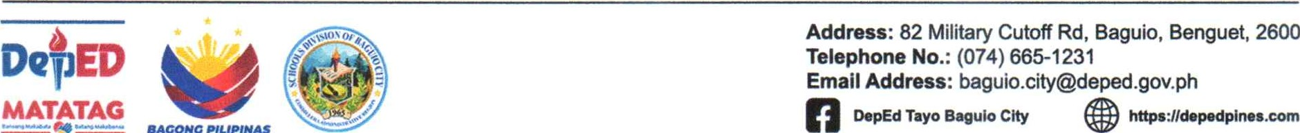
I. Learner Profile
Name of Learner: |  | Grade &  Section:
Sub ect Teacher: |  | Class Adviser:
Subject Area Observed: |  | Observation Period:

Il. Details of Observations
Activity/  Context of  Observation | Observed  Difficulty | Intervention/  Strategy Used | Impact on Learning/ Participation
Ill. Summary and Teacher Recommendation
Example:

