This is the sample Day One Book’s Title
  - This is the book’s subtitle
John Doe, Joe Bloggs
2026-01-10
Table of Contents

List of Figures

List of Tables

1 Goal of this Article
This article provides a detailed overview of Filter-Based Forwarding (FBF), also known as Policy-Based Routing (PBR), on MX Series routers (AFT), using common deployment scenarios to illustrate configuration methods.
The Filter-Based Forwarding (FBF) concept is relatively simple. On ingress, filtering (via the Firewall Filter toolkit) is applied before the the source or destination route lookup. The diagram below illustrates this process. In a standard routing scenario without any constraints, the destination IP from the IP datagram is used for a rou te lookup (using Longest Prefix Match), which returns a next-hop and an associated egress interface. (Encapsulation may occur prior to egress.)
With FBF, we alter the ingress lookup behavior in one of the following ways:
- Forcing traffic to exit through a specific egress port;
- Using a “proxy” or alias IP address as the lookup key (as shown in our example below);
- Leveraging a specific, constrained forwarding instance to influence the lookup outcome.
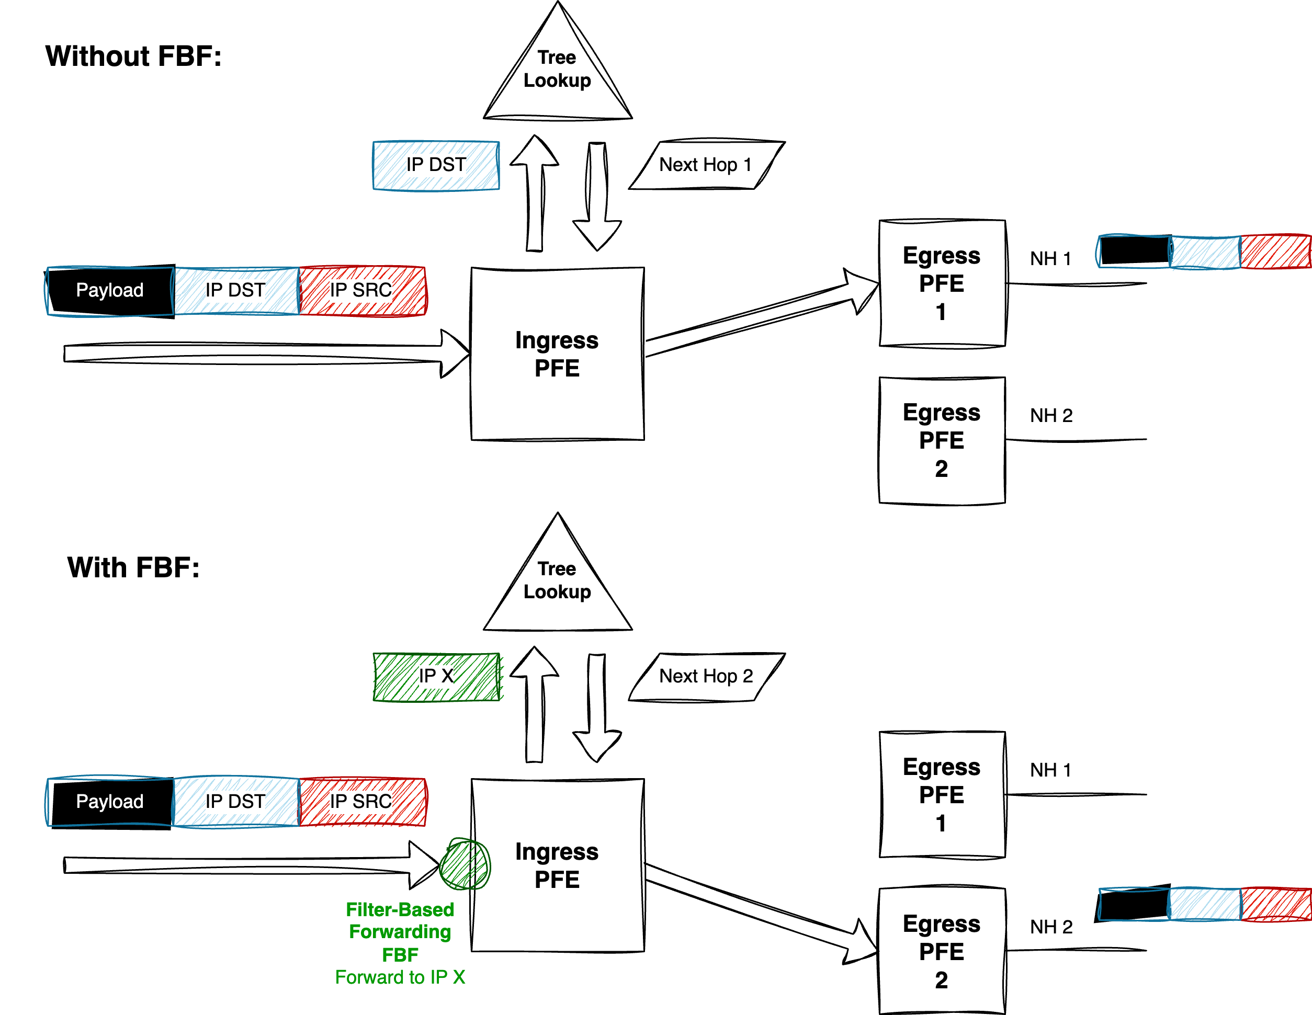
FBF concepts
To summarize, on Juniper platforms, FBF can generally be implemented using two main approaches. The first is more straightforward and involves minimal configuration, but offers limited flexibility. It uses a single firewall filter to directly redirect traffic. The second approach requires slightly more configuration but offers more granular traffic handling.
All examples are based on Junos OS release 24.2. We’ll begin with the simpler method.

2 Case 1 - FBF Using next-ip / next-interface Actions
RLI 14784 introduces two new terminating actions in firewall filters:
- next-interface routing-instance
- next-ip routing-instance
Note: IPv6 is also supported via the next-ip6 variant.
These actions are terminating, meaning there’s no need to include an explicit accept statement. Both are supported under the inet and inet6 families.
The typical usage for these actions is illustrated below:
firewall {
family inet|inet6 {
filter foo {
from {
Any from the set of ip match conditions
} then {
next-interface <intf-name> routing-instance <RI-name>
}
}
}
family inet {
filter foo4 {
from {
Any from the set of ipv4 match conditions
} then {
next-ip <prefix> routing-instance <RI-name>
}
}
}
family inet6 {
filter foo6 {
from {
Any from the set of ipv6 match conditions
} then {
next-ip6 <prefix> routing-instance <RI-name>
}
}
}
}

2.1 Overall Behavior
When a packet matches a term using one of the below actions:
- next-interface: The system verifies the operational state of the specified interface, along with the availability of an ARP (or ND for IPv6) entry for the next-hop. If a routing-instance is specified, the interface lookup is performed within that context. If all conditions are met, the packet is forwarded via the corresponding egress IFL. If the interface is down or unresolved, the packet is dropped.
- next-ip(6): The IP address specified in next-ip or next-ip6 is not automatically resolved. On Ethernet interfaces, reachability must be ensured through routing-either via dynamic protocols or static routes. If a matching route (exact or more specific) is found, the packet follows the next-hop associated with that route. If no matching route exists, the packet is rejected.
Read carefully: if next-ip address becomes unreachable the default approch is to point the traffic to the default reject next-hop. Traffic rejected are thus punted to the RE for sending back an ICMP unreachable. However, no worries about “overloading” the internal host-path. Indeed, there is a default DDOS protection policer that will rate-limit those rejected punted packets to 2Kpps. We will see later, how to handle this behavior in case you want silencly discard the packet when next-ip address becomes unreachable.

2.2 Caveats
Known limitations include:
- Supported only for ingress filtering
- No fallback mechanism (The EVO exact match option is not supported)
- Not supported on LT interfaces

2.3 Example 1 - topology
The diagram below illustrates the topology used to demonstrate simple FBF on an MX platform.
The Device Under Test (DUT) is an MX480 equipped with an MPC10E line card.
This simplified setup represents a typical DCI router connected to an IP Fabric, providing access to remote resources via two distinct paths:
- A quality path through an MPLS/SR core network, and
- A best-effort path via a direct peering or transit (PNI) connection.
By default, remote resources are reached via the direct PNI link. The DUT hosts an Internet VRF, which is also used by a remote ASBR in the same AS. This ASBR advertises “public/remote” prefixes to all PE routers-including the DUT-via L3VPN (inet-vpn). The direct PNI interface is also part of the Internet VRF.
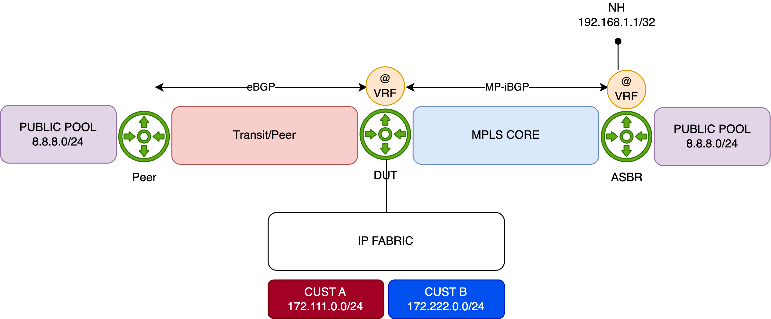
Network topology
For demonstration purposes, the remote resource is simulated using the public prefix 8.8.8.0/24. This prefix is preferred by default via the direct PNI, with a backup path available through the MPLS/SR core:
regress@rtme-mx-62> show route 8.8.8.0/24
VRF1.inet.0: 9 destinations, 13 routes (9 active, 0 holddown, 0 hidden)
+ = Active Route, - = Last Active, * = Both
8.8.8.0/24 *[BGP/170] 00:00:04, localpref 10000
AS path: 1234 6000 I, validation-state: unverified
> to 172.16.8.1 via et-2/0/0.0 <<< Via PNI
[BGP/170] 21:23:18, localpref 100, from 193.252.102.201
AS path: I, validation-state: unverified
> to 172.16.1.1 via et-5/0/0.0, Push 16, Push 20103(top) <<< Via MPLS/SR Core
The IP Fabric serves two customer types-A and B-represented by IP prefixes 172.111.0.0/24 and 172.222.0.0/24, respectively. The DUT exchanges IP traffic with these customers directly.
This is just a table for test:
Interface Naming of the 6xQSFPP PIC
PFE COMPLEX | Port Number | 10GE mode | 40GE or 100GE modes
EA ASIC 0 | 0 | xe-x/1/0:[0..3] | et-x/1/0
 | 1 | xe-x/1/1:[0..3] | et-x/1/1
 | 2 | xe-x/1/2:[0..3] | et-x/1/2
 | 3 | xe-x/1/3:[0..3] | et-x/1/3
EA ASIC 1 | 4 | xe-x/1/4:[0..3] | et-x/1/4
 | 5 | xe-x/1/5:[0..3] | et-x/1/5
 | 6 | xe-x/1/6:[0..3] | et-x/1/6
 | 7 | xe-x/1/7:[0..3] | et-x/1/7
EA ASIC 2 | 8 | xe-x/1/8:[0..3] | et-x/1/8
 | 9 | xe-x/1/9:[0..3] | et-x/1/9
 | 10 | xe-x/1/10:[0..3] | et-x/1/10
 | 11 | xe-x/1/11:[0..3] | et-x/1/11
Initial Configuration
Below is the initial configuration for the DUT’s Internet VRF, kept simple for clarity:
- The DUT receives customer prefixes via eBGP from the peer group FABRIC.
- It receives public prefixes from the peer ASBR via eBGP, with an import policy (PREF) setting a high local preference to make this path the best.
- Two interfaces belong to the Internet VRF-one facing the IP Fabric, and the other towards the PNI peer.
- The DUT also connects to the MPLS core, running IS-IS with Segment Routing for label distribution.
regress@rtme-mx-62> show configuration routing-instances VRF1
instance-type vrf;
protocols {
bgp {
group FABRIC {
type external;
local-address 172.16.0.4;
peer-as 5000;
neighbor 172.16.0.5;
}
group PEER {
type external;
local-address 172.16.8.0;
import PREF;
family inet {
unicast;
}
peer-as 1234;
neighbor 172.16.8.1;
}
}
}
interface et-4/0/0.0;
interface et-5/2/0.100;
route-distinguisher 193.252.102.101:1;
vrf-target target:65000:1234;
vrf-table-label;
Configuration of FBF
Using the previous topology, we demonstrate a typical FBF use case leveraging the next-ip action (the same behavior applies to next-ip6 and next-interface).
The objective is to override the default forwarding behavior-where traffic exits via the direct PNI interface-for traffic sourced from Customer B (172.222.0.0/24). Instead, traffic from this prefix should be redirected through the MPLS backbone, targeting the remote ASBR to reach the public resource.
Traffic from other sources will continue to follow the default “best path,” which remains the direct PNI link.
The diagram below illustrates this behavior:
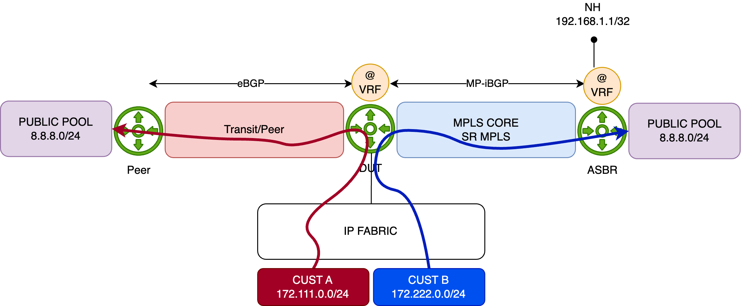
Source based forwarding with next-ip
How will we achieve this?
The configuration is straightforward. First, we define a firewall filter that matches the source prefix 172.222.0.0/24, and apply the next-ip action to redirect traffic.
Which next-ip address should be used?
That depends on the network design. In this example, we target the loopback address of the remote ASBR, which is advertised via BGP (L3VPN). As shown below, the route to this loopback is reachable through the MPLS/SR core via an established tunnel:
regress@rtme-mx-62> show route 192.168.1.1 table VRF1.inet
VRF1.inet.0: 9 destinations, 13 routes (9 active, 0 holddown, 0 hidden)
+ = Active Route, - = Last Active, * = Both
192.168.1.1/32 *[BGP/170] 20:42:26, localpref 100, from 193.252.102.201
AS path: I, validation-state: unverified
> to 172.16.1.1 via et-5/0/0.0, Push 16, Push 20103(top)
Now let’s configure the FBF filter. Since we’re operating within a VRF context, the routing-instance parameter is specified along with the next-ip action-this ensures that the next-hop lookup is performed in the correct FIB instance.
An additional term is included to match all remaining traffic, allowing it to follow the default forwarding behavior.
family inet {
filter FBF {
term PBR_CUSTOMER_B {
from {
source-address {
172.222.0.0/24;
}
}
then {
count CUSTOMERB;
next-ip 192.168.1.1/32 routing-instance VRF1;
}
}
term OTHER {
then {
count OTHER;
accept;
}
}
}
}
Before applying the filter, we’ll generate traffic from Customer A and Customer B. To distinguish between the two flows, we configure the traffic rates as follows:
- Customer A: 1000 packets per second (pps)
- Customer B: 5000 packets per second (pps)
Both customers will send traffic toward the 8.8.8.0/24 prefix.
We now start the traffic and verify the statistics on the PNI interface:
regress@rtme-mx-62> monitor interface et-2/0/0.0
<- truncated output ->
Remote statistics:
Input bytes: 132708516 (0 bps) [0]
Output bytes: 48292808336 (23518344 bps) [11195520]
Input packets: 270844 (0 pps) [0]
Output packets: 98556757 (6000 pps) [22848] <<< Customer A + Customer B traffics
At this point, all traffic is following the best active path-via the PNI interface-to reach the 8.8.8.0/24 prefix.
Another table just for test:
Interface Naming of the 4xQSFPP PIC
PFE COMPLEX | Port Number | 10GE mode | 40GE or 100GE mode
EA ASIC 0 | 0 | xe-0/0/0:[0..3] | et-0/0/0
 | 1 | xe-0/0/1:[0..3] | et-0/0/1
 | 2 | xe-0/0/2:[0..3] | et-0/0/2
 | 3 | xe-0/0/3:[0..3] | et-0/0/3
We now apply the FBF filter in the ingress direction on the interface connected to the IP Fabric:
edit private
set interfaces et-5/2/0 unit 100 family inet filter input FBF
commit comment "ADD_FBF" and-quit
And then, recheck the PNI interface statistics:
regress@rtme-mx-62> monitor interface et-2/0/0.0
Interface: et-2/0/0.0, Enabled, Link is Up
<- truncated output ->
Remote statistics:
Input bytes: 132708516 (0 bps) [0]
Output bytes: 49128737556 (3921056 bps) [0]
Input packets: 270844 (0 pps) [0]
Output packets: 100262735 (1000 pps) [0] <<< Only Customer A traffic
The FBF filter is functioning as expected. Only Customer A traffic continues to follow the default best path toward 8.8.8.0/24 via the PNI interface.
Next, we check the statistics on the core-facing interfaces to confirm that Customer B traffic is being properly redirected through the SR/MPLS tunnel as intended by the FBF configuration:
regress@rtme-mx-62> monitor interface et-5/0/0.0
Interface: et-5/0/0.0, Enabled, Link is Up
<- truncated output ->
Remote statistics:
Input bytes: 253750639 (584 bps) [0]
Output bytes: 57241664165 (19600072 bps) [0]
Input packets: 533880 (1 pps) [0]
Output packets: 116839924 (5000 pps) [0] <<< the tunneled Customer B traffic
Everything looks good! To demonstrate that there is no fallback mechanism with next-ip-based FBF, we’ll remove the loopback (192.168.1.1/32) announcement from the ASBR. As a result, the DUT will no longer have a route to the loopback, and the traffic will be dropped:
regress@rtme-mx-62> show route 192.168.1.1 table VRF1.inet
This means that traffic from Customer B should be dropped, which is exactly what we observe. As shown below, there is no longer any traffic on the Core interface, and Customer A traffic continues to flow through the PNI port.
regress@rtme-mx-62> monitor interface et-5/0/0.0
Interface: et-5/0/0.0, Enabled, Link is Up
<- truncated output ->
Remote statistics:
Input bytes: 253763429 (248 bps) [0]
Output bytes: 58533097602 (0 bps) [57]
Input packets: 534091 (0 pps) [0]
Output packets: 119475689 (0 pps) [1] <<< Customer B traffic dropped
monitor interface et-2/0/0.0
Interface: et-2/0/0.0, Enabled, Link is Up
<- truncated output ->
Remote statistics:
Input bytes: 132708516 (296 bps) [0]
Output bytes: 49685006066 (3921096 bps) [0]
Input packets: 270844 (0 pps) [0]
Output packets: 101397976 (1000 pps) [0] <<< Customer A still forwarded
As discussed earlier, the default action when next-ip address becomes unreachable is to redirect traffic to the reject next-hop. Above, we issue a show route of the next-ip address and nothing was return as expected. Just now issue the show route forwarding-table:
regress@rtme-mx-62> show route forwarding-table destination 192.168.1.1 table VRF1
Routing table: VRF1.inet
Internet:
Destination Type RtRef Next hop Type Index NhRef Netif
default perm 0 rjct 695 1 <<< rjct = reject next-hop
The route points to reject next-hop in the FIB. As said, the next-hop will punted the packets to the RE for further processing (ICMP unreachable). As also mentioned those punted packet are rate-limited by the ASIC to 2kpps. We can verify this behavior, by checking the DDOS protection statistics for the “reject” protocol:
regress@rtme-mx-62> show ddos-protection protocols reject statistics terse
Packet types: 1, Received traffic: 1, Currently violated: 1
Protocol Packet Received Dropped Rate Violation State
group type (packets) (packets) (pps) counts
reject aggregate 6396663340756 6395549305435 5000 9 viol
We saw our 5K of Customer B traffic before being rate-limited. Issue the “violation” check command to see the rate-limit value of 2K pps:
regress@rtme-mx-62> show ddos-protection protocols violations
Packet types: 255, Currently violated: 1
Protocol Packet Bandwidth Arrival Peak Policer bandwidth
group type (pps) rate(pps) rate(pps) violation detected at
reject aggregate 2000 5000 11682678 2025-04-10 08:22:39 PDT <<< Bandwidth = rate-limit = 2k pps
Detected on: FPC-5
So it means our RE will received a maximum of 2K rejected packets and will generate 2K ICMP unreachable packets in reply. Just check our port connected to the IP Fabric and oh ! Suprise 2Kpps in output. These are our ICMP unreachable sent out back to the Customer B.
regress@rtme-mx-62> monitor interface et-2/0/0.0
Interface: et-2/0/0.0, Enabled, Link is Up
<- truncated output ->
Remote statistics:
Input bytes: 117022326356 (23519664 bps) [11197970]
Output bytes: 178738122 (895984 bps) [426496]
Input packets: 238821075 (6000 pps) [22853]
Output packets: 3191752 (2000 pps) [7616] <<< 2K ICMP Unreachable targeting Cust. B
How we can avoid that?
The easiest solution is to have in your FIB always a last resort route entry, that could be discard but why not a fallback path to route the next-ip address. In our case, if 192.168.1.1 deaseappers, we may want:
- to not reject/discard the traffic but move back to the PNI interface. For that we need to configure a static route pointing to PNI peer, with a higher preference as a backup path for 192.168.1.1. Let’s do simply add this static route in our VRF and check just after the commit the statistics of our PNI interface to see if all our 6K pps (A+B traffic) are forwarded back:
edit private
set routing-instances VRF1 routing-options static route 192.168.1.1/32 next-hop 172.16.8.1 preference 254
commit comment "ADD_BACKUP_NEXT_IP" and-quit
regress@rtme-mx-62> monitor interface et-2/0/0.0
Interface: et-2/0/0.0, Enabled, Link is Up
<- truncated output ->
Remote statistics:
Input bytes: 132708516 (0 bps) [0]
Output bytes: 50812435866 (23522568 bps) [5629120]
Input packets: 270844 (0 pps) [0]
Output packets: 103698854 (6000 pps) [11488] <<< We backup B traffic to PNI
- or to silently discard the traffic. In this scenario we can create a static route with higher preference pointing to discard next-hop. In our case, I’ve just added a default discard route in the VRF. so, if 192.168.1.1/32 is not announce anymore, the lookup of the next-ip address will fall back to this default discard instead of matching the default reject. Let’s remove the previous static route and add the new default one:
edit private
delete routing-instances VRF1 routing-options static route 192.168.1.1/32
set routing-instances VRF1 routing-options static route 0.0.0.0/0 discard
commit comment "ADD_DEFAULT" and-quit
So, with this last configuration, our Customer B traffic should be now silently discared and we shouldn’t observe DDOS protocol violation and ICMP unreachable traffic:
regress@rtme-mx-62> monitor interface et-2/0/0.0
Interface: et-2/0/0.0, Enabled, Link is Up
Flags: SNMP-Traps 0x4000
Encapsulation: ENET2
Local statistics: Current delta
Input bytes: 216186 [0]
Output bytes: 505399 [0]
Input packets: 3530 [0]
Output packets: 6274 [0]
Remote statistics:
Input bytes: 119682374166 (23516136 bps) [5628630]
Output bytes: 230359258 (0 bps) [0]
Input packets: 244249744 (5999 pps) [11487]
Output packets: 4113558 (0 pps) [0] <<< No more ICMP Unreach.
regress@rtme-mx-62> show ddos-protection protocols violations
Packet types: 255, Currently violated: 0 <<< No more Violation

2.4 PFE analysis
Now, let’s re-announce the 192.168.1.1/32 prefix and examine how the FBF filter is applied on the PFE. Begin by running the following command to access the PFE CLI:
regress@rtme-mx-62> start shell pfe network fpc5
Next, list all the filters available on the linecard:
root@rtme-mx-62-fpc5:pfe> show firewall
Name Index Token Status
FBF 1 2875 DMEM
<- truncated output ->
Now resolve the token index 2875 to display the filter’s program:
root@rtme-mx-62-fpc5:pfe> show sandbox token 22571514
<- truncated output ->
Filter properties: None
Filter state = CONSISTENT
term PBR_CUSTOMER_B
term priority 0
source-address
172.222.0/24
false branch to match action in rule OTHER
then
accept
count CUSTOMERB
Policy Route:
Destination Prefix: 192.168.1.1
Routing instance: VRF1
Policy route action is valid: TRUE
term OTHER
term priority 0
then
accept
count OTHER
Previous nodes count: 1
Next nodes count : 0
Entries count : 0
The above output shows the filter program optimized by the Firewall Filter compiler. To display the actual program pushed into hardware, use the following PFE commands:
root@rtme-mx-62-fpc5:pfe> show firewall instance
Name,Index Instance Key InstanceToken LinkCount
FBF,1 no-next-filter-0 5424 1
<- truncated output ->
Then, run this second command using the Token ID 5424, retrieved from the previous step:
root@rtme-mx-62-fpc5:pfe> show sandbox token 5424
<- truncated output ->
JNH_FW_START:
opcode = 0x0000000c
anonymous_union_0 = 0x00008605
filter_id = 0x00000000
cntr_base = 0x00000001
flt_base = 0x00000000
base_ptr = 0x000255af
Filter is not interface specific 1
Current context : 0.
Pfe Inst:0 Hw Instance 1, type:1 op:2 ref 0
Counter Base:- 0x5400f8
Policer Base:- 0
Number of counters : 2 (including PSAs)
term PBR_CUSTOMER_B (pfe-inst 0)
Start Addr :- 0x8605
Stop Addr :- 0x8607
Stop NH :- 0x6808255ab012ad58
Decoding :- FW_STOP: pdesc:0x104ab56 desc:0x4ab56
Action Addr :- 0x4ab56
Action NH :- 0x812aed800010000
match type: prefix
loc: 0x8605 nh: 0x7e30004002800000
FW_4BMATCH: fwop:0 desc:0x8005 koffset:396 boffset:0 mask:0x149c00e8 data:0x7fb7
Inst: 0 Action-Type: 134
JNH :- 0x2bfffffd00000300: <<< count CUSTOMERB;
CounterNH: Relative Base = 1, Offset = 0x0, nextNH = 0xffffff
Inst: 0 Action-Type: 0
JNH :- 0x201282240000000c: <<< next-ip 192.168.1.1/32 routing-instance VRF1;
UcodeNH: Indirect Decode: Indirect, Next = 0x4a089, pnh_id = 0, ,
<- truncated output ->
Pick the JNH dword corresponding to the next-ip action 0x201282240000000c (line 40), and decode it:
root@rtme-mx-62-fpc5:pfe> show jnh decode word 0x201282240000000c inst 2
UcodeNH: Indirect Decode: Indirect, Next = 0x4a089, pnh_id = 0,
UcodeNH will run a micro-code sequence. Here, it is an indirection to a virtual address found in the Next field. To read the data at 0x4a089, run:
root@rtme-mx-62-fpc5:pfe> show jnh vread vaddr 0x4a089 NH inst 2
Addr:Nexthop 0x4a089 Paddr:0x104a089, Data = 0x0812659400040000
This returns two key values:
- Paddr (physical address): 0x104a089
- Data read: 0x0812659400040000
Note: To read a physical address, use show pread paddr xxx.
Since the value is a JNH word, decode it again. This time it reveals a CallNH, a list of ordered next-hops (when mode=0):
root@rtme-mx-62-fpc5:pfe> show jnh decode word 0x0812659400040000 inst 2
CallNH:desc_ptr:0x49965, mode=0, count=0x5
0x049960 0 : 0x168c000000000000
0x049961 1 : 0x40101ffffff81510
0x049962 2 : 0x40181fffffe02030
0x049963 3 : 0x1810318200200008
0x049964 4 : 0x23fffffc00000001 <<< this one will be skipped - related to fabric encap.
Now decode each action (excluding the fifth one, which is outside the scope of this article):
- The first is a ModifyNH, which modifies local memory - in this case, resetting the encapsulation length:
root@rtme-mx-62-fpc5:pfe> show jnh decode word 0x168c000000000000 inst 2
ModifyNH: Subcode=Misc(26)
(Reset encap len)
- The second and third entries are BitOpNH actions, performing operations on specific data:
root@rtme-mx-62-fpc5:pfe> show jnh decode word 0x40101ffffff81510 inst 2
BitOpNH: opcode=0x00000008, data32=0, desc_ptr=0xffffff, key=0x4/0 PPPoE Session ID, op=0, data=49320, nbits=16
root@rtme-mx-62-fpc5:pfe> show jnh decode word 0x40181fffffe02030 inst 2
BitOpNH: opcode=0x00000008, data32=0, desc_ptr=0xffffff, key=0x6/0 Unknown, op=0, data=257, nbits=16
These actions extract the next-ip address from local memory in two steps:
- First, we fetch 49320 (0xC0A8 = 192.168)
- Then, we fetch 257 (0x0101 = 1.1)
Combined, we recover the next-ip address from our FBF filter: 192.168.1.1. This is a “key” that will be used for further processing (route lookup).
- The fourth NH in the list 0x1810318200200008 is a KTREE structure used for route lookup:
A KTREE is Juniper’s implementation of a binary structure known as a Patricia Tree.
root@rtme-mx-62-fpc5:pfe> show jnh decode word 0x1810318200200008 inst 2
KtreeNH: skip=8, sw_token=0, arOffset=0, mode=1, descPtr=0xc60800, key=0x4/0 LookupKey
To dump the full KTREE, use:
root@rtme-mx-62-fpc5:pfe> show jnh decode word 0x1810318200200008 inst 2 ktree yes dump yes
Route Depth JNH
------------------------------------ ------ ------------------
Default 0 0x0812ad6000000000
00000000/32 1 0x0812a08400000000
080808/24 1 0x08129d0400000000
acde00/24 2 0x08129df400000000
ac6f00/24 2 0x08129df400000000
ac100800/31 3 0x000000000004ab3c
ac100801/32 4 0x0812ade000000000
ac100800/32 4 0x0812ac9800010000
ac100004/31 3 0x000000000004abc0
ac100005/32 4 0x08129d4800000000
ac100004/32 4 0x0812aec800010000
c0a80101/32 1 0x08129a1800000000 <<< 192.168.1.1/32
e0000001/32 1 0x0812a0c400000000
ffffffff/32 1 0x0812a0e400000000
Routes found: 14, Bytes used: 6664
This KTREE acts as the FIB for our VRF1 instance. For instance, traffic hitting the 192.168.1.1/32 prefix is redirected to the action identified by the JNH word 0x08129a1800000000, pointing to a CallNH:
root@rtme-mx-62-fpc5:pfe> show jnh decode word 0x08129a1800000000 inst 2
CallNH:desc_ptr:0x4a686, mode=0, count=0x1
0x04a685 0 : 0x20129af00000000c
This value (0x20129af00000000c) is another UcodeNH indirection:
root@rtme-mx-62-fpc5:pfe> show jnh decode word 0x20129af00000000c inst 2
UcodeNH: Indirect Decode: Indirect, Next = 0x4a6bc, pnh_id = 0, ,
To follow the indirection, read the next-hop at 0x4a6bc:
root@rtme-mx-62-fpc5:pfe> show jnh vread vaddr 0x4a6bc NH inst 2
Addr:Nexthop 0x4a6bc Paddr:0x104a6bc, Data = 0x08129ad400000000
Once again, decode the JNH word retrieved from the virtual memory address - it points to another CallNH list:
root@rtme-mx-62-fpc5:pfe> show jnh decode word 0x08129ad400000000 inst 2
CallNH:desc_ptr:0x4a6b5, mode=0, count=0x1
0x04a6b4 0 : 0x11c0000000026c14
Decode the final NH word 0x11c0000000026c14:
root@rtme-mx-62-fpc5:pfe> show jnh decode word 0x11c0000000026c14 inst 2
ModifyNH: Subcode=SetNH-Token(7),Desc=0x0,Data=0x26c14,NextNH=0
(pfeDest:20, TokenIdMode:0/ , VC memberId:0, isReass:0, token:0x26c/620)
We’ve reached the final forwarding action - setting the forwarding NH index via the NH Token. Here, the token 0x26c corresponds to the NH ID from our route lookup.
To get more info on this next-hop:
root@rtme-mx-62-fpc5:pfe> show nh db index 0x26c
Index Type Func-Type Proto Nh-Flags Ifl-Name Ifl-Index Nh-Token Nh-Prefix
620 Unicast - ipv4_tag 0x41 et-5/0/0.0 356 5519 ac100101/32
Perfect - this confirms that the traffic is forwarded via the correct path: our core-facing interface et-5/0/0.0 and doesn’t follow anymore the “best path”.
To go further (e.g., check Layer 2 headers or MPLS encapsulation), use:
root@rtme-mx-62-fpc5:pfe> show nh detail index 0x26c
Nexthop Info:
NH Index : 620
NH Type : Unicast
NH Proto : ipv4_tag
NH Flags : 0x41
IF Name : et-5/0/0.0
Prefix : ac100101/32
NH Token Id : 5519
NH Route Table Id : 0
Sgid : 0
OIF Index : 356
Underlying IFL : .local..0 (0)
Session Id : 788
Num Tags : 2
Label : 0x4e87eff0 (20103)lbFlags: 0
Label : 0x10fff000 (16)lbFlags: 0
MTU : 0
L2 Length : 12
L2 Data : 00:00:01:64:80:00:a8:d0:e5:ef:6a:87
Filter Index : 0
Platform Info
-------------
FabricToken: 5527
EgressToken: 5526
IngressFeatures:
Container token: 5519
#5 SetNhToken tokens:
Mask : 0x0
[ SetNhToken:5518 ]
EgressFeatures:
Container token: 5526
#2 PushLabels tokens:
Mask : 0x0
[ PushLabels:5522 Token-1:5520 Token-2:5521 ]
#4 StatsCounter tokens:
Mask : 0x1
[ StatsCounter:5523 ]
#11 UcastEncap tokens:
Mask : 0x0
[ UcastEncap:5524 ]
#12 SetOIF tokens:
Mask : 0x0
[ SetOIF:5525 ]
The figure below summarizes our packet walkthrough and highlights the main FBF steps:
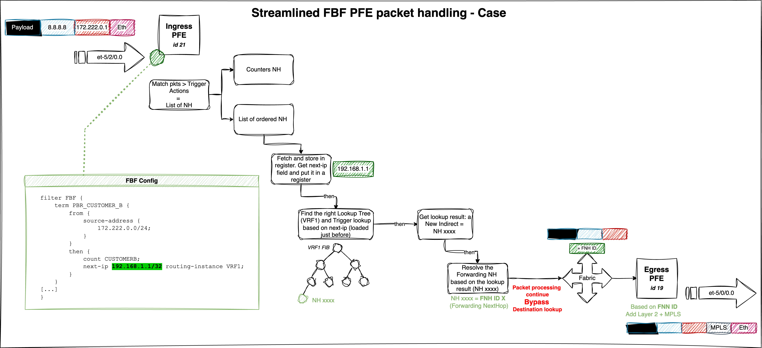
FBF next-ip at PFE level
And that wraps up part one. Take a break - in part two, we’ll dive into configuring FBF thanks to the rib-group feature.

3 Case 2 - FBF Using forwarding instance
The second approach to achieving Filter-Based Forwarding (FBF) leverages the forwarding-type routing instance. In this method, the FBF filter term action redirects traffic to a specific routing instance of type forwarding.
This solution is considered the legacy approach and is widely supported on MX platforms. Compared to Case 1, it requires a deeper understanding of the rib-group concept. The following section will elucidate the necessary concepts to effectively implement FBF using this method.

3.1 rib-group Concept
A RIB group on Juniper devices enables routes learned in one routing table (the source or initial RIB) to be simultaneously installed into multiple routing tables (the destination RIBs). This feature is commonly utilized to share routes between routing instances (VRFs) or between the global routing table and a VRF. Policies can control which routes are imported, making RIB groups a flexible method for internal route redistribution without relying on BGP or other protocols.
Without a RIB group, each protocol - depending on the address family - feeds routes into a default routing table. In the context of RIB groups, this default table is referred to as the source or initial RIB. Similarly, protocols fetch routes (for a given family) from this default table when exporting routes.
The figure below illustrates the default routing behavior:
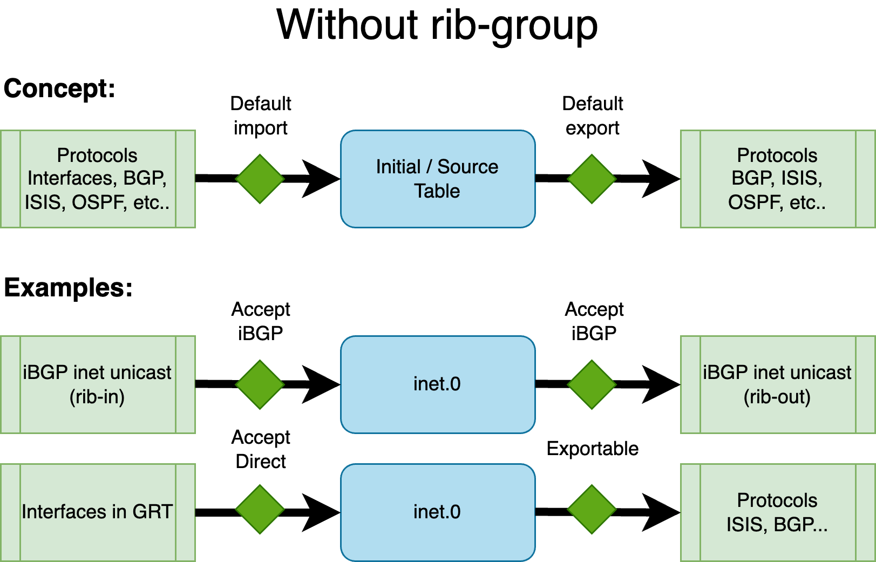
Default routing table management
As shown above, for BGP with the inet family (IPv4 unicast), the default routing table in the global context is inet.0 - both for importing and exporting routes. Similarly, interface IPv4 addresses (direct routes) in the global context also reside in inet.0.
To leak routes from one table to another, the RIB group feature is employed, configured under routing-options. A RIB group is defined with the following parameters:
[edit routing-options]
rib-groups {
<rib-group-name> {
import-rib [ <source_table> <destination_table_1> <destination_table_2> ... ];
import-policy <rib-group-import-policy>;
export-policy <rib-group-export-policy>;
}
}
Note: import-policy and export-policy are optional, but at least one destination table must be specified in import-rib.
The import-rib statement is crucial. The order of tables matters: the first table is the source (or initial, standard, contributing) table. This is the default RIB associated with a given protocol/family combination. With a RIB group, routes are taken from this source table and replicated into one or more destination tables.
The RIB group establishes a link between the source RIB and the destination RIBs. The import-policy provides fine-grained control, allowing only specific routes or protocols to be leaked to the destination tables. Similarly, export-policy controls which routes from the destination tables are eligible for export by routing protocols.
The next figure illustrates the concept:
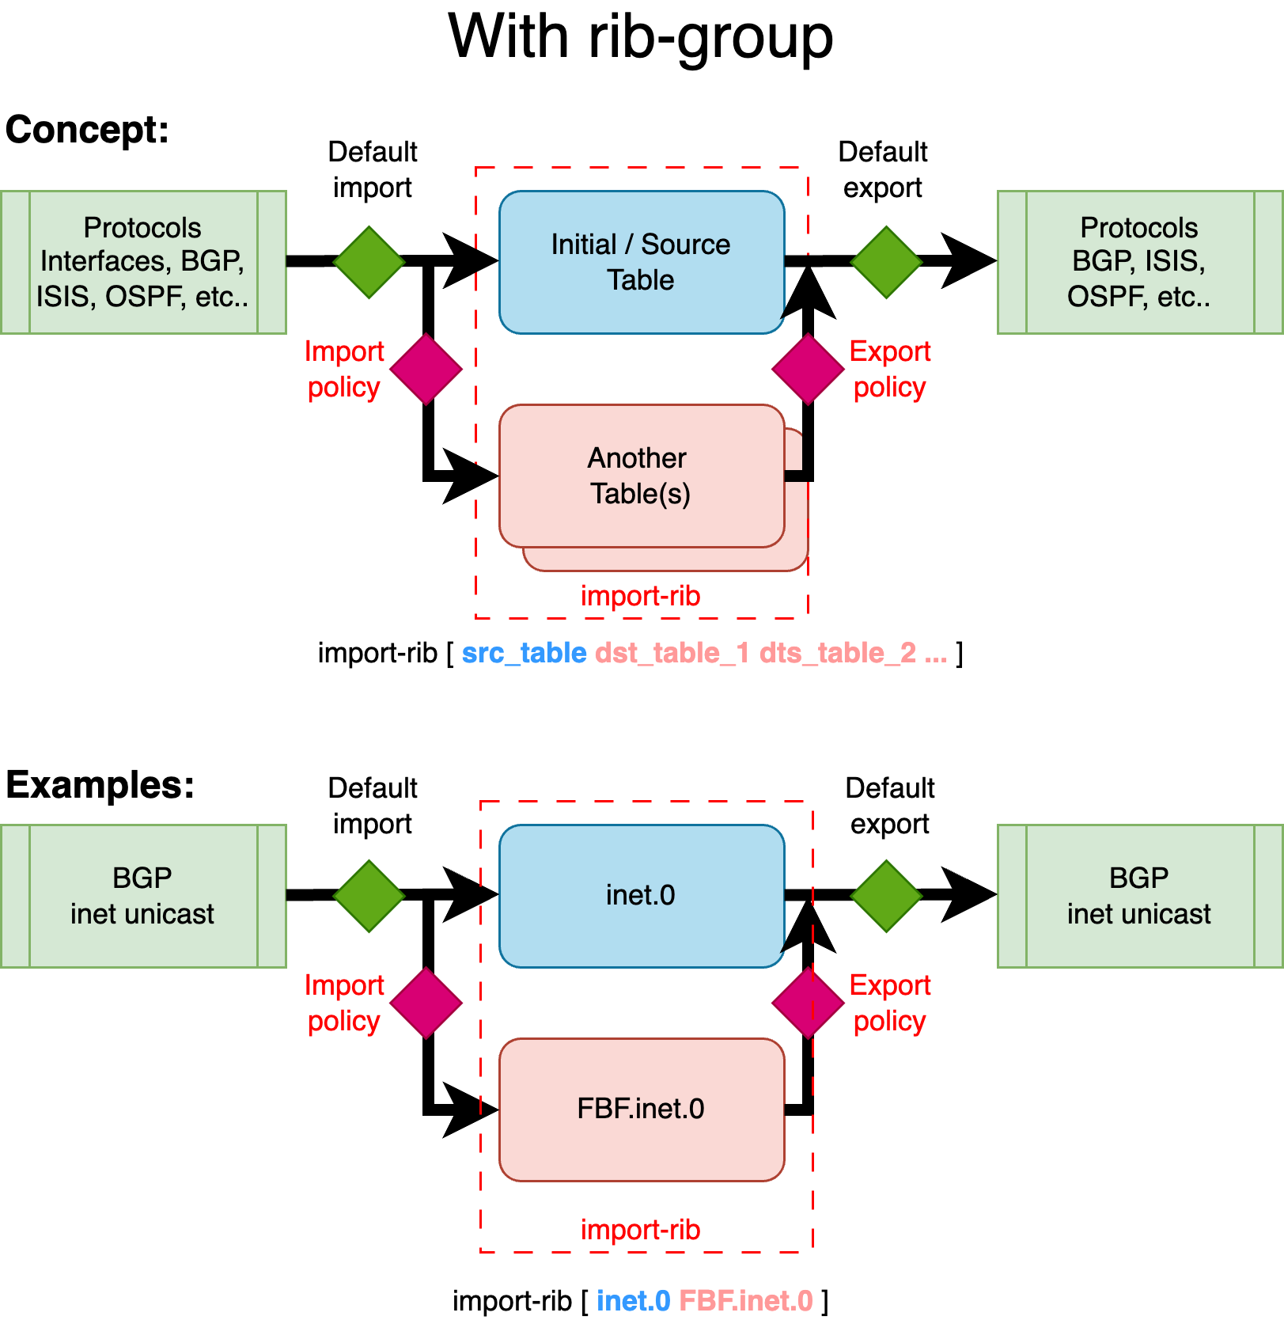
Routes leaking thanks to rib-group feature
This example demonstrates how BGP unicast routes from the global routing context are leaked into a new routing table (or instance) called FBF. While these routes remain in their default (source) table - inet.0 - they are also copied into an additional table, in this case, the destination FBF.inet.0, using a RIB group.
In the context of Filter-Based Forwarding (FBF), this allows you to constrain routing decisions to a specific set of routes - not by using the standard FIB, but by relying on a custom FIB built from the custom destination RIB. This destination RIB can be selectively populated with only the routes you want to use for FBF-based traffic steering.
Let’s illustrate this second FBF method with an example.

3.2 Example 2 - Topology
The Device Under Test (DUT) is an MX480 equipped with an MPC10E line card.
This simplified setup represents a typical DCI router connected to an IP Fabric, providing access to remote resources via two distinct paths:
- A quality path through an MPLS/SR core network, and
- A best-effort path via a direct peering or transit (PNI) connection.
In this scenario, remote resources are reached via the direct PNI link connected in the Global Routing Table (GRT) and sent from the peer to our DUT via an eBGP session. The DUT also receives the same remote resources from a remote ASBR through an iBGP session. The remote ASBR sets the next-hop address of these routes with its Segment Routing node-SID (advertised in the ISIS SR domain). This allows for a BGP Free-core by tunneling traffic in a transport SR tunnel.
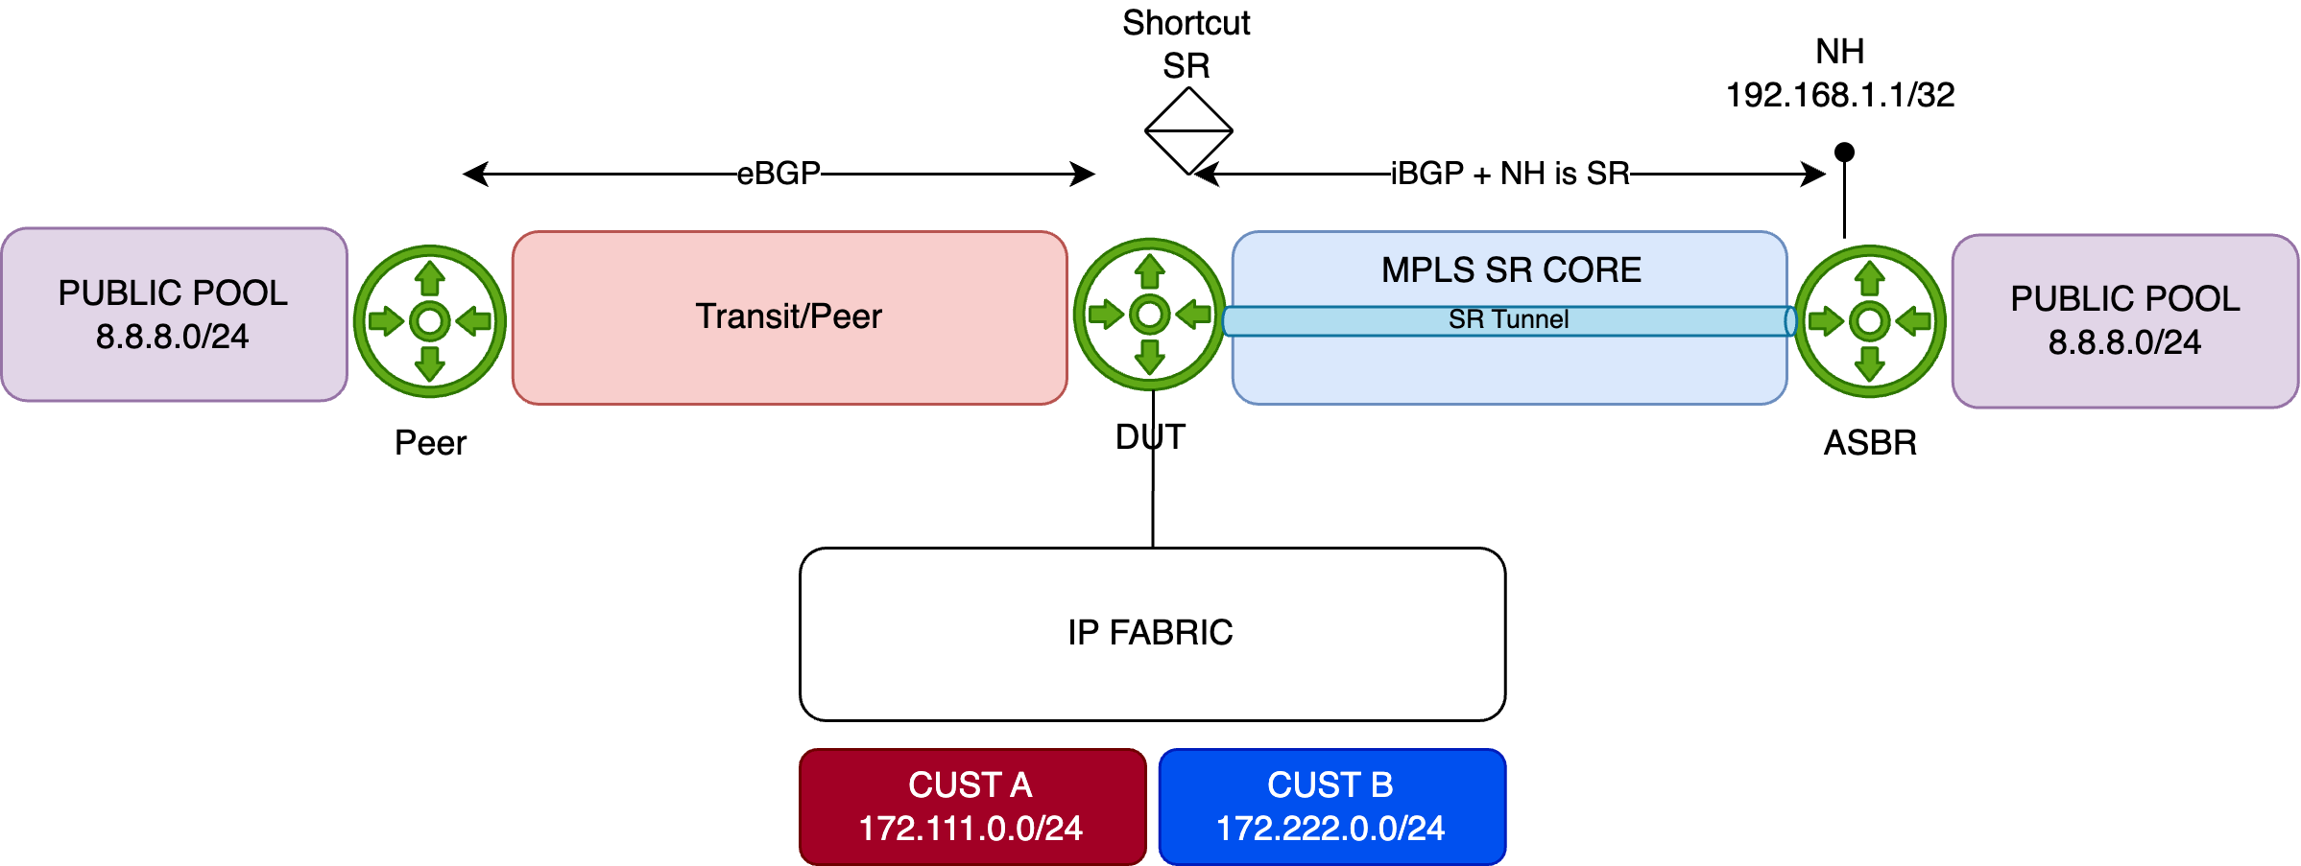
Network topology
For demonstration purposes, the remote resource is simulated using the public prefix 8.8.8.0/24. This prefix is preferred by default via the direct PNI, with a backup path available through the MPLS/SR core (shortcut SR):
regress@rtme-mx-62> show route 8.8.8.0/24
inet.0: 43 destinations, 44 routes (43 active, 0 holddown, 0 hidden)
+ = Active Route, - = Last Active, * = Both
8.8.8.0/24 *[BGP/170] 6d 17:31:10, localpref 10000
AS path: 1234 6000 I, validation-state: unverified
> to 172.16.8.1 via et-2/0/0.0 <<< PNI
[BGP/170] 00:00:11, localpref 50, from 193.252.102.2
AS path: I, validation-state: unverified
> to 172.16.1.1 via et-5/0/0.0, Push 20002 <<< SR Tunnel
Initial Configuration
Below is the initial configuration for the DUT, kept simple for clarity:
- The DUT receives customer prefixes via eBGP from the peer group FABRIC.
- The DUT receives public prefixes from the PNI peer-this is the primary/best path. A higher local-preference is set using the PREF import policy.
- It also receives public prefixes from the peer ASBR via iBGP-this is a backup path-remotely reachable through an MPLS SR Tunnel.
regress@rtme-mx-62> show configuration
protocols {
bgp {
group FABRIC {
type external;
local-address 172.16.0.4;
peer-as 5000;
neighbor 172.16.0.5;
}
group PEER {
type external;
local-address 172.16.8.0;
import PREF;
family inet {
unicast;
}
peer-as 1234;
neighbor 172.16.8.1;
}
group ASBR {
type internal;
local-address 193.252.102.101;
family inet {
unicast;
}
neighbor 193.252.102.2;
}
}
}
Configuration of FBF
The next steps involve creating a new routing instance (type forwarding) and leaking both the interface routes (i.e., direct routes for resolving the Layer 2 header) and the remote resources (in our case, 8.8.8.0/24), but only those announced by the core network - not those learned via the PNI.
First, create the FBF routing instance:
edit
load merge terminal relative
routing-instances {
FBF {
instance-type forwarding;
}
}
commit comment "add_fbf_ri"
Next, create a new rib-group called RG_FBF, establishing a relationship between the inet.0 table and FBF.inet.0. In other words, a relation between the default IPv4 table and the IPv4 table of our newly created FBF routing instance.
edit
load merge terminal relative
routing-options {
rib-groups {
RG_FBF {
import-rib [ inet.0 FBF.inet.0 ];
}
}
}
commit comment "add_rib-group"
Remember, the order inside the import-rib option is important. The first table is considered the source table, and the second one is the destination table. At this point, nothing is leaked between these two tables; this configuration merely establishes the relationship.
The first routes to leak are the direct interfaces attached to inet.0. This can be achieved with the following configuration under routing-options:
edit
load merge terminal relative
routing-options {
interface-routes {
rib-group inet RG_FBF;
}
}
commit comment "import-direct"
Once committed, you should see direct and local routes in the FBF.inet.0 table. Verify with:
regress@rtme-mx-62> show route table FBF.inet.0
FBF.inet.0: 10 destinations, 10 routes (10 active, 0 holddown, 0 hidden)
+ = Active Route, - = Last Active, * = Both
172.16.0.4/31 *[Direct/0] 6d 20:12:58
> via et-5/2/0.0 <<< Fabric
172.16.0.4/32 *[Local/0] 00:00:59
Local via et-5/2/0.0
172.16.1.0/31 *[Direct/0] 6d 20:12:58
> via et-5/0/0.0 <<< Core
172.16.1.0/32 *[Local/0] 00:00:59
Local via et-5/0/0.0
172.16.8.0/31 *[Direct/0] 6d 20:12:58
> via et-2/0/0.0 <<< PNI
172.16.8.0/32 *[Local/0] 00:00:59
Local via et-2/0/0.0
193.252.102.101/32 *[Direct/0] 6d 20:12:58
> via lo0.0
Everything looks good so far. The next step is to leak some BGP routes into the FBF routing table. But which ones?
Our goal is to redirect traffic entering this forwarding instance along a specific path - the one advertised by our remote ASBR. This route is available in the default inet.0 table as a backup path. To achieve this, we’ll configure BGP to use the RG_FBF rib-group. This rib-group allows routes normally imported into inet.0 to be simultaneously leaked into FBF.inet.0.
Let’s apply this on the ASBR peer-group:
edit
edit protocols
load merge terminal relative
bgp {
group ASBR {
type internal;
local-address 193.252.102.101;
family inet {
unicast {
rib-group RG_FBF; <<< This tells BGP to use the rib-group and specifies where to leak learned routes
}
}
neighbor 193.252.102.2;
}
}
commit comment "import_bgp"
With this configuration, all routes received from this peer-group will be leaked into FBF.inet.0. However, for demonstration purposes, we’ll restrict the leaking to a specific BGP prefix: 8.8.8.0/24.
To do that, we’ll use the import-policy feature of the rib-group. First, we define a policy to authorize leaking from inet.0 to FBF.inet.0, but only for:
- direct routes, and
- the BGP prefix 8.8.8.0/24
Here’s the policy definition, followed by its application to the RG_FBF rib-group:
edit
load merge terminal relative
policy-options {
policy-statement FBF_POLICY {
term LEAK_DIRECT {
from protocol direct;
then accept;
}
term LEAK_BGP {
from {
protocol bgp;
route-filter 8.8.8.0/24 orlonger;
}
then accept;
}
term REJECT_OTHER {
then reject;
}
}
}
routing-options {
rib-groups {
RG_FBF {
import-rib [ inet.0 FBF.inet.0 ];
import-policy FBF_POLICY; <<< controls which routes get leaked
}
}
}
commit comment "add_leaking_policy"
After committing, you can verify the result with:
regress@rtme-mx-62> show route table FBF.inet.0 protocol bgp
FBF.inet.0: 7 destinations, 7 routes (7 active, 0 holddown, 0 hidden)
+ = Active Route, - = Last Active, * = Both
8.8.8.0/24 *[BGP/170] 01:16:31, localpref 50, from 193.252.102.2
AS path: I, validation-state: unverified
> to 172.16.1.1 via et-5/0/0.0, Push 20002
Perfect - only the 8.8.8.0/24 prefix received from the internal ASBR is installed. The primary route via the PNI isn’t present in this instance and remains solely in the inet.0 table.
Now, to actually redirect the traffic, we’ll use a simple firewall filter. It will match traffic sourced from Customer B and redirect it to the FBF routing instance. This filter is applied to the physical interface connected to the IP Fabric:
edit
load merge terminal relative
firewall {
family inet {
filter FBF_FWD {
term CUSTOMER_B {
from {
source-address {
172.222.0.0/24;
}
}
then {
count FBF;
routing-instance FBF;
}
}
term other {
then {
count OTHER;
accept;
}
}
}
}
}
interfaces {
et-5/2/0 {
mtu 9200;
unit 0 {
family inet {
filter {
input FBF_FWD;
}
address 172.16.0.4/31;
}
}
}
}
commit comment "apply_fbf"
At this point, traffic should be redirected as expected:
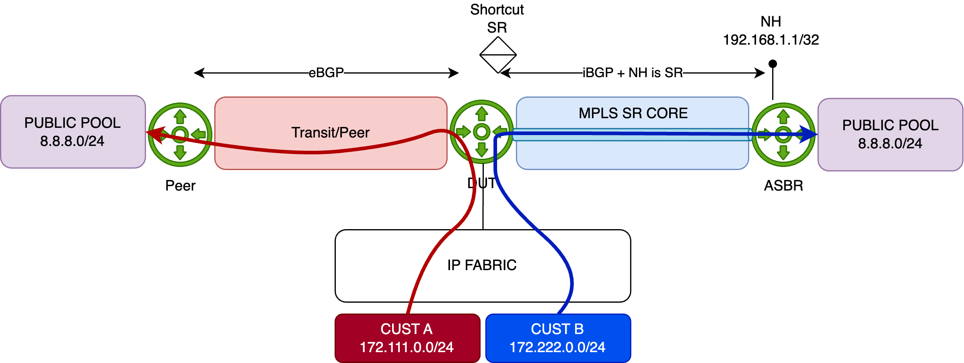
FBF in action
To help distinguish the flows, we’ve configured traffic rates as follows:
- Customer A: 1000 packets per second (pps)
- Customer B: 5000 packets per second (pps)
Let’s monitor the PNI interface. As expected, only Customer A traffic goes through it (1000pps):
regress@rtme-mx-62> monitor interface et-2/0/0.0
Interface: et-2/0/0.0, Enabled, Link is Up
<- truncated output ->
Remote statistics:
Input bytes: 132708516 (0 bps) [0]
Output bytes: 49128737556 (3921056 bps) [0]
Input packets: 270844 (0 pps) [0]
Output packets: 100262735 (1000 pps) [0] <<< Only Customer A traffic
Now let’s check the core-facing interface - we can see Customer B’s traffic being redirected via FBF to the ASBR:
regress@rtme-mx-62> monitor interface et-5/0/0.0
Interface: et-5/0/0.0, Enabled, Link is Up
<- truncated output ->
Remote statistics:
Input bytes: 253750639 (584 bps) [0]
Output bytes: 57241664165 (19600072 bps) [0]
Input packets: 533880 (1 pps) [0]
Output packets: 116839924 (5000 pps) [0] <<< the tunneled Customer B traffic
Now, what if the iBGP session to the ASBR drops, or the 8.8.8.0/24 prefix is no longer announced?
In that case, the route will vanish from FBF.inet.0, and the default reject route will take over:
regress@rtme-mx-62> show route forwarding-table destination 0.0.0.0/0 table FBF
Routing table: FBF.inet
Internet:
Destination Type RtRef Next hop Type Index NhRef Netif
default perm 0 rjct 520 1 <<< default reject route
Just like in Case 1, traffic to 8.8.8.0/24 will be rejected and punted to the routing engine (RE), which will respond with ICMP Unreachable messages (after being HW-policed to 2k pps).
To silently drop such packets instead of punting them, configure a static discard route as the default inside the FBF instance. But what if you want a fallback to the default routing table instead?
That’s simple. If fallback forwarding is needed, just configure a default route inside the FBF instance pointing to the inet.0 table. If 8.8.8.0/24 disappears, traffic is then forwarded via the primary PNI path through inet.0.
Here’s the configuration:
edit
load merge terminal relative
routing-instances {
FBF {
instance-type forwarding;
routing-options {
static {
route 0.0.0.0/0 next-table inet.0; <<< default fallback route
}
}
}
}
commit comment "add_fallback_route"

3.3 PFE analysis
Assuming the FBF configuration is active, let’s break down how the firewall filter behaves at the PFE level. Start by listing the filter instances:
regress@rtme-mx-62> start shell pfe network fpc5
root@rtme-mx-62-fpc5:pfe> show firewall instance
Name,Index Instance Key InstanceToken LinkCount
FBF_FWD,2 no-next-filter-0 4777 1
<- truncated output ->
Next, pick up the InstanceToken and resolve it using the following command:
root@rtme-mx-62-fpc5:pfe> show sandbox token 4777
<- truncated output ->
Pfe Inst:0 Hw Instance 1, type:1 op:2 ref 0
Counter Base:- 0x5400e8
Policer Base:- 0
Number of counters : 2 (including PSAs)
term CUSTOMER_B (pfe-inst 0)
Start Addr :- 0x85fc
Stop Addr :- 0x85fe
Stop NH :- 0x680825491812a48c
Decoding :- FW_STOP: pdesc:0x104a923 desc:0x4a923
Action Addr :- 0x4a923
Action NH :- 0x812a81c00020000
match type: prefix
loc: 0x85fc nh: 0x7e3000401e000000
FW_4BMATCH: fwop:0 desc:0x803c koffset:396 boffset:0 mask:0x149c00e8 data:0x7fb7
Inst: 0 Action-Type: 134
JNH :- 0x2bfffffd00000300:
CounterNH: Relative Base = 1, Offset = 0x0, nextNH = 0xffffff
Inst: 0 Action-Type: 0
JNH :- 0x23fffffc0000100c:
UcodeNH: Indirect Decode: Indirect, Next = 0xffffff, pnh_id = 0, ,
Inst: 0 Action-Type: 0
JNH :- 0x20129a4c0000000c:
UcodeNH: Indirect Decode: Indirect, Next = 0x4a693, pnh_id = 0, ,
<- truncated output ->
Focus on the Action NH (line 17) and decode the JNH word. As shown, this represents a chain of Next-hops:
The parameter inst below refers to the PFE id.
root@rtme-mx-62-fpc5:pfe> show jnh decode word 0x812a81c00020000 inst 2
CallNH:desc_ptr:0x4aa07, mode=0, count=0x3
0x04aa04 0 : 0x2bfffffd00000300 <<< Action Counter
0x04aa05 1 : 0x23fffffc0000100c <<< dummy action for clearing some internal states
0x04aa06 2 : 0x20129a4c0000000c <<< Action routing-instance FBF
Now let’s analyze the third action by decoding the JNH word 0x20129a4c0000000c - UcodeNH will execute a micro-code sequence:
root@rtme-mx-62-fpc5:pfe> show jnh decode word 0x20129a4c0000000c inst 2
UcodeNH: Indirect Decode: Indirect, Next = 0x4a693, pnh_id = 0, ,
This is an indirection to a virtual address found in the Next field. To read data at 0x4a693, use:
root@rtme-mx-62-fpc5:pfe> show jnh vread vaddr 0x4a693 NH inst 2
Addr:Nexthop 0x4a693 Paddr:0x104a693, Data = 0x0812944c00020000
This yields two important values:
- Paddr (physical address): 0x104a693
- Data read: 0x0812944c00020000
Note: to read a physical address, use show pread paddr xxx.
Since this is a JNH word, decode it again:
root@rtme-mx-62-fpc5:pfe> show jnh decode word 0x0812944c00020000 inst 2
CallNH:desc_ptr:0x4a513, mode=0, count=0x3
0x04a510 0 : 0x168c000000000000
0x04a511 1 : 0x08129d1c00000000
0x04a512 2 : 0x23fffffc00000001 <<< this one will be skipped - related to fabric encap.
Now decode each action (except the third one - out of the scope of this article):
- First is a ModifyNH (we modify some bytes of the Local Memory - here we reset en encap len)
root@rtme-mx-62-fpc5:pfe> show jnh decode word 0x168c000000000000 inst 2
ModifyNH: Subcode=Misc(26)
(Reset encap len)
- Second points to another JNH word 0x1810318100200008 - This one is a CallNH which means execute a list of NH in order (when mode=O):
root@rtme-mx-62-fpc5:pfe> show jnh decode word 0x08129d1c00000000 inst 2
CallNH:desc_ptr:0x4a747, mode=0, count=0x1
0x04a746 0 : 0x1810318100200008
Decode the first and single NH in the list, 0x1810318100200008 to reveal a KTREE structure used for route lookup:
A KTREE is the Juniper implementation of a standard binary structure known as Patricia Tree
root@rtme-mx-62-fpc5:pfe> show jnh decode word 0x1810318100200008 inst 2
KtreeNH: skip=8, sw_token=0, arOffset=0, mode=1, descPtr=0xc60400, key=0x4/0 LookupKey
Use additional options to dump the full KTREE:
root@rtme-mx-62-fpc5:pfe> show jnh decode word 0x1810318100200008 inst 2 ktree yes dump yes
Route Depth JNH
------------------------------------ ------ ------------------
Default 0 0x08129df400000000
00000000/32 1 0x08129d4000000000
080808/24 1 0x0812a04000000000 <<< 8.8.8.0/24 entry
<- truncated output ->
This KTREE acts as the FIB for our FBF routing-instance. For example, if traffic hits the 8.8.8.0/24 prefix, it’s “redirected” to the action identifed by the JNH word 0x0812a04000000000 which refers to a list of NH (CallNH):
root@rtme-mx-62-fpc5:pfe> show jnh decode word 0x0812a04000000000 inst 2
CallNH:desc_ptr:0x4a810, mode=0, count=0x1
0x04a80f 0 : 0x2012a0a40000000c
Whose the value 0x2012a0a40000000c refers to indirection - UcodeNH:
root@rtme-mx-62-fpc5:pfe> show jnh decode word 0x2012a0a40000000c inst 2
UcodeNH: Indirect Decode: Indirect, Next = 0x4a829, pnh_id = 0, ,
To read this NH indirection at the virtual address 0x4a829:
root@rtme-mx-62-fpc5:pfe> show jnh vread vaddr 0x4a829 NH inst 2
Addr:Nexthop 0x4a829 Paddr:0x104a829, Data = 0x0812a5fc00000000
One mmore time, we decode the JNH word retrieved from the previous virtual memory address - and we find out a new list of NH (CallNH):
root@rtme-mx-62-fpc5:pfe> show jnh decode word 0x0812a5fc00000000 inst 2
CallNH:desc_ptr:0x4a97f, mode=0, count=0x1
0x04a97e 0 : 0x11c0000000038d14
And decode 0x11c0000000038d14:
root@rtme-mx-62-fpc5:pfe> show jnh decode word 0x11c0000000038d14 inst 2
ModifyNH: Subcode=SetNH-Token(7),Desc=0x0,Data=0x38d14,NextNH=0
(pfeDest:20, TokenIdMode:0/ , VC memberId:0, isReass:0, token:0x38d/909)
We’ve reached the final forwarding result - which will set the forwarding NH index into the NH Token. Here, the token 0x38d corresponds to the NH ID of our lookup result.
You can get more info on this NH:
root@rtme-mx-62-fpc5:pfe> show nh db index 0x38d
Index Type Func-Type Proto Nh-Flags Ifl-Name Ifl-Index Nh-Token Nh-Prefix
909 Unicast - ipv4_tag 0x1 et-5/0/0.0 356 5187 ac100101/32
Perfect - this matches expectations. Traffic targeting 8.8.8.0/24 via the FBF routing instance will be forwarded to the core interface et-5/0/0.0.
You can dig deeper using this detailed view (to retrieve Layer 2 header information, MPLS encap…)
root@rtme-mx-62-fpc5:pfe> show nh detail index 0x38d
Nexthop Info:
NH Index : 909
NH Type : Unicast
NH Proto : ipv4_tag
NH Flags : 0x1
IF Name : et-5/0/0.0
Prefix : ac100101/32
NH Token Id : 5187
NH Route Table Id : 0
Sgid : 0
OIF Index : 356
Underlying IFL : .local..0 (0)
Session Id : 788
Num Tags : 1
Label : 0x4e22fff0 (20002)lbFlags: 0
MTU : 0
L2 Length : 12
L2 Data : 00:00:01:64:80:00:a8:d0:e5:ef:6a:87
Filter Index : 0
Platform Info
-------------
FabricToken: 5193
EgressToken: 5192
IngressFeatures:
Container token: 5187
#5 SetNhToken tokens:
Mask : 0x0
[ SetNhToken:5186 ]
EgressFeatures:
Container token: 5192
#2 PushLabels tokens:
Mask : 0x0
[ PushLabels:5188 ]
#4 StatsCounter tokens:
Mask : 0x1
[ StatsCounter:5189 ]
#11 UcastEncap tokens:
Mask : 0x0
[ UcastEncap:5190 ]
#12 SetOIF tokens:
Mask : 0x0
[ SetOIF:5191 ]
If we repeat the exercise with the 8.8.8.0/24 prefix no longer present in the FBF.inet.0 table, any traffic destined for 8.8.8.0/24 will match the default 0/0 route, which redirects to the inet.0 table via a next-table action. In this scenario, we would notice slightly longer processing - just a few extra instructions - due to the need for two lookups:
- The first lookup occurs in the FBF FIB instance, which triggers the next-table action and redirects the processing to the main IPv4 inet.0 table,
- The second lookup happens in the inet.0 FIB, where the best route to 8.8.8.0/24 is selected-in our case, through interface et-2/0/0.0, which connects to our PNI.
In this situation, two KTREE structures are involved: first the FBF.inet.0 KTREE, followed by the inet.0 KTREE.
and another table - just for illustration
Interface Naming of the 8xSFP+ PIC
PFE COMPLEX | Port Number | 10GE mode
EA ASIC 0 | 0 | xe-0/1/0
 | 1 | xe-0/1/1
 | 2 | xe-0/1/2
 | 3 | xe-0/1/3
 | 4 | xe-0/1/4
 | 5 | xe-0/1/5
 | 6 | xe-0/1/6
 | 7 | xe-0/1/7
The following figure provides a consolidated view of the packet traversal process and outlines the key steps of the FBF mechanism:
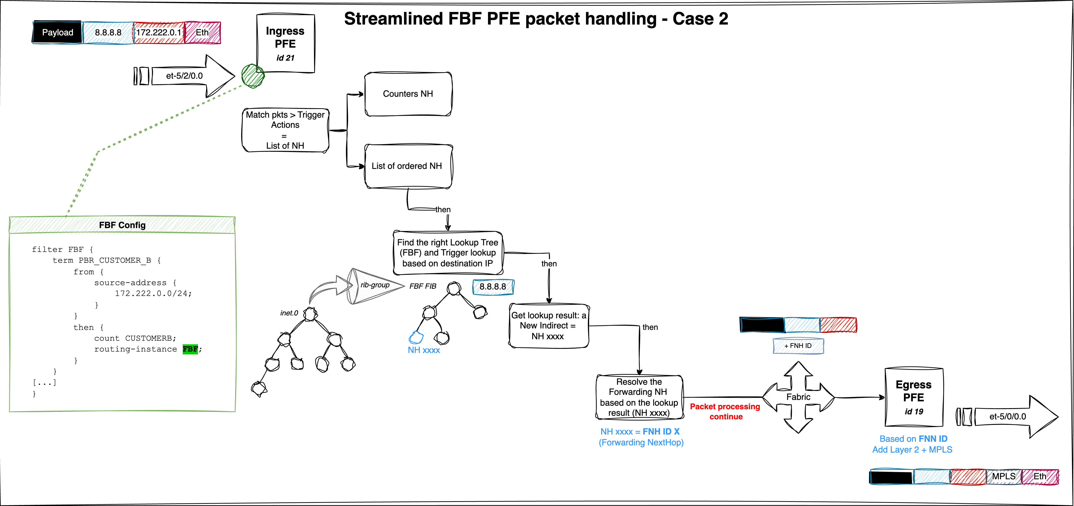
FBF with rib-group at PFE level
This is a test to refer to this section

3.4 Conclusion
In this article, we explored the mechanics of the Filter-Based Forwarding (FBF) feature, focusing on how traffic steering is implemented at the PFE level. We demonstrated two distinct approaches to configuring and validating FBF behavior. While both are effective, the second method provides greater flexibility, making it especially useful for advanced use cases.
All tests and examples provided were conducted within the IPv4 address family, but it’s important to highlight that the same FBF logic and infrastructure are fully supported for IPv6 as well, offering consistent behavior across protocol versions.
By understanding the inner workings of FBF down to the hardware abstraction layer, network engineers can confidently design and validate sophisticated traffic steering policies.

aka. LPM

