Packet Tester On Chip Generate your traffic from the router
  - An HPE Juniper Networking Techpost
David Roy
2026-10-20
Table of Contents

List of Figures

List of Tables

1 Packet Tester On Chip Generate your traffic from the router
David Roy 2026-10-01

1.1 PTOC and the PTOC Manager GUI
Over the years, the port count and per-port speed of modern routers have grown significantly (100G to 800G and beyond), with platforms now shipping tens to hundreds of high-speed interfaces. Qualifying or testing a specific feature at line rate across this density of ports increasingly requires an external traffic tester with matching port count and speed, which can quickly become complex to set up ’snake topology) and costly to acquire or maintain.
In this article we will cover an interesting feature for Lab only. This is important to mention this feature uses, under the hood, PFE commands that are not officially supported for production, or in other words outside a lab environement. We will present how HPE Networking Trio and Express ASICs can become their own traffic generators - this capability is called PTOC, which stands Packet Tester On Chip. In the last section I will also introduce a small tool ptocm I developed, which turns that capability into a lightweight, multi-router traffic management tool.

1.2 What is PTOC and the Traffic-Tester library?

1.2.1 PTOC - Packet Tester On Chip
PTOC is a dedicated hardware “macro” block embedded directly in HPE Networking Trio (MX family) and Express (PTX family) ASICs. Instead of relying on an external traffic generator wired into the device under test, PTOC lets the forwarding ASIC itself build, transmit, receive, and analyze packets at line rate.
In practical terms, PTOC gives every supported router two on-chip functions:
- A generator - crafts fully-formed packets (L2 → L4), injects them into the forwarding pipeline or straight out of a WAN port, at a configurable rate.
- An analyzer - captures packets, counts them, filters them and measures latency, all in hardware. The analyzer capability is out of the scope of this article and might be covered in further techpost.
Because the packets are produced and consumed on the same silicon that forwards production traffic, PTOC can drive interfaces to their true linerate limits with nanosecond-grade timing, something that is hard and expensive to achieve with external tester.
Note: depending on the ASIC Generation you should expect to have more or less capabilities available.

1.2.2 PTOC - packet generation
PTOC is part of the ASIC and is “connected” to the ingress and egress data paths. we can illutrate how PTOC is internally interfaced with this following diagram:
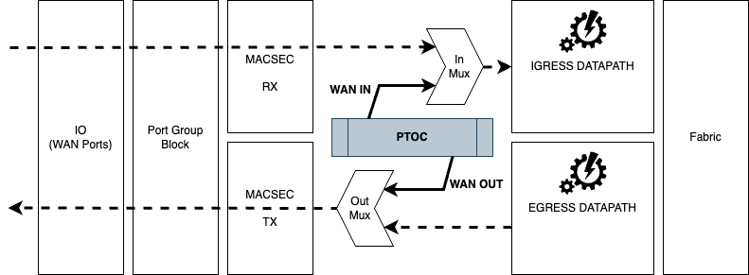
PTOC Internal Interfacing
This figure provides a simplified view for both Trio and Express chipsets. This macro block is dual ‘attached’:
- WAN IN: To the ingress mux, just after the “Port Group Block” and “MACSEC RX” processing but just before packets ingestion into the ingress datapath processing (Ingress MQSS/LUSS for Trio, or Ingress Pipeline on Express).
- WAN OUT: To the egress mux, just before “MACSEC TX” and “PORT Group Block” processing, but bypassing the Egress datapath.
Note: traffic injected in WAN IN direction can be routed as normal packets, and thus be forwarded to a remote PFE, traversing the Fabric and even be sent out the router (with some limitations explained later).
There is one PTOC macro block per port-group. A port group, also known as PG, for both Trio and Express, group a subset of physical WAN ports sharing common hardware ressources. The main capabilities of a PG are:
- Aggregate traffic from multiple ports. For example on the latest Trio generation (Trio 7 - products based on Trio 7 are expected early 2027) a PG can handle up to 8x8 lanes across one PG (up to 112 Gbps), collecting Ethernet frames from all its member ports/streams into one common data path.
- Normalize/interface between the physical layer and the ASIC core. It converts fixed-size flits from/to the MACSEC Rx/TX and Ingress/Egress datapath.
- Provide shared framing and error-checking services: validating PCS framing, checking for errors, de-multiplexing streams, and re-multiplexing frames on the way out, so each port doesn’t need its own dedicated logic for this.
- Support control-plane features per port, such as 802.3x Link Pause and PFC (802.1Qbb) flow control, and IEEE 1588 PTP one-step timestamping, all applied consistently across the group’s ports.
- Enable efficient statistics counting: MAC Rx/Tx, per-port MRU/MTU checks, and SOP/EOP run counting, at the group level rather than requiring separate counters per port.
Each PG has a maximum throughtput (you can’t exceed). This max bandwitdh of a PG depends on the ASIC generation and the hardware platforms. We list below the most common platforms:
- MX based on Trio 6 generation (codename YT): MX304, LC9600, LC400X, MX301…Each Trio 6 has 4 port-groups with each a max full-duplex bandwidth of 400Gbps. See below Diagram.
PTX based on Express 4 (codename BT):

1.2.3 1.2 Traffic-Tester - the platform-agnostic library on top of PTOC
Raw PTOC is a set of hardware registers. Programming them by hand is not realistic, so Juniper exposes a traffic-tester shell/VTY layer - also known as the PTOC common library - that abstracts the hardware behind a clean, declarative CLI.
The library is intentionally platform-agnostic: the same set traffic-tester … grammar works whether the underlying ASIC is Trio or Express, so a test written once can run across the portfolio.
It is built around four composable components:
The Traffic-Tester components
Component | Role
Header | Defines packet content per protocol layer (Ethernet, VLAN, MPLS, IPv4, IPv6, TCP, UDP) or a full raw hex frame. Header-modifiers let a field sweep over a value range to synthesize many micro-flows.
Flow | Assembles one or more headers into a packet template and sets packet size (fixed, range, or random) and repeat count.
Stream | Wraps a flow and adds transmission semantics: rate weight for bandwidth sharing, payload, loop count, continuous vs. counted transmit.
Interface | The control point. Streams are bound to a physical interface, programmed into the PTOC ASIC, and started/stopped. Also owns capture, packet-filter and latency-measurement functions.
The relationship between the four is strictly hierarchical - headers build flows, flows build streams, streams are applied to interfaces:

