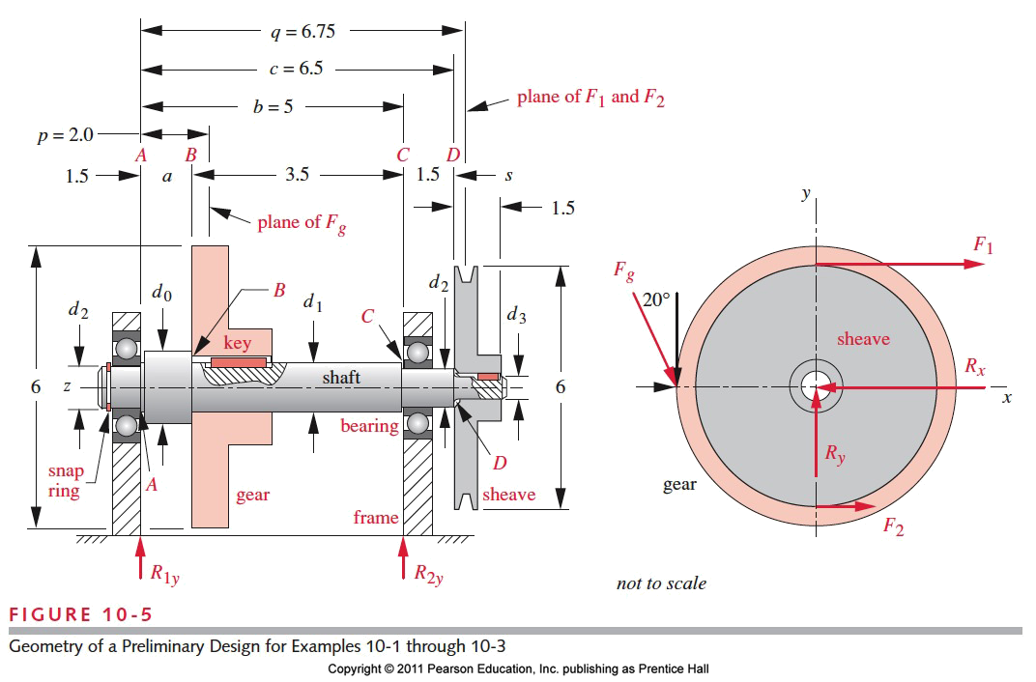ICE 2: A preliminary design of the shaft is shown in figure. It must be able to transmit 2 hp at 1725 rpm. Assume that the computed torque magnitude is both alternating and mean. In a similar manner, the computed moment magnitude has a mean and alternate component. Design the shaft with a minimum design safety factor of 2.5.

Assumptions: No applied axial loads.

Soln:

Basic approach:

1. First determine the transmitted torque from the given power and angular velocity using P=T  This torque exists only between the sheave (D at the right) and the gear (B towards the left)
2. Use above and find the tangential force using the radii of the sheave and gear.
3. A V-belt has tension on both sides and ratio between the tight side and slack side is about 5.
4. As shown the spur gear (we will cover this later) has a 20-degree pressure angle. This means we will have a radial component
5. We will assume that the gear and sheave forces are concentrated at their centers.
6. Now solve for the reaction forces in the xz and yz planes.
7. Next find the shear load and bending moment on the shaft. (Can use singularity functions and obtain the load equation, then integrate to obtain shear force and bending moment)
8. Find the critical points – They are at point B (step) and keyway, point C (step), point D at the sheave step. (Snap ring groove has high stress concentration, but the moment and torque are zero here). Remember that unlike the previous problem we now have an alternating torque and a mean moment
9. Select a trial material (Pick SAE 1030 HR Sut=68 kpsi and Sy=38 kpsi. Now find the corrected endurance strength
10. Apply various factors to find the fatigue endurance strength
11. Obtain the fatigue stress concentration factor for bending and shear, based on the stress concentration factor
12. Now obtain the diameter of shaft using moment and torque at point C using any equation (Goodman, modified Goodman, ASME etc.). We generally use Modified Goodman
13. Repeat for point B and point D in a similar fashion
14. We will not do it, but at this point you want check for the diameter of standard bearings, gears etc. to see if they are available. If not you will need to make changes.
15. If you made any diameter changes OR rounded them in previous steps, recalculate the factor of safety to ensure that they are still above acceptable level.

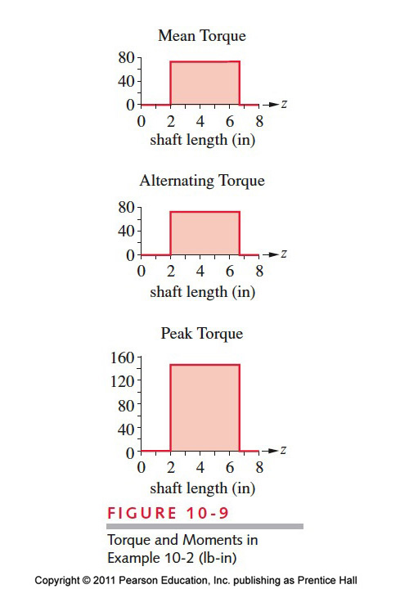First determine the transmitted torque from the given power and angular velocity using P=T  This torque exists only between the sheave (D at the right) and the gear (B towards the left). Remember that this torque is now both the mean and alternating component



Remember now we have the same magnitude of torque but both alternating and mean - to give a total of double the magnitude

Generally, the ratio of force from the tight side to slack side for a belt is 5 (same as before)



From this information, find the driving torque



Net force on the shaft due to sheave





The gear forces act at an angle and hence we need to worry about the components in directions. Using the torque, we obtained to obtain the tangential force and from that, the radial force.





Let us draw a 3-D FBD to first to understand what is going on. Then we can consider the individual planes (what assumptions are we making at A and C where the bearings are located?)





Consider the x-z plane



Consider the y-z plane

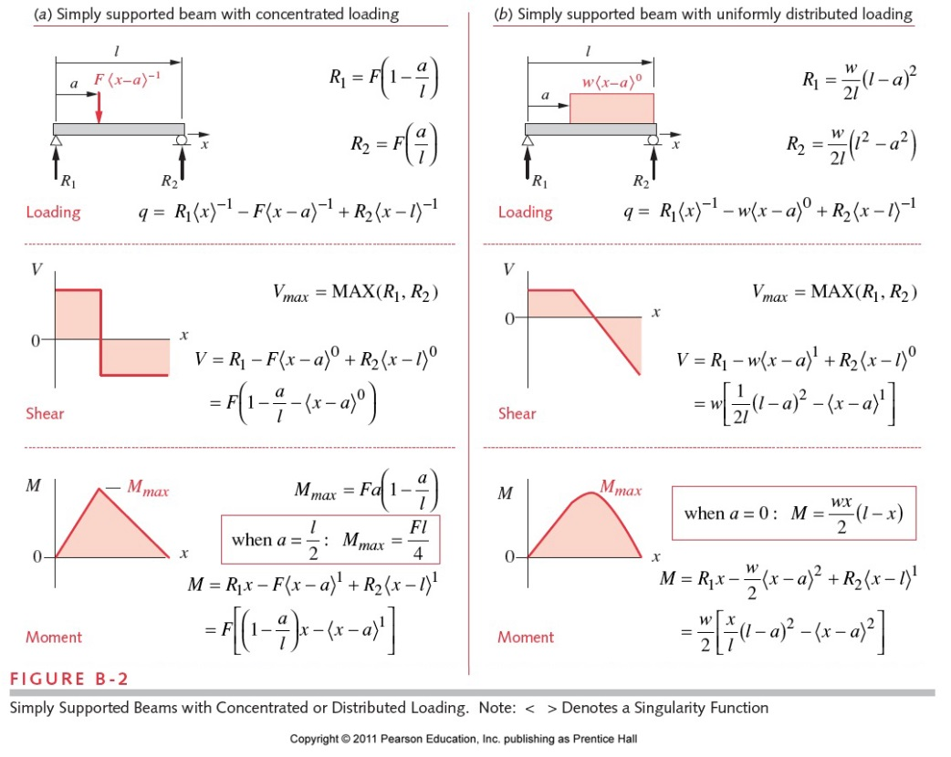SF, BM diagram (x-z plane)

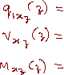



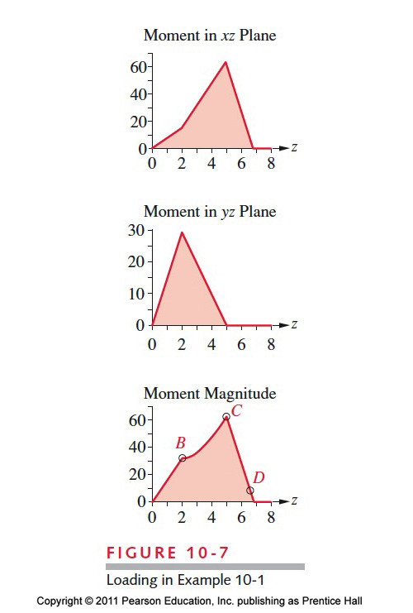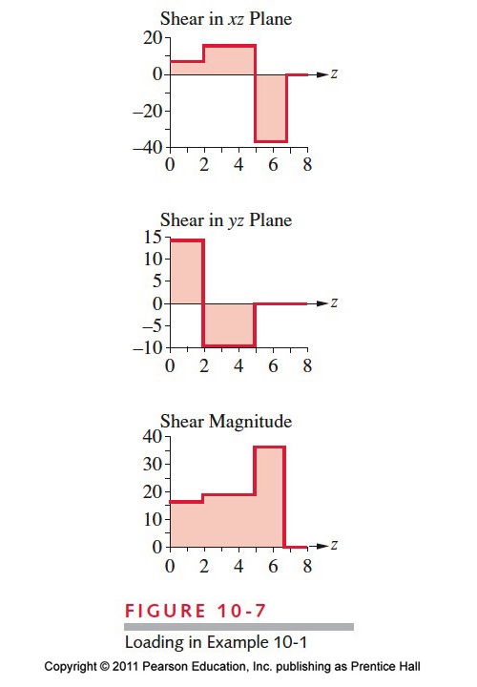

SF, BM, diagram (y-z plane)





Loads at the critical places





**Now to the fatigue design part**

For SAE 1030 steel Sut=68 ksi and Sy=38 ksi

We know there are required features in the shaft, but we do not have a good idea of radius and diameters – we will start with some basic assumed stress concentration factors as below

Now let us find the load, size, surface, temperature and reliability factor.

Now let us find the stress concentration factor and any required factors or corrections

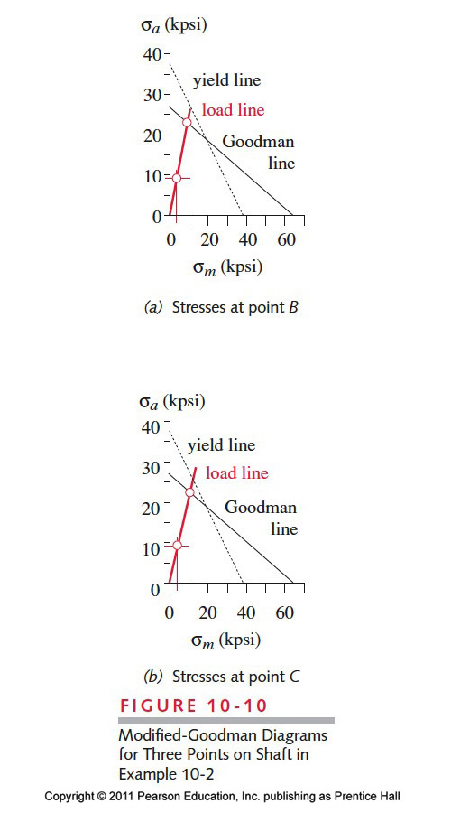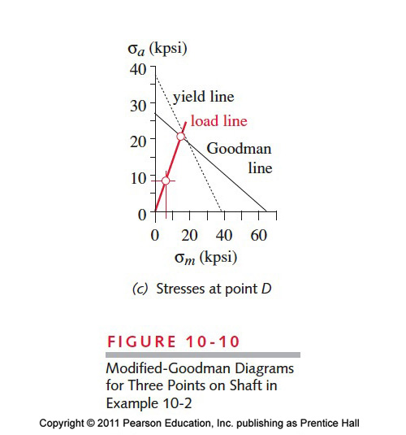

ASME method (not recommended)

Equation 10.6 b page 590

Assumes zero mean bending moment and zero alternating torsion

Von Mises stress approach to above

Equation 10.8 page 592

Both bending moment and torsion can have alternating and mean components