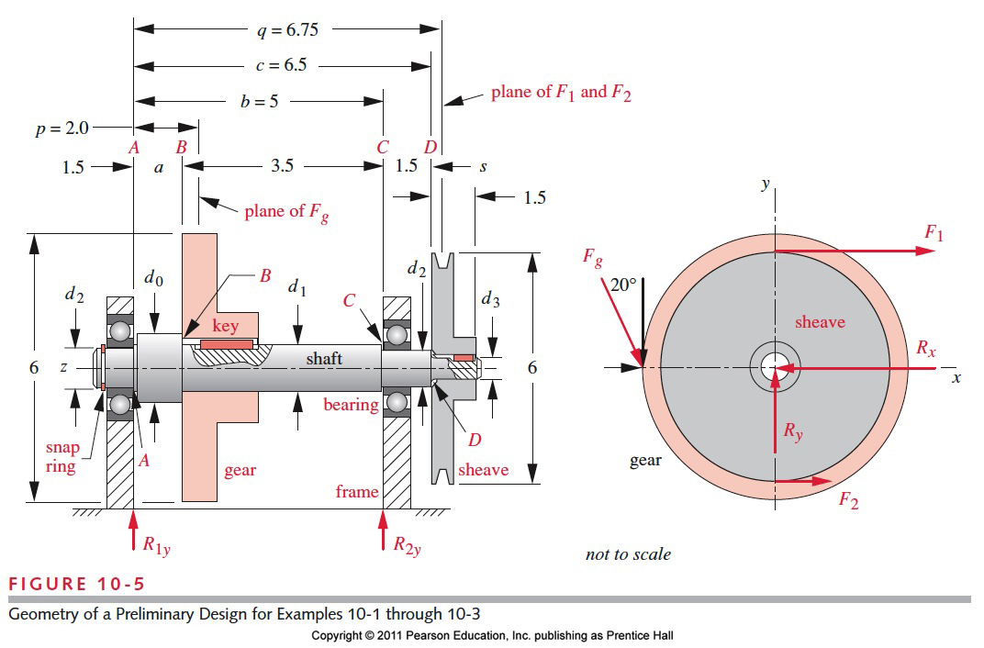ICE 03: A preliminary design of the shaft is shown in figure. It must be able to transmit 2 hp at 1725 rpm. The torque and the moment are both varying in time. The mean and alternating torque are 73 lb\*in making the peak torque twice the mean value of example ICE01 or same as ICE 02. We are now to design the shaft to have a maximum angular deflection of 0.5 degrees between the gear and sheave. Design the shaft with a minimum design safety factor of 2.5. (See ICE03.m for the matlab solution)

Assumptions: No applied axial loads. (will this have any effect on the angular twist?)

Soln:

Basic approach:

1. The general formula for obtaining the angular deflection/torsional deflection for a circular shaft is given by , where  and d is the diameter. We have different sections with different diameters so need to find the polar moment of inertia for each section and finally add the deflections to get the total deflection. (divide and conquer)