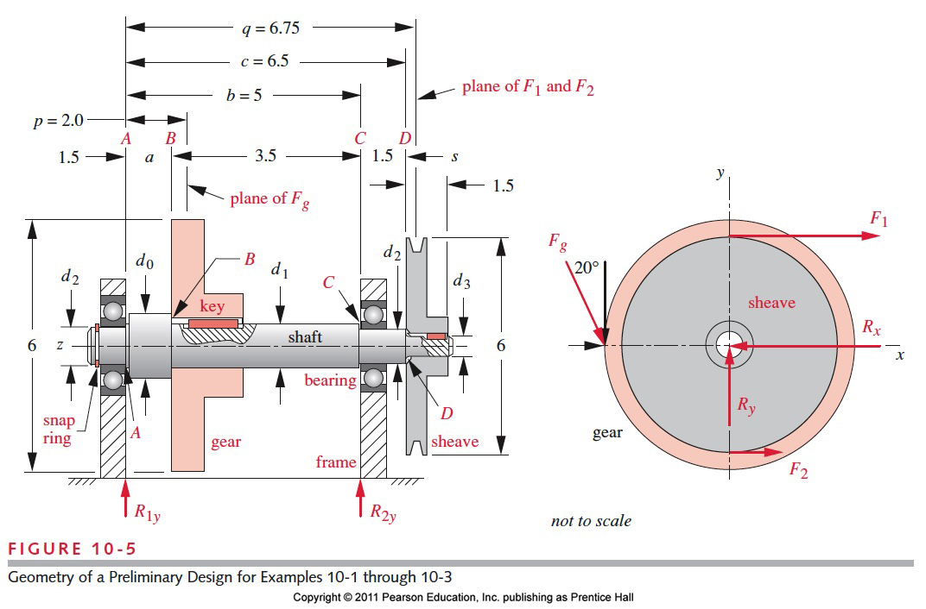ICE 04: A preliminary design of the shaft is shown in figure. It must be able to transmit 2 hp at 1725 rpm. The torque and the moment are both varying in time as stated in ICE 02. We are now to design the shaft to have a maximum bending deflection of 0.002 in. (See ICE04.m for the matlab solution)

Assumptions: No applied axial loads.

Soln:

Basic approach:

1. The basic approach as before will be to find the internal forces using singularity functions and obtain the slope and then bending deflection.
2. We had previously obtained the bending moment (written in general form for both planes combined) is 
3. The general formula for obtaining the angular deflection/torsional deflection for a circular shaft is given by 
4. Divide the expression in step 2 by EI (Young’s modulus and second moment of area) to get 
5. Integrate the above expression along the shaft to obtain slope (*C­3* should be divided by EI)
6. Integrate the above expression along the shaft to obtain deflection  (*C­3* and *C­4* should be divided by EI)
7. Notice the problem you run into is that I the area of moment of inertia is not the same throughout as you did in EMCH 213 and probably ME 349
8. Obtain the constants using constraints like you have done before