This project involves designing of a shaft that is part of a gear reduction unit. The problem has been isolated and is built up step by step so you can work through it. You will have to bring it all together so we finally have the specifications for a shaft, two gears, two bearings and the keyways used in the design.

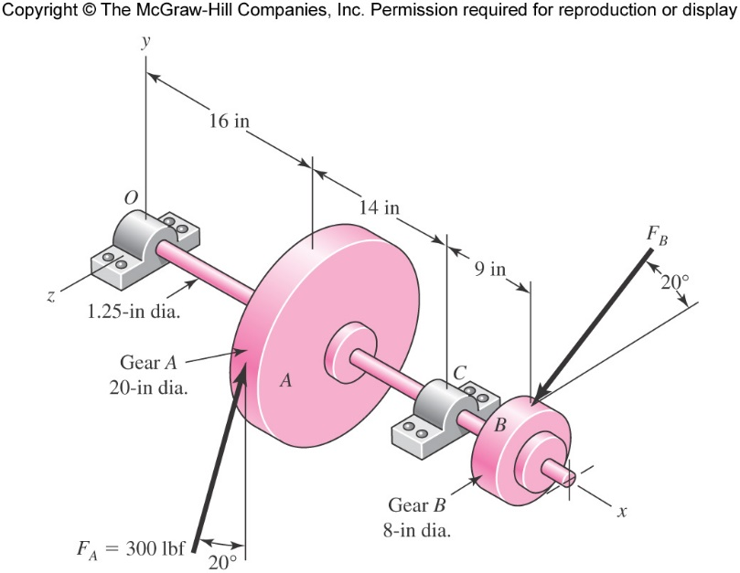

*FD*

*y*

*z*

*x*

The Gear A receives power from another gear with the transmitted force *FA*applied at the 20-degree pressure angle as shown. The power transmitted through the shaft is delivered through Gear *B* through a transmitted force *FB*at the pressure angle 20 degree shown. A force *FD* is generated from the housing (which is not shown) and has a magnitude of 2000 lb. The approximate layout is given as a starting point for your design – you can welcome to make changes.

1. Determine the force *FB*. A constant input power of 0.75 hp is delivered to the shaft arrangement shown a constant speed of 600 rpm. Gear diameter is 8 in.
2. Find the magnitudes of the bearing reaction forces, assuming the bearing at *O* provides a simple and thrust support, (if in doubt refer to your statics book) while the bearing at *C* provides a simple support. If required you can assume that the two bearings are perfectly aligned. (You must explain in the handwritten part why this assumption is made)
3. Draw the a) axial force, b) shear force, c) bending moment and d) torsion diagram for the shaft. Use as many different planes (xy, yz, zx) as you think is necessary to show all the forces and moments involved. You are permitted to choose a different set of axis – but be sure to show in **BOLD** that you chose your own axis.
4. Find all the maximum stresses and their locations based on diagrams from step 3 above. For this calculation assume that the shaft has a constant diameter of 1.2 in as shown in the figure. Choose any cold drawn steel from this website. (<http://www.matweb.com/>) Please be sure to provide a link in your report and in the matlab file as a comment. Also include the property downloaded from matweb as a pdf in your report. (you will have to create an account in matweb)
5. Using the diagram in step 3, at the point of maximum bending moment determine all the stresses that exists in the shaft.
6. Obtain the principal stress at this location. Draw stress cubes at this critical location to show all the stresses. Draw as many stress cubes as required to convey the information.
7. Find the angular twist, deflection and slope along the shaft and draw a graph of this. (again use as many different planes as you think is necessary). Remember that at this point you are assuming a shaft of diameter 1.2 in.
8. Determine the new minimum shaft diameter if the maximum slope at the two bearing locations has to be less than 0.07 degrees. (This ensures that the bearings do not bind)
9. Determine the minimum safety factor for static loading using the Distortion Energy Theory and choose any cold drawn steel from this website. (<http://www.matweb.com/>) Please be sure to provide a link in your report and in the matlab file as a comment. Also include the property downloaded from matweb as a pdf in your report. (you will have to create an account in matweb)
10. Determine the minimum factor of safety for fatigue based on infinite life using the new diameter you obtained above from the slope criteria. At this point assume that the torsion has an alternating component that is 0.3 of the value you obtained in the beginning in step 1. Similarly assume that your bending moment has an alternating component which is 0.3 of the value obtained in step 3. It is known that the force *FA*has a mean component of 300 lb and has an alternating component of ±100 lb.
11. Sketch a general shaft layout, including means to locate the components and to transmit the torque. You can assume that the gears will seat against a step, and that we will use double end milled keyways and parallel keys. You can also assume that the bearings will be press-fit against a shoulder.
12. If required select a different material for the shaft at this point. Determine the critical diameters of the shaft based on infinite fatigue life and a safety factor of 2.0. The worst-case slope should be less than 0.025 radians and the worst case deflection should be less than 0.01 inch.
13. Design the keys assuming double end milled keyways and parallel keys. Determine the safety factor of the two keys.
14. A report with the following sections (a good preparation for future career)
    1. Title sheet (create your own, but must have your name)
    2. Problem statement – this is to cover your “back” and tell the company this is the scope of the problem you solved. Use figures if needed.
    3. Executive summary – briefly tell a highly paid executive of the company what you did in this project for all the money he/his/she/her/they/their organization paid. Provide him/her/them a drawing so most of the pertinent information is given. This will be his/her/their “informed” talking points. Assume he/she/them is a technical person with an engineering degree. (Remember the executive generally will not read any other part of the document)
    4. A descriptive outline of the solution you have provided. This would be for an engineer trying to replicate your results OR to adopt it for a new design.
    5. A neatly drawn diagram showing the parts and your design (can be hand drawn with a straight edge or make a solidworks drawing)
    6. Appendix A – your well documented legibly and cleanly done hand calculation. No “spaghetti solution”. Use equation numbers and page numbers to cross reference.
    7. Appendix B – your matlab code in the same order as mentioned above (Can have multiple functions, but only one file
    8. Appendix C – matlab publish of each of the file above.
15. Upload the report as a single file using the following naming scheme Lastname_Firstname.docx OR Lastname_Firstname.pdf. Also upload the matlab file using the naming scheme of Lastname_Firstname.m. All of this is uploaded to Box.