1. Table 1

2. Why are the FFT frequencies different when FFT_Lab_Signal_3 is sampled at 5000 Hz and 10000 Hz?
There are aliases present and the true signal component frequencies are higher than the Nyquist frequency for this sampling.

3. Why are the FFT frequencies the same when FFT_Lab_Signal_3 is sampled at 10000 Hz and 20000 Hz?
The sampling was done at a high enough frequency that the Nyquist frequency was higher than all true signal component frequencies which eliminated any aliasing that could of happened at a sampling frequency below 5100.

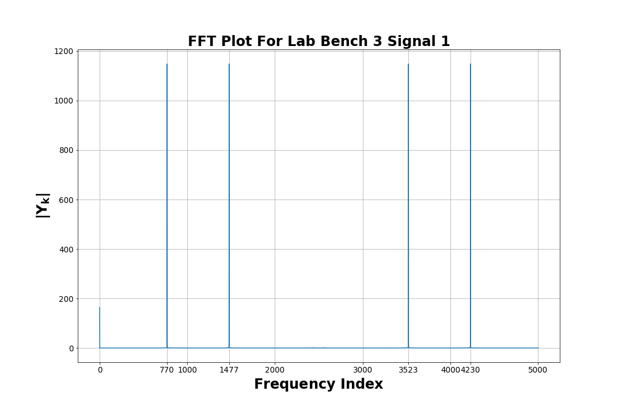
4. The FFT plot of the mystery waveform for your bench.

5. State which frequencies are present in the FFT plot for your mystery waveform.
There is a frequency components of 770 Hz and 1477 Hz in the mystery waveform.

6. State which DTMF number is represented by the frequencies in your mystery waveform.
The DTMF number represented by the mystery waveform frequencies is 6.

