**Protocol For sevilleta Long-term ecological research site aboveground net primary production measurements**

Prepared by Dave Lightfoot, Mike Friggens, and Heather L. Simpson, Sevilleta LTER

**Updated:**03/21/02,Kristin Vanderbilt, Mike Friggens,Heather Simpson

01/21/03, Karen Wetherill and Esteban Muldavin

                  03/04/04, Karen Wetherill

01/04/10, John Mulhouse

                 10/09/13, Stephanie Baker and Megan McClung

07/16/14, Stephanie Baker

**Introduction**

Net primary production (NPP) is a fundamental ecological variable that quantifies the rate of carbon consumption and fixation. Estimates of NPP are important in understanding energy flow at a community level and assessing the spatial and temporal responses of the community to a wide range of ecological processes. A long-term study has been established at the Sevilleta Long-Term Ecological Research (LTER) site to monitor NPP across four distinct ecosystems, or core sites: creosote-dominated shrubland, black grama-dominated grassland, blue grama-dominated grassland, and piñon-juniper-dominated woodland. NPP data is also collected for a number of other projects, including Fertilizer, Monsoon, the Burn study, and the Warming project. While measurements of both above and belowground biomass are important in estimating NPP, these studies focus on aboveground net primary production (ANPP). Above-ground net primary production is equal to the change in plant mass, including any loss to death or decomposition, over a given period of time. To quantify this change, ANPP is measured twice a year (spring and fall) for all plant species at all study sites and three times a year (winter, spring, and fall) for the species *Larrea tridendata*.  In addition, volumetric measurements are obtained from permanent plots to construct regressions correlating biomass and volume.

**STUDY SITES**

The Sevilleta National Wildlife Refuge, operated by the U.S. Fish & Wildlife Service, is located in Soccoro County in central New Mexico.  The Sevilleta encompasses approximately 100,000ha of land and contains vegetation communities representative of the Chihuahuan Desert, the Great Plains grassland, and the Colorado Plateau.

1. **The Core Sites**
   1. **Five Points *Larrea* (Site C):** A creosote/shrub study site south of Deep Well.  It is located on the south side of the road that runs west from the intersection at Five Points.  The site is dominated by creosote (*Larrea tridentata*) with black grama (*Bouteloua eriopoda*), snakeweed (*Gutierrezia sarothrae*), dropseed (*Sporobolus* spp.), and galleta grass (*Hilaria jamesii*) as associated species.
   2. **Five Points grassland (Site G):** A black grama/grassland study site south of Deep Well.  It is located on the north side of the road that runs west from the intersection at Five Points.  This site is dominated by black grama (*Bouteloua eriopoda)* with snakeweed (*Gutierrezia sarothrae*), dropseed (*Sporobolu*s spp.), and galleta grass (*Hilaria jamesii*) as associated species.
   3. **Blue Grama grassland (Site B):** A blue grama/grassland study site south of the Los Piños gate and just west of the Los Piños Mountains.  This site is dominated by blue grama (*Bouteloua gracilis)* with tree cholla (*Opuntia imbricata*), dropseed (*Sporobulus* spp.), sand muhly (*Muhlenbergia arenicola*), and Great Plains yucca (*Yucca glauca*) as associated species.
   4. **Cerro Montosa (Site P):** A piñon-juniper woodland north of Cerro Montosa at the end of Goat Draw Road in the Los Piños Mountains.  This site is dominated by piñon and juniper with blue (*Bouteloua gracilis*) and hairy grama grass (*B. hirsuta*), mountain mahogany (*Cercocarpus montanus*), and red barberry (*Mahonia haematocarpa*) as associated species.
2. **Fertilizer:** In December 1995, a second ANPP study was initiated. This  
   study examines fertilization effects on ANPP in a semi-arid mixed-grassland. The study includes 20 experimental plots, of which half are fertilized and half are not. Fertilizer is applied in the spring and fall as granular NH4NO3.
3. **Monsoon:** The Monsoon Rainfall Manipulation Experiment (MRME) examines changes in ecosystem structure and function of a semiarid grassland caused by increased precipitation variability, which alters the pulses of soil moisture that drives primary productivity, community composition, and ecosystem functioning.
4. **Burn Study:** In 2003, the U.S. Fish and Wildlife Service conducted a prescribed burn over a large part of the northeastern corner of the Sevilleta National Wildlife Refuge. Following this burn, this study was designed to look at the effect of fire on ANPP within three different vegetation types: mixed grassland (MG), mixed shrubland (MS) and black grama grassland (G).
5. **Warming:** Humans are creating significant global environmental change, including shifts in climate, increased nitrogen (N) deposition, and the facilitation of species invasions. A multi-factorial field experiment, call Warming-El Nino-Nitrogen Deposition Experment (WENNDEx or Warming), is being performed in an arid grassland within the Sevilleta National Wildlife Refuge (NWR) to simulate increased nighttime temperature, higher N deposition, and heightened El Niño frequency (which increases winter precipitation by an average of 50%). The purpose of the experiment is to better understand the potential effects of environmental change on grassland community composition and the growth of introduced creosote seeds and seedlings. The focus is on the response of three dominant species, all of which are near their range margins and thus may be particularly susceptible to environmental change.

**Collecting the Data**

Aboveground net primary production (ANPP) is measured in the spring, fall, and winter (for *L. tridentata)*.  Spring measurements are taken in May, when early season annuals have attained maximum biomass.  Fall measurements are taken September through October when summer annuals and perennials have reached maximum biomass just prior to killing frosts. Winter measurements are taken in February before the onset of spring growth.  ANPP data are collected in two distinct phases: Quadrat measurements and vegetation collections.  This protocol explains the quadrat measurement phase.

The primary target for measuring ANPP data at each study site is the quadrat, or quad. This is a 1 m2 square permanently marked by either short pieces of rebar or fiberglass at two corners. These quads may be arranged in any number of ways according to each study’s design. The arrangement of quads is outlined below for each site.

1. **The Core Sites:** Each core site, except Cerro Montosa, contains five sampling webs and also a grid of 40 quads. Each web consists of twelve 100m transects radiating out from a central rebar stake marked #145. There are four permanently marked ANPP plots on each of the webs located approximately 10m from the ends of transects extending in the cardinal directions (**Fig. 1**) (exceptions outlined below). Each plot consists of four 1 m2 quadrats located around a tall, orange stake. Quadrats are marked by two short, orange fiberglass stakes (**Fig. 2**). Quadrat 1 is northwest of the center stake with quadrats 2, 3, and 4 following in a clockwise direction. Quads 1 and 3 are sampled at each plot. The grids are arranged in an 8-quad X 5-quad matrix. See **Figure 3** for web layout at each core site.
   1. **Five Points *Larrea* (Site C):** Quads 1 and 3 at each plot in each cardinal direction are sampled at all five webs for a total of 40 quadrats. There is also an 8-quad X 5-quad grid (**CG**) located between webs 2 and 3 adjacent to the road. A total of 80 quadrats are sampled at this site.
   2. **Five Points grassland (Site G):** Webs 2 and 3 are no longer sampled at this site because a natural fire burned these two webs. As a result, plots were added to the remaining webs (1, 4, and 5) to total 30 quadrats. On web 1 and web 5, plots are located at the ends of transects extending in four cardinal directions and also at the end of the transect that extends in the northeast direction. On web 4, plots are located at the end of transects extending in the following directions: northwest, northeast, east, south, and west. There is also an 8-quad X 5-quad grid (**GG**) located northeast of web 5. Quads in the grid are numbered 1-40 in a snaking fashion. Quads 16-25 are not sampled. There are a total of 60 quadrats sampled at this site.
   3. **Blue Grama grassland (Site B):** Quads 1 and 3 at each plot in three cardinal directions (north, east, and west) are sampled at all five webs for a total of 30 quadrats. There is also an 8-quad X 5-quad grid (**BG**) located just south of web 5. Quads in the grid are number 1-40 in a snaking fashion. Quads 16-25 are not sampled. There are a total of 60 quadrats sampled at this site.
   4. **Cerro Montosa (Site P):** This piñon-juniper woodland site is set-up differently than the other core sites. There are three plots at this site, each plot contains four transects set up to capture different habitat types. Plots 1 and 2 each have four transects that capture the following habitat type: Vega (**V**), Ridge (**R**), South-facing slope (**S**), and North-facing slope (**N**). Each transect is made up of 10 quads, totaling 40 quads at each of these plots. Plot 3 is made up of four transects (**A**, **B**, **C**, **D**) that each contain 5 quads that capture the Piedmont habitat type, for a total of 20 quads. There are a total of 100 quadrats sampled at this Core site. Plot 1 is north of Plots 2 and 3 and is accessible via a trail. Plots 2 and 3 are accessed by a trail leading to the weather station, Plot 3 is located just west of the weather station on the wide piedmont (**Fig. 3**).

**Figure 1. Web Layout**

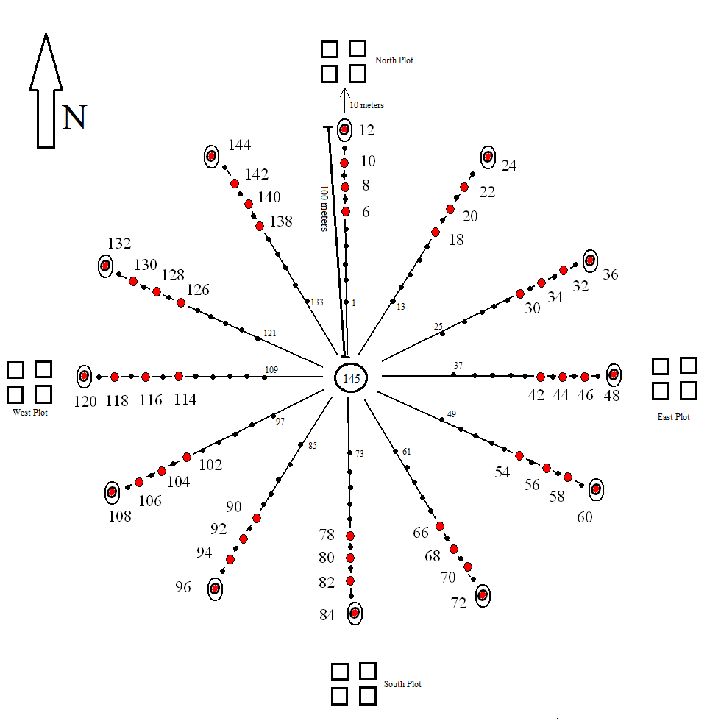

Figure 2. Plot Layout

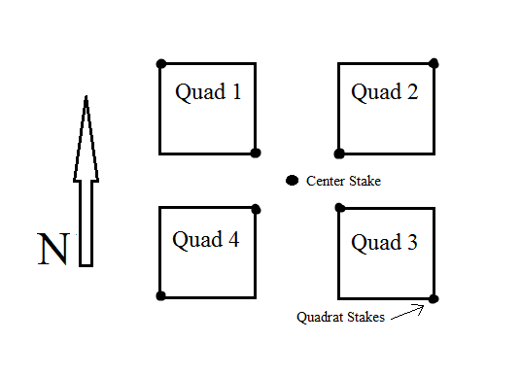

Figure 3. Arrangement of webs and transects at the Core sites

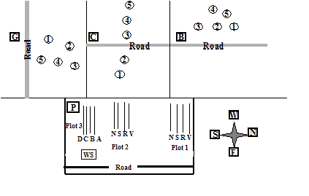

1. **Fertilizer:** This study is comprised of 20 experimental plots, each plot 10m X 5m, that are arranged along two transects that run west to east and are numbered 1-20. Each plot contains four quadrats that are directly adjacent to one another, numbered 1-4, with quadrat 1 at the southwest corner of each plot. There are a total of 80 quads that are sampled at this site (**Fig. 4**).
2. **Monsoon:** This study is comprised of 13 plots that receive one of three treatments. Five plots receive small watering treatments, five plots receive large watering treatments, and three plots serve as controls and receive no additional water treatment. Each plot contains two adjacent subplots, subplots A and B. One subplot receives a fertilizer treatment and one does not. Each subplot is divided into four quadrats. Quads 1 and 2 are the only quads that are sampled. Quad 1 is located in the northwest corner of the subplot while quad 2 is diagonal from quad 1, located in the southeast corner of the subplot (**Fig. 5**).
3. **Burn Study:** A prescribed burn was conducted over a large part of the northeastern corner of the Sevilleta National Wildlife Refuge. Following this burn, this study was designed to look at the effect of fire on ANPP within three different vegetation types: mixed grassland (MG), mixed shrubland (MS) and black grama grassland (G). There are a total of 170 quads sampled in this study.
   1. **Mixed Shrubland (MS):** 40 permanent quadrats were installed in both burned and unburned (i.e., control) sections of mixed shrubland (MSB, MSC). These quads are arranged in an 8-quad X 5-quad grid and are numbered 1-40 in a snaking fashion.
   2. **Mixed Grassland (MG):** 40 permanent quadrats were installed in both burned and unburned (i.e., control) sections of mixed grassland (MGB, MGC). These quads are arranged in an 8-quad X 5-quad grid. They are numbered 1-40 in a snaking fashion at the burn site (MGB) but do not snake at the unburned site (MGC). In spring of 2010, sampling of quads 16-25 was discontinued, bringing the number of quads sampled at each site to 30. The MGC control site caught fire unexpectedly in the fall of 2009 and some plots were subsequently moved to the south.
   3. **Grassland (GB):** 40 permanent quadrats were installed in the burned section of grassland (GB). These quads are arranged in an 8-quad X 5-quad grid. They are numbered 1-40 in a snaking fashion. In spring of 2010, sampling of quads 16-25 was discontinued, bringing the number of quads sampled at each site to 30. The Five Points Grassland core site (G) is used as a control site (unburned) for analysis and does not appear in this dataset.
4. **Warming:** This study is comprised of 40 plots, each plot 3m X 3.5m. Each plot contains two quads: Quad 1 is located to the north and Quad 2 is located to the south. The plot numbers are found on PVC piping next to the plot frame. There are 80 quads sampled at this site (**Fig. 6**).

Figure 4. Fertilizer Study Plot Layout

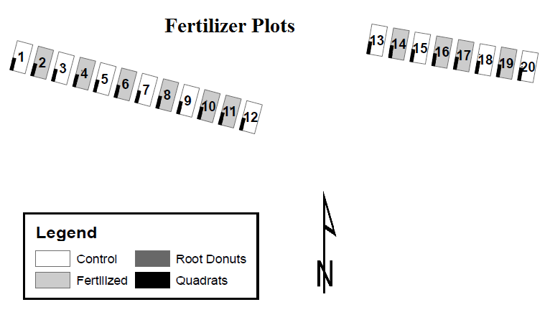

Figure 5. Monsoon Study Plot Layout

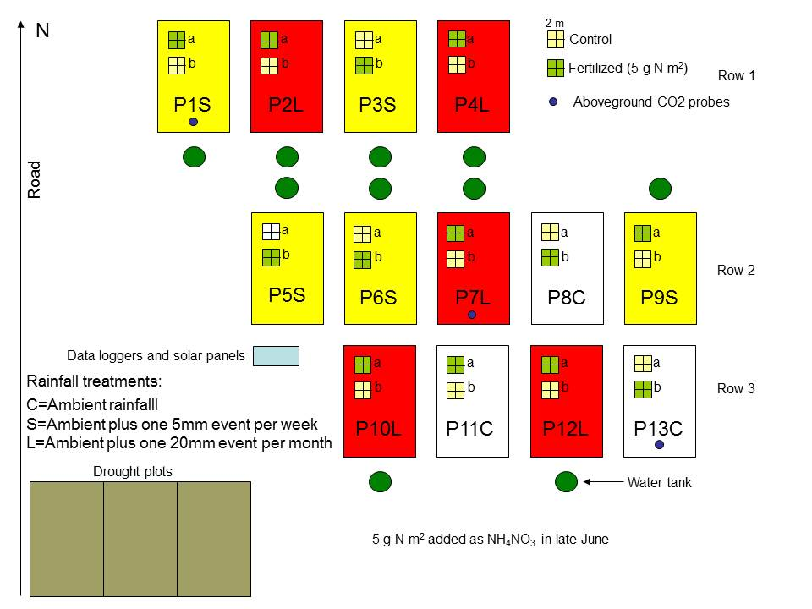

Figure 6. Warming Experiment Plot Layout

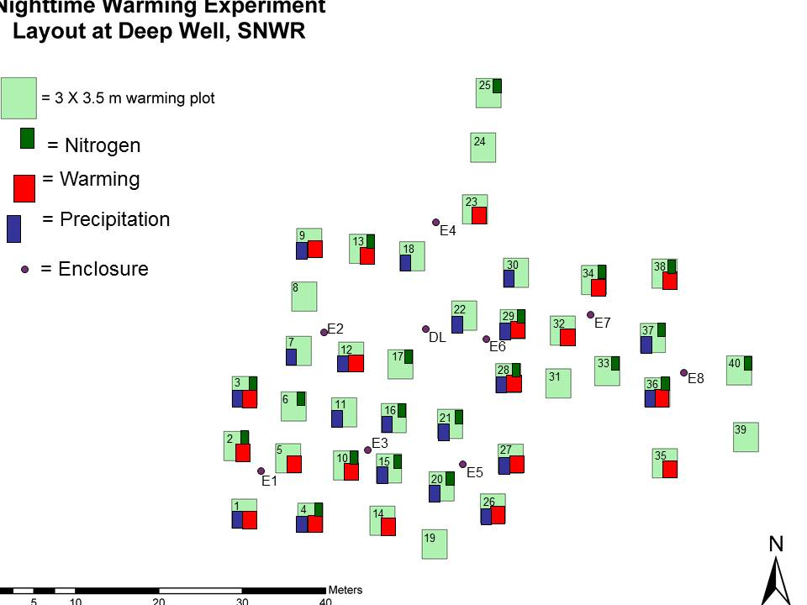

**MEASURING** **VEGETATION**

Quadrat orientation and construction: Measurements are always begun at Quad 1. A 1m2 PVC frame is placed over the fiberglass stakes or rebar that mark the diagonal corners of each quad. Once placed, the square frame should be as close as possible to the vegetation canopy without touching it. If the ground is sloped the frame should be adjusted so that it is parallel to the vegetation, not the ground.

The frame is constructed of ½” PVC. The interior dimensions of the square are 1 m on each side. Each corner coupling is a female-threaded right-angle “T” (threads are for attachment to the adjustable legs). Each PVC frame is divided with nylon string into 100 squares. The dimensions of each square are 10cm X 10cm, representing 1% of total quadrat area.

Additional measuring tools: “niners” and “plexidecs” are additional tools that can be used to determine vegetation cover. A “niner” is a small, hand-held PVC frame used to measure canopy systems or low-growing plants. The “niner” is also made of ½” PVC and nylon string but has no legs. The interior dimensions of the square are 30 cm on each side and the enclosed area is divided into nine 10 cm x 10 cm squares. Each square represents 1% of the total 1m2 quadrat cover.

“Plexidecs” are used to measure vegetative units with covers < 1%. They are small, clear, ¼” plexiglass squares that are held over vegetation. A “plexidec” is 0.71 cm on each side, representing a cover of 0.5%. Squares are etched with dimensions of 0.1, 0.22, 0.32, and 0.5 cm. These squares delineate covers of 0.01%, 0.05%, 0.10%, and 0.25% respectively. Hint: to help relocate a “plexidec” dropped into vegetation, tie brightly colored surveyor's tape to a small hole drilled into one corner.

Obtaining measurements: standing plant biomass within a quad is measured in terms of vegetative units, which consist of a specific size class of a particular species. A size class is defined as a unique cover and height for a species within the quad. The cover and height of each vegetative unit that falls within the 1m2 quad is measured separately. Height is determined with a tape measure while cover is obtained by counting the number of 10cm X 10cm squares occupied by each vegetative unit. Partially-occupied squares are consolidated and added to the total cover.

When measuring cover it is important to stay centered over the vegetation. If an observer is not directly over the vegetation, the angle of observation (parallax) can result in inaccurate measurements. If the surrounding plants prohibit you from leaning directly over the vegetation, use a tape measure to delineate a vertical column from which to maintain the proper perspective.

**CALIBRATION AMONG TECHNICIANS**

Prior to measuring quadrats, calibrate cover and height measurements amongst technicians. To calibrate measurements, place a PVC frame over an area of vegetation. It is helpful to choose an area that contains all the vegetation types expected at a site. It may be necessary to choose more than one area to ensure all vegetation types are represented. Each person then measures the cover and height of every plant species in the quadrat without disclosing their results. Measurements are then compared and discussed and adjustments made to bring all technicians into agreement. If there is a large disparity between technicians this exercise should be repeated until measurements are consistent.

It is extremely important that cover and height measurements remain consistent over time to ensure that regressions based on this data are valid. Below are guidelines on how to make these measurements within specific vegetation types.

**MEASURING THE COVER OF SPECIFIC VEGETATION TYPES**

Cover and height measurements are made on separate vegetative units that occur within the PVC frame. A vegetative unit consists of a specific size class (as defined by a unique cover and height) of a particular species within the quadrat. This includes vegetation that is rooted outside but has foliage that hangs inside the frame.

Cover is quantified by counting the number of 10cm x 10cm squares encompassed by each vegetative unit. It is possible to obtain a total percent cover greater than 100% for a given quadrat because vegetation often overlaps, particularly shrubs (branches) and cacti (branches or pads).

The smallest cover category is 0.01%. Seedlings often have covers below 0.01%; record seedlings as 0.01%. The next cover increments up to 1.0% are 0.05%, 0.10%, 0.25%, 0.5%, 0.75%. For covers above 1.0% up to 10.0%, the covers are rounded to the nearest 0.5%. Covers above 10.0% are rounded to the nearest 1.0%.

To increase accuracy and to reduce the size of harvested samples (see below), divide the total canopy cover of large individuals into smaller units and measure the cover and heights of each separately. For example, an observation of black grama with a total canopy cover of 80% could be divided into several observations of smaller cover by breaking the total cover into individual clumps or groups of clumps. As a general rule, try not to record cover values that exceed 15%. During really wet years, large perennial grasses can be measured up to 30%, but no higher than that.

**Grasses:** To determine the cover of a grass clump, envision a perimeter around the central mass or densest portion of the plant, excluding individual long leaves, wispy ends, or more open upper regions. Live tissue is frequently mixed with dead tissue in grass clumps. It is unnecessary to try and separate individual live stems from dead stems as this is accounted for when samples are harvested and sorted. At the same time, the goal is to measure only the plant biomass growth for the current season. As recently dead foliage is yellow and long-dead foliage gray, try to include only yellow or green portions of the plant in cover measurements, excluding gray areas.

Stoloniferous stems of grasses that are not rooted should be ignored. If the stem is rooted in the soil it should be recorded as a separate observation from the parent plant.

**Shrubs and Sub-Shrubs**: To measure dominant shrubs (e.g., *Larrea tridenta, Atriplex canescens*) and sub-shrubs (*Gutierrezia sorothrae*).

Measure the cover as the perimeter of the green leaves/foliage of the plant, ignoring small open spaces (keeping in mind the 15% guideline stated above). For plants that do not have leaves, such as *Ephedra torreyana*, draw the perimeter around the needles instead of the leaves. For *Gutierrezia sorothrae*, simply measure the cover and height as with any other perennial forb or grass.

Do not measure dead stems or areas of dead foliage. If in doubt about whether a stem is alive, scrape the stem with your fingernail and check for the presence of green cambium.

For shrubs that drop their leaves in winter, lump the branches into canopy systems and record the cover of each.

It is especially important in the case of shrubs and sub-shrubs to remember to record the cover of vegetation rooted outside the quadrat but hanging inside.

**Forbs:** Forb cover is measured as the perimeter of the densest portion of the plant. Measure all foliage produced in the current season, including any recently dead (yellow). Avoid measuring gray foliage.

During really wet years, KAPA can be measured as a total cover if individuals cannot be idendified.

**Cacti:** For cacti that consist of a series of pads or jointed stems (i.e., *Cylindropuntia imbricata*, *Opuntia phaeacantha*) measure the average length and width of each pad instead of cover and height. Cacti that occur as a dense ball/clump of stems (*Cylindropuntia leptocaulis*) are measured using the same method as shrubs, which is one total cover. Pincushion or hedgehog cacti (i.e., *Echinocereus fendleri*, *Echinomastus intertextus*, or *Escobaria vivipara, also Grusonia clavata*) that occur as single or clustered cylindrical stems are measured as a single cover.

**Yuccas:** The leaves and caudices (thick basal stems) of yucca are recorded separately. Break the observations into sections of leaves that are approximately the same height and record the cover as the perimeter of the group of leaf blades. The caudex is measured as a single cover. The thick leaves of yucca make it difficult to measure cover while centered over the caudex. The cover of the caudex may be better estimated by a “niner” or tape measure. For measurements of yucca leaves add “L” to the species code and for yucca caudices add “C” (i.e., ‘YUBAL’ or ‘YUBAC’).

**Vines:** Because vines often grow diffusely, measuring cover can be difficult. Each square that the vine crosses is a 0.5%. Count up the squares that the vine crosses and divide by 2.

**Overstory in PJ:** (*Quercus, Rhus*, PIED, JUMO) Measure the cover as the perimeter of the green leaves/foliage of the plant above or in the quad. This number will be rough as some of the vegetation will be meters above the quad. Approximate the cover of the tree/shrub and record that value.

**MEASURING THE HEIGHT OF SPECIFIC VEGETATION TYPES**

Height is recorded as a whole number in centimeters. Height measurements remain perpendicular to the ground even if plants are on a slope.

**Annual Grasses and All Forbs:** Measure the height from the base of the plant to the top of the inflorescence, if present. If an inflorescence is not present, measure to the top of the green foliage.

**Perennial Grasses:** Measure the height from the base of the plant to the top of the green foliage of the main leaf mass. Do not include the inflorescence or extreme outliers in the height measurement.

**Perennial Shrubs and Sub-Shrubs:** Measure the height from the base of the green foliage to the top, ignoring all bare stems. Do not measure to the ground unless green foliage reaches the ground.

**Plants Rooted Outside but Hanging into the Quadrat:** Do not measure the height to the ground. Measure only the height of the portion of the plant within the quadrat.

**Overstory in PJ:** Measure from the ground to the highest point of the individual tree/shrub that is either in or hanging in the quad. This is done so that the tree/shrub can be classified into strata if needed. If trees are too tall to measure to highest point, approximate by a 0.5 meter increment.

**RECORDING THE DATA**

Data is recorded using a Hewlett-Packard Handheld personal computer, commonly referred to as a palm top. Using Active-Sync software, a template is uploaded onto the palmtop. There is a template for each site. A new file is created for everyday.

**Core Web Site File Name: npp_core.MM.DD.YY.recorderinitials&sitecode**

SITE: b (blue grama grassland), c (Five Points Larrea), or g (Five Points grassland)

WEB: 1, 2, 3, 4, or 5

PLOT: N, S, E, or W, NW and NE (for web 4 Grassland)

QUAD: 1, or 3 (See Figure 2 for quadrat layout.)

SPECIES: Kartez code for each plant species.

OBS: Observations numbered consecutively for each distinct size class (defined by

cover and height) for a species in the quadrat.

COVER: Percent cover measurement of an observation.

HEIGHT: Height in cm of an observation.

COUNT: Number of individual vegetative units of a size class within a quadrat.

COMMENTS: Notes regarding an observation

**Core Grid Site File Name: npp_grid.MM.DD.YY.recorderinitals&sitecode**

SITE: bg (blue grama grassland), cg (Five Points Larrea), or gg (Five Points grassland)

QUAD: 1-40

SPECIES: Kartez code for each plant species.

OBS: Observations numbered consecutively for each distinct size class

(defined by cover and height) for a species in the quadrat.

COVER: Percent cover measurement of an observation.

HEIGHT: Height in cm of an observation.

COUNT: Number of individual vegetative units of a size class within a quadrat.

COMMENTS: Notes regarding an observation

**Pinon-juniper woodland (Cerro Montosa) File Name: npp_pinj.MM.DD.YY.recorderintials**

SITE: P

PLOT: 1, 2, or 3

TRANS: S (south slope), N (north slope), V (vega), or R (ridge);

A, B, C, or D for the four piedmont transects.

QUAD: 1 through 10

SPECIES: Kartez code for each plant species.

OBS: Observations numbered consecutively for each distinct size class. (defined by

cover and height) for a species in a quadrat.

COVER: Percent cover measurement of an observation.

HEIGHT: Height in cm of an observation.

COUNT: Number of individual vegetative units of a size class within the quadrat.

COMMENTS: Notes regarding an observation, (i.e., a plant was hanging into a quadrat, a plant was impacted by heavy herbivory, etc.).

**Fertilizer File Name: npp_fert.MM.DD.YY.recorderintials**

SITE: f (fertilizer)

PLOT: 1-20

QUAD: 1-4

SPECIES: Kartez code for each plant species.

OBS: Observations numbered consecutively for each distinct size class

(defined by cover and height) for a species in the quadrat.

COVER: Percent cover measurement of an observation.

HEIGHT: Height in cm of an observation.

COUNT: Number of individual vegetative units of a size class within a quadrat.

COMMENTS: Notes regarding an observation

**Monsoon File Name: npp.mons.MM.DD.YY.recorderintials**

SITE: m (monsoon)

PLOT: 1-13

SUBPLOT: A or B

QUAD: 1 or 2

SPECIES: Kartez code for each plant species.

OBS: Observations numbered consecutively for each distinct size class

(defined by cover and height) for a species in the quadrat.

COVER: Percent cover measurement of an observation.

HEIGHT: Height in cm of an observation.

COUNT: Number of individual vegetative units of a size class within a quadrat.

COMMENTS: Notes regarding an observation

**Burn Study File Name: npp_burn.MM.DD.YY.recorderintials&sitecode&treatment**

SITE: gb (grassland burned), mg (mixed grass), or ms (mixed shrub)

TRT: b (burned) or c (control)

QUAD: 1-40

SPECIES: Kartez code for each plant species.

OBS: Observations numbered consecutively for each distinct size class (defined by

cover and height) for a species in the quadrat.

COVER: Percent cover measurement of an observation.

HEIGHT: Height in cm of an observation.

COUNT: Number of individual vegetative units of a size class within a quadrat.

COMMENTS: Notes regarding an observation

**Warming File Name: npp_warm.MM.DD.YY.recorderintials**

SITE: w (warming)

PLOT: 1-40

QUAD: 1 or 2

SPECIES: Kartez code for each plant species.

OBS: Observations numbered consecutively for each distinct size class (defined by

cover and height) for a species in the quadrat.

COVER: Percent cover measurement of an observation.

HEIGHT: Height in cm of an observation.

COUNT: Number of individual vegetative units of a size class within a quadrat.

COMMENTS: Notes regarding an observation

The first observation for each species is always recorded as ‘1’ in the observation column. Subsequent observations for that species are then recorded in a series as shown in the example above. It is not necessary to fill in redundant vertical columns for site, web, plot, quad, species and/or comments.

The observer will take numerous measurements in each quadrat and, for the sake of clarity and efficiency, the following is recommended:

Make all observations for a single species before moving on to another species;

Make all measurements on one size class within a species before moving on to another size class;

Group observations of the same vegetative unit together and record a total count.

A count can be added to later if a vegetative unit was overlooked initially. Also, observations can be added to a previous species after a new species has been begun. In such a case, a new line is added with the updated observation number recorded for the species.

**Unknown Plant Codes**

When encountering an unknown plant, first show the plant to other technicians. If it is not recognized by other technicians use the unknown plant list to see if matches an already unknown plant for the season. If so, use the code most recently assigned to that species. If not, assign a new code to the unknown. Use the below codes to name unknowns. If an individual of the plant can be found off plot, collect for later identification. If the unknown is found at other sites or other plots, the code given to it originally is its code for the entire season.

UKGR1…- unknown grass

UKFO1…- unknown forb

UKSH1…- unknown shrub

MATERIALS AND SUPPLIES

1. Quadrat Measurement Tools and Supplies:

Palm top computers

Plant species list

Protocol

3-meter measuring tapes

3-decimeter measuring frames (“niner”)

1-meter PVC vegetation frame

1-meter PVC collapsible under-canopy frame

1-decimeter plexiglass measuring squares (“plexidec”)

Zip-lock bags and/or plant press for vouchers

Plant ID references (Ivey, etc.)

Notebook for compiling a record of unknown plants