Question 1

a)

two game engines: Unity, Construct 2

Unity was chosen over Construct 2 because:

* With Unity you have full control over your scripting unlike construct 2 which is limited.
* Unity can create 3D games whereas Construct 2 can only create 2D.
* Unity Physicsis a brilliant part of the game engine where a built-in support system for PhysX physics engine is included.
* With its MSF (Multiplatform Solutions Framework) it simplifies various aspects of development. It is an essential tool which makes receiving content from the server much easier.

b)

Amongst the programming languages which are used to program games (such as Java and C#), C# was chosen because:

* The Assembly concept solves the versioning control problem well.
* Cross-platform. Your application has the ability to run on other platforms if .Net framework is installed.
* Easy to develop, the advanced class library makes many functions easy to be implemented.
* It is more type safe

Question 2a)

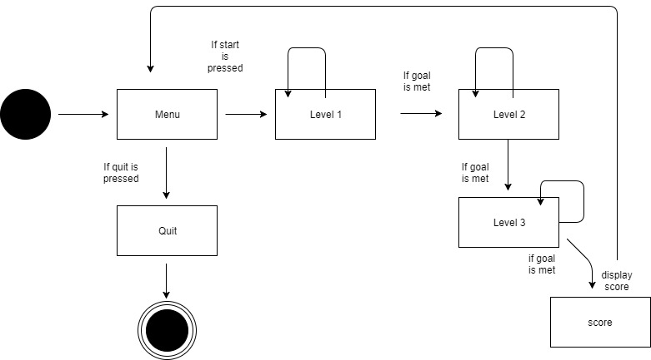

Question 2b)

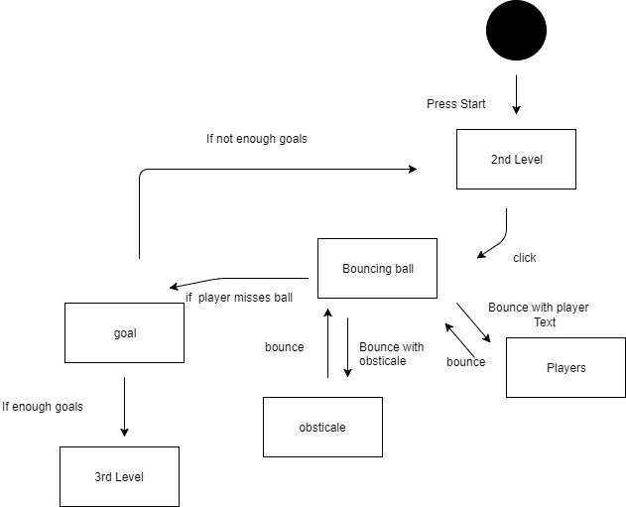

Question 3:

Files are large therefore they consume hard disk space. The files size makes it a tedious process to move them from place to place or to send them to the Internet. Compression shrinks files, making them smaller and more practical to store. It works by removing redundant information thus summarizing the file in a way that preserves as much of the original meaning as possible. Example when you compress an image into Jpeg to take less space or when compress an entire folder into a .zip to be able to send it online.

Bibliography:

(www1.curriculum.edu.au, n.d.)

(simplicable.com, n.d.)