Class 0: Acer (maple) 96

Class 1: Alnus (Alder) 48
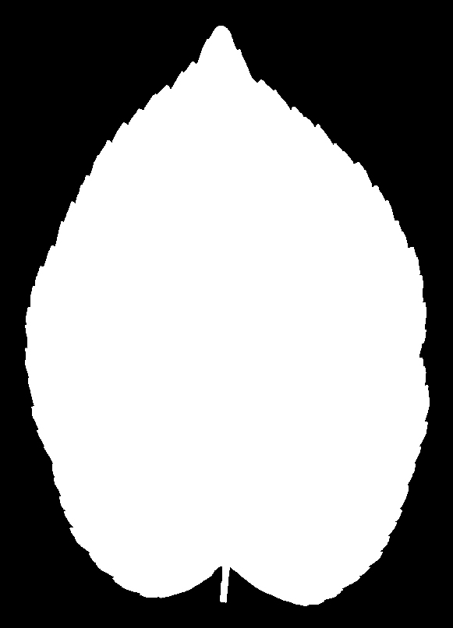
Class 2: Eucalyptus 48
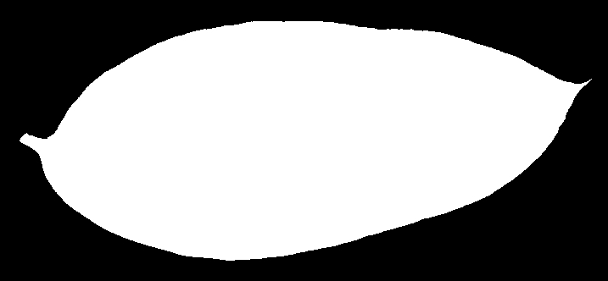
Class 3: Populus (poplar) 48

Class 4 : Quercus4 (oak) 96
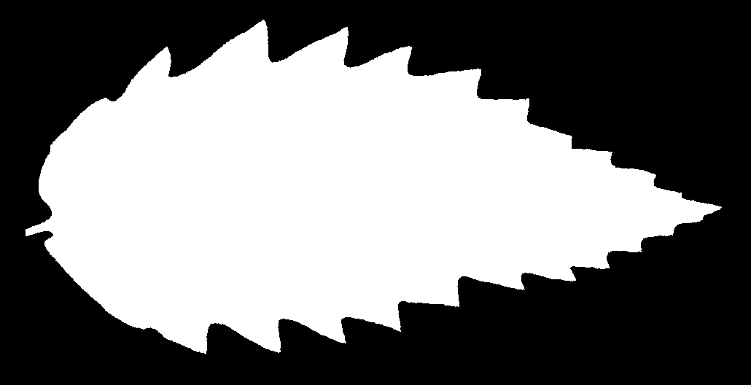
Class 5: Tilia 48
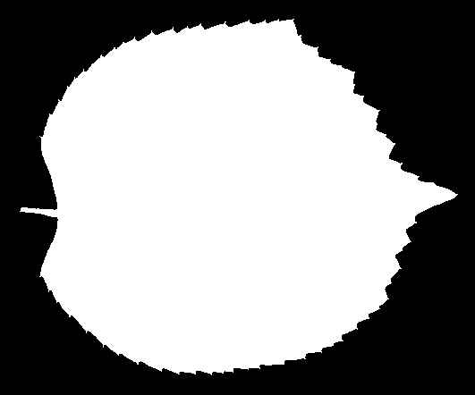

Map leave 16 to leave 6
{1,2}0, {3}->1,{5}->2, {6}->3, {12, 13}->4, {15}->5

