**R scripts for dose rate calculation in trapped charge dating**

Junjie Zhang1*, Sumiko Tsukamoto1,2

1 LIAG: Institute for Applied Geophysics, Hannover, Germany.

2Department of Geosciences, University of Tübingen, Tübingen, Germany.

*Email: [junjie.zhang@liag-institut.de](mailto:junjie.zhang@liag-institut.de)

# Abstract

We present R scripts for environmental dose rate calculations for trapped charge dating. This contribution introduces the R scripts and templates, and provides instructions for their use. We also discuss issues related to radon loss and alpha dose rate calculation. In addition to the R scripts for quartz and feldspar, we have prepared R scripts for calculating dose rates of carbonate minerals in a homogeneous medium, along with the scripts to model the time-dependent changes in dose rates resulting from U-series disequilibrium following carbonate crystallization. These R scripts are freely available on GitHub and Zenodo.

**Keywords**: luminescence dating, ESR, dose rate, R scripts, radon loss, alpha efficiency

# Introduction

To date, a number of programs for dose rate calculation have been developed in trapped charge dating (OSL, TL, and ESR). These include, but are not limited to: ADELE (Degering and Degering, 2020), AGE (Grün, 2009), Carb (Nathan and Mauz, 2008; Mauz and Hoffmann, 2014) and RCarb (Kreutzer et al., 2019), DARC (Durcan et al., 2015), DosiVox (Martin et al., 2015), DRc (Tsakalos et al., 2015), LDAC (Liang and Forman, 2019), µRate (Tudyka et al., 2022).

In this short communication, we introduce an alternative approach for dose rate calculation, using code written in the R programming language (R Core Team, 2025). The code and associated data files are organized within an R project named ‘doserate_rProject.Rproj’. The main R script used for quartz and feldspar (or polymineral) is ***doserate_main.R***. Two additional R scripts have been prepared for calculating dose rates of carbonate minerals, assuming an infinite homogeneous medium. They are ***doserate_carbonate_keff.R*** and ***doserate_carbonate_sa.R***. A total of 12 R functions have been developed to support the dose rate calculation process and are utilized by the main R scripts. Unlike previous programs with encapsulated code, these R scripts are fully open and freely modifiable, allowing users to easily customize them to suit their specific needs.

# R scripts for quartz and feldspar

For quartz and feldspar (or polymineral), the ***doserate_main.R*** should be used for dose rate calculation. The flow chart of the calculation is shown in Fig. 1. The R scripts for the functions used for dose rate calculation are stored in the folder ‘functions’. The information of the samples should be input into a comma separated value (CSV) template file: ***Template_sample_input.csv***. In the 'mineral' column of the CSV template, either ‘F’ or ‘Q’ should be entered. The ‘F’ indicates K-feldspar or polymineral. The ‘Q’ indicates quartz samples. When 'Q' is specified, internal dose rates are assumed to be zero.

In the “grainsize” column of the CSV template, enter either “coarse” or “fine”. Here, 'fine' refers to 4–11 µm grains, while 'coarse' encompasses sizes ranging from 20 to 1000 µm. Depending on whether it is ‘fine’ or ‘coarse’, different R functions for alpha and beta dose rate calculations will be applied in the main script. The alpha attenuation factors are based on Brennan et al. (1991), and beta absorption factors are based on Guérin et al. (2012). The absorbed dose fraction of Rb for internal dose rate of K-feldspar is from Readhead (2002). When ‘fine’ is specified for the ‘grainsize’, these parameters are estimated based on a mean grain size of 7.5 µm. Once ‘coarse’ is specified, these parameters are estimated based on the ‘grain.min’ and ‘grain.max’ values (unit: µm) provided in the CSV file. These functions used to calculate alpha attenuation and beta absorption factors from the grain size are valid for the grain sizes between 20 and 1000 µm.

The CSV template includes an 'etch_depth' parameter (unit: µm), which represents the reduction in grain radius due to HF etching of coarse grains. For fine grains (4–11 µm), zero should always be entered for the ‘etch_depth’ parameter. For coarse grains, when ‘etch_depth’ is zero, the alpha dose rates are calculated. When 'etch_depth' is greater than zero, alpha dose rates are simply set to zero with the assumption that the HF etching has sufficiently removed the outer rim affected by alpha irradiation. However, the exact value of ‘etch_depth’ will be used to calculate the etching factor for the beta absorption factor, following the data in Brennan (2003). For etched coarse grains, an ‘etch_depth’ of 10 µm is suggested to enter in the CSV template.

Other information in the CSV template include: alpha efficiency (*a*-value), radon loss, latitude, longitude, altitude (m), burial depth (m), water content (%), U concentration (µg/g), Th concentration (µg/g) and K concentration (%), as well as the corresponding errors. Cosmic ray dose rates are calculated following Prescott and Hutton (1988, 1994). Latitude values should be negative for locations in the Southern Hemisphere, and longitude values should be negative for locations in the Western Hemisphere. The default *a*-value is set as 0.04 ± 0.01 for quartz (e.g., Rees-Jones, 1995; Rees-Jones and Tite, 1997; Lai et al., 2008), and 0.09 ± 0.02 for the pIRIR signal of feldspar (e.g., Kreutzer et al., 2014; Schmidt et al., 2018). Three sets of conversion coefficients are stored as CSV files in the ‘conversion_data’ folder, which are from Guérin et al. (2011), Liritzis et al. (2013), and Cresswell et al. (2018), respectively. Users can choose which one to use, by specifying in the read.csv command within the script ***doserate_main.R***. The calculated dose rates will be saved in the file ***Doserate_output.csv***.

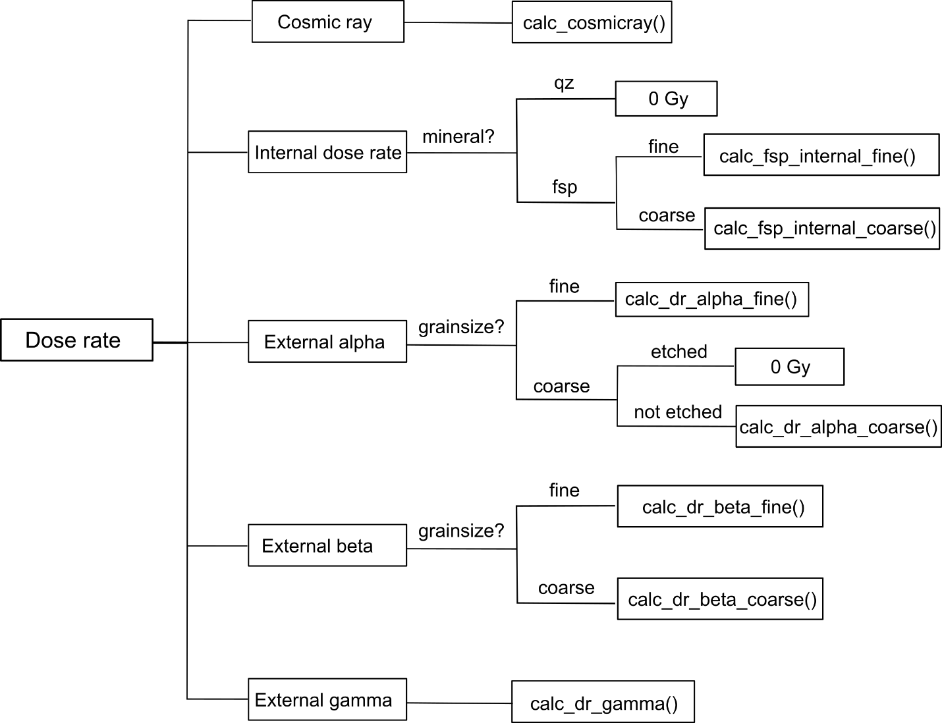

Fig. 1. Flowchart of dose rate calculation using the ***doserate_main.R*** script with defined ‘calc_’ functions. The ‘mineral’ and ‘grainsize’ are the parameters entered in the CSV template.

## 2.1. Radon loss

In the gas phase, 222Rn from the 238U decay chain may escape from the sediment matrix causing disequilibrium in the 238U decay system (Olley et al., 1997). In this case, dose rates calculated assuming U series equilibrium will be overestimated. In the R scripts, the 238U decay chain is divided into two segments, pre-Rn and after-Rn. Users can enter any value between 0 and 1 for the ‘Rnloss’ parameter in the CSV template. For example, a value of 0 means no Rn loss, and a value of 0.25 means 25% Rn loss. The degrees of Rn loss ratio can be estimated from the 210Pb/226Ra activity ratios, in case the samples have been measured by gamma-ray spectrometry (De Corte et al., 2006).

We tested the influence of Rn loss on the total dose rate, based on sediments from the Rodderberg crater basin (Zhang et al., 2024b). With a 25% Rn loss, the dose rates will be 4–5 % lower compared to the dose rate without Rn loss (Fig. 2).

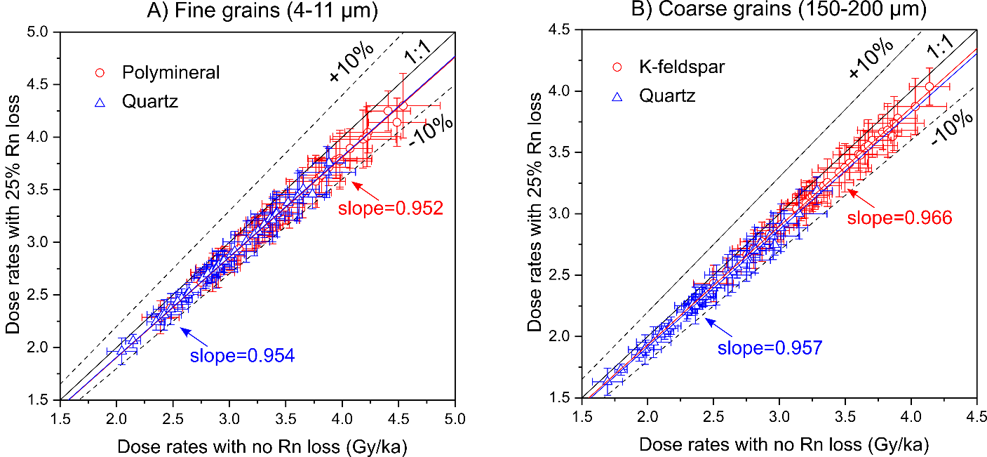

Fig. 2. Comparison between dose rates calculated with 25% Rn loss and no Rn loss, for fine grans (A) and coarse grains (B). The samples are loess and lacustrine sediments from the Rodderberg crater basin (Zhang et al., 2024b).

## 2.2. Alpha efficiency

Alpha irradiation is less efficient in generating trapped charges (luminescence or ESR signals) than beta and gamma irradiation, per unit of energy deposited. The *k*-value is defined to describe the alpha efficiency (Zimmerman, 1971), which equals to the ratio of luminescence intensity generated by per Gy alpha dose to the luminescence intensity generated by per Gy beta or gamma dose. However, by losing the same amount of energy (e.g., 0.1 keV), an alpha particle with a higher energy (e.g., 3.7 MeV) is more effective than an alpha particle with a lower energy (e.g., 3.0 MeV), in generating luminescence signals. As a result, the *k*-value increases with alpha particle’s energy (Zimmerman, 1971). The *k*-values were measured using artificial alpha sources, such as 210Po (Zimmerman, 1971), 238Pu (Tribolo et al., 2001), 244Cm (Zhang and Wang, 2020) and mostly 241Am (Biswas et al., 2013; Kreutzer et al., 2014; Lai et al., 2008; Mauz et al., 2006; Schmidt et al., 2018). In the pioneering work of Zimmerman (1971), the author assumed that all the alpha particles emitted by a 210Po source arriving at the sample were mono-energetic at around 3.7 MeV. Hence, the *k*-value measured by Zimmerman was termed *k*3.7. Following studies also applied this assumption, and took their measured *k*-values as *k*3.7.

While a lower-energy alpha particle produces less luminescence per unit of energy lost compared to a higher-energy alpha particle, it loses more energy per unit track length. As a result, the luminescence signal produced per unit track length is nearly independent of the alpha particle’s energy, provided that the energy exceeds 2 MeV (Aitken and Bowman, 1975; Aitken, 1985). Thus, the *a*-value system was proposed to describe alpha efficiency based on the track length (Aitken and Bowman, 1975; Aitken, 1985). From the definition of *a*-value, the *a*-value equals *k*3.7 for quartz.

In natural environments, the alpha particles received by a fine grain (from U and Th decay chains) have a wide energy spectrum. The overall efficiency of these alpha particles in generating luminescence is lower than that of a 3.7 MeV alpha particle (Zimmerman, 1971; Bowen, 1976). Consequently, the effective *k*-value (*k*eff) in nature is typically smaller than the *k*3.7 or the *a*-value. When calculating the natural alpha dose rate, a correction factor should be applied to the *a*-value or *k*3.7, to obtain the *k*eff. The correction factors are slightly different between different minerals (Zimmerman, 1971; Bowman, 1976). A mean correction factor of 0.9 for both U and Th was calculated, based on the Table K.1 of Aitken (1985). It is worthy to be noted that this mean correction factor is based on TL signals, and such correction factors for OSL and ESR signals have not been reported yet. The corrections factors before and after Rn in the decay chain of 238U are also slightly different (Zimmerman, 1971; Bowman, 1976; Aitken, 1985). We have not accounted for the influence of Rn loss on the correction factors, and have applied a constant correction factor of 0.9 in our scripts. If needed, users can easily change the correction factor in functional R scripts ***calc_dr_alpha_fine.R*** and ***calc_dr_alpha_coarse.R***, by the parameter of ‘a2k’ in the code.

Using the sediments from Rodderberg crater basin as an example, alpha dose rates contribute approximately 25% and 13% to the total dose rates of fine-grain polymineral and quartz, respectively (Zhang et al., 2024b). Thus, a 10% decrease in the alpha dose rate will have a negligible effect on the total dose rate, as shown in Fig. 3. In cases where the alpha dose rate makes a major contribution, such as in carbonate rocks, the correction factor from *a*-value to *k*eff will be crucial.

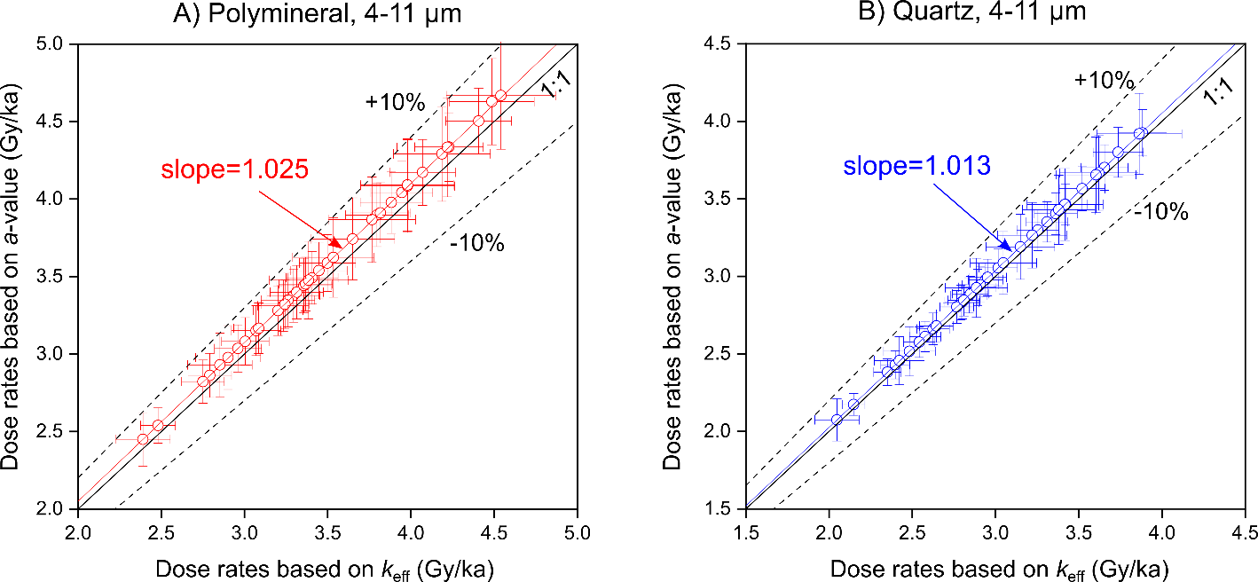

Fig. 3. Comparison between dose rates calculated with the effective *k*-value (*k*eff) and the *a*-value. Using the *a*-values, dose rates are overestimated by 2.5% for fine-grained polymineral (A) and 1.3% for fined-grain quartz (B). The samples are sediments from Rodderberg crater basin (Zhang et al., 2024b).

## 2.3. Comparison with DRAC

The dose rates of quartz and feldspar calculated from our R scripts are compared with those calculated by the DRAC software (Durcan et al., 2015). Dose rates were calculated with no Rn loss, as DRAC cannot assume Rn loss in its calculation. In the input CSV template of DARC, we entered the *k*eff values rather than the *a*-values. The *k*eff values were calculated by multiplying a correction factor of 0.9 with the *a*-values, which are 0.036 ± 0.01 for quartz and 0.081 ± 0.02 for feldspar, respectively. The dose rate results from our R scripts are identical to those from DRAC (Fig. 4), demonstrating the accuracy of our scripts.

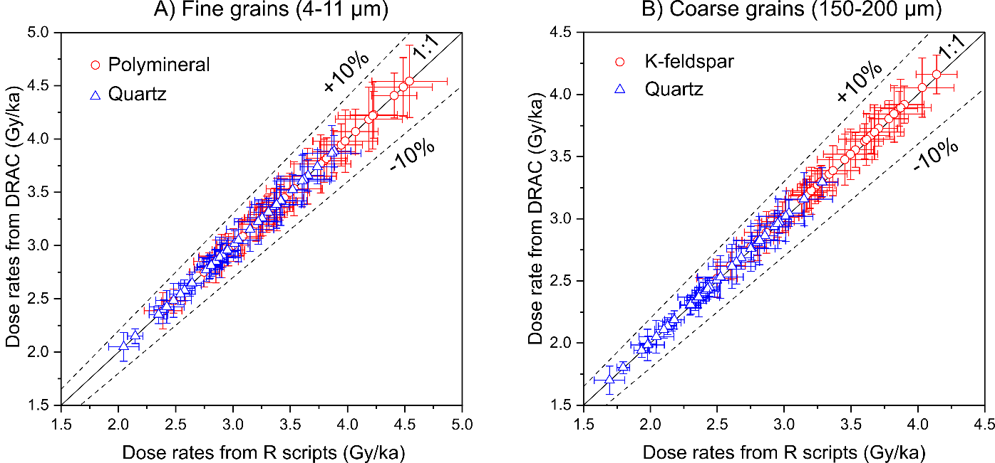

Fig. 4. Comparison between dose rates calculated by our R scripts and DRAC, for fine grains (A) and coarse grains (B) of sediments from Rodderberg crater basin (Zhang et al., 2024b). For coarse grains, the HF etched depth is set as 10 µm for coarse-grained quartz and 0 um for coarse-grained K-feldspar.

# 3. R scripts for carbonates

The existing Matlab code ‘Carb’ (Mauz and Hoffmann, 2014) and R-package ‘Rcarb’ (Kreutzer et al., 2019) were developed for dose rate calculation of quartz grains inside carbonate rich sediments, to account for the dose rate change with time resulting from the replacement of air and water in the pore space by carbonates. We have prepared two R scripts for dose rate estimation of carbonate minerals in carbonate rocks (e.g., speleothem, limestone, dolostone), using an assumption of an infinite homogeneous medium. These two scripts are ***doserate_carbonate_keff.R*** and ***doserate_carbonate_sa.R***, in the folder named ‘doserate_homogeneous_carbonate’ under the doserate_rProject. If users apply the effective *k*-value for alpha dose rate calculation, the script of ***doserate_carbonate_keff.R***should be used in combination with the ***Template_carbonate_keff.csv*** file. In the template CSV file, users need to enter the *k*eff values for each individual sample, as alpha efficiency values may vary significantly between different calcite and dolomite samples (e.g., Debenham and Aitken, 1984; Zhang et al., 2025). The alpha dose rate contributes more than 50% to the total dose rate for carbonate samples in an infinite homogeneous medium (Fig. 5). Therefore, we recommend measuring the alpha efficiency for each individual sample as part of routine procedures in dating carbonates.

In addition to the *k*-value and *a*-value systems, a *S*a-value system (Guérin and Valladas, 1980) have also been used in calculating the alpha dose rate. With the *S*a-value, the effective alpha dose rate can be obtained from the alpha flux. If the users apply the *S*a-value system, the ***doserate_carbonate_sa.R*** script should be used in combination with the ***Template_carbonate_sa.csv*** file. *S*a-values need to be entered for each sample. The alpha fluxes of 1 ppm U or Th in calcite and dolomite are slightly different. In the ‘mineral’ column of the CSV template, either ‘calcite’ or ‘dolomite’ should be entered. The ranges (in mg cm-2) of alpha particles with different energies for calcite (ρ = 2.71 g cm-3) and dolomite (ρ = 2.85 g cm-3) were obtained from the software ‘The Stopping and Range of Ions in Matter’ (SRIM version 2013) (Ziegler and Biersack, 1985). With these alpha ranges, the alpha fluxes of 1 ppm U or Th in calcite and dolomite were calculated based on the energy spectrum of emitted alpha particles in their decay chains (by an Excel table from Norbert Mercier, provided in Supplementary Materials). For calcite, the alpha fluxes of 1 ppm U and 1 ppm Th are 18468 and 5166 cm-2*a-1, respectively. For dolomite, the corresponding values are 18013 and 5047 cm-2*a-1, respectively. Previous studies have reported alpha ranges for quartz, feldspar and calcite (e.g., Brenann and Lyons, 1989; Valladas, 1988). We have updated these alpha range data with the SRIM 2013 software. Though the ranges of alpha particles are slightly different between different minerals, the alpha fluxes from 1 ppm U or Th differ by less than 3% between quartz, K-feldspar, calcite and dolomite (data in Supplementary Materials).

Similar to the *a*-value, the *S*a-value is almost independent of the energy of alpha particles. However, when alpha particle energy falls below 2 MeV, the luminescence generated per unit track length decreases significantly. The *S*a-values we entered into the ***Template_carbonate_sa.csv*** file were measured with a 241Am source in the University Bordeaux Montaigne (Zhang et al., 2024a, 2025). These values are slightly different from the *S*a-values in nature, as the energy spectrum of the alpha particles emitted by the Bordeaux 241Am source arriving at the aliquots differs from that of the U and Th decay chains in nature (Kreutzer et al., 2018). Correction factors of 0.92 for U and 0.96 for Th have been simulated for the measured *S*a-values, respectively (personal communication with Norbert Mercier). Thus, inside the ***doserate_carbonate_sa.R*** script, these two correction factors have been multiplied with the *S*a-values when calculating alpha dose rates. These correction factors should differ for different alpha sources used for measuring the *S*a-values.

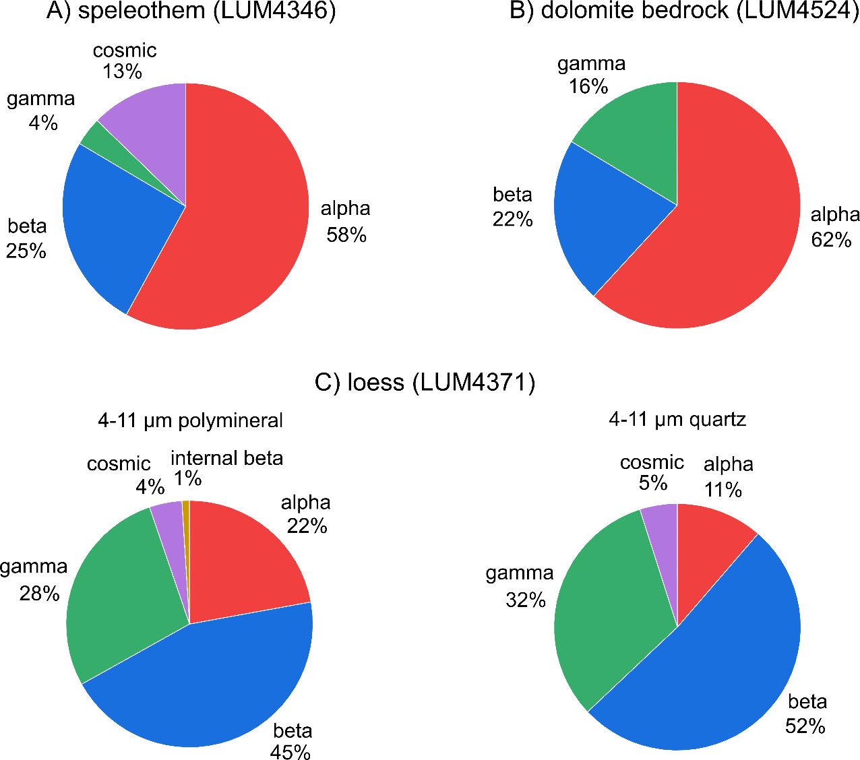

Fig. 5. Pie charts of dose rate composition of carbonate samples and a loess sample. A) Speleothem sample from Bleßberg cave, Germany (Zhang et al., 2024a). B) Dolomite sample from L’Aquila, Italy (Zhang et al., 2025). C) Loess sample from Rodderberg crater basin (Zhang et al., 2024b). Note that, for carbonate samples, alpha dose rates contribute more than half of the total dose rates.

These two R scripts for carbonate dose rate calculation are based on the secular equilibrium state of 238U. When dating the crystallization event of carbonates (e.g., speleothem growth, shell formation), U-series disequilibrium should be considered. Variation of dose rate on time since carbonate crystallization can be modelled by the ***dose_rate_simulation***.R script in the folder **‘**correction_for_238U_disequilibrium’. Results are saved ***doserate_change_simulation_238U_disequilibrium.csv***. The simulation is based on the U concentration and the initial 234U/238U radioactivity ratio. The radioactivities of 238U, 234U and 230Th (Bq/kg) are calculated from their decay constants (Fig. 6A). The dose rates from three segments of the 238U decay chain (238U to 234U, 234U to 230Th, 230Th to 206Pb) are calculated separately and summed up to obtain the dose rate of the full decay chain (Fig. 6B). Adding the constant dose rates from the 232Th decay chain, 40K and cosmic ray, the totally accumulated dose (*D*e) with time can be simulated (Fig. 6C). The ***dose_rate_simulation_for_age_err.R*** is used to deduce the age error by the Monte Carlo method. The ***age_iteration.R*** is another R script to deduce the crystallization age, by an iteration method modified from Ikeya and Ohmura (1983). More details about the modelling are in Zhang et al. (2024a).

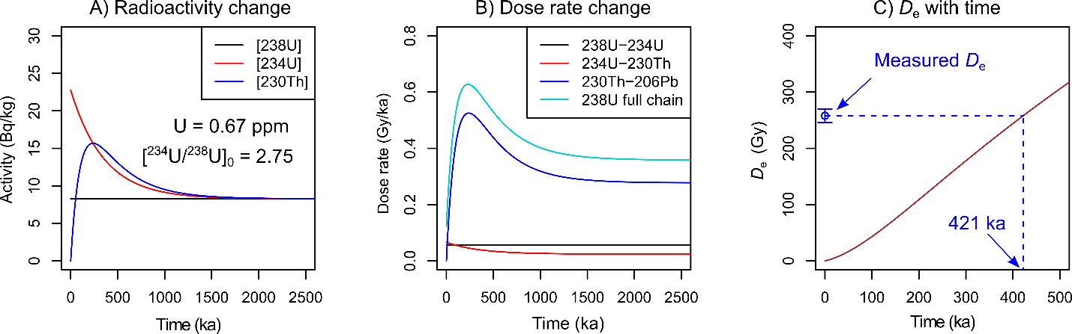

Fig. 6. Example for simulating dose rate change with time since carbonate crystallization. The sample is a speleothem (LUM4347) from Bleßberg cave, Germany (Zhang et al., 2024a).

# 4. Access to code

The R scripts are freely available on GitHub at <https://github.com/JunjieZhang113/R-scripts-dose-rate-calculator>, and Zenodo at <https://doi.org/10.5281/zenodo.15682786>.

# Acknowledgements

J.Z. and S.T. thank Nobert Mercier, Chantal Tribolo, Sebastian Kreutzer, Markus Fuchs, Thomas Kolb and Mariana Sontag-González for providing the opportunities to measure *S*a-values of calcite and dolomite samples at the University Bordeaux Montaigne and the Justus-Liebig University of Giessen, as well as the discussion about *S*a-value evaluation. Norbert Mercier prepared the Excel table to calculate the alpha flux from alpha ranges. Norbert Mercier simulated the correction factors for the measured *S*a-values to account for the energy spectrum difference between the 241Am alpha source in Bordeaux and the natural environment.

# References

Aitken, M.J. *Thermoluminescence Dating*. Academic Press, London. 1985.

Aitken, M.J. and Bowman, S.G.E. *Thermoluminescence dating: assessment of alpha particle contribution*. Archaeometry, 17: 132–138, 1975. https://doi.org/10.1111/j.1475-4754.1975.tb00127.x

Biswas, R.H., Williams, M.A.J., Raj, R., Juyal, N., and Singhvi, A.K. *Methodological studies on luminescence dating of volcanic ashes*. Quaternay Geochronology, 17: 14–25, 2013. https://doi.org/10.1016/j.quageo.2013.03.004

Bowman, S.G.E. *Thermoluminescence dating: the evaluation of radiation dosage*. Unpublished PhD thesis, Faculty of Physical Sciences, Oxford University. 1976.

Brennan, B.J. *Beta doses to spherical grains*. Radiation Measurements, 37: 299–303, 2003. https://doi.org/10.1016/S1350-4487(03)00011-8

Brennan, B.J. and Lyons, R.G. *Ranges of alpha particles in various media*. Ancient TL, 7: 32–37, 1989. https://doi.org/10.26034/la.atl.1989.147

Brennan, B.J., Lyons, R.G., and Phillips, S.W. *Attenuation of alpha particle track dose for spherical grains*. International Journal of Radiation Applications and Instrumentation. Part D. Tracks Radiation Measurements, 18: 249–253, 1991. https://doi.org/10.1016/1359-0189(91)90119-3

Cresswell, A.J., Carter, J., and Sanderson, D.C.W. *Dose rate conversion parameters: Assessment of nuclear data*. Radiation Measurements, 120: 195–201, 2018. https://doi.org/10.1016/j.radmeas.2018.02.007

De Corte, F., Vandenberghe, D., De Wispelaere, A., Buylaert, J.-P., and Van Den Haute, P. *Radon loss from encapsulated sediments in Ge gamma-ray spectrometry for the annual radiation dose determination in luminescence dating*. Czechoslovak Journal of Physics, 56: 183–194, 2006. https://doi.org/10.1007/s10582-006-1016-3

Debenham, N.C. and Aitken, M.J. *Thermoluminescence dating of stalagmitic calcite*. Archaeometry, 26: 155–170, 1984. https://doi.org/10.1111/j.1475-4754.1984.tb00330.x

Degering, D. and Degering, A. *Change is the only constant - time-dependent dose rates in luminescence dating*. Quaternary Geochronology, 58: 101074, 2020. https://doi.org/10.1016/j.quageo.2020.101074

Durcan, J.A., King, G.E., and Duller, G.A.T. *DRAC: Dose Rate and Age Calculator for trapped charge dating*. Quaternary Geochronology, 28: 54–61, 2015. https://doi.org/10.1016/j.quageo.2015.03.012

Grün, R. *“AGE” program for the calculation of luminescence age estimates*. Ancient TL, 27: 45–46, 2009. https://doi.org/10.26034/la.atl.2009.429

Guérin, G., Mercier, N., and Adamiec, G. *Dose-rate conversion factors: update*. Ancient TL, 29: 5–8, 2011. https://doi.org/10.26034/la.atl.2011.443

Guérin, G., Mercier, N., Nathan, R., Adamiec, G., and Lefrais, Y. *On the use of the infinite matrix assumption and associated concepts: A critical review*. Radiation Measurements, 47: 778–785, 2012. https://doi.org/10.1016/j.radmeas.2012.04.004

Guérin, G. and Valladas, G. *Thermoluminescence dating of volcanic plagioclases*. Nature, 286: 697–699, 1980. https://doi.org/10.1038/286697a0

Ikeya, M. and Ohmura, K. *Comparison of ESR ages of corals from marine terraces with 14C and 230Th/234U ages*. Earth and Planetary Science Letters, 65: 34–38, 1983. https://doi.org/10.1016/0012-821X(83)90187-5

Kreutzer, S., Martin, L., Dubernet, S., and Mercier, N. *The IR-RF alpha-Efficiency of K-feldspar*. Radiation Measurements, 120: 148–156, 2018. https://doi.org/10.1016/j.radmeas.2018.04.019

Kreutzer, S., Mauz, B., Martin, L., and Mercier, N. *‘RCarb’: Dose Rate Modelling of Carbonate-Rich Samples - an Implementation of Carb in R -*. Ancient TL, 37(2): 1–8, 2019. https://doi.org/10.26034/la.atl.2019.533

Kreutzer, S., Schmidt, C., DeWitt, R., and Fuchs, M. *The a-value of polymineral fine grain samples measured with the post-IR IRSL protocol*. Radiation Measurements, 69: 18–29, 2014. https://doi.org/10.1016/j.radmeas.2014.04.027

Lai, Z.P., Zöller, L., Fuchs, M., and Brückner, H. *Alpha efficiency determination for OSL of quartz extracted from Chinese loess*. Radiation Measurements, 43: 767–770, 2008. https://doi.org/10.1016/j.radmeas.2008.01.022

Liang, P. and Forman, S.L. *LDAC: An Excel-based program for luminescence equivalent dose and burial age calculations*. Ancient TL, 37: 21–40, 2019. https://doi.org/10.26034/la.atl.2019.536

Liritzis, I., Stamoulis, K., Papachristodoulou, C., and Ioannides, K. *A re-evaluation of radiation dose-rate conversion factors*. Mediterranean Archaeology and Archaeometry, 13: 1–15, 2013. doi:10.1007/978-3-319-00170-8_3

Mauz, B. and Hoffmann, D. *What to do when carbonate replaced water: Carb, the model for estimating the dose rate of carbonate-rich samples*. Ancient TL, 32(2): 24–32, 2014. https://doi.org/10.26034/la.atl.2014.481

Mauz, B., Packman, S.C., and Lang, A. *The alpha effectiveness in silt-sized quartz: new data obtained by single and multiple aliquot protocols*. Ancient TL, 24: 47–52, 2006. https://doi.org/10.26034/la.atl.2006.396

Martin, L., Incerti, S., and Mercier, N. *DosiVox: Implementing Geant 4-based software for dosimetry simulations relevant to luminescence and ESR dating techniques*. Ancient TL, 33(1): 1–10, 2015. https://doi.org/10.26034/la.atl.2015.484

Nathan, R. P. and Mauz, B. *On the dose-rate estimate of carbonate-rich sediments for trapped charge dating*. Radiation Measurements, 43(1): 14–25, 2008. doi: 10.1016/j.radmeas.2007.12.012

Olley, J.M., Roberts, R.G., and Murray, A.S. *Disequilibria in the uranium decay series in sedimentary deposits at Allen’s cave, nullarbor plain, Australia: Implications for dose rate determinations*. Radiation Measurements, 27: 433–443, 1997. https://doi.org/10.1016/S1350-4487(96)00114-X

Prescott, J.R. and Hutton, J.T. *Cosmic ray and gamma ray dosimetry for TL and ESR*. Nuclear Tracks and Radiation Measurements, 14: 223–227, 1988. https://doi.org/10.1016/1359-0189(88)90069-6

Prescott, J.R. and Hutton, J.T. *Cosmic ray contributions to dose rates for luminescence and ESR dating: Large depths and long-term time variations*. Radiation Measurements, 23: 497–500, 1994. https://doi.org/10.1016/1350-4487(94)90086-8

R Core Team. *R: A Language and Environment for Statistical Computing. R Foundation for Statistical Computing*, Vienna, Austria, 2025. https://www.R-project.org/.

Readhead, M. *Absorbed dose fraction for 87Rb β particles*. Ancient TL, 20: 25–28, 2002. https://doi.org/10.26034/la.atl.2002.342

Rees-Jones, J. *Optical dating of young sediments using fine-grain quartz*. Ancient TL, 13: 9–14, 1995. https://doi.org/10.26034/la.atl.1995.242

Rees-Jones, J. and Tite, M.S. *Optical dating results for British archaeological sediments*. Archaeometry, 39: 177–187, 1997. https://doi.org/10.1111/j.1475-4754.1997.tb00797.x

Schmidt, C., Bösken, J., and Kolb, T. *Is there a common alpha-efficiency in polymineral samples measured by various infrared stimulated luminescence protocols?* Geochronometria, 45: 160–172, 2018. https://doi.org/10.1515/geochr-2015-0095

Tudyka, K., Koruszowic, M., Osadnik, R., Adamiec, G., Moska, P., Szymak, A., Bluszcz, A., Zhang, J., Kolb, T., and Poręba, G. *μRate: An online dose rate calculator for trapped charge dating*. Archaeometry, 65: 423–443, 2023. https://doi.org/10.1111/arcm.12828

Tribolo, C., Mercier, N., and Valladas, H. *Alpha sensitivity determination in quartzite using an OSL single aliquot procedure*. Ancient TL, 19: 47–50, 2001. https://doi.org/10.26034/la.atl.2001.334

Tsakalos, E., Christodoulakis, J., and Charalambous, L., 2015. *The Dose Rate Calculator (DRc) for Luminescence and ESR Dating-a Java Application for Dose Rate and Age Determination*. Archaeometry 58: 347–352, 2015. doi: https://doi.org/10.1111/arcm.12162

Valladas, G. *Stopping power and range for alpha particles in SiO2*. Ancient TL, 6: 7–8, 1988. https://doi.org/10.26034/la.atl.1988.128

Zhang, J., Arriga, G., Rossetti, F., Argante, V., Kraemer, D., Sontag-González, M., Cosentino, D., Cipollari, P., and Tsukamoto, S. *Dolomite luminescence thermochronometry reconstructs the low-temperature exhumation history of carbonate rocks in the central Apennines, Italy*. Communications Earth & Environment, 6: 252, 2025. https://doi.org/10.1038/s43247-025-02216-1

Zhang, J., Klose, J., Scholz, D., Marwan, N., Breitenbach, S.F.M., Katzschmann, L., Kraemer, D., and Tsukamoto, S. *Isothermal thermoluminescence dating of speleothem growth – A case study from Bleßberg cave 2, Germany*. Quaternary Geochronology, 85: 101628, 2024a. https://doi.org/10.1016/j.quageo.2024.101628

Zhang, J. and Wang, L., 2020. *Thermoluminescence dating of calcite – Alpha effectiveness and measurement protocols*. Journal of Luminesence, 223: 117205, 2020. https://doi.org/10.1016/j.jlumin.2020.117205

Zhang, J., Zolitschka, B., Hogrefe, I., Tsukamoto, S., Binot, F., and Frechen, M. *High-resolution luminescence-dated sediment record for the last two glacial-interglacial cycles from Rodderberg, Germany*. Quaternary Geochronology, 82: 101535, 2024b. https://doi.org/10.1016/j.quageo.2024.101535

Ziegler, J.F. and Biersack, J.P. *The Stopping and Range of Ions in Matter*, in: Bromley, D.A. (Ed.), *Treatise on Heavy-Ion Science: Volume 6: Astrophysics, Chemistry, and Condensed Matter*. Springer US, Boston, MA, pp. 93–129, 1985

Zimmerman, D.W. *Thermoluminescent Dating Using Fine Grains from Pottery*. Archaeometry, 13: 29–52, 1971. https://doi.org/10.1111/j.1475-4754.1971.tb00028.x

**Submitted to Ancient TL on June 17, 2025**