CTA-ED Exercise 5: Unsupervised learning (topic models)
Junke Guan; Cullen; Xiao wen Leng; Yunnuo; Yan Ge
11/03/2026

Introduction
The hands-on exercise for this week focuses on: 1) estimating a topic model ; 2) interpreting and visualizing results. Remember that you will need to: 1) comment your code and 2) write out the interpretation of your results.
You will learn how to:
- Generate document-term-matrices in format appropriate for topic modelling
- Estimate a topic model using the quanteda and topicmodels package
- Visualize results
- Reverse engineer a test of model accuracy
- Run some validation tests

Setup
Before proceeding, we’ll load the packages we will need for this tutorial.
library(tidyverse) # loads dplyr, ggplot2, and others
library(stringr) # to handle text elements
library(tidytext) # includes set of functions useful for manipulating text
library(topicmodels) # to estimate topic models
library(gutenbergr) # to get text data
library(scales)
library(tm)
library(ggthemes) # to make your plots look nice
library(readr)
library(quanteda)
library(quanteda.textmodels)
You may need to install the preText package if you haven’t done so yet. For that you will need to run the next code chunk (it is currently set to ‘eval=F’, which tells R ‘do not execute this code chunk’). That package is not readily available on through RStudio directly. It needs to be downloaded from the Github repository set up by its creater Matthew J Denny. We can do that using the command install_github(). This command is part of the ‘devtools’ package, which you will need to install as well (if you haven’t done so already). The devtools package is directly available through R so it can be installed with the usual command install_packages.
#install_package(devtools)
devtools::install_github("matthewjdenny/preText")
library(preText)

Data collection
We’ll be using data from Alexis de Tocqueville’s “Democracy in America.”
We have already downloaded some data for you, but we also included the code to download it yourself (it is currently set to ‘eval=F’ so it won’t run unless you remove the eval=F argument or you run the chunk directly.
The code downloads these data, both Volume 1 and Volume 2, and combine them into one data frame. For this, we’ll be using the gutenbergr package, which allows the user to download text data from over 60,000 out-of-copyright books. The ID for each book appears in the url for the book selected after a search on https://www.gutenberg.org/ebooks/.
This example is adapted by Text Mining with R: A Tidy Approach by Julia Silge and David Robinson.

Here, we see that Volume of Tocqueville’s “Democracy in America” is stored as “815”. A separate search reveals that Volume 2 is stored as “816”.
tocq <- gutenberg_download(c(815, 816),
meta_fields = "author")
Or we can read the dataset we already downloaded for you in the following way:
tocq <- readRDS(gzcon(url("https://github.com/cjbarrie/CTA-ED/blob/main/data/topicmodels/tocq.RDS?raw=true")))
Once we have read in these data, we convert it into a different data shape: the document-term-matrix. We also create a new columns, which we call “booknumber” that recordss whether the term in question is from Volume 1 or Volume 2. To convert from tidy into “DocumentTermMatrix” format we can first use unnest_tokens() as we have done in past exercises, remove stop words, and then use the cast_dtm() function to convert into a “DocumentTermMatrix” object.
tocq_words <- tocq %>%
mutate(booknumber = ifelse(gutenberg_id==815, "DiA1", "DiA2")) %>%
unnest_tokens(word, text) %>%
filter(!is.na(word)) %>%
count(booknumber, word, sort = TRUE) %>%
ungroup() %>%
anti_join(stop_words)
## Joining with `by = join_by(word)`
tocq_dtm <- tocq_words %>%
cast_dtm(booknumber, word, n)
tm::inspect(tocq_dtm)
## <<DocumentTermMatrix (documents: 2, terms: 12092)>>
## Non-/sparse entries: 17581/6603
## Sparsity : 27%
## Maximal term length: 18
## Weighting : term frequency (tf)
## Sample :
## Terms
## Docs country democratic government laws nations people power society time
## DiA1 357 212 556 397 233 516 543 290 311
## DiA2 167 561 162 133 313 360 263 241 309
## Terms
## Docs united
## DiA1 554
## DiA2 227
We see here that the data are now stored as a “DocumentTermMatrix.” In this format, the matrix records the term (as equivalent of a column) and the document (as equivalent of row), and the number of times the term appears in the given document. Many terms will not appear in the document, meaning that the matrix will be stored as “sparse,” meaning there will be a preponderance of zeroes. Here, since we are looking only at two documents that both come from a single volume set, the sparsity is relatively low (only 27%). In most applications, the sparsity will be a lot higher, approaching 99% or more.
Estimating our topic model is then relatively simple. All we need to do if specify how many topics that we want to search for, and we can also set our seed, which is needed to reproduce the same results each time (as the model is a generative probabilistic one, meaning different random iterations will produce different results).
tocq_lda <- LDA(tocq_dtm, k = 10, control = list(seed = 1234))
After this we can extract the per-topic-per-word probabilities, called “β” from the model:
tocq_topics <- tidy(tocq_lda, matrix = "beta")
head(tocq_topics, n = 10)
## # A tibble: 10 × 3
## topic term beta
## <int> <chr> <dbl>
## 1 1 democratic 0.00855
## 2 2 democratic 0.0115
## 3 3 democratic 0.00444
## 4 4 democratic 0.0193
## 5 5 democratic 0.00254
## 6 6 democratic 0.00866
## 7 7 democratic 0.00165
## 8 8 democratic 0.0108
## 9 9 democratic 0.00276
## 10 10 democratic 0.00334
We now have data stored as one topic-per-term-per-row. The betas listed here represent the probability that the given term belongs to a given topic. So, here, we see that the term “democratic” is most likely to belong to topic 4. Strictly, this probability represents the probability that the term is generated from the topic in question.
We can then plots the top terms, in terms of beta, for each topic as follows:
tocq_top_terms <- tocq_topics %>%
group_by(topic) %>%
top_n(10, beta) %>%
ungroup() %>%
arrange(topic, -beta)
tocq_top_terms %>%
mutate(term = reorder_within(term, beta, topic)) %>%
ggplot(aes(beta, term, fill = factor(topic))) +
geom_col(show.legend = FALSE) +
facet_wrap(~ topic, scales = "free", ncol = 4) +
scale_y_reordered() +
theme_tufte(base_family = "Helvetica")
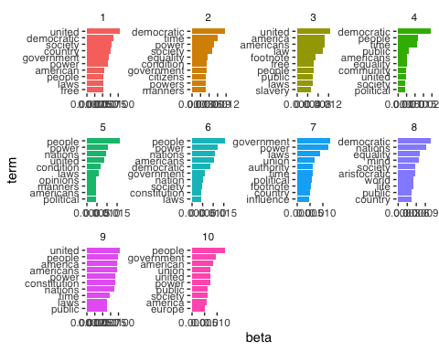
But how do we actually evaluate these topics? Here, the topics all seem pretty similar.

Evaluating topic model
Well, one way to evaluate the performance of unspervised forms of classification is by testing our model on an outcome that is already known.
Here, two topics that are most obvious are the ‘topics’ Volume 1 and Volume 2 of Tocqueville’s “Democracy in America.” Volume 1 of Tocqueville’s work deals more obviously with abstract constitutional ideas and questions of race; Volume 2 focuses on more esoteric aspects of American society. Listen an “In Our Time” episode with Melvyn Bragg discussing Democracy in America here.
Given these differences in focus, we might think that a generative model could accurately assign to topic (i.e., Volume) with some accuracy.

Plot relative word frequencies
First let’s have a look and see whether there really are words obviously distinguishing the two Volumes.
tidy_tocq <- tocq %>%
unnest_tokens(word, text) %>%
anti_join(stop_words)
## Joining with `by = join_by(word)`
## Count most common words in both
tidy_tocq %>%
count(word, sort = TRUE)
## # A tibble: 12,092 × 2
## word n
## <chr> <int>
## 1 people 876
## 2 power 806
## 3 united 781
## 4 democratic 773
## 5 government 718
## 6 time 620
## 7 nations 546
## 8 society 531
## 9 laws 530
## 10 country 524
## # ℹ 12,082 more rows
bookfreq <- tidy_tocq %>%
mutate(booknumber = ifelse(gutenberg_id==815, "DiA1", "DiA2")) %>%
mutate(word = str_extract(word, "[a-z']+")) %>%
count(booknumber, word) %>%
group_by(booknumber) %>%
mutate(proportion = n / sum(n)) %>%
select(-n) %>%
spread(booknumber, proportion)
ggplot(bookfreq, aes(x = DiA1, y = DiA2, color = abs(DiA1 - DiA2))) +
geom_abline(color = "gray40", lty = 2) +
geom_jitter(alpha = 0.1, size = 2.5, width = 0.3, height = 0.3) +
geom_text(aes(label = word), check_overlap = TRUE, vjust = 1.5) +
scale_x_log10(labels = percent_format()) +
scale_y_log10(labels = percent_format()) +
scale_color_gradient(limits = c(0, 0.001), low = "darkslategray4", high = "gray75") +
theme_tufte(base_family = "Helvetica") +
theme(legend.position="none",
strip.background = element_blank(),
strip.text.x = element_blank()) +
labs(x = "Tocqueville DiA 2", y = "Tocqueville DiA 1") +
coord_equal()
## Warning: Removed 6173 rows containing missing values or values outside the scale range
## (`geom_point()`).
## Warning: Removed 6174 rows containing missing values or values outside the scale range
## (`geom_text()`).
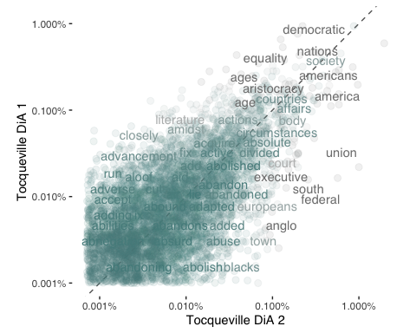
We see that there do seem to be some marked distinguishing characteristics. In the plot above, for example, we see that more abstract notions of state systems appear with greater frequency in Volume 1 while Volume 2 seems to contain words specific to America (e.g., “north” and “south”) with greater frequency. The way to read the above plot is that words positioned further away from the diagonal line appear with greater frequency in one volume versus the other.

Split into chapter documents
In the below, we first separate the volumes into chapters, then we repeat the same procedure as above. The only difference now is that instead of two documents representing the two full volumes of Tocqueville’s work, we now have 132 documents, each representing an individual chapter. Notice now that the sparsity is much increased: around 96%.
tocq <- tocq %>%
filter(!is.na(text))
# Divide into documents, each representing one chapter
tocq_chapter <- tocq %>%
mutate(booknumber = ifelse(gutenberg_id==815, "DiA1", "DiA2")) %>%
group_by(booknumber) %>%
mutate(chapter = cumsum(str_detect(text, regex("^chapter ", ignore_case = TRUE)))) %>%
ungroup() %>%
filter(chapter > 0) %>%
unite(document, booknumber, chapter)
# Split into words
tocq_chapter_word <- tocq_chapter %>%
unnest_tokens(word, text)
# Find document-word counts
tocq_word_counts <- tocq_chapter_word %>%
anti_join(stop_words) %>%
count(document, word, sort = TRUE) %>%
ungroup()
## Joining with `by = join_by(word)`
tocq_word_counts
## # A tibble: 69,781 × 3
## document word n
## <chr> <chr> <int>
## 1 DiA2_76 united 88
## 2 DiA2_60 honor 70
## 3 DiA1_52 union 66
## 4 DiA2_76 president 60
## 5 DiA2_76 law 59
## 6 DiA1_42 jury 57
## 7 DiA2_76 time 50
## 8 DiA1_11 township 49
## 9 DiA1_21 federal 48
## 10 DiA2_76 constitution 48
## # ℹ 69,771 more rows
# Cast into DTM format for LDA analysis
tocq_chapters_dtm <- tocq_word_counts %>%
cast_dtm(document, word, n)
tm::inspect(tocq_chapters_dtm)
## <<DocumentTermMatrix (documents: 132, terms: 11898)>>
## Non-/sparse entries: 69781/1500755
## Sparsity : 96%
## Maximal term length: 18
## Weighting : term frequency (tf)
## Sample :
## Terms
## Docs country democratic government laws nations people power public time
## DiA1_11 10 0 23 19 7 13 19 15 6
## DiA1_13 13 5 34 9 12 17 37 15 6
## DiA1_20 9 0 25 13 2 14 32 13 10
## DiA1_21 4 0 20 29 6 12 20 5 5
## DiA1_23 10 0 35 9 24 20 13 4 8
## DiA1_31 7 12 10 13 4 30 18 31 6
## DiA1_32 10 14 25 6 9 25 11 43 8
## DiA1_47 12 2 5 3 3 6 8 0 3
## DiA1_56 12 0 3 7 19 3 8 3 22
## DiA2_76 11 10 24 39 12 31 27 27 50
## Terms
## Docs united
## DiA1_11 13
## DiA1_13 19
## DiA1_20 21
## DiA1_21 23
## DiA1_23 15
## DiA1_31 11
## DiA1_32 14
## DiA1_47 8
## DiA1_56 25
## DiA2_76 88
We then re-estimate the topic model with this new DocumentTermMatrix object, specifying k equal to 2. This will enable us to evaluate whether a topic model is able to generatively assign to volume with accuracy.
tocq_chapters_lda <- LDA(tocq_chapters_dtm, k = 2, control = list(seed = 1234))
After this, it is worth looking at another output of the latent dirichlet allocation procedure. The γ probability represents the per-document-per-topic probability or, in other words, the probability that a given document (here: chapter) belongs to a particular topic (and here, we are assuming these topics represent volumes).
The gamma values are therefore the estimated proportion of words within a given chapter allocated to a given volume.
tocq_chapters_gamma <- tidy(tocq_chapters_lda, matrix = "gamma")
tocq_chapters_gamma
## # A tibble: 264 × 3
## document topic gamma
## <chr> <int> <dbl>
## 1 DiA2_76 1 0.551
## 2 DiA2_60 1 1.000
## 3 DiA1_52 1 0.0000464
## 4 DiA1_42 1 0.0000746
## 5 DiA1_11 1 0.0000382
## 6 DiA1_21 1 0.0000437
## 7 DiA1_20 1 0.0000425
## 8 DiA1_28 1 0.249
## 9 DiA1_50 1 0.0000477
## 10 DiA1_22 1 0.0000466
## # ℹ 254 more rows

Examine consensus
Now that we have these topic probabilities, we can see how well our unsupervised learning did at distinguishing the two volumes generatively just from the words contained in each chapter.
# First separate the document name into title and chapter
tocq_chapters_gamma <- tocq_chapters_gamma %>%
separate(document, c("title", "chapter"), sep = "_", convert = TRUE)
tocq_chapter_classifications <- tocq_chapters_gamma %>%
group_by(title, chapter) %>%
top_n(1, gamma) %>%
ungroup()
tocq_book_topics <- tocq_chapter_classifications %>%
count(title, topic) %>%
group_by(title) %>%
top_n(1, n) %>%
ungroup() %>%
transmute(consensus = title, topic)
tocq_chapter_classifications %>%
inner_join(tocq_book_topics, by = "topic") %>%
filter(title != consensus)
## # A tibble: 15 × 5
## title chapter topic gamma consensus
## <chr> <int> <int> <dbl> <chr>
## 1 DiA1 45 1 0.762 DiA2
## 2 DiA1 5 1 0.504 DiA2
## 3 DiA1 33 1 0.570 DiA2
## 4 DiA1 34 1 0.626 DiA2
## 5 DiA1 41 1 0.512 DiA2
## 6 DiA1 44 1 0.765 DiA2
## 7 DiA1 8 1 0.791 DiA2
## 8 DiA1 4 1 0.717 DiA2
## 9 DiA1 35 1 0.576 DiA2
## 10 DiA1 39 1 0.577 DiA2
## 11 DiA1 7 1 0.687 DiA2
## 12 DiA1 29 1 0.983 DiA2
## 13 DiA1 6 1 0.707 DiA2
## 14 DiA2 27 2 0.654 DiA1
## 15 DiA2 21 2 0.510 DiA1
# Look document-word pairs were to see which words in each documents were assigned
# to a given topic
assignments <- augment(tocq_chapters_lda, data = tocq_chapters_dtm)
assignments
## # A tibble: 69,781 × 4
## document term count .topic
## <chr> <chr> <dbl> <dbl>
## 1 DiA2_76 united 88 2
## 2 DiA2_60 united 6 1
## 3 DiA1_52 united 11 2
## 4 DiA1_42 united 7 2
## 5 DiA1_11 united 13 2
## 6 DiA1_21 united 23 2
## 7 DiA1_20 united 21 2
## 8 DiA1_28 united 14 2
## 9 DiA1_50 united 5 2
## 10 DiA1_22 united 8 2
## # ℹ 69,771 more rows
assignments <- assignments %>%
separate(document, c("title", "chapter"), sep = "_", convert = TRUE) %>%
inner_join(tocq_book_topics, by = c(".topic" = "topic"))
assignments %>%
count(title, consensus, wt = count) %>%
group_by(title) %>%
mutate(percent = n / sum(n)) %>%
ggplot(aes(consensus, title, fill = percent)) +
geom_tile() +
scale_fill_gradient2(high = "red", label = percent_format()) +
geom_text(aes(x = consensus, y = title, label = scales::percent(percent))) +
theme_tufte(base_family = "Helvetica") +
theme(axis.text.x = element_text(angle = 90, hjust = 1),
panel.grid = element_blank()) +
labs(x = "Book words assigned to",
y = "Book words came from",
fill = "% of assignments")
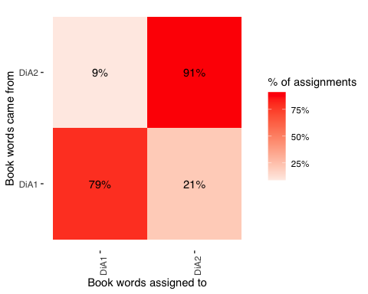
Not bad! We see that the model estimated with accuracy 91% of chapters in Volume 2 and 79% of chapters in Volume 1

Validation
In the articles by @ying_topics_2021 and @denny_text_2018 from this and previous weeks, we read about potential validation techniques.
In this section, we’ll be using the preText package mentioned in @denny_text_2018 to see the impact of different pre-processing choices on our text. Here, I am adapting from a tutorial by Matthew Denny.
First we need to reformat our text into a quanteda corpus object.
# load in corpus of Tocequeville text data.
corp <- corpus(tocq, text_field = "text")
# use first 10 documents for example
documents <- corp[sample(1:30000,1000)]
# take a look at the document names
print(names(documents[1:10]))
## [1] "text5173" "text21229" "text18196" "text15155" "text11021" "text20458"
## [7] "text7926" "text11002" "text14619" "text24562"
And now we are ready to preprocess in different ways. Here, we are including n-grams so we are preprocessing the text in 128 different ways. This takes about ten minutes to run on a machine with 8GB RAM.
preprocessed_documents <- factorial_preprocessing(
documents,
use_ngrams = TRUE,
infrequent_term_threshold = 0.2,
verbose = FALSE)
We can then get the results of our pre-processing, comparing the distance between documents that have been processed in different ways.
preText_results <- preText(
preprocessed_documents,
dataset_name = "Tocqueville text",
distance_method = "cosine",
num_comparisons = 20,
verbose = FALSE)
And we can plot these accordingly.
preText_score_plot(preText_results)
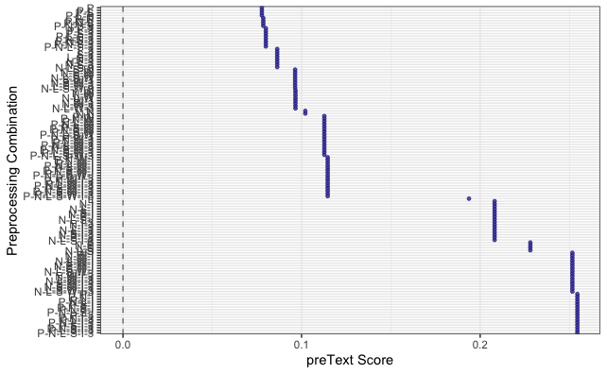

Exercises
- Choose another book or set of books from Project Gutenberg
- Run your own topic model on these books, changing the k of topics, and evaluating accuracy.
- Validate different pre-processing techniques using preText on the new book(s) of your choice.
For this exercise, I analyse Jane Austen’s Pride and Prejudice (Project Gutenberg ID: 1342). The novel is divided into chapters, which are treated as individual documents for topic modelling.
book <- gutenberg_download(1342, meta_fields = "author")
## Using mirror https://aleph.pglaf.org.
head(book)
## # A tibble: 6 × 3
## gutenberg_id text author
## <int> <chr> <chr>
## 1 1342 " [Illustration:" Austen, Jane
## 2 1342 "" Austen, Jane
## 3 1342 " GEORGE ALLEN" Austen, Jane
## 4 1342 " PUBLISHER" Austen, Jane
## 5 1342 "" Austen, Jane
## 6 1342 " 156 CHARING CROSS ROAD" Austen, Jane
book_chapters <- book %>%
filter(!is.na(text)) %>%
mutate(chapter = cumsum(str_detect(text, regex("^chapter", ignore_case = TRUE)))) %>%
filter(chapter > 0)
head(book_chapters)
## # A tibble: 6 × 4
## gutenberg_id text author chapter
## <int> <chr> <chr> <int>
## 1 1342 "Chapter I.]" Auste… 1
## 2 1342 "" Auste… 1
## 3 1342 "" Auste… 1
## 4 1342 "It is a truth universally acknowledged, that a s… Auste… 1
## 5 1342 "of a good fortune must be in want of a wife." Auste… 1
## 6 1342 "" Auste… 1
To estimate a topic model, the text needs to be divided into multiple documents. In this analysis, each chapter of Pride and Prejudice is treated as a separate document. This approach allows the model to identify thematic differences across chapters of the novel.
book_words <- book_chapters %>%
unnest_tokens(word, text)
head(book_words)
## # A tibble: 6 × 4
## gutenberg_id author chapter word
## <int> <chr> <int> <chr>
## 1 1342 Austen, Jane 1 chapter
## 2 1342 Austen, Jane 1 i
## 3 1342 Austen, Jane 1 it
## 4 1342 Austen, Jane 1 is
## 5 1342 Austen, Jane 1 a
## 6 1342 Austen, Jane 1 truth
Next, the text is tokenized into individual words using the unnest_tokens() function from the tidytext package. This converts the text into a tidy format where each row represents a single word. Tokenization is an important preprocessing step in text analysis, as it allows us to analyse word frequencies and construct a document-term matrix for topic modelling.
book_word_counts <- book_words %>%
anti_join(stop_words) %>%
count(chapter, word, sort = TRUE)
## Joining with `by = join_by(word)`
head(book_word_counts)
## # A tibble: 6 × 3
## chapter word n
## <int> <chr> <int>
## 1 43 elizabeth 36
## 2 18 darcy 33
## 3 18 elizabeth 25
## 4 8 bingley 21
## 5 16 darcy 21
## 6 29 lady 21
Common stopwords such as “the”, “and”, and “of” are removed because they do not carry meaningful semantic information. Removing these words helps the topic model focus on more informative terms. After removing stopwords, we count how frequently each word appears in each chapter of the novel.
book_dtm <- book_word_counts %>%
cast_dtm(chapter, word, n)
tm::inspect(book_dtm)
## <<DocumentTermMatrix (documents: 61, terms: 6014)>>
## Non-/sparse entries: 26589/340265
## Sparsity : 93%
## Maximal term length: 17
## Weighting : term frequency (tf)
## Sample :
## Terms
## Docs bennet bingley darcy elizabeth jane lady miss sister time wickham
## 16 3 4 21 18 0 9 5 2 5 17
## 18 10 19 33 25 10 13 11 7 11 16
## 29 2 0 1 12 0 21 9 0 1 1
## 35 1 4 4 2 0 1 2 7 4 11
## 43 0 1 14 36 0 4 7 5 11 4
## 46 0 0 9 11 6 0 1 3 5 5
## 47 7 0 3 18 15 1 3 5 3 11
## 52 2 0 10 5 2 2 2 6 6 14
## 53 12 13 7 14 13 0 3 10 7 2
## 56 18 1 6 19 1 16 15 2 0 0
The dataset is converted into a DocumentTermMatrix (DTM) where each row represents a chapter and each column represents a word. The values in the matrix correspond to the number of times a word appears in a chapter. The resulting matrix contains 61 documents (chapters) and 6014 unique terms. As expected in text data, the matrix is sparse, with about 93% of the entries being zeros, meaning that most words do not appear in most chapters.
book_lda <- LDA(book_dtm, k = 5, control = list(seed = 1234))
book_topics <- tidy(book_lda, matrix = "beta")
head(book_topics)
## # A tibble: 6 × 3
## topic term beta
## <int> <chr> <dbl>
## 1 1 elizabeth 0.0172
## 2 2 elizabeth 0.0125
## 3 3 elizabeth 0.0127
## 4 4 elizabeth 0.0223
## 5 5 elizabeth 0.0146
## 6 1 darcy 0.00882
We estimate a Latent Dirichlet Allocation (LDA) topic model with five topics using the DocumentTermMatrix created earlier. LDA identifies groups of words that frequently appear together across chapters. We then extract the beta values, which represent the probability that a word belongs to a specific topic. Higher beta values indicate stronger associations between words and topics.
book_top_terms <- book_topics %>%
group_by(topic) %>%
slice_max(beta, n = 10) %>%
ungroup() %>%
arrange(topic, -beta)
book_top_terms
## # A tibble: 50 × 3
## topic term beta
## <int> <chr> <dbl>
## 1 1 elizabeth 0.0172
## 2 1 jane 0.0131
## 3 1 bingley 0.0108
## 4 1 bennet 0.00978
## 5 1 darcy 0.00882
## 6 1 time 0.00769
## 7 1 miss 0.00750
## 8 1 dear 0.00666
## 9 1 sister 0.00635
## 10 1 illustration 0.00499
## # ℹ 40 more rows
To interpret the topics produced by the LDA model, we extract the ten words with the highest beta values for each topic. These words represent the most probable terms associated with each topic. The resulting topics appear to capture major themes and character interactions in the novel. For example, some topics are dominated by character names such as Elizabeth, Darcy, and Bennet, reflecting the central relationships in the story. Other topics include words such as Collins, Lady, and Catherine, which relate to social hierarchy and marriage proposals. Another topic includes words such as Wickham and letter, suggesting narrative moments involving conflict and revelations in the plot. Overall, the topics capture recurring character interactions and social dynamics within the novel.
book_top_terms %>%
mutate(term = reorder_within(term, beta, topic)) %>%
ggplot(aes(beta, term, fill = factor(topic))) +
geom_col(show.legend = FALSE) +
facet_wrap(~ topic, scales = "free") +
scale_y_reordered() +
theme_minimal()
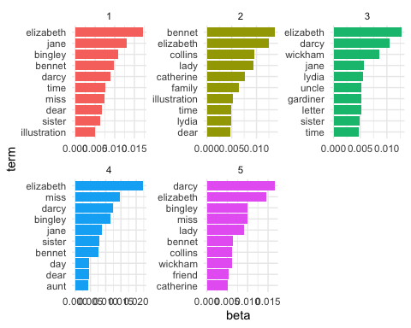 The figure shows the most important words associated with each of the five topics estimated by the LDA model. The bar charts display the top ten words with the highest beta values for each topic, indicating the strength of association between words and topics. The topics appear to capture central elements of the novel. Several topics are dominated by character names such as Elizabeth, Darcy, Jane, and Bennet, reflecting the importance of interpersonal relationships in the story. One topic includes words such as Collins, Lady, and Catherine, which relate to social hierarchy and marriage proposals. Another topic contains words such as Wickham, Lydia, and letter, suggesting plot developments involving conflict and revelations. Overall, the topic model successfully captures recurring character interactions and social dynamics in the novel.
book_lda_8 <- LDA(book_dtm, k = 8, control = list(seed = 1234))
book_topics_8 <- tidy(book_lda_8, matrix = "beta")
book_top_terms_8 <- book_topics_8 %>%
group_by(topic) %>%
slice_max(beta, n = 10) %>%
ungroup() %>%
arrange(topic, -beta)
book_top_terms_8 %>%
mutate(term = reorder_within(term, beta, topic)) %>%
ggplot(aes(beta, term, fill = factor(topic))) +
geom_col(show.legend = FALSE) +
facet_wrap(~ topic, scales = "free") +
scale_y_reordered() +
theme_minimal()
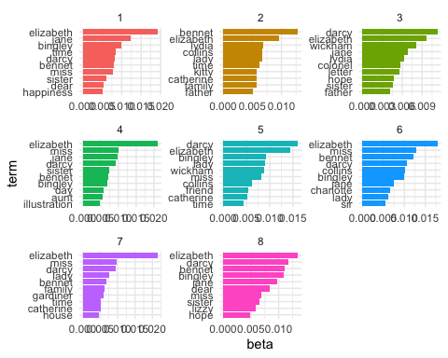 This figure presents the topics identified when the number of topics is increased to eight. Compared to the five-topic model, the eight-topic model produces more fine-grained distinctions between themes in the novel. While several topics continue to be dominated by character names such as Elizabeth, Darcy, and Bennet, additional topics capture more specific narrative elements, such as interactions involving Mr Collins, the Wickham storyline, and family relationships. Increasing the number of topics allows the model to separate certain narrative elements into more specialized clusters. However, because character names dominate the vocabulary of the novel, some overlap between topics remains. Overall, the eight-topic model provides more detailed thematic distinctions but may be slightly harder to interpret compared to the five-topic model.
Overall, the topic models capture key themes in the novel, particularly interpersonal relationships and social dynamics among central characters. The five-topic model provides a clearer and more interpretable overview of the main narrative themes, while the eight-topic model reveals more specific sub-themes within the story. This comparison highlights how the choice of the number of topics influences the granularity and interpretability of topic modeling results.

