House Price Prediction Using Machine Learning
Ames Housing Dataset Analysis
CS 7331 Final Project Report
Junliang Lyu, Patricio Martinez, Sean Kane
Spring 2026

Abstract
This project investigates house price prediction using the Ames Housing Dataset. The goal is to predict residential sale prices and identify important factors that influence housing value. The project compares a regularized linear baseline with ensemble-based machine learning models, including Lasso Regression, Random Forest, and XGBoost. The final models were evaluated using RMSE, MAE, and R-squared. Among the three models, XGBoost achieved the best performance, with an RMSE of $22,947, MAE of $14,080, and R-squared of 0.9343 on the final dollar-scale evaluation. The results suggest that overall house quality, total square footage, garage-related features, and basement-related features are important predictors of sale price. Overall, this project shows that machine learning methods can support house price estimation and provide useful insights for buyers, sellers, and real estate analysts. However, the model is limited by the location-specific nature of the dataset and the lack of broader market factors such as interest rates, school district quality, and local housing trends.

1. Introduction
House price prediction is an important problem in real estate analysis because property value affects buyers, sellers, investors, and financial institutions. A reliable prediction model can help users better understand whether a house is reasonably priced based on its physical features, overall condition, and location-related characteristics. In practice, this type of analysis can support more transparent property valuation and help reduce uncertainty in housing market decisions.
In this project, we use the Ames Housing Dataset to analyze the relationship between housing characteristics and sale price. The dataset includes structural attributes, housing quality ratings, garage and basement information, year-related variables, and neighborhood-related variables. Our goal is not only to build predictive models, but also to understand which housing features contribute most strongly to final sale price.
The main contributions of this project are threefold. First, the project prepares a real-world housing dataset containing both numerical and categorical variables. Second, it compares multiple regression models under a consistent evaluation setting. Third, it interprets the results to identify practical insights about the factors associated with housing value.

2. Related Work
House price prediction is commonly framed as a supervised regression problem. The systematic survey by Geerts, vanden Broucke, and De Weerdt (2023) shows that house price prediction research has used a wide range of traditional and machine learning methods, while also emphasizing that property value depends on structural, spatial, and market-related factors. This background supports treating the Ames Housing task as both a prediction problem and an interpretation problem, because the goal is not only to estimate SalePrice but also to understand which housing attributes contribute most strongly to price.
The proposal review also included studies that used Linear Regression on the Ames Housing dataset. These studies showed that a simple linear model can achieve reasonable performance, with one reviewed example reporting an R-squared score of about 0.82. This supports the use of a linear model as a baseline in our project. However, linear models assume relatively simple relationships between predictors and the target, so they may not capture nonlinear effects or interactions among housing features such as quality, living area, garage capacity, and neighborhood.
Several reviewed studies suggest that tree-based and ensemble models can improve housing price prediction. Wang and Zhao (2022), for example, studied the King County housing dataset and compared several machine learning models, including CatBoost, LightGBM, and XGBoost. Their work used preprocessing steps such as winsorizing extreme values and removing highly correlated features, and evaluated models using RMSE, R-squared, adjusted R-squared, and K-fold cross-validation. This type of comparative approach is closely related to our project because we also compare multiple models under the same evaluation setting.
A particularly relevant study is Sharma, Harsora, and Ogunleye (2024), which used the Ames City housing dataset to compare XGBoost, Support Vector Regressor, Random Forest Regressor, Multilayer Perceptron, and Multiple Linear Regression. Their study found XGBoost to be the best-performing model and identified important variables such as Overall Qual, Gr Liv Area, Garage Cars, and Total Bsmt SF. These findings align closely with our model selection and with the important variables observed in our own results.
Related work also emphasizes the value of data preparation and feature engineering. The proposal review included work on feature engineering for the Ames dataset and market-segmentation research using clustering, such as Kim and Irakoze's (2023) cluster-analysis study of green-certified housing. Although our final project focuses on supervised regression rather than clustering, these studies show that housing data can reveal useful patterns when preprocessing, feature construction, and model comparison are handled carefully.

3. Dataset and Exploratory Data Analysis
This section will be completed by the teammate responsible for the dataset and exploratory data analysis portion. It should briefly describe the Ames Housing dataset, the number of records and variables used in the final report, the target variable, and the basic SalePrice statistics. It should also include one or two relevant visualizations, such as the SalePrice distribution and the most strongly correlated housing features. The writing should follow the same paragraph style and level of detail used in the rest of this report.

4. Method
This section will be completed by the teammate responsible for preprocessing and modeling. It should summarize the data cleaning process, missing-value treatment, feature engineering, encoding, feature selection, model setup, and evaluation metrics. It should also briefly explain the models used in the project, including Lasso Regression, Random Forest, and XGBoost. The section should be written as a concise research-method description rather than as code-level notes.

5. Results
The final model comparison is shown in Table 1. The models were evaluated on the final dollar scale using RMSE, MAE, and R-squared. Lasso Regression served as a linear baseline, while Random Forest and XGBoost represented more advanced tree-based ensemble methods.
Table 1. Final model comparison on the original dollar scale.
Model | RMSE | MAE | R-squared
Lasso Regression | $33,540 | $16,484 | 0.8597
Random Forest | $24,754 | $15,507 | 0.9236
XGBoost | $22,947 | $14,080 | 0.9343

XGBoost achieved the best overall performance, with the lowest RMSE and MAE and the highest R-squared value. Random Forest also improved substantially over the Lasso baseline on the final dollar-scale evaluation. This suggests that ensemble-based models were better able to capture nonlinear relationships and feature interactions among housing characteristics. Although Lasso Regression had lower performance on the dollar-scale metrics, it remained useful as a simpler and more interpretable baseline model.
The feature importance results from Random Forest showed that Overall Qual and Total_SF were the two strongest predictors, followed by Total_Bathrooms, Garage Yr Blt, Lot Area_log, Central Air, Remod_Age, Garage Cars, and House_Age. These results are consistent with the EDA findings and suggest that both housing quality and usable space are central factors in predicting sale price.
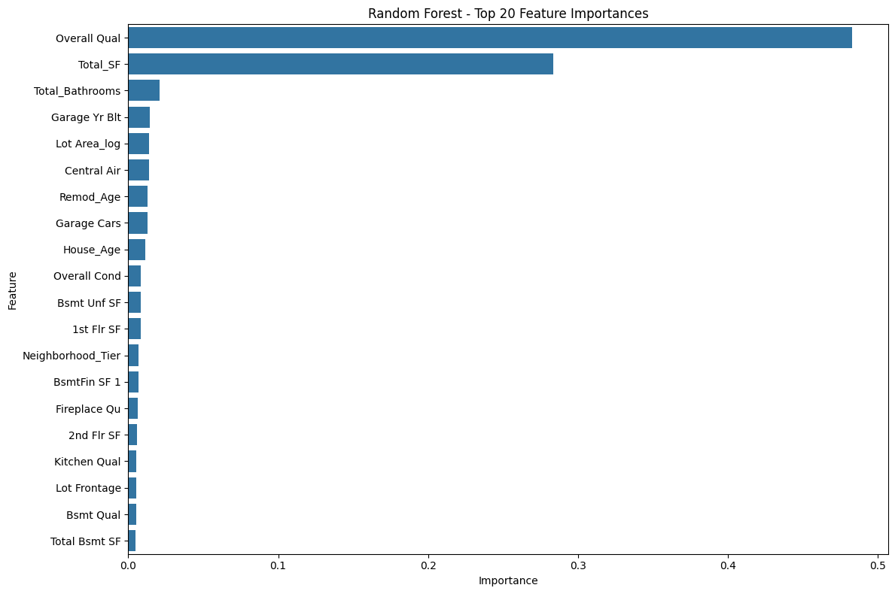
Figure 1. Random Forest top 20 feature importances.
The residual plots show that most prediction errors were concentrated around zero, but some larger errors remained for expensive houses and outlier cases. This pattern suggests that the models captured the general relationship between features and price, while unusual high-value properties remained more difficult to predict accurately.
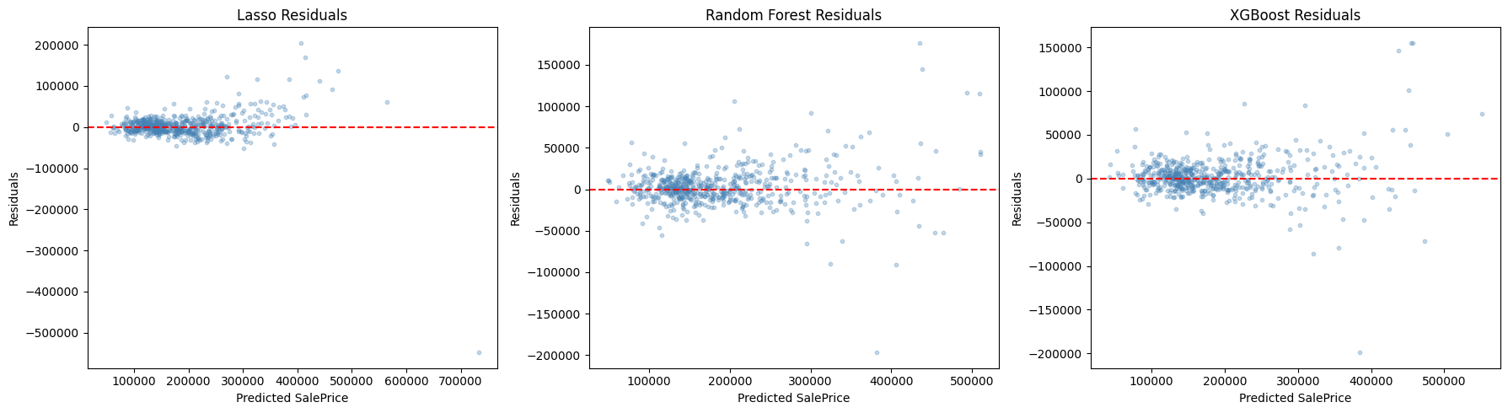
Figure 2. Residual plots for Lasso Regression, Random Forest, and XGBoost.

6. Discussion

6.1 Key Findings
The results support the original hypothesis that stronger machine learning models can improve house price prediction compared with a simple linear baseline. XGBoost performed best overall, which suggests that house prices are affected by nonlinear relationships and feature interactions rather than only simple linear effects. For example, the effect of living area may depend on house quality, garage capacity, neighborhood, and other physical conditions.
The findings from EDA and feature importance were also consistent. Overall house quality and total square footage were among the strongest predictors in both stages of the project. Garage-related features, basement-related features, bathrooms, and age-related variables also contributed to prediction. This consistency strengthens the interpretation that model performance was based on meaningful housing attributes rather than random noise.

6.2 Actionable Insights
For sellers, the results suggest that improvements related to overall property condition, usable living space, and functional home features may contribute to higher valuation. For buyers, variables such as overall quality, total square footage, garage capacity, basement size, and house age can be used as reference points when evaluating whether a listed house is reasonably priced. For real estate analysts, the model can serve as a supporting tool for estimating property value, but it should be combined with local market knowledge and professional judgment.

6.3 Limitations
This project has several limitations. First, the dataset is limited to houses in Ames, Iowa, so the results may not generalize well to other cities or housing markets. Second, the dataset does not include broader market factors such as interest rates, inflation, school district quality, crime rate, local demand, or recent housing market trends. Third, the model only uses structured tabular features and does not include property images or listing descriptions. Finally, high-priced outlier houses may be harder to predict accurately because they appear less frequently in the dataset.

7. Conclusion
This project applied data mining methods to predict house prices using the Ames Housing Dataset. Three regression models were compared: Lasso Regression, Random Forest, and XGBoost. The results showed that XGBoost achieved the strongest predictive performance, followed by Random Forest, while Lasso Regression provided a useful linear baseline. The analysis also showed that overall quality, total square footage, garage capacity, basement-related features, and age-related features were important factors related to sale price. Overall, the project demonstrates that machine learning can support house price estimation and provide useful insights into housing value. Future work could improve generalization by adding external market variables, testing the model on other cities, and incorporating additional data sources such as property images or listing descriptions.

References
Breiman, L. (2001). Random forests. Machine Learning, 45, 5-32.
Chen, T., & Guestrin, C. (2016). XGBoost: A scalable tree boosting system. In Proceedings of the 22nd ACM SIGKDD International Conference on Knowledge Discovery and Data Mining (pp. 785-794).
De Cock, D. (2011). Ames, Iowa: Alternative to the Boston Housing Data as an end of semester regression project. Journal of Statistics Education, 19(3).
Geerts, M., vanden Broucke, S., & De Weerdt, J. (2023). A survey of methods and input data types for house price prediction. ISPRS International Journal of Geo-Information, 12(5), 200. https://doi.org/10.3390/ijgi12050200
Kim, D. H., & Irakoze, A. (2023). Identifying market segment for the assessment of a price premium for green certified housing: A cluster analysis approach. Sustainability, 15(1), 507. https://doi.org/10.3390/su15010507
Kaggle. (n.d.). Ames Housing Dataset. Retrieved from https://www.kaggle.com/datasets/prevek18/ames-housing-dataset
Pedregosa, F., Varoquaux, G., Gramfort, A., et al. (2011). Scikit-learn: Machine learning in Python. Journal of Machine Learning Research, 12, 2825-2830.
Sharma, H., Harsora, H., & Ogunleye, B. (2024). An optimal house price prediction algorithm: XGBoost. Analytics, 3(1), 30-45. https://doi.org/10.3390/analytics3010003
Wang, Y., & Zhao, Q. (2022). House price prediction based on machine learning: A case of King County. In Proceedings of the 2022 7th International Conference on Financial Innovation and Economic Development (ICFIED 2022) (pp. 1547-1555). Atlantis Press. https://doi.org/10.2991/aebmr.k.220307.253

Contributions of Each Team Member
Table 2. Contributions of each team member.
Team Member | Contribution
Junliang Lyu | Co-wrote the project proposal with Patricio Martinez, helped search related literature, and helped select the Ames Housing dataset. Prepared the results, key insights, limitations, and conclusion content, and helped organize and revise the final report.
Patricio Martinez | Co-wrote the project proposal with Junliang Lyu, helped search related literature, and helped select the dataset. Completed the data processing and analysis work, including cleaning, preprocessing, EDA, feature engineering, and method-related details.
Sean Kane | Created the PowerPoint template and prepared the early presentation content, including the motivation, objective, hypothesis, and dataset background. Helped organize the presentation materials and final review.
All Members | Discussed the project direction, reviewed the presentation and report materials, and contributed to the final project submission.

