Some discussion on the dowel action

Part A: Modeling of finite length foundation  
The dowel action model respect to our specimen can be simplified as follows.



1. The approximate analytical solution for region Ld is available from book [1], and we derived the following piecewise function for the complete right part starting from center.

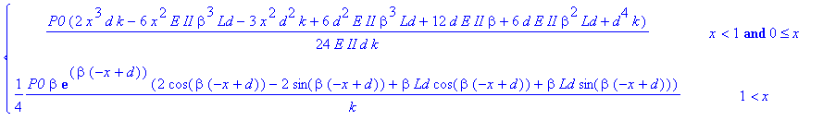

1. We also derived the exact solution, based on the equation for free finite length beam with concentrated load or moment at one end from book [1] as follows.

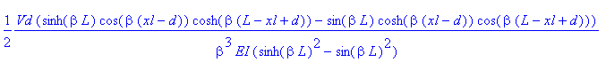



Use the same technology, we get the complete expression for the right part, (though fairly long),

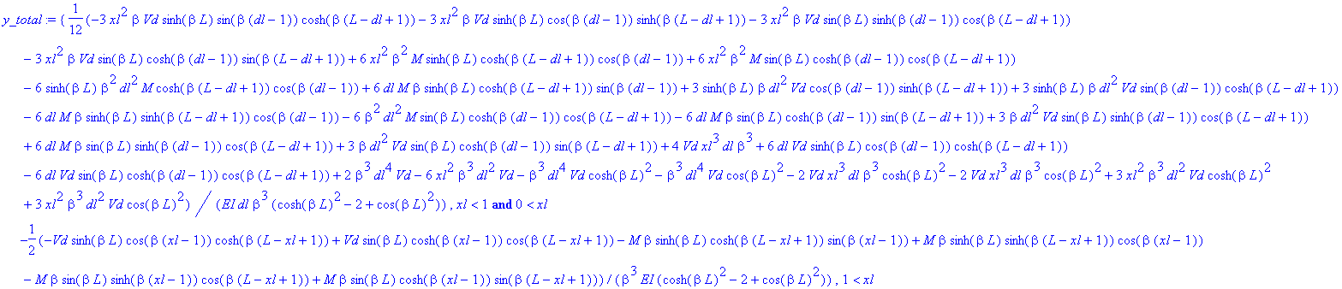

The comparisons between these three solutions are shown as follows, no big differences were found between infinite solution and exact solution of the finite length (especially when β is big). The approximate solution differs a little bit from the other two.

|  |  |
| --- | --- |
|  |  |
| Β=0.5 | Β=2 |

1. Some discussion  
   The deformation shape still not match with experiment, there is negative deformation in all solutions, while in real specimen, the negative deformation was restrained by the force from rebar bearing on concrete core. Something like following drawings.



Trying to create functions in region [0,d],[d,d+Lm]

The results contains parameter Lm,P0, β, now trying to seek relation between these three parameters.  
The following figures show deformation curves under same load level, same β=1, but different, Lm = [0.35, 1, 2, 3, 7] for curves from left to right. Some of the curves have negative regions, which is not correct. Trying the way to find the critical curve which will determined the Lm value.

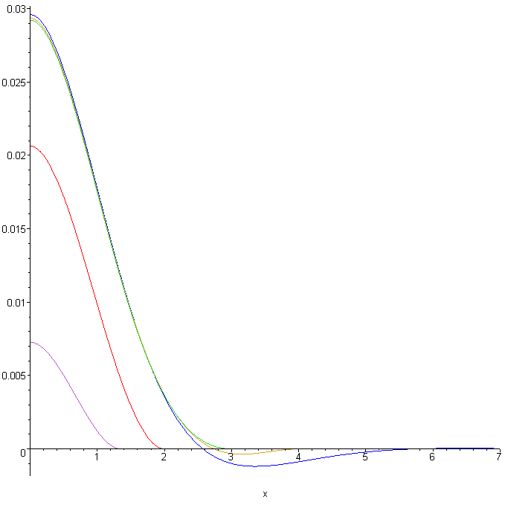

The curve shows along with the increase of load the area of concrete participate in the dowel action get spread until concrete crack.

Part B: Curve Fitting  
A few discussions

Along with the crack development, the β value is changing in space (along with the length of beam) and also changing in time. (decrease with widen of cracks at certain location), so try to fit the whole curve with same β is not reasonable.

Instead of fit the curve with all points, we tried to fit the curve by individual locations to reflect the β change in space, the right side of experiment data was mirror to the left side, and the average was used for curve fitting purpose.

To reflect the change of β with time, different load range were used to fit the curves. The results listed in the following table using exact solution function, with -1 denote a failed curve fitting.

5%-50%

|  |  |  |  |  |  |  |  |  |  |  |  |  |  |  |
| --- | --- | --- | --- | --- | --- | --- | --- | --- | --- | --- | --- | --- | --- | --- |
| ID | 11 | 12 | 21 | 22 | 23 | 31 | 32 | 33 | 34 | 41 | 51 | 52 | 53 | 54 |
| β 3.5 | 1.627 | 1.778 | 2.013 | 1.871 | 1.837 | 2.013 | 2.013 | 2.013 | 1.588 | 1.747 | 2.013 | 2.013 | 1.751 | 2.013 |
| β 2.5 | 1.036 | 1.037 | 0.972 | 0.828 | 1.040 | 0.974 | 1.033 | 1.042 | 0.655 | 1.039 | 0.982 | 1.038 | 1.019 | 0.972 |
| β 1.5 | -1.000 | 2.087 | 0.790 | 2.452 | 0.399 | 0.799 | 1.559 | 1.960 | 2.384 | 1.728 | 0.407 | 1.433 | 0.585 | 2.418 |

60%-90%

|  |  |  |  |  |  |  |  |  |  |  |  |  |  |  |
| --- | --- | --- | --- | --- | --- | --- | --- | --- | --- | --- | --- | --- | --- | --- |
| ID | 11 | 12 | 21 | 22 | 23 | 31 | 32 | 33 | 34 | 41 | 51 | 52 | 53 | 54 |
| β 3.5 | 2.013 | 2.013 | -1.000 | 1.931 | 2.013 | 1.936 | 2.013 | 2.013 | 2.013 | -1.000 | -1.000 | 2.013 | -1.000 | -1.000 |
| β 2.5 | 1.035 | 0.918 | 0.874 | 0.685 | 0.920 | 0.946 | 0.938 | 1.030 | 0.687 | 0.725 | 0.811 | 0.743 | 0.813 | 0.719 |
| β 1.5 | 1.219 | 1.306 | 0.851 | 0.910 | -0.544 | 0.815 | 1.159 | 1.584 | 0.992 | 0.795 | -0.562 | 0.787 | 0.732 | 0.837 |

90%-100%

|  |  |  |  |  |  |  |  |  |  |  |  |  |  |  |
| --- | --- | --- | --- | --- | --- | --- | --- | --- | --- | --- | --- | --- | --- | --- |
| ID | 11 | 12 | 21 | 22 | 23 | 31 | 32 | 33 | 34 | 41 | 51 | 52 | 53 | 54 |
| β 3.5 | 2.013 | 2.013 | -1.000 | -2.013 | -1.000 | 2.013 | 2.013 | 2.013 | -1.000 | -1.000 | -1.000 | -1.000 | -1.000 | -1.000 |
| β 2.5 | 1.013 | 0.844 | 0.780 | -0.617 | 0.699 | 0.782 | 0.839 | 0.999 | -0.545 | 0.590 | 0.707 | -0.646 | 0.702 | 0.473 |
| β 1.5 | 0.966 | 1.016 | 0.814 | 0.663 | 0.571 | 0.815 | 0.953 | 1.481 | 0.581 | 0.597 | 0.701 | 0.676 | 0.725 | -0.458 |

Reference:

[1] Beams on Elastic Foundation: Theory with Applications in the Fields of Civil and Mechanical Engineering