Worksheet-2 in R

**Worksheet for R Programming**

**Instructions:**

* Use RStudio or the RStudio Cloud accomplish this worksheet. + Save the R script as *RWorksheet_lastname#2.R*.
* Create your own *GitHub repository* and push the R script as well as this pdf worksheet to your own repo.

Accomplish this worksheet by answering the questions being asked and writing the code manually.

**Using Vectors**

1. Create a vector using : operator

1. Sequence from -5 to 5. Write the R code and its output. Describe its output.

Rcode:

**#seq <- c(-5:5)**

**#seq**

Output:

**# [1] -5 -4 -3 -2 -1 0 1 2 3 4 5**

**# It displays the negative and positive numbers, then it displays the 0 in between the negative and positive number.**

1. x <- 1:7. What will be the value of x?

Rcode:

**#x <- 1:7**

**#x**

Output:

**# [1] 1 2 3 4 5 6 7**

2.* Create a vector using seq() function

a. seq(1, 3, by=0.2) # specify step size

Write the R code and its output. Describe the output.

Rcode:

**# Creating a Sequence of Numeric Values with the seq Function**

**#(1,3)**

**#seq(1,3)**

**#seq(1, 3, 0.2) #specifies that in every number you need to jump by 0.2**

**# The by argument**

**#seq(1, 3, by = 0.2) #sequence from 1 to 3 by 0.2**

Output:

**# [1] 1.0 1.2 1.4 1.6 1.8 2.0 2.2 2.4 2.6 2.8 3.0**

3. A factory has a census of its workers. There are 50 workers in total. The following list shows their ages: 34, 28, 22, 36, 27, 18, 52, 39, 42, 29, 35, 31, 27, 22, 37, 34, 19, 20, 57, 49, 50, 37, 46, 25, 17, 37, 43, 53, 41, 51, 35,

24,33, 41, 53, 40, 18, 44, 38, 41, 48, 27, 39, 19, 30, 61, 54, 58, 26,

18.

1. Access 3rd element, what is the value?

**[1] 22**

1. Access 2nd and 4th element, what are the values?

**[1] 28**

**[1] 36**

1. Access all but the 1st element is not included. Write the R code and its output.

**R Code:**

**#workers_age <- c(34, 28, 22, 36, 27, 18, 52, 39, 42, 29, 35, 31, 27, 22, 37, 34, 19, 20, 57, 49, 50, #37, 46, 25, 17, 37, 43, 53, 41, 51, 35,24,33, 41, 53, 40, 18, 44, 38, 41, 48, 27, 39, 19, 30, #61, 54, 58, 26,18)**

**#workers_age**

**#wokers_age = c(34, 28, 22, 36, 27, 18, 52, 39, 42, 29, 35, 31, 27, 22, 37, 34, 19, 20, 57, 49, 50, 37, 46, 25, 17, 37, 43, 53, 41, 51, 35, 24,33, 41, 53, 40, 18, 44, 38, 41, 48, 27, 39, 19, 30, 61, 54, 58, 26,18)**

**#print(workers_age[3])**

**#print(workers_age[2])**

**#print(workers_age[4])**

**#print(workers_age[-1])**

**Output:**

**#[1] 34 28 22 36 27 18 52 39 42 29 35 31 27 22 37**

**[16] 34 19 20 57 49 50 37 46 25 17 37 43 53 41 51**

**[31] 35 24 33 41 53 40 18 44 38 41 48 27 39 19 30**

**[46] 61 54 58 26 18**

**#[1] 22**

**#[1] 28**

**#[1] 36**

**#[1] 28 22 36 27 18 52 39 42 29 35 31 27**

**[13] 22 37 34 19 20 57 49 50 37 46 25 17**

**[25] 37 43 53 41 51 35 24 33 41 53 40 18**

**[37] 44 38 41 48 27 39 19 30 61 54 58 26**

**[49] 18**

1. *Create a vector x <- c("first"=3, "second"=0, "third"=9). Then named the vector, names(x).
   1. Print the results. Then access x[c("first", "third")]. Describe the output.

Output: W

* 1. Write the code and its output.

1. Create a sequence x from -3:2.
   1. Modify 2nd element and change it to 0;x[2] <- 0 x

Describe the output.

* 1. Write the code and its output.

1. *The following data shows the diesel fuel purchased by Mr. Cruz.

|  |  |  |  |  |  |  |
| --- | --- | --- | --- | --- | --- | --- |
| Month | Jan | Feb | March | Apr | May | June |
| Price per liter (PhP) | 52.50 | 57.25 | 60.00 | 65.00 | 74.25 | 54.00 |
| Purchase–quantity(Liters) | 25 | 30 | 40 | 50 | 10 | 45 |

* 1. Create a data frame for month, price per liter (php) and purchase-quantity (liter).Write the codes.
  2. What is the average fuel expenditure of Mr. Cruz from Jan to June? Note: Use

weighted.mean(liter, purchase)

1. R has actually lots of built-in datasets. For example, the rivers data “gives the lengths

(in miles) of 141 “major” rivers in North America, as compiled by the US Geological Survey”.

* 1. Type “rivers” in your R console. Create a vector data with 7elements, containing the number of elements (length) in rivers, their sum (sum), mean (mean), median (median), variance (var) standard deviation (sd), minimum (min) and maximum (max).

data <- c(length(rivers), sum(rivers), mean(rivers), median(rivers), var(rivers), sd(rivers), min(rivers), max(rivers))

* 1. What are the results?
  2. Write the code and its outputs.

1. The table below gives the 25 most powerful celebrities and their annual pay as ranked by the editions of Forbes magazine and as listed on the Forbes.com website.

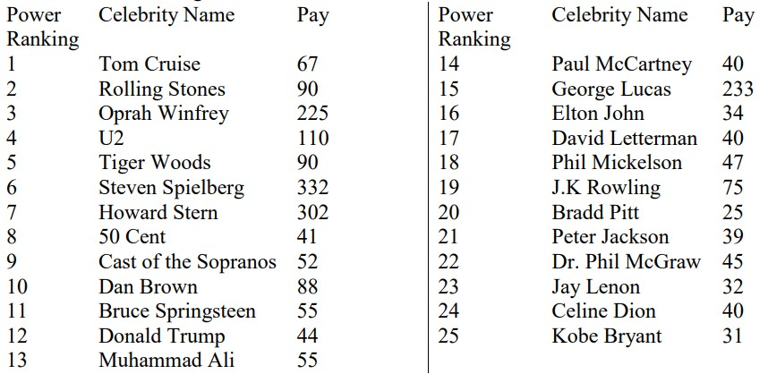

Figure 1: Forbes Ranking

* 1. Create vectors according to the above table. Write the codes.
  2. Modify the power ranking and pay of J.K. Rowling. Change power ranking to 15 and

pay to 90. Write the codes and its output.

* 1. Interpret the data.