# Pets

[Link to Pet Files](https://drive.google.com/drive/folders/1nhZB2OqrJRNrIEnGaLqT-YyQ_IX5Owve)

## Pet Name Chako

1. Primary Image of Pet

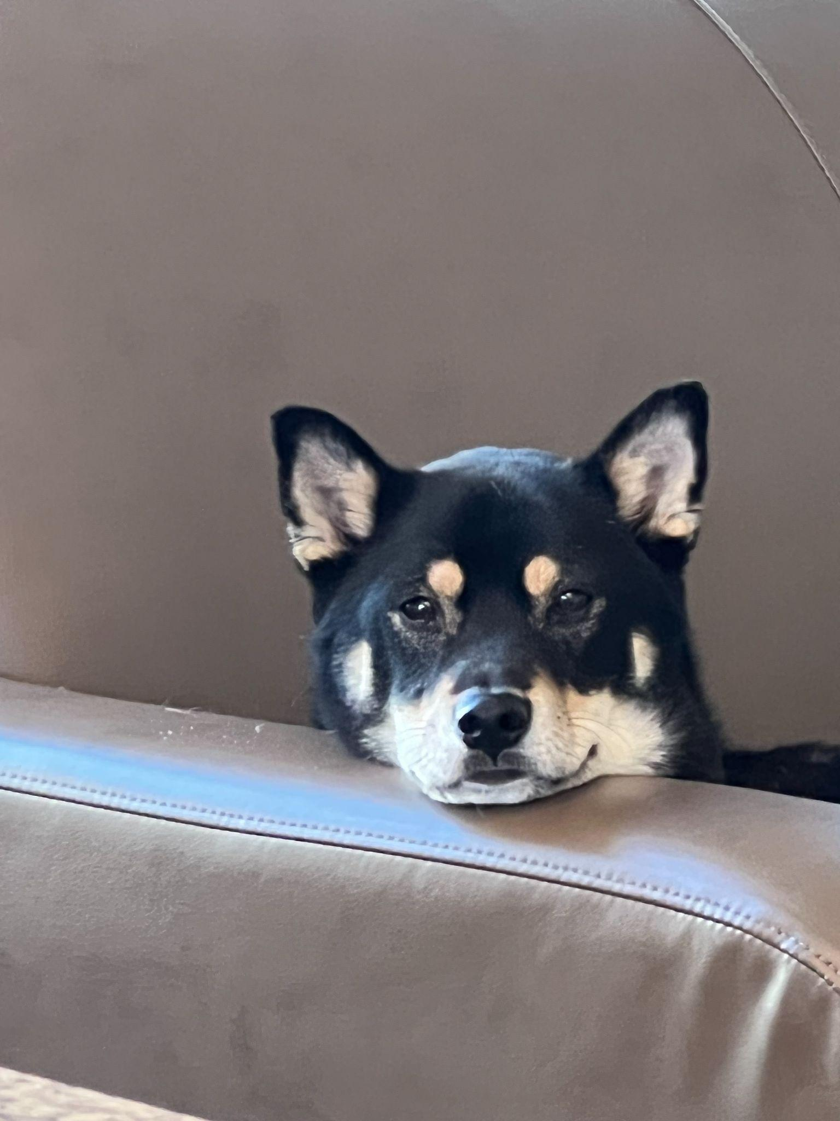

1. Chako1.jpg
2. Black and Tan color Shiba Inu
3. With a coat as dark as midnight but eyes as bright as stars, he seemed to embody both the mystery and the exuberance of life itself. Agile and playful, he danced around the park as if the grass were his personal stage, captivating everyone with his vivacity.
4. Yet, when at home, Chako transformed into a zen master. He would curl up on his favorite rug, eyes half-closed in contemplation, as if solving the great puzzles of the universe. Both spirited and serene, Mochi was a living testament to the richness of dualities, teaching his human companions that one could be many things all at once.
5. **Photo Gallery – (Just write Photo Gallery)**
6. Chako2.jpg
7. Chako is lazy but still wants to look outside.
8. Chako3.jpg
9. Chako is so tired and he is having a good night's sleep.
10. Chako4.jpg
11. Chako doesn’t want to move, so he sits there and watches.
12. Chako5.jpg
13. Chako loves comfortable beds.
14. **Likes – (Just write Likes)**
15. Sleep
16. Play
17. Eat
18. Linghao Shi