**Overview of Technical Design**

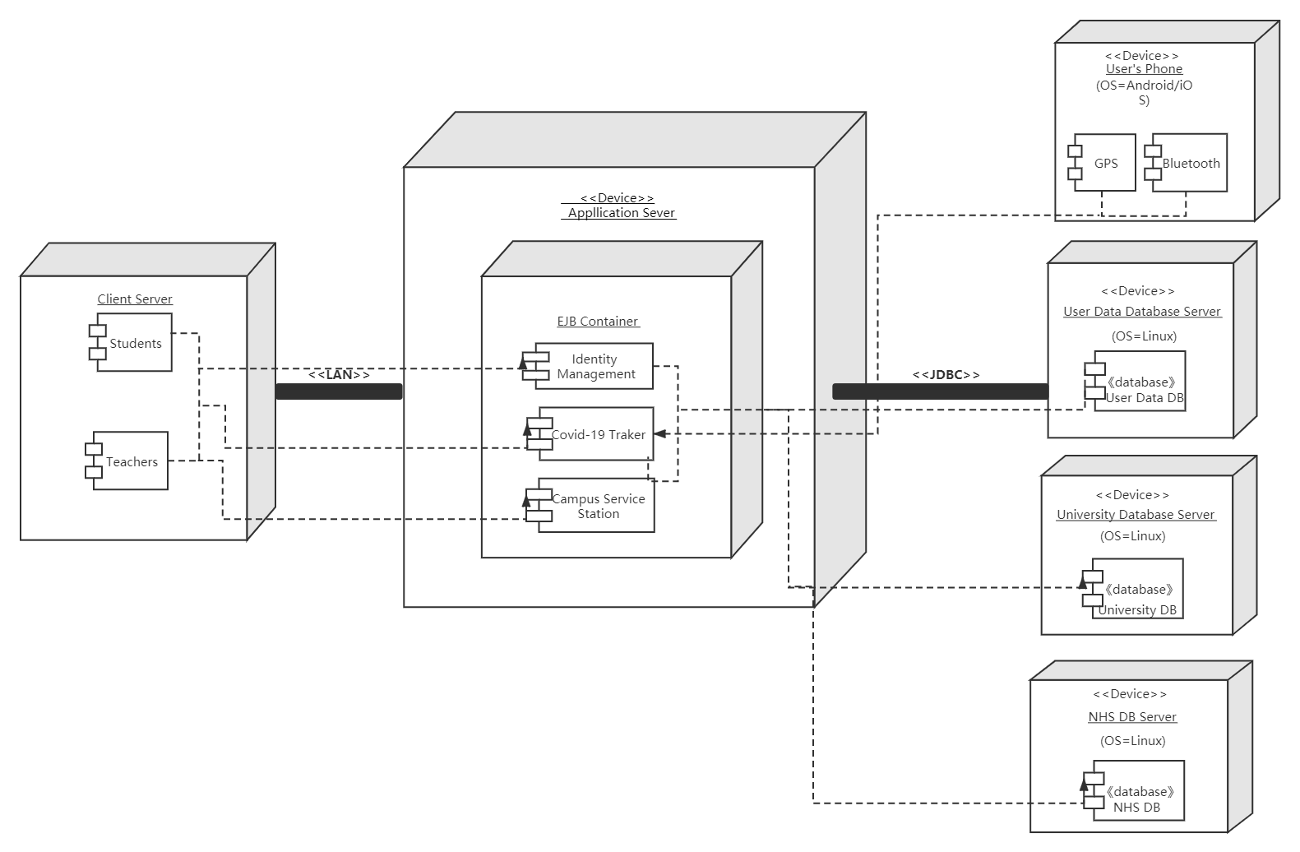

As stated in the previous coursework, the overall structure of this work will continue to use 3-tier architecture, which is user interface layer, business logic layer and data access layer. Since the whole project is huge with too many technology implementations, I will mainly focus on Identity Management as well as Off-campus Report of Covid-19 Tracker module, which are information record process when users input personal information and location tracking information.

For real life testing, functions of registration and login page has to be tested first because it is the interface that will be displayed directly to the users at the beginning, check whether user interface operates normally on the different devices such as mobile phones with different operating systems, desktop and laptop, then with various browsers like Firefox and Google, check whether user input data has been put into database with correct format.

For programming languages, HTML, CSS and JavaScript are used for front end web page designed for users display, Python is used for constructing Flask framework.

Flask is used as main web application framework for its features of lightweight and well combination with MVC model for development to connect front end applications and database, besides, it is more flexible, light, safe and easy to use than other similar frameworks.

For libraries, in respect of front-end libraries, boostrap, materialize and style are used for CSS and boostrap, jquery, core, delete, moment, search and materialize are used for JavaScript. As for Flask framework design, flask, flask-wtf, json, sqlalchemy with more flask libraries are used.

Mysql is used for database testing and development.

For development tools, PyCharm Community Edition 2020.1 x64 is used for flask framework development and Adobe Dreamweaver8.0 as web code editor.

**Evidence of Development**