How’s Lite/Pro/Elite version

Lite — Market Context
“What’s going on?”
• Shows who controls price using the 4-Color Candle Logic
• Helps traders stop random guessing
• Prevents emotional trades
• No imbalance logic
• No validation
• No timing
Retail analogy:
Watching store traffic and shelf movement before making business decisions.

Pro — Pressure Confirmation
“Is this pressure real?”
• Confirms buying vs selling pressure
• Detects absorption behavior
• Filters weak market moves
• Still no FVG imbalance tracking
• Still no timing signals
Retail analogy:
Checking supplier stability and customer demand before ordering inventory.

Elite — Execution Context
“Is this the right moment?”
• Detects Fair Value Gap (FVG) imbalance
• Tracks FVG Lifecycle
• Identifies trap vs takeover
• Shows when control actually shifts
This is where your FVG Execution Logic™ (CFE) actually operates.
Retail analogy:
You know exactly when wholesalers stop dumping inventory and buyers start paying higher prices.
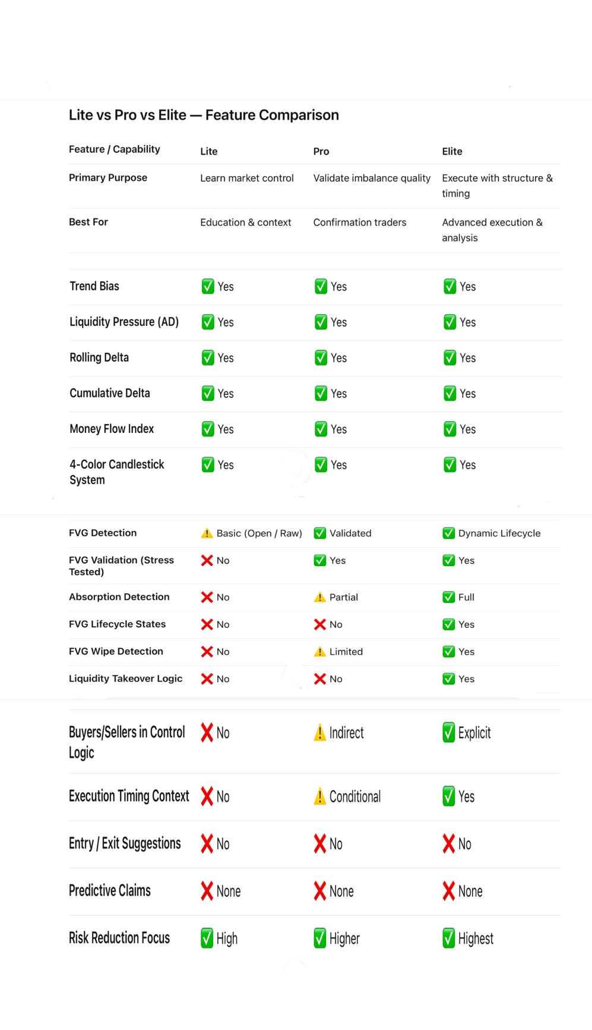
TERMINOLOGY LESSON
(How Price Actually Behaves — Not How It’s Marketed)

Imbalance (Birth)
A price inefficiency created by aggressive order execution across three candles.
It is not a signal, not a prediction, and not a trade idea.
Imbalance = footprint of size, nothing more.

Fair Value Gap (FVG)
The visible price gap left by an imbalance.
FVGs form constantly because markets are inefficient by design.
Most FVGs are:
- auto-filled
- wiped
- neutralized
- resolved instantly
An FVG does not imply a return.

Age Counter
The moment an FVG is created, time tracking begins.
Age does not equal strength or probability.
Price does not owe time a reaction.

Automatic Rebalancing
When an imbalance forms, algorithms and liquidity providers respond immediately to restore price efficiency — often in milliseconds.
This is normal market behavior.
Not a strategy. Not manipulation. Not astrology.

AD + Delta Validation
A pressure filter that determines whether imbalance is backed by real participation.
- Fail → stall, neutral, erase
- Pass → continuation potential
Shape without pressure is noise.

Neutralization
Price interaction that reduces imbalance without reaction.
Often mistaken for a “failed setup”.
Neutral ≠ rejection.

Stress Test (Partial Fill)
A brief revisit caused by execution needs, not confirmation.
May be shallow, violent, or one-candle only.
Stress test ≠ retest.

FVG Wipe
Complete resolution of imbalance.
The FVG is invalid because it no longer exists, not because price “respected” it.
Delete the box. Move on.

FVG Ignored
Price continues without revisiting the FVG.
Balance was achieved elsewhere or internally.
Price fell forward — it didn’t come back.

Tradable FVG
A rare survivor that:
- avoids instant rebalance
- passes AD + Delta validation
- aligns with structure / liquidity context
This is the exception — not the rule.

Retest (Retail Term — Incorrect)
A misleading word implying intention, memory, or respect.
Markets do not retest.
They complete unfinished business or they don’t.

Core Principle
Most FVGs die fast.
A few survive.
The job is not to predict — it’s to identify which ones remain relevant.

