**Drawing Course Selling Platform**

**Software Requirement Specifications**

Version: 1.0

Ho Chi Minh, October 2023

**Approval Page**

|  | |
| --- | --- |
| **Project** | Drawing Course Selling Platform |
| **Group** | Group 3 |
| **Group Member** | SE171696 - Nguyen Le Hoang Dung SE172621 - Nguyen Minh Nguyet  SE171537 - Nguyen Tien Toan  SE171617 - Nguyen Hoang My Phuoc  SE161154 - Le Hoang Trong |
| **Supervisor** | Mr. Nguyen Ngoc Lam |

# **TABLE OF CONTENT**

[**1. INTRODUCTION**](https://docs.google.com/document/d/1DFH1iHd8-TwCrqitfsqnShYBUMNnHY_W/edit?fbclid=IwAR0eFDztVrlY5FT9DvhykwC-gzt5PuQ7Th-EQLq4Wv_BqM1Wrnogg0Co4pw#heading=h.cf7lzj8c3ias)[**4**](https://docs.google.com/document/d/1DFH1iHd8-TwCrqitfsqnShYBUMNnHY_W/edit?fbclid=IwAR0eFDztVrlY5FT9DvhykwC-gzt5PuQ7Th-EQLq4Wv_BqM1Wrnogg0Co4pw#heading=h.cf7lzj8c3ias)

[1.1. Purpose](https://docs.google.com/document/d/1DFH1iHd8-TwCrqitfsqnShYBUMNnHY_W/edit?fbclid=IwAR0eFDztVrlY5FT9DvhykwC-gzt5PuQ7Th-EQLq4Wv_BqM1Wrnogg0Co4pw#heading=h.n0ok896myebr) [5](https://docs.google.com/document/d/1DFH1iHd8-TwCrqitfsqnShYBUMNnHY_W/edit?fbclid=IwAR0eFDztVrlY5FT9DvhykwC-gzt5PuQ7Th-EQLq4Wv_BqM1Wrnogg0Co4pw#heading=h.n0ok896myebr)

[1.2. Scope](https://docs.google.com/document/d/1DFH1iHd8-TwCrqitfsqnShYBUMNnHY_W/edit?fbclid=IwAR0eFDztVrlY5FT9DvhykwC-gzt5PuQ7Th-EQLq4Wv_BqM1Wrnogg0Co4pw#heading=h.a0oid8mmws2e) [5](https://docs.google.com/document/d/1DFH1iHd8-TwCrqitfsqnShYBUMNnHY_W/edit?fbclid=IwAR0eFDztVrlY5FT9DvhykwC-gzt5PuQ7Th-EQLq4Wv_BqM1Wrnogg0Co4pw#heading=h.a0oid8mmws2e)

[1.3. Definitions, Acronyms, and Abbreviations](https://docs.google.com/document/d/1DFH1iHd8-TwCrqitfsqnShYBUMNnHY_W/edit?fbclid=IwAR0eFDztVrlY5FT9DvhykwC-gzt5PuQ7Th-EQLq4Wv_BqM1Wrnogg0Co4pw#heading=h.s1ipmqmqaw5x) [5](https://docs.google.com/document/d/1DFH1iHd8-TwCrqitfsqnShYBUMNnHY_W/edit?fbclid=IwAR0eFDztVrlY5FT9DvhykwC-gzt5PuQ7Th-EQLq4Wv_BqM1Wrnogg0Co4pw#heading=h.s1ipmqmqaw5x)

[1.4. References](https://docs.google.com/document/d/1DFH1iHd8-TwCrqitfsqnShYBUMNnHY_W/edit?fbclid=IwAR0eFDztVrlY5FT9DvhykwC-gzt5PuQ7Th-EQLq4Wv_BqM1Wrnogg0Co4pw#heading=h.rvmrhbuemsne) [6](https://docs.google.com/document/d/1DFH1iHd8-TwCrqitfsqnShYBUMNnHY_W/edit?fbclid=IwAR0eFDztVrlY5FT9DvhykwC-gzt5PuQ7Th-EQLq4Wv_BqM1Wrnogg0Co4pw#heading=h.rvmrhbuemsne)

[1.5. Overview](https://docs.google.com/document/d/1DFH1iHd8-TwCrqitfsqnShYBUMNnHY_W/edit?fbclid=IwAR0eFDztVrlY5FT9DvhykwC-gzt5PuQ7Th-EQLq4Wv_BqM1Wrnogg0Co4pw#heading=h.tr6q63g9n37e) [6](https://docs.google.com/document/d/1DFH1iHd8-TwCrqitfsqnShYBUMNnHY_W/edit?fbclid=IwAR0eFDztVrlY5FT9DvhykwC-gzt5PuQ7Th-EQLq4Wv_BqM1Wrnogg0Co4pw#heading=h.tr6q63g9n37e)

[**2. OVERALL DESCRIPTION**](https://docs.google.com/document/d/1DFH1iHd8-TwCrqitfsqnShYBUMNnHY_W/edit?fbclid=IwAR0eFDztVrlY5FT9DvhykwC-gzt5PuQ7Th-EQLq4Wv_BqM1Wrnogg0Co4pw#heading=h.h87ppd3gvmi4)[**7**](https://docs.google.com/document/d/1DFH1iHd8-TwCrqitfsqnShYBUMNnHY_W/edit?fbclid=IwAR0eFDztVrlY5FT9DvhykwC-gzt5PuQ7Th-EQLq4Wv_BqM1Wrnogg0Co4pw#heading=h.h87ppd3gvmi4)

[2.1. Product Overview](https://docs.google.com/document/d/1DFH1iHd8-TwCrqitfsqnShYBUMNnHY_W/edit?fbclid=IwAR0eFDztVrlY5FT9DvhykwC-gzt5PuQ7Th-EQLq4Wv_BqM1Wrnogg0Co4pw#heading=h.lommknt2kbbz) [7](https://docs.google.com/document/d/1DFH1iHd8-TwCrqitfsqnShYBUMNnHY_W/edit?fbclid=IwAR0eFDztVrlY5FT9DvhykwC-gzt5PuQ7Th-EQLq4Wv_BqM1Wrnogg0Co4pw#heading=h.lommknt2kbbz)

[2.1.1. Customer Requirements](https://docs.google.com/document/d/1DFH1iHd8-TwCrqitfsqnShYBUMNnHY_W/edit?fbclid=IwAR0eFDztVrlY5FT9DvhykwC-gzt5PuQ7Th-EQLq4Wv_BqM1Wrnogg0Co4pw#heading=h.c44psdvbgbri)  [7](https://docs.google.com/document/d/1DFH1iHd8-TwCrqitfsqnShYBUMNnHY_W/edit?fbclid=IwAR0eFDztVrlY5FT9DvhykwC-gzt5PuQ7Th-EQLq4Wv_BqM1Wrnogg0Co4pw#heading=h.lommknt2kbbz)

[2.1.2. Instructor Requirements](https://docs.google.com/document/d/1DFH1iHd8-TwCrqitfsqnShYBUMNnHY_W/edit?fbclid=IwAR0eFDztVrlY5FT9DvhykwC-gzt5PuQ7Th-EQLq4Wv_BqM1Wrnogg0Co4pw#heading=h.8odx8jpkr5zc)  [7](https://docs.google.com/document/d/1DFH1iHd8-TwCrqitfsqnShYBUMNnHY_W/edit?fbclid=IwAR0eFDztVrlY5FT9DvhykwC-gzt5PuQ7Th-EQLq4Wv_BqM1Wrnogg0Co4pw#heading=h.8odx8jpkr5zc)

[2.1.3 Staff Requirements](https://docs.google.com/document/d/1DFH1iHd8-TwCrqitfsqnShYBUMNnHY_W/edit?fbclid=IwAR0eFDztVrlY5FT9DvhykwC-gzt5PuQ7Th-EQLq4Wv_BqM1Wrnogg0Co4pw#heading=h.8q1dp5ets1dr)  [7](https://docs.google.com/document/d/1DFH1iHd8-TwCrqitfsqnShYBUMNnHY_W/edit?fbclid=IwAR0eFDztVrlY5FT9DvhykwC-gzt5PuQ7Th-EQLq4Wv_BqM1Wrnogg0Co4pw#heading=h.8q1dp5ets1dr)

[2.1.4 Admin Requirements](https://docs.google.com/document/d/1DFH1iHd8-TwCrqitfsqnShYBUMNnHY_W/edit?fbclid=IwAR0eFDztVrlY5FT9DvhykwC-gzt5PuQ7Th-EQLq4Wv_BqM1Wrnogg0Co4pw#heading=h.86491x5duxyh)  [7](https://docs.google.com/document/d/1DFH1iHd8-TwCrqitfsqnShYBUMNnHY_W/edit?fbclid=IwAR0eFDztVrlY5FT9DvhykwC-gzt5PuQ7Th-EQLq4Wv_BqM1Wrnogg0Co4pw#heading=h.86491x5duxyh)

[2.2. Business Rules](https://docs.google.com/document/d/1DFH1iHd8-TwCrqitfsqnShYBUMNnHY_W/edit#heading=h.3b5l69jhtary) 8

[**3. FUNCTIONAL REQUIREMENT**](https://docs.google.com/document/d/1DFH1iHd8-TwCrqitfsqnShYBUMNnHY_W/edit?fbclid=IwAR0eFDztVrlY5FT9DvhykwC-gzt5PuQ7Th-EQLq4Wv_BqM1Wrnogg0Co4pw#heading=h.xv5bv5bwq274)[**9**](https://docs.google.com/document/d/1DFH1iHd8-TwCrqitfsqnShYBUMNnHY_W/edit?fbclid=IwAR0eFDztVrlY5FT9DvhykwC-gzt5PuQ7Th-EQLq4Wv_BqM1Wrnogg0Co4pw#heading=h.xv5bv5bwq274)

[3.1. Use Case Explanation](https://docs.google.com/document/d/1DFH1iHd8-TwCrqitfsqnShYBUMNnHY_W/edit?fbclid=IwAR0eFDztVrlY5FT9DvhykwC-gzt5PuQ7Th-EQLq4Wv_BqM1Wrnogg0Co4pw#heading=h.9pn74ptnw1ie) [9](https://docs.google.com/document/d/1DFH1iHd8-TwCrqitfsqnShYBUMNnHY_W/edit?fbclid=IwAR0eFDztVrlY5FT9DvhykwC-gzt5PuQ7Th-EQLq4Wv_BqM1Wrnogg0Co4pw#heading=h.9pn74ptnw1ie)

[3.2. Use Case Diagram](https://docs.google.com/document/d/1DFH1iHd8-TwCrqitfsqnShYBUMNnHY_W/edit?fbclid=IwAR0eFDztVrlY5FT9DvhykwC-gzt5PuQ7Th-EQLq4Wv_BqM1Wrnogg0Co4pw#heading=h.7768m7as52s5) [9](https://docs.google.com/document/d/1DFH1iHd8-TwCrqitfsqnShYBUMNnHY_W/edit?fbclid=IwAR0eFDztVrlY5FT9DvhykwC-gzt5PuQ7Th-EQLq4Wv_BqM1Wrnogg0Co4pw#heading=h.7768m7as52s5)

[3.3. Use Case List](https://docs.google.com/document/d/1DFH1iHd8-TwCrqitfsqnShYBUMNnHY_W/edit?fbclid=IwAR0eFDztVrlY5FT9DvhykwC-gzt5PuQ7Th-EQLq4Wv_BqM1Wrnogg0Co4pw#heading=h.1icrh14nntl1) [10](https://docs.google.com/document/d/1DFH1iHd8-TwCrqitfsqnShYBUMNnHY_W/edit?fbclid=IwAR0eFDztVrlY5FT9DvhykwC-gzt5PuQ7Th-EQLq4Wv_BqM1Wrnogg0Co4pw#heading=h.1icrh14nntl1)

[3.4. Use Case Detail](https://docs.google.com/document/d/1DFH1iHd8-TwCrqitfsqnShYBUMNnHY_W/edit?fbclid=IwAR0eFDztVrlY5FT9DvhykwC-gzt5PuQ7Th-EQLq4Wv_BqM1Wrnogg0Co4pw#heading=h.ocei7uxl8qcv) [11](https://docs.google.com/document/d/1DFH1iHd8-TwCrqitfsqnShYBUMNnHY_W/edit?fbclid=IwAR0eFDztVrlY5FT9DvhykwC-gzt5PuQ7Th-EQLq4Wv_BqM1Wrnogg0Co4pw#heading=h.ocei7uxl8qcv)

[UC-01: Sign In](https://docs.google.com/document/d/1DFH1iHd8-TwCrqitfsqnShYBUMNnHY_W/edit?fbclid=IwAR0eFDztVrlY5FT9DvhykwC-gzt5PuQ7Th-EQLq4Wv_BqM1Wrnogg0Co4pw#heading=h.vuj1vd46f8b6) [11](https://docs.google.com/document/d/1DFH1iHd8-TwCrqitfsqnShYBUMNnHY_W/edit?fbclid=IwAR0eFDztVrlY5FT9DvhykwC-gzt5PuQ7Th-EQLq4Wv_BqM1Wrnogg0Co4pw#heading=h.vuj1vd46f8b6)

[UC-02: Sign Up](https://docs.google.com/document/d/1DFH1iHd8-TwCrqitfsqnShYBUMNnHY_W/edit?fbclid=IwAR0eFDztVrlY5FT9DvhykwC-gzt5PuQ7Th-EQLq4Wv_BqM1Wrnogg0Co4pw#heading=h.3b2e363lngsa) [13](https://docs.google.com/document/d/1DFH1iHd8-TwCrqitfsqnShYBUMNnHY_W/edit?fbclid=IwAR0eFDztVrlY5FT9DvhykwC-gzt5PuQ7Th-EQLq4Wv_BqM1Wrnogg0Co4pw#heading=h.3b2e363lngsa)

[UC-03: Sign Out](https://docs.google.com/document/d/1DFH1iHd8-TwCrqitfsqnShYBUMNnHY_W/edit?fbclid=IwAR0eFDztVrlY5FT9DvhykwC-gzt5PuQ7Th-EQLq4Wv_BqM1Wrnogg0Co4pw#heading=h.h3z6vlkaewr7) [15](https://docs.google.com/document/d/1DFH1iHd8-TwCrqitfsqnShYBUMNnHY_W/edit?fbclid=IwAR0eFDztVrlY5FT9DvhykwC-gzt5PuQ7Th-EQLq4Wv_BqM1Wrnogg0Co4pw#heading=h.h3z6vlkaewr7)

[UC-04: Forget Password](https://docs.google.com/document/d/1DFH1iHd8-TwCrqitfsqnShYBUMNnHY_W/edit?fbclid=IwAR0eFDztVrlY5FT9DvhykwC-gzt5PuQ7Th-EQLq4Wv_BqM1Wrnogg0Co4pw#heading=h.cvf6ll51zf9)

UC-05: Search Course [16](https://docs.google.com/document/d/1DFH1iHd8-TwCrqitfsqnShYBUMNnHY_W/edit?fbclid=IwAR0eFDztVrlY5FT9DvhykwC-gzt5PuQ7Th-EQLq4Wv_BqM1Wrnogg0Co4pw#heading=h.cvf6ll51zf9)

[UC-06:](https://docs.google.com/document/d/1DFH1iHd8-TwCrqitfsqnShYBUMNnHY_W/edit?fbclid=IwAR0eFDztVrlY5FT9DvhykwC-gzt5PuQ7Th-EQLq4Wv_BqM1Wrnogg0Co4pw#heading=h.4xjn6oi2xbbv) View Course

UC-07: View Course Detail [18](https://docs.google.com/document/d/1DFH1iHd8-TwCrqitfsqnShYBUMNnHY_W/edit?fbclid=IwAR0eFDztVrlY5FT9DvhykwC-gzt5PuQ7Th-EQLq4Wv_BqM1Wrnogg0Co4pw#heading=h.4xjn6oi2xbbv)

[UC-08:](https://docs.google.com/document/d/1DFH1iHd8-TwCrqitfsqnShYBUMNnHY_W/edit?fbclid=IwAR0eFDztVrlY5FT9DvhykwC-gzt5PuQ7Th-EQLq4Wv_BqM1Wrnogg0Co4pw#heading=h.9old79gq5ju0) Add Course(s) To Cart [19](https://docs.google.com/document/d/1DFH1iHd8-TwCrqitfsqnShYBUMNnHY_W/edit?fbclid=IwAR0eFDztVrlY5FT9DvhykwC-gzt5PuQ7Th-EQLq4Wv_BqM1Wrnogg0Co4pw#heading=h.9old79gq5ju0)

[UC-09:](https://docs.google.com/document/d/1DFH1iHd8-TwCrqitfsqnShYBUMNnHY_W/edit?fbclid=IwAR0eFDztVrlY5FT9DvhykwC-gzt5PuQ7Th-EQLq4Wv_BqM1Wrnogg0Co4pw#heading=h.pgzqe0igcz8b) View Cart [20](https://docs.google.com/document/d/1DFH1iHd8-TwCrqitfsqnShYBUMNnHY_W/edit?fbclid=IwAR0eFDztVrlY5FT9DvhykwC-gzt5PuQ7Th-EQLq4Wv_BqM1Wrnogg0Co4pw#heading=h.pgzqe0igcz8b)

[UC-10:](https://docs.google.com/document/d/1DFH1iHd8-TwCrqitfsqnShYBUMNnHY_W/edit?fbclid=IwAR0eFDztVrlY5FT9DvhykwC-gzt5PuQ7Th-EQLq4Wv_BqM1Wrnogg0Co4pw#heading=h.tdqkecebpwp) Remove Course From Cart [21](https://docs.google.com/document/d/1DFH1iHd8-TwCrqitfsqnShYBUMNnHY_W/edit?fbclid=IwAR0eFDztVrlY5FT9DvhykwC-gzt5PuQ7Th-EQLq4Wv_BqM1Wrnogg0Co4pw#heading=h.tdqkecebpwp)

[UC-11: Check Out](https://docs.google.com/document/d/1DFH1iHd8-TwCrqitfsqnShYBUMNnHY_W/edit?fbclid=IwAR0eFDztVrlY5FT9DvhykwC-gzt5PuQ7Th-EQLq4Wv_BqM1Wrnogg0Co4pw#heading=h.24nklu4fvnb7)

UC-12: Choose Payment Methods

UC-13: View Order History

UC-14: View Learning Course

UC-15: View Finished Course

UC-16: Learning Course

UC-17: View Profile

UC-18: Edit Profile

UC-19: Deactivate Account

UC-20: View Account Detail

UC-21: Create Account

UC-22: Edit Account

UC-23: Remove Account

UC-24: View Post

UC-25: Create Post

UC-26: Edit Post

UC-27: Remove Post

UC-28: View Statistic

UC-29: Import Excel

UC-30: Create Course

UC-31: Edit Course

UC-32: Remove Course

UC-33: Verify Course

UC-34: Verify Post

UC-35: Apply Coupon

UC-36: Create Coupon

UC-37: Edit Coupon

UC-38: Remove Coupon

UC-39: Grading Assignment

UC-40: View Bill Of Customers

**4**[**. Database**](https://docs.google.com/document/d/1DFH1iHd8-TwCrqitfsqnShYBUMNnHY_W/edit?fbclid=IwAR0eFDztVrlY5FT9DvhykwC-gzt5PuQ7Th-EQLq4Wv_BqM1Wrnogg0Co4pw#heading=h.mujsfiuloz7)[**58**](https://docs.google.com/document/d/1DFH1iHd8-TwCrqitfsqnShYBUMNnHY_W/edit?fbclid=IwAR0eFDztVrlY5FT9DvhykwC-gzt5PuQ7Th-EQLq4Wv_BqM1Wrnogg0Co4pw#heading=h.mujsfiuloz7)

**5. Wireframe**

**6. Activity Diagram**

# **1. INTRODUCTION**

## **1.1. Purpose**

This document represents the Software Requirements Specification (SRS) of **Drawing Course Selling Platform.** Its purpose is to describe the scope, both the functional and non-functional software requirements, as well as the design constraints of the whole logic sub-component. Furthermore, this document shows how the system's interfaces are designed in detail.

## **1.2. Scope**

**Drawing Course Selling Platform** is the website that supports customers who want to improve their thinking and create a love for painting but do not have to go to centres because of time and geographical constraints. This website also provides drawing courses to help customers access lessons quickly, and can learn comfortably and without much effort.

The staff can provide their website information using web-portal. This information will act as the base for the search results displayed to the user. An administrator also uses the web-portal in order to administer the system and keep the information accurate. Furthermore, the instructors can manage their course and grade their students’ projects.

## **1.3. Definitions, Acronyms, and Abbreviations**

| **Acronym** | **Definition** |
| --- | --- |
| Customer | A person who signed in as a customer, the purpose is to buy courses and learning. |
| Instructor | A person who signed in as an instructor, the purpose is to manage their courses and grade their students’ projects. |
| Staff | A person who signed in as a staff, the purpose is to verify courses and post. |
| Administrator | A person who signed in as an admin, the purpose is to manage information and organise accounts. |

## **1.4. References**

**This subsection is purpose to:**

❖ Provide a complete list of all documents referenced elsewhere in the SRS.

❖ Identify each document by title, report number (if applicable), date and publishing organisation.

❖ Specify the sources from which the references can be obtained.

This information may be provided by reference to an appendix or to another document

| **Title** | **Reference** | **Description** |
| --- | --- | --- |
| Skill Share | [SkillShare.com](https://www.skillshare.com/browse/free-class?locale=en&coupon=GOOGNBEN30DAYSFREE&utm_source=Google&utm_medium=paidsearch&utm_campaign=Croud_Search_Google_AS_VN_EN_BOF_Non-Brand&utm_term=&matchtype=&gclid=CjwKCAjws9ipBhB1EiwAccEi1KKvqOMZmpIJaBqMPN6Pq7S5tGX2Ylhk4BHjN6txbtTm4ROxbkf3zhoCF7EQAvD_BwE) | Refer Template |
| Online Shopping Use Cases | [OnlineShoppingUseCases](https://www.uml-diagrams.org/examples/online-shopping-use-case-diagram-example.html) | Refer Use Cases |

## **1.5. Overview**

The next chapter, the Overall Description, of this document provides an overview of the product's functionality. It describes the informal requirements and is used to establish the context for the specification in the next chapter.

The third chapter, the Functional Requirements section, of this document is written to describe the functionality of the product in technical terms including its use-cases and details.

The fourth chapter, the Non-functional Requirements section, of this document is written to describe in detail the non-functionality of the product, defining how a system should look like.

The fifth chapter, the Database section, of this document is written to describe in detail the database (specifically, ERD and Relation Schema) of the product, defining how data are stored and organised.

The last chapter, is the Supporting Information section, of this document provides the supporting information that makes the SRS easier to use. It includes:

* Table of contents
* Index
* Appendices and be considered part of the requirements or not.

# **2. OVERALL DESCRIPTION**

## **2.1. Product Overview**

### *2.1.1. Customer Requirements* Members are people who have signed in to the website with the “Customer” role. They can use all these following ones:

### Sign In, Sign Up, Sign Out, Forget Password

### View, Search Course

### View Course Detail

### View, Add, Remove Course(s) To Cart

### View Learning/ Finished Course(s)

### Learning Course

### View Order History

### View, Search Course

### 

### *2.1.2 Instructor Requirements* Members are people who have logged in to the website with the “Instructor” role. They can use all these following ones:

* Sign in
* Create Course
* Update Course
* Grading Assignments
* View Customer Bill

### 

### 

### *2.1.3 Staff Requirements* Members are people who have logged in to the website with the “Staff” role. They can use all these following ones:

* Sign in
* Create Instructor
* Update Instructors
* Deactivate Instructor
* Approve Course
* Deactivate Course

### 

### *2.1.4 Admin Requirements* Members are people who have logged in to the admin dashboard website with “Admin” role. They can use all Guest’s functions, plus these following ones:

* Sign in
* View total customers order
* View order detail
* Manage customer account
* View dashboard
* Manage staff account

### 

## **2.2. Business Rules**

| **ID** | **Rule Definition** |
| --- | --- |
| BR-01 | Invalid value input will have a error message to warn actors |
| BR-02 | Staff and instructor can not view account ID and password |

## 

# **3. FUNCTIONAL REQUIREMENT**

## **3.1. Use Case Diagram:**

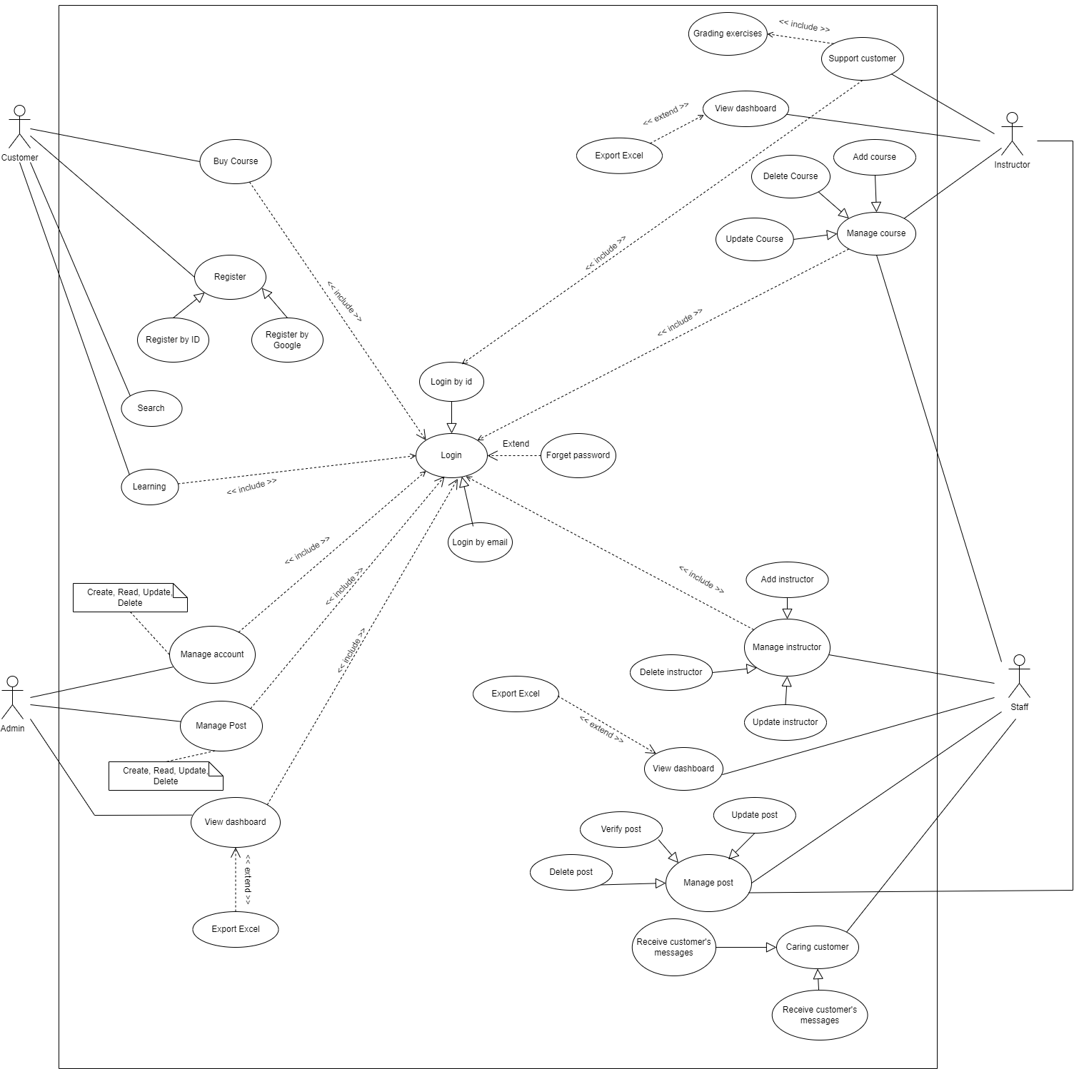

## **3.2. Use Case List**

| ID | UseCase | Primary Actor |
| --- | --- | --- |
| UC-01 | Sign In | All Actors |
| UC-02 | Sign Up | All Actors |
| UC-03 | Sign Out | All Actors |
| UC-04 | Forget Password | All Actors |
| UC-05 | Search Course | All Actors |
| UC-06 | View Course | All Actors |
| UC-07 | View Course Detail | All Actors |
| UC-08 | Add Course(s) To Cart | Customer |
| UC-09 | View Cart | Customer |
| UC-10 | Remove Course From Cart | Customer |
| UC-11 | Check Out | Customer |
| UC-12 | Choose Payment Methods | Customer |
| UC-13 | View Order History | Customer |
| UC-14 | View Learning Course | Customer |
| UC-15 | View Finished Course | Customer |
| UC-16 | Learning Course | Customer |
| UC-17 | View Profile | Customer |
| UC-18 | Edit Profile | Customer |
| UC-19 | Deactivate Account | Customer |
| UC-20 | View Account Detail | Admin |
| UC-21 | Create Account | Admin |
| UC-22 | Edit Account | Admin |
| UC-23 | Remove Account | Admin |
| UC-24 | View Instructor | Staff |
| UC-25 | Create Instructor | Staff |
| UC-26 | Edit Instructor | Staff |
| UC-27 | Remove Instructor | Staff |
| UC-28 | View Statistic | Admin |
| UC-29 | Submit assignment | Customer |
| UC-30 | Create Course | Instructor |
| UC-31 | Edit Course | Instructor |
| UC-32 | Remove Course | Staff |
| UC-33 | Verify Course | Staff |
| UC-34 | Apply Coupon | Customer |
| UC-35 | Create Coupon | Staff |
| UC-36 | Edit Coupon | Staff |
| UC-37 | Remove Coupon | Staff |
| UC-38 | Grading Assignment | Instructor |
| UC-39 | View Bill Of Customer | Staff |
| UC-40 | Receive Certificate after learning | Customer |
| UC-41 | Filter Course | Customer |

## 

## 

## **3.1. Use Case Detail:**

### UC-01: Sign In

| **ID and Name:** | **UC-01: Sign In** | | |
| --- | --- | --- | --- |
| Created By: | Nguyen Le Hoang Dung | Date Created: | 04/10/2023 |
| Primary Actor: | All Actor | Secondary Actors: | N/A |
| Priority: | High | Frequency of Use: | Usually |
| Trigger: | The actor wants to sign in to the Drawing Course Online Website. | | |
| Description: | This feature allows actor to login the system | | |
| Preconditions: | Actor has a Google Account or website account that has registered before | | |
| Post-conditions: | Success: Redirect to actor’s home page  Fail: The system shows error message corresponding to error code | | |
| Normal Flow: | Flow 1:   | Step | Actor Action | System Response | | --- | --- | --- | | 1 | In sign in page, Actor inputs userName and passwords |  | | 2 | Actor clicks “Sign in” | System redirects to the home page | | | |
| Alternative Flow: | Flow 1:   | Step | Actor Action | System Response | | --- | --- | --- | | 1 | In sign in page, Actor clicks on the Google icon | System shows a list of google accounts of users | | 2 | Actor clicks the account they want to use to sign in | System redirects to the home page | | | |
| Exceptions: | | No | Cause | System Response | | --- | --- | --- | | 1 | The userName or password is not correct | System informs “useName or password is incorrect” | | | |
| Business Rules: | * Password is not empty and at least 8 characters | | |
| Assumptions: | * Actor’s internet connection is available * Actor has signed up Website account or Google Account before | | |

### 

### UC-02: Sign Up

| **ID and Name:** | **UC-02: Sign Up** | | |
| --- | --- | --- | --- |
| Created By: | Nguyen Minh Nguyet | Date Created: | 08/10/2023 |
| Primary Actor: | Customer | Secondary Actors: | N/A |
| Priority: | High | Frequency of Use: | Usually |
| Trigger: | The actor wants to register an account in Drawing Course selling Website | | |
| Description: | This feature allows actor to create new account to become customer in the system | | |
| Preconditions: | Actor has an email that has been authorised before (Google,Facebook, … ). | | |
| Post-conditions: | Success: Redirect to home page  Fail: The system shows error message corresponding to error code | | |
| Normal Flow: | Flow 1:   | Step | Actor Action | System Response | | --- | --- | --- | | 1 | In the sign in page, actor clicks “Sign Up” | System shows a form with these fields:  - Email: a text input, a string input must follow the email regex ([XXX@YYY.ZZ](mailto:XXX@YYY.ZZ)).  - Full Name: a text input, a string input is not empty.  - Date of Birth: date is not empty.  - UserName: a text input, a string input is not empty.  - Password/Confirm password: two strings must be identical, not empty and at least 8 characters, include lowercase, at least 1 uppercase, at least 1 number. | | 2 | Actor inputs email, full name, date of birth, user name, password, confirm password. |  | | 5 | Actor clicks “Sign Up” | System checks the validations. If correct, create new customer account and redirect to home page | | | |
| Alternative Flow: | N/A | | |
| Exceptions: | | No | Cause | System Response | | --- | --- | --- | | 1 | At least UserName, Full Name, Date of Birth input is empty | System shows an error message corresponding to the fail constraint. | | 2 | Email is not existed | System detects that the registered email does not exist, then shows a warning error. | | 3 | Password and Confirm Password input field doesn’t match each other or format | System shows an error message corresponding to the fail constraint. | | | |
| Business Rules: | N/A | | |
| Assumptions: | * Actor’s internet connection is available | | |

### 

### UC-03: Sign Out

| **ID and Name:** | **UC-03: Sign Out** | | |
| --- | --- | --- | --- |
| Created By: | Nguyen Le Hoang Dung | Date Created: | 04/10/2023 |
| Primary Actor: | All Actor | Secondary Actors: | N/A |
| Priority: | High | Frequency of Use: | Usually |
| Trigger: | The actor wants to sign out to the Drawing Course Online Website. | | |
| Description: | This feature allows actor to sign out the system | | |
| Preconditions: | Actor has already logged in Website | | |
| Post-conditions: | Success: Redirect to Home Page with no role  Fail: The system shows error message corresponding to error code | | |
| Normal Flow: | Flow 1:   | Step | Actor Action | System Response | | --- | --- | --- | | 1 | In nav bar, actor clicks “Sign Out” | System redirects to the default home page | | | |
| Alternative Flow: | N/A | | |
| Exceptions: | N/A | | |
| Business Rules: | N/A | | |
| Assumptions: | * Actor’s internet connection is available * Actor has signed up Website account or Google Account before | | |

### UC-04: Forget Password

| **ID and Name:** | **UC-04: Forget Password** | | |
| --- | --- | --- | --- |
| Created By: | Nguyen Tien Toan | Date Created: | 30/10/2023 |
| Primary Actor: | All Actor | Secondary Actors: | N/A |
| Priority: | Normal | Frequency of Use: | Occasionally |
| Trigger: | The actor forget password while signing in to the Drawing Course Online Website. | | |
| Description: | This feature allows actor to get OTP to login in the system | | |
| Preconditions: | Actor has a Google Account or website account that has registered before | | |
| Post-conditions: | Success: The system send OTP code to actor’s mail  Fail: The system shows error message corresponding to error code | | |
| Normal Flow: | Flow 1:   | Step | Actor Action | System Response | | --- | --- | --- | | 1 | In sign in page, actor clicks “forgot password” | System redirects to the forgot password page | | 2 | Actor input userName, gmail | The system send OTP code to actor’s gmail | | 3 | Actor input OTP code and change new password |  | | 4 | Actor clicks “Change Password” | System redirects to the sign in page | | | |
| Alternative Flow: | N/A | | |
| Exceptions: | | No | Cause | System Response | | --- | --- | --- | | 1 | The userName or gmail is not correct or not registered | System informs “userName or gmail is incorrect” | | | |
| Business Rules: | * The system must send OTP code when actor forget password | | |
| Assumptions: | * Actor’s internet connection is available * Actor has signed up Website account or Google Account before | | |

### UC-05: Search Course

| **ID and Name:** | **UC-05: Search Course** | | |
| --- | --- | --- | --- |
| Created By: | Nguyen Hoang My Phuoc | Date Created: | 28/10/2023 |
| Primary Actor: | All Actor | Secondary Actors: | N/A |
| Priority: | Normal | Frequency of Use: | Often |
| Trigger: | The actor wants to search courses in Website | | |
| Description: | This feature allows actors to search for courses that contain details of the keyword, or filter. | | |
| Preconditions: | N/A | | |
| Post-conditions: | Success: Search Results have been generated based on the actor's search keywords or categories. This result needs to be displayed for the actor to see.  Fail: The system shows message “No data” | | |
| Normal Flow: | Flow 1:   | Step | Actor Action | System Response | | --- | --- | --- | | 1 | In the homepage, the actor types the keyword into the search textbox. |  | | 2 | Actor clicks on the “search” icon. | System show the list of courses containing the keyword. |   Flow 2:   | Step | Actor Action | System Response | | --- | --- | --- | | 1 | In the homepage, the actor chooses the categories |  | | 2 | Actor clicks on each of the categories button | System shows the list of courses that available with that genres | | | |
| Alternative Flow: | N/A | | |
| Exceptions: | | No | Cause | System Response | | --- | --- | --- | | 1 | Result is empty. | System shows the message “No data”. | | | |
| Business Rules: | * All courses must have a record in the storage and still be available. | | |
| Assumptions: | Actor’s internet connection is available | | |

### UC-06: View Course

| **ID and Name:** | **UC-06: View Course** | | |
| --- | --- | --- | --- |
| Created By: | Nguyen Minh Nguyet | Date Created: | 29/10/2023 |
| Primary Actor: | All Actor | Secondary Actors: | N/A |
| Priority: | Normal | Frequency of Use: | Usually |
| Trigger: | The actor wants to view the list of courses. | | |
| Description: | This feature allows actors to view courses. | | |
| Preconditions: | N/A | | |
| Post-conditions: | Success: The system shows lists of courses.  Fail: System informs “No data” . | | |
| Normal Flow: | | Step | Actor Action | System Response | | --- | --- | --- | | 1 | After the actor clicks “Courses” page on nav bar | System shows the list of courses. | | | |
| Alternative Flow: | N/A | | |
| Exceptions: | | No | Cause | System Response | | --- | --- | --- | | 1 | Result is empty. | System shows the message “No data” . | | | |
| Business Rules: | * The course must have a record in the storage and still be available. * All information in the list must be clear and up-to-date. | | |
| Assumptions: | Actor’s internet connection is available | | |

### UC-07: View Course Detail

| **ID and Name:** | **UC-07: View Course Detail** | | |
| --- | --- | --- | --- |
| Created By: | Nguyen Minh Nguyet | Date Created: | 29/10/2023 |
| Primary Actor: | All Actor | Secondary Actors: | N/A |
| Priority: | Normal | Frequency of Use: | Usually |
| Trigger: | The actor wants to view the course in detail. | | |
| Description: | This feature allows actors to view information about a specific course such as instructor name, level, type, … . | | |
| Preconditions: | N/A | | |
| Post-conditions: | Success: The system shows lists of courses.  Fail: System informs “No data” . | | |
| Normal Flow: | | Step | Actor Action | System Response | | --- | --- | --- | | 1 | After the actor clicks any courses | Redirect to the course detail information page. The website shows course detail information such as:   * Name * Price * Picture * Description * Instructor Name * Level * …   And below page shows “add to cart” and “Buy Now”button | | | |
| Alternative Flow: | N/A | | |
| Exceptions: | N/A | | |
| Business Rules: | * All information in the list must be clear and up-to-date. | | |
| Assumptions: | Actor’s internet connection is available | | |

### UC-08: Add Course(s) to Cart

| **ID and Name:** | **UC-04: Add Course(s) to Cart** | | |
| --- | --- | --- | --- |
| Created By: | Nguyen Le Hoang Dung | Date Created: | 16/10/2023 |
| Primary Actor: | Customer | Secondary Actors: | N/A |
| Priority: | High | Frequency of Use: | Often |
| Trigger: | The actor wants to add courses to cart for learning in website | | |
| Description: | This feature allows actor to add courses to cart before buying | | |
| Preconditions: | Actors must sign in as “Customer”.  Actors should be viewing details of a product. | | |
| Post-conditions: | Success: The actor have right to add courses and view cart  Fail: If the actor wants to add more than 1, the system will announce “Already Add to Cart” | | |
| Normal Flow: | Flow 1:   | Step | Actor Action | System Response | | --- | --- | --- | | 1 | The user click course to view detail | System redirects to the course detail page | | 2 | In the course detail page, actor click “Add to cart” button | System saves the course to the cart. | | 3 | In the course detail page, actor click “Add to cart” button | System redirects to the view cart page and checks all the courses that are added to cart. | | | |
| Alternative Flow: | N/A | | |
| Exceptions: | | No | Cause | System Response | | --- | --- | --- | | 1 | If the actor have already add to cart but click “Add to Cart” again | System shows message “Already Add to Car” | | | |
| Business Rules: | The course must be added once | | |
| Assumptions: | Actor’s internet connection is available | | |

## 

## 

### UC-09: View Cart

| **ID and Name:** | **UC-09: View Cart** | | |
| --- | --- | --- | --- |
| Created By: | Nguyen Le Hoang Dung | Date Created: | 18/10/2023 |
| Primary Actor: | Customer | Secondary Actors: | N/A |
| Priority: | Medium | Frequency of Use: | Often |
| Trigger: | The actor wants to view their cart. | | |
| Description: | This feature allows actors to view what course they have chosen to buy by their name, price, number,... | | |
| Preconditions: | The actor must login to their account as “Customer” role | | |
| Post-conditions: | Success: System shows the cart with some course  Fail: The system shows the message “You haven’t picked anything!” | | |
| Normal Flow: | | Step | Actor Action | System Response | | --- | --- | --- | | 1 | In Edit account, Actor clicks “View Cart” section | System redirects to the cart section and shows some course cart that has been picked and a “checkout” button. | | | |
| Alternative Flow: | N/A | | |
| Exceptions: | | No | Cause | System Response | | --- | --- | --- | | 1 | There is no course that has been picked | System informs the message “You haven’t picked anything!” | | | |
| Business Rules: | System must show total price of the cart | | |
| Assumptions: | Actor’s internet connection is available | | |

### 

### UC-10: Remove Course(s) From Cart

| **ID and Name:** | **UC-10: Remove Course(s) From Cart** | | |
| --- | --- | --- | --- |
| Created By: | Nguyen Le Hoang Dung | Date Created: | 16/10/2023 |
| Primary Actor: | Customer | Secondary Actors: | N/A |
| Priority: | High | Frequency of Use: | Often |
| Trigger: | The actor wants to remove course(s) from Cart | | |
| Description: | This feature allows actor to remove the course(s) that they have chosen to buy from cart | | |
| Preconditions: | Actor has signed in as “Customer” and has picked some course(s) | | |
| Post-conditions: | Success: The Course is removed from the cart. | | |
| Normal Flow: | | Step | Actor Action | System Response | | --- | --- | --- | | 1 | In Edit account, Actor clicks “View Cart” section | System redirects to the cart section and shows some course cart that has been picked and a “checkout” button. | | 2 | Actor clicks the “X” button | The course card is removed from the cart. | | | |
| Alternative Flow: | N/A | | |
| Exceptions: | N/A | | |
| Business Rules: | N/A | | |
| Assumptions: | Actor’s internet connection is available | | |

### 

### UC-11: Checkout

| **ID and Name:** | **UC-11: Check out** | | |
| --- | --- | --- | --- |
| Created By: | ToanNT | Date Created: | 18/10/2023 |
| Primary Actor: | Customer | Secondary Actors: | N/A |
| Priority: | High | Frequency of Use: | Usually |
| Trigger: | The actor wants to buy a course in website | | |
| Description: | The actor need to buy course by online banking to have right access course to learn | | |
| Preconditions: | N/A | | |
| Post-conditions: | Success: Notice payment successfully and can right to access course | | |
| Normal Flow: | | Step | Actor Action | System Response | | --- | --- | --- | | 1 | Access the Learning Platform:  Open a web browser and access the learning platform's website. | The learning platform's homepage loads, and you can see the available courses and features. | | 2 | Search for a Course:  Use the platform's search function to find and select the course of your interest | The platform provides a search bar where you can enter keywords. As you type, the system suggests relevant courses, making it easier to find the course of your choice. | | 3 | View Course Information:  The website will display detailed information about the course, including its name, description, instructor, duration, price, and user ratings (if available). | When you select a course, the platform displays a dedicated course page with detailed information, including the course title, description, instructor's credentials, course duration, pricing, and user reviews. | | 4 | Buy in the Course:  Choose the course you want to join by clicking on the "Buy now" button in course detail or cart view. | When clicking the “Buy now” in course detail site or cart view it leads to checkout. | | 5 | Payment:  If you click on the “Payment” button on the checkout page, it will lead to the VNPAY web ( just one way to pay), the actor can choose a way to buy in VNPAY pages like Card, Online Banking,... | After click “Payment” button, the information total will send to VNPAY to proceed with payment | | 6 | Completing Payment  In filling information site, the actor have to fill detail account banking correctly to check this is a correct payment and complete payment | The result will return server side to generate data to the actor in the screen, if the payment is done successfully it will return information of payment and information bought of course. | | 7 | Have right to access bought course:  It will have a link learning course in page, the actor can click on this link to go directly the course that is bought | The system to let the actor have a right to enrol in a course and tracking activity of learning in this course for each the actor | | | |

### UC-12: Choose payment methods

| **ID and Name:** | **UC-12: Choose payment methods** | | |
| --- | --- | --- | --- |
| Created By: | Nguyen Tien Toan | Date Created: | 7/11/2023 |
| Primary Actor: | Customer | Secondary Actors: | N/A |
| Priority: | High | Frequency of Use: | Usually |
| Trigger: | When user want to choose payment method to check out | | |
| Description: | The student choose payment method | | |
| Preconditions: | The user have to login with Customer role  The user have at least one course in cart | | |
| Post-conditions: | N/A | | |
| Normal Flow: | | Step | Actor Action | System Response | | --- | --- | --- | | 1 | Access the Learning Platform:  Open a web browser and access the learning platform's website. | The learning platform's homepage loads, and you can see the available courses and features. | | 2 | Login into website:  User input accountID and password to validate | The system will check data input and return homepage with personal account when login is valid | | 3 | Click “view cart” in tab dowdrop | Website return list course that are add to cart before | | 4 | Click “Checkout” to leads to checkout page | Verify what the user want to buy and show total and basic information to checkout | | 5 | Click “VNPAY” below basic user information ( default choosed) | System choose default method payment is VNPAY | | | |
| Alternative Flow: | N/A | | |
| Exceptions: | N/A | | |
| Business Rules: | N/A | | |
| Assumptions: | Actor’s internet connection is available | | |

### 

### UC-13 : View Order History

| **ID and Name:** | **UC-13: View order history** | | |
| --- | --- | --- | --- |
| Created By: | Nguyen Minh Nguyet | Date Created: | 7/11/2023 |
| Primary Actor: | Customer | Secondary Actors: | N/A |
| Priority: | High | Frequency of Use: | Usually |
| Trigger: | The actor wants to see history order | | |
| Description: | When buy a course successfully the actor can see order information about detail information bought course and payment transtraction information to check and see when needed | | |
| Preconditions: | N/A | | |
| Post-conditions: | Success: show table including order detail and payment information | | |
| Normal Flow: | | Step | Actor Action | System Response | | --- | --- | --- | | 1 | Access the Learning Platform:  Open a web browser and access the learning platform's website. | The learning platform's homepage loads, and you can see the available courses and features. | | 2 | Login into website:  The actor has a account to login and the role is customer to have right seeing order bill | After go to see order bill, login is needed to identify the actor account to get order data | | 3 | Go to history order  In account tag in header, the actor click on history order button to see what they need | The website provides feature to see detail order and detail payment to check when needed | | 3 | View Order Information:  The website will show all of order of the actor in a table, the actor can see order by date | All information of order including order detail, transaction detail and status of order can | | | |
| Alternative Flow: | N/A | | |
| Exceptions: | N/A | | |
| Business Rules: | N/A | | |
| Assumptions: | Actor’s internet connection is available | | |

### UC-14: View Learning Course

| **ID and Name:** | **UC-14: View Learning Course** | | |
| --- | --- | --- | --- |
| Created By: | Nguyen Le Hoang Dung | Date Created: | 03/11/2023 |
| Primary Actor: | Customer | Secondary Actors: | N/A |
| Priority: | Medium | Frequency of Use: | Often |
| Trigger: | The actor wants to view their learning course after buying. | | |
| Description: | This feature allows actors to view what course they have chosen to learn such as progress, expired day, … . | | |
| Preconditions: | The actor must login to their account as “Customer” role | | |
| Post-conditions: | Success: System shows learning courses  Fail: The system shows the message “You haven’t bought any course yet!” | | |
| Normal Flow: | | Step | Actor Action | System Response | | --- | --- | --- | | 1 | In Edit account, Actor clicks “Learning” section | System redirects to the learning page and shows some courses that are still in progress and a “learning” link. | | | |
| Alternative Flow: | N/A | | |
| Exceptions: | | No | Cause | System Response | | --- | --- | --- | | 1 | There is no course that has been learned | System informs the message “You haven’t bought any course yet!” | | | |
| Business Rules: | N/A | | |
| Assumptions: | Actor’s internet connection is available | | |

## 

### UC-15: View In Progress/Finished Course

| **ID and Name:** | **UC-14: View Learning Course** | | |
| --- | --- | --- | --- |
| Created By: | Nguyen Le Hoang Dung | Date Created: | 03/11/2023 |
| Primary Actor: | Customer | Secondary Actors: | N/A |
| Priority: | Medium | Frequency of Use: | Often |
| Trigger: | The actor wants to view their learning course after buying. | | |
| Description: | This feature allows actors to view what course they have chosen to learn such as progress, expired day, … . | | |
| Preconditions: | The actor must login to their account as “Customer” role | | |
| Post-conditions: | Success: System shows learning courses  Fail: The system shows the message “You haven’t bought any course yet!” | | |
| Normal Flow: | | Step | Actor Action | System Response | | --- | --- | --- | | 1 | In Edit account, Actor clicks “Learning” section | System redirects to the learning page and shows some courses that are still in progress and a “learning” link. | | | |
| Alternative Flow: | N/A | | |
| Exceptions: | | No | Cause | System Response | | --- | --- | --- | | 1 | There is no course that has been learned | System informs the message “You haven’t bought any course yet!” | | | |
| Business Rules: | N/A | | |
| Assumptions: | Actor’s internet connection is available | | |

### UC-16: Learning Course

| **ID and Name:** | **UC-16: Learning Course** | | |
| --- | --- | --- | --- |
| Created By: | Nguyen Le Hoang Dung | Date Created: | 03/11/2023 |
| Primary Actor: | Customer | Secondary Actors: | N/A |
| Priority: | Medium | Frequency of Use: | Often |
| Trigger: | The actor wants to view their learning course after buying. | | |
| Description: | This feature allows actors to learn a course. | | |
| Preconditions: | The actor must login to their account as a “Customer” role, and choose a course to learn. | | |
| Post-conditions: | Success: System shows learning courses  Fail: The system shows the message “You haven’t bought any course yet!” | | |
| Normal Flow: | | Step | Actor Action | System Response | | --- | --- | --- | | 1 | Actors choose one of each module. |  | | 2 | In each module, actor choose lesson | System shows video and description of that lesson | | 3 | Actor choose to do assignment when finished lesson | System shows assignment and description of that topic with choose file and “Submit” button | | 4 | Actor choose file and clicks “Submit” button | System shows message “Your submission is successful” | | | |
| Alternative Flow: | N/A | | |
| Exceptions: | | No | Cause | System Response | | --- | --- | --- | | 1 | The file is invalid | System informs the message “Your submission is not successful” | | | |
| Business Rules: | N/A | | |
| Assumptions: | Actor’s internet connection is available | | |

### UC-17: View Profile

| **ID and Name:** | **UC-17: View Profile** | | |
| --- | --- | --- | --- |
| Created By: | Lê Hoàng Trọng | Date Created: | 11/10/2023 |
| Primary Actor: | Users | Secondary Actors: | N/A |
| Priority: | High | Frequency of Use: | Often |
| Trigger: | The actor wants to view the profile of users | | |
| Description: | This feature allows the actor to add a detailed profile such as name, date of birth, account id, password,... | | |
| Preconditions: | The actor must login to their account | | |
| Post-conditions: | Success: System shows the profile page | | |
| Normal Flow: | | Step | Actor Action | System Response | | --- | --- | --- | | 1 | In home page, actor clicks avatar choose manage profile | System redirects to the page showing:   * Password * Confirm password * Name * Date of Birth   Email   * Image | | | |
| Alternative Flow: | N/A | | |
| Exceptions: | N/A | | |
| Business Rules: | N/A | | |
| Assumptions: | Actor’s internet connection is available | | |

### UC-18: Edit Profile

| **ID and Name:** | **UC-18: Edit Profile** | | |
| --- | --- | --- | --- |
| Created By: | Lê Hoàng Trọng | Date Created: | 11/10/2023 |
| Primary Actor: | Users | Secondary Actors: | N/A |
| Priority: | High | Frequency of Use: | Often |
| Trigger: | The actor wants to edit their profile | | |
| Description: | This feature allows actor to change user name, email and/or date of birth | | |
| Preconditions: | The actor must login to their account | | |
| Post-conditions: | Success: Show detail information of accounts  Fail: Show not found page if the account does not exist or the account is not public | | |
| Normal Flow: | | Step | Actor Action | System Response | | --- | --- | --- | | 1 | In manage profile , actor clicks manage profile- | System redirects to the management showing:   * Name * Email * button * Contact * Date of Birth | | 2 | Actor clicks personal information card | System shows a form containing textbox for:   * Name * Address * Date of Birth | | 3 | Actor inputs the form and clicks “save” button | System shows a new information profile page. | | | |
| Alternative Flow: | N/A | | |
| Exceptions: | N/A | | |
| Business Rules: | The date of birth textbox must be imputed by choosing a day from the calendar. | | |
| Assumptions: | Actor’s internet connection is available | | |

### UC-19: Deactive Account Customer

### 

| **ID and Name:** | **UC-19: Deactive Account** | | |
| --- | --- | --- | --- |
| Created By: | ToanNT | Date Created: | 15/11/2023 |
| Primary Actor: | Admin | Secondary Actors: | N/A |
| Priority: | Medium | Frequency of Use: | Often |
| Trigger: | The actor wants to inactive an Account. | | |
| Description: | This feature allows actors to inactive accounts. | | |
| Preconditions: | * The actor has logged in by an Admin account. * Choose “All Customer” button in Manage Account * Click on the manage customer tag * Current list customer will be displayed | | |
| Post-conditions: | Success: System created account  Fail: System shows message error | | |
| Normal Flow: | | Step | Actor Action | System Response | | --- | --- | --- | | 1 | In Customer list, choose “Inactive Customer” button on the account the actor want to inactive | The system show message when inactive successfully and the selected account will be disappeared | | | |
| Alternative Flow: | N/A | | |
| Exceptions: | N/A | | |
| Business Rules: | N/A | | |
| Assumptions: | Actor’s internet connection is available | | |

### UC-20: View Account Detail

| **ID and Name:** | **UC-20: View Account Detail** | | |
| --- | --- | --- | --- |
| Created By: | PhucLM | Date Created: | 11/10/2022 |
| Primary Actor: | Admin | Secondary Actors: | N/A |
| Priority: | High | Frequency of Use: | Often |
| Trigger: | The actor wants to create a new Account. | | |
| Description: | This feature allows actor to create a new account as public. | | |
| Preconditions: | * The actor has logged in by an Admin account. * Current screen is “Account List” screen | | |
| Post-conditions: | Success: System created account  Fail: System shows message error | | |
| Normal Flow: | | Step | Actor Action | System Response | | --- | --- | --- | | 1 | The actor clickson “Create Account” button on “Account List” screen | System shows pop up showing all field for the admin to fill, includes:  - Name: text  - Email: text  - Phone: text  - Gender: text  - Birthday: text  - Avatar: image  - Role: text | | 2 | Admin fills information, then clicks on the “Create” button. (Alternative A1) | System valid item’s information inputted by admin and creates account. | | | |
| Alternative Flow: | | Step | Actor Action | System Response | | --- | --- | --- | | 1 | User clicks on the “Cancel” button. | System closes the pop up. | | | |
| Exceptions: | | No | Cause | System Response | | --- | --- | --- | | 1 | Existing invalid input | System informs a specified error message in a popup dialog. | | | |
| Business Rules: | Name cannot be null | | |
| Assumptions: | Actor’s internet connection is available | | |

### UC-21: Create Account

| **ID and Name:** | **UC-21: Create Accounts** | | |
| --- | --- | --- | --- |
| Created By: | ToanNT | Date Created: | 15/11/2023 |
| Primary Actor: | Admin | Secondary Actors: | N/A |
| Priority: | Normal | Frequency of Use: | Often |
| Trigger: | The actor wants to add detailed information of accounts. | | |
| Description: | This feature allows Admin to add a new accounts. | | |
| Preconditions: | * User has logged in as Admin successfully. * Choose the “All Customer” button. * Choose “manage customer” tab to show list account member | | |
| Post-conditions: | Success: System shows a dialog with a successful message when the account has been modified successfully in the database.  Fail: System shows error message and invalid input (if have) | | |
| Normal Flow: | | Step | Actor Action | System Response | | --- | --- | --- | | 1 | Click on “Add account” in tab | The add account will show up with input space:   * Name: text * Email: text * Phone: text * Birthday: text * Image: image * AccountID: text * Password: text (default) | | 2 | Input all required input | The system wait for filling data, and will notice error when actor don’t fill rough required input textbox | | 3 | Click “Add Customer” button to add a new acc | The system will get input and handle as well as check validate | | | |
| Alternative Flow: | N/A | | |
| Exceptions: | | No | Cause | System Response | | --- | --- | --- | | 1 | Existing invalid input. | System informs a specified error message in a popup dialog. | | | |
| Business Rules: | Account just only can be created by the Admin that created it. | | |
| Assumptions: | Actor’s internet connection is available | | |

### UC-22: Edit Account

| **ID and Name:** | **UC-22: Edit Account** | | |
| --- | --- | --- | --- |
| Created By: | Le Hoang Trong | Date Created: | 11/10/2023 |
| Primary Actor: | User | Secondary Actors: | N/A |
| Priority: | High | Frequency of Use: | Often |
| Trigger: | The actor wants to edit information about Accounts. | | |
| Description: | This feature allows actors to view details such as Name, Phone, to edit | | |
| Preconditions: | The account publicises their profile. | | |
| Post-conditions: | Success: the account success to update  Fail: Show not found page if the account does not exist or the account is not public and not update success | | |
| Normal Flow: | | Step | Actor Action | System Response | | --- | --- | --- | | 1 | Click on Account detail’s card. | Redirect to enterprise detail information page showing enterprise detail information such as:   * Name * Phone * Address * Date of Birth * Contact information (if any)   And 1 Dot Selection with values | | 2 | Actor clicks on the “Activate” button.  **[Alternative 1]** | System redirects to the manage account page and set user’s account as  Active account. | | | |
| Alternative Flow: | N/A | | |
| Business Rules: | * The date of birth textbox must be imputed by choosing a day from the calendar. | | |
| Assumptions: | Actor’s internet connection is available | | |

### UC-23: Inactive Account Staff

### 

| **ID and Name:** | **UC-23: Deactive Account** | | |
| --- | --- | --- | --- |
| Created By: | Nguyen Tien Toan | Date Created: | 11/11/2023 |
| Primary Actor: | Admin | Secondary Actors: | N/A |
| Priority: | Medium | Frequency of Use: | Often |
| Trigger: | The actor wants to inactive an Account. | | |
| Description: | This feature allows actors to inactive accounts. | | |
| Preconditions: | * The actor has logged in by an Admin account. * Choose “All Staff” button in Manage Account * Click on the manage customer tag * Current list customer will be displayed | | |
| Post-conditions: | Success: System created account  Fail: System shows message error | | |
| Normal Flow: | | Step | Actor Action | System Response | | --- | --- | --- | | 1 | In Customer list, choose “Inactive” button on the account the actor want to inactive | The system show message when inactive successfully and the selected account will be disappeared | | | |
| Alternative Flow: | N/A | | |
| Exceptions: | N/A | | |
| Business Rules: | N/A | | |
| Assumptions: | Actor’s internet connection is available | | |

### UC-24: View Instructor

### 

| **ID and Name:** | **UC-24: View Instructor** | | |
| --- | --- | --- | --- |
| Created By: | Nguyen Hoang My Phuoc | Date Created: | 11/10/2023 |
| Primary Actor: | Staff | Secondary Actors: | N/A |
| Priority: | High | Frequency of Use: | Often |
| Trigger: | The actor wants to view instructor | | |
| Description: | This feature allows actor to view instructor list | | |
| Preconditions: | The actor must login to their account as “Staff” role | | |
| Post-conditions: | A list of instructors will be shown in management page | | |
| Normal Flow: | | Step | Actor Action | System Response | | --- | --- | --- | | 1 | In staff’s management page, actor clicks management instructor -> all instructor section | System redirects to the management showing two tabs: Add instructor and All instructors | | 2 | Actor clicks on all instructors | * A list of active instructors will be shown | | | |
| Alternative Flow: | N/A | | |
| Exceptions: | N/A | | |
| Business Rules: | Account ID and password must not be shown on the screen | | |
| Assumptions: | Actor’s internet connection is available | | |

### UC-25: Create Instructor

### 

| **ID and Name:** | **UC-24: Create Instructor** | | |
| --- | --- | --- | --- |
| Created By: | Nguyen Hoang My Phuoc | Date Created: | 11/10/2023 |
| Primary Actor: | Staff | Secondary Actors: | N/A |
| Priority: | High | Frequency of Use: | Often |
| Trigger: | The actor wants to add instructor | | |
| Description: | This feature allows actor to add instructor list | | |
| Preconditions: | The actor must login to their account as “Staff” role | | |
| Post-conditions: | A new instructor will be added to database successfully | | |
| Normal Flow: | | Step | Actor Action | System Response | | --- | --- | --- | | 1 | In staff’s management page, actor clicks management instructor -> all instructor section | System redirects to the management showing two tabs: Add instructor and All instructors | | 2 | Actor clicks on add instructor | An add form will be shown on the screen with required field:   * AccountID * Name * Date of Birth * Email * Image * Password and role can only read | | 3 | Actor clicks on “Add instructor” button | A successfully message will be shown and a new instructor will be added to database | | | |
| Alternative Flow: | N/A | | |
| Exceptions: | | No | Cause | System Response | | --- | --- | --- | | 1 | Invalid input | Error message will display directly on screen | | | |
| Business Rules: | * Password will be set default and staff can not change it * After create instructor account, account id and password will be sent to that instructor | | |
| Assumptions: | Actor’s internet connection is available | | |

### UC-26: Edit Instructor

### 

| **ID and Name:** | **UC-24: Edit Instructor** | | |
| --- | --- | --- | --- |
| Created By: | Nguyen Hoang My Phuoc | Date Created: | 11/10/2023 |
| Primary Actor: | Staff | Secondary Actors: | N/A |
| Priority: | High | Frequency of Use: | Often |
| Trigger: | The actor wants to edit instructor | | |
| Description: | This feature allows actor to edit existed instructor | | |
| Preconditions: | The actor must login to their account as “Staff” role | | |
| Post-conditions: | An existed instructor will be updated to database successfully | | |
| Normal Flow: | | Step | Actor Action | System Response | | --- | --- | --- | | 1 | In staff’s management page, actor clicks management instructor -> all instructor section | System redirects to the management showing two tabs: Add instructor and All instructors | | 2 | Actor clicks on all instructors tab | * A list of active instructors will be shown | | 3 | Actor input data wanted to update in fields |  | | 4 | Actor click on “Edit” button | A successful message will be shown and an updated instructor will be saved to database and shown on screen | | | |
| Alternative Flow: | N/A | | |
| Exceptions: | | No | Cause | System Response | | --- | --- | --- | | 1 | Invalid input | Error message will display directly on screen | | | |
| Business Rules: | * Password and account id can not be shown | | |
| Assumptions: | Actor’s internet connection is available | | |

### UC-27: Remove Instructor

### 

| **ID and Name:** | **UC-27: Remove instructor** | | |
| --- | --- | --- | --- |
| Created By: | Nguyen Hoang My Phuoc | Date Created: | 11/10/2023 |
| Primary Actor: | Staff | Secondary Actors: | N/A |
| Priority: | High | Frequency of Use: | Often |
| Trigger: | The actor wants to edit instructor | | |
| Description: | This feature allows actor to edit existed instructor | | |
| Preconditions: | The actor must login to their account as “Staff” role | | |
| Post-conditions: | An existed instructor will be updated to database successfully | | |
| Normal Flow: | | Step | Actor Action | System Response | | --- | --- | --- | | 1 | In staff’s management page, actor clicks management instructor -> all instructor section | System redirects to the management showing two tabs: Add instructor and All instructors | | 2 | Actor clicks on all instructors tab | * A list of active instructors will be shown | | 4 | Actor selects instructor wanted to deactivate and click on “Deactive” button | A successful message will be shown and deactivated instructor can not be shown in the list display on screen | | | |
| Alternative Flow: | N/A | | |
| Exceptions: |  | | |
| Business Rules: | * Password and account id can not be shown | | |
| Assumptions: | Actor’s internet connection is available | | |

### UC-28: View Statistic

### 

| **ID and Name:** | **UC-28: View Cart** | | |
| --- | --- | --- | --- |
| Created By: | ToanNT | Date Created: | 11/10/2023 |
| Primary Actor: | Customer | Secondary Actors: | N/A |
| Priority: | Medium | Frequency of Use: | Often |
| Trigger: | The actor wants to view statistic | | |
| Description: | This feature allows actors to view the all of order including profit, detail order | | |
| Preconditions: | The actor must login to their account as “Admin” role | | |
| Post-conditions: | Success: System shows the chart and number statistics about order on the website.  Fail: The system shows error | | |
| Normal Flow: | | Step | Actor Action | System Response | | --- | --- | --- | | 1 | The actor access admin page with valid account | System shows all the number statistic about order, profit,.... | | | |
| Alternative Flow: | N/A | | |
| Exceptions: | N/A | | |
| Business Rules: | System must show total profit | | |
| Assumptions: | Actor’s internet connection is available | | |

### UC-29: Submit assignment

### 

| **ID and Name:** | **UC-29: Submit assignment** | | |
| --- | --- | --- | --- |
| Created By: | Nguyen Le Hoang Dung | Date Created: | 03/11/2023 |
| Primary Actor: | Customer | Secondary Actors: | N/A |
| Priority: | High | Frequency of Use: | Often |
| Trigger: | The actor wants to submit assignment | | |
| Description: | This feature allows actor to submit assignment | | |
| Preconditions: | The actor must login to their account as Customer role | | |
| Post-conditions: | Success: System shows the successful submission message  Fail: The system shows error | | |
| Normal Flow: | | Step | Actor Action | System Response | | --- | --- | --- | | 1 | The Actor choose “Assignment” module, then choose “Go to Assignment” section | System redirects to show assignment page | | 2 | Actor choose the image file of their assignment | A successful message will be shown | | | |
| Alternative Flow: | N/A | | |
| Exceptions: | N/A | | |
| Business Rules: | N/A | | |
| Assumptions: | Actor’s internet connection is available | | |

### UC-30: Create Course

### 

| **ID and Name:** | **UC-32: Create Course** | | |
| --- | --- | --- | --- |
| Created By: | Le Hoang Trongg | Date Created: | 11/10/2023 |
| Primary Actor: | Instructors | Secondary Actors: | N/A |
| Priority: | High | Frequency of Use: | Often |
| Trigger: | The actor wants to create a new course for students | | |
| Description: | This feature allows actor to create new course | | |
| Preconditions: | The actor must login to their account as Instructor role | | |
| Post-conditions: | The status of course will be change to inactive and can not display on home page for customer | | |
| Normal Flow: | | Step | Actor Action | System Response | | --- | --- | --- | | 1 | In instructors create courses page, actor clicks management Course -> all Course section | System redirects to show the create courses page | | 2 | Actor input information of the courses | * A list of active course will be shown | | 4 | Actor selects create courses | A successful message will be shown | | | |
| Alternative Flow: | N/A | | |
| Exceptions: | N/A | | |
| Business Rules: | N/A | | |
| Assumptions: | Actor’s internet connection is available | | |

### UC-31: Edit Course

### 

| **ID and Name:** | **UC-32: update Course** | | |
| --- | --- | --- | --- |
| Created By: | Le Hoang Trong | Date Created: | 11/10/2023 |
| Primary Actor: | Instructors | Secondary Actors: | N/A |
| Priority: | High | Frequency of Use: | Often |
| Trigger: | The actor wants to edit a course for students | | |
| Description: | This feature allows actor to edit new course | | |
| Preconditions: | The actor must login to their account as Instructor role | | |
| Post-conditions: | The status of course will be change to inactive and can not display on home page for customer | | |
| Normal Flow: | | Step | Actor Action | System Response | | --- | --- | --- | | 1 | In instructors create courses page, actor clicks management Course -> all Course section | System redirects to show the create courses page | | 2 | Actor input information of the courses to update | * A list of active course will be shown | | 4 | Actor selects update courses | A successful message will be shown | | | |
| Alternative Flow: | N/A | | |
| Exceptions: | N/A | | |
| Business Rules: | N/A | | |
| Assumptions: | Actor’s internet connection is available | | |

### UC-32: Remove Course

### 

| **ID and Name:** | **UC-32: Remove Course** | | |
| --- | --- | --- | --- |
| Created By: | Nguyen Hoang My Phuoc | Date Created: | 11/10/2023 |
| Primary Actor: | Staff | Secondary Actors: | N/A |
| Priority: | High | Frequency of Use: | Often |
| Trigger: | The actor wants to remove a course | | |
| Description: | This feature allows actor to remove an existed course | | |
| Preconditions: | The actor must login to their account as “Staff” role | | |
| Post-conditions: | The status of course will be change to inactive and can not display on home page for customer | | |
| Normal Flow: | | Step | Actor Action | System Response | | --- | --- | --- | | 1 | In staff’s management page, actor clicks management Course -> all Course section | System redirects to the management showing two tabs: Course waiting and course active | | 2 | Actor clicks on all Course active tab | * A list of active course will be shown | | 4 | Actor selects course wanted to deactivate and click on “Deactive” button | A successful message will be shown and deactivated course can not be shown in the list display on screen | | | |
| Alternative Flow: | N/A | | |
| Exceptions: | N/A | | |
| Business Rules: | N/A | | |
| Assumptions: | Actor’s internet connection is available | | |

### UC-33: Verify Course

### 

| **ID and Name:** | **UC-33: Verify Course** | | |
| --- | --- | --- | --- |
| Created By: | Nguyen Hoang My Phuoc | Date Created: | 11/10/2023 |
| Primary Actor: | Staff | Secondary Actors: | N/A |
| Priority: | High | Frequency of Use: | Often |
| Trigger: | The actor wants to approve a course | | |
| Description: | This feature allows actor to approve an inactive course | | |
| Preconditions: | The actor must login to their account as “Staff” role | | |
| Post-conditions: | The status of course will be change to active and can display on home page for customer | | |
| Normal Flow: | | Step | Actor Action | System Response | | --- | --- | --- | | 1 | In staff’s management page, actor clicks management Course -> all Course section | System redirects to the management showing two tabs: Course waiting and course active | | 2 | Actor clicks on Course waiting tab | * A list of waiting course will be shown | | 4 | Actor selects course wanted to approve and click on “Approve” button | A successful message will be shown and approved course can be shown in the list display on screen | | | |
| Alternative Flow: | N/A | | |
| Exceptions: | N/A | | |
| Business Rules: | N/A | | |
| Assumptions: | Actor’s internet connection is available | | |

### UC-34: Apply Coupon

### 

| **ID and Name:** | **UC-34: Apply Coupon** | | |
| --- | --- | --- | --- |
| Created By: | ToanNT | Date Created: | 11/10/2023 |
| Primary Actor: | Staff | Secondary Actors: | N/A |
| Priority: | High | Frequency of Use: | Often |
| Trigger: | The total of order will be discount when apply voucher successfully | | |
| Description: | This feature allow user to write code voucher and check whether code is valid or not | | |
| Preconditions: | The actor must login to their account as “Customer” role and already in checkout process | | |
| Post-conditions: | Success: the system will discount total for customer  Error: the system will notice error when code voucher not exist or expired | | |
| Normal Flow: | | Step | Actor Action | System Response | | --- | --- | --- | | 1 | In learning page, customer select course that they want to buy | The system will go to check view cart when clicking on “Buy Now” button | | 2 | Customer click to checkout page | * System leads to checkout page | | 3 | The actor enter code input text box voucher | * The system will check whether the code is valid or not | | 4 | The discount number will return when success and return error message when not fail | * The system show discount total or message error depend on context | | | |
| Alternative Flow: | N/A | | |
| Exceptions: | N/A | | |
| Business Rules: | The voucher have a short code | | |
| Assumptions: | Actor’s internet connection is available | | |

### UC-35: Create Coupon

### 

| **ID and Name:** | **UC-35: Create Coupon** | | |
| --- | --- | --- | --- |
| Created By: | Nguyen Le Hoang Dung | Date Created: | 14/10/2023 |
| Primary Actor: | Staff | Secondary Actors: | N/A |
| Priority: | High | Frequency of Use: | Often |
| Trigger: | The actor wants to create a new coupon | | |
| Description: | This feature allows actor to create a new coupon | | |
| Preconditions: | The actor must login to their account as Staff role | | |
| Post-conditions: | Success: The system will show successful creation voucher message  Error: The system will show unsuccessful creation voucher message | | |
| Normal Flow: | | Step | Actor Action | System Response | | --- | --- | --- | | 1 | In staff home page, actor clicks “Create coupon” | System redirects to show the create coupon page | | 2 | Actor input information of the coupon | An add form will be shown on the screen with required field:   * Discount Percent * Voucher Code * Created Day * Expired Day * Create Voucher Button * Turn Back Button | | 4 | Actor clicks “Create voucher” button | A successful message will be shown | | | |
| Alternative Flow: | N/A | | |
| Exceptions: | N/A | | |
| Business Rules: | N/A | | |
| Assumptions: | Actor’s internet connection is available | | |

### 

### UC-38: Grading assignment

### 

| **ID and Name:** | **UC-38: Grading assignment** | | |
| --- | --- | --- | --- |
| Created By: | Nguyen Le Hoang Dung | Date Created: | 14/11/2023 |
| Primary Actor: | Instructor | Secondary Actors: | N/A |
| Priority: | High | Frequency of Use: | Often |
| Trigger: | The actor wants to grade student assignment | | |
| Description: | This feature allows actor to grade student assignment | | |
| Preconditions: | The actor must login to their account as “Instructor” role | | |
| Post-conditions: | Success: The system will show successful grading message  Error: The system will show unsuccessful grading message | | |
| Normal Flow: | | Step | Actor Action | System Response | | --- | --- | --- | | 1 | In Grading Page, actor choose one of student assignment to grade | System will redirect Grading Detail Page | | 2 | Actor fill in field grading and clicks | System will check field validation | | 3 | Actor clicks “Submit” button | System will show successful submission message | | | |
| Alternative Flow: | N/A | | |
| Exceptions: | N/A | | |
| Business Rules: | N/A | | |
| Assumptions: | Actor’s internet connection is available | | |

### UC-39: View Order History of Customer

### 

| **ID and Name:** | **UC-39: View all order of customer** | | |
| --- | --- | --- | --- |
| Created By: | Nguyen Tien Toan | Date Created: | 04/11/2023 |
| Primary Actor: | Adminn | Secondary Actors: | N/A |
| Priority: | Medium | Frequency of Use: | Sometimes |
| Trigger: | The actor wants to view all history order | | |
| Description: | This feature allows actor to view history order | | |
| Preconditions: | The actor must login to their account as “Admin” role | | |
| Post-conditions: | Success: System shows the history order list | | |
| Normal Flow: | | Step | Actor Action | System Response | | --- | --- | --- | | 1 | In dashboard page, admin select dashboard and choose all orders | All of order will show on dashboard | | | |
| Alternative Flow: | N/A | | |
| Exceptions: | N/A | | |
| Business Rules: | N/A | | |
| Assumptions: | Actor’s internet connection is available | | |

### UC-40: Receive certificate after learning

### 

| **ID and Name:** | **UC-40: Receive certificate after learning** | | |
| --- | --- | --- | --- |
| Created By: | Nguyen Hoang My Phuoc | Date Created: | 11/10/2023 |
| Primary Actor: | Staff | Secondary Actors: | N/A |
| Priority: | High | Frequency of Use: | Often |
| Trigger: | The actor wants to receive certificate after learning | | |
| Description: | This feature allows actor to receive certificate | | |
| Preconditions: | The actor must login to their account as “Customer” role and already pass in progress course | | |
| Post-conditions: | The course will change to finished course and redirect customer to certificate page | | |
| Normal Flow: | | Step | Actor Action | System Response | | --- | --- | --- | | 1 | In learning page, customer select course that had full process bar or had submission status is passed |  | | 2 | Student click on “Get certificate” button | * System will redirect customer to certificate page that contain Name of customer and Name of course | | | |
| Alternative Flow: | N/A | | |
| Exceptions: | N/A | | |
| Business Rules: | N/A | | |
| Assumptions: | Actor’s internet connection is available | | |

### UC-41: Filter Course

### 

| **ID and Name:** | **UC-41: Filter Course** | | |
| --- | --- | --- | --- |
| Created By: | Nguyen Hoang My Phuoc | Date Created: | 11/10/2023 |
| Primary Actor: | Customer | Secondary Actors: | N/A |
| Priority: | High | Frequency of Use: | Often |
| Trigger: | The actor wants to search course using filter | | |
| Description: | This feature allows actor to filter course base on categories | | |
| Preconditions: | Actor need to access to Art Center web application | | |
| Post-conditions: | The result will display on screen for customer | | |
| Normal Flow: | | Step | Actor Action | System Response | | --- | --- | --- | | 1 | In home page, customer select Course in header bar | System will redirect to Course page | | 2 | Customer select category from filter | * System will display courses that related to selected category | | | |
| Alternative Flow: | N/A | | |
| Exceptions: | N/A | | |
| Business Rules: | N/A | | |
| Assumptions: | Actor’s internet connection is available | | |

# **4. DATABASE:**

## 4.1/ ERD

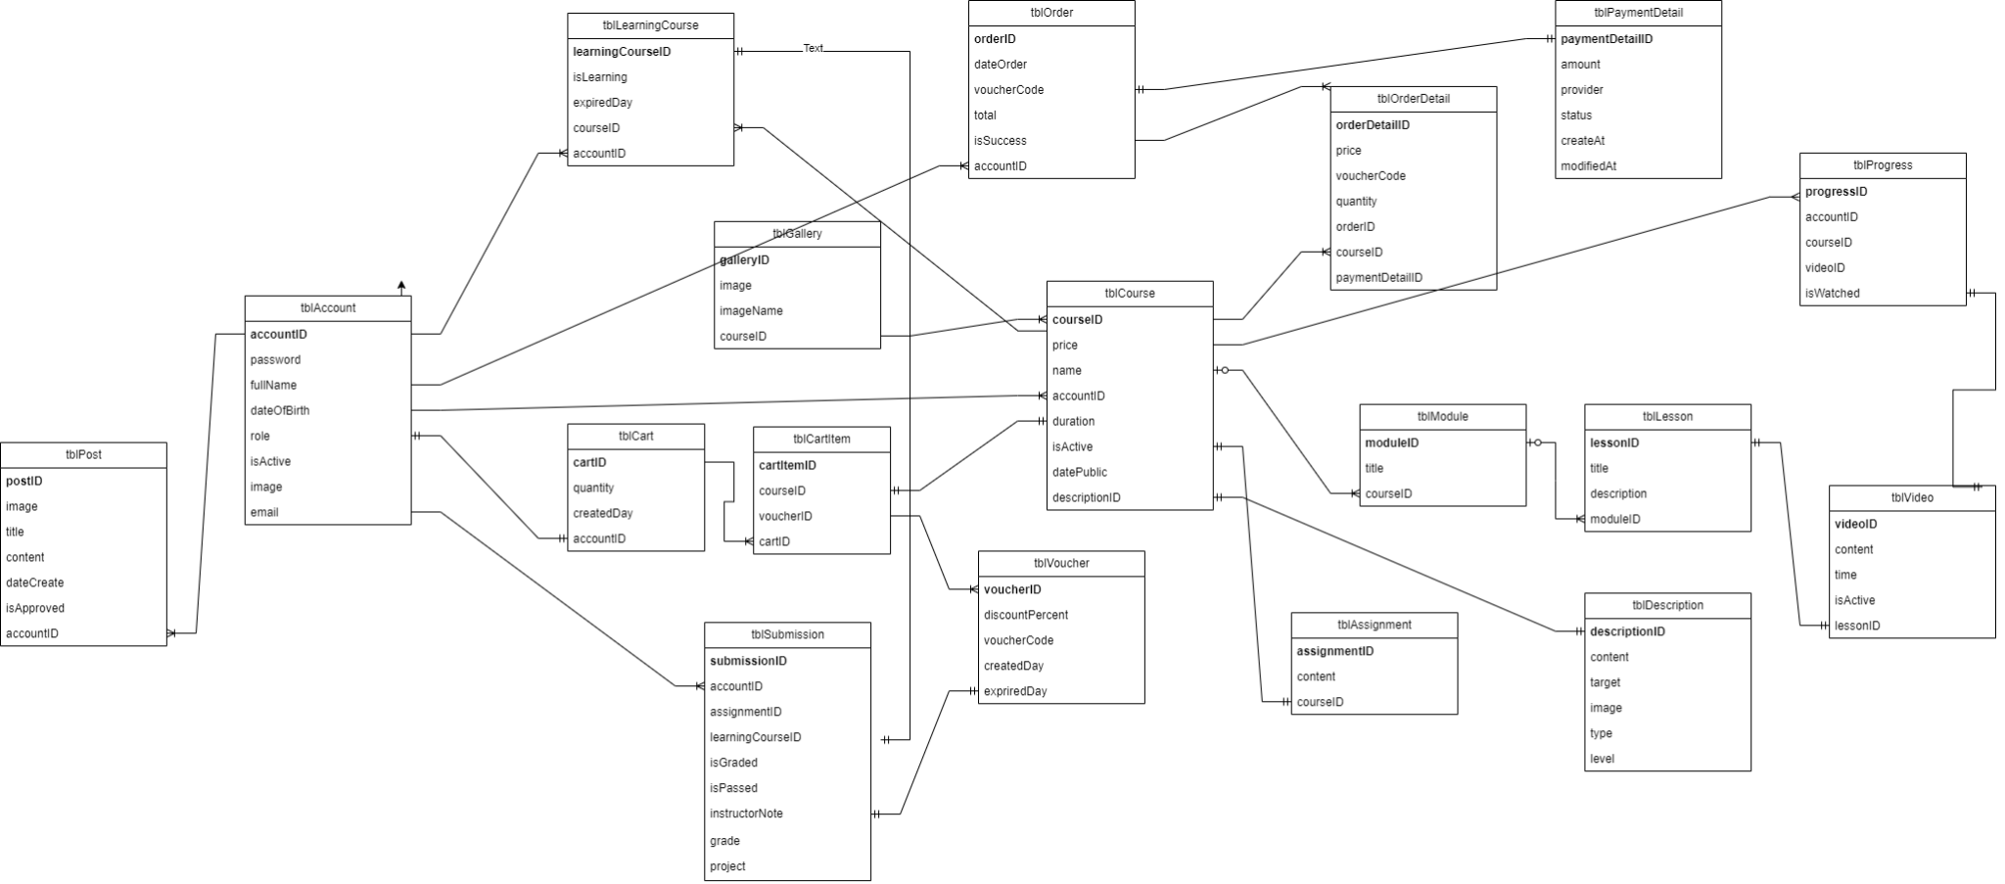

## 4.2/ Database Diagram

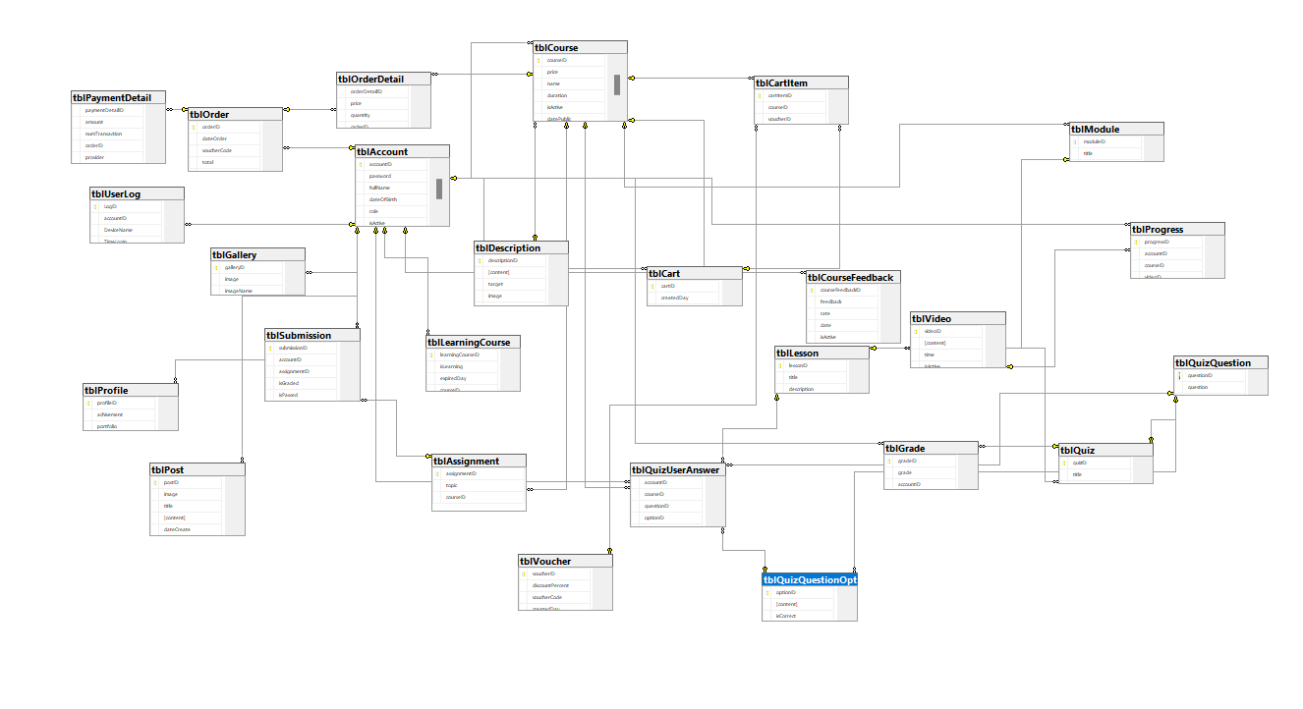

# **5. WIREFRAME**

## 5.1/ Login Page

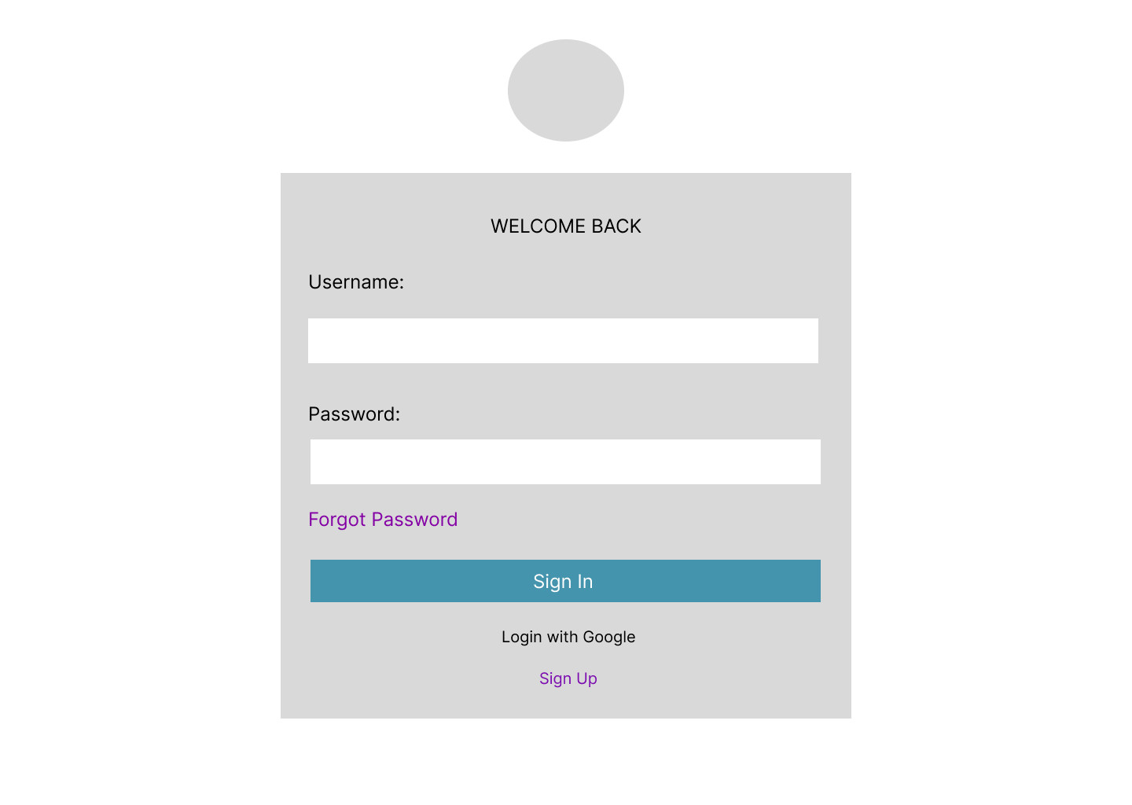

## 

## 5.2/ Register Page

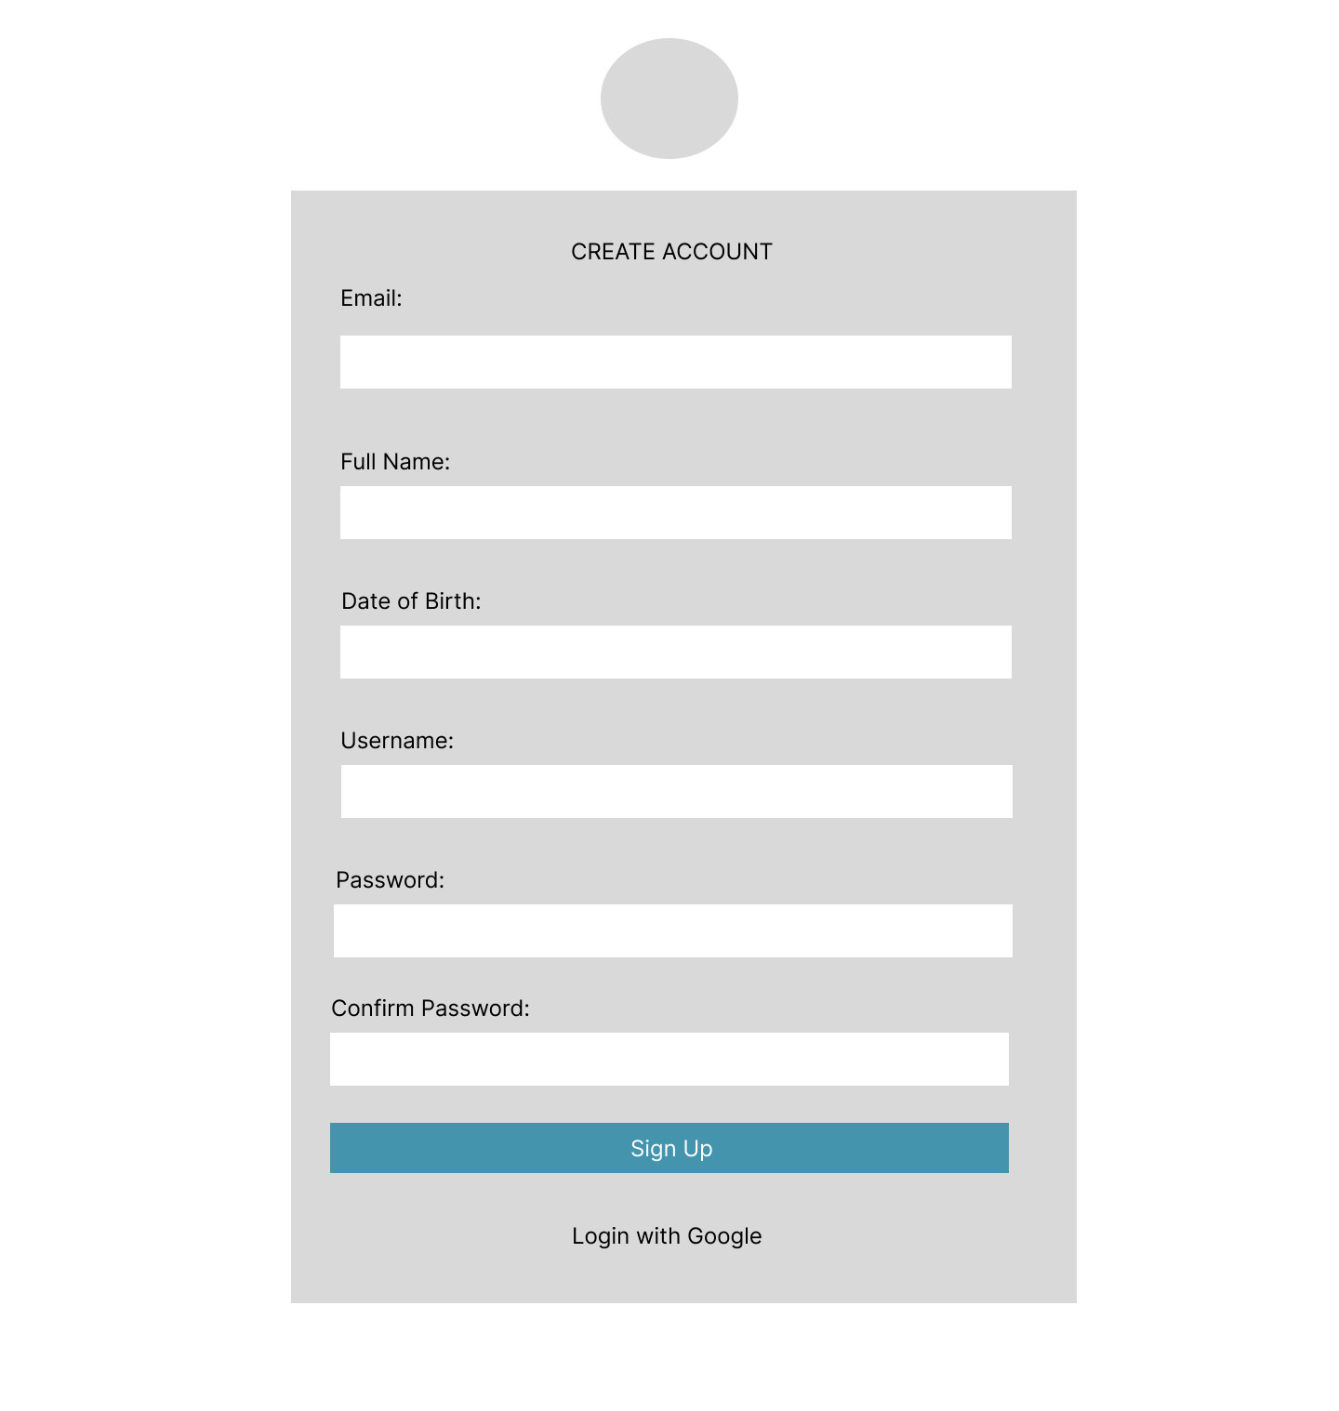

## 5.3/ Home Page

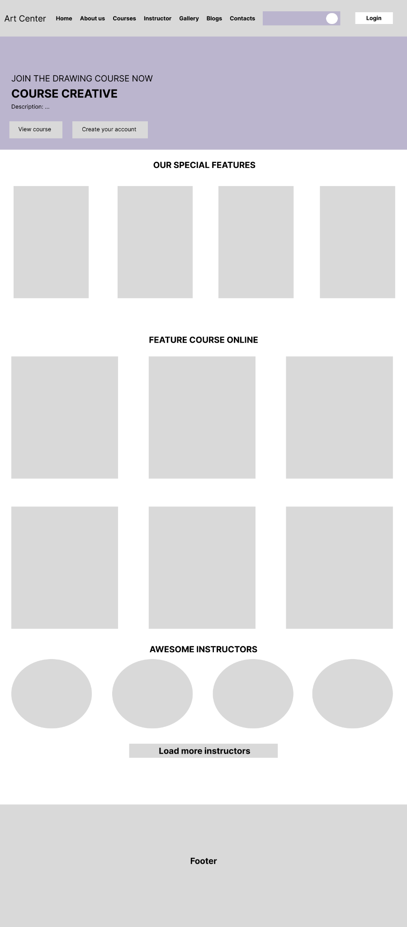

## 5.4/ Shopping Cart

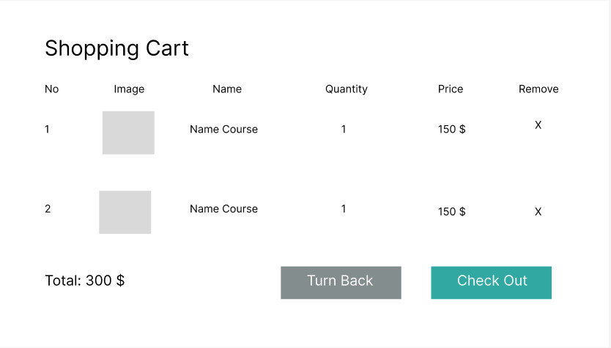

## 5.5/ Course Detail

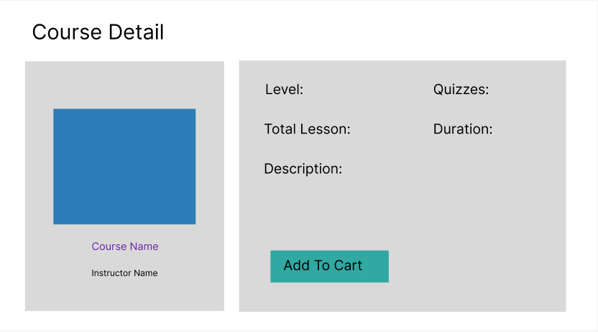

## 5.6/ Learning Course Page

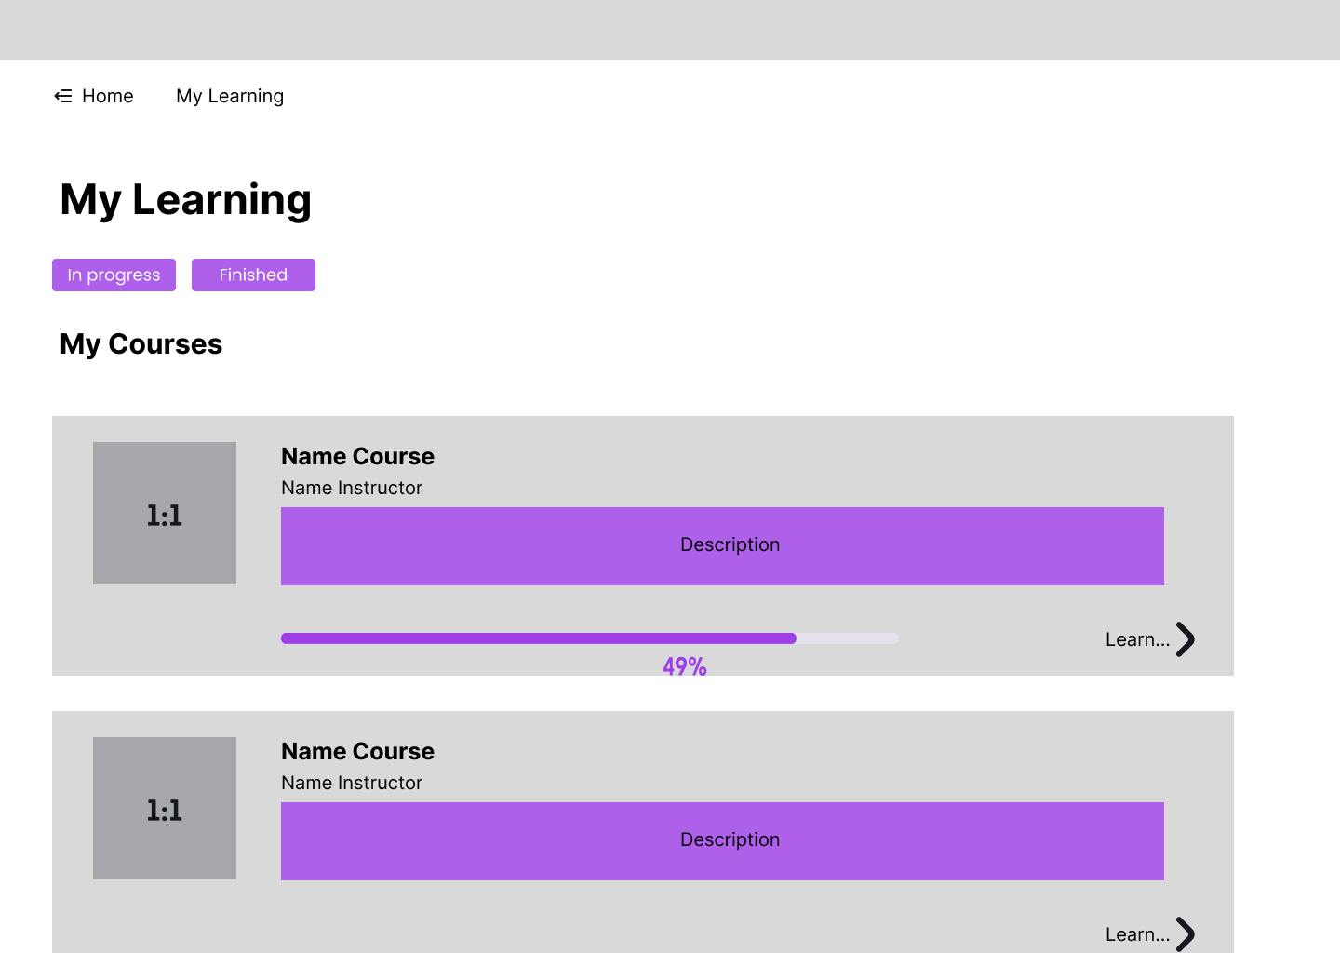

## 5.7/ Learning Page

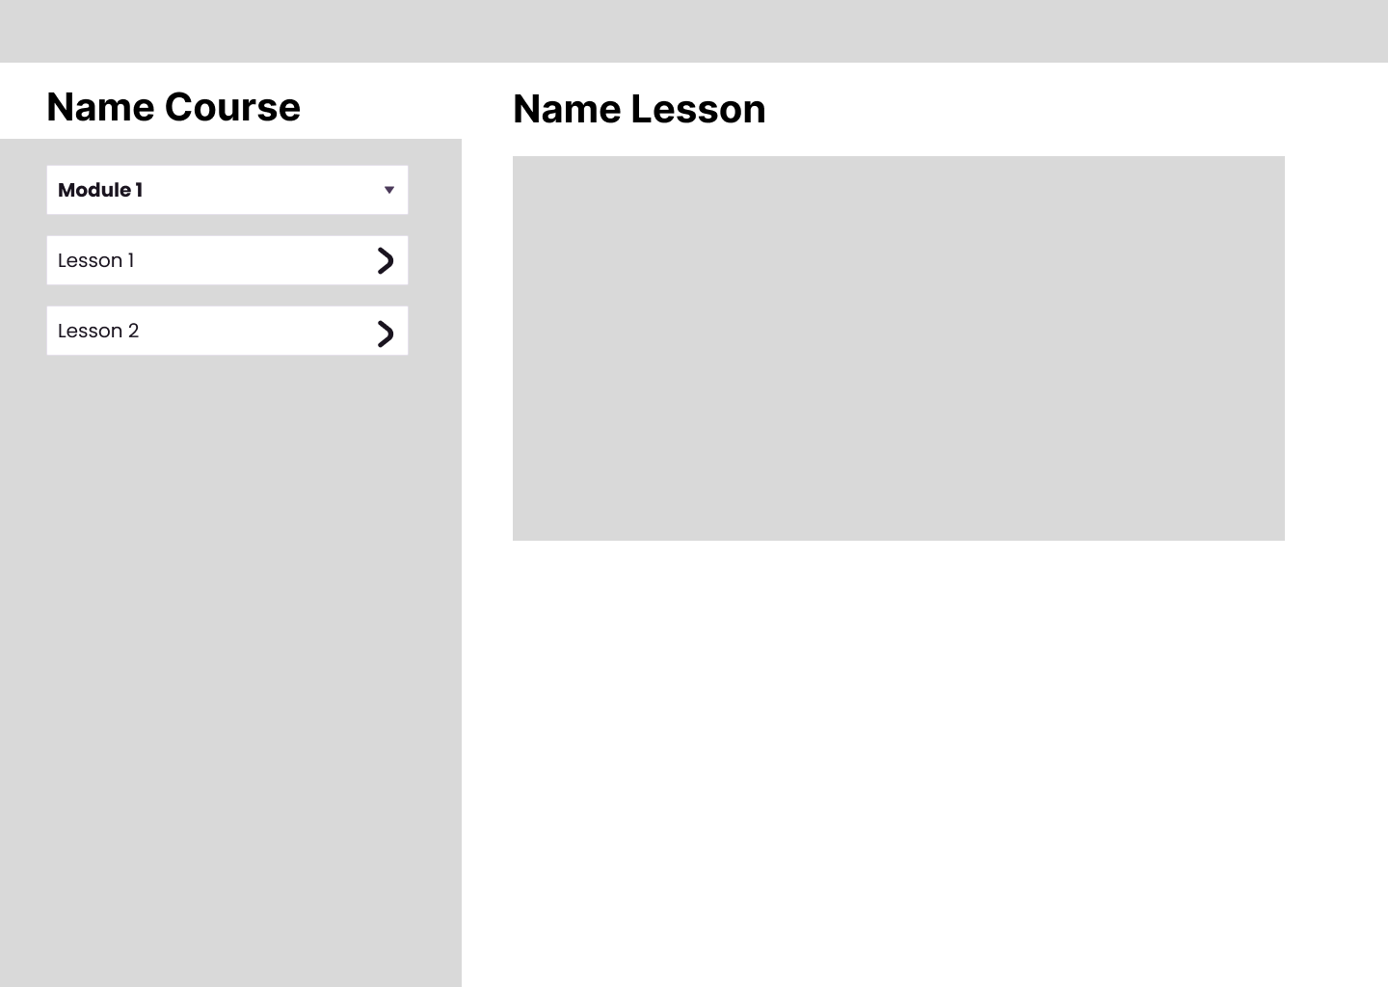

## 5.8/ Submit Assignment Page

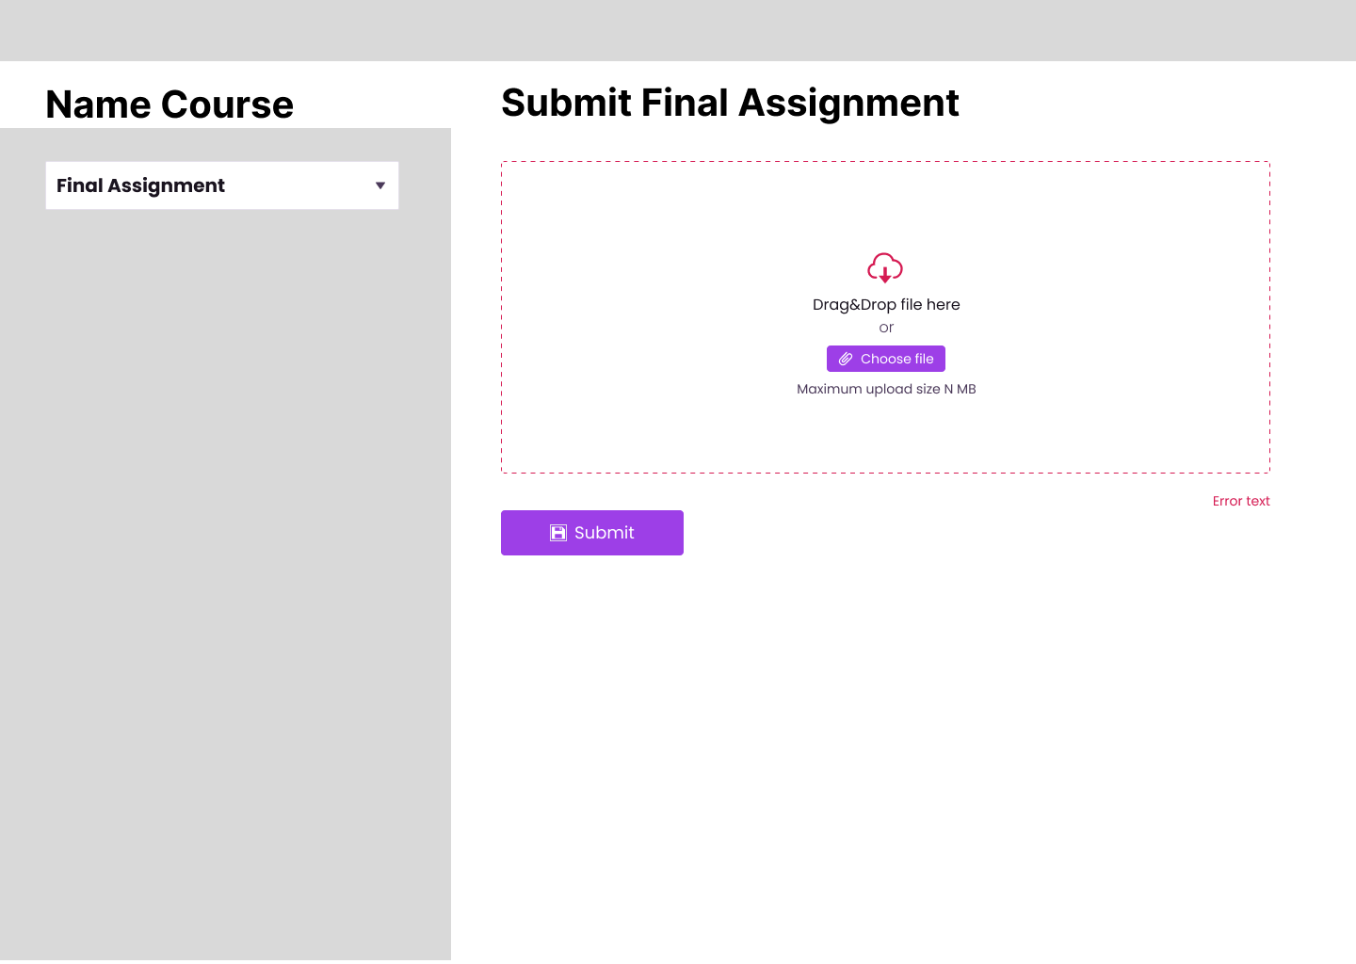

## 5.9/ Certificate



## 5.10/ Staff/ Admin Management Page

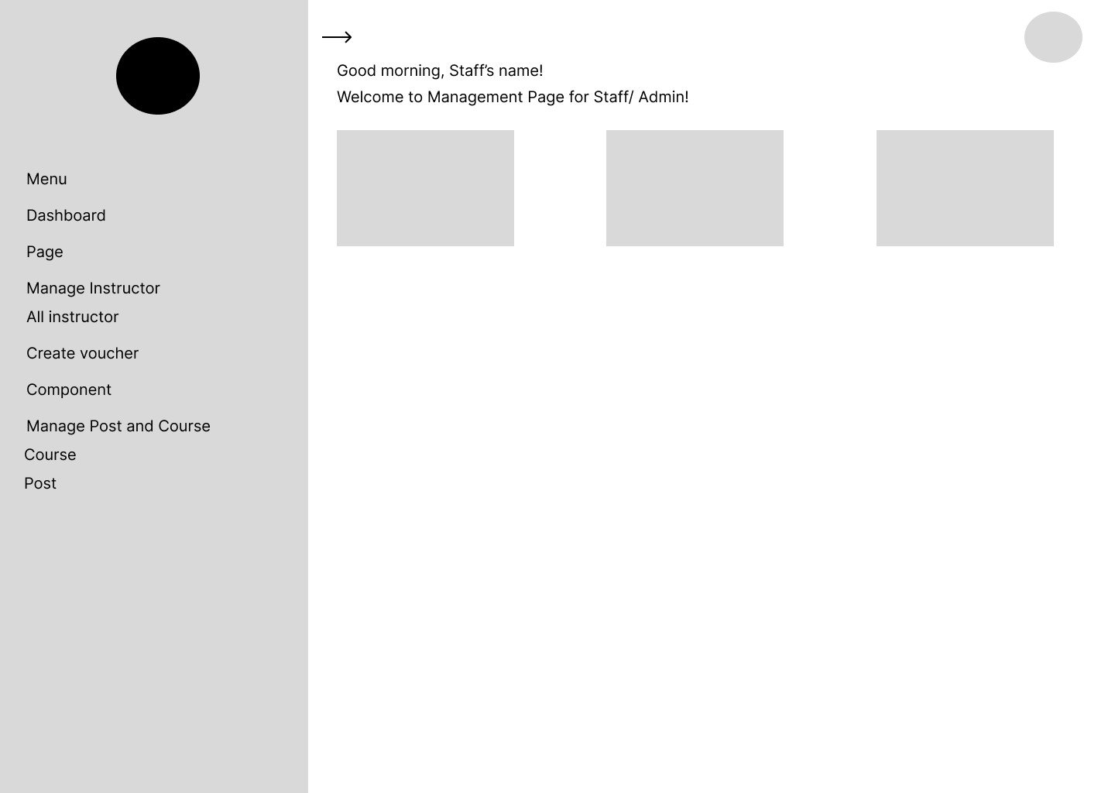

# 6. Activity Diagram

## 6.1 Sign up

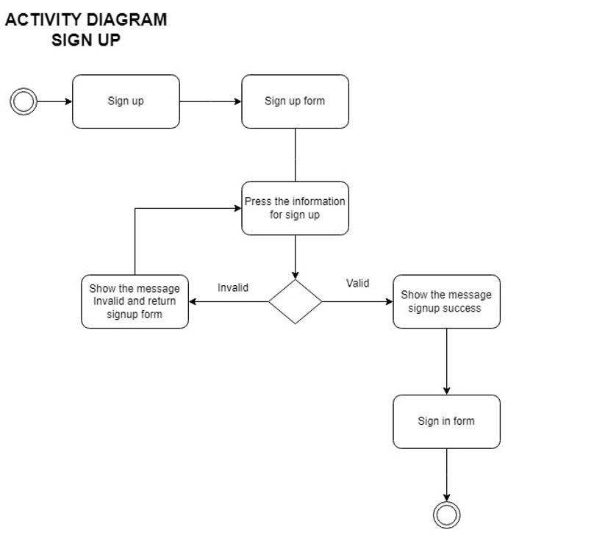

## 6.2/ Sign in

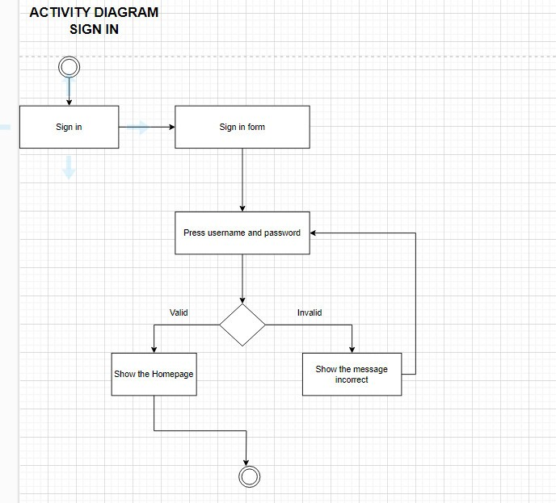

## 6.3/ Add to cart

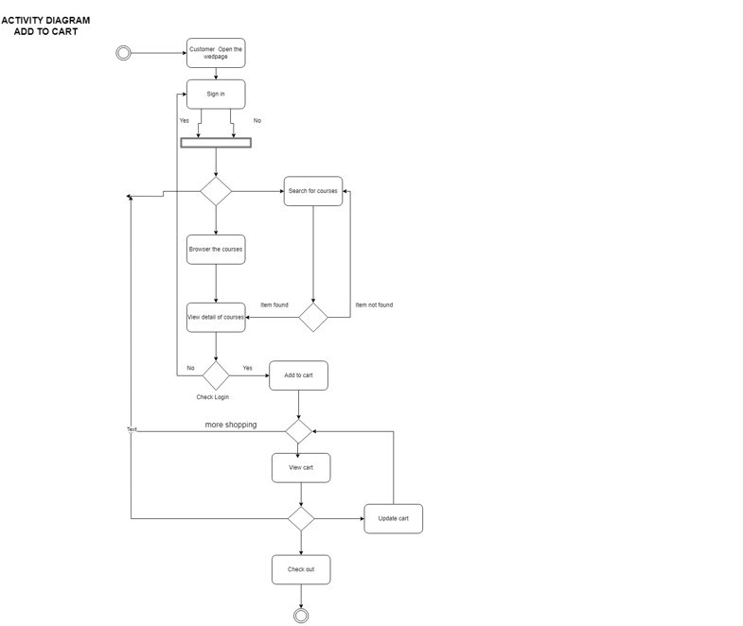

## 6.4/ Check out

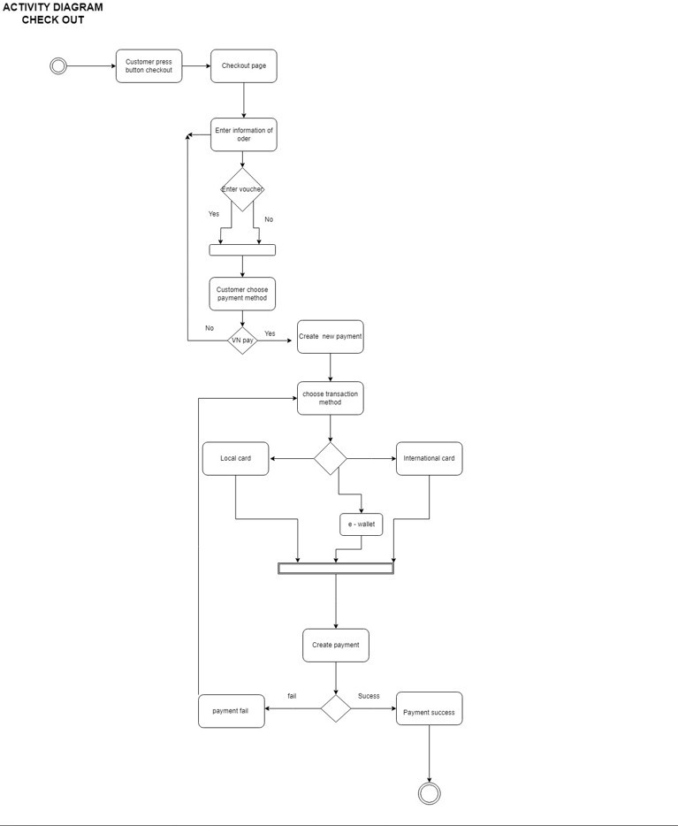

## 6.5/ Add Staff

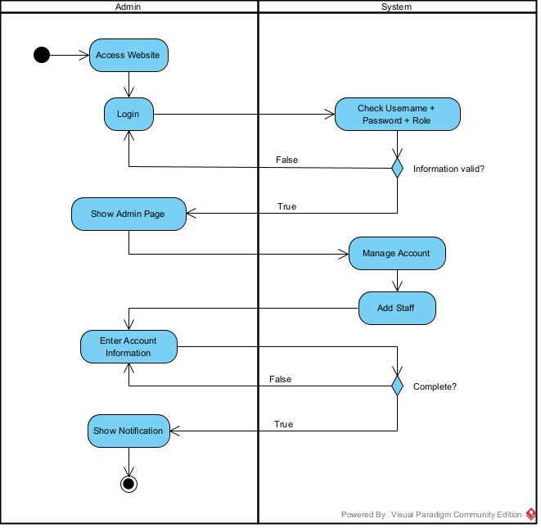

## 6.6/ Buy Course

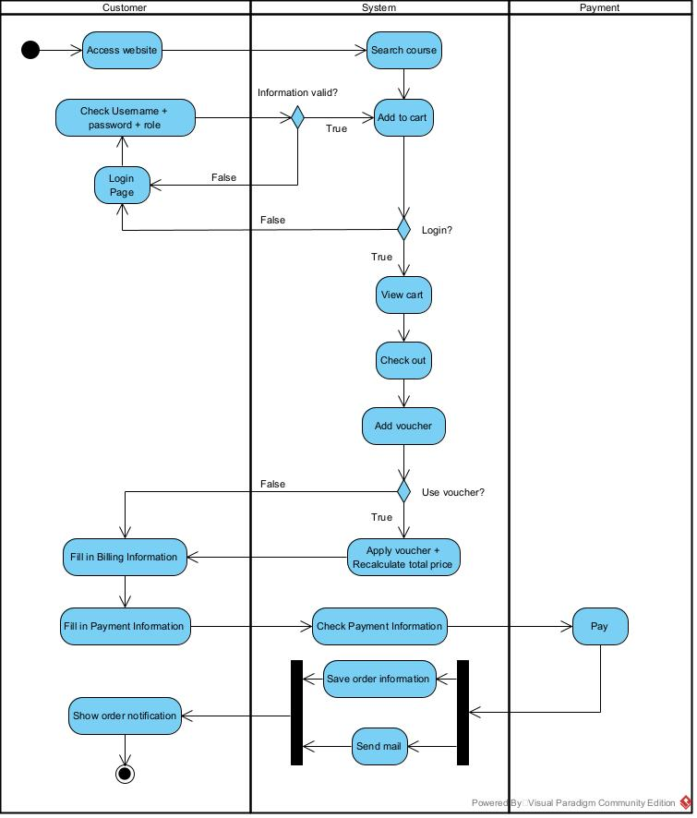

Delete Staff

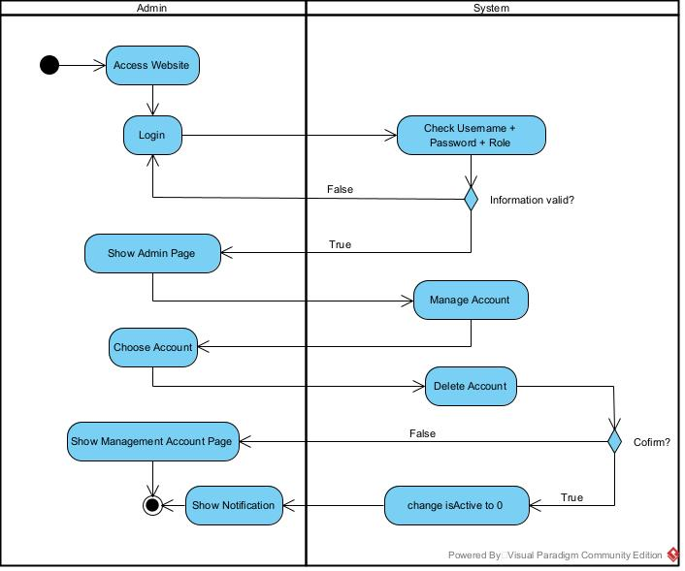

## 6.7/ Edit Course

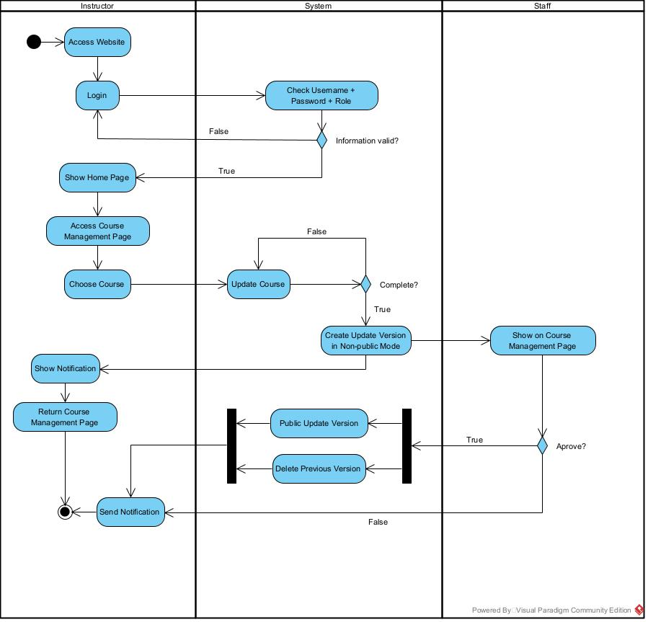

## 6.8/ Learn Course

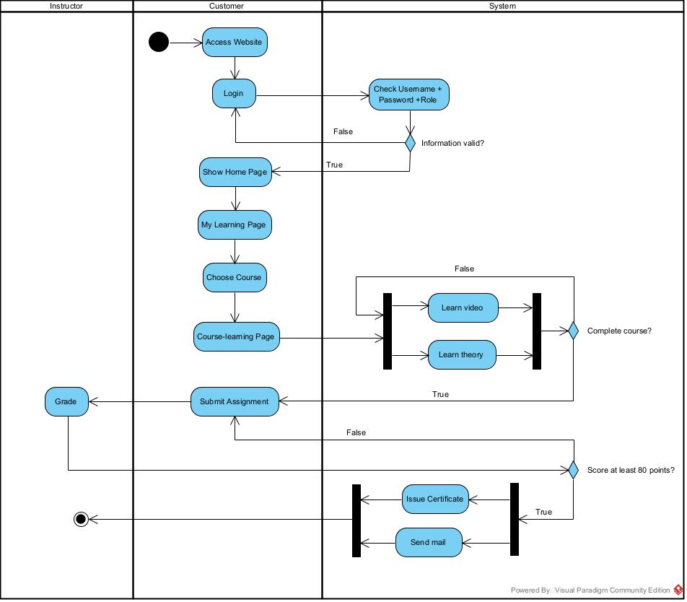

# 7. NON-FUNCTIONAL REQUIREMENT

## 7.1/ Reliability

* Staff and admin need at least 2 weeks training to use this web application. Otherwise, they are required to have neccessary knowledge about drawing course, voucher,...

# 