Stroke Analysis Report

Christine Do, Alyssa Guillory, Johnny Le, Giselle Ruiz, Christopher Turcios, Jimmy Vuong

2022-11-21

# Introduction

Response Variable:

* stroke:

Possible Predictors:

* smoking_status: The smoking status of the observation. Factor variable with 3 levels: “formerly smoked”, “never smoked”, and “smokes”.

## Cleaning the data

To use this data set, we first converted variables to their correct representations and then omitted any incomplete observations.

### Notable fixes:

* The categorical variable smoking_status was reformatted to remove the level “Unknown”, as it was used to represent unavailable data. Any cells that previously had “Unknown” were updated to reflect their unavailable status.
* The quantitative variable bmi was fixed by converting the data type from character to numeric. This change does not apply to non-numeric cells, so the cells containing “N/A” were changed to reflect their unavailable status in the now numeric column.

—**still need to list the rest of the variables, short description of data, and the question we want to answer**

# Logistic Regression Model

We chose to use a logistic regression model for our data because our response variable is qualitative with two classes. It was desirable to have a model predict the probability of a person having a stroke using binary classification. If linear regression had been used to predict the probability of whether or not a person will have a stroke instead, then the model may have predicted Y values outside of our intended range of 0-1. The logistic regression model allows us to enforce this restriction of range.

## Model Formula

Our basic logistic regression formula with all our predictors would be as follows:



$$\tiny P(stroke = 1) = \frac{exp(b_0+b_1*gender+b_2*age+b_3*hypertension+b_4*heart\_disease+b_5*ever\_married+b_6*work\_type+b_7*Residence\_type+b_8*avg\_glucose\_level+b_9*bmi+b_10*smoking\_status)}{1+exp(b_0+b_1*gender+b_2*age+b_3*hypertension+b_4*heart\_disease+b_5*ever\_married+b_6*work\_type+b_7*Residence\_type+b_8*avg\_glucose\_level+b_9*bmi+b_10*smoking\_status)}$$

This is what our logistic regression formula would look like if we considered all of our variables as predictors with the response variable being stroke. However, we automatically did not consider the unique identifier (id) as this variable is only used to identify patients, which does not have any influence on predicting the probability of strokes. Using the glm() function, we created our initial logistic model with stroke being the response and all the other variables as predictors (except id).

##   
## Call:  
## glm(formula = stroke ~ ., family = "binomial", data = health)  
##   
## Deviance Residuals:   
## Min 1Q Median 3Q Max   
## -1.2163 -0.3357 -0.1914 -0.1051 3.1357   
##   
## Coefficients:  
## Estimate Std. Error z value Pr(>|z|)   
## (Intercept) -1.911e+01 4.775e+02 -0.040 0.968076   
## genderFemale 7.625e-02 1.681e-01 0.454 0.650091   
## genderOther -1.234e+01 3.956e+03 -0.003 0.997511   
## age 7.304e-02 6.958e-03 10.497 < 2e-16 ***  
## hypertension1 5.694e-01 1.828e-01 3.114 0.001845 **   
## heart_disease1 3.906e-01 2.211e-01 1.767 0.077249 .   
## ever_marriedYes -1.795e-01 2.627e-01 -0.683 0.494366   
## work_typeGovt_job 1.092e+01 4.775e+02 0.023 0.981747   
## work_typeNever_worked -2.958e-01 1.157e+03 0.000 0.999796   
## work_typePrivate 1.117e+01 4.775e+02 0.023 0.981339   
## work_typeSelf-employed 1.081e+01 4.775e+02 0.023 0.981936   
## Residence_typeUrban -4.830e-03 1.624e-01 -0.030 0.976276   
## avg_glucose_level 4.696e-03 1.377e-03 3.409 0.000651 ***  
## bmi 6.501e-03 1.292e-02 0.503 0.614789   
## smoking_statusnever smoked -7.476e-02 1.894e-01 -0.395 0.692999   
## smoking_statussmokes 3.151e-01 2.305e-01 1.367 0.171639   
## ---  
## Signif. codes: 0 '***' 0.001 '**' 0.01 '*' 0.05 '.' 0.1 ' ' 1  
##   
## (Dispersion parameter for binomial family taken to be 1)  
##   
## Null deviance: 1411.0 on 3425 degrees of freedom  
## Residual deviance: 1141.8 on 3410 degrees of freedom  
## AIC: 1173.8  
##   
## Number of Fisher Scoring iterations: 16

As the summary shows, the predictors age, hypertension, and avg_glucose_level show high levels of significance, and the predictor heart_disease shows a moderate level of significance. Since our p-values for all four of these predictors are less than =0.1, we believe that these are the most important variables in predicting the probability of having a stoke; To confirm that these variables are significant, we used the backwards step() function to see if it would give us the same significant variables, and it did.

#Model created from backwards step()  
summary(health2.glm)

##   
## Call:  
## glm(formula = stroke ~ age + hypertension + heart_disease + avg_glucose_level,   
## family = "binomial", data = health)  
##   
## Deviance Residuals:   
## Min 1Q Median 3Q Max   
## -1.1420 -0.3357 -0.1927 -0.1072 3.1976   
##   
## Coefficients:  
## Estimate Std. Error z value Pr(>|z|)   
## (Intercept) -7.632810 0.439480 -17.368 < 2e-16 ***  
## age 0.067773 0.006359 10.659 < 2e-16 ***  
## hypertension1 0.568379 0.181386 3.134 0.001727 **   
## heart_disease1 0.453704 0.216660 2.094 0.036253 *   
## avg_glucose_level 0.004701 0.001334 3.524 0.000426 ***  
## ---  
## Signif. codes: 0 '***' 0.001 '**' 0.01 '*' 0.05 '.' 0.1 ' ' 1  
##   
## (Dispersion parameter for binomial family taken to be 1)  
##   
## Null deviance: 1411.0 on 3425 degrees of freedom  
## Residual deviance: 1149.9 on 3421 degrees of freedom  
## AIC: 1159.9  
##   
## Number of Fisher Scoring iterations: 7

#Model created without heart_disease  
summary(health3.glm)

##   
## Call:  
## glm(formula = stroke ~ age + hypertension + avg_glucose_level,   
## family = "binomial", data = health)  
##   
## Deviance Residuals:   
## Min 1Q Median 3Q Max   
## -1.0523 -0.3398 -0.1939 -0.1058 3.2054   
##   
## Coefficients:  
## Estimate Std. Error z value Pr(>|z|)   
## (Intercept) -7.750124 0.437181 -17.728 < 2e-16 ***  
## age 0.070099 0.006262 11.194 < 2e-16 ***  
## hypertension1 0.579247 0.180838 3.203 0.001359 **   
## avg_glucose_level 0.004932 0.001326 3.720 0.000199 ***  
## ---  
## Signif. codes: 0 '***' 0.001 '**' 0.01 '*' 0.05 '.' 0.1 ' ' 1  
##   
## (Dispersion parameter for binomial family taken to be 1)  
##   
## Null deviance: 1411.0 on 3425 degrees of freedom  
## Residual deviance: 1154.1 on 3422 degrees of freedom  
## AIC: 1162.1  
##   
## Number of Fisher Scoring iterations: 7

By removing the predictors that had little to no significance in predicting the response variable, we are able to refit our data into a second model (health2.glm) with the four predictors that are significant. The original model with all predictors had an AIC of 1173.8, while the second model with the four significant predictors had an AIC of 1159.9. As there was not much of a difference between the first and second model, we decided to remove the lowest significant predictor (heart_disease) out of the four to perform one last model refitting on our data. This time, our AIC for the third model (health3.glm) came out to be 1162.1, which was a slight increase compared to the second model.

Additional information was obtained by using the Goodness of Fit statistical hypothesis test. Given the three models we tested above, we are able to determine each models’ null deviance, residual deviance, R^2 value, AIC value, and BIC value. The lower the residual deviance, AIC, and BIC values, the better the model is able to predict the value of the response variable. As for R^2, a value closest to 1 is best.

## Null Deviance Residual Deviance R^2 AIC BIC  
## health.glm 1411.002 1141.806 0.1907835 1173.806 1272.032  
## health2.glm 1411.002 1149.914 0.1850374 1159.914 1190.609  
## health3.glm 1411.002 1154.069 0.1820928 1162.069 1186.625

Between all three models, health2.glm and health3.glm provided the closest fit for our data, with health2.glm having a slight advantage in lower residual deviance and AIC values. The test results show that each model’s R^2 value is extremely low, with values being between 0.1 and 0.2, indicating that these models are not a good fit for our data. This means that using the logistic regression model to fit our data may not result in the best fitting model in general. Even so, we can conclude that the model health2.glm (predictors: age, hypertension, heart_disease, and avg_glucose_level) had the best fit and is somewhat accurate in predicting whether or not a stroke will occur, in comparison to the other two models.

#Mean of the train error rate  
(train.error.mean = mean(train.error))

## [1] 0.05275447

#Mean of the test error  
(test.error.mean = mean(test.error))

## [1] 0.05080292

#Test Sensitivity  
test.sensitivity

## [1] 0.00000000 0.00000000 0.03225806 0.00000000 0.00000000 0.00000000  
## [7] 0.00000000 0.00000000 0.00000000 0.00000000

(test.sensitivity.mean = mean(test.sensitivity))

## [1] 0.003225806

#Test Specificity  
(test.specificity.mean = mean(test.specificity))

## [1] 1

# Decision Tree Model

## Base Decision Tree

## Test Error: 0.05107998

## Test Sensitivity: 0.001204819

## Test Specificity: 0.9999387

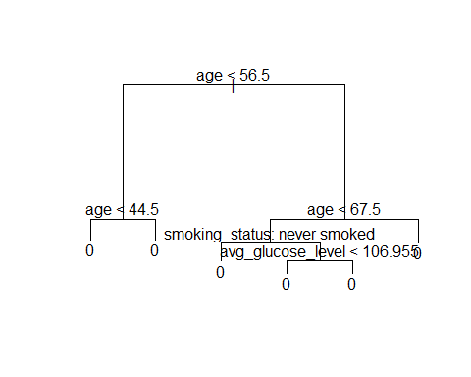

## Pruned Decision Tree

## Test Error: 0.05107998

## Test Sensitivity: 0

## Test Specificity: 1

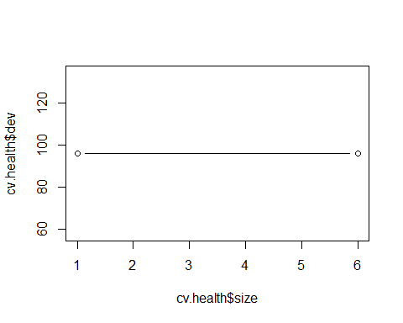

## Bagged Decision Tree

## Test Error: 0.05452423

## Test Sensitivity: 0.02140718

## Test Specificity: 0.9952017

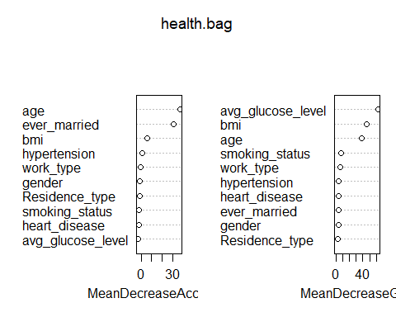

## Random Forest

## Test Error: 0.05207239

## Test Sensitivity: 0.007972732

## Test Specificity: 0.9985244

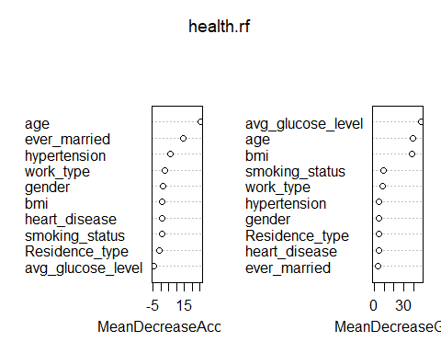

# Conclusion