High Level Design
CleanCAD - AI-based Mold/Part Defeaturing
Project Name | Mold-Part Defeaturing (with HP Printing Korea)
Team Name | CleanCAD
Team Members | Junoh Lee (Team Lead), Hemanth Reddy Vangala, Aneela Tahir, Balcha Kidus Elias
Document Version | 2.0
Date of Revision | 2026-10-08
Status | Draft for team review (reviewer: Hemanth Reddy Vangala); aligned with FR_SA_DE_CleanCAD_Fall26_v1_3.docx and the prototype in src/

Change Record
Revision | Date | Author | Changes
1.0 | 2026-09-11 | Junoh Lee | Initial Version
1.1 | 2026-09-17 | Junoh Lee | Removed premature pythonocc-core naming
1.2 | 2026-09-18 | Junoh Lee | Toolchain confirmed as FreeCAD Python API; added deployment constraint (CPU inference), success criteria, staged Decision Logic, and failure-case retraining loop
1.3 | 2026-09-29 | Junoh Lee | Added a note that the core mechanism (M1, M5, and the face-adjacency traversal M2 will build on) is already prototyped and verified in src/cleancad_core.py (9/9 example shapes). No architectural changes.
1.4 | 2026-10-02 | Junoh Lee | Noted HP mentor feedback as open, unverified candidates: explicit Stage 1 dimension thresholds and a supervisory decision layer for rule/ML conflicts (M4), logo feature category (M3), separate tracking of removal-execution failures (M5). No architectural change decided.
1.5 | 2026-10-02 | Junoh Lee | Per professor request: added FR/NFR requirement numbers for readability - new "Related Requirements" column in the module table, requirement IDs on the design constraints, and a requirements traceability matrix (Section 7). No architectural changes.
1.6 | 2026-10-08 | Junoh Lee | Per professor's review: team name corrected to CleanCAD; NFR-USE-02 shown as Must in the module table and the traceability matrix.
2.0 | 2026-10-08 | Junoh Lee | Rewritten on the course HLD template and the nine-module system architecture; added the interaction design (use cases and sequence diagrams) and the integration-test considerations; aligned with the prototype code and the HP mentor's reply of 2026-10-08. Replaces the M1-M8 draft (v1.0-v1.6).
2.0 | 2026-10-08 | Hemanth Reddy Vangala | Input incorporated into this version: the nine-module system architecture (SA v1.1, 2026-10-05) used in 3.2 and Figure 1; engineer review after the output, outside the system (2.1, 3.3.3); the open-source pretrained model instead of training from scratch (2.2, 3.3.2); no database, files stored on the engineer's PC (3.4); the NFR-PERF-02 wording "less time than an engineer working manually" (3.12). Review of this draft pending.

Contents
1. Introduction
2. General Description
3. Design Details (3.1 Main Design Features ... 3.20 Major Classes and Modules)
4. Interaction Design (use cases and sequence diagrams)
5. Integration Test Considerations
Appendix A. Requirements Traceability

1. Introduction

1.1 Why This High Level Design Document?
This High Level Design (HLD) adds the detail needed to turn the project description and the requirements into a model that can be coded. It also helps the team find contradictions before coding, and it serves as a reference for how the modules interact. Version 2.0 replaces the earlier M1-M8 draft and follows the nine-module system architecture and the working prototype in the repository (src/).

1.2 Scope
This document covers the architecture and its nine modules, the interfaces between them, how files are stored (there is no database), the user interface and reports, error handling, how the non-functional requirements are realized, the interaction design (use cases and sequence diagrams) and integration-test considerations.
It does not cover per-module detailed design: graph schemas, the internals of the pretrained model, the exact rule implementation and metadata schemas belong to the Low-Level Design (LLD).
FR/NFR References: FR-IO-01..04, NFR-MAINT-01

1.3 Definitions
Term | Definition
CleanCAD | The system that removes unnecessary small features from mold/part CAD models for CAE analysis.
STEP | Standard neutral file format for 3D CAD models (.step / .stp), ISO 10303.
B-rep | Boundary representation: a solid described by its faces, edges and vertices.
Feature | A recognizable shape detail: hole, fillet, chamfer, rib, boss, emboss or logo.
Defeaturing | Removing features that barely affect CAE results but increase mesh size and solve time.
Geometry healing | Repairing the geometry after a removal so the result is a valid, watertight solid.
Face map | The mapping between B-rep faces, graph nodes, model predictions and CAD face references; it keeps the same face identity through the whole pipeline.
Feature group | The connected faces that form one physical feature (for example the faces of one rib). A feature is removed as a whole.
Silent failure | A removal that FreeCAD does not report as an error but that changed nothing; detected by comparing face count and volume.
Pretrained model | A feature-recognition model trained beforehand by others and reused here.
Ground truth | The known correct answer recorded when a test shape is generated (which faces belong to each added feature).
Headless | Running without a graphical window, as automated batch code.
C1-C9 | The nine architecture modules (see 3.2).
Nominal / off-nominal | The normal flow of a scenario / a flow in which something goes wrong.

1.4 Overview
Chapter 2 describes the product, tools, constraints and assumptions. Chapter 3 gives the design details following the course HLD template. Chapter 4 describes the interaction between engineer and modules as use cases and sequence diagrams. Chapter 5 describes how the modules are tested together. Appendix A maps every requirement to the modules.

2. General Description

2.1 Product Perspective
CleanCAD is a self-contained batch tool for CAE engineers. The engineer provides a mold or part model as a STEP file; CleanCAD recognizes small features, decides which are candidates for removal with explainable rules, removes them, heals the geometry and returns a simplified STEP file together with a before/after visualization and a record of what was removed. The original file is never modified.
The system runs on the engineer's laptop without a GPU. After the output, the HP engineer reviews the result and corrects mistakes manually outside the system; a tool for correcting the face selection and saving labels is a candidate (FR-VAL-08).
CleanCAD uses two external elements: FreeCAD (CAD kernel and 3D view) and an open-source pretrained feature-recognition model. Figure 1 in section 3.2 shows the module view.
FR/NFR References: FR-IO-01..04, FR-FEAT-05, FR-VAL-01, FR-VAL-02, NFR-PERF-03, NFR-PORT-01

2.2 Tools and Technologies Used
Category | Technology | Details / status
CAD kernel and API | FreeCAD 1.1.3, Python API, headless | Confirmed by the HP mentor (2026-09-18). STEP read/export, face removal (Shape.defeaturing), validity checks.
Feature recognition | Open-source pretrained model | Specific model still to be selected (candidates: AAGNet, UV-Net, BRepNet, BrepMFR). Acceptable for initial testing per the HP mentor (2026-10-08); no pretrained model for plastic-part features is known.
Decision logic | Rule-based (Python) | Initial thresholds from the HP mentor: hole diameter 3 mm, fillet radius 5 mm, chamfer size 5 mm. ML-based removal decisions are a later stage.
Mesh evaluation | Gmsh | Planned for FR-VAL-03 (element count, generation time); not used in the prototype yet.
Visualization | FreeCAD 3D view (PySide overlays) | Used by the live demo (src/demo_freecad.py): red/orange highlights, before/after result screen.
Language and runtime | Python 3.11 | Code runs inside FreeCAD's embedded interpreter; documents tooling uses the system Python.
Test data | Self-authored shapes, public datasets | gen_examples.py builds 9 shapes with expected results; public datasets (MFCAD family); the MFCAD-VLM set suggested by the mentor has feature counts but no face-level labels.
Version control | Git / GitHub | Shared public repository; personal branches and pull requests by convention.

FR/NFR References: FR-IO-02, FR-FEAT-03, FR-FEAT-06, FR-FEAT-07, FR-VAL-03, FR-DATA-01..05, NFR-PORT-03, NFR-MAINT-02

2.3 General Constraints
- STEP is the only supported CAD format; NX is out of scope (FR-IO-04).
- The core pipeline runs headless as batch code with FreeCAD's Python API (NFR-PORT-03).
- Inference must run on an office laptop without a GPU; a GPU server may be used for training only (NFR-PERF-03).
- No confidential HP CAD data is stored or transmitted; training and test data are public datasets or our own shapes (NFR-SEC-01, NFR-SEC-02, FR-DATA-02).
- Generated files are kept outside the Git repository in one workspace folder (NFR-SEC-01).
- Defeaturing accuracy is the success criterion; downstream CAE analysis accuracy is not measured (FR-VAL-05, NFR-ACC-02).
FR/NFR References: FR-IO-04, FR-VAL-05, NFR-PERF-03, NFR-PORT-03, NFR-SEC-01, NFR-SEC-02, NFR-ACC-02

2.4 Assumptions
- FreeCAD's face removal followed by healing can remove the feature types HP named; the prototype verified this on nine generated shapes (9/9).
- An open-source pretrained model can recognize at least part of our feature types; its labels may not include ribs, bosses, embossing or logos, so rule-based geometry checks may be needed (the HP mentor asked us to evaluate this).
- The HP mentor's thresholds (3 mm, 5 mm, 5 mm) are valid starting values and can be adjusted case by case.
- The HP engineer reviews the result after the output and corrects mistakes manually.
- Test shapes follow HP's guidance: about 2-3 mm thick and 100-200 mm wide, with a curved cut-out, ribs, or features near an edge (FR-DATA-03).
FR/NFR References: FR-FEAT-01, FR-FEAT-05, FR-FEAT-07, FR-DATA-03

2.5 Special Design Aspects
- Face map: every face keeps one identity from the B-rep through the graph, the recognition result, the removal decision and the CAD kernel (face-signature matching in the prototype).
- Features are removed as groups: the connected faces of one feature are passed to the CAD kernel together; removing a single face usually fails or removes only a sliver.
- Silent-failure detection: FreeCAD does not raise an error when a face cannot be removed, so every removal is judged by comparing face count and volume before and after.
- Staged decision logic: rules decide removal in the prototype; ML-based removal decisions can be added later without changing the other modules.
- Test data with ground truth: shapes are generated by code and the faces of each added feature are recorded, so predictions can be checked automatically.
FR/NFR References: FR-FEAT-02, FR-FEAT-06, FR-DEF-01, FR-DEF-02, FR-DEF-04, FR-DATA-05

3. Design Details

3.1 Main Design Features
# | Feature | Implementation reference | Status
1 | STEP input and output through FreeCAD (headless) | Part.read / Shape.exportStep in src/cleancad_core.py, run_headless.py | Prototype
2 | Group selected faces into physical features by face adjacency | groups() in cleancad_core.py | Prototype
3 | Remove a feature and heal the geometry | remove_group() (Shape.defeaturing) in cleancad_core.py | Prototype
4 | Silent-failure detection (face count and volume before/after, validity check) | remove_group() and process() | Prototype
5 | End-to-end removal loop that keeps failures | process() in cleancad_core.py; failure records in run_headless.py and demo_freecad.py | Prototype
6 | Pluggable removal rules | @rule registry (cyl, prot, recess, chamfer, fail_demo) in cleancad_core.py; test scaffolding, the real thresholds are to be implemented | Scaffolding
7 | Highlighted-face STEP export (red) | ImportGui.export in demo_freecad.py (GUI mode only) | Prototype
8 | Before/after result screen with failure display | demo_freecad.py (orange failed face, banner, side-by-side result) | Prototype
9 | Test shapes with expected results | gen_examples.py, manifest.json; checked by run_headless.py (9/9 pass) | Prototype
10 | Feature recognition with a pretrained model | C4 (model to be selected) | Planned
11 | Face-selection review and label tool | C8 extension (FR-VAL-08) | Candidate
12 | Mesh statistics evaluation with Gmsh | evaluation script (FR-VAL-03) | Planned

FR/NFR References: FR-IO-01..03, FR-FEAT-01..03, FR-DEF-01..05, FR-VAL-03, FR-VAL-06, FR-VAL-08, FR-DATA-03

3.2 Application Architecture
Figure 1 shows the nine modules and the information exchanged between them. The engineer provides the STEP file to the ingestion module and receives the result through the visualization module; the file management module stores all files.
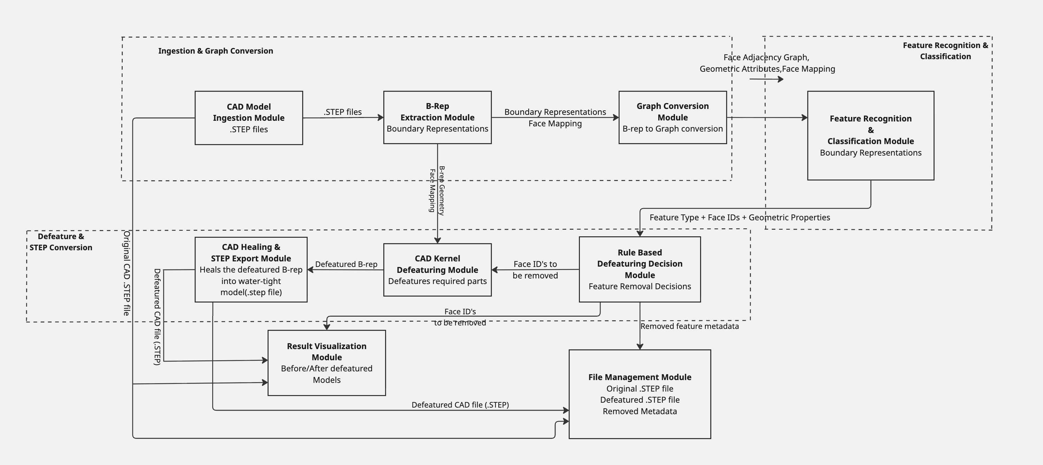
Figure 1. CleanCAD system architecture (module view, by Hemanth Reddy Vangala)

3.2.1 Component Descriptions
ID | Module | Responsibility | Prototype status
C1 | CAD Model Ingestion | Accepts the original STEP file and makes it available to the other modules. | File opened in run_headless.py / demo
C2 | B-Rep Extraction | Reads the STEP into a B-rep and establishes the face map. | Part.read; face identity by face signature
C3 | Graph Conversion | Builds the face-adjacency graph with geometric attributes, keeping the face map. | Adjacency traversal in groups(); graph building planned
C4 | Feature Recognition & Classification | Pretrained model (and rule-based geometry checks) that identifies feature types and their face IDs. | Planned; rules stand in for it
C5 | Rule-Based Defeaturing Decision | Applies removal rules (thresholds) and selects the face IDs/features to remove; produces the removed-feature metadata. | @rule scaffolding in select()
C6 | CAD Kernel Defeaturing | Removes the targeted faces from the B-rep and detects failed removals. | remove_group(), process()
C7 | CAD Healing & STEP Export | Repairs the intermediate B-rep into a valid watertight model and exports the final STEP. | Healing inside defeaturing(); exportStep
C8 | Result Visualization | Shows the original with the selected faces highlighted and the final model as the before/after result. | demo_freecad.py
C9 | File Management | Stores the original STEP, the defeatured STEP and the removed-feature metadata (and failure records). | Workspace folder layout

3.2.2 Core Data Flows
Flow | Path
Defeaturing flow | STEP -> C1 -> C2 (B-rep + face map) -> C3 (graph) -> C4 (features + face IDs) -> C5 (faces to remove) -> C6 (intermediate B-rep) -> C7 (healed STEP) -> C8 (before/after) and C9 (files).
Failure flow | C6 detects an unchanged shape -> original geometry kept -> failure record (geometry, face IDs, reason) to C9 -> failed face shown in orange by C8.
Review and label flow (candidate) | C8 shows the highlighted selection -> engineer corrects the faces -> C9 stores the face-selection labels (for later training) -> optional new removal through C6/C7.

FR/NFR References: FR-IO-02, FR-FEAT-02, FR-FEAT-03, FR-DEF-01..04, FR-VAL-01, FR-VAL-02, FR-VAL-06, FR-VAL-08, NFR-MAINT-01

3.3 Technology Architecture

3.3.1 CAD Processing Layer (C1, C2, C6, C7)
All CAD operations use FreeCAD's Python API run headless. The scripts run in FreeCAD's embedded Python (freecadcmd), not in the system Python, because the CAD modules are not pip packages. Removal calls Shape.defeaturing on one feature group at a time and judges the result by comparing it with the input; STEP is written with exportStep.

3.3.2 Feature Recognition Layer (C3, C4)
Recognition uses an open-source pretrained model on a face-adjacency graph. The HP mentor accepts a pretrained model for initial testing and is unsure how reliably rule-based geometry checks can recognize ribs, bosses, embossing and logos; the team evaluates this approach. The selection of the model and the evaluation result are still open.

3.3.3 Decision Layer (C5)
Removal decisions are rule-based and explainable. A feature is a removal candidate when it is below the configured thresholds (initial values: hole diameter 3 mm, fillet radius 5 mm, chamfer size 5 mm; our reading of the mentor's wording, to be confirmed). Features whose removal could affect the analysis, such as fastener or mounting holes where loads or constraints are applied, are an open question for HP. ML-based removal decisions are a later stage.

3.3.4 Result Viewing Layer (C8)
The result is shown in FreeCAD's 3D view: first the live removal with the selected faces in red, then a result screen with the original on the left and the defeatured model on the right. A failed face is orange and a banner states the failure.
FR/NFR References: FR-IO-02, FR-FEAT-01, FR-FEAT-06, FR-FEAT-07, FR-FEAT-08, FR-VAL-02, FR-VAL-06, NFR-PORT-03

3.4 Database Design
CleanCAD has no database. The File Management Module stores a small set of files on the local disk of the engineer's laptop or PC; there is nothing to query, so a database would add complexity without benefit. If face-selection labels from several engineers are later collected in one place for training (FR-VAL-08), a database can be introduced behind the File Management Module.
File | Content | Format
Original STEP | The unmodified input model | STEP
Defeatured STEP | The final healed result | STEP
Removed-feature metadata | Which features and faces were removed (schema defined in the LLD) | to be defined (JSON proposed)
Failure record | Geometry (STEP) and the failed face identities with the reason | STEP + JSON
Highlighted STEP | Original model with the faces selected for removal in red | STEP (colored)

Example of a failure record (from the fail_demo test shape):
[ { "faces": 1,
"types": ["Plane"],
"sigs": [["Plane", 5949.735, 50.0, 30.0, 0.0]],
"reason": "no-op (shape unchanged)" } ]
Each face is identified by a signature: surface type, area and center of mass.
FR/NFR References: FR-DEF-04, FR-DEF-05, FR-VAL-06, FR-VAL-08, NFR-REL-02, NFR-SEC-01

3.5 Standards
- STEP files conform to ISO 10303 (AP203/AP214/AP242) (NFR-PORT-02).
- Python code follows PEP 8 and a modular layout (src/).
- Units are millimetres; thresholds are in millimetres.
- Version control with Git; requirement IDs (FR-/NFR-) are used in all documents.
FR/NFR References: NFR-PORT-02, NFR-MAINT-01, NFR-MAINT-02

3.6 Files
File type | Purpose
STEP (.step/.stp) | Input model, defeatured result, highlighted model, failure geometry.
JSON | Failure records, test manifest (expected face count, volume and failure flag per generated shape).
Logs (.log) | One log per run with START/HIGHLIGHT/REMOVED/FAILED/DONE lines.
Images (.png) | Snapshots of the before/after views.
Python scripts | src/cleancad_core.py, gen_examples.py, run_headless.py, demo_freecad.py, fcdemo.sh.

FR/NFR References: FR-IO-01, FR-IO-03, FR-DEF-04, FR-DATA-03

3.7 User Interface
The engineer works in FreeCAD's 3D view. During the run the faces selected for removal are red and disappear one feature at a time; at the end a result screen shows the original (left) and the result (right) with a caption and a summary banner. A failed face is orange and the camera turns to show it. Figure 2 shows the result screens of two test shapes. A tool for correcting the face selection is a candidate (FR-VAL-08).
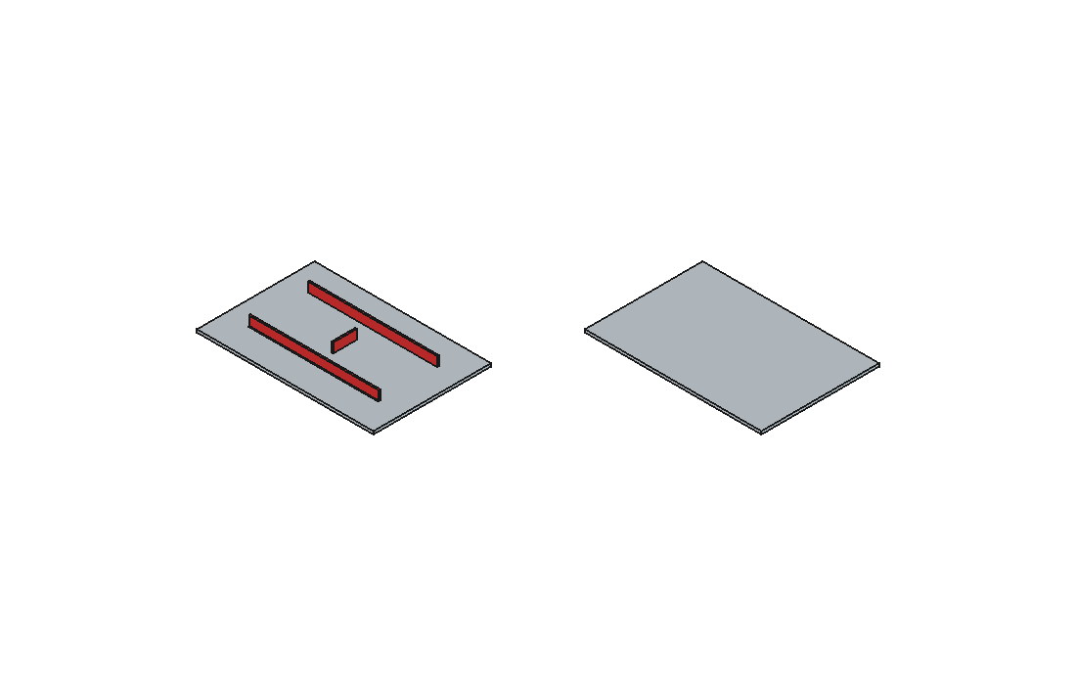
Figure 2a. Result screen of the ribbed test shape: original with selected ribs in red, and the plate after removal
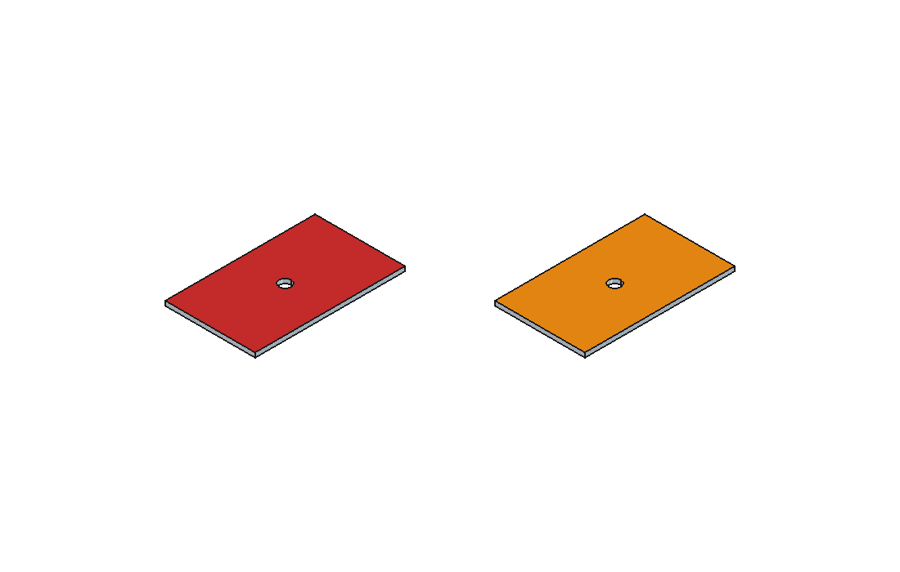
Figure 2b. Result screen of the failure test shape: the failed face (bottom) is orange
FR/NFR References: FR-VAL-01, FR-VAL-02, FR-VAL-06, FR-VAL-08, NFR-USE-01

3.8 Reports
The comparison report is visual only: the before/after rendering of the original and the defeatured model. The faces selected for removal are saved in a red-marked STEP file for review. A record of the removed features and the failure records support the engineer's review. Mesh statistics (element count, generation time) are evaluated separately with Gmsh. The final report format (FreeCAD window or saved images) is still to be agreed with HP.
FR/NFR References: FR-VAL-01, FR-VAL-02, FR-VAL-03, FR-VAL-06, NFR-USE-01

3.9 Error Handling
Situation | Handling | Status
Silent failure: the kernel returns the shape unchanged | Detected by comparing face count and volume; the feature is kept; a failure record is stored; the face is shown in orange. | Implemented
The kernel raises an exception | Treated as a failed removal with the exception as the reason; same handling as above. | Implemented
The result is not a valid solid | Treated as a failed removal; the original geometry is kept. | Implemented
Geometry healing fails | The feature is skipped, the original geometry kept, geometry and face IDs stored. | Implemented (FR-DEF-04)
The input STEP cannot be read | A clear message states the reason; no output file is written; the original is untouched. | Designed (S3)
A feature type is not recognized | The feature is kept and listed; nothing is removed on a guess. | Proposed
Colored STEP export in headless mode | Not possible (no per-face color without the GUI); the red-marked STEP is created in GUI mode. | Known limitation

FR/NFR References: FR-DEF-02, FR-DEF-04, FR-DEF-05, FR-VAL-06, NFR-REL-01, NFR-REL-02, NFR-USE-02

3.10 Interfaces
Interface | Type | Description
Engineer -> C1 | File selection | The engineer provides the STEP file.
C1 -> C2 | In-process call | STEP file path -> B-rep and face map.
C2 -> C3 -> C4 | In-process data | B-rep and face map -> face-adjacency graph -> feature types with face IDs.
C4 -> C5 | In-process data | Feature type, face IDs and geometric properties.
C5 -> C6 | In-process call | Selected face IDs and the original B-rep.
C6 -> C7 | In-process data | Intermediate defeatured B-rep.
C5, C6, C7 -> C8 | In-process data | Selected face IDs, original model, final model for the before/after view.
C1, C5, C6, C7 -> C9 | File write | Original STEP, metadata, failure records, defeatured STEP.
Modules <-> FreeCAD | Python API | STEP read/export, defeaturing, validity checks, 3D view.
C4 <-> pretrained model | Library call | Graph in, predictions out (model to be selected).
C8 -> Engineer | 3D view | Before/after result, highlights and messages.

FR/NFR References: FR-IO-02, FR-FEAT-02, FR-FEAT-03, FR-DEF-01, FR-VAL-01, NFR-MAINT-01

3.11 Help
There is no built-in help. Assistance comes from the project documents (requirements, architecture, development environment), the README, and the live demo (src/fcdemo.sh), which shows the whole flow on the test shapes.
FR/NFR References: NFR-USE-01

3.12 Performance
NFR | Target | Implementation strategy
NFR-PERF-01 | Preprocessing time 70-90% below manual defeaturing, measured on representative test shapes | Fully automated single-process pipeline; the manual baseline time is to be obtained from HP.
NFR-PERF-02 | Less time than an engineer needs manually, from opening the STEP file to saving the final STEP file | Headless run without a GUI; one pass per feature group; interval measured by run logs.
NFR-PERF-03 | Inference on an office laptop without a GPU | Pretrained model run on the CPU; GPU only for training experiments.

FR/NFR References: NFR-PERF-01, NFR-PERF-02, NFR-PERF-03, FR-VAL-03

3.13 Security
NFR | Control | Implementation
NFR-SEC-01 | No confidential HP data in the repository | Public repository; generated files kept in a workspace folder outside it; only self-authored shapes and public data are used.
NFR-SEC-02 | Permitted data sources | Public datasets, shapes authored by the team, and corrected failure cases from our own runs.

Access details of the training server are shared privately and are not recorded in the repository.
FR/NFR References: NFR-SEC-01, NFR-SEC-02, FR-DATA-02

3.14 Reliability
- The original input file is read-only for the system and is never modified (NFR-REL-01).
- A failed removal never stops the run or damages the output; the feature is kept and the failure stored (NFR-REL-02).
- Every output is checked for validity; the prototype passes all nine generated shapes with the expected face count and volume (NFR-REL-04).
- More complex geometry (multiple bodies, curved surfaces) is a Want and will be tested on additional shapes (NFR-REL-03).
FR/NFR References: NFR-REL-01, NFR-REL-02, NFR-REL-03, NFR-REL-04

3.15 Maintainability
The code is organized by role: mechanism (cleancad_core.py), test-data generation (gen_examples.py), automated checks (run_headless.py) and the live demo (demo_freecad.py). The architecture modules C1-C9 map to separate responsibilities so that team members can work independently. The repository is under Git with a documented history.
FR/NFR References: NFR-MAINT-01, NFR-MAINT-02

3.16 Portability
The pipeline runs headless with FreeCAD's Python API and needs no licensed CAD software. The prototype is verified on macOS; Windows and Linux paths are to be confirmed by the team members. The live-demo launcher currently assumes the macOS application bundle.
FR/NFR References: NFR-PORT-01, NFR-PORT-02, NFR-PORT-03

3.17 Reusability
groups() and remove_group() do not depend on a specific rule and can be reused with any decision logic; the rule registry accepts new rules without changing the mechanism. The test-shape generator and the manifest can be extended with face-level ground truth for other feature types.
FR/NFR References: FR-DATA-05, NFR-MAINT-01

3.18 Application Compatibility
The pipeline relies on FreeCAD 1.1.3 and its embedded Python. Some pretrained models are built on other OCCT-based libraries (for example pythonocc-core and occwl), which may number the faces of the same STEP file differently from FreeCAD; a reliable face map between the two is therefore required and still has to be verified. STEP files follow ISO 10303 for exchange with other CAD software.
FR/NFR References: FR-FEAT-02, NFR-PORT-02

3.19 Resource Utilization
The pipeline needs a normal laptop CPU and memory; no GPU is used at run time. The AI Lab GPU server is used for model experiments only. No separate database or server process is needed.
FR/NFR References: NFR-PERF-03, NFR-PORT-01

3.20 Major Classes and Modules
Name | Location | Responsibility
rule(name) / RULES | src/cleancad_core.py | Decorator and registry for removal rules (face, context) -> remove or not.
sig(face), normal(face) | src/cleancad_core.py | Face signature (type, area, center) used as face identity; face normal.
Ctx | src/cleancad_core.py | Shared per-shape context for rules (for example the base plate height).
select(shape, rule_names, failed) | src/cleancad_core.py | Faces selected for removal by the named rules, skipping known failures.
groups(shape, faces) | src/cleancad_core.py | Connected components of the selected faces: one feature each.
remove_group(shape, group) | src/cleancad_core.py | Removes one feature and judges the result (no error is not success).
process(shape, rule_names) | src/cleancad_core.py | Removal loop returning the final shape, removed features and failures.
gen_examples.py | src/ | Builds nine test shapes and the manifest with expected results.
run_headless.py | src/ | Runs all shapes headless and compares with the manifest (report in the workspace logs).
demo_freecad.py / fcdemo.sh | src/ | Live FreeCAD demo: highlights, removal, failure display, before/after result screen.

FR/NFR References: FR-DEF-01..04, FR-FEAT-02, FR-VAL-06, FR-DATA-03, NFR-MAINT-01

4. Interaction Design
Following the course lecture, the HLD describes the behavior as use cases, scenarios and sequence diagrams, for the normal flow and for flows in which something goes wrong. The engineer selects the input through C1 and sees the result through C8.

4.1 Use Cases
ID | Use case | Actor | Requirements
UC1 | Defeature a part: give a STEP file and receive the defeatured STEP file and the before/after result | CAE engineer | FR-IO-01..04, FR-FEAT-01..03, FR-DEF-01..03, FR-VAL-01, 02, 06
UC2 | Handle a failed removal: keep the original geometry and store a failure record | System | FR-DEF-04, FR-DEF-05, NFR-REL-02
UC3 | Handle an unreadable input: explain the reason | System | NFR-USE-02, NFR-REL-01
UC4 | Correct the face selection and save labels (candidate) | HP engineer | FR-VAL-08 (Want)

4.2 Scenarios and Sequence Diagrams
Each scenario has one sequence diagram. PRE is the precondition, POST the postcondition.

S1 - Nominal: defeature a part (UC1)
The engineer selects the STEP file; the original is stored; the B-rep and the face map are read; the graph is built; features are recognized; the decision module selects the faces to remove and stores the metadata; the selection is highlighted in red; the kernel removes each feature group and compares the shape before and after; the result is healed and exported, stored and shown as before/after.
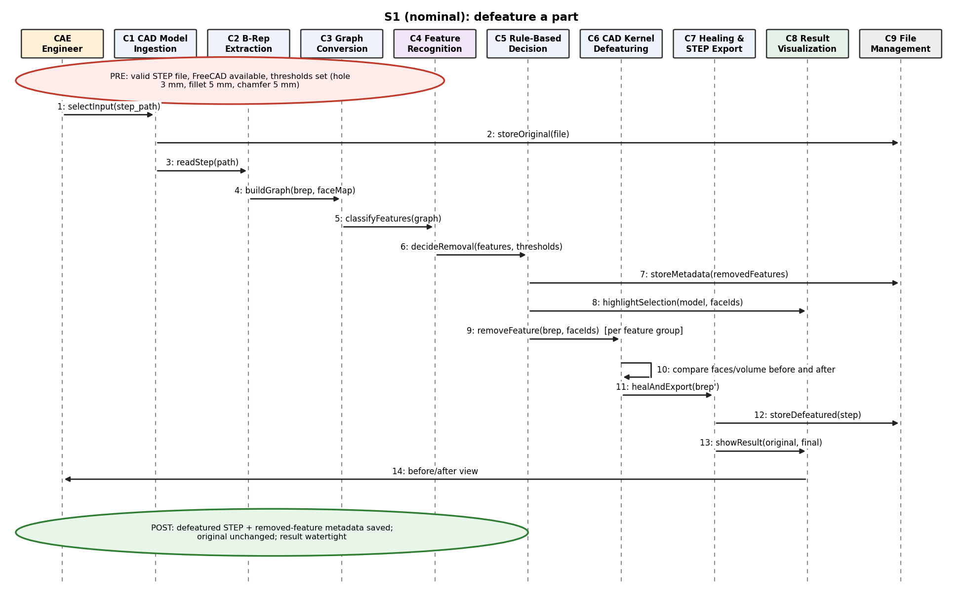
Figure 3. Sequence diagram of scenario S1

S2 - Off-nominal: a removal fails (UC2)
FreeCAD returns the shape unchanged without an error. The kernel module notices that nothing changed, keeps the original geometry, stores a failure record, shows the failed face in orange and continues with the other features. The prototype test shape fail_demo follows this flow.
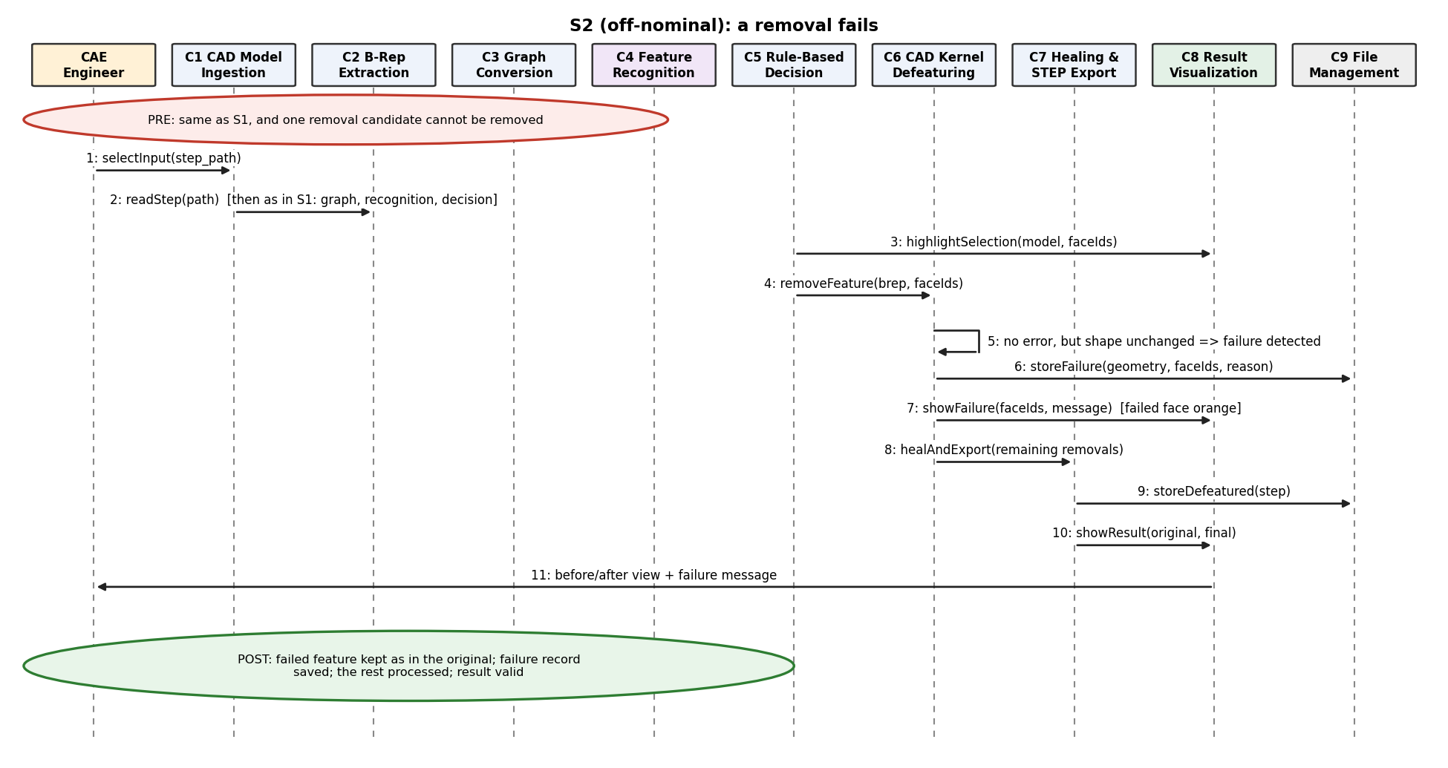
Figure 4. Sequence diagram of scenario S2

S3 - Off-nominal: the input cannot be read (UC3)
The STEP file is damaged, has an unsupported version or is not a solid. The engineer gets a message with the reason and no file is written. This flow is designed but not yet implemented in the prototype.
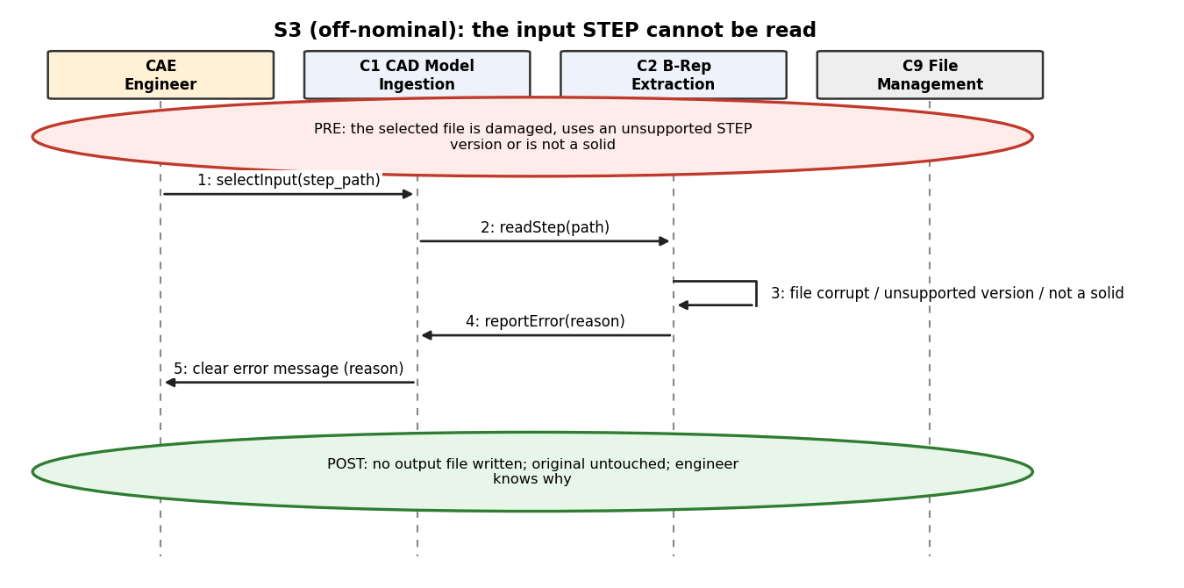
Figure 5. Sequence diagram of scenario S3

S4 - Candidate: correct the face selection and save labels (UC4)
The HP engineer opens the highlighted selection, toggles faces between keep and remove, and the labels are saved for future training; an optional new removal uses the corrected selection.
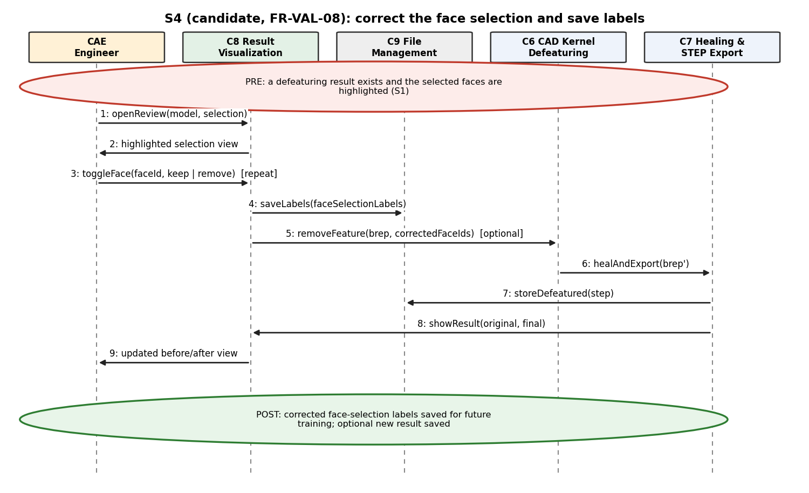
Figure 6. Sequence diagram of scenario S4 (candidate, FR-VAL-08)

5. Integration Test Considerations
The architecture is tested at three levels. The first exists in the prototype; the others are planned.
Level | What is tested | How | Status
Mechanism | Removal and healing on nine generated shapes (holes, fillets, ribs, bosses, embossing, chamfers, near-edge, curved press, failure case) | run_headless.py compares face count, volume and failure flag with manifest.json: 9/9 pass | Done
Interfaces | Face identity is kept from the B-rep to the removal (C2 -> C3 -> C4 -> C5 -> C6) and between the pretrained model and FreeCAD | Generated shapes with recorded ground-truth faces; compare the predicted and the removed faces | Planned (FR-DATA-05)
Scenarios | S1, S2, S3 from chapter 4 end to end | Scripted runs; the live demo shows S1 and S2 | S1, S2 done; S3 planned
Recognition | How reliably rule-based checks and the pretrained model find ribs, bosses, embossing, logos and holes | Evaluation on generated shapes; feature counts on the public test set (no face-level labels) | Planned
Performance | Time from opening the STEP file to saving the result versus the manual time | Run logs; manual baseline from HP | Planned (NFR-PERF-01, 02)

FR/NFR References: FR-DATA-03, FR-DATA-05, FR-VAL-05, FR-VAL-07, NFR-PERF-01, NFR-PERF-02, NFR-REL-04

Appendix A. Requirements Traceability
Every functional (FR) and non-functional (NFR) requirement is mapped to the module(s) that realize it (C1-C9, see 3.2.1). 'Engineer (external)' is the user outside the system boundary; 'Offline data' is data preparation outside the runtime; a dash means an evaluation activity not allocated to a runtime module.
Requirement ID | Requirement Statement | Must/Want | Component(s)
FR-IO-01 | The system shall accept a mold/part CAD model as a STEP (.step/.stp) file as input. | Must | C1
FR-IO-02 | The system shall parse the input STEP file into a B-rep (Boundary Representation) model using the FreeCAD Python API, run headless as standalone batch code. | Must | C2
FR-IO-03 | The system shall export the processed (simplified) CAD model as a STEP file. | Must | C7, C9
FR-IO-04 | The system shall use STEP as its only supported CAD format; NX-format support is out of scope. | Must | C1, C7
FR-FEAT-01 | The system shall identify individual shape features (hole, fillet, chamfer, rib, boss, emboss) present in the input B-rep model. | Must | C4
FR-FEAT-02 | The system shall convert the B-rep model into a graph representation (face adjacency graph with geometric attributes) suitable as input to a machine learning model. | Must | C3
FR-FEAT-03 | For each recognized feature, the system shall classify whether it is safe to remove, prioritizing defeaturing accuracy. | Must | C4, C5
FR-FEAT-04 | The system should report a confidence score for each feature classification. | Want | C4
FR-FEAT-05 | The system shall provide the engineer with the information needed to review the result (the before/after visualization, the faces selected for removal, and the removed-feature metadata). The review itself, and any correction of mistakes, is performed by the HP engineer after the system output, outside the system. | Must | Engineer (external), C8
FR-FEAT-06 | The Decision Logic shall operate in two stages: Stage 1 rule-based selection (e.g., by feature size), Stage 2 ML-based selection. | Must | C5
FR-FEAT-07 | Stage 1 rule-based decisions shall use explicit, configurable dimension thresholds so that decisions remain explainable. The initial thresholds for evaluating removal candidates are: hole diameter 3 mm, fillet radius 5 mm and chamfer size 5 mm. The values can be adjusted case by case. | Must | C5
FR-FEAT-08 | The system shall support logos (characters, surface markings, and embossed or engraved logos) as a feature category for recognition and removal. | Must | C4
FR-FEAT-09 | When the Stage 1 (rule-based) and Stage 2 (ML-based) recommendations for a feature conflict, a supervisory decision step should determine the final proposed action. | Want | C5
FR-DEF-01 | The system shall remove shape features classified as safe to remove from the CAD model. | Must | C6
FR-DEF-02 | After removing a feature, the system shall perform geometry healing to repair the resulting geometry into a valid, watertight model. | Must | C7
FR-DEF-03 | The system shall preserve the overall external dimensions and topology of the part except for the removed features. | Must | C6, C7
FR-DEF-04 | If geometry healing fails for a given feature, the system shall skip removing that feature, retain the original geometry, and store the geometry and the ID of the failed face for later manual correction. | Must | C6, C7, C9
FR-DEF-05 | Cases where a feature is correctly selected for removal but the removal or healing fails should be tracked as a separate failure category, distinct from wrong feature selection. | Want | C6, C7, C9
FR-VAL-01 | The system shall generate a comparison report between the original and defeatured CAD models, for the engineer to review before accepting the result. | Must | C8
FR-VAL-02 | The comparison report shall be visual: a side-by-side (or before/after) rendering of the original and defeatured geometry. No text-only summary is required. | Must | C8
FR-VAL-03 | The system shall evaluate the meshes generated from the original and the defeatured models using Gmsh and report measurable mesh statistics (for example element count and mesh generation time), to quantify the processing-time improvement. | Must | -
FR-VAL-04 | The system should allow visual inspection of the defeatured model using FreeCAD. | Want | C8
FR-VAL-05 | Defeaturing accuracy shall be the primary success criterion; downstream CAE analysis accuracy (e.g., stress/deformation error) is explicitly out of scope and shall not be measured. | Must | -
FR-VAL-06 | Before feature removal, the system shall mark the faces selected for removal in red and save the marked model as a STEP file, processing multiple STEP files sequentially, so the engineer can review the face selection. | Must | C8, C9
FR-VAL-07 | Defeaturing accuracy should be evaluated and reported as two separate categories: feature selection accuracy (were the correct faces/features selected) and removal execution accuracy (could the selected feature be removed and healed without geometry issues). | Want | -
FR-VAL-08 | The system should provide a software tool with which the engineer can view the processed STEP model with the selected faces highlighted, correct the selection of faces to remove, and save the face-selection labels for future training. | Want | C8, C9
FR-DATA-01 | The feature recognition model shall be trainable using publicly available CAD feature datasets (e.g., MFCAD, MFCAD++, Fusion 360 Gallery Segmentation Dataset). | Must | Offline data
FR-DATA-02 | The team shall author a set of simple CAD shapes (STEP files) containing representative features (hole, fillet, chamfer, rib, boss) to supplement training and validation. | Must | Offline data
FR-DATA-03 | Self-authored test shapes shall follow HP's guidance: approx. 2-3mm thickness, ~100-200mm width, covering (a) slightly curved shapes with a press-formed cut-out, (b) ribbed parts, and (c) parts with features near an edge. | Must | Offline data
FR-DATA-04 | The validation dataset should be expanded beyond the initial nine self-authored shapes: greater geometric diversity, multiple feature-type combinations, harder edge cases, varied feature sizes and locations, and cases that intentionally trigger healing difficulties or removal failures. | Want | Offline data
FR-DATA-05 | The team should generate test STEP models programmatically by adding features through code and record the faces of each added feature as face-level ground truth, so that the face predictions can be checked automatically. | Want | Offline data
NFR-PERF-01 | The system shall reduce CAD preprocessing (defeaturing) time by 70-90% compared to manual defeaturing, measured on representative test shapes. | Must | All
NFR-PERF-02 | The system shall complete the defeaturing of a single part, measured from opening the input STEP file to saving the final defeatured STEP file, in less time than an engineer needs to defeature the same part manually. | Must | C2-C7
NFR-PERF-03 | The feature recognition model shall run inference on a standard office laptop without a GPU. | Must | C4
NFR-REL-01 | The system shall not modify or corrupt the original input STEP file; it shall remain unchanged during processing. | Must | C1, C9
NFR-REL-02 | If geometry healing fails for a given feature, the system shall skip removing that feature, avoid crashing or producing an invalid output file, and retain the failure information for later use. | Must | C6, C7
NFR-REL-03 | The system should handle CAD models with moderately complex geometry (multiple bodies, curved surfaces), beyond the simple shapes used in early development. | Want | C2-C7
NFR-REL-04 | Every output CAD model shall be a valid, watertight solid - free of gaps or non-manifold geometry left behind by feature removal. | Must | C7
NFR-PORT-01 | The system shall run on the standard desktop operating systems used by team members (macOS, Windows, Linux) without requiring licensed CAD software. | Must | All
NFR-PORT-02 | The system shall read/write STEP files conforming to ISO 10303 (AP203/AP214/AP242) for interoperability with common CAD software. | Must | C1, C7
NFR-PORT-03 | The core processing pipeline shall be runnable headless (without the FreeCAD GUI), as standalone batch/automated code. | Must | C2, C6, C7
NFR-SEC-01 | The system and its public repository shall not store or transmit any confidential HP CAD data. | Must | All
NFR-SEC-02 | All training/validation data committed to the repository shall be either publicly available datasets, CAD shapes authored by the team, or manually-corrected failure cases generated by the team's own pipeline runs. | Must | Offline data
NFR-USE-01 | The comparison report shall be understandable by a non-AI-expert reviewer (e.g., a CAE engineer) at a glance, since the report is visual rather than text-based. | Must | C8
NFR-USE-02 | The system shall provide clear error messages when an input file cannot be processed (e.g., unsupported STEP version, corrupted file). | Must | C1
NFR-USE-03 | The system shall be designed as a decision-support tool that speeds up the engineer's work, not a fully autonomous replacement for engineer judgment. | Must | Engineer (external)
NFR-MAINT-01 | The codebase shall be organized into modules corresponding to the pipeline layers (CAD I/O, graph conversion, feature recognition, removal, validation) to allow independent development by team members. | Must | All
NFR-MAINT-02 | The system shall be version-controlled using Git, with a shared GitHub repository and documented commit history accessible to all team members. | Must | All
NFR-ACC-01 | The system's feature-removal decisions shall be optimized to maximize defeaturing accuracy. | Must | C4, C5
NFR-ACC-02 | Downstream CAE analysis accuracy (e.g., stress/deformation error) shall NOT be measured; it is explicitly out of scope for this project. | Must | -
NFR-ACC-03 | Defeaturing accuracy should be defined as two separately measured categories: feature selection accuracy and removal execution accuracy. Removal/healing failures on correctly selected features should be tracked as their own category. | Want | -

