System Architecture
Project Name: Mold-Part Defeaturing
Team Name: HP2
Team members: Junoh Lee (Team Lead), Hemanth Reddy Vangala, Aneela Tahir, Balcha Kidus Elias

Revised History
Name | Date | Reason For Changes | Version
Junoh Lee | 2026-09-17 | Initial Version | 1.0
Junoh Lee | 2026-09-18 | Toolchain confirmed (FreeCAD Python API); added deployment constraint (CPU inference), success criteria (defeaturing accuracy only), staged Decision Logic, failure-case retraining loop | 1.1

1. Overview
The system consists of a core runtime pipeline that processes one CAD model at a time, and a separate offline training pipeline that produces the trained feature-recognition model used inside the runtime pipeline.
The tool only proposes a defeatured result - it does not auto-finalize. Every result goes through mandatory engineer review before being accepted, since this is a decision-support tool, not a fully autonomous replacement for engineer judgment.
Toolchain: FreeCAD's Python API, run headless as standalone batch code (not manual GUI scripting) is the confirmed platform. cadquery may optionally be used for STEP generation only. This resolves the earlier discrepancy between the mentor's meeting slide and the school's AI Lab server guide.
Deployment constraint: geometry processing (inference) must run on a GPU-less office laptop; only model training may use a GPU server. The feature recognition model choice must respect this.

2. Core Runtime Pipeline
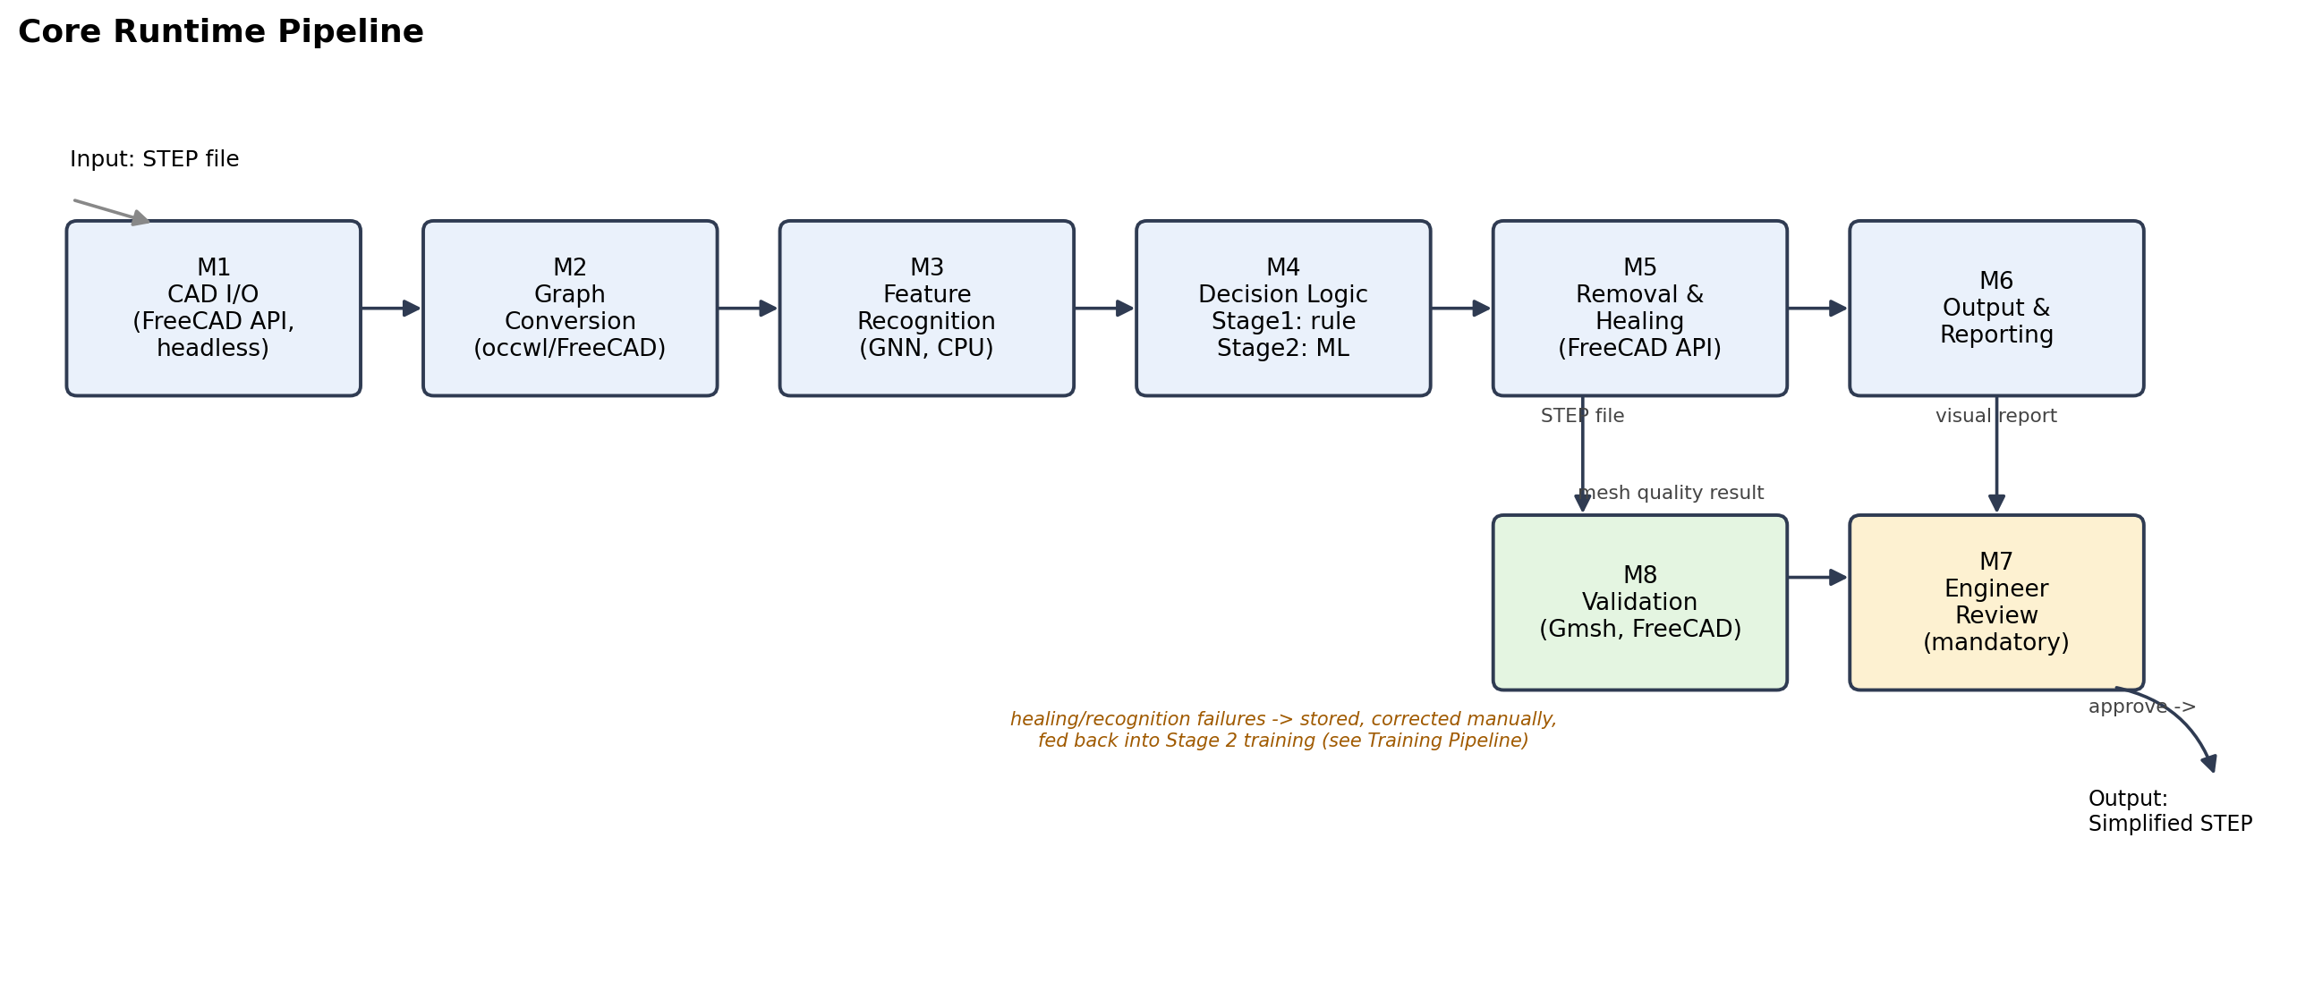
Figure 1. Core Runtime Pipeline (M1-M8)

3. Offline Model Training Pipeline
Trains the Feature Recognition Model ahead of time. Includes a retraining loop: cases the runtime pipeline fails on (recognition errors, healing failures) are manually corrected and added back into the training set.
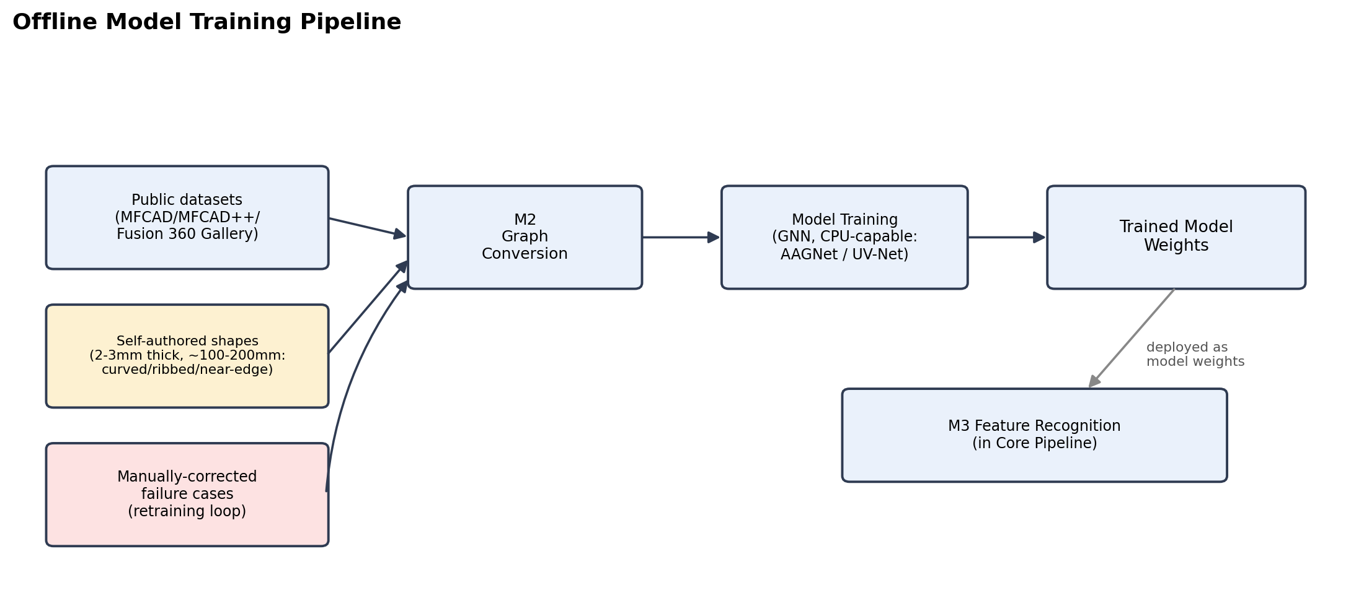
Figure 2. Offline Model Training Pipeline

4. Layer Descriptions
Layer | Component | Responsibility
Input | STEP file | Original CAD provided by the user/HP
CAD Kernel | FreeCAD Python API, headless/standalone (cadquery optional, STEP-generation only) | Parse STEP, access face/edge/vertex, execute the final shape manipulation
Graph Conversion | occwl or a FreeCAD-API-based equivalent (re-check needed) | Convert B-rep into a face adjacency graph + UV parameter samples (model input format)
Feature Recognition Model | GNN-family model (candidates: UV-Net/BRepNet/AAGNet/BrepMFR - team's choice, must run on CPU at inference) | Classify each face/feature; estimate impact on defeaturing accuracy
Decision Logic | Staged: Stage 1 rule-based (by size), Stage 2 ML-based | Proposes whether a feature can be removed - a proposal, not a final decision. Wrong cases are corrected manually and fed back into Stage 2 training
Feature Removal Engine | FreeCAD Python API, headless | Suppress/remove proposed features, then geometry-heal into a valid, watertight model. On failure, store geometry + failed face ID for manual correction and retraining
Output | Simplified STEP + visual comparison report | Deliverable presented to the engineer; no text summary, only a before/after visual
Engineer Review | Human (mandatory) | Reviews the visual comparison report and accepts/rejects the result before it is finalized - every run
Validation | Gmsh (mesh quality), FreeCAD (visual) | Compare before/after simplification; success = defeaturing accuracy, NOT downstream CAE analysis accuracy (out of scope)

5. Confirmed Decisions
• CAD toolchain: FreeCAD Python API, headless/standalone. Confirmed 2026-09-18. cadquery optional for STEP generation only.
• Visual verification: FreeCAD.
• NX support is not required.
• Training/test data will not come from HP (confidential); self-authored shapes (2-3mm thick, ~100-200mm wide; curved cut-out / ribbed / near-edge types) plus public datasets.
• STEP is the only supported format.
• Comparison report is visual only.
• Engineer review is mandatory for every result.
• Deployment: inference on a GPU-less laptop; training may use a GPU server. Confirmed 2026-09-18.
• Success criteria: defeaturing accuracy is the top priority; downstream CAE analysis accuracy is explicitly out of scope. Confirmed 2026-09-18.
• Decision Logic is staged (rule-based, then ML-based) with a manual-correction retraining loop, not a single one-shot model. Confirmed 2026-09-18.
• Feature recognition model is the team's own choice - the mentor has no preference. Confirmed 2026-09-18.

6. Open Points
• Pick the specific Feature Recognition Model (UV-Net/BRepNet/AAGNet/BrepMFR), weighing CPU-inference feasibility.
• Re-evaluate occwl (built on pythonocc-core) now that the confirmed toolchain is FreeCAD's own Python API.
• Whether a web demo/UI is needed, or a batch/CLI pipeline is sufficient.

Related Documents
- docs/step_library_comparison.md (tech stack rationale and mentor Q&A)
- docs/High_Level_Design_Document.docx (module responsibilities and interfaces)
- docs/Functional_Requirements_Document.docx / docs/Non_Functional_Requirements_Document.docx

