High-Level Design Document
Project Name: Mold-Part Defeaturing
Team Name: HP2
Team members: Junoh Lee (Team Lead), Hemanth Reddy Vangala, Aneela Tahir, Balcha Kidus Elias

Revised History
Name | Date | Reason For Changes | Version
Junoh Lee | 2026-09-11 | Initial Version | 1.0
Junoh Lee | 2026-09-17 | Removed premature pythonocc-core naming | 1.1
Junoh Lee | 2026-09-18 | Toolchain confirmed as FreeCAD Python API; added deployment constraint (CPU inference), success criteria, staged Decision Logic, and failure-case retraining loop | 1.2
Junoh Lee | 2026-09-29 | Added a note that the core mechanism (M1, M5, and the face-adjacency traversal M2 will build on) is already prototyped and verified in src/cleancad_core.py (9/9 example shapes). No architectural changes. | 1.3

1. Purpose
This document describes the module-level (high-level) architecture of the Mold-Part Defeaturing system: the responsibility of each module, the interfaces between modules, and the technology stack. It elaborates on the Functional and Non-Functional Requirements defined in the FRD/NFRD, and will be refined into per-module Low-Level Design (LLD) in a later phase.

2. System Architecture Overview
The system consists of a core runtime pipeline (M1-M8) that processes one CAD model at a time, and a separate offline training pipeline that produces the trained feature-recognition model used by M3. The tool only proposes a defeatured result - every result is reviewed and approved by an engineer (M7) before being finalized.
Toolchain (confirmed 2026-09-18): FreeCAD's Python API, run headless as standalone batch/automated code. cadquery may optionally be used, but only for generating STEP files. Deployment constraint: inference must run on a GPU-less office laptop; only training may use a GPU server.
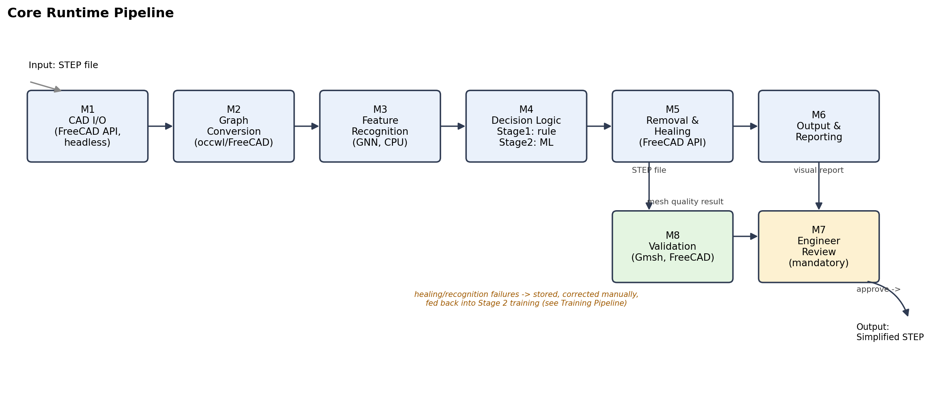
Figure 1. Core Runtime Pipeline (M1-M8)
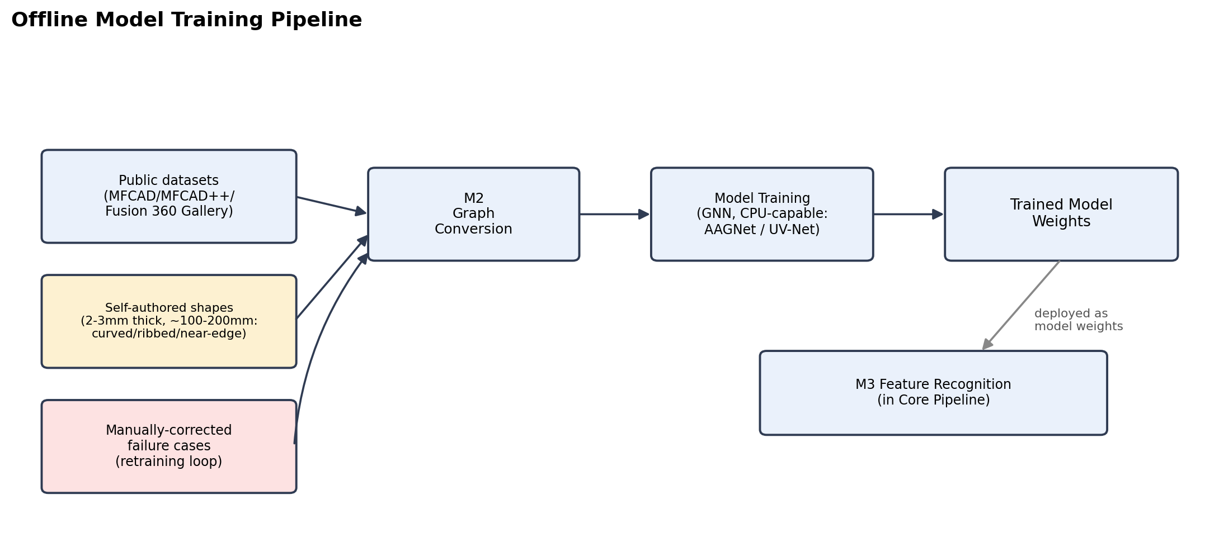
Figure 2. Offline Model Training Pipeline

3. Module Descriptions
Module | Responsibility | Technology
M1 — CAD I/O | Parse input STEP file into a B-rep model; export the final result as a STEP file. | FreeCAD Python API, headless
M2 — Graph Conversion | Convert the B-rep model into a face adjacency graph with UV parameter samples, usable as ML model input. Shared by both the runtime pipeline and the offline training pipeline. | occwl or a FreeCAD-API-based equivalent (re-check needed) — note: src/cleancad_core.py already implements FreeCAD-API-based face-adjacency traversal (groups()), usable as a starting point
M3 — Feature Recognition | Classify each recognized feature (hole/fillet/chamfer/rib/boss/emboss); estimate impact on defeaturing accuracy. | GNN model — team's choice (UV-Net/BRepNet/AAGNet/BrepMFR), must run on CPU at inference
M4 — Decision Logic | Stage 1: rule-based (by size). Stage 2: ML-based. Proposes a keep/remove decision per feature — never auto-finalized. Wrong cases are corrected manually and fed back into Stage 2 training. | Rule engine + GNN classifier
M5 — Removal & Healing | Remove features approved in M4's proposal; run geometry healing so the result is a valid, watertight solid. On failure, store the geometry + failed face ID for manual correction. | FreeCAD Python API, headless
M6 — Output & Reporting | Export the simplified STEP file; generate a visual (image-based) before/after comparison report. | Same FreeCAD toolchain + rendering
M7 — Engineer Review | Present the visual comparison report to the engineer; the engineer accepts or rejects the result. Mandatory for every run. | TBD (interface format not yet decided)
M8 — Validation | Evaluate mesh quality (element count, generation time) and allow visual inspection. Success = defeaturing accuracy, not downstream CAE analysis accuracy (out of scope). | Gmsh (mesh quality), FreeCAD (visual check)

4. Interfaces Between Modules
From -> To | Data Passed
M1 -> M2 | In-memory B-rep model (FreeCAD document/shape object)
M2 -> M3 | Graph structure: nodes = faces (with UV-sampled geometric attributes), edges = face adjacency
M3 -> M4 | Per-feature classification label + confidence score
M4 -> M5 | Proposed list of features to remove
M5 -> M6 | Modified, healed B-rep model
M6 -> M7 | Visual comparison report (rendered before/after images) + candidate output STEP file
M6 -> M8 | Output STEP file (original + defeatured) for mesh quality evaluation
M7 -> Output | Approve: finalize and release the STEP file. Reject: discard or route back for manual handling (policy TBD).
M5 (failure) -> Training Data | Geometry + failed face ID stored, manually corrected, fed into the retraining loop
Training: datasets -> M2 | Public dataset CAD files + self-authored simple CAD shapes + manually-corrected failure cases
Training: M2 -> Model Training -> M3 | Graph-converted training data -> trained GNN weights -> deployed into M3

5. Technology Stack Summary
Layer | Choice | Status
STEP I/O & geometry manipulation | FreeCAD Python API, headless/standalone (cadquery optional, STEP-generation only) | Confirmed 2026-09-18
Visual/mesh validation | FreeCAD, Gmsh | Confirmed
B-rep -> graph conversion | occwl or FreeCAD-API equivalent | Needs re-check (occwl is built on pythonocc-core)
Feature recognition model | UV-Net / BRepNet / AAGNet / BrepMFR | Team's own choice — no mentor preference; must support CPU inference
Input/output CAD format | STEP only | Confirmed — NX out of scope
Training/validation data | Public datasets + self-authored shapes + failure-case retraining | Confirmed — no HP data
Inference deployment | GPU-less office laptop | Confirmed 2026-09-18 — training may use a GPU server
See docs/step_library_comparison.md for the detailed comparison, mentor Q&A, and rationale behind each choice.

6. Design Constraints
- STEP is the only supported CAD format; NX support is explicitly out of scope.
- The system must not store or transmit any confidential HP CAD data.
- Engineer review (M7) is mandatory for every run, not conditional on model confidence.
- The comparison report (M6 output) must be visual; a text-only summary does not satisfy the requirement.
- Every output CAD model must be a valid, watertight solid.
- Geometry processing (inference) must run without a GPU; only training may use a GPU server.
- Success is measured by defeaturing accuracy; downstream CAE analysis accuracy (stress/deformation) is explicitly out of scope.

Related Documents
- docs/architecture.md (source diagrams and open points)
- docs/step_library_comparison.md (tech stack rationale and mentor Q&A)
- docs/Functional_Requirements_Document.docx / docs/Non_Functional_Requirements_Document.docx

