Project One
  - Junpei Liang
jliang390@gatech.edu
Abstract – Project one is to build a simple gambling simulator to simulate 1000 successive bets on the outcomes of the American roulette wheel using different betting strategies, then perform analysis on the experiment result.

Introduction
In experiment 1, I developed a function to take four parameters: the number of episodes (10 and 1000), the number of spins per episode (1000), the win probability (0.60), and the target winning amount ($80). This would remain flexibility in the future experiment, without hardcoding the value. The results are stored in the NumPy array which is [number of episodes, number of spins + 1]. The additional column is used to store the initial bet winning bet value ($0) for each episode. During the execution, the program runs for the specified number of episodes, starting with an initial bet of 1 and doubling it until the occurs. If a win occurs, the bet is reset to 1, given that the maximum number of spins per episode has not been reached. Each winning result is saved in the NumPy array. If the target winning amount is reached, it will fill the data forward with a target value or the value greater than target.
In experiment 2, I developed another function to take five parameters: the number of episodes (1000), the number of spins per episode (1000), the win probability (0.60), the target winning amount ($80), and the bankroll ($256). Like the function develop for experiment 1, the winning results are stored in the NumPy array and the program runs for the specified number of episode. However, unlike experiment 1, the bankroll imposes a cap on the maximum dollar can be used. Therefore, if the bet is lost, the next bet will be the minimum of either double the current bet or the remaining balance. If a won occurs, the best is rest to 1, given that the maximum number of spins per episode has not been reached.
Next, I calculate the mean, median, and standard deviation for the data using NumPy’s build-in functions (np.mean, np.media, np.std). Then I proceed to generate each required figure using matplotlib according to the assignment requirement, The plots have a horizontal (x) range from 0 to 300 and a vertical (y) range from -256 to +100, with labeled x and y and a title. The figures are saved to /images folder.

Questions

Question Set 1
Based on the experiment 1 results, the estimated probability of winning exactly $80 within 1000 sequential bets is 100%. This calculation involves counting the number of episodes that end with a winning balance of exactly $80 and dividing it by the total number of episodes (1,000). Since all 1,000 episodes resulted in a winning balance of exactly $80, the probability is therefore 100%.

Question 2
Based on the Experiment 1 results, the estimated expected value of winning after 1000 sequential bets is $80. The estimated expected value is calculated by multiplying each outcome's probability (in this case, 1/1000) by its value (each episode's outcome) and summing them. Therefore, in this case, the expected value is just a mean calculation.
E[X] = X1∙P(X1) + X2∙P(X2) + ∙∙∙ + Xn∙P(Xn)
E[X] = 80*1000/1000 = 80

Question 3
In Experiment 1, the upper standard deviation line (mean + stdev) and lower standard deviation (mean - stdev) stabilize at a maximum of $80. The standard deviation lines converge with one another as the number of sequential bets increases. This is due to the unlimited bankroll and the win probability being set to 0.60. The bet strategy with an unlimited bankroll allows the player a chance to recover their losses at every next spin; as the number of bets increases, the winning amount gets closer to $80, and the standard deviation will continue to decrease and eventually converge to zero. See Figure 6.

Question 4
Based on experiment 2 results, the estimated probability of winning exactly $80 within 1000 sequential bets is 96.2%. This calculation involves counting the number of episodes (962) that end with a winning balance of exactly $80 and dividing it by the total number of episodes (1,000). Since all 962 episodes resulted in a winning balance of exactly $80, the probability is therefore 96.2%.

Question 5
Based on the Experiment 1 results, the estimated expected value of winning after 1000 sequential bets is $67.232. The estimated expected value is calculated by multiplying each outcome's probability (in this case, 1/1000) by its value (each episode's outcome) and summing them. Therefore, the expected value is just a mean calculation for this experiment. We have 962 episodes that end with exactly $80, 38 episodes end with exactly -$256. Therefore, the estimated expected value equal is
E[X] = 80*962/1000 + -256 * 38/1000 = 67.232.

Question Set 6
In Experiment 2, The upper standard deviation line (mean + stddev) and lower Standard deviation line (mean - stddev) stabilize as the number of spin increase. The standard deviation converges to a value of 64.24, I review the last 100 standard deviations. As shown in figure 7, the standard deviation initially increases rapidly but stables as the number of spins increases.
The upper and lower standard deviation lines do not converge with each other as the number of sequential bets increases. With the play betting on black, with a win probability of 0.60, and setting a target win amount of $80 and a maximum loss of -$254, that would lead to approximately 60% of the winning amount will be $80, while about 40% of the winning amount will be -$254. This maintains a stable distance between the upper and lower bounds, preventing them from converging to the mean.

Question 7
The benefit using expected values when conducting experiment instead of simply using the result of one specific random episode:
Perform comparison: We can look at many outcomes with expected value, then we can evaluate different strategies.
Improved Accuracy: Expect value gives us more accurate representation of probability distribution. If we just use episodes, the result will either $80 or -$256, so we could conclude either 100% of winning $80 and 100% losing $256 in the long run.
More information: Research can see patterns that do not appear in one episode.

Figures
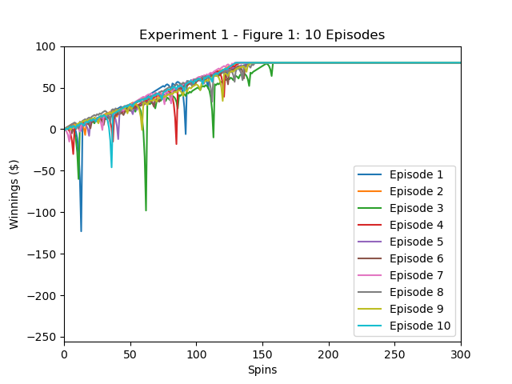
- Experiment 1: 10 episodes, and winning amount history

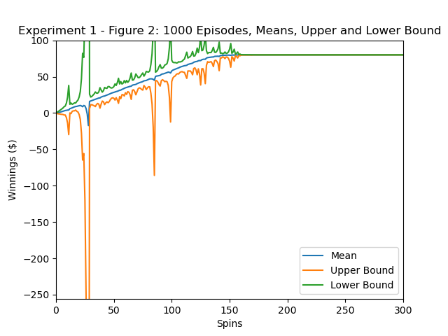
- Experiment 1: 1000 episodes, means of the winning amount with upper and lower bounds.
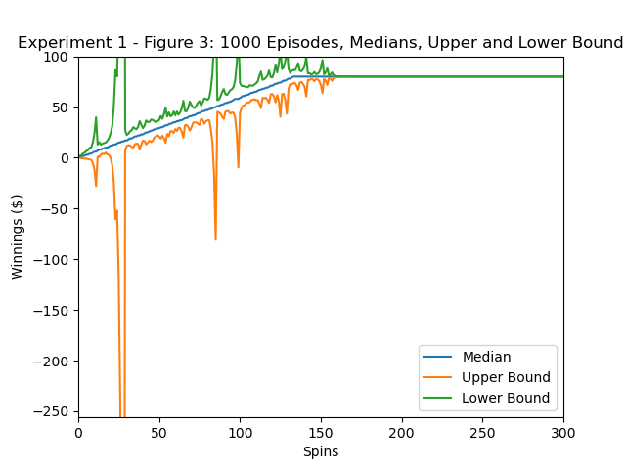
- Experiment 1, 10000 episodes, median of winning amount with upper and lower bounds.
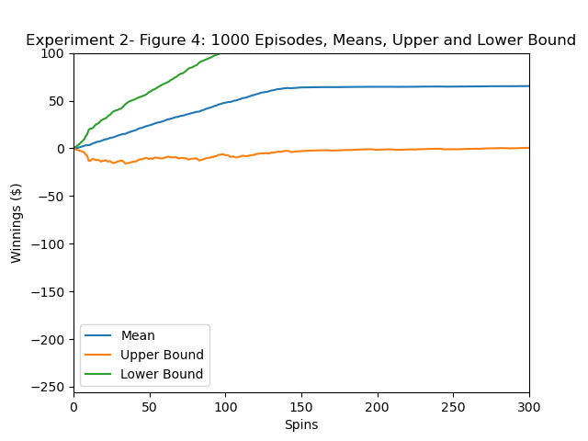
- Experiment 2: 1000 episodes, means of the winning amount with upper and lower bounds.
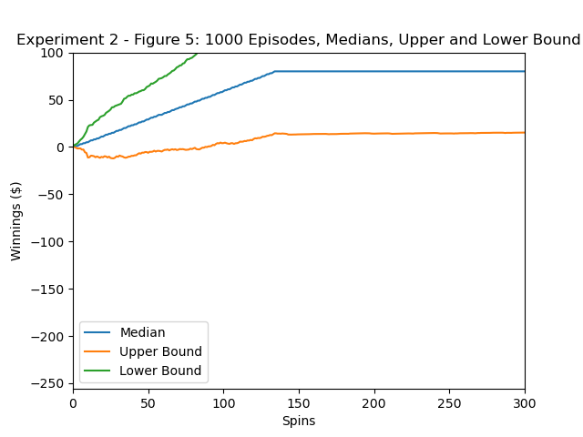
- Experiment 2: 1000 episodes, medians of the winning amount with upper and lower bounds.
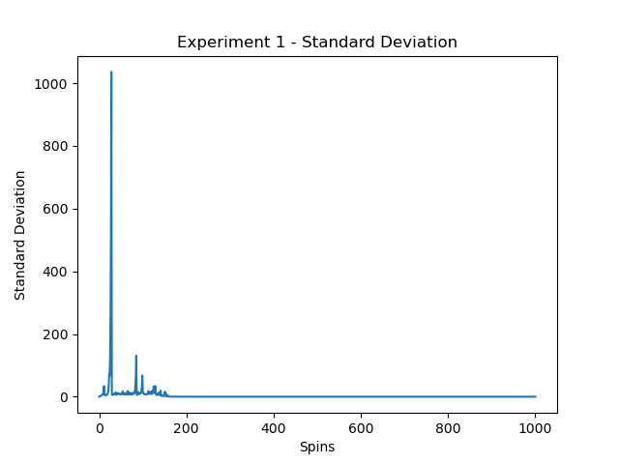
- Experiment 1, standard deviation of winnings amounts by number of spins.
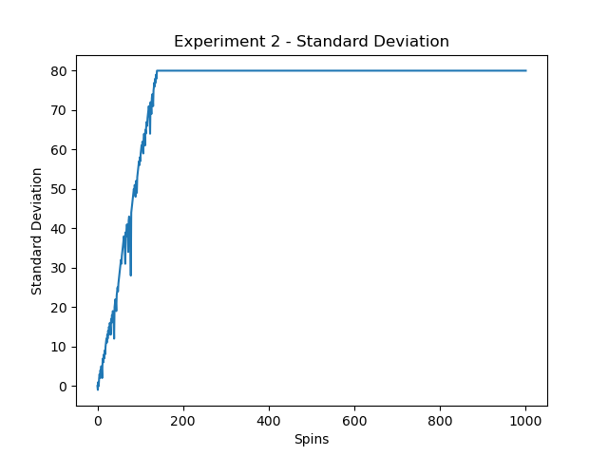
- Experiment 2, standard deviation of winnings amounts by number of spins

