Project Two
  - Junpei Liang
jliang390@gatech.edu

Figures
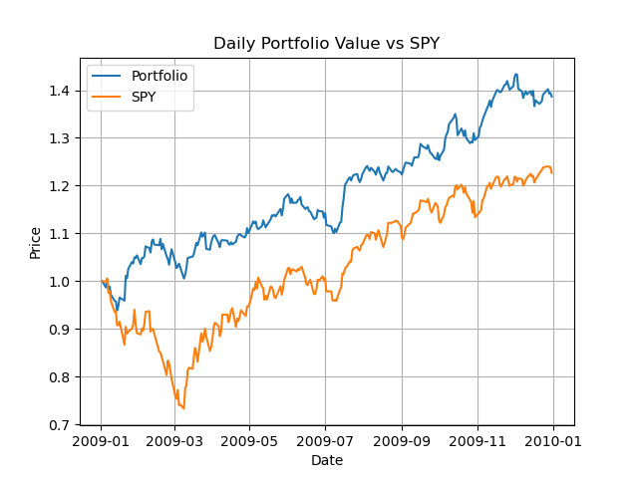
- The chart shows the comparison between the optimal normalized portfolio with SPY.

