Project Three: Assess Learners
  - Junpei Liang
jliang390@gatech.edu
Abstract – This project assesses the performance of various learning algorithms, including decision trees, random decision tree, and ensemble learners. Experiments were conducted to investigate the impact of overfitting on their effectiveness.

Introduction
This project evaluates the efficacy of several machine learning algorithms, including decision tree, randomized decision tree, bagging and ensemble methods that aggregate multiple learning models. The project involves conducting three experiments to investigate how leaf size and bagging affect overfitting in each respective learning model. In theory, it is expected that reducing the leaf size in decision tree learning will lead to overfitting, even when involving other learning techniques such as bagging for training data. In contrast, random decision trees are anticipated to achieve more accuracy and faster computation time to traditional decision trees.

Methods
The following three experiments are designed to investigate the performance of learning algorithms with varying leaf sizes, perform quantitative comparison between decision tree and random tree.
In Experiment 1, the Istanbul.csv dataset was divided into two parts: 60% for training (in-sample data) and 40% for testing (out-of-sample data). Then I trained 40 decision tree learners on the training data, selecting the feature with the highest correlation at each node. I varied the leaf size of the decision trees from 1 to 40 and evaluated the difference in root mean squared error (RMSE) between the in-sample and out-of-sample data across different models. By examining these differences, I aimed to assess the effect of overfitting corresponding to the leaf size on the decision tree.
In Experiment 2, the Istanbul.csv dataset was divided into two parts: 60% for training (in-sample data) and 40% for testing (out-of-sample data). This experiment built by involving bagging technique, I created an ensemble of 20 decision trees, where each tree was trained on a random subset of 60% of the training data. I varied the leaf size of the decision trees from 1 to 40, and by examining the differences in RMSE between the in-sample and out-of-sample data, I aimed to assess the effect of overfitting corresponding to the leaf size on the decision tree.
In Experiment 3, I conducted a quantitative comparison between decision trees and random trees to assess their performance in terms of accuracy and efficiency. I varied the leaf size from 1 to 40 and randomly selected 60% of the Istanbul.csv data to train both the decision tree and random tree models. For each combination of leaf size and training data, I captured two quantitative measures: mean absolute error (MAE) and training time. By comparing these two measures across different leaf sizes and models, I aimed to evaluate the accuracy and efficiency of the learning models.

Discussion
In the following, we'll explore how overfitting affects various learning algorithms, including a comparison of decision trees and random trees in terms of their effectiveness.

Experiment 1
The results of Experiment 1 shows that overfitting occurs when the leaf size reaches around 10, and as we decrease the leaf size towards zero, the root mean squared error (RMSE) for the in-sample data also decreases towards zero. This is because, by narrowing the leaf size to zero, we are trying to fit the learning model as closely as possible to the training data. However, when we introduce the testing data, the RMSE shoots up, indicating that our model has become too specialized to the training data and fails to generalize well. To mitigate this issue, one is implement early stopping, where we stop the training process as soon as we detect overfitting. Alternatively, we can use ensemble methods, and or bagging or boosting, which involve combining the predictions of multiple models trained on different subsets of the data.
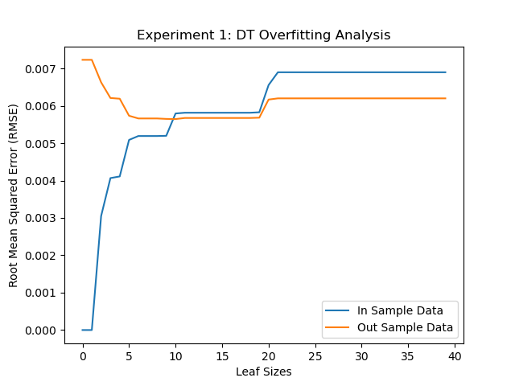
- Experiment 1: RMSE results for the decision tree model, comparing in-sample and out-of-sample performance across leaf sizes of 1 to 40.

Experiment 2
The results of Experiment 2 indicate that using a bag learner with 20 bags and decision tree learners leads to a reduction in RMSE compared to Experiment 1, which used a single decision tree. Note that the out-of-sample RMSE remains stable at approximately 0.050. However, despite this improvement, overfitting is still not completely eliminated, as the figure 2. shown that when the leaf size is set to 5, the RMSE for the in-sample data continues to decline, indicating that the model is becoming too specialized to the training data.
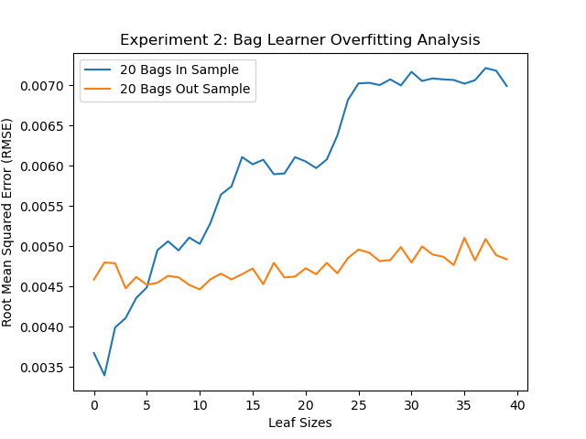
- Experiment 2: RMSE results for the bag learner (20 bags and Decision Tree model), comparing in-sample and out-of-sample performance across leaf size of 1 to 40

Experiment 3
The results of Experiment 3 suggest that the random tree outperforms the decision tree for Istanbul.csv dataset. The average Mean Absolute Error (MAE) for the random tree is 0.48, whereas the MAE for the classical decision tree is 0.56, as shown in Figure 3. Furthermore, the training time for the random decision tree is significantly shorter, at 0.002 seconds, compared to the average training time of 0.017 seconds for the classical decision tree, as show in Figure 4.
However, there is no single model that is universally superior. The choice of model ultimately depends on the specific data set being used. There may be cases where the classical decision tree performs better, and its interpretability and explainability are advantages. On the other hand, if speed is a priority, the random decision tree is likely a better choice.
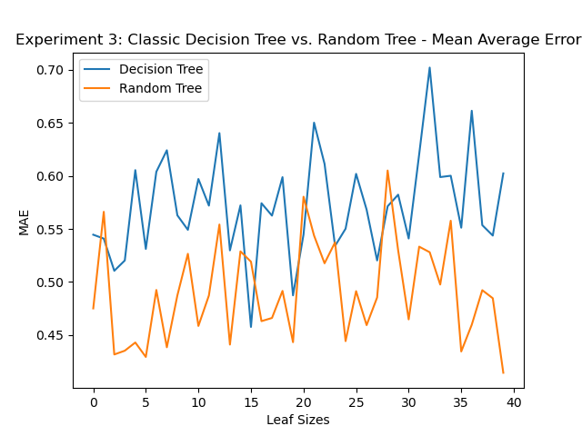
- Experiment 3: MAE results for comparing decision tree and random tree across leaf size of 1 to 40
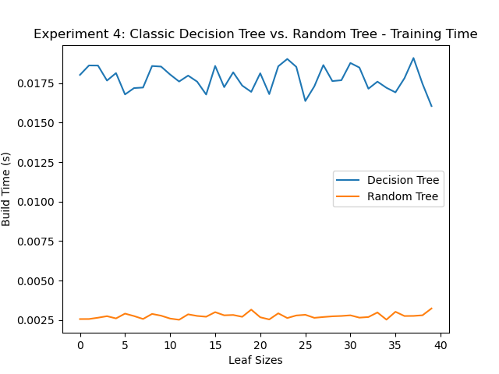
- Experiment 3: Training time for comparing decision tree and random tree across leaf size of 1 to 40.

Summary
In summary, our experiments show that overfitting occurs when the leaf size decreases in decision trees. While using bagging and ensemble learners can help reduce and mitigate this issue, they don't completely eliminate overfitting. On the other hand, random trees tend to perform faster than traditional decision trees, yielding more accurate results.

