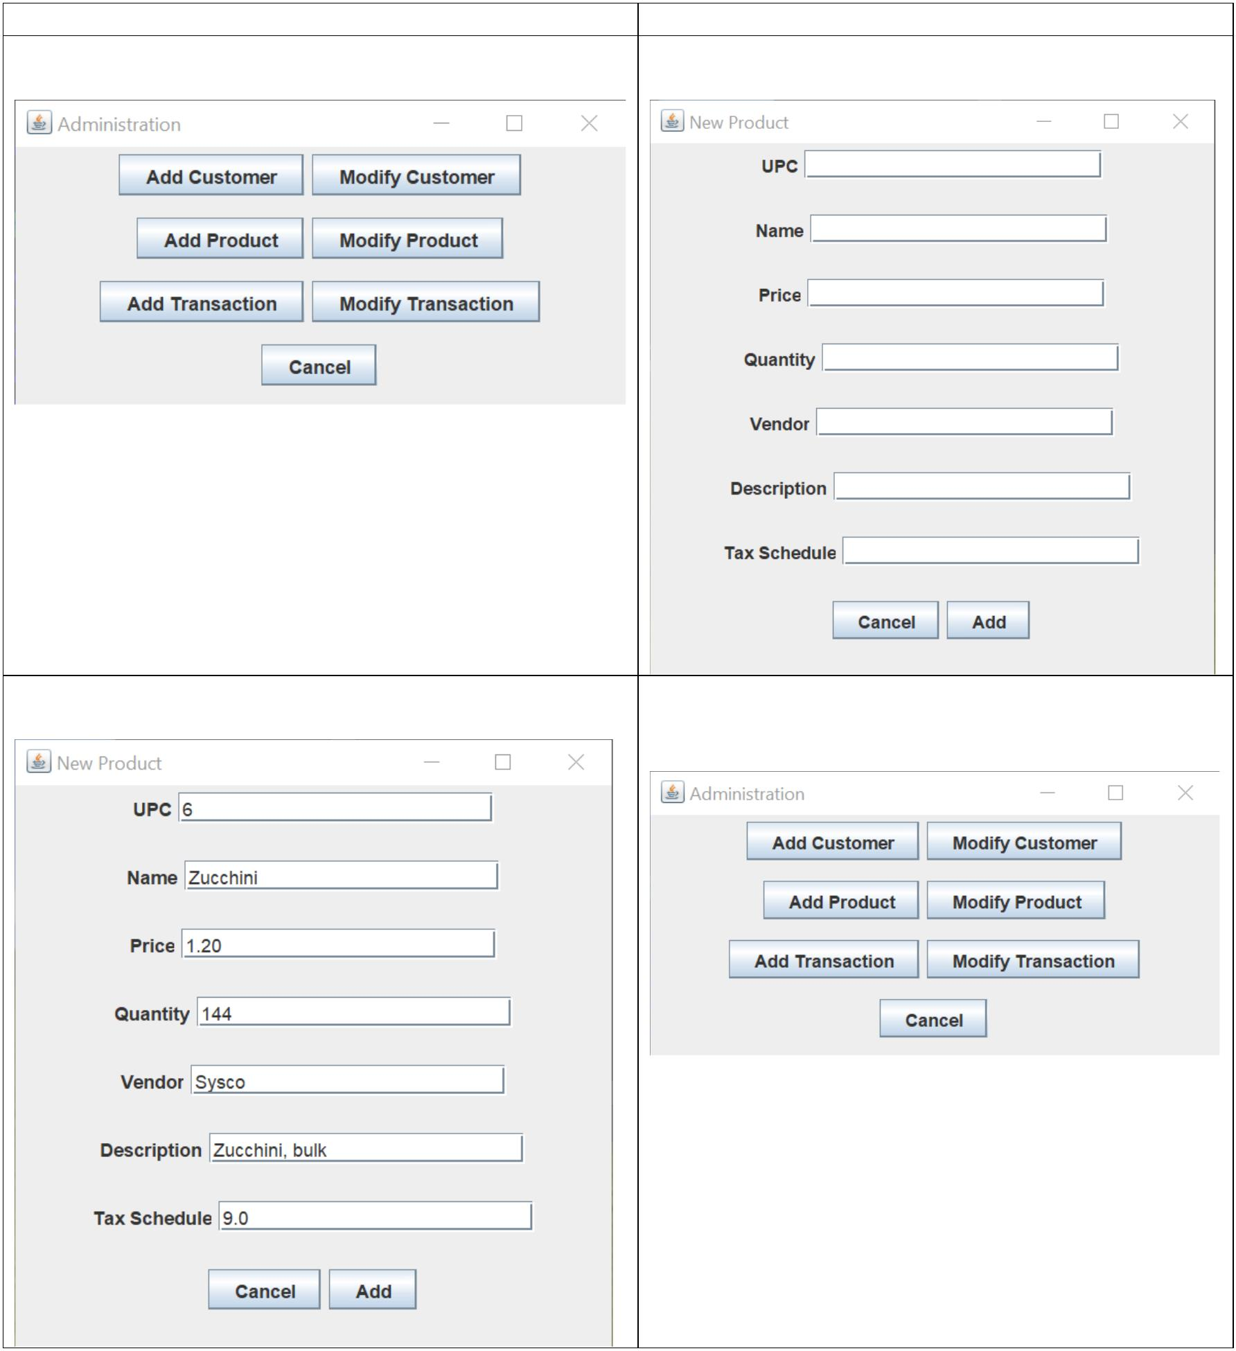
Use case: Add a new product into the system Steps
Actor System
1. Select “Add Product” from the main menu 2. Display “Add Product” dialog
Main menu: “Add Product” dialog:
 | - Input data and confirm  “Add Product” dialog with properties: |  | - Hide “Add Product” dialog and return to main  menu  Main menu:

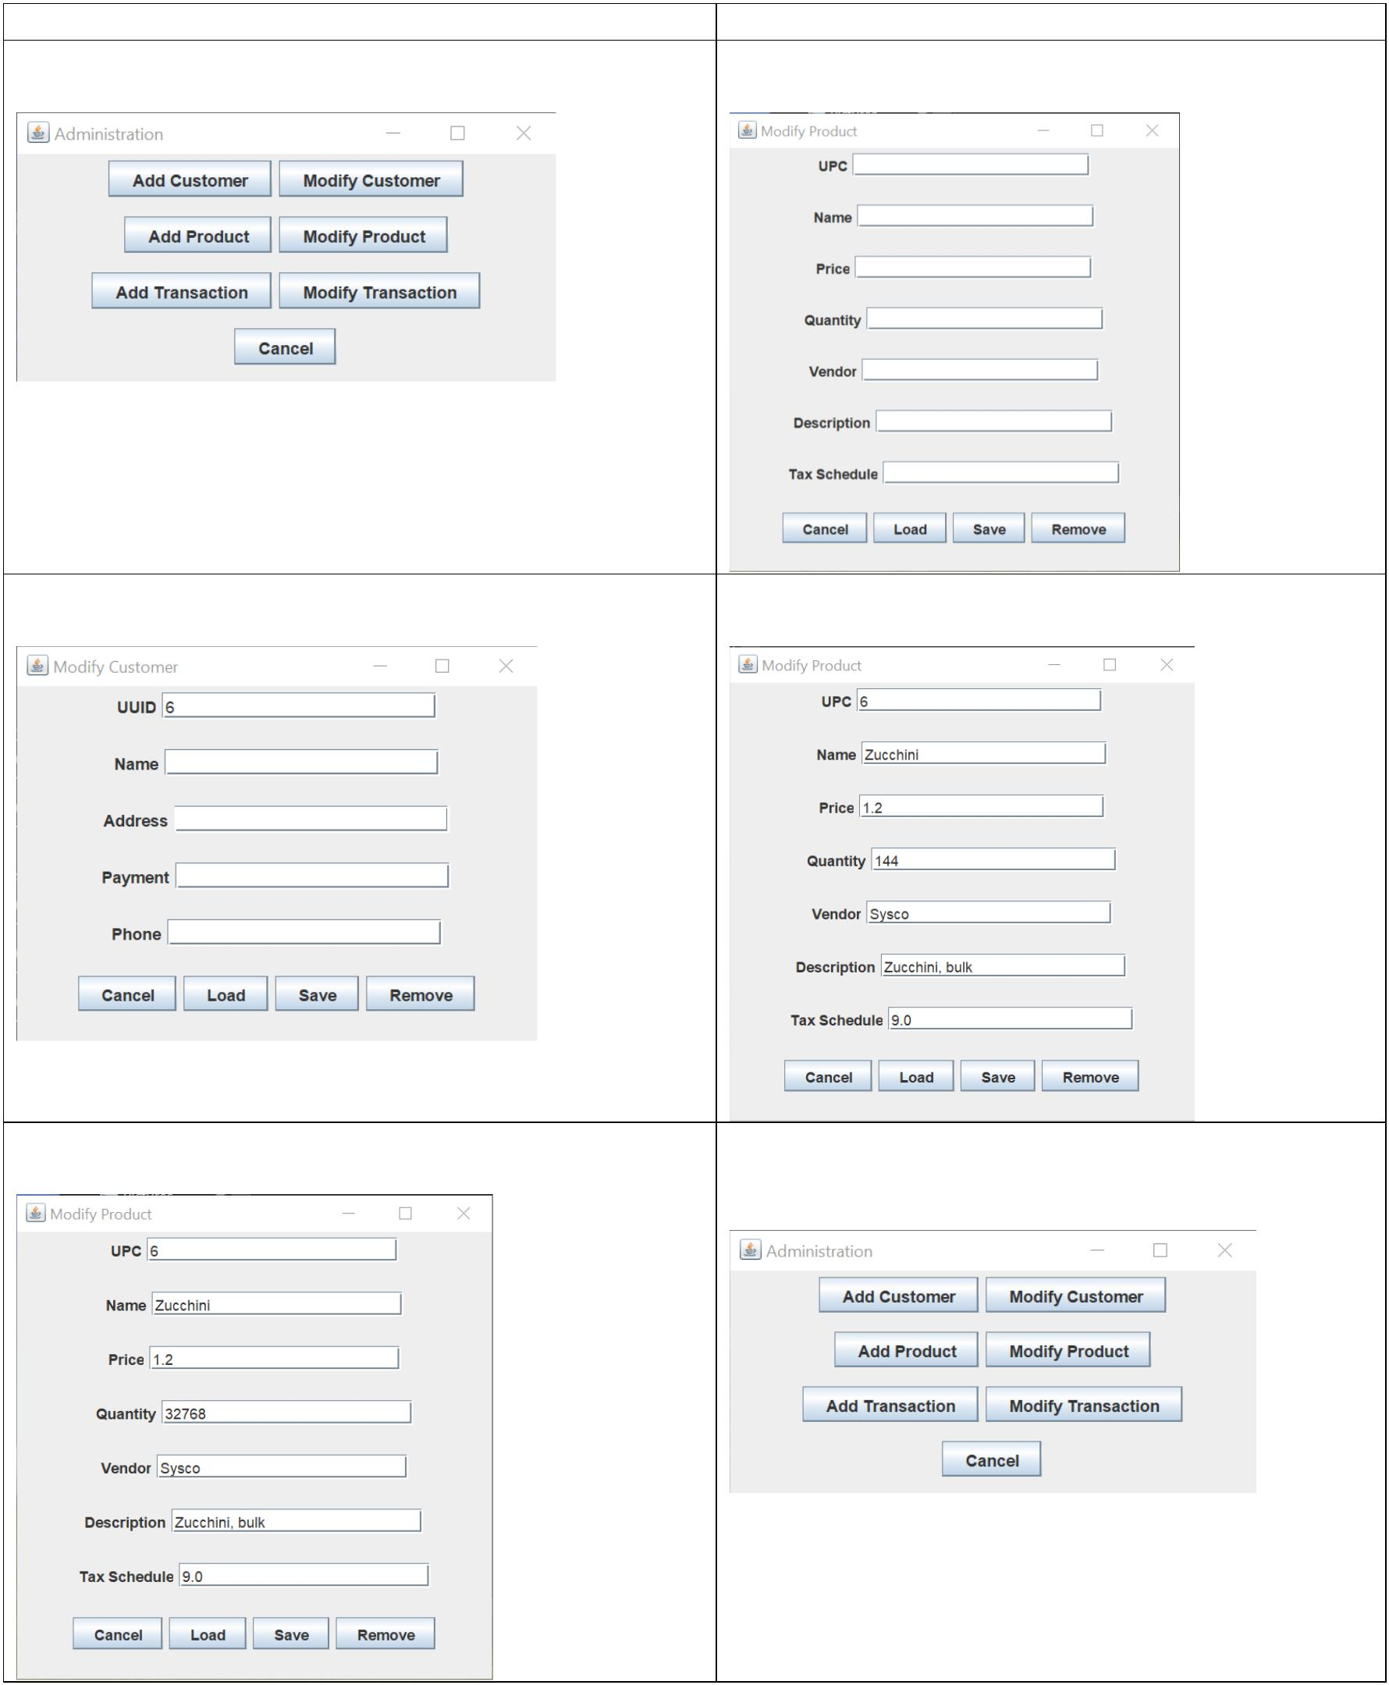
Use case: Modify product already in system Steps
Actor System
1. Select “Modify Product” from the main menu 2. Display “Modify Product” dialog
Main menu: “Modify Product” dialog:
 | 3. Input Product UPC and select “Load”  “Modify Product” dialog with UPC: |  | - Fetch product data and populate fields  “Modify Product” dialog with data:
 | - Update data and confirm  “Modify Product” dialog with updated properties: |  | - Hide "Modify Product" dialog and return to  main menu  Main menu:

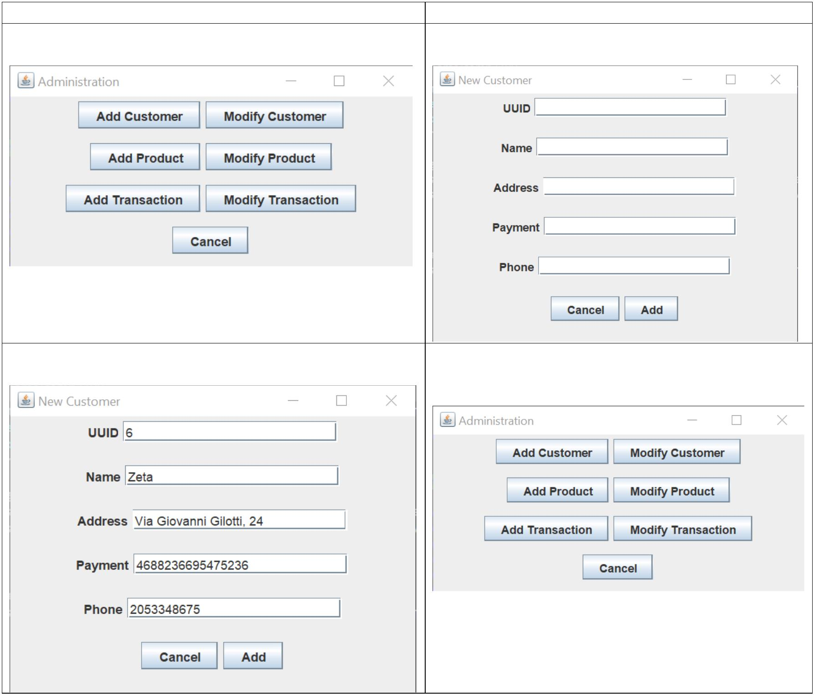
Use case: Add a new customer into the system Steps
Actor System
1. Select “Add Customer” from the main menu 2. Display “Add Customer” dialog
Main menu: “Add Customer” dialog:
 | - Input data and confirm  “Add Customer” dialog with properties: |  | - Hide “Add Customer” dialog and return to  main menu  Main menu:

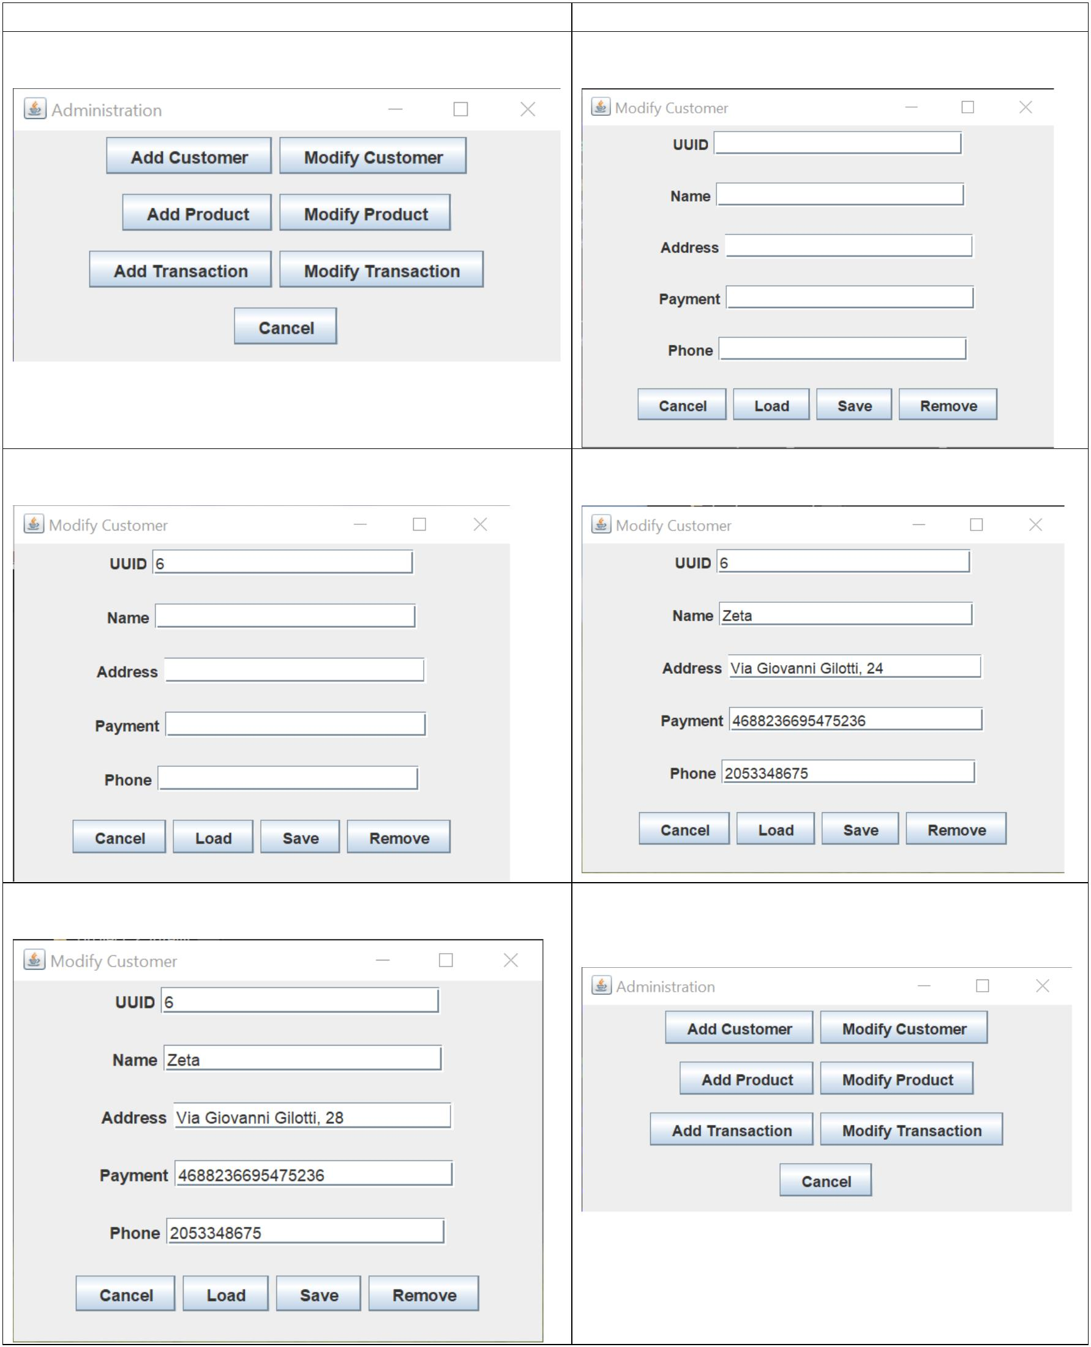
Use case: Modify customer already in system Steps
Actor System
1. Select “Modify Customer” from the main menu 2. Display “Modify Customer” dialog
Main menu: “Modify Customer” dialog:
 | 3. Input Customer UUID and select “Load”  “Modify Customer” dialog with UUID: |  | - Fetch customer data and populate fields  “Modify Product” dialog with data:
 | - Update data and confirm  “Modify Customer” dialog with updated properties: |  | - Hide “Modify Customer” dialog and return to  main menu  Main menu:

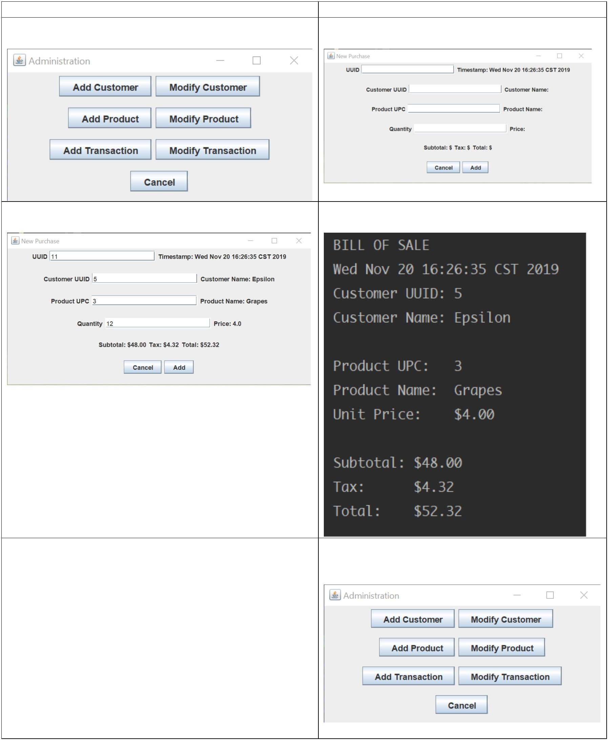
Use case: Add a Purchase to the system Steps
Actor System
1. Select “Add Transaction” from the main menu 2. Display “Add Transaction” dialog
Main menu: “New Transaction” dialog:
 | - Input data and confirm  “Add Transaction” dialog with properties: |  | - Generate and print receipt  Receipt:
- Hide “Add Transaction” dialog and return to
Main Menu.
Main menu:

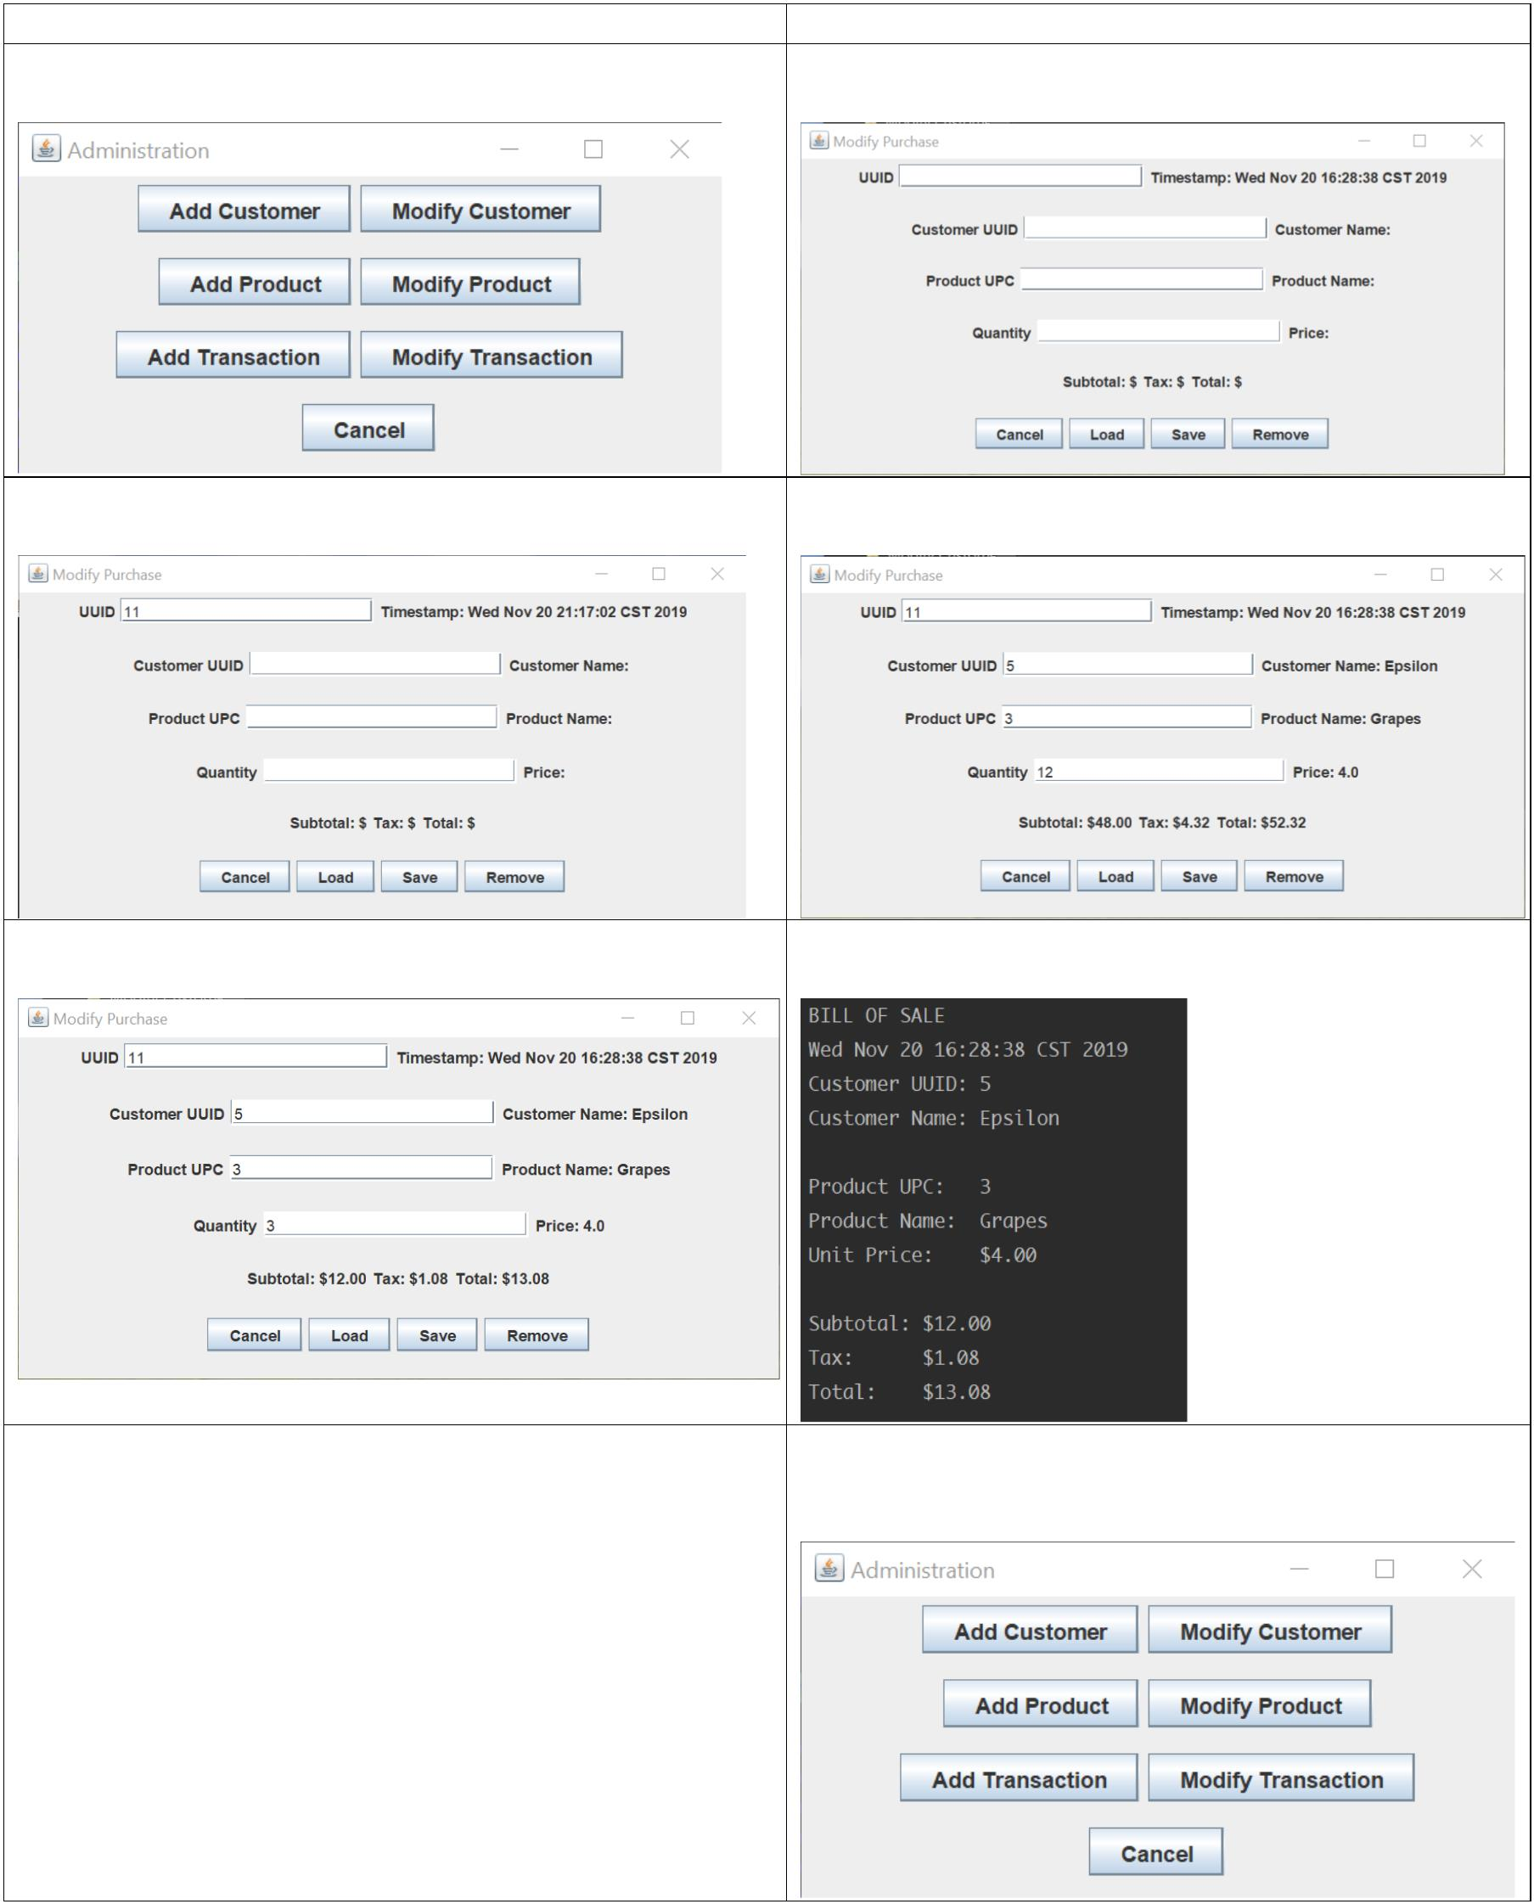
Use case: Modify a purchase already in the system Steps
Actor System
1. Select “Modify Transaction” from the main menu 2. Display “Modify Purchase” dialog
Main menu: “Modify Purchase” dialog:
 | 3. Input transaction UUID and select “Load”  “Modify Purchase” dialog with UUID: |  | - Fetch transaction data and populate fields  “Modify Purchase” dialog with data:
 | - Update data and confirm  “Modify Purchase” dialog with updated data: |  | - Generate and print updated receipt  Receipt:
- Hide “Modify Purchase” dialog and return to
main menu
Main menu:

