## Simple Neo4j Code

From bilibili neo4j 101

### 1, Neo4j Concepts

1. data structure

Nodes – entities – can have LABELS

Edges - lines – can have RELATIONSHIP

PROPERTITIES – information that relates to nodes – can be used to describe Nodes and Edges

For example,

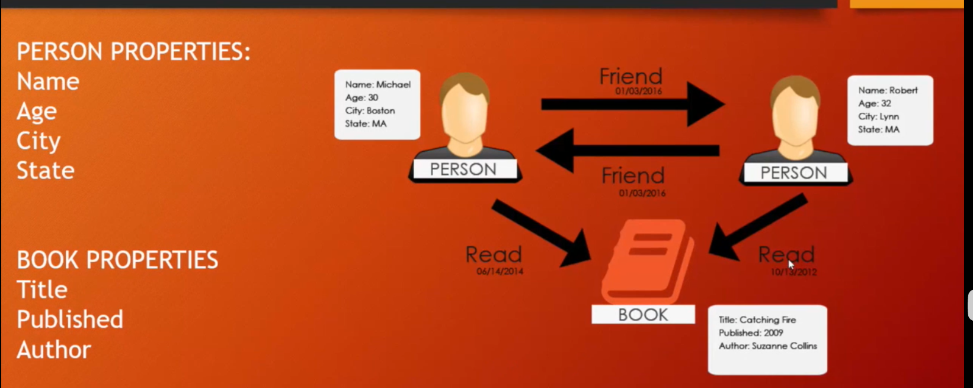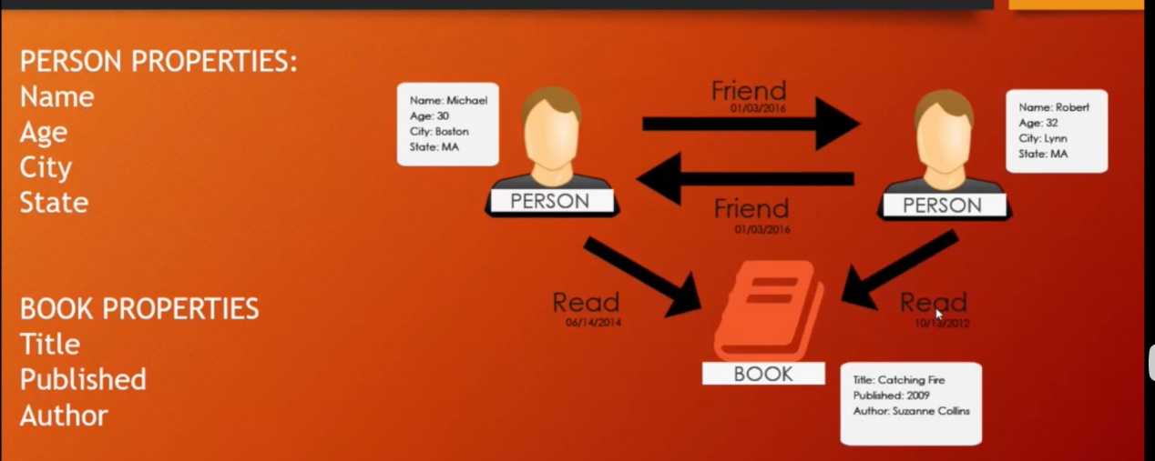

1. Cypher Query Language

MATCH - used to match /find / select patterns

WHERE - adds optional constraints

CRATE - create nodes and relationship

DELETE - delete nodes and relationship

SET & REMOVE - set and remove values to properties and adds labels on nodes

RETURN - returns nodes, properties, data

MERGE - match existing or create new nodes and patterns

For example,

Nodes - MATCH (person) RETURN person

Labels – MATCH(n:Person) RETURN n

Relationships – MATCH(a) 🡪 () , MATCH(a:Person) –[:Knows]->(b:Person)

Properties – MATCH(a:Person) RETURN a.name

Other details,

Relationship Patterns:

(a)🡪(b)

(a)—(b)

(a:Person)🡪(b)

(a)-[r]->(b)

Variable Length Patterns

(a)-[*1…5]->(b)

Size((a)🡪()🡪())

### 2, Neo4j Codes

1. **Building nodes and match**

##labeled person, property John

CREATE(n:Person{name:’John’}) RETURN n

CREATE(n:Location{city:’MIanyang’, state:’Sichuan’}) RETURN n

##SQL

MATCH(n:Person) RETURN n

MATCH(n{name:;Mike}) RETURN n

**2） Building Relationship**

##Adding friends relationship

MATCH(a:Person{name:’Liz’}), (b:Person{name:’Mike’})

MERGE(a)-[:FRIENDS]->(b)

MATCH(a:Health{name:'Health'}),(b:Health{name:'He_Behavious'})

MERGE(a)-[:CONTAINS]->(b)

MATCH(a:Person{name:’Liz’}), (b:Person{name:’Mike’})

MERGE(a)-[:FRIENDS {since:2000}]->(b)

#SQL find relationship

MATCH(a:Person)-[:BORN_IN]->(b:location{city:’Boston’}) RETURN a,b

MATCH(a)—() RETURN a

MATCH(a)-[r]-() RETURN a.name, type(r)

MATCH(a)-[r]-() RETURN DISTINCT type(r)

##From new nodes

CREATE(a:Person {name:’Todd’}) – [r:FRIENDS] -> (b:Person{name:’Carlos’})

**3）Update and Delete Nodes and Relations**

MATCH(a:Person {name:’Liz’}) SET a.age = 34

MATCH(a:Person{name:’Mike’}) REMOVE a.test

##Delete relations and nodes

MATCH(a:Location {city:’Portland’}) DELETE a

MATCH(a:Person{name:’Todd’}) – [rel] – (b:Person) DELETE a, b, rel

##Change it’s Name:

match (r) where id(r) = 0 set r.name = "Normal People