## From bilibili kuangshen

Lec_1: Use blog to keep track of the study

Lec_2: Intro

Hadoop (Big data)

Andriod

JavaSE (Disktop)

JavaME (Mobile phone)

JavaEE (Enterprise)

JDK (Java Development Kit)

JRE (Java Runtime Environment)

JVM (Java Virtual Machine)

Uninstall (Delete install home, Java_home, Java_path)

Lec_3:

Hello word:

Public class Hello{

Public static void main (String[] args) {

System.out.print (“Hello, World!”);

}

}

Note that:

class name = file name

Java is capital sensitive

Gramma:

Sentence is end by ;

// This is the note /**/

Java is both Compile (C language) and Interpretive (Websites)

Lec_4: Identifier

Can only start with Letters, $, or _

Java is strong decretive language

Two types of data:

1. Primitive type:

1, Value

1,1Int

Byte

Short (2B)

Int (4B)

Long (8B)

1,2Float

Float (4B)

Double (8B)

1,3Character

2, Boolean (T &F)

1. Reference Type (Object,

Lec_25: Type transfer

Byte, short, char, 🡪 int 🡪 long 🡪 float 🡪 double

Componsory exchange 🡪 may overflow

Lec_26: The variables

Type varName [=value] [{, varName[=value]}];

Every var(including name, type and domain) has type, each is a sentence.

Domain

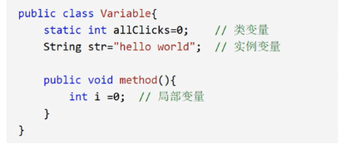

Constant – Use final

Some rules:

Class_member_name: monthSalary

Constant: MAX_VALUE

Method: use

P27~

Computation marks:

+, -, *, /, %, ++, --,

=

See Demo_operator

Lec_33: Scanner

To receive the input of the users

Next(): use tab to return

NextLine(): Use enter to return

Lec35: Structure

NO_1: The sequence order

Mark: P35

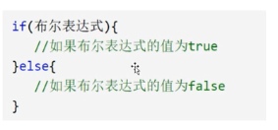

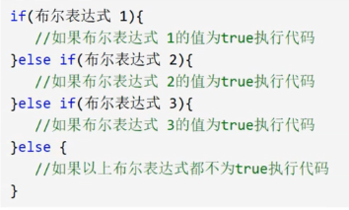

Lec_37: Switch

How to find the raw code

Lec_38.39 while:

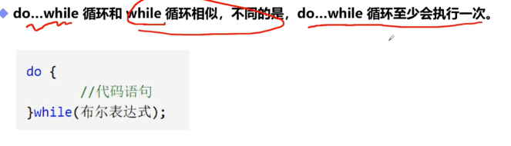  
Lec_40:

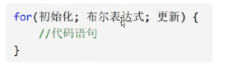

Lec_43: Break, Continue, Goto

Break: could be used to jump out of a loop

Continue: to skip one of the loop

Lec_46: method2

Lec_47: Reload

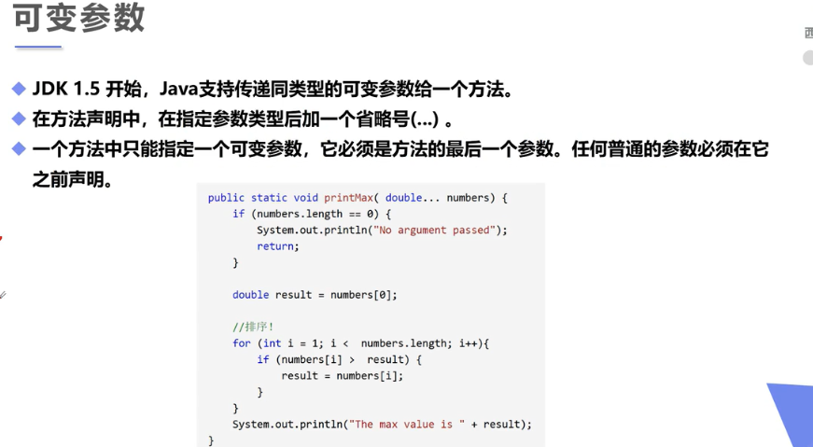

Lec_50: Recursion

Useable when the number is small

Lec_51: Truple

An ordered data with a same type

Can not be changed, could be viewed as an object

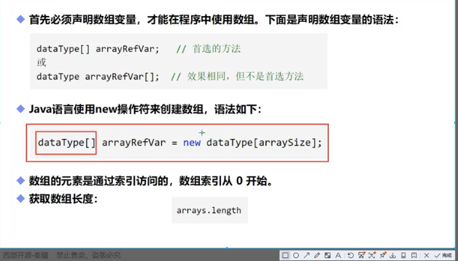

Lec_52: Memory

Lec_56

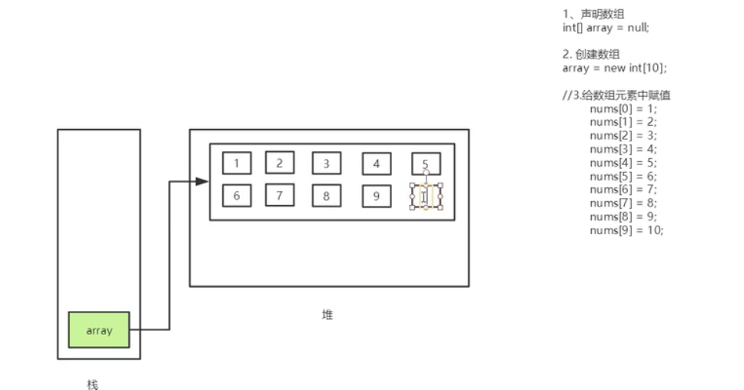

Lec_57: 2-dim array

Lec_59: Sparse table

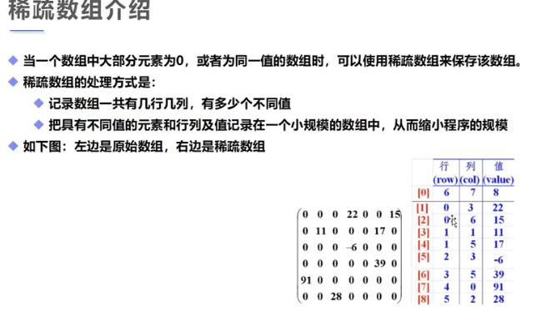

Lec_60: OOP

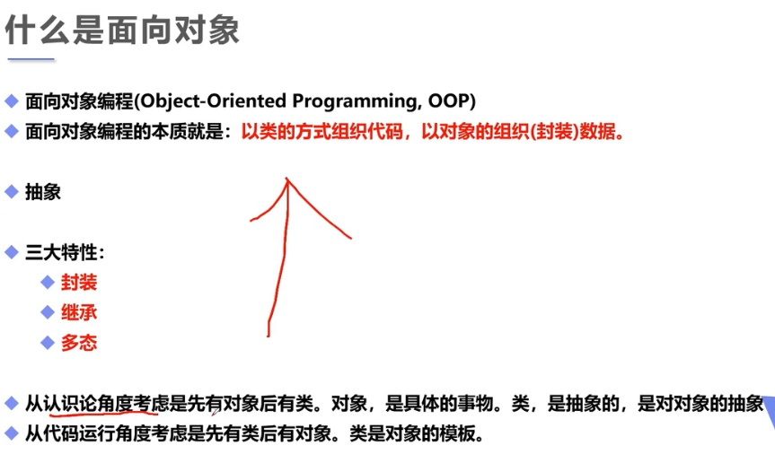

Lec_64;: Constructor

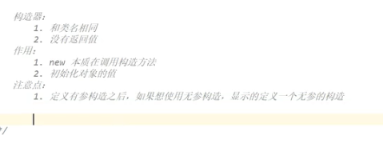

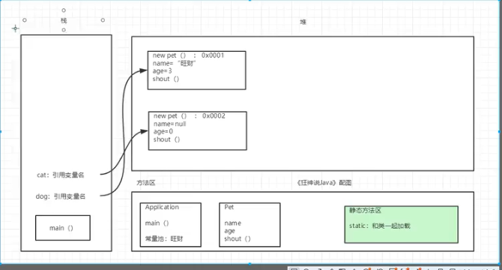

Lec_67: Encapsture

Lec_69: Super

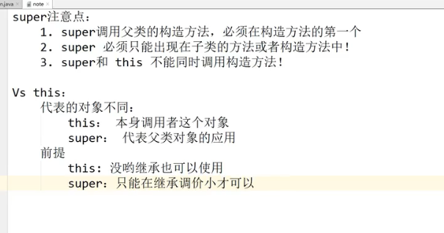

Lec_70: Override

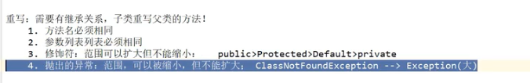

Lec_71: Ploymorphic

Lec_74: Abstract

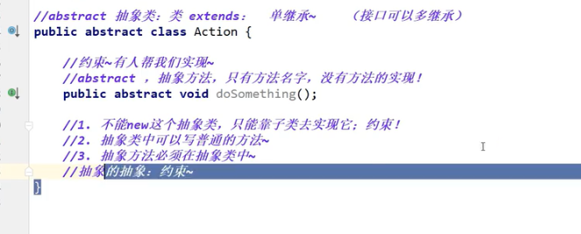

Lec_75: API?

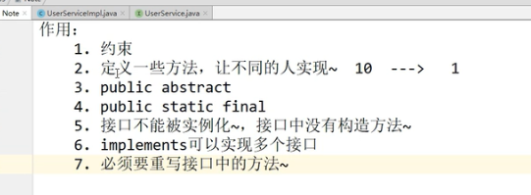

Lec_76: Internal class

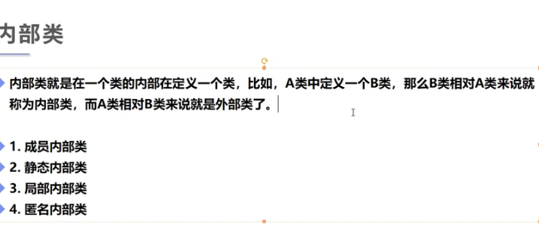

Lec_77: Exception

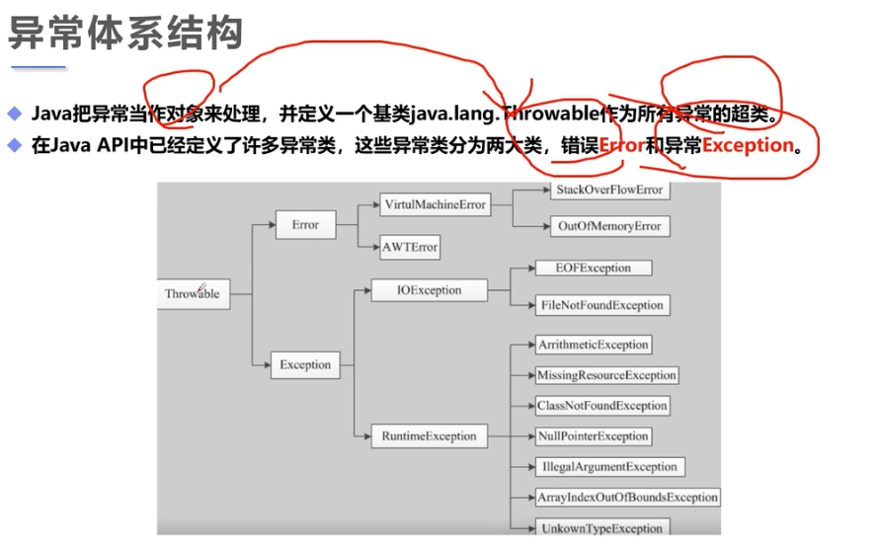

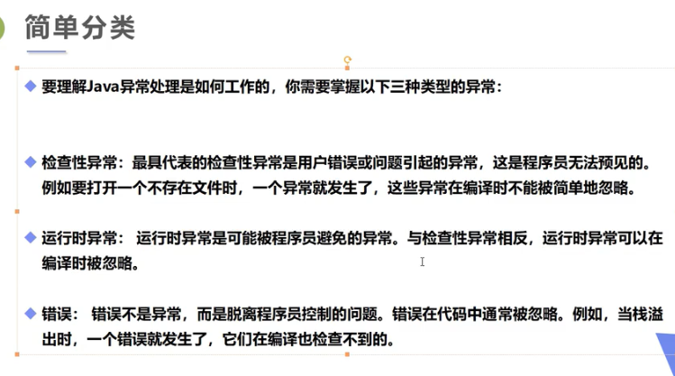

Lec_78:

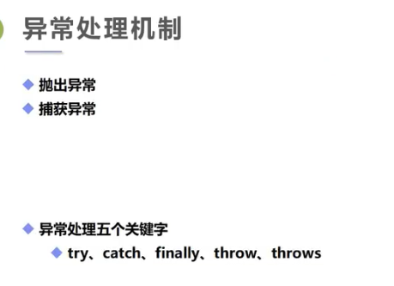

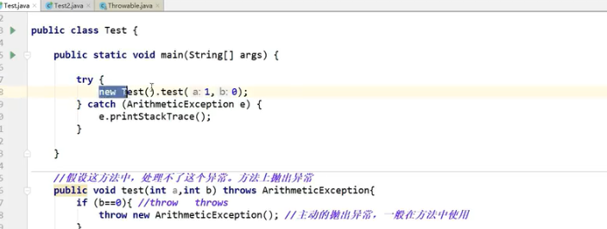

## From the book First Head Java

The structure:

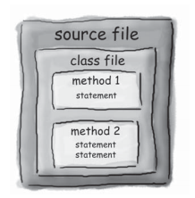

**CH_1: Concepts**

**CH_2: Class and object**

**CH_3: Primitive variables**

**CH_4: Instance (Knows) and method(does)**

**CH_5: Build a small game using method**

**CH_6: Using Java functions**

**CH_7: Inherit P107**

**CH_8: Polymorphic**

**CH_9: Object**

CH_1: Concepts

CH_2: Class and object

CH_3: Primitive variables

CH_4: Instance (Knows) and method(does)

CH_5: Build a small game using method

CH_6: Using Java functions

CH_7: Inherit P107

Is-a

Has-a (extends)

Private 🡪 default 🡪 protected 🡪 public

CH_8: Polymorphic

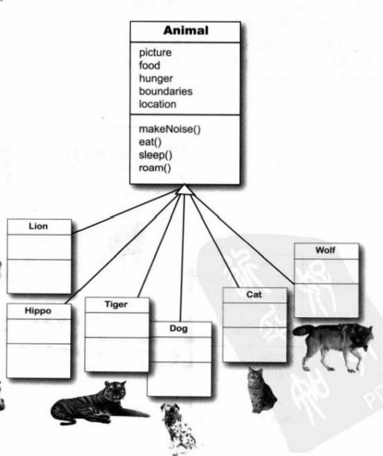

CH_8: Polymorphic

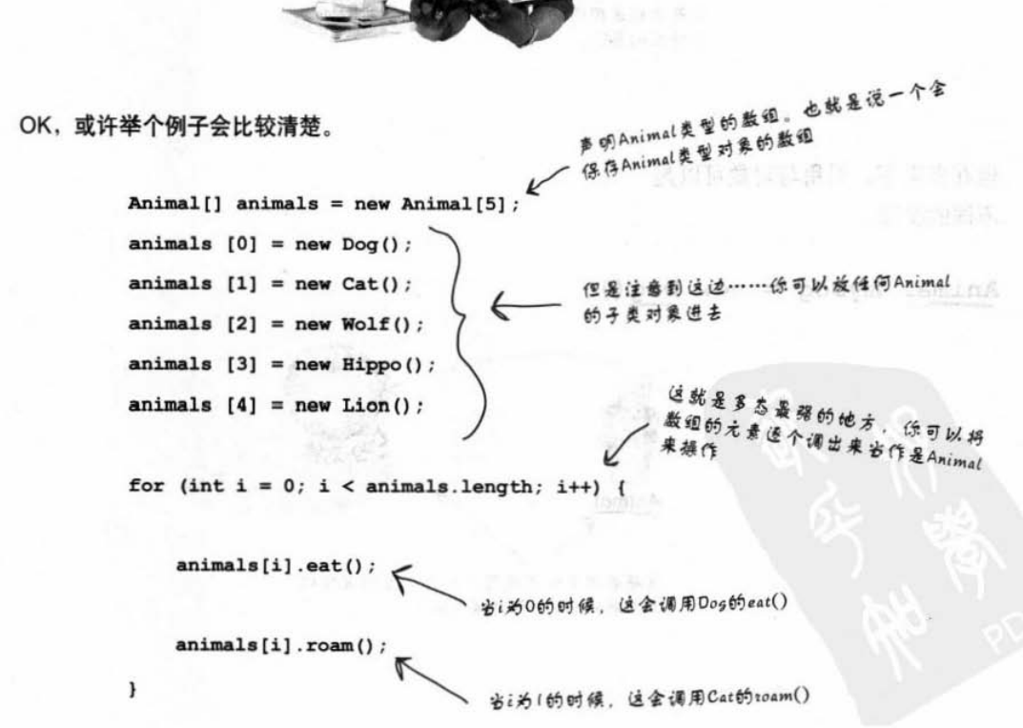

Abstract

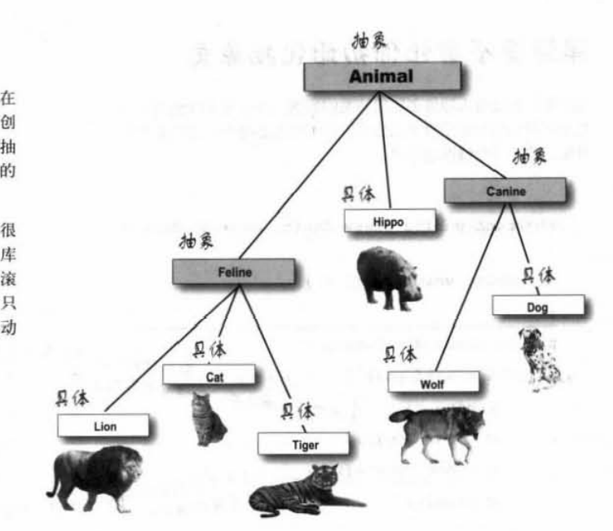

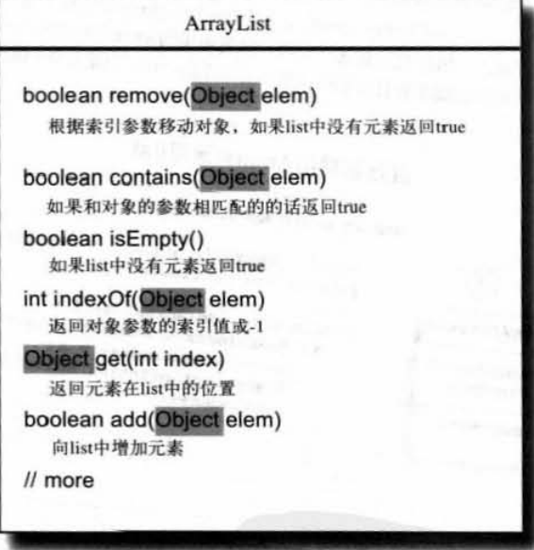

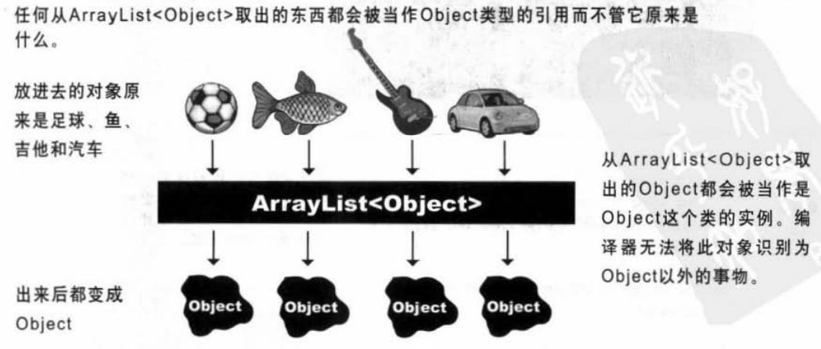

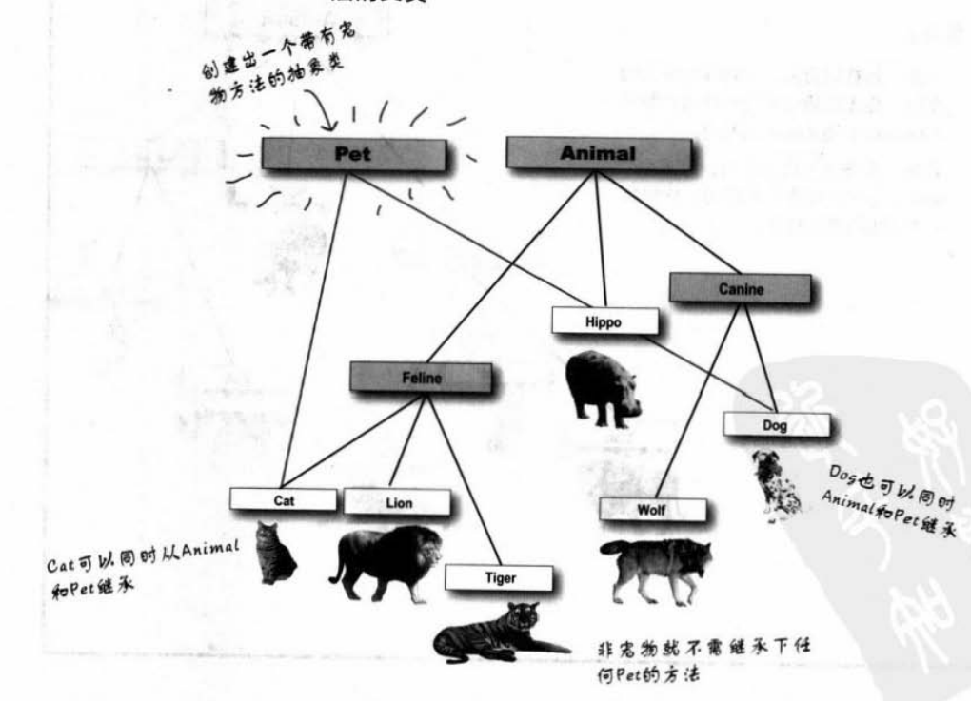

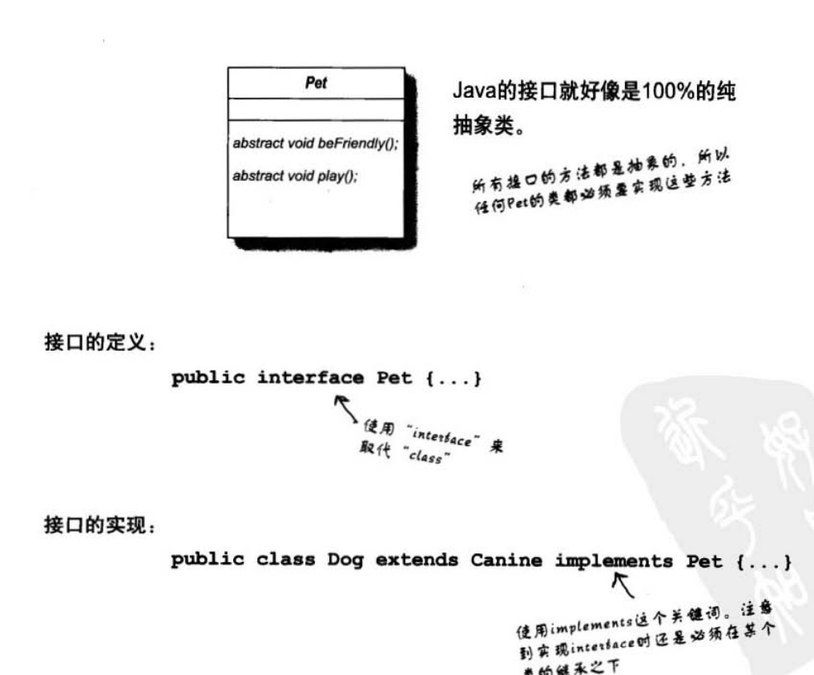

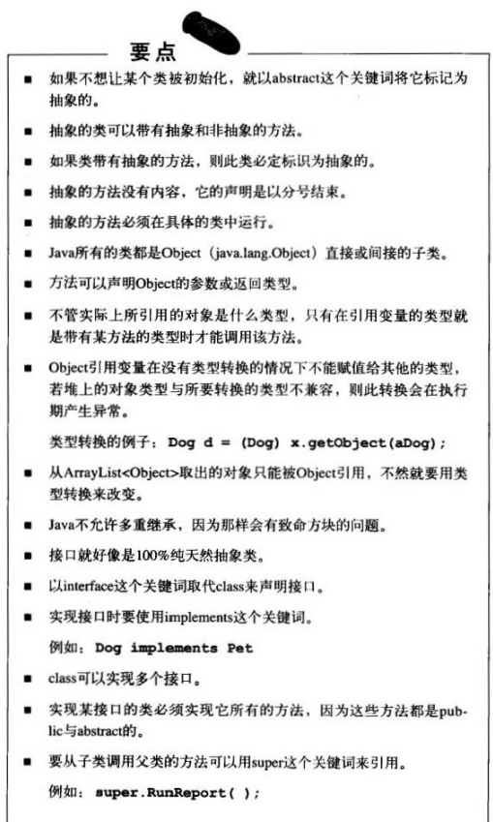

**P237**

**Lec_9: Object**

